Heroes of Pymoli Readme

This python script reads purchase data for the video game Heroes of Pymoli. The purchase data includes the following: purchase ID, SN, Age, Gender, Item ID, Item Name, and Price. Using that data, the python script runs an analysis to determine the following insights:

**player count**

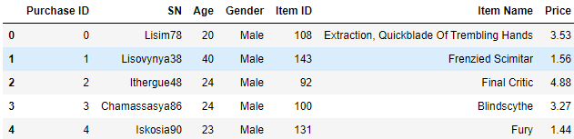

**purchasing analysis (total)**

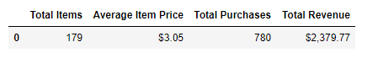

gender demographics

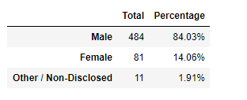

**purchasing analysis (gender)**

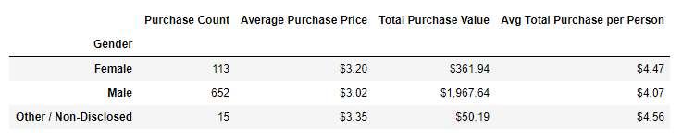

**age demographics**

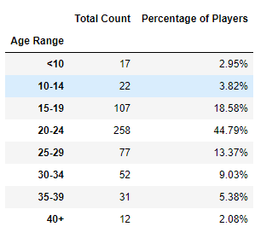

**Purchase analysis (age)**

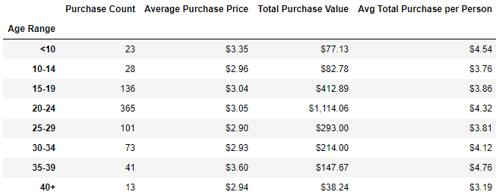

**Top spenders**

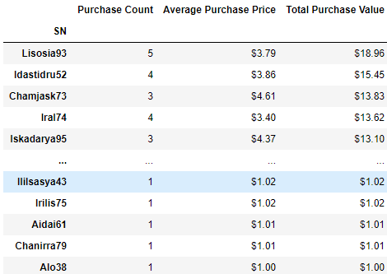

**most popular items**

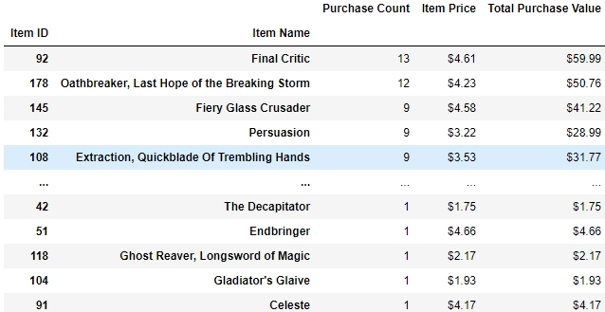

**most profitable items**

