Readme

**PyBank** - for this challenge, we are looking at a company’s financial records. The data provided is in a CSV file. It contains profits and losses per month. Based on the provided data, a python script was created to assess the following:

* Number of months in the data provided
* Profit/loss total
* Average monthly change in profit/loss
* The month and amount with the greatest increase
* The month and amount with the greatest loss

Here are the results returned from the python script:

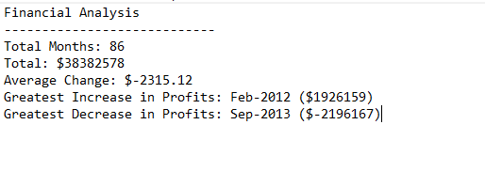

**PyPoll** – this challenge is calculating results from an election poll. The data provided is in a CSV file containing entries for each vote submitted. Each entry contains the following: voter ID, county, and the candidate selected. Using this data, a script was made with python to calculate return the following: total votes cast, list of candidates, percentage and total of votes per candidate, and the winning candidate.

Here are the results from the python script:

