Ultrashort pulses and applications

Ultrashort pulses are brief bursts of electromagnetic radiation with extremely short temporal duration. Typically, this duration range from 10 to 100 fs although we can also find these pulses reaching the attosecond regime.

Due to their limited temporal duration, they inherently possess a broad spectral bandwidth due to the Fourier transform relationship between time and frequency domains. Generating a short pulse in time requires the coherent superposition of a wide range of frequencies.

Besides this, the bandwidth is influenced by the carrier frequency of the pulse envelope. This means that for a fixed pulse width, the required bandwidth decreases as the carrier frequency increases.

Spectral resolution and sampling issues in Fourier-transform spectral interferometry

* DOI:
* [10.1364/JOSAB.17.001795](http://dx.doi.org/10.1364/JOSAB.17.001795)

Spectral interferometry, a technique relying on the use of frequency-domain interferences between two beams of different optical pathds, has been shown to be of great use in femtosecond spectroscopy and analysis of temporal pulse sahep.

Spectral interferometry allows the retrieval, in a simple way, of the difference in spectral phase between two tiem-delayed light pulses. This makes possible the measurement of the complex transfer function of any linear optical element by use of a broadband light source such as a femtosecond laser or an incoherent white lamp. It also allows the full characterization of the electric field of an unknown pulse, assuming that a well-characterized reference pulse of appropriate spectrum is available. Because the measured quantity is linear in the electric field of the unknown pulse, this technique is much more sensitive than its nonlinear counterparts and can be used for extremely weak pulses, which is one of the main reasons for its widespread use in femtosecond spectroscopy.

FOURIER TRANSFORM SPECTRAL INTERFEROMETRY

In this section we describe how FTSI permits the retrieval of the difference in spectral phase between two light pulses from their interference spectrum.

In a typical spectral interferometry experiment, a relative time delay tau is inftroduced between the two beams, which are then recombined collinearly with a beam splitter. The total electric field $E_{0}\left(t\right)+E(t-τ)$ is then spectrally resolved with a spectrometer and a CCD detector. The total frequency spectrum thus reads:

$$I\left(ω\right)=|E_{0}\left(ω\right)+E(ω)e^{iωτ}|^{2}$$

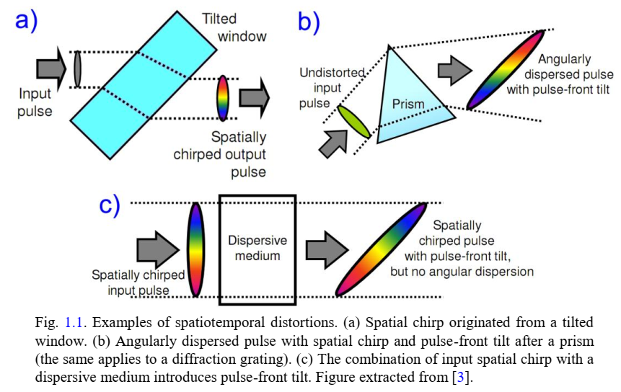

DESCRIPTION OF ULSTRASHORT LASER PULSES: BASIC CONCEPTS AND DEFINITIONS

In this section, we will introduce the concepts of optics required for the description and characterization of ultrashort laser pulses, including the physical and mathematical definition of the pulses (such as electric field, amplitude and phase), as well as the mathematicl tools to deal with the pulses.

The light is an electromagnetic wave consisting of a vibrating electromagnetic field Ref_hetch. The electric field E and the magnetic field B are related by Maxwell’s equations. Therefore, it is enough to consider the electric field for the description of the laser radiation and disregard the magnetic field from now on. In many situations the electric field is a vector that oscillates in the plane perpendicular to the propagation direction. The trajectory described by the electric field vector in that plane is known as polarization. In our case, the lasers employed are linearly polarized (oscillating in one direction), so we can consider the pulses as a scalar electric field.

Basic definitions:

Despite being a real function (sice it stands for a physical ampliftude), electric field is usually expressed as a complex function: The actual electric field is simply the real part of the complex representation.

  es la frecuencia angular central