**Carousel simulator documentation**

v0, Francesco Destro, October 14 2021

**1. Process description**

The unit whose behavior is reproduced by the simulator is schematically drawn in Figure 1. A schematic P&ID of the process is provided in Figure 2, with the legend of equipment, sensors and controllers reported in Table 1.

The carousel features five cylindrical ports, each one of 15 mm diameter, which allow a maximum hold-up of 10 mL. The ports are embedded in a main cylindrical body, aligned to five processing stations (Stations 1-5). For illustrative purposes, in Figure 5.1 the stations are represented as vessels in series (V102-V106), although the actual layout of the carousel is as in Figure 1. Stations 1-4 present a filter mesh at the bottom (F101-104), whereas Station 5 is open at the bottom for cake discharge, which is enabled by the action of a pneumatic piston. The pressure gradient for filtration and drying is provided by a compressor (P102), whereas all ports are maintained at atmospheric pressure on the bottom part.

The carousel operates in cyclic mode: processing cycles, during which every port processes batch-wise the material therein contained, are alternated to carousel rotations, during which the ports containing the material being processed are moved to the following station. Carousel rotations are represented in the P&ID as material streams, controlled by FC101. The alternating processing cycles and carousels rotations are interrupted when significant mesh fouling is detected: a cleaning-in-place cycle is triggered, and all meshes are automatically cleaned by sending a wash solvent into the carousel (Figure 1). Stations 1-3 are dedicated to filtration and deliquoring, while in Station 4 thermal drying is carried out. In Station 5, only cake discharge occurs.

Slurry processing occurs as follows. The crystallization slurry is fed to Station 1 at the beginning of each cycle. After slurry feeding, a subsequent filtration step starts in Station 1, and it continues until filtration ends, or throughout the whole cycle duration, until the following carousel rotation. In the latter situation, filtration will continue in Station 2. During filtration, the liquid contained in the slurry is filtered out of the port by the action of the vacuum pump and stored in filtrate collector V107, while the crystals are retained on top of the filter mesh, leading to cake formation. We distinguish between actual filtration, when there is a slurry hold-up on top of the cake being formed, and the subsequent deliquoring, during which the only remaining liquid is the one retained inside the cake pores. Upon deliquoring, the liquid in the pores of the cake is mechanically displaced out of the cake by the action of the vacuum pump, until a certain pore saturation equilibrium is achieved. Filtration duration depends on the cake properties and on the pressure drop delivered by the vacuum pump. Depending on filtration duration, the cake can also be partially deliquored in Stations 1-3, or it might even enter Station 4 with some slurry hold-up (drying cannot be properly conducted in this situation, which should be avoided). Thermal drying is performed in Station 4 by flowing a hot gas stream through the cake.

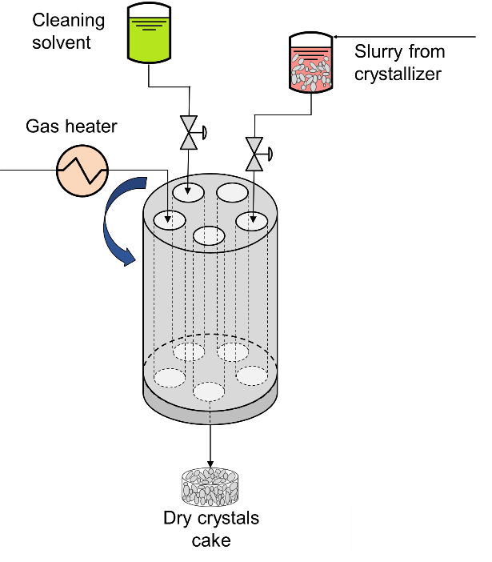

**Figure 1.** *Schematic drawing of the unit reproduced by the simulator.*

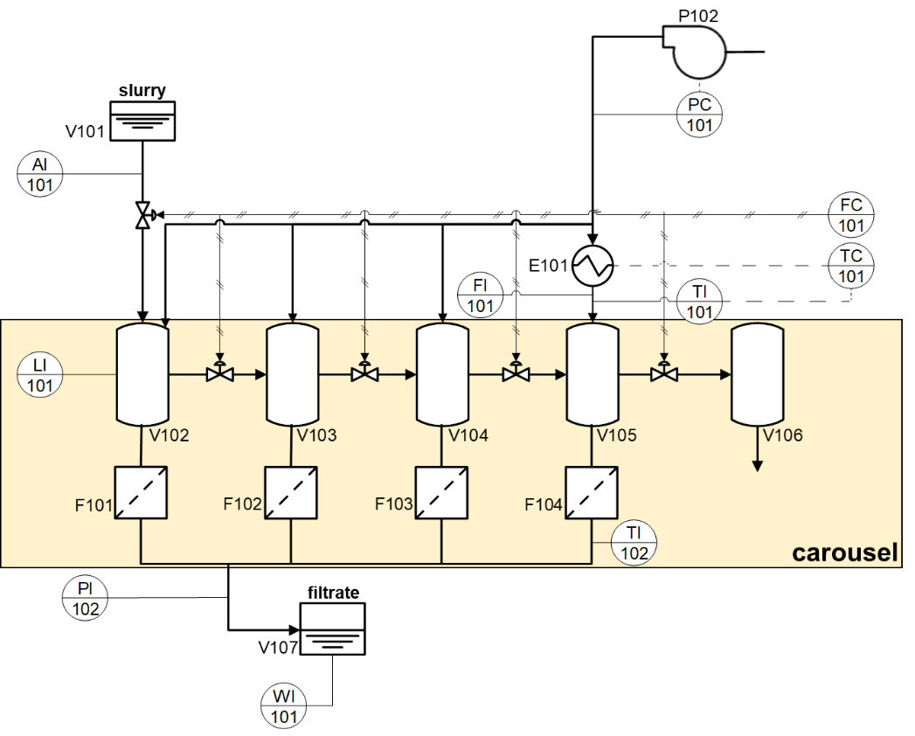

**Figure 2.** *P&ID of the unit reproduced by the simulator. The equipment legend is reported in Table 2.*

**Table 2.** *Legend of equipment of Figure 2.*

|  |  |
| --- | --- |
| **Name** | **Description** |
| *Unit ID* |  |
| F101-F104 | Filter mesh below Stations 1-4 (respectively) |
| P102 | Compressor |
| E101 | Drying gas heater |
| VI101 | Slurry tank |
| VI102 | Carousel Station 1 |
| VI103 | Carousel Station 2 |
| VI104 | Carousel Station 3 |
| VI105 | Carousel Station 4 |
| VI106 | Carousel Station 5 |
| VI107 | Filtrate collector |
|  |  |
| *Controllers and sensors* |  |
| AI101 | Slurry concentration sensor (ultrasonic probe; Bamberger and Greenwood, 2004a, 2004b) |
| FC101 | Fictitious flowrate controller representing carousel rotation and slurry feeding routines enabled by PLC |
| FI101 | Flowmeter for gas entering carousel ports |
| LI101 | Camera system (Ottoboni et al., 2020a) measuring volume of fed slurry and cake height |
| PC101 | Pressure controller |
| PI102 | Pressure indicator |
| TC101 | Drying gas inlet temperature controller |
| TI101 | Thermocouple for inlet drying gas temperature |
| TI102 | Thermocouple for outlet drying gas temperature |
| WI101 | Scale for inferring filtrate flowrate |

**2. Overview of simulator routines**

Figure 2 shows the logical order with which the scripts and functions of the simulator are called during a simulation. The colored blocks refer to the scripts/functions that can be edited by users.

The simulator is initiated by running the script run_carousel.m, where the simulation settings can also be modified.

The functions controller_online.m, controller_cycle_switch.m, estimator_online.m, and estimator_cycle_switch.m can be edited for modifying the control strategy of the unit. The default implementation of the simulator consists of open-loop operation.

Table 2 provides an overview of the structure and of the content of the simulation output object (simulation_output.mat). The fields of simulation_output.mat are:

* states, storing the value assumed by selected system states during the simulation;
* measurements, storing the process measurements;
* disturbances, containing the profiles of the disturbances during the simulation;
* manipulated_vars, storing the profiles of the manipulated variables;
* estimated_states_parameters, containing potential estimated states/parameters;
* feed, storing the slurry concentration profile during the simulation;
* settings, containing the settings that were set in run_carousel.m before initiating the simulation.

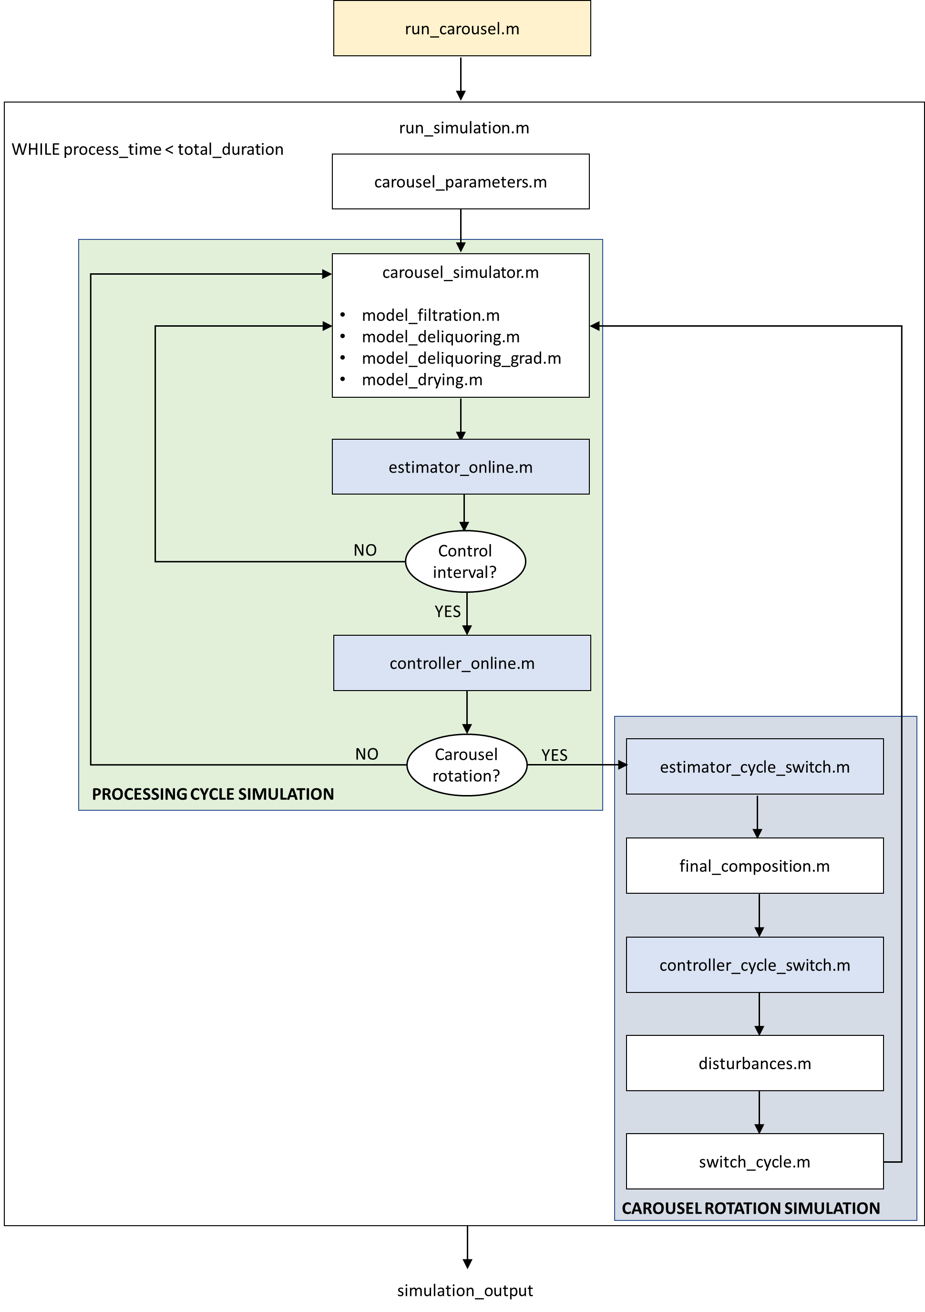

**Figure 2.** *Block diagram of the carousel simulator. Yellow: block to be (optionally) edited with desired operating settings and then run. Blue: blocks that can be edited for modifying the control strategy.*

**Table 2.** Structure of simulation_output.mat.

|  |  |  |  |  |  |
| --- | --- | --- | --- | --- | --- |
| **Field** | **Sub-field** | **Sub-sub-field** | **Variable** | **Description** | **UOM** |
| states | pos1 | batch_x | t | Readings of timer reinitialized at every carousel rotation – vector – step: sampling_time | s |
|  |  |  | m_filt | Filtrate mass time profile for batch_x in Station 1 – vector [1xlength(t)] | kg |
|  |  |  | S | Average cake saturation time profile for batch_x in Station 1 – vector [1xlength(t)] | - |
|  |  |  | w_EtOH_cake | Time profile of average ethanol mass fraction in cake for batch_x in Station 1 – vector [1xlength(t)] | - |
|  |  |  | L_cake | Length of cake of batch_x – scalar | m |
|  |  |  | c_slurry | Slurry concentration for batch_x - scalar | kg/m3 |
|  |  |  | V_slurry | Loaded slurry volume for batch_x - scalar | m3 |
|  | pos2/pos3/pos4 | batch_x | t | Readings of timer reinitialized at every carousel rotation – vector – step: sampling_time | s |
|  |  |  | m_filt | Filtrate mass time profile for batch_x in Station 2/3/4 – vector [1xlength(t)] | kg |
|  |  |  | S | Average cake saturation time profile for batch_x in Station 2/3/4 – vector [1xlength(t)] | - |
|  |  |  | w_EtOH_cake | Time profile of average ethanol mass fraction in cake for batch_x in Station 2/3/4 – vector [1xlength(t)] | - |
|  | sequence | batch_x | filtration_duration | Cumulative filtration duration for batch_x in Stations 1-4 |  |
|  |  |  | deliquoring_duration | Cumulative deliquoring duration for batch_x in Stations 1-4 |  |
|  |  |  | drying_duration | Cumulative drying duration for batch_x in Stations 1-4 |  |
| measurements |  |  | t_meas | Readings of timer initialized at process onset - vector: step = sampling_time | s |
|  |  |  | m_filt_WI101 | Readings of WI101 – vector [1xlength(t_meas)] | kg |
|  |  |  | P_PI102 | Readings of PI102– vector [1xlength(t_meas)] | Pa |
|  |  |  | c_slurry_AI101 | Readings of AI101– vector [1xlength(t_meas)] | kg/m3 |
|  |  |  | L_cake_LI101 | Readings of LI101– vector [1xlength(t_meas)] | m |
|  |  |  | V_slurry_LI101 | Readings of LI101– vector [1xlength(t_meas)] | m3 |
|  |  |  | Tg_top_TI101 | Readings of TI101– vector [1xlength(t_meas)] | K |
|  |  |  | Tg_bot_TI102 | Readings of TI102– vector [1xlength(t_meas)] | K |
|  |  |  | Vdryer_FI101 | Readings of FI101– vector [1xlength(t_meas)] | L/min |
| disturbances |  |  | resistances | Vector [n_cycles x 4] – element (*i*, *j*) = resistance of mesh in position *j* during processing cycle *i* | 1/m |
|  |  |  | ports_working | Vector [n_cycles x 4] –  if port *j* processes material during cycle i, ports_working(*i*, *j*) = 1. Otherwise, ports_working(*i*, *j*) = 0. | - |
|  |  |  | c_slurry | Gaussian multiplicative disturbances to nominal slurry concentration –  Vector [1 x n_cycles] | - |
|  |  |  | V_slurry | Gaussian multiplicative disturbances to current fed slurry set-point –  Vector [1 x n_cycles] | - |
|  |  |  | E | Gaussian multiplicative disturbances to nominal cake porosity –  Vector [1 x n_cycles] | - |
|  |  |  | hM | Gaussian multiplicative disturbances to nominal mass transfer coefficient –  Vector [1 x n_cycles] | - |
|  |  |  | hT | Gaussian multiplicative disturbances to nominal heat transfer coefficient –  Vector [1 x n_cycles] | - |
| manipulated_vars |  |  | t_vector | Readings of timer initialized at process onset – vector: step = control_interval | s |
|  |  |  | dP_vector | Set-point of pressure drop – vector [1 x length(t_vector)] | Pa |
|  |  |  | Tin_drying_vector | Set-point of drying gas temperature – vector [1 x length(t_vector)] | K |
|  |  |  | n_cycle_vector | Cycles counter - vector | - |
|  |  |  | t_rot_vector | Cycles duration – vector [1 x length(n_cycle_vector)] |  |
|  |  |  | V_slurry_vector | Set-point of fed slurry volume – vector [1 x length(n_cycle_vector)] | m3 |
| estimated_states_parameters *defined by user in run_carousel.m* | | | | | |
| feed |  |  | c_slurry_vector | Nominal slurry concentration –  vector [1 x n_cycles] |  |
| settings |  |  | control_flag | Scalar | - |
|  |  |  | disturbance_flag | Scalar | - |
|  |  |  | control_interval | Time interval at which control routines are called - scalar | s |
|  |  |  | sampling_time | Sampling time for all sensors – scalar | s |
|  |  |  | total_duration | Simulation duration – scalar | s |
|  |  |  | c_slurry_initial | Initial slurry concentration in feed – scalar | kg/m3 |
|  | u_nominal |  | t_rot | Nominal cycle duration – scalar | s |
|  |  |  | V_slurry | Nominal fed slurry volume - scalar | m3 |
|  |  |  | dP | Nominal pressure drop – scalar | Pa |
|  |  |  | Tinlet_drying | Nominal inlet drying gas temperature | K |

**Additonal details on scripts and functions**

run_carousel.m Script for initiating carousel simulation

run_simulation.m Function handling carousel simulation schedule

carousel_parameters.m Function containing simulation and model parameters

carousel_simulator.m Function simulating carousel operation using filtration, deliquoring and drying models

estimator_online.m Function that can be written by the user for online state/parameter estimation

controller_online.m Function that can be written by the user, containing online control routines

estimator_cycle_switch.m Function that can be written by the user for state/parameter estimation routines to be executed at every carousel rotation

final_composition.m Function executed at the end of every cycle to calculate the composition of the discharged cake, if any

controller_cycle_switch.m Function that can be written by the user, containing control routines to be executed at every carousel rotation

disturbances.m Function that sets the value of the disturbances for the following cycle (e.g., filter mesh resistance, Gaussian fluctuations, …)

switch_cycle.m Function containing carousel rotation simulation routines, such as material transfer from one port to the following one

model_filtration.m Function simulating filtration (ODE model)

model_deliquoring.m Function simulating deliquoring with design charts (approximate method called when cake is very small, i.e. with height below 0.3 mm)

model_deliquoring_grad.m Function simulating deliquoring (PDE model)

model_drying.m Function simulating drying (PDE model)

Functions to run for starting the simulation with the desired settings:

run_carousel.m

Functions to edit for changing the control strategy:

controller_cycle_switch.m

controller_online.m

estimator_cycle_switch.m

estimator_online.m