Vehicle Rental System — Project Report
**STATUS: Final content complete** — only Appendix B screenshots and the
cover-page personal details (name, ID, module, college) remain to be added.
---

1. Cover Page
Field | Value
Project Title | Vehicle Rental System
Module | [Module Code / Name]
Student Name | [Your Name]
Student ID | [Your Student ID]
College / University | [College Name]
Assessment | Coursework — Artefact (50%)
Submission Date | 28 July 2026
Programming Language | Java 17 (Maven), PostgreSQL
---

2. Problem Statement
Traditional vehicle rental businesses manage bookings, vehicle availability, payments and
customer records manually or with spreadsheets. This leads to:
- **No centralized booking records** — double-booking and lost revenue.
- **Inconsistent business logic** — rental, payment and notification rules scattered across code.
- **No late-return enforcement** — customers returning vehicles late pay nothing extra.
- **No security** — any user can view business reports.
- **Hard-to-maintain code** — new payment methods or add-on features require rewriting core logic.
This project solves these problems by building a console-based Vehicle Rental System whose
architecture is organized with 12 GoF design patterns from all three categories, ensuring
the system is modular, extensible, secure, and easy to maintain.
---

3. Functional Requirements

FR1 — User Management
- Register customers (name, email, phone, **username**, password).
- Login with username + password; roles: **ADMIN** and **CUSTOMER**.

FR2 — Core Business Process (Rental Workflow)
- Browse available vehicles; rent a Car or Bike for a chosen number of days.
- Optional add-ons per day: GPS ($15), Insurance ($25), Child Seat ($10).
- Payment via Credit Card, PayPal or Mobile Wallet (user-chosen).
- Return a vehicle — with a **late-return fine** when returned after the agreed days.
- Cancel an active booking.

FR3 — Notifications
- SMS confirmation sent to the customer after a successful booking.

FR4 — Reports
- Revenue Report (total income, number of bookings).
- Rental History Report (all booking records).

FR5 — Status Tracking
- Vehicles: `Available → Booked → Available / UnderMaintenance`.
- Bookings: `CONFIRMED → COMPLETED / CANCELLED`.

FR6 — Security
- Admin-only access to reports; logged-out or customer access returns `Access Denied`.
---

4. Architecture Design
The system follows a layered architecture with dependencies pointing inward:
Presentation (Main)
↓
Facade (structural.RentalServiceFacade)
↓
Services (UserService, structural.ReportServiceProxy)
↓
Repository Interfaces ← JDBC Implementations (PostgreSQL) | In-Memory (tests)
- **UI layer**: `Main` — interactive numbered menus, formatted output via `ConsoleOutput`
(pattern-labeled headings, e.g. ==== STRATEGY PATTERN - PAYMENT PROCESSING ====).
- **Facade layer**: `structural.RentalServiceFacade` exposes one simple entry point for
rent / cancel / return and hides payment, booking, state and notification subsystems.
- **Pattern layer**: the 12 patterns live in three packages — `creational/`, `structural/`,
behavioral/ — each class documented with its pattern role and rationale.
- **Repository layer**: interfaces (`BookingRepository`, `VehicleRepository`, ...) with
two implementations each — Jdbc* (PostgreSQL) for the real app and InMemory* for JUnit tests.
- **Database**: PostgreSQL schema managed by `SchemaInitializer` (`schema.sql`):
tables users, customers, vehicles, bookings (incl. late_fee column).
SOLID highlights: repositories depend on interfaces (DIP); each class has one
responsibility (SRP); patterns are open for extension (OCP) — e.g. adding a new payment
method or fine strategy needs no changes to existing classes.

Architecture Diagram
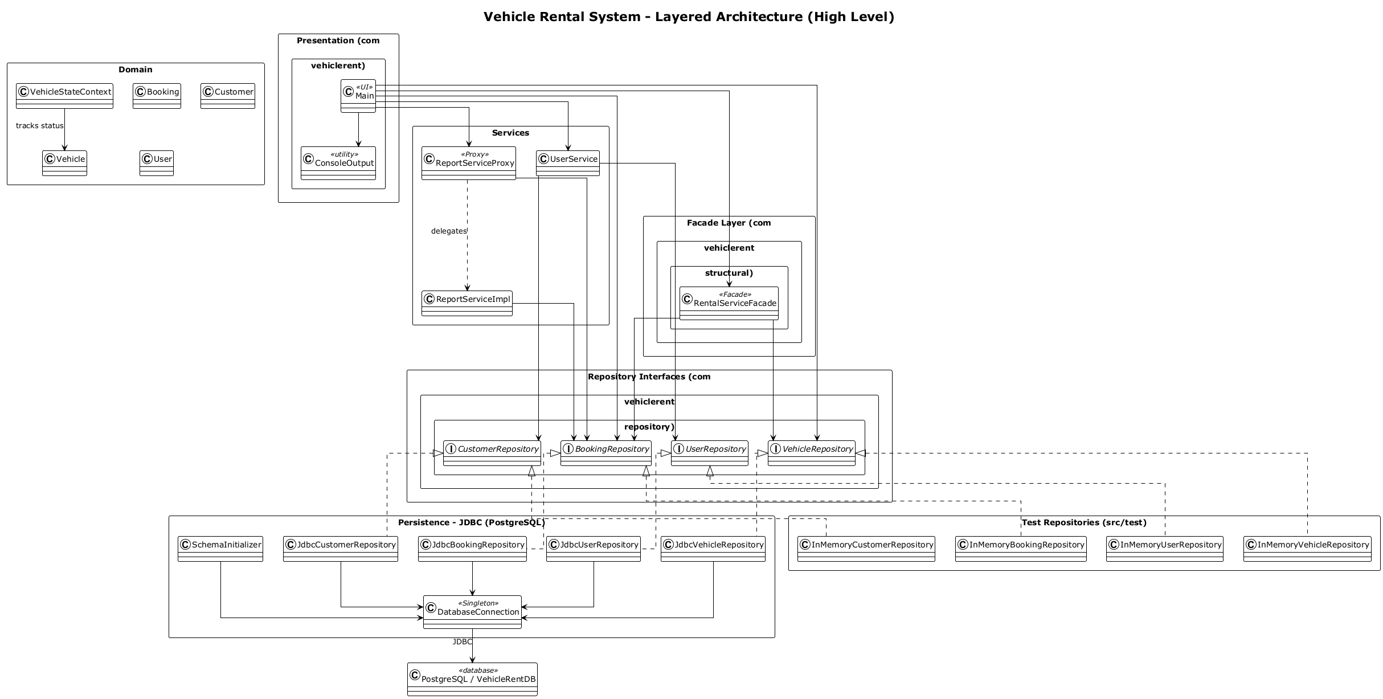
Layered Architecture
---

5. Design Pattern Mapping
# | Pattern | Category | Package | Key Classes | Where it fires
1 | Singleton | Creational | `creational/` | `SystemConfig`, `DatabaseConnection` | App startup — single config + single DB connection
2 | Factory Method | Creational | `creational/` | `NotificationCreator` + `Email/Sms/PushNotificationCreator` | Booking confirmation — SMS created by factory
3 | Builder | Creational | `creational/` | `VehicleBuilder` (+ `Car`, `Bike` in `vehicle/`) | Vehicle objects constructed step-by-step
4 | Decorator | Structural | `structural/` | `VehicleDecorator`, `Gps/Insurance/ChildSeatDecorator` | "Add GPS?" prompts — add-ons wrap the vehicle
5 | Adapter | Structural | `structural/` | `PaymentGatewayAdapter`, `ThirdPartyPaymentApi` | Every payment — legacy API adapted to internal gateway
6 | Facade | Structural | `structural/` | `RentalServiceFacade` | Rent / cancel / return entry point
7 | Proxy | Structural | `structural/` | `ReportServiceProxy`, `ReportServiceImpl` | Report generation — access control
8 | Strategy | Behavioral | `behavioral/` | `PaymentStrategy` + `CreditCard/PayPal/MobileWallet`; `LateFeeStrategy` + `Standard/FlatLateFee` | Payment method choice; late-return fine policy choice
9 | Observer | Behavioral | `behavioral/` | `VehicleStatusSubject`, `CustomerNotifier` | Vehicle status change → notify observers
10 | Command | Behavioral | `behavioral/` | `BookingInvoker`, `Rent/Cancel/ReturnCommand` | Each user action executed as a command
11 | State | Behavioral | `behavioral/` | `VehicleStateContext` + `Available/Booked/UnderMaintenanceState` | Vehicle lifecycle transitions

Pattern Class Diagram
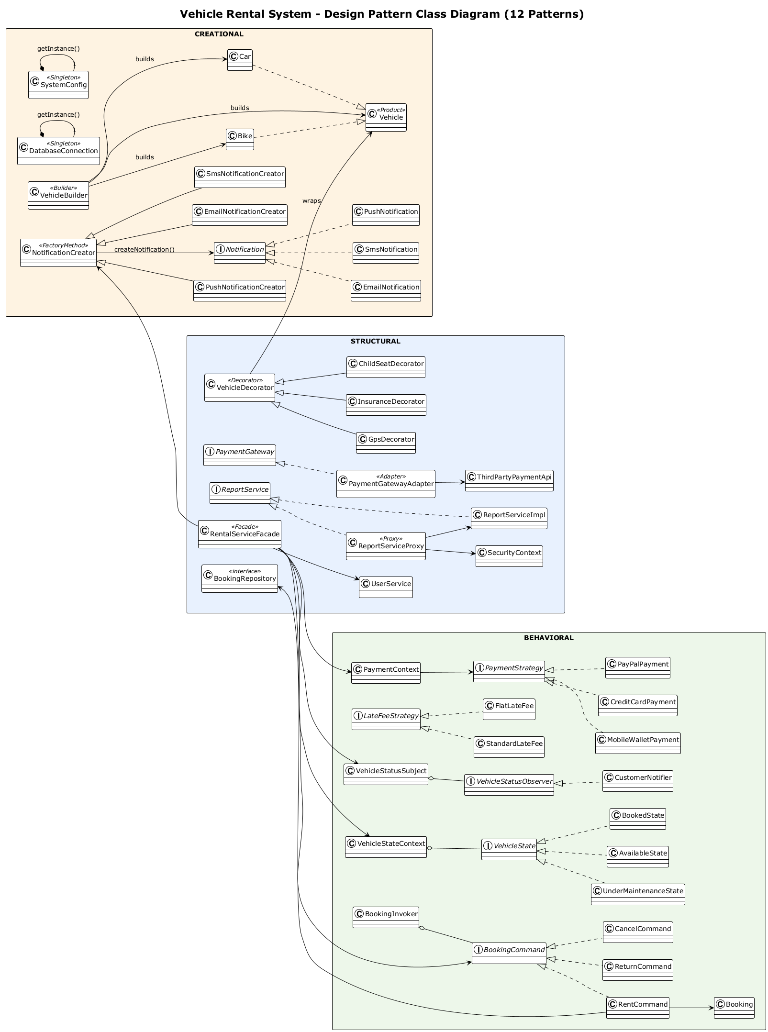
Design Patterns
---

6. Pattern Justification (summary)
Pattern | Problem it solves | Why this pattern | Alternative rejected
Singleton | Multiple DB connections / duplicate config | One shared connection + one config | Static globals (no lazy init, no testability)
Factory Method | Hard-coded notification types | Client code doesn't know concrete notifier | Direct `new SmsNotification()` everywhere
Builder | Car/Bike with many optional attributes | Step-by-step construction, readable | Telescoping constructors
Decorator | Many optional add-on combinations | Wrap to add price/features at runtime | Subclass explosion (GPS+Insurance+ChildSeat × car/bike)
Adapter | Third-party payment API incompatible | Translate internal gateway calls | Rewriting third-party code
Facade | Complex subsystem usage | Single simple API for Main | Main depending on all subsystem classes
Proxy | Reports must be admin-only | Gate access before real work | Inline if-checks in every report method
Strategy | Payment methods / fine policies vary | Swap algorithms at runtime | if/else chains
Observer | Notify interested parties on status change | Loose coupling via subscription | Polling status manually
Command | Rent/cancel/return as undoable actions | Encapsulate action + state as object | Direct method calls with repeated state code
State | Vehicle status rules (can't rent booked car) | Behavior depends on state, transitions centralized | if/else on status strings everywhere

Pattern-by-pattern justification
1. Singleton — SystemConfig and DatabaseConnection both use a volatile
instance with double-checked locking in getInstance(), giving thread-safe lazy
initialization of one shared configuration object and one JDBC connection manager.
This prevents conflicting settings (e.g. different DB credentials) and avoids opening
a new connection factory for every repository call. A static global was rejected
because it cannot be lazily initialized and is harder to test.
2. Factory Method — NotificationCreator declares createNotification(), and
EmailNotificationCreator, SmsNotificationCreator and PushNotificationCreator
each return their own Notification implementation. Main asks for an SMS
notification after booking without ever naming a concrete class, so a new channel
(e.g. WhatsApp) can be added as one new Creator + Notification pair with zero changes
to existing client code.
3. Builder — Car and Bike have many optional attributes, so VehicleBuilder
constructs them step-by-step (withBrand(), withDailyRate(), …) and returns a fully
configured product. This is more readable than long telescoping constructors and
makes the construction of the demo vehicles in VehicleFactory explicit and
self-documenting.
4. Decorator — optional add-ons (GPS, Insurance, Child Seat) are VehicleDecorator
subclasses that wrap a Vehicle and add their daily price on top of the base rate.
This avoids a class explosion (Car+Gps, Car+Gps+Insurance, Bike+ChildSeat, …) and lets
the user combine add-ons freely at runtime without touching the Car/Bike classes.
5. Adapter — ThirdPartyPaymentApi exposes an incompatible legacy interface, so
PaymentGatewayAdapter implements the internal PaymentGateway interface and
translates every call (including processPayment) into the legacy API's own format.
The rest of the system depends only on the stable PaymentGateway contract.
6. Facade — RentalServiceFacade provides rentVehicle(), cancelBooking() and
returnVehicle() as single entry points, hiding the payment context, state machine,
subject/observer registry, command invoker and repositories from Main. Without it,
the presentation layer would have to wire up every subsystem class directly.
7. Proxy — ReportServiceProxy wraps the real ReportServiceImpl and checks
SecurityContext before delegating: no user logged in → *Access Denied*; non-admin →
*Access Denied*; admin → *Access Granted* then the real report is generated. Security
stays out of the report logic itself and can be applied to any future service.
8. Strategy — two interchangeable families: PaymentStrategy
(CreditCardPayment, PayPalPayment, MobileWalletPayment) selected at checkout, and
LateFeeStrategy (StandardLateFee = 50% of the daily rate per late day, FlatLateFee
= fixed $25 per day) chosen at vehicle return. PaymentContext and the return flow
hold only the interface, so policies are swapped at runtime with no if/else chains.
9. Observer — VehicleStatusSubject keeps a list of VehicleStatusObservers and
broadcasts every state change (e.g. *Available → Booked*); CustomerNotifier reacts by
printing a notification. A vehicle can gain new interested parties (audit logger,
dashboard) without the state machine knowing about them.
10. Command — each user action is an object: RentCommand, CancelCommand,
ReturnCommand, all implementing BookingCommand, executed by BookingInvoker.
This separates the action from its execution, keeps repeated state-management code out
of Main, and each command can be reused, logged or undone.
11. State — VehicleStateContext owns a VehicleState
(AvailableState, BookedState, UnderMaintenanceState) and delegates behaviour such
as rent()/return() to it, so rules like *"a booked vehicle cannot be rented"* live
in one place instead of scattered if/else checks on status strings. Transitions are
enforced centrally, and VehicleStateTest covers the invalid-action cases.
12. Strategy (fine policy) doubling — the late-return fine is the second use of the
Strategy family: it proves the pattern scales to any swappable policy, and the fine is
persisted to the bookings.late_fee column so reports reflect real revenue.
---

7. JUnit Test Cases
11 test classes, 39 tests — all passing (mvn test → BUILD SUCCESS).
Test Class | Package | Tests | Verifies
`SystemConfigTest` | `creational/` | 2 | Singleton config values
`NotificationFactoryTest` | `creational/` | 3 | Factory Method creates correct notification types
`VehicleBuilderDecoratorTest` | `vehicle/` | 4 | Builder builds vehicles; decorators add price correctly
`PaymentPatternTest` | `behavioral/` | 5 | Strategy payment + Adapter transaction
`ObserverPatternTest` | `behavioral/` | 2 | Status change broadcast
`VehicleStateTest` | `behavioral/` | 5 | State transitions + invalid actions
`BookingCommandTest` | `behavioral/` | 4 | Command pattern: rent/cancel/return commands
`LateFeeStrategyTest` | `behavioral/` | 3 | Fine strategies interchangeable
`RentalWorkflowTest` | `structural/` | 4 | Full rent→return workflow + late-fine calculation
`ReportServiceProxyTest` | `structural/` | 3 | Proxy denies non-admin / logged-out users
`UserServiceTest` | `user/` | 4 | Username login, duplicate username rejected
Example result excerpt (from mvn test):
Tests run: 39, Failures: 0, Errors: 0, Skipped: 0
BUILD SUCCESS
---

8. Conclusion
The Vehicle Rental System demonstrates how **creational, structural and behavioral design
patterns collaborate inside one real-world application**: a single rental action travels
through Builder → Decorator → Facade → Strategy (payment) → Adapter → Command → State →
Observer → Factory Method (notification), while Singleton/Proxy/Factory Method and the
late-fine Strategy keep the system configurable, secure and data-persistent. All 39 JUnit
tests pass, and every console screen is labeled with the active pattern so the design is
auditable end-to-end.
---

Appendix A — How to Run
1. Start PostgreSQL, create database VehicleRentDB (config in src/main/resources/database.properties).
2. mvn clean test — runs all 39 tests (no DB needed).
3. mvn exec:java or run Main in IntelliJ — schema + demo data auto-create on startup.
4. Demo login: admin / admin123; demo vehicles: CAR001 (Toyota Corolla $50),
CAR002 (BMW X5 $120), BIKE001 (Honda CB500 $20).
---

Appendix B — Screenshots
Capture each flow in the console and paste the screenshot into the space provided
below its label (replace the placeholder line with the image). Keep the console window
wide enough to show the pattern headings.

B.1 — Main menu + registration
Shows the main menu and the USER MANAGEMENT - CUSTOMER REGISTRATION heading.
[ PASTE SCREENSHOT B.1 HERE ]
*Caption: Customer registration screen.*

B.2 — Login as admin
Shows the USER MANAGEMENT - LOGIN heading and successful login.
[ PASTE SCREENSHOT B.2 HERE ]
*Caption: Admin login with username admin.*

B.3 — Rent flow (full pipeline)
Shows, in order: BUILDER PATTERN - VEHICLE CONSTRUCTION, `FACADE PATTERN - RENTAL
SERVICE, STRATEGY PATTERN - PAYMENT PROCESSING, ADAPTER PATTERN - PAYMENT
GATEWAY, STATE PATTERN - VEHICLE STATUS, OBSERVER PATTERN - STATUS NOTIFICATION`,
FACTORY METHOD PATTERN - NOTIFICATION, and the final price breakdown with add-ons.
[ PASTE SCREENSHOT B.3 HERE ]
*Caption: Complete rental workflow — patterns visible end to end.*

B.4 — My bookings
Shows the customer's active booking listed with status CONFIRMED and the late-fee
column.
[ PASTE SCREENSHOT B.4 HERE ]
*Caption: Booking list showing CONFIRMED status.*

B.5 — Return flow with late fee
Shows the return prompt, the days-late question, the fine-strategy choice
(1 = Standard / 2 = Flat), the LATE FINE breakdown, and confirmation that the
fine was applied and persisted.
[ PASTE SCREENSHOT B.5 HERE ]
*Caption: Late return — fine calculated with the Strategy pattern.*

B.6 — Revenue report as admin
Shows PROXY PATTERN - SECURE REPORT ACCESS, Access Granted, and the revenue
summary (total income, number of bookings).
[ PASTE SCREENSHOT B.6 HERE ]
*Caption: Admin generating the revenue report through the proxy.*

B.7 — Report access denied (customer)
Shows Access Denied: <username> lacks admin privileges. when a customer tries to
generate a report.
[ PASTE SCREENSHOT B.7 HERE ]
*Caption: Proxy blocks a non-admin user from report access.*

