420-331-VA: Application Development I

sect. 0002

Ron Friedman

1926133

Vanier College

16-02-2021

CC BY-NC-ND 4.0

# Input of variables

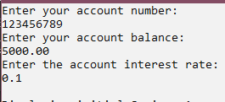

# Savings Account Display

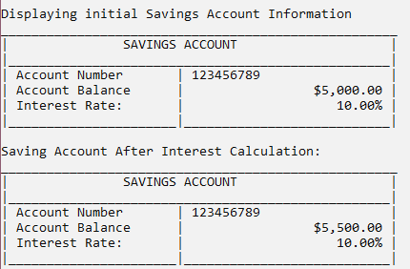

# Checking Account - Debit

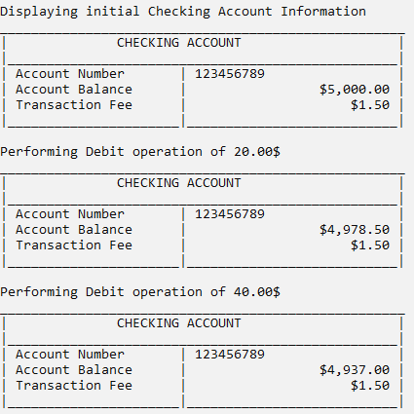

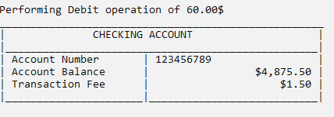

# Checking Account – Credit

