420-331-VA: Application Development I

sect. 0002

Ron Friedman

1926133

Vanier College

19-01-2021

CC BY-NC-ND 4.0

# Example 1: First C# Program – Output

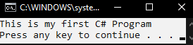

# Example 1: Error-induction

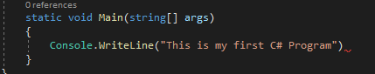

As you can see, I have purposely removed the semicolon (;) from the statement. Building the solution again, an Error Dialog Box is created:

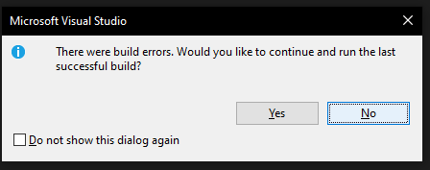

Clicking “No”, displays the Error List window, which provides accurate information regarding as to where the error is, and what the error is:

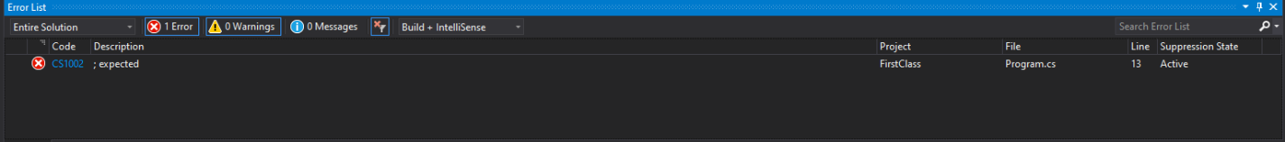

# Example 2: Arithmetic Operation – Initial Output

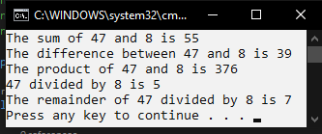

# Example 2: Arithmetic Operation – Modified Output

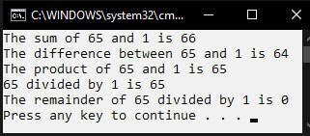

# Example 2: Arithmetic Operation – Comment of libraries

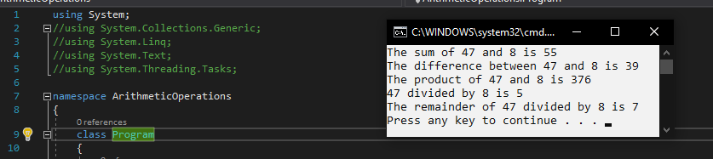

As you can see, the program executes normally even with most of the system libraries removed.

# Example 3: Compare Names – Output

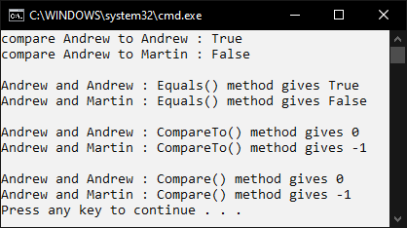

As seen in the screenshot above, the program executes normally and produces the expected results.