Hardware/Software Mapping

Diagram 1 summarizes the general deployment structure of CrypDist including Distribution system, Client application and the blockchain structure.

CrypDist consists of two main components as following;

* Distribution System
  + A de-centralized distribution structure is going to be serving clients. (The component is powered by Akamai Technologies)
  + Database
* CrypDist Application (Client Side)
  + Blockchain
  + CrypDist management panel

Client’s computer is going to be connected to the other clients with HTTP protocol by the peer to peer design for being updated by the ongoing updates made by the other clients on the raw data. The client application’s internet connection module is going to be always listening for requests from other clients. Raw data is going to be stored in distribution system which includes servers located in different parts of the world. Each client is going to be connected to the distribution system with HTTP protocol and requests to download/upload data are going to be made by this channel. In servers, one database application and one connection module are going to be running and listening for requests. The server application is going to fetch/store the data from/in the database according to the requests made by the connection module.

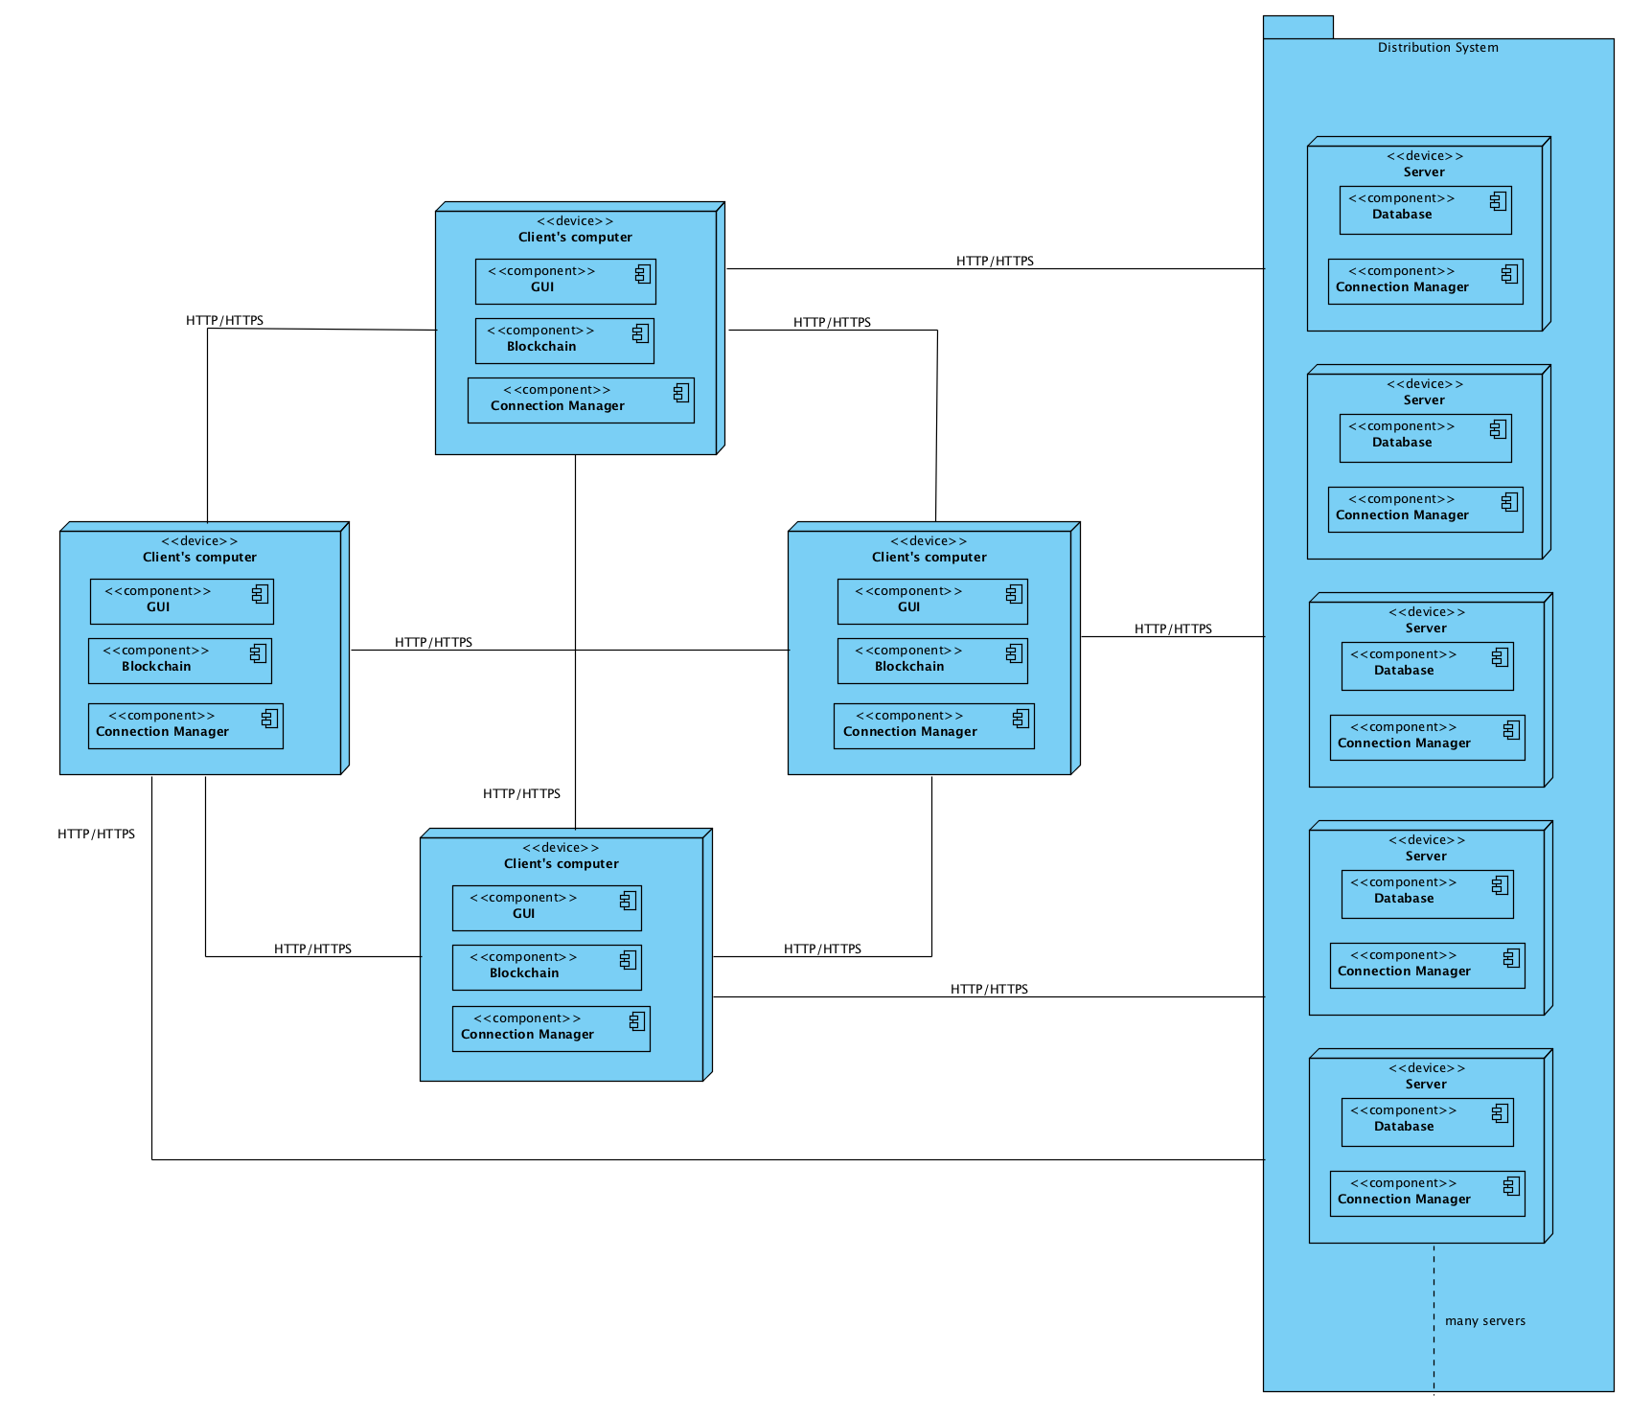

**Diagram 1: Hardware Mapping**