**User’s Manual**

**Main Screen**

Figure X Main screen

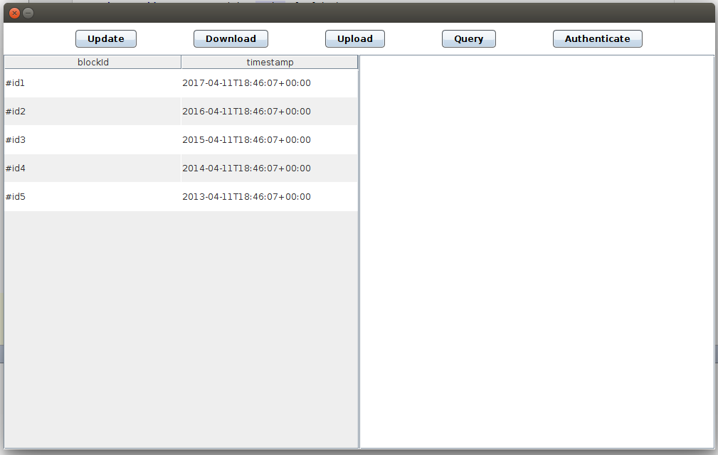

The main screen of the CrypDist is in the figure above. Via this screen, you can access to all functionalities of the system. To update or download a block, you should select the target block from the block-chain list on the left panel of the main screen. Otherwise you may encounter with the warnings shown in Figure X. To process confidential blocks, authentication is required and it can be accessed via ‘Authenticate’ button. To see the content of a block, you can click on that block from the block-chain list on the left panel and the content comes into view on the right panel.

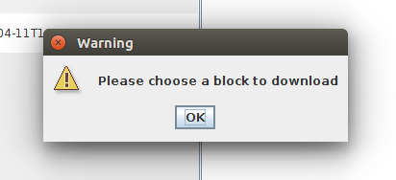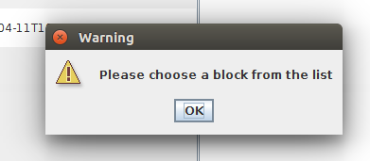

Figure X The warning screens

**Upload**

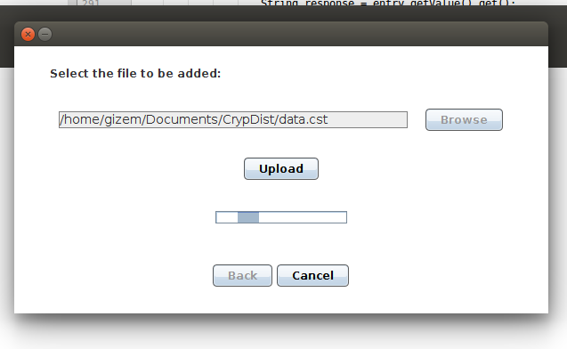

Figure X Upload Screen

In the main screen, when you click on the ‘Upload’ button, the upload screen shown above is displayed. By clicking on the ‘Browse’ button or typing to text field, you can enter the path of the block to be added. After entering a valid path, you can add a completely new data block to the system via ‘Upload’ button. If the path is not valid, you may encounter with a warning message shown in Figure X below. While uploading, you may click on the ‘Cancel’ button to stop the process. You may return to main screen via ‘Back’ button after upload process is finished.

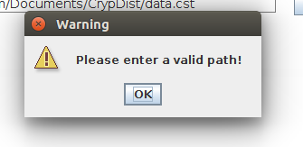

Figure X Invalid path warning screen

**Update**

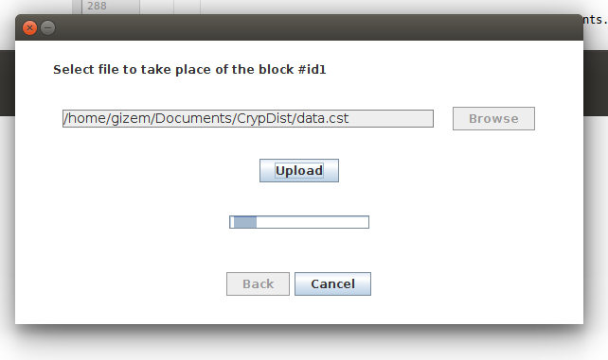

Figure X Update Screen

In the main screen, after selecting the target block when you click on the ‘Update’ button, the update screen shown above is displayed. By clicking on the ‘Browse’ button or typing to text field, you can enter the path of the block to be updated. After entering a valid path, you can add the block via ‘Upload’ button. If the path is not valid, you may encounter with a warning message shown in Figure X. While uploading, you may click on the ‘Cancel’ button to stop the process. You may return to main screen via ‘Back’ button after upload process is finished.

**Download**

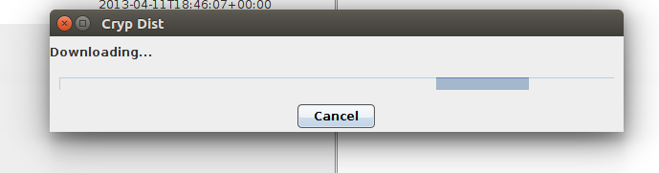

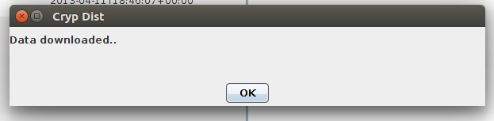

Figure X Download screens

In the main screen, after selecting the target block when you click on the ‘Download’ button, the progress box shown above is displayed. While downloading, you may cancel the download. After the downloading process is done a message appears indicating that download is succesfull and you are directed to the main screen after clicking on the ‘OK’ button.

**Authenticate**

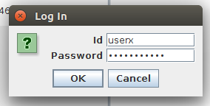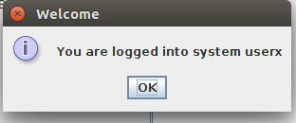

Figure X Authentication screen

In the main screen, when you click on the ‘Authenticate’ button, the dialog box shown above is displayed. Authentication requires id and password details. You can return to main screen via ‘Cancel’ button. After entering authentication details, by clicking on the ‘OK’ button you may enter the system as authenticated user. After a successful login, a welcome message pops up and you are directed to the main screen after clicking on the ‘OK’ button. Otherwise a warning message appears indicating the failure cause.

**Query**

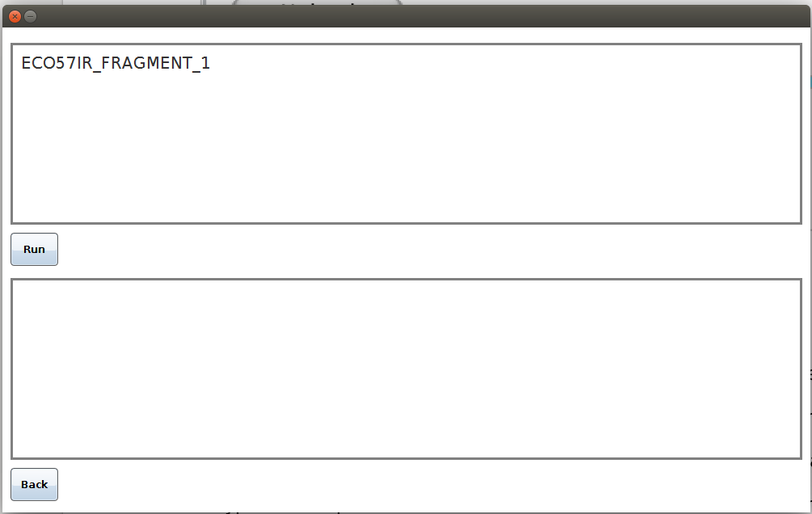Figure X Query screen

In the main screen, when you click on the ‘Query’ button, the query screen shown above is displayed. To run the queries on raw data, you should type the string to be searched on the top panel and click on the ‘Run’ button. If the query is successful, the transaction results taken from the server are shown on the bottom panel. You can return to main screen via ‘Back’ button.