Introduction

This document is being prepared before any code has been considered or developed for the purpose of this exercise. The task is to design and build a complete web-based accommodation marketplace application called StayBnB. The idea is to create a platform that allows people in South Africa to list their properties for short-term rental and to allow guests to find, book, and review those properties in a safe and controlled manner. The application should support multiple user roles, clear booking rules, a check-in process, messaging between guests and hosts, reviews, and administrative oversight. The purpose of this report is to describe what the application does, how it works, and to show the working application through screenshots of its pages once implemented.

The intention is for StayBnB to work like a local accommodation marketplace, but with specific rules to make it reliable. Guests should be able to browse stays by location and property type, search with dates and guest counts, request bookings with prices calculated on the server, and manage their trips. Hosts should be able to apply to host, manage listings, handle booking requests, configure check-in steps, and verify guest documents. Administrators should review host applications and monitor activity, while a SuperAdmin can promote guests to administrators. All of these flows need to follow strict role and booking rules so that only authorised users can carry out actions, and so that bookings move through a controlled lifecycle.

This report will cover the purpose, features, how the system works, the pages that make up the application, and a conclusion about what was built and how the different parts come together.

What the application does

StayBnB is an ASP.NET Core MVC accommodation marketplace for South African stays. It brings together guests, hosts, and administrators in one application. Guests can explore properties, filter by city and dates, request bookings, keep a wishlist, message hosts, complete a guided check-in, and leave reviews after their stay. Hosts can apply to become hosts, publish and manage listings with images and amenities, respond to booking requests, configure check-in processes, and verify guest documents. Administrators can review host applications, manage users, and look at activity logs. The application is role-based and enforces business rules on the server to keep bookings, reviews, and permissions consistent.

How it works

The application is built with ASP.NET Core MVC using C#, with Entity Framework Core for data access and ASP.NET Core Identity for authentication and roles. There are four main roles: Guest, Host, Admin, and SuperAdmin. New registrations start as Guests. A Guest must submit a host application with property details and images. An Admin or SuperAdmin reviews the application and either approves or rejects it. If approved, the user is promoted from Guest to Host, the Guest role is removed, and the property is published. Only a SuperAdmin can promote a Guest to Admin.

Bookings follow a strict state machine. When a guest requests a booking, the total price is calculated only on the server as (PricePerNight times nights) plus cleaning fee plus service fee. Nights are whole days between check-in and check-out. The system checks for date overlaps with existing bookings that are Pending, Approved, or CheckedIn. A guest can cancel only their own booking in allowed states. A host can approve or reject only bookings on their own property. Once approved and after the guest completes check-in and all documents are verified by the host, the booking can move to CheckedIn. A booking can move to Completed only after the check-out date.

For check-in, hosts configure an ordered set of steps for each property. Guests work through the steps, upload required documents such as ID or passport for document steps, and acknowledge when needed. The host reviews and verifies each document. After verification, the host can check the guest in. Reviews can only be left by guests who have a CheckedIn or Completed booking for the property, and each guest can leave only one review per property. Messaging allows guests and hosts to communicate about bookings, with notifications for important events. All actions are logged in an activity log for administrators to review.

The application can use SQL Server with migrations, or fall back to an in-memory database for quick setup. Demo data is seeded on first run with sample properties, bookings in different states, reviews, messages, and notifications so that the application can be explored immediately.

Application pages and screenshots

The following pages show the running application. Each screenshot shows how guests, hosts, and administrators interact with the system.

home
Home page. The landing page shows a search bar for finding stays by location, dates, and number of guests. Featured and newly listed properties are shown to help users discover stays.

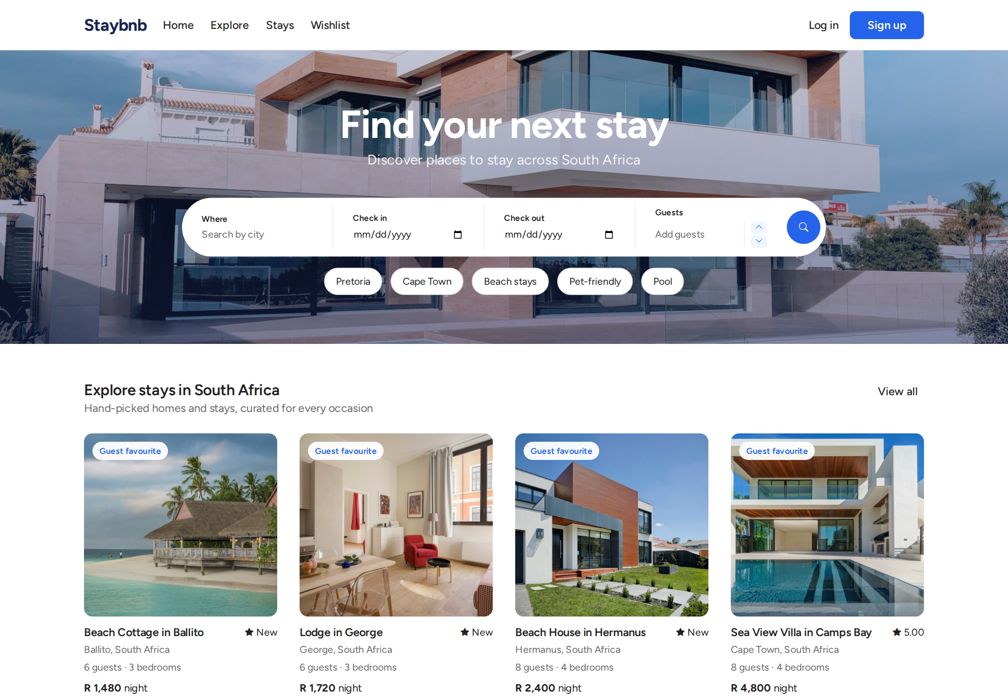
Home page. The landing page shows a search bar for finding stays by location, dates, and number of guests. Featured and newly listed properties are shown to help users discover stays.

explore
Explore page. Properties are grouped by city and property type. Users can browse by location to quickly find stays in a particular area.

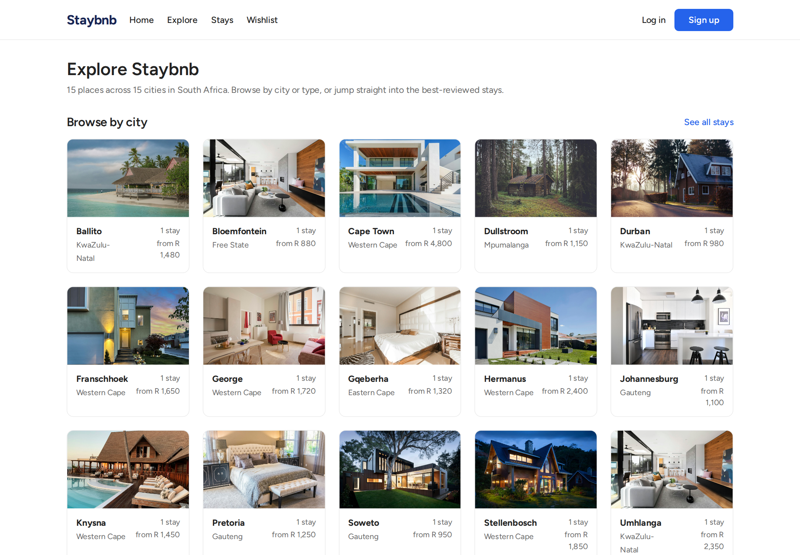
Explore page. Properties are grouped by city and property type. Users can browse by location to quickly find stays in a particular area.

stays
Stays page. A filterable list of all active properties. Users can filter by city, property type, dates, number of guests, and price range.

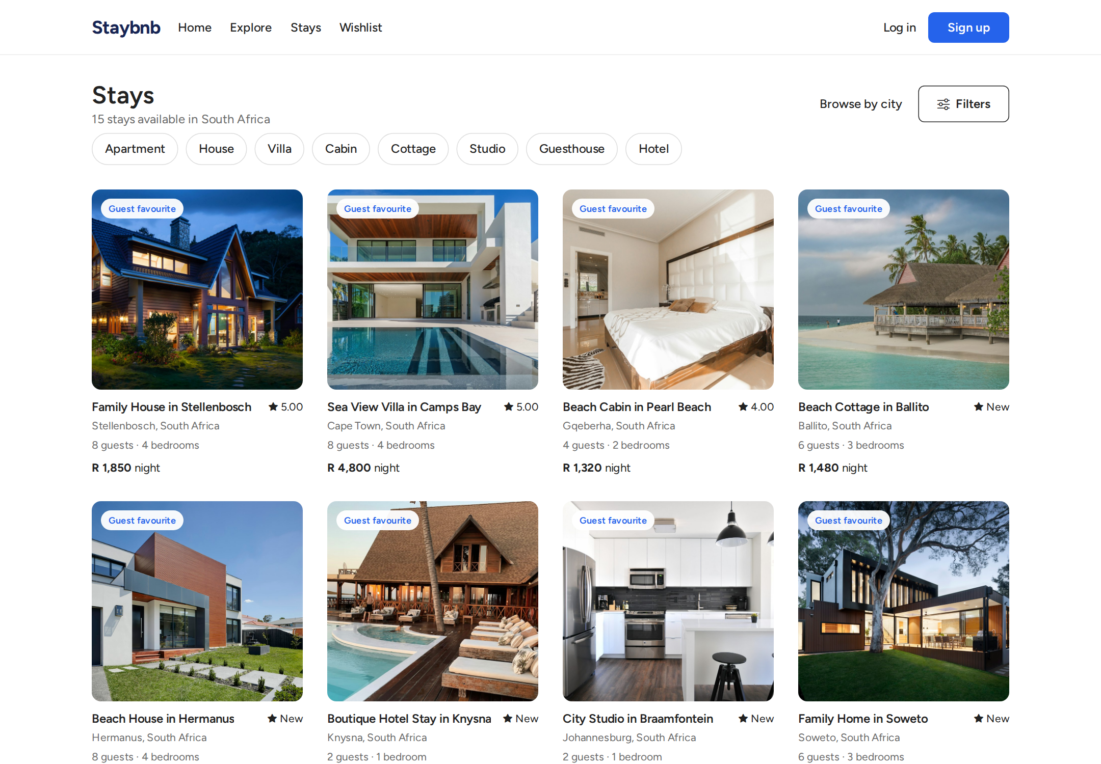
Stays page. A filterable list of all active properties. Users can filter by city, property type, dates, number of guests, and price range.

stays filtered
Stays page with filters applied. When searching from the home page or applying filters, results update to show matching properties with availability considered.

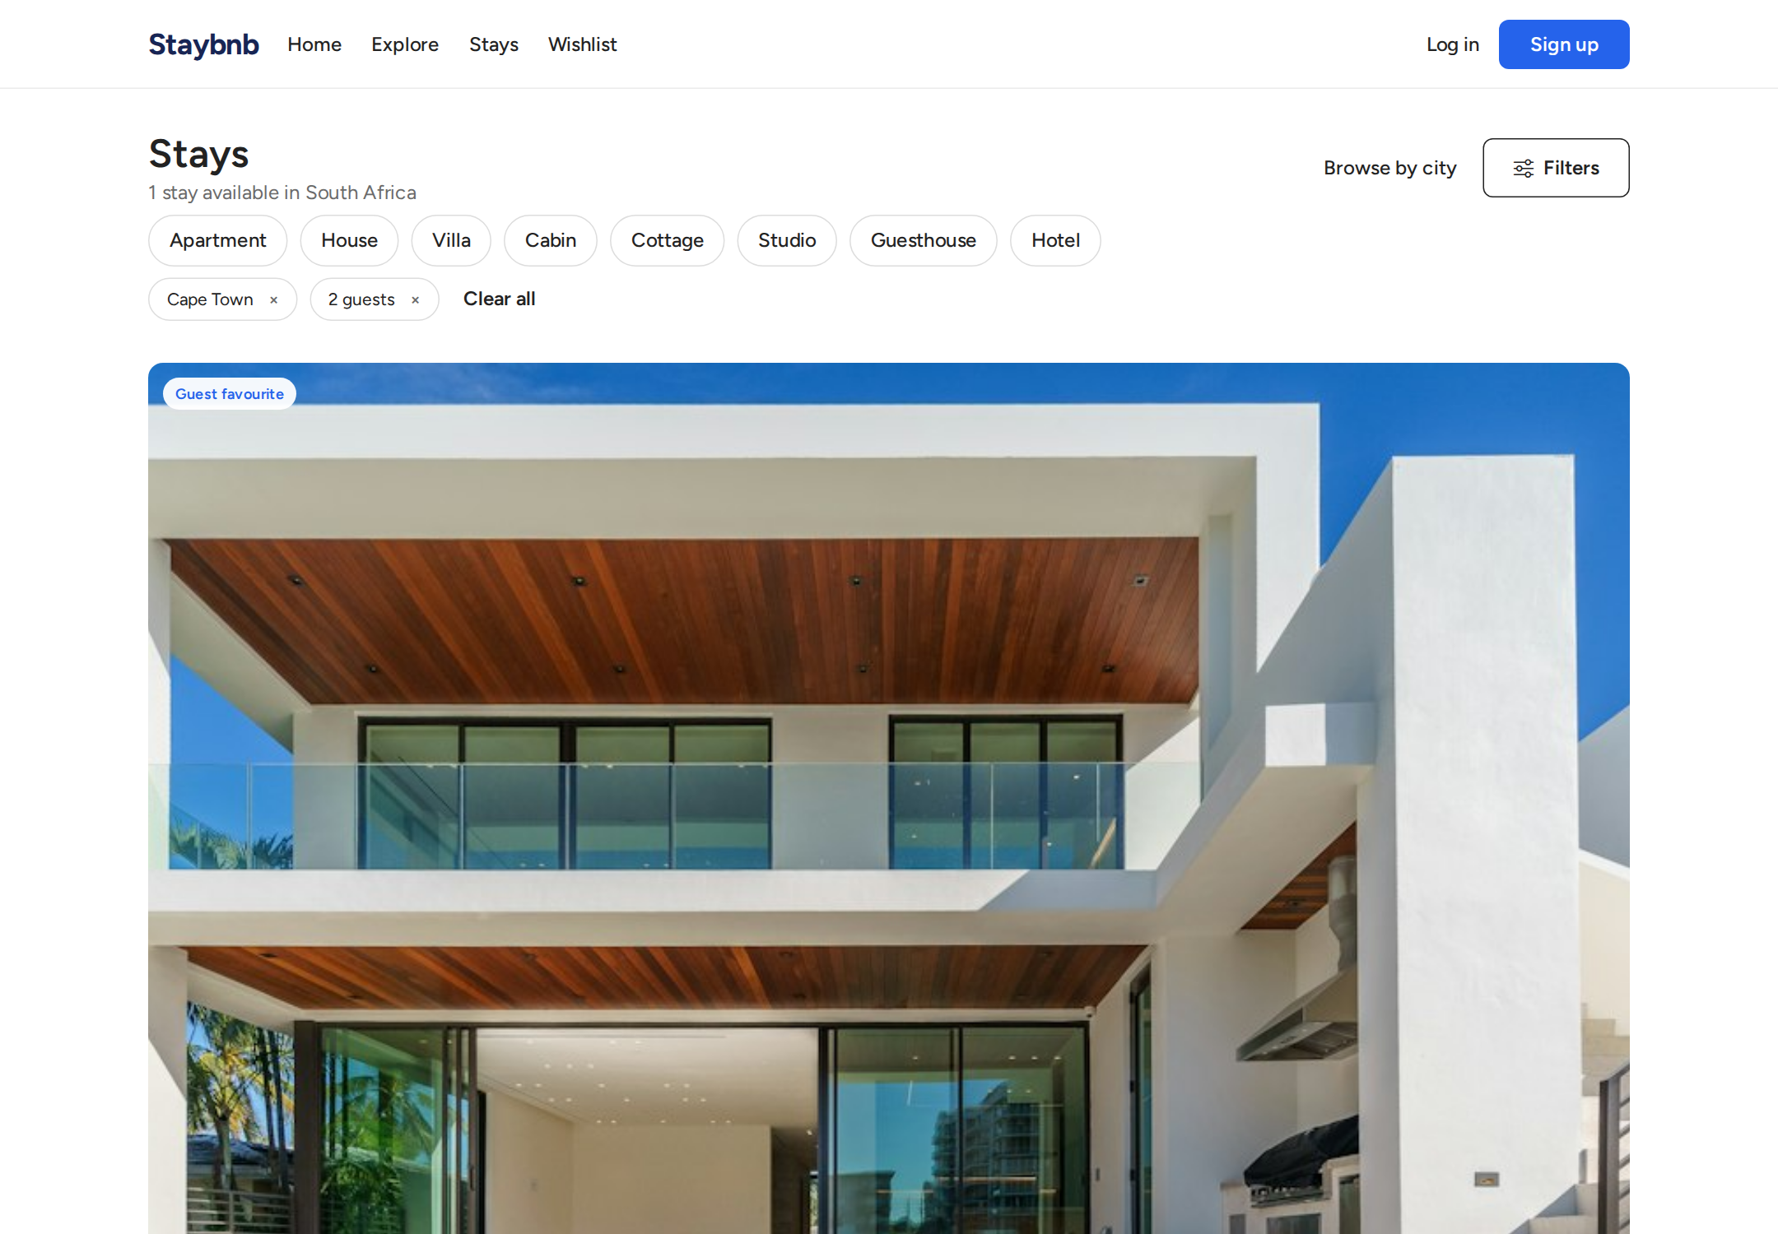
Stays page with filters applied. When searching from the home page or applying filters, results update to show matching properties with availability considered.

property details
Property details page. Shows images, description, amenities, host information, price breakdown, reviews, and a booking widget to request a stay.

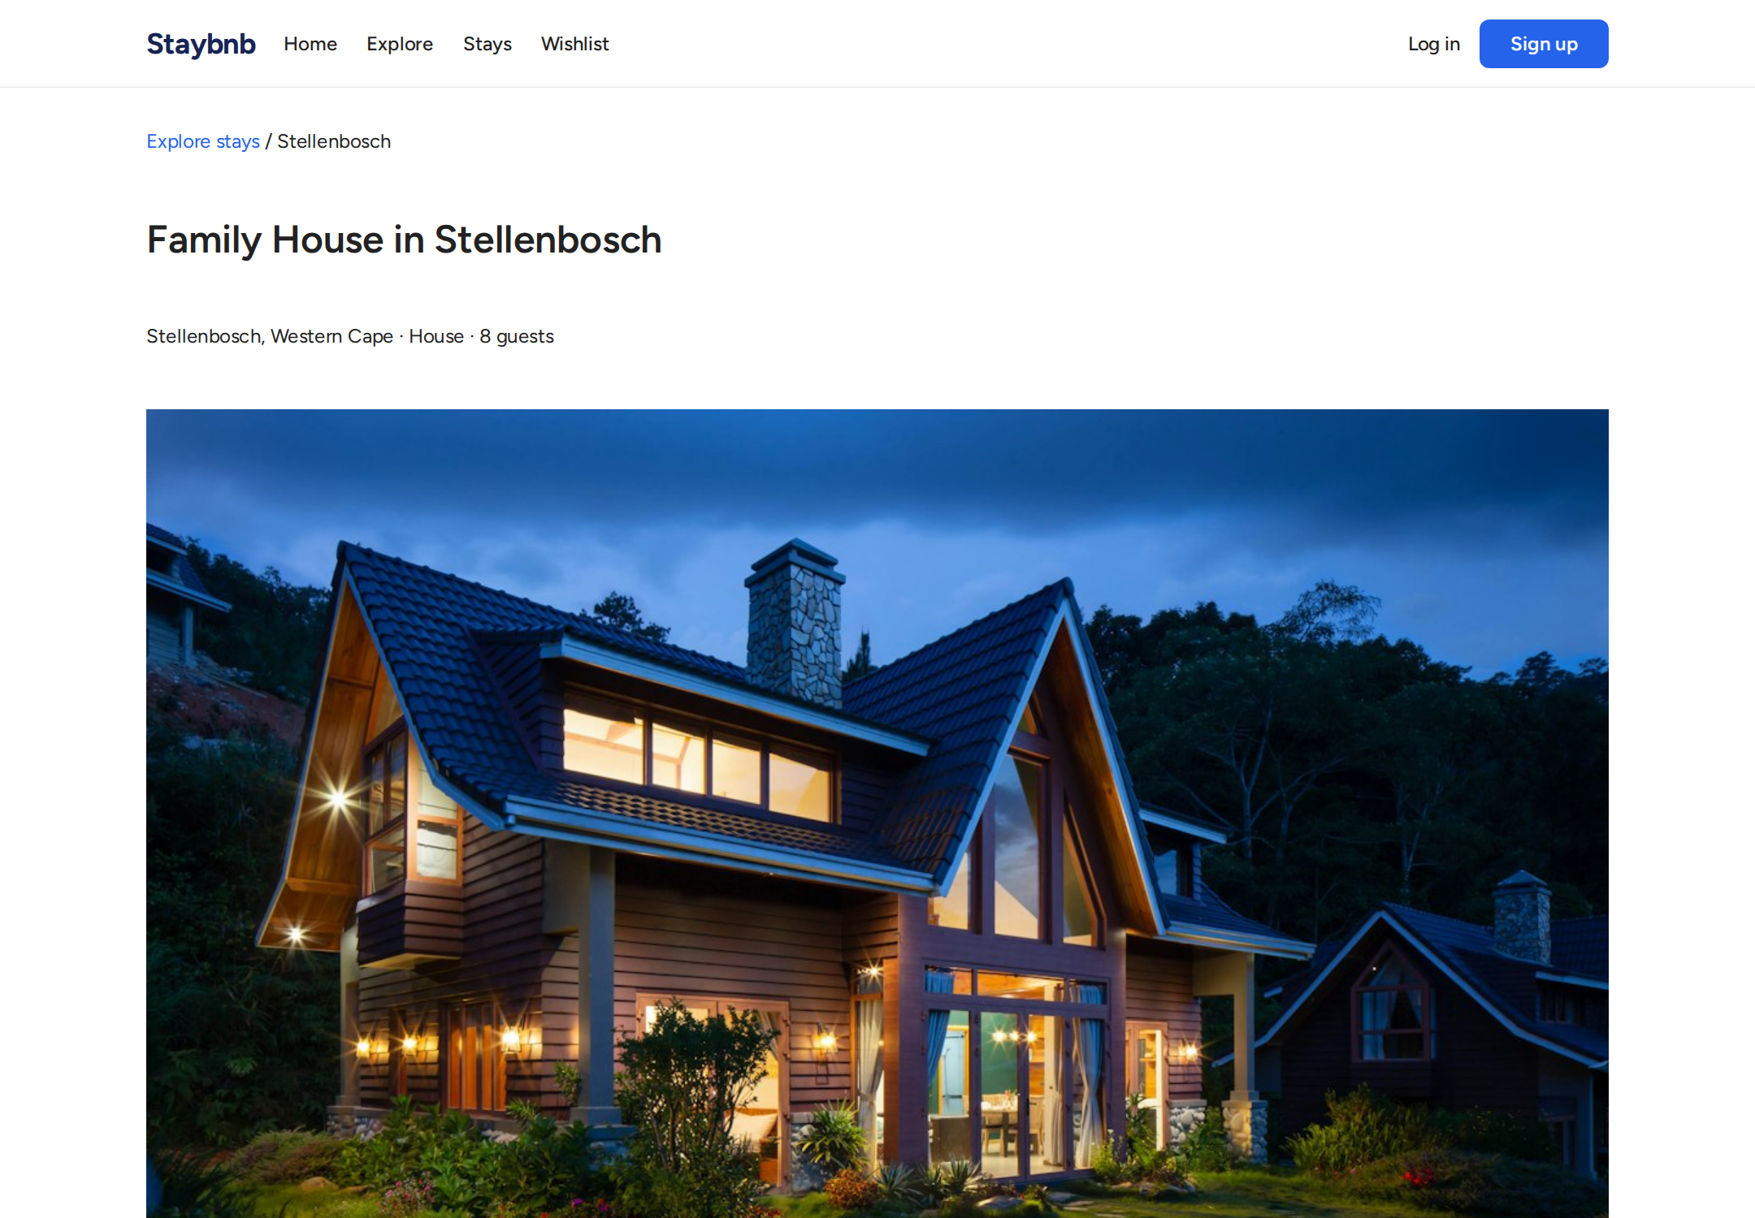
Property details page. Shows images, description, amenities, host information, price breakdown, reviews, and a booking widget to request a stay.

login
Login page. Authenticated access is required for booking, messaging, hosting, and administrative functions.

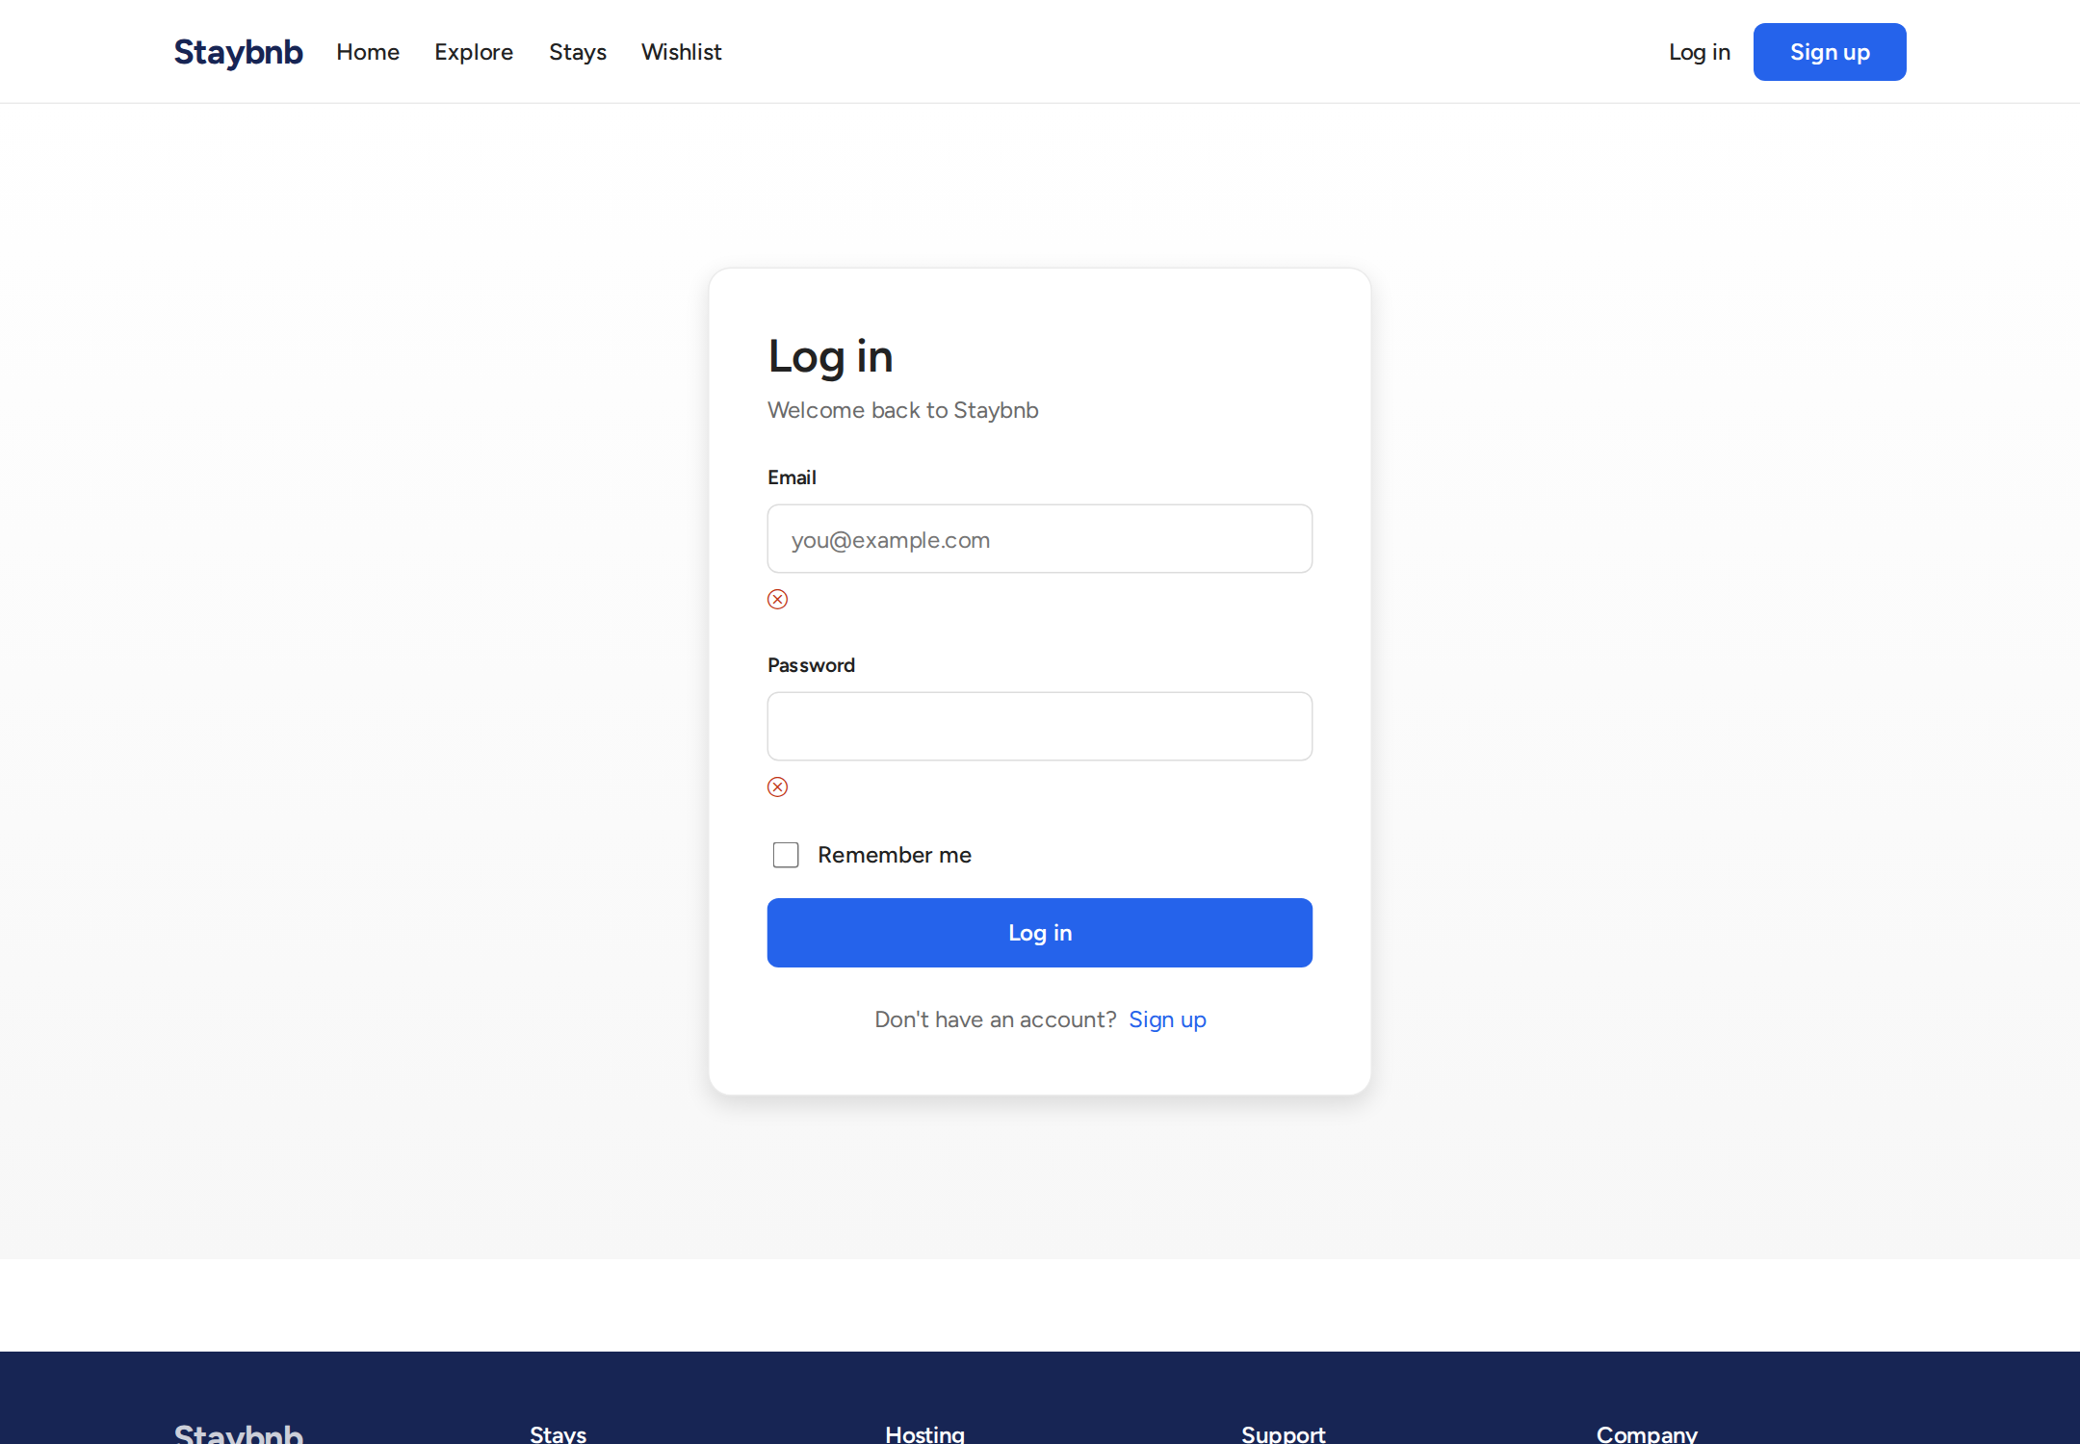
Login page. Authenticated access is required for booking, messaging, hosting, and administrative functions.

register
Registration page. New users register as Guests. They can later apply to become hosts.

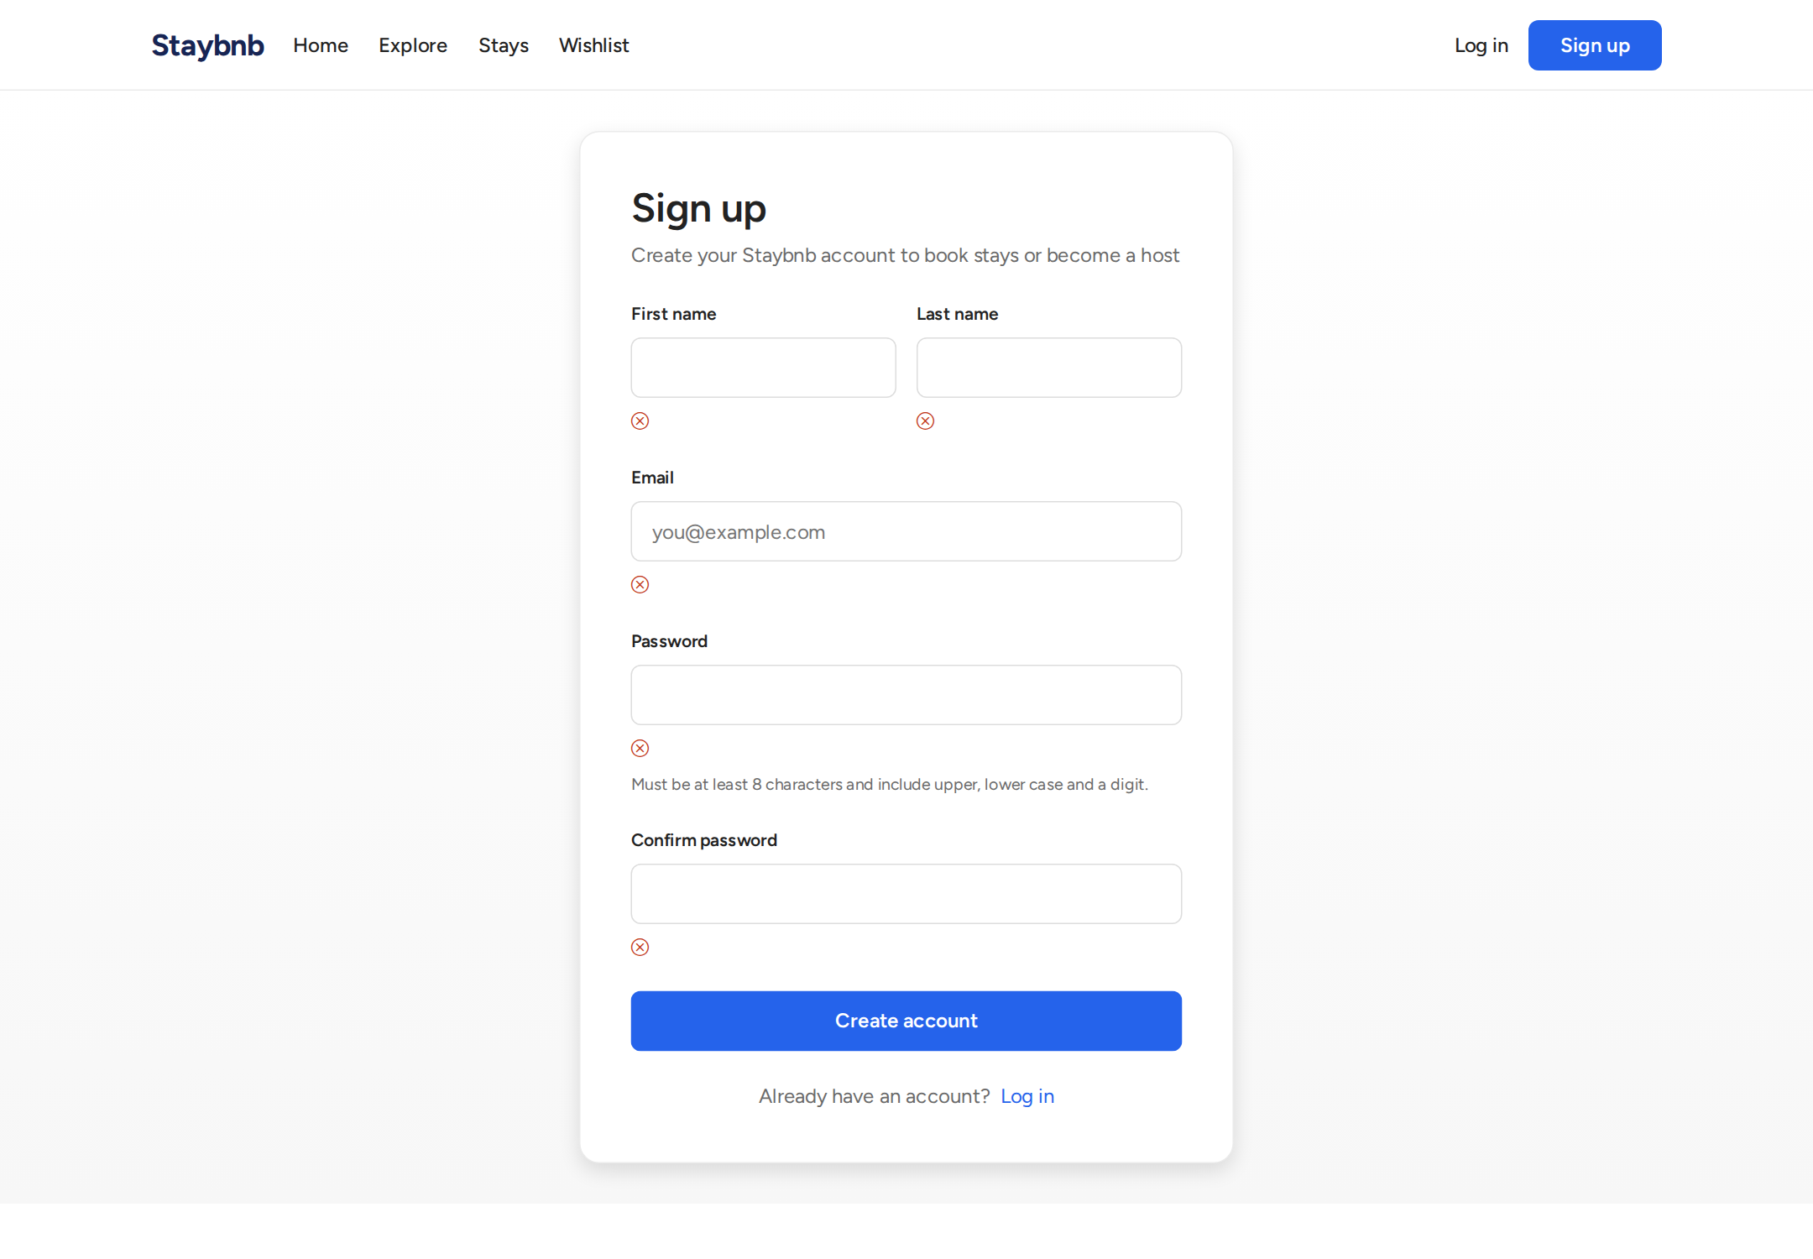
Registration page. New users register as Guests. They can later apply to become hosts.

status 404
Status code page. The application handles errors gracefully with custom status pages.

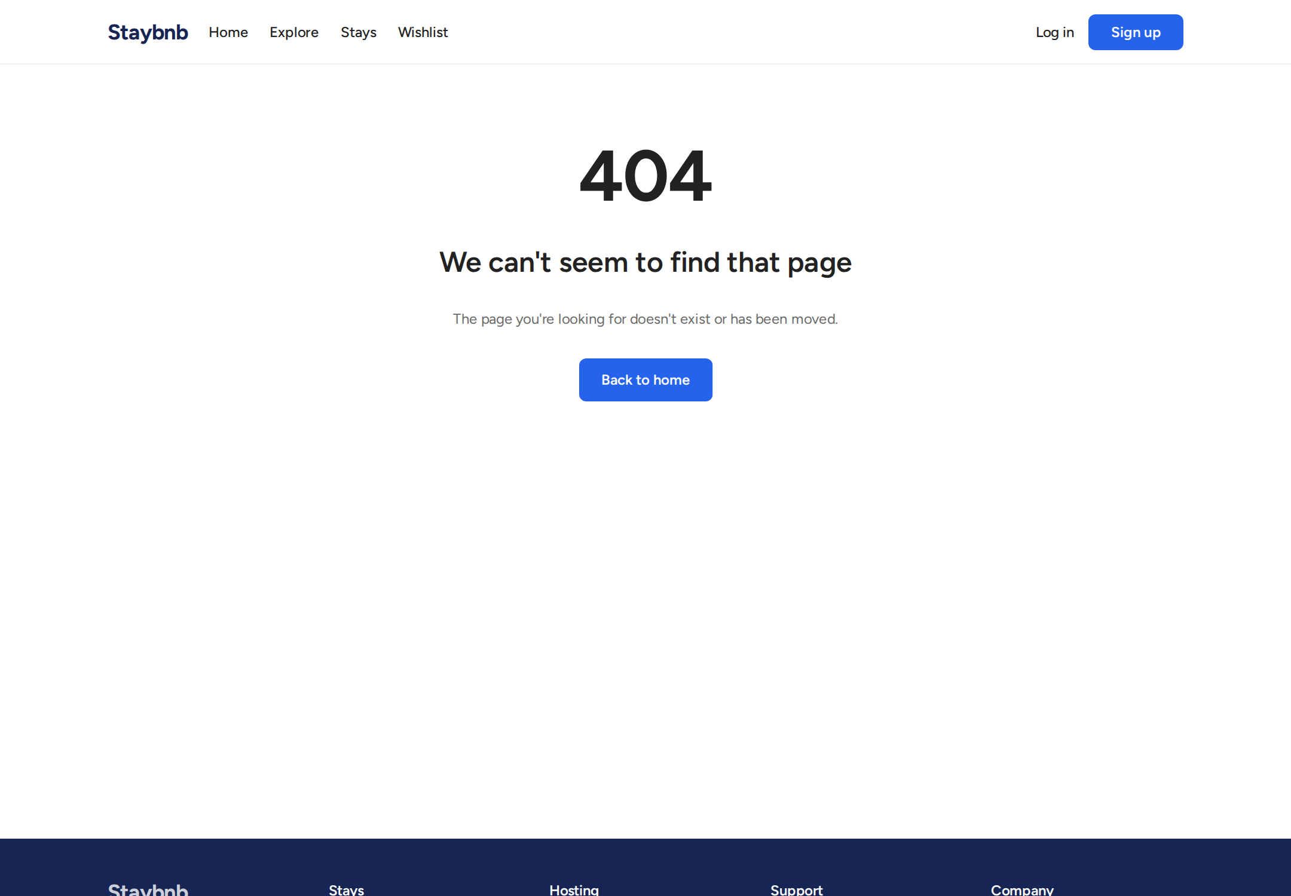
Status code page. The application handles errors gracefully with custom status pages.

host application form
Host application form. A Guest fills in property details, location, pricing, amenities, and uploads photos to apply to become a host.

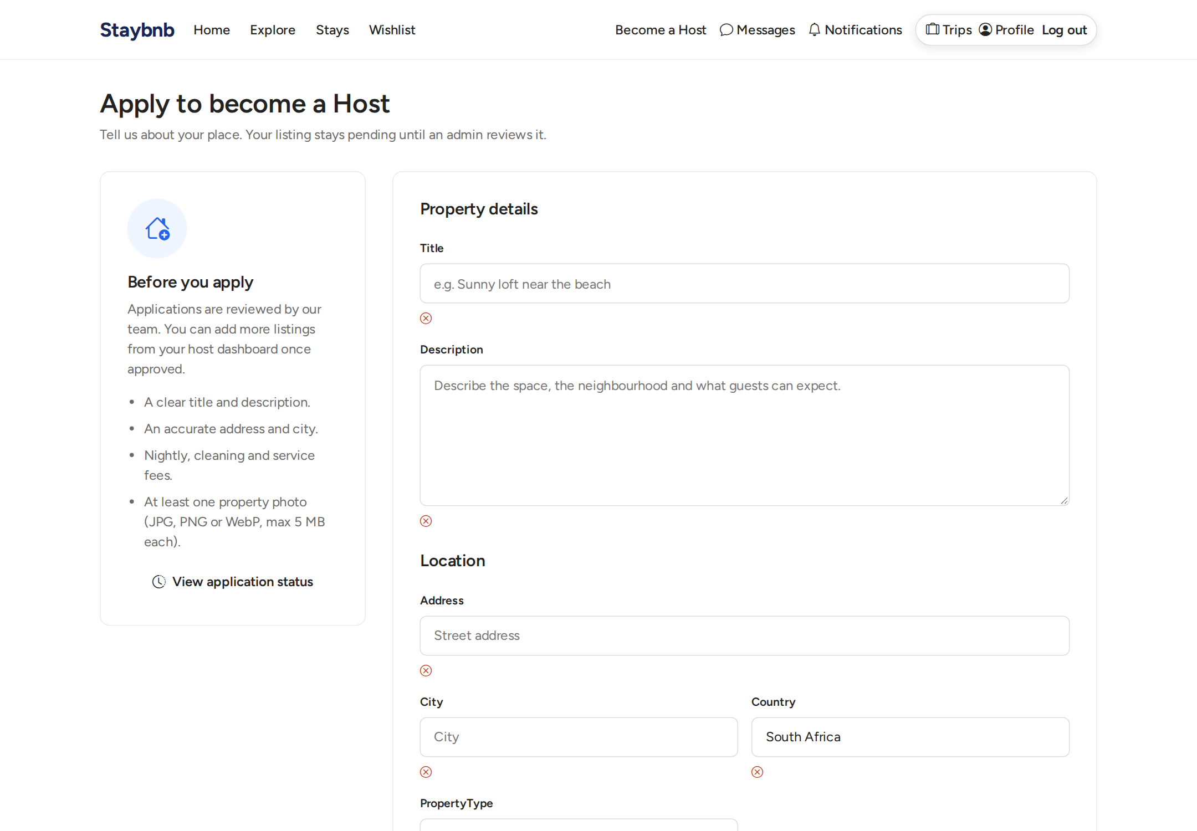
Host application form. A Guest fills in property details, location, pricing, amenities, and uploads photos to apply to become a host.

host application status
Host application status page. Shows the current status of the application after submission, along with property details.

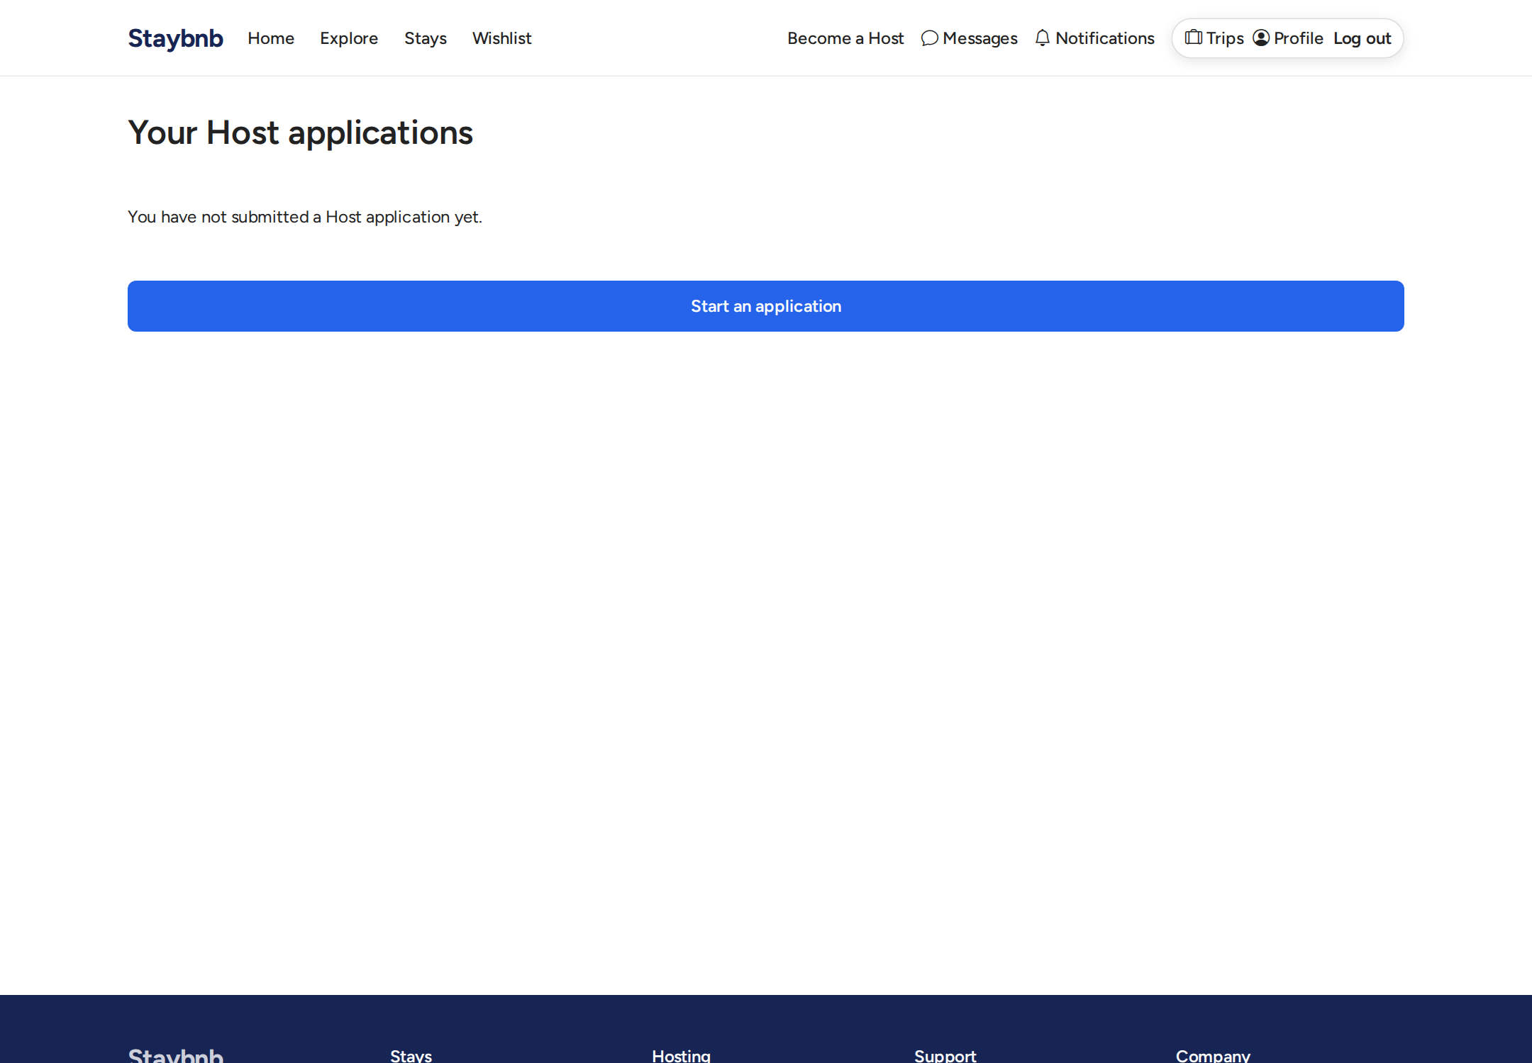
Host application status page. Shows the current status of the application after submission, along with property details.

guest profile
Guest profile page. Users can view and edit their profile information.

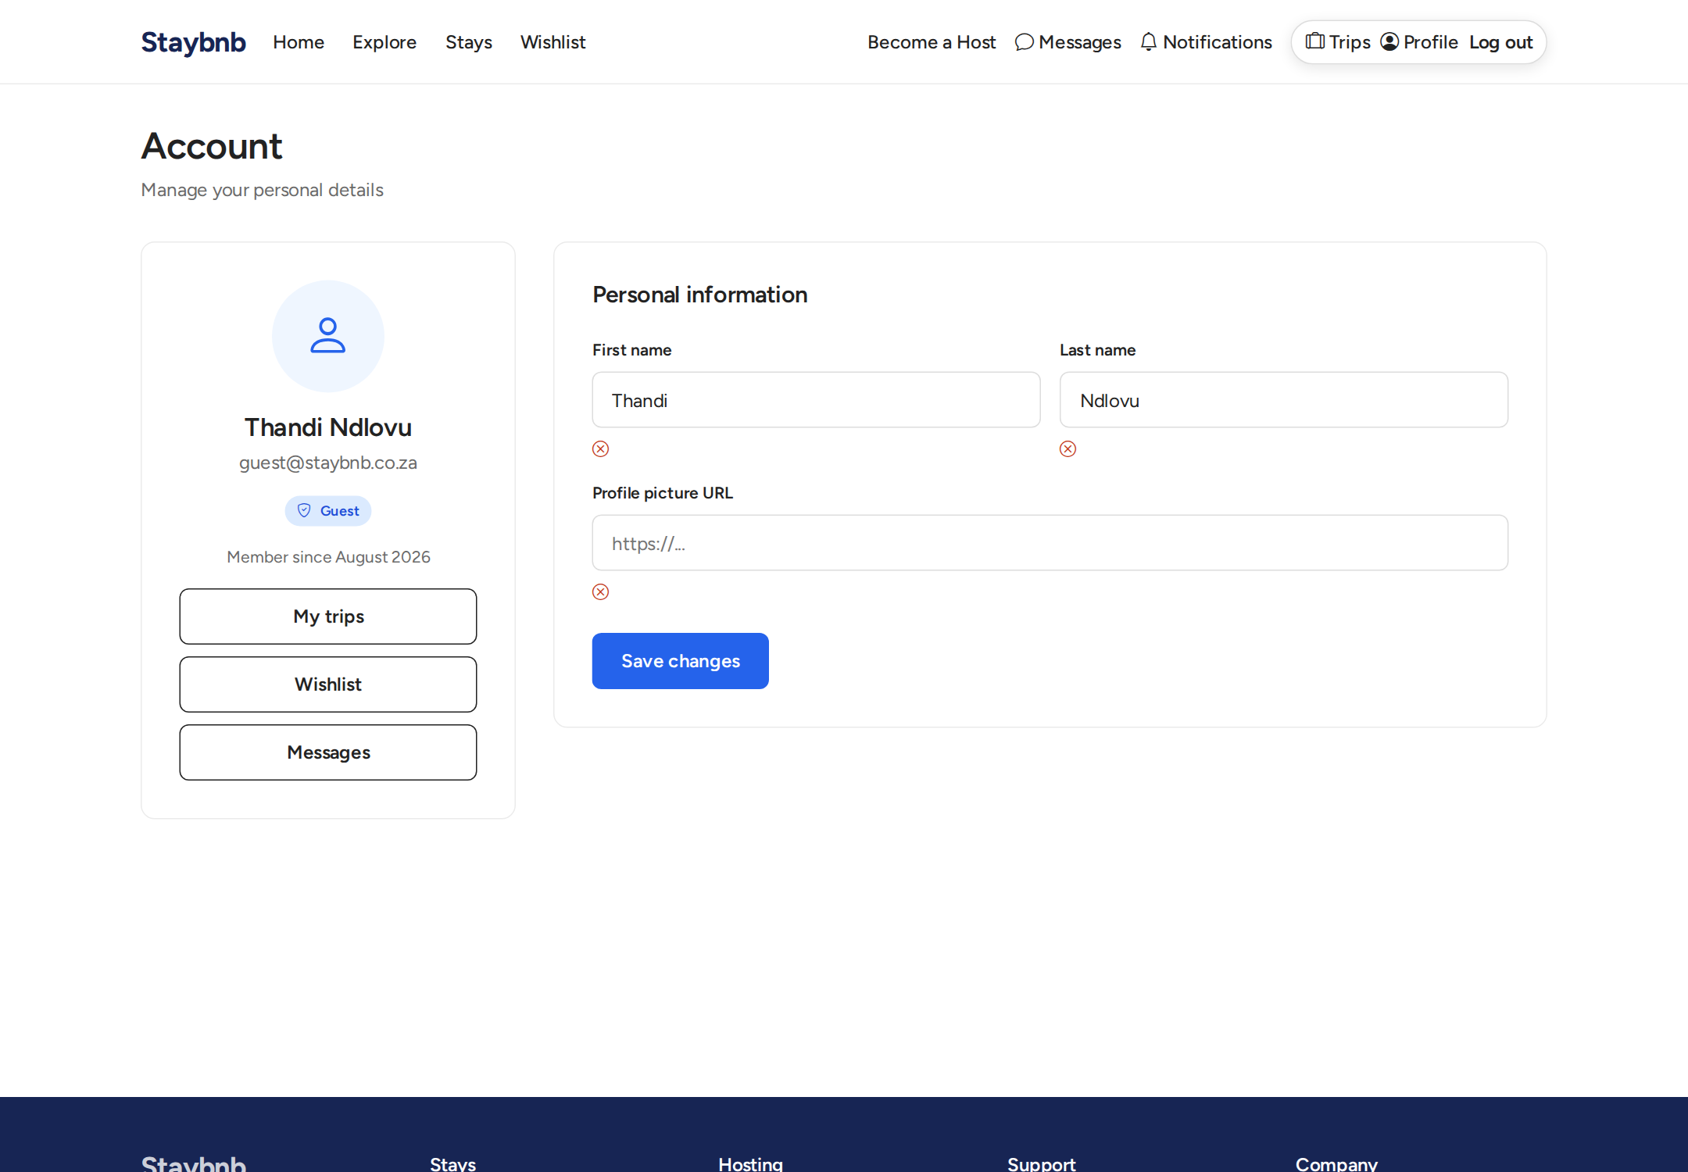
Guest profile page. Users can view and edit their profile information.

guest trips
Trips page. Shows upcoming and past bookings for the guest, with links to booking details and actions like starting check-in or leaving reviews.

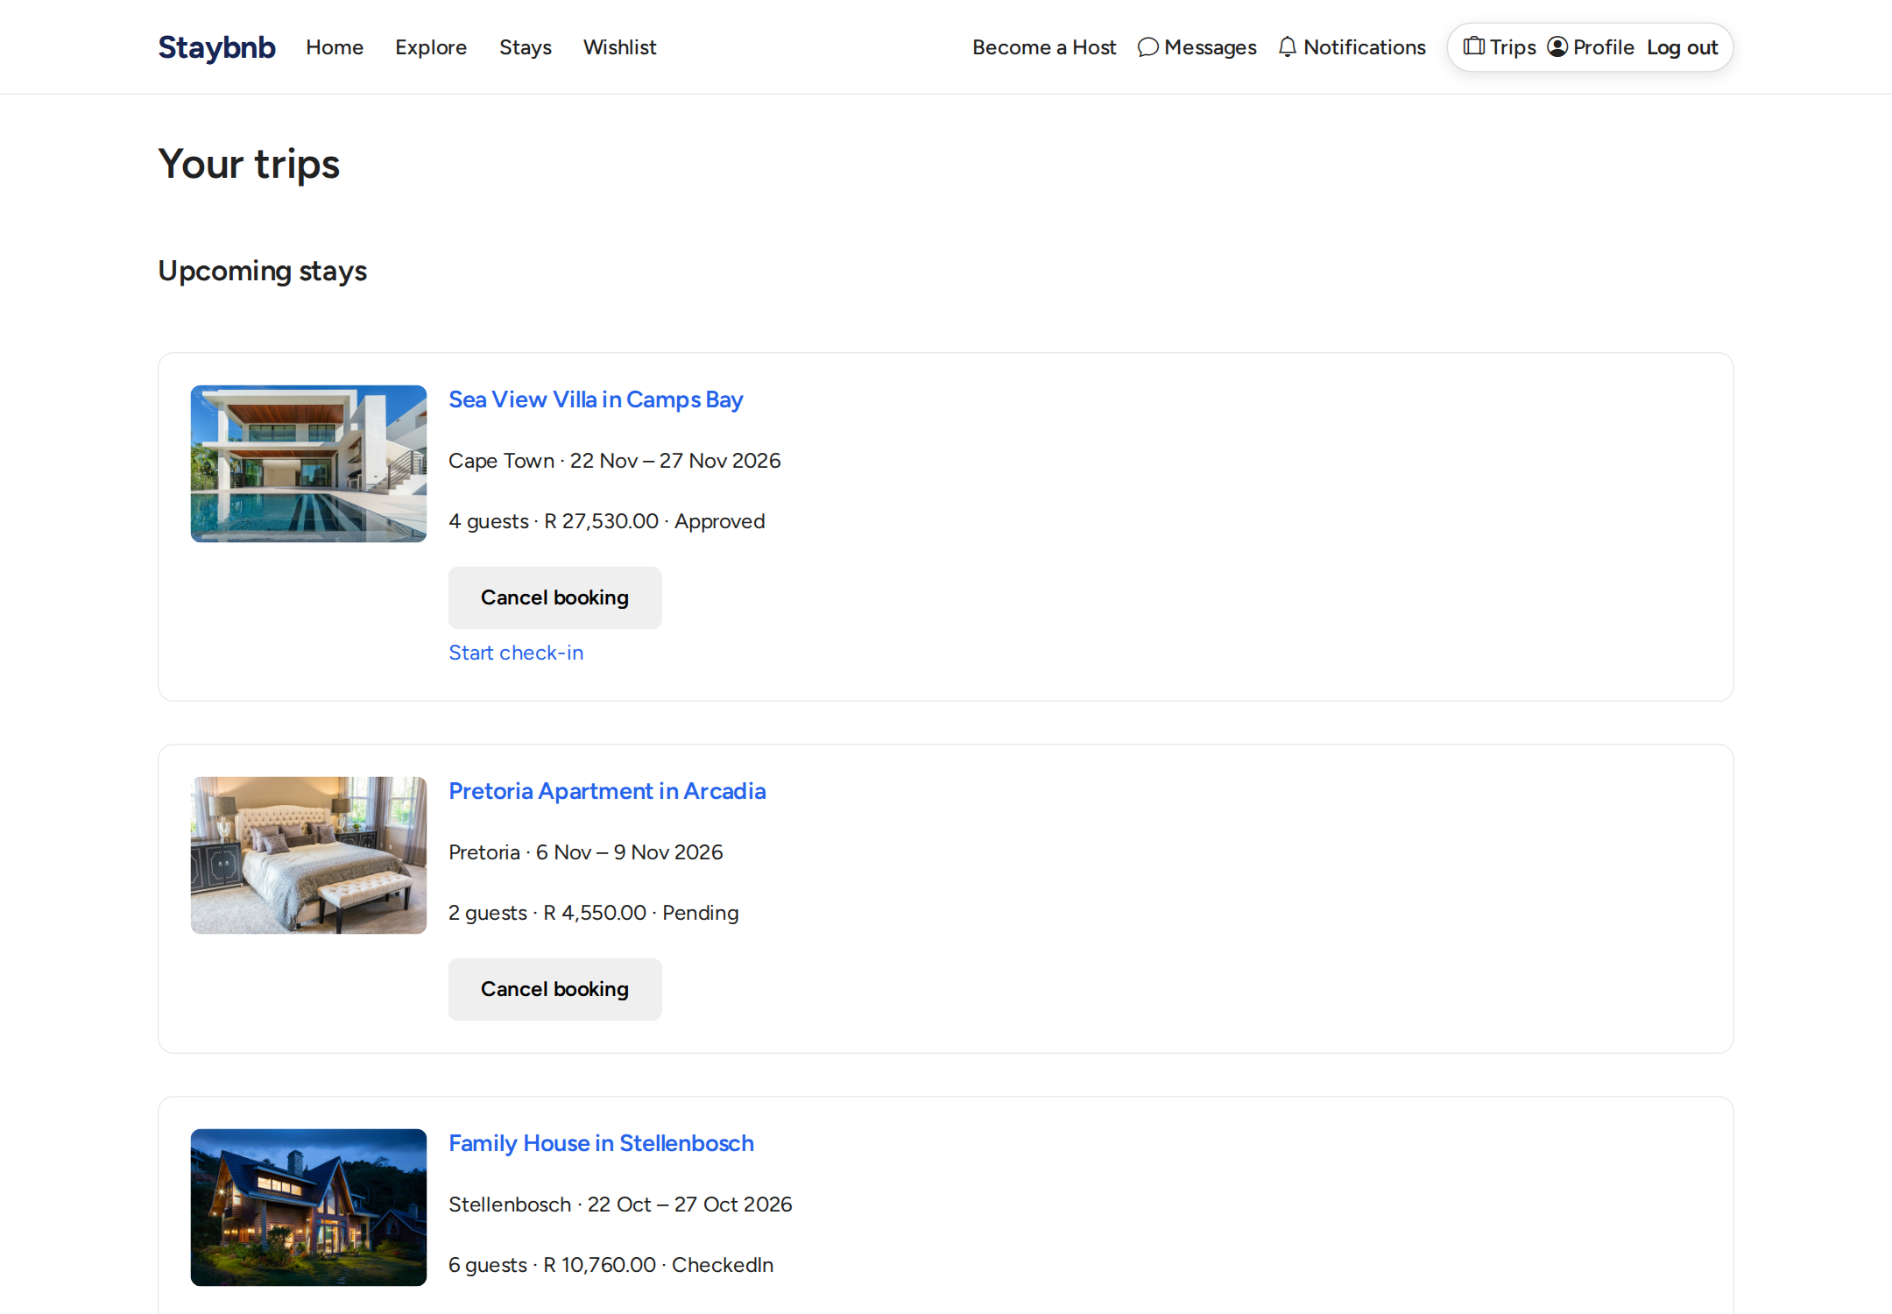
Trips page. Shows upcoming and past bookings for the guest, with links to booking details and actions like starting check-in or leaving reviews.

booking details
Booking details page. Shows full booking information, pricing breakdown, status, and available actions based on the booking state.

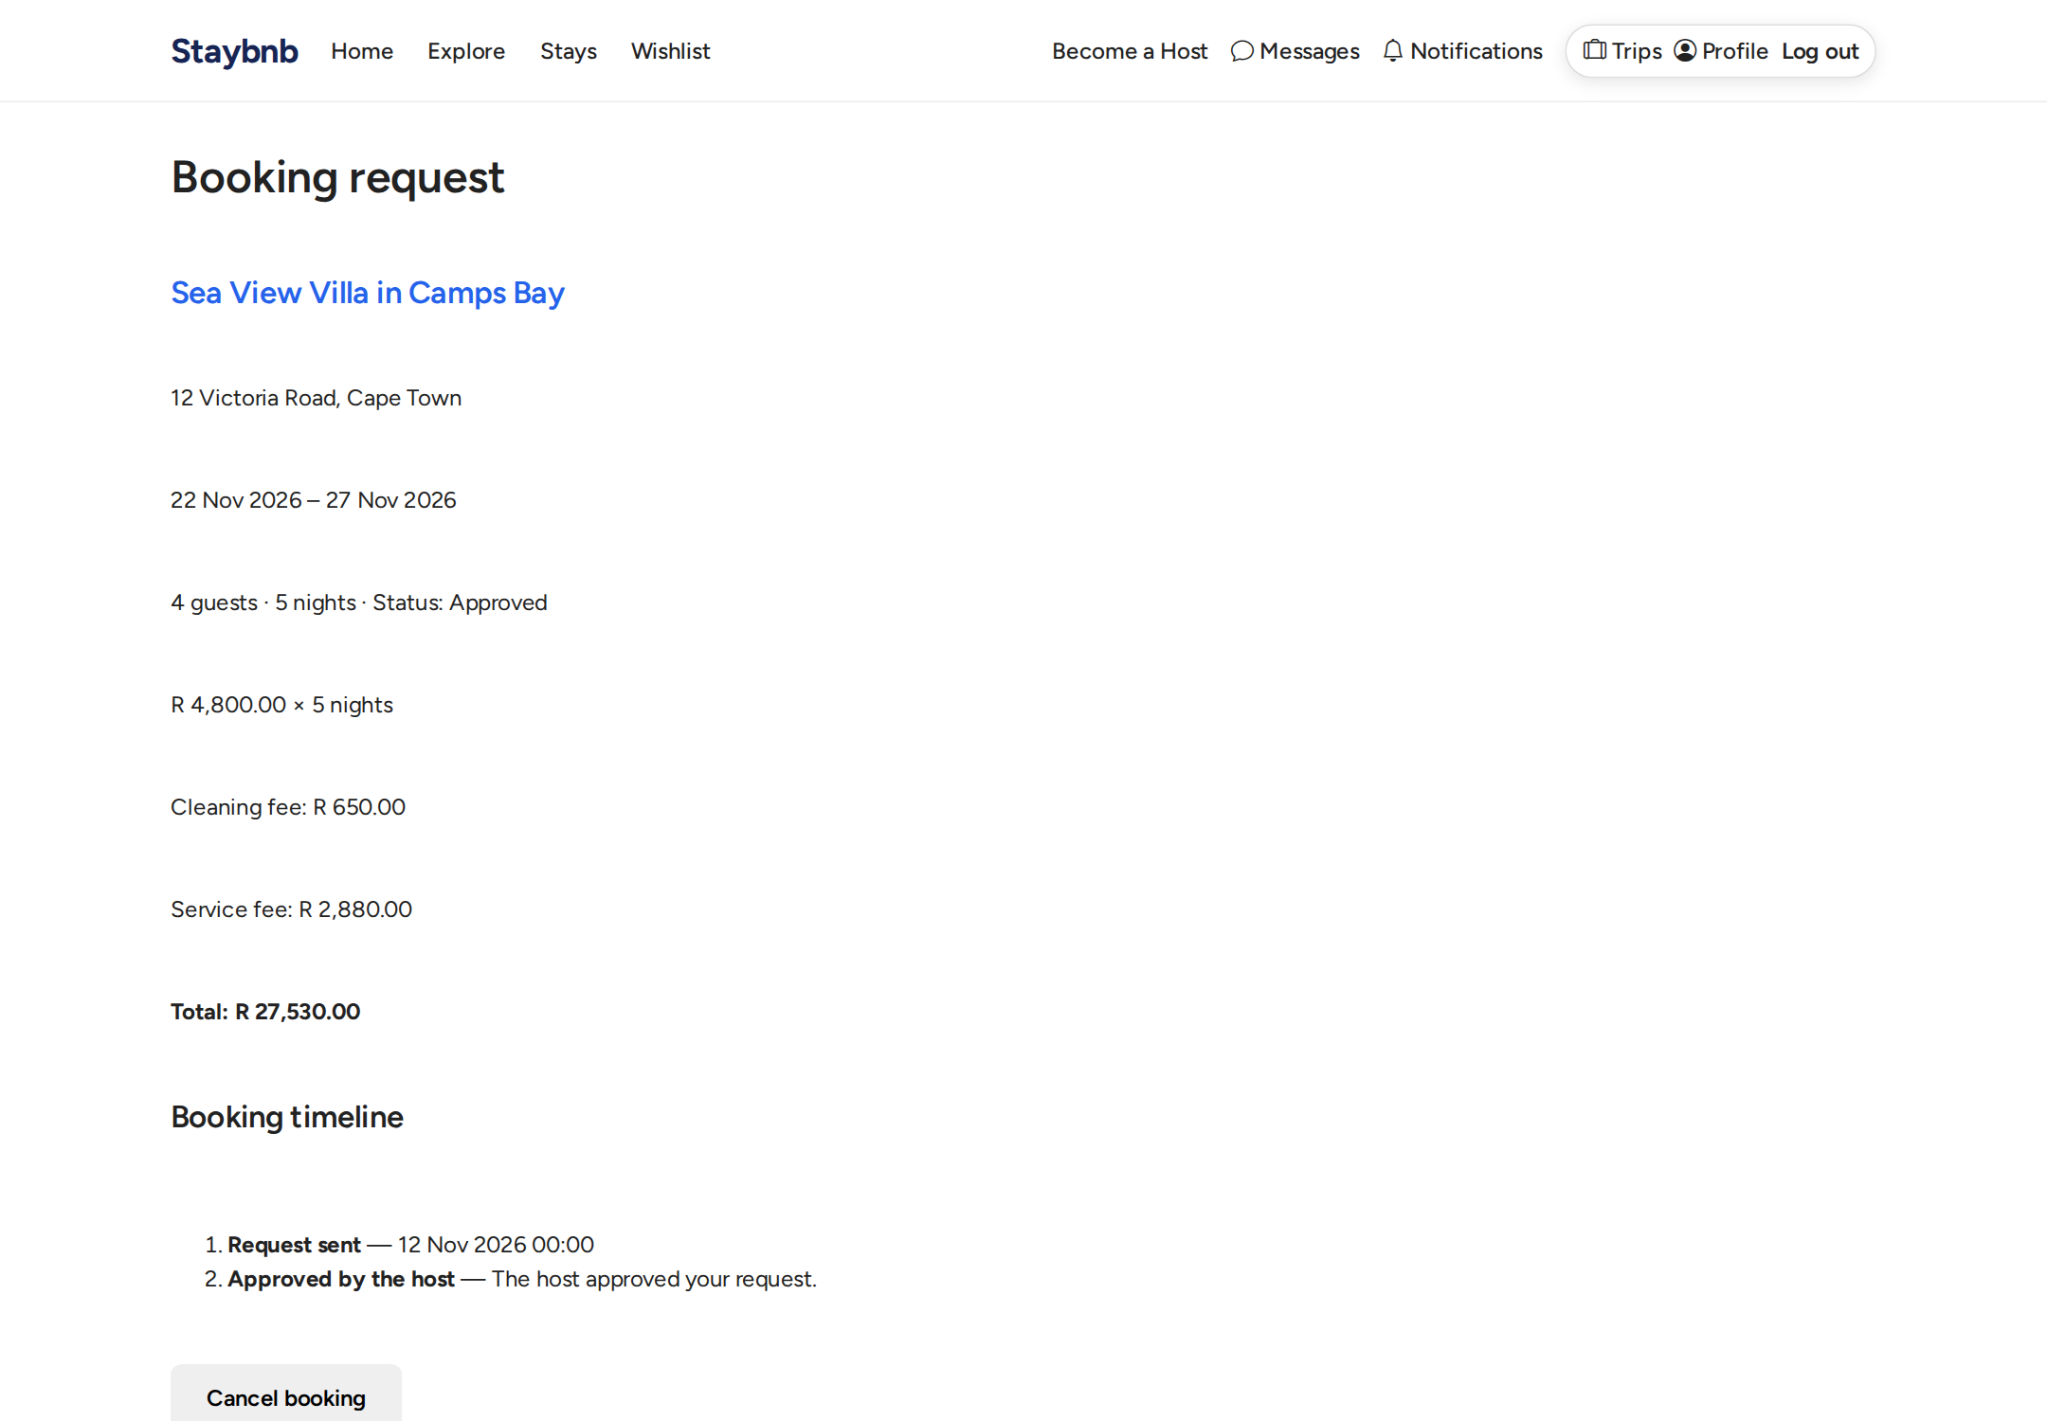
Booking details page. Shows full booking information, pricing breakdown, status, and available actions based on the booking state.

booking create
Booking request page. The guest selects dates and number of guests. The price is calculated on the server and shown before submitting the request.

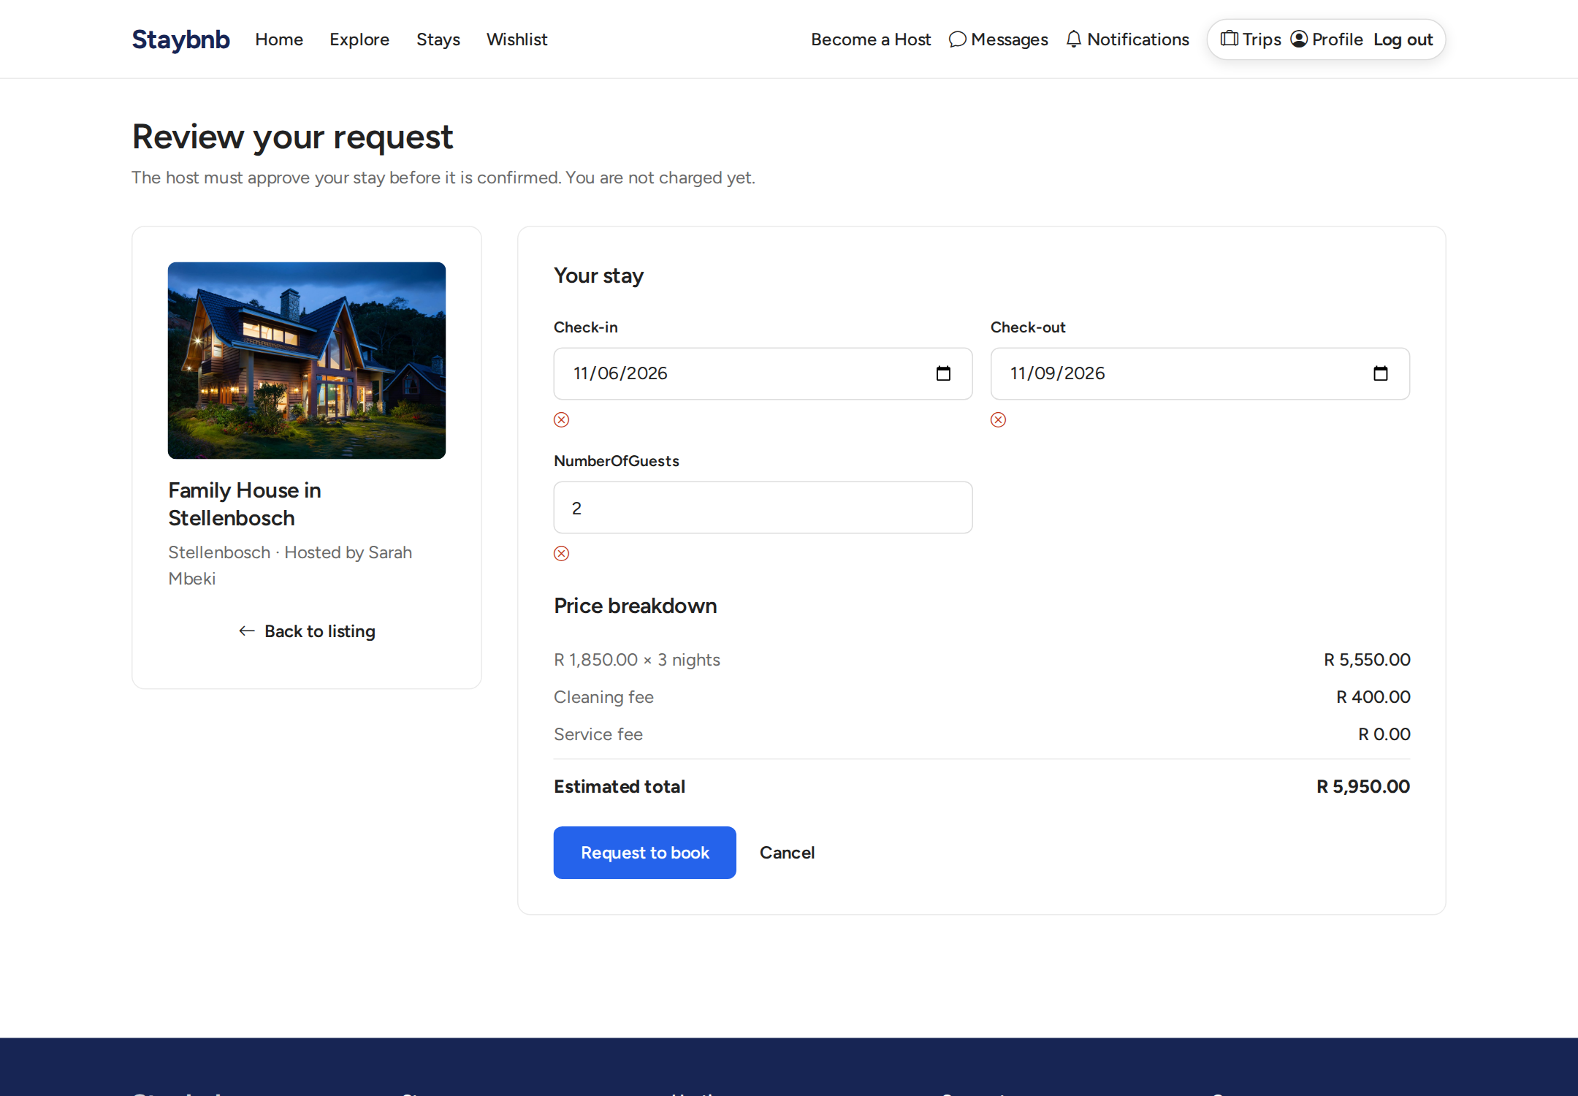
Booking request page. The guest selects dates and number of guests. The price is calculated on the server and shown before submitting the request.

wishlist
Wishlist page. Signed-in guests can save properties they are interested in for later.

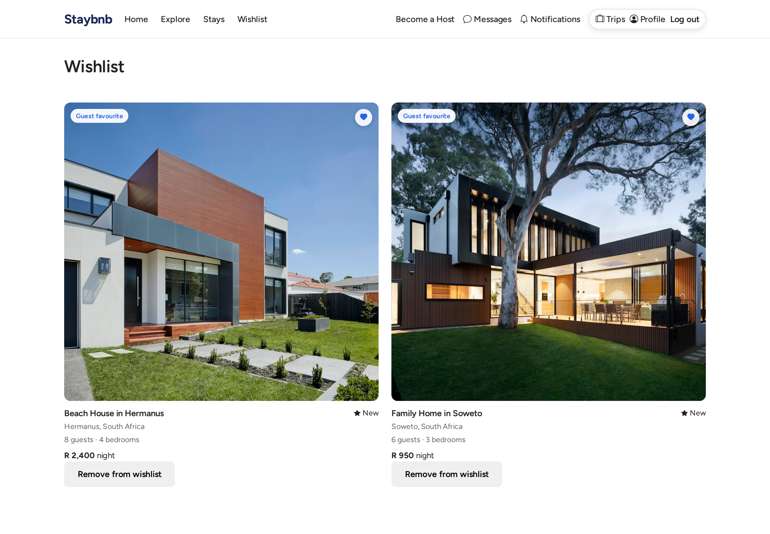
Wishlist page. Signed-in guests can save properties they are interested in for later.

messages inbox
Messages inbox. Guests and hosts can view conversations and see unread messages.

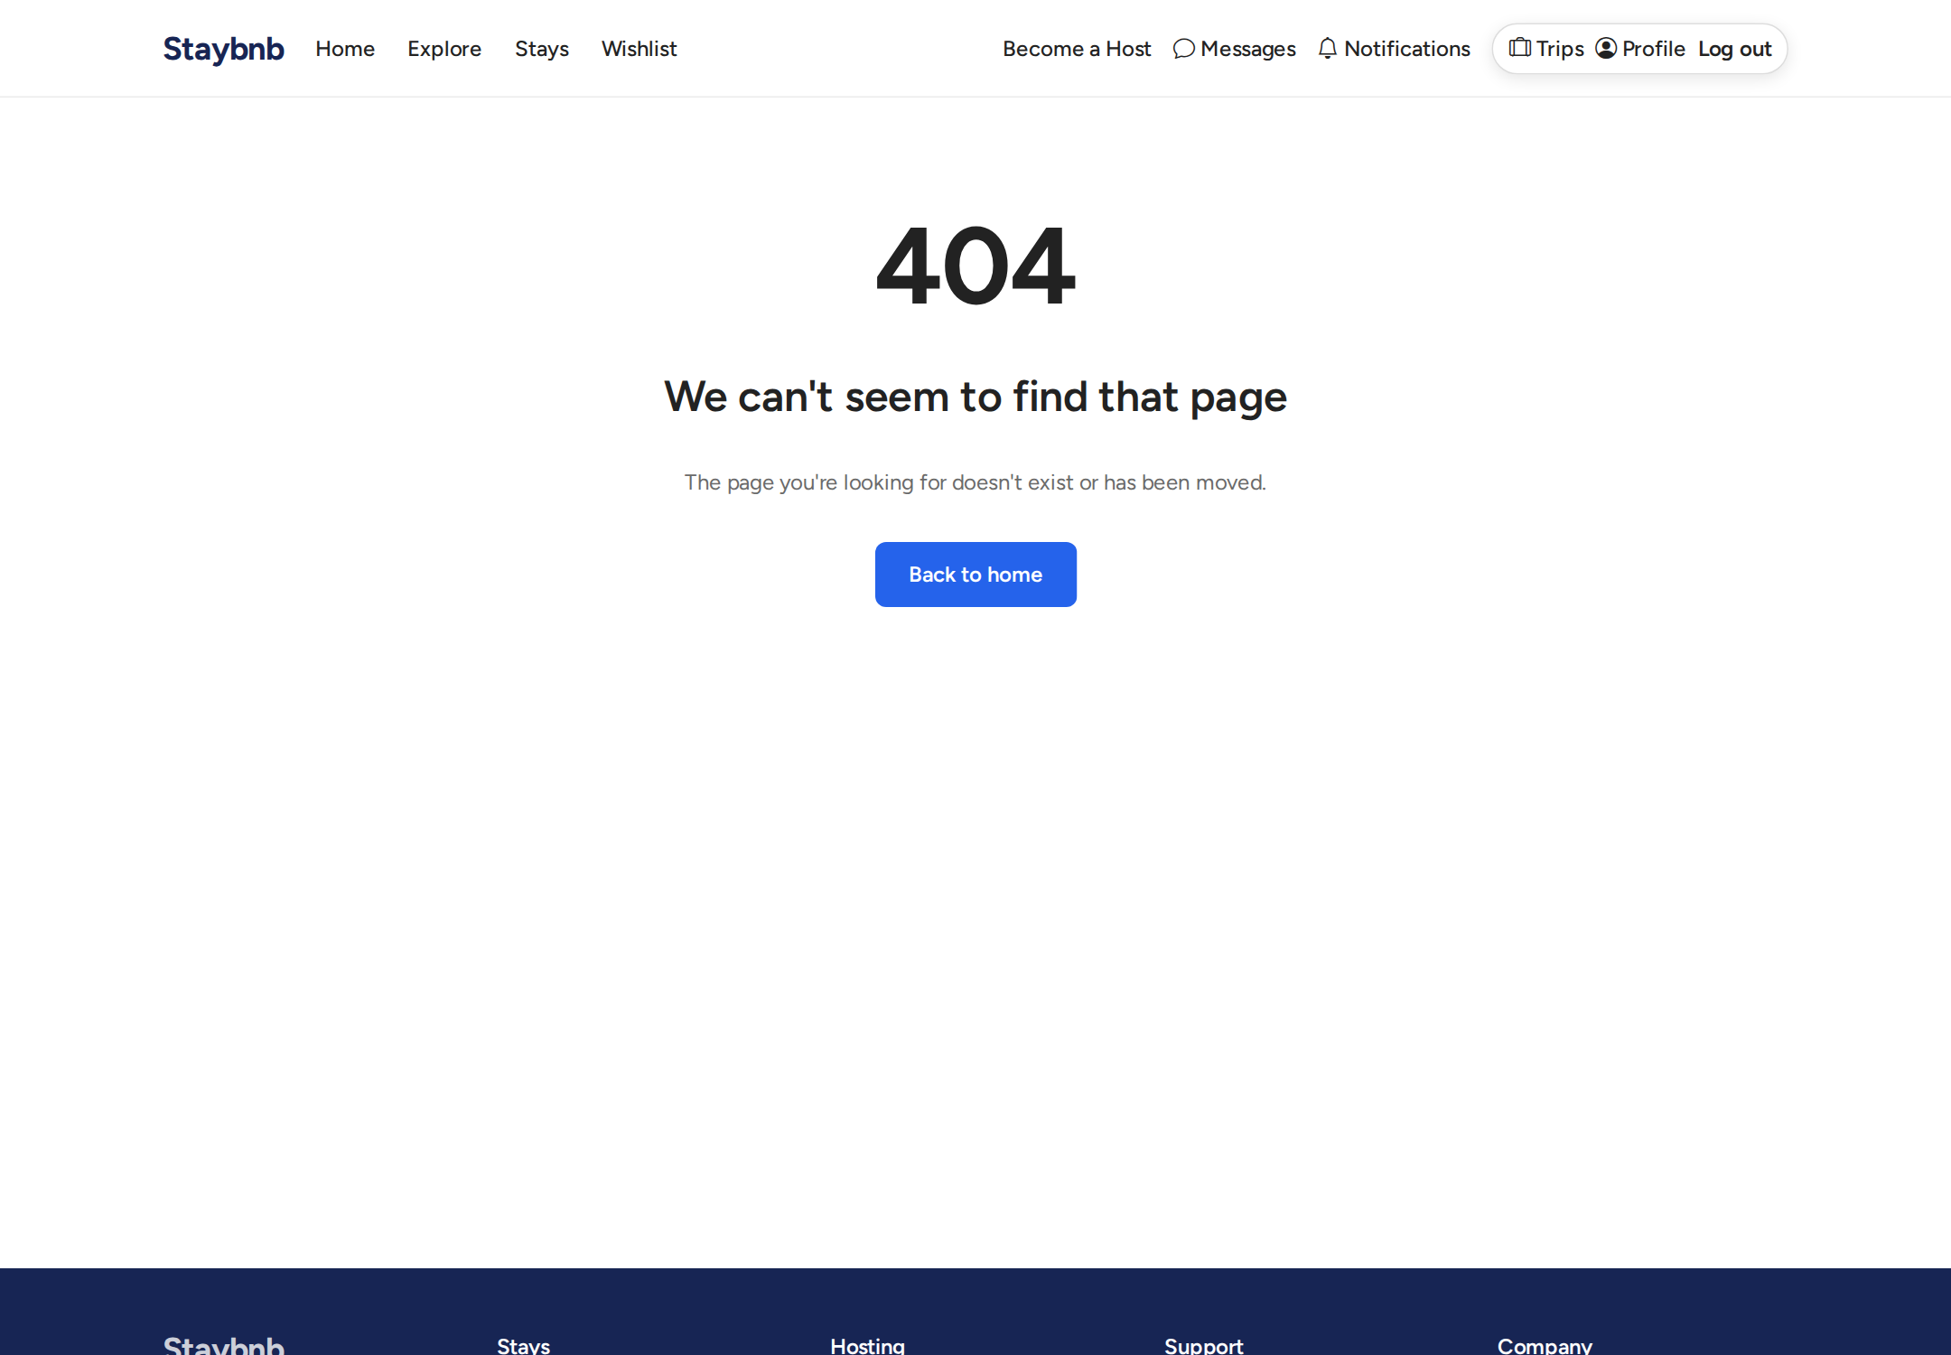
Messages inbox. Guests and hosts can view conversations and see unread messages.

notifications
Notifications page. Shows alerts for bookings, messages, applications, and check-in events.

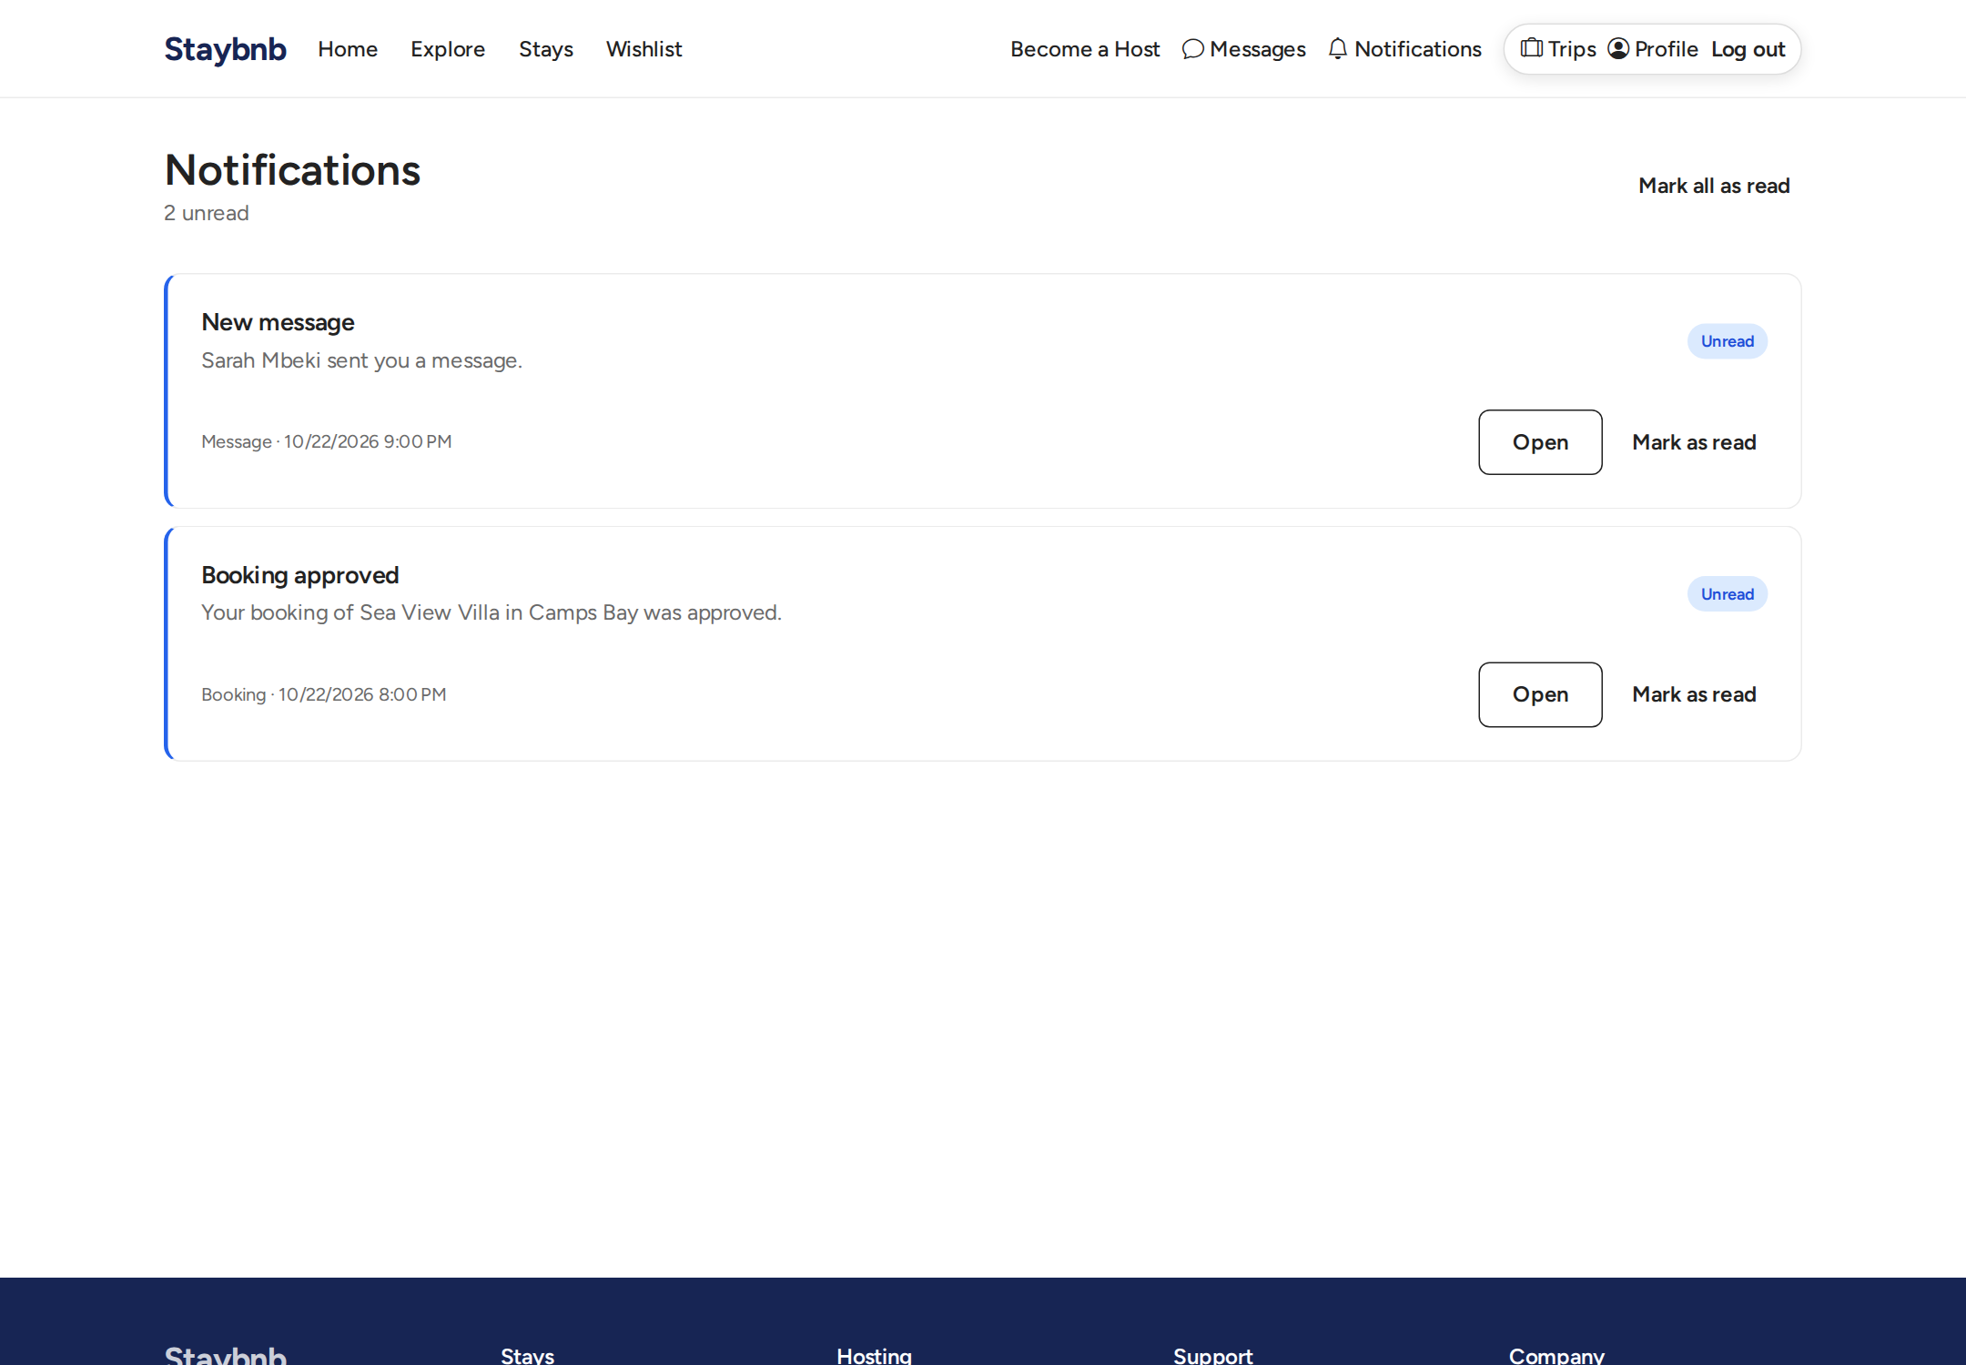
Notifications page. Shows alerts for bookings, messages, applications, and check-in events.

review form
Review form. Guests who have checked in or completed a stay can leave a rating and comment for the property.

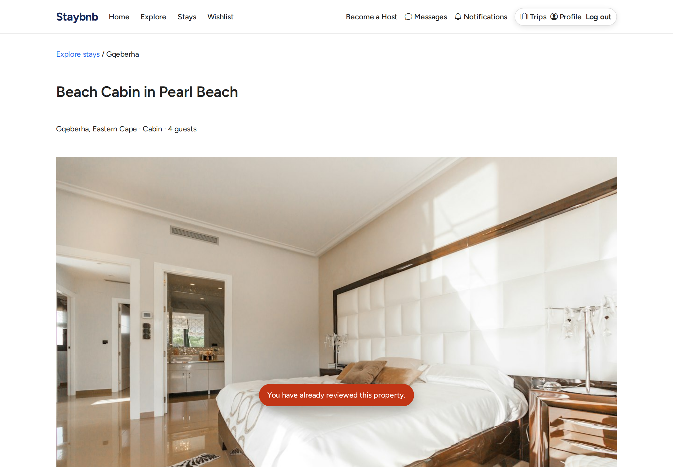
Review form. Guests who have checked in or completed a stay can leave a rating and comment for the property.

host checkin configure
Host check-in configuration. The host sets up ordered check-in steps, including document steps that require guests to upload ID or passport.

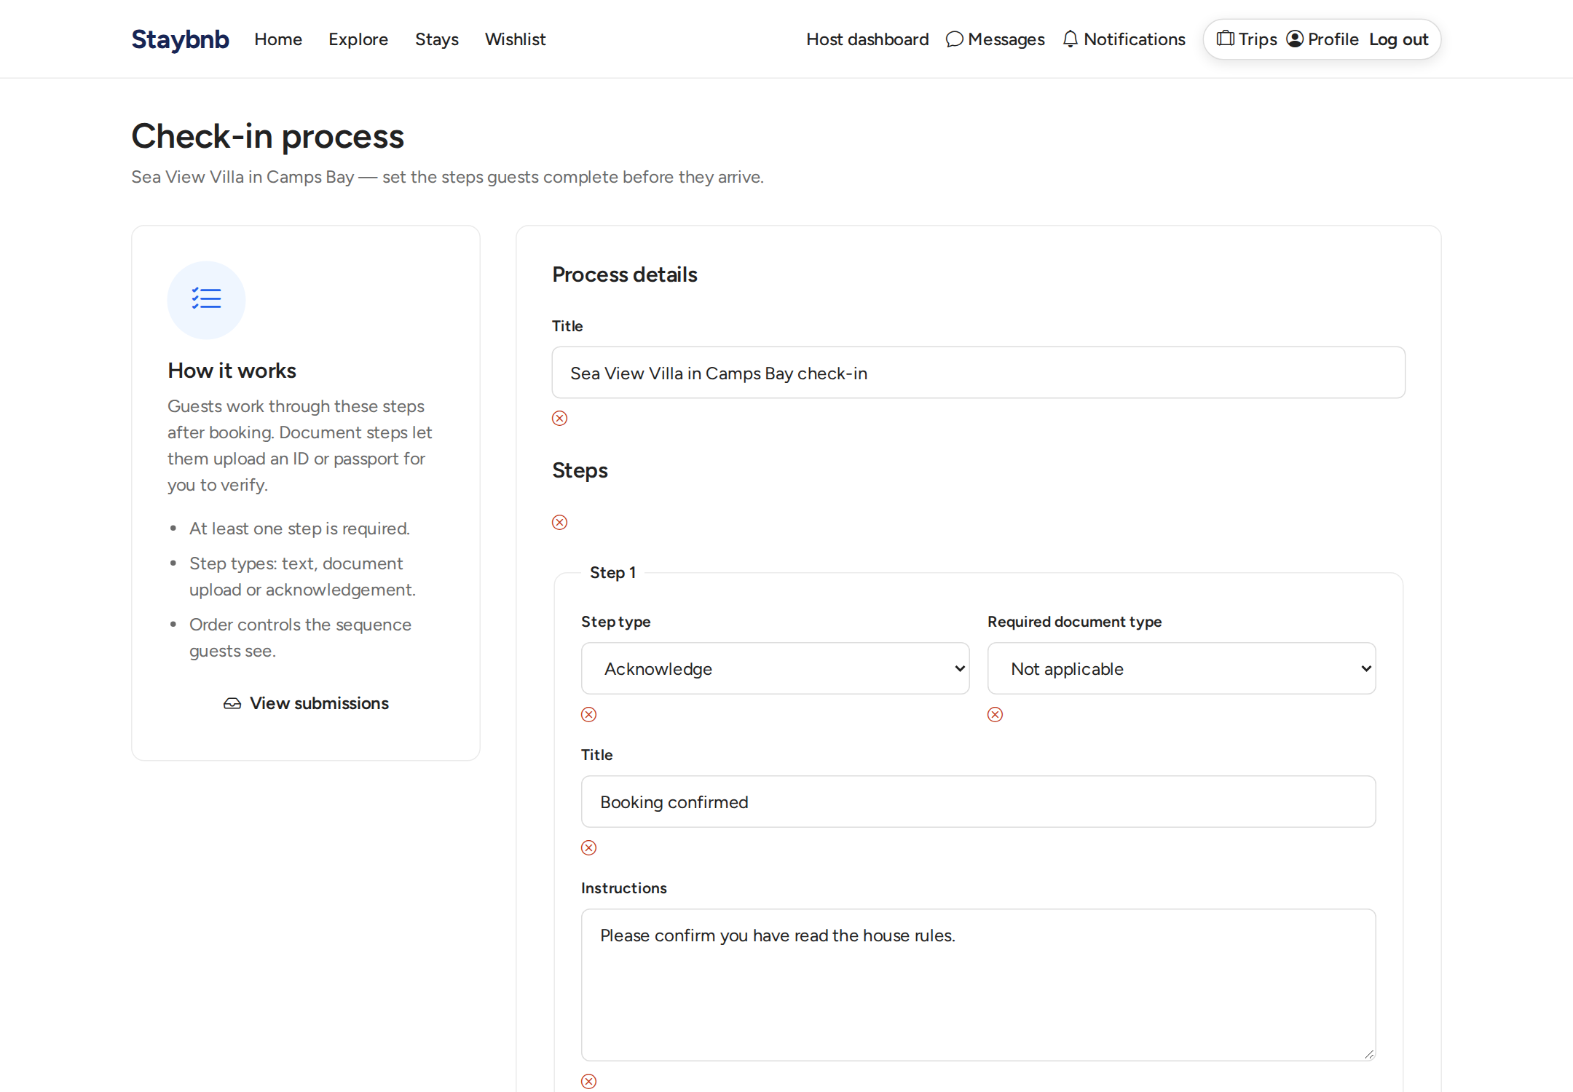
Host check-in configuration. The host sets up ordered check-in steps, including document steps that require guests to upload ID or passport.

host dashboard
Host dashboard. Shows listings, pending bookings, check-ins to verify, earnings, and quick links to manage the hosting business.

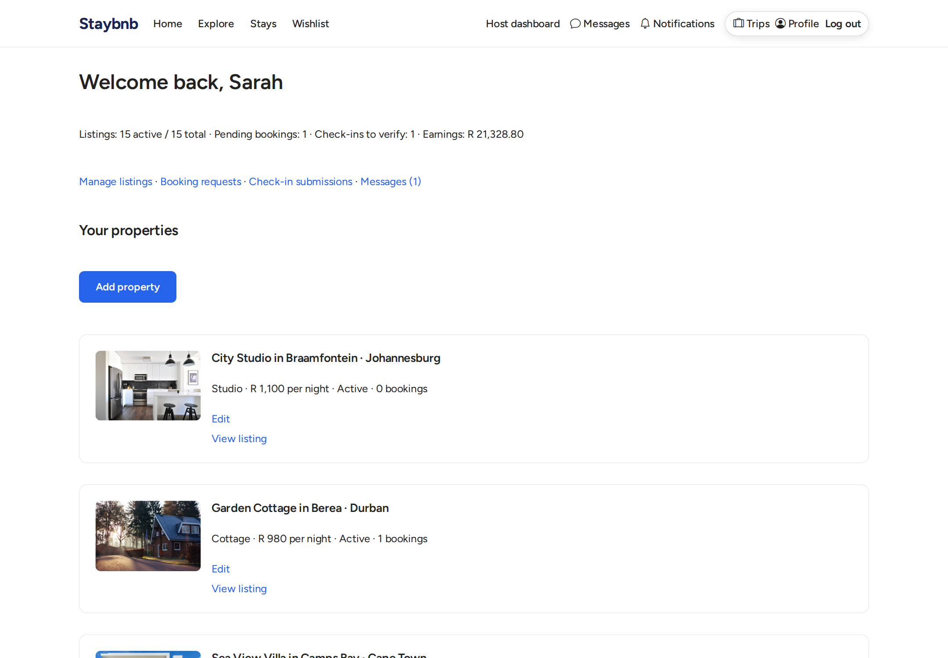
Host dashboard. Shows listings, pending bookings, check-ins to verify, earnings, and quick links to manage the hosting business.

host listings
Host listings management. The host can create, edit, activate or deactivate, and delete their properties.

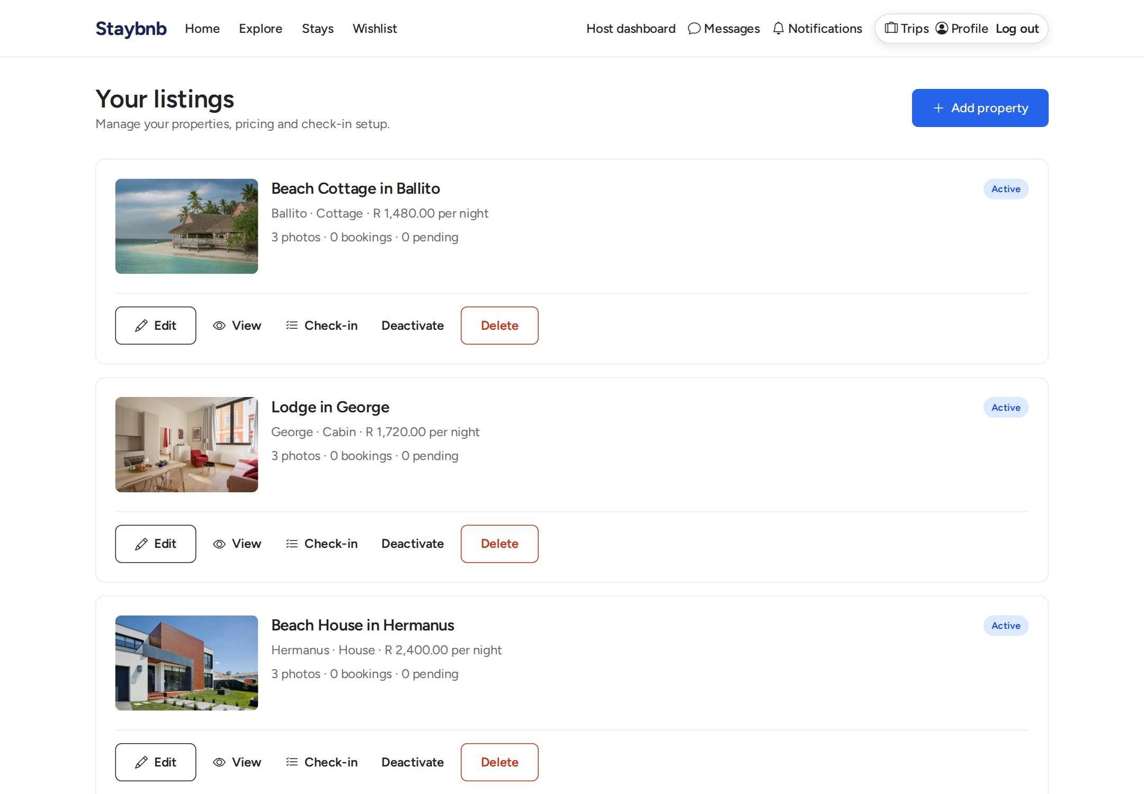
Host listings management. The host can create, edit, activate or deactivate, and delete their properties.

host bookings
Host bookings page. Hosts can approve or reject booking requests, and complete stays after check-out.

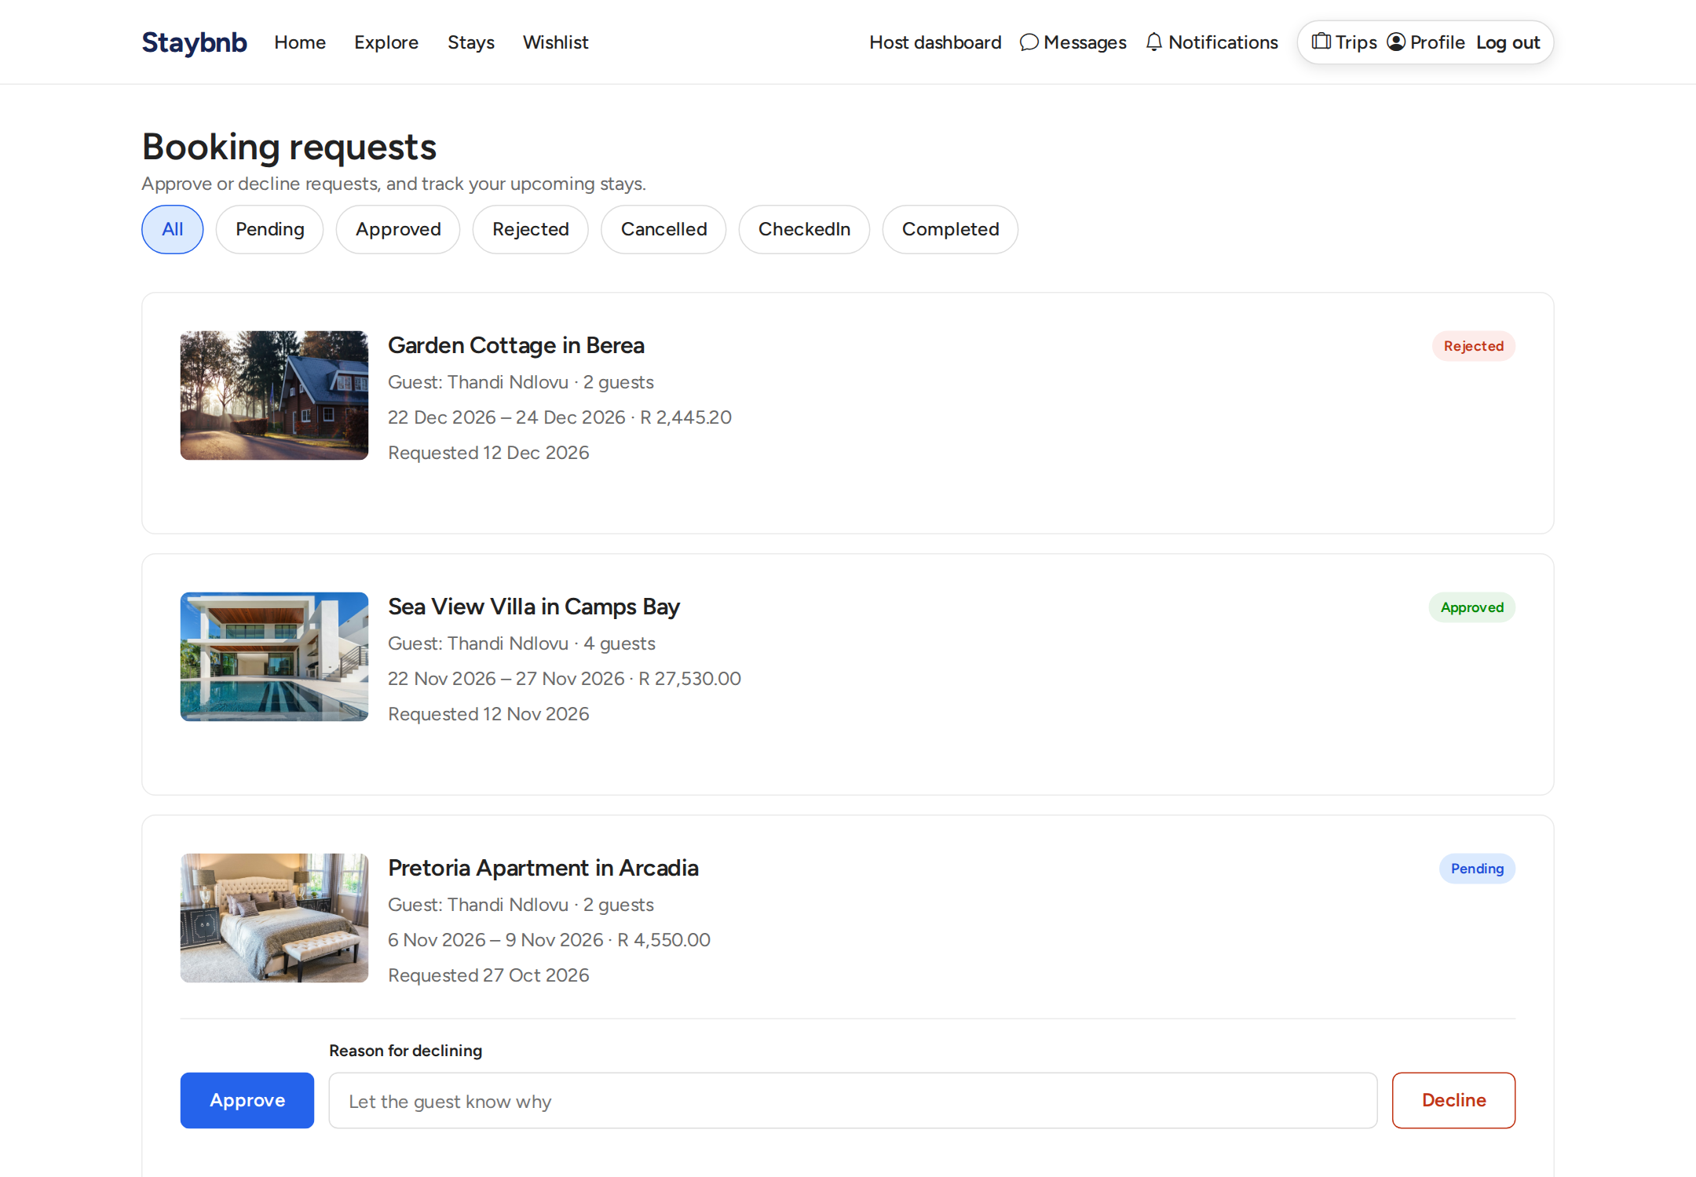
Host bookings page. Hosts can approve or reject booking requests, and complete stays after check-out.

host checkin submissions
Host check-in submissions. Hosts review uploaded documents and verify or reject them before allowing check-in.

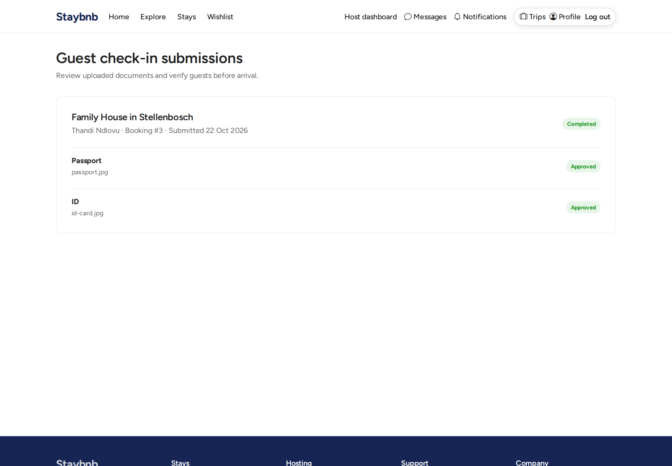
Host check-in submissions. Hosts review uploaded documents and verify or reject them before allowing check-in.

host listing create
Create listing page. Hosts can add a new property with details, pricing, amenities, and photos.

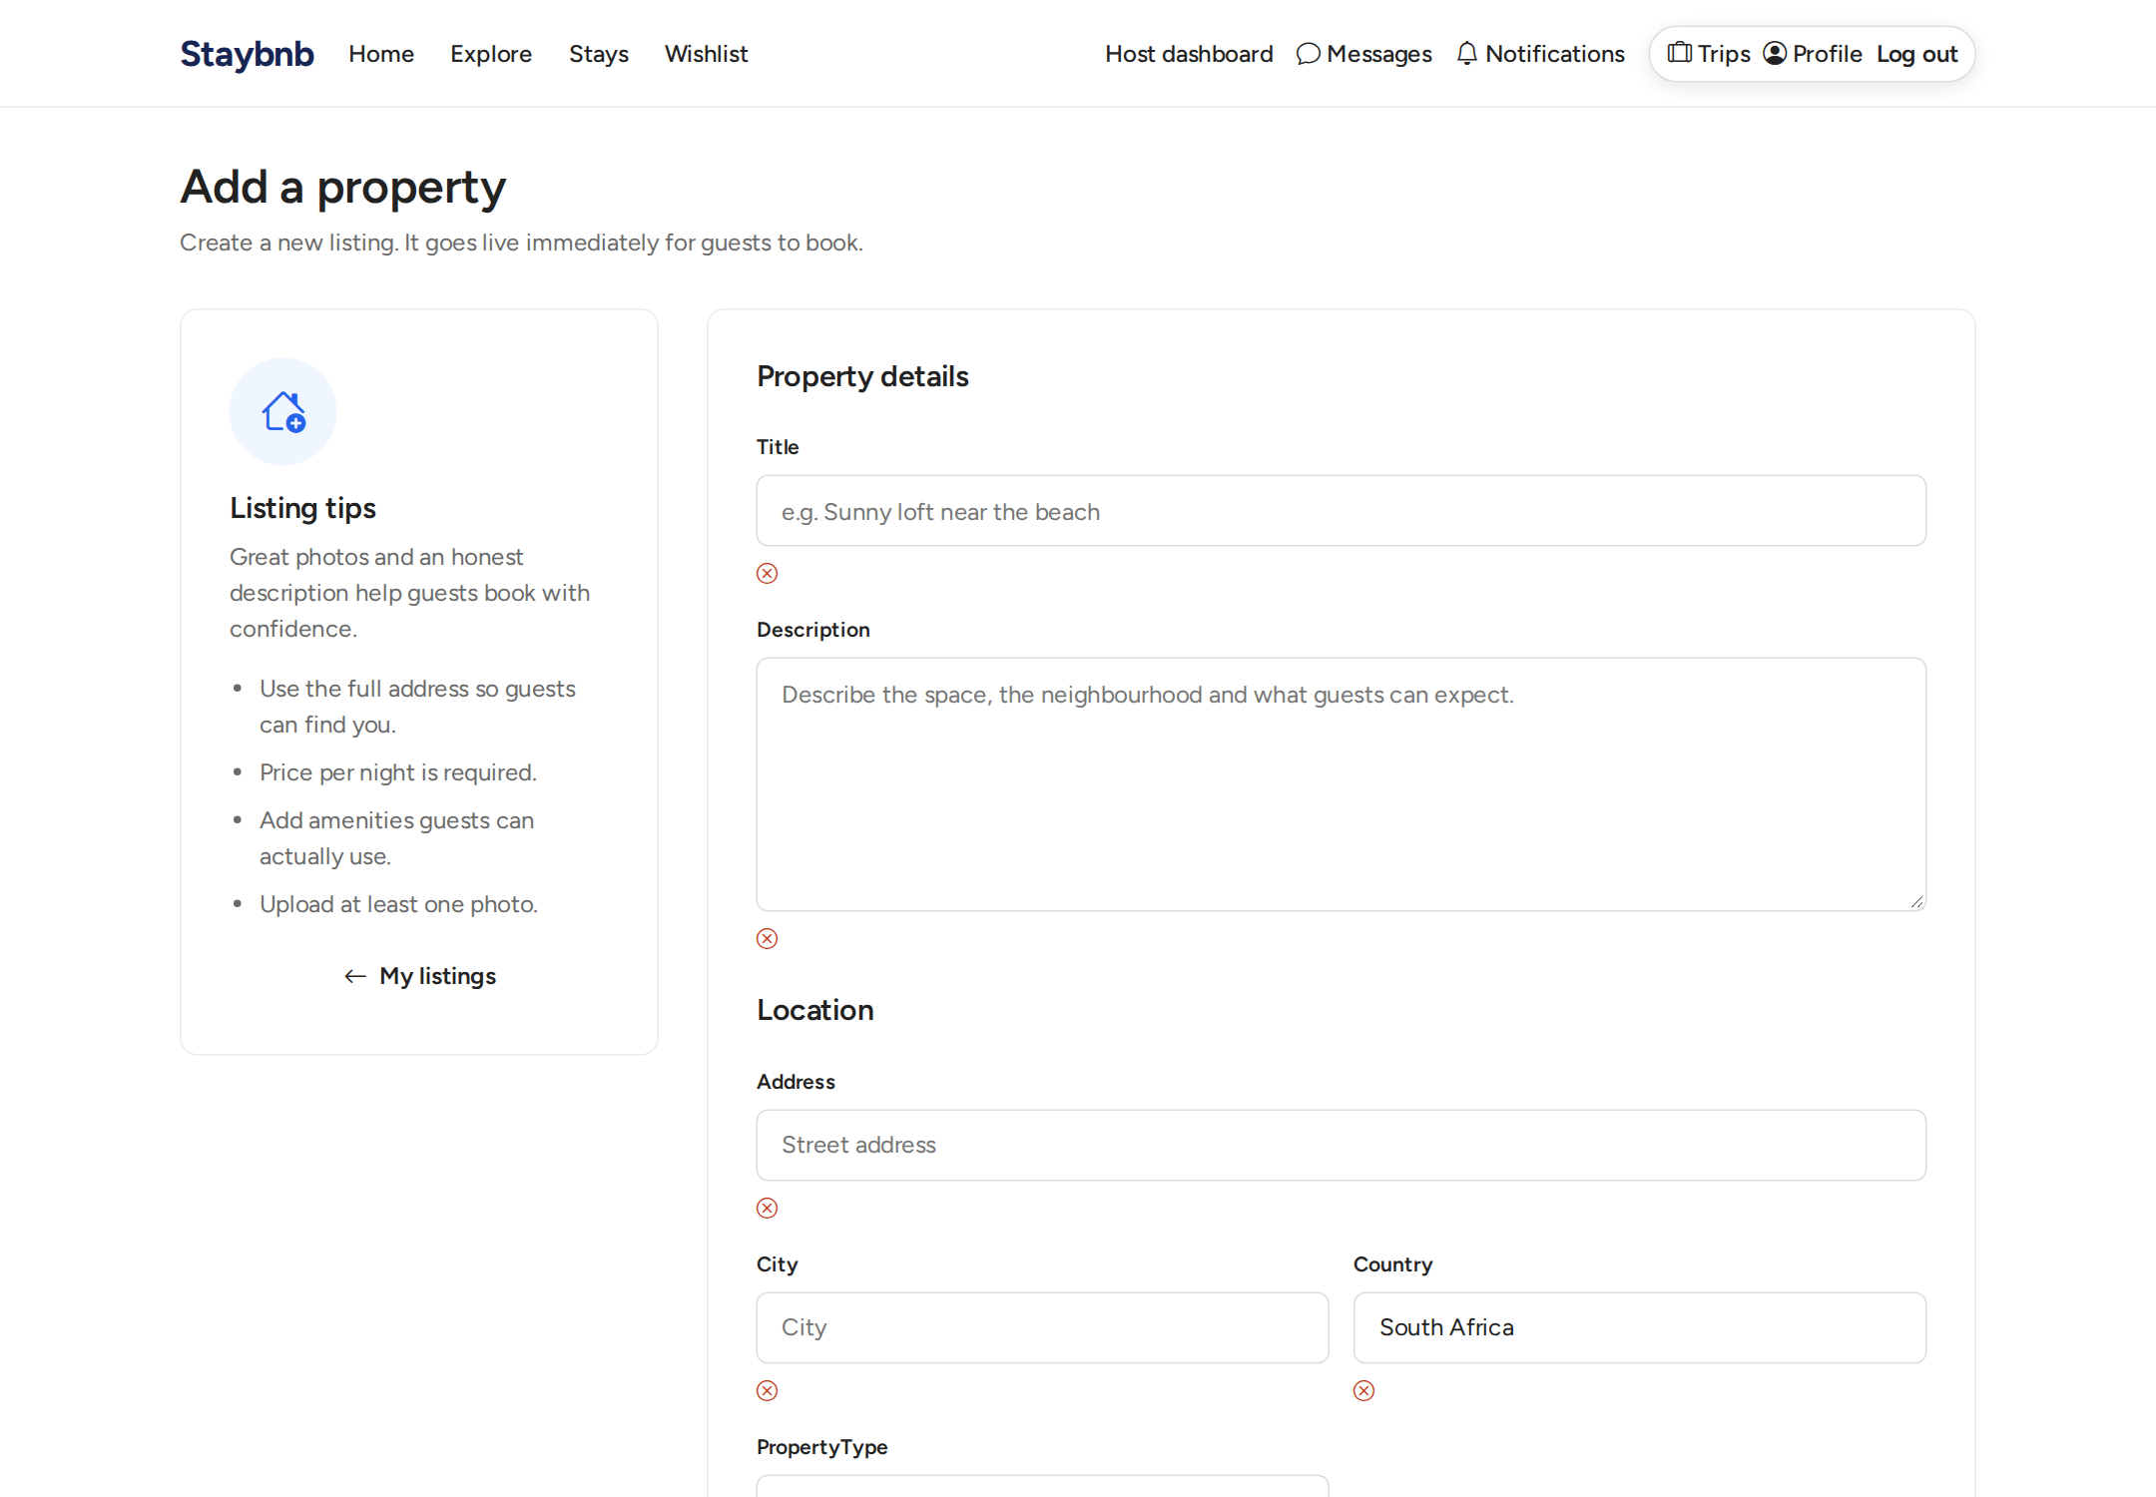
Create listing page. Hosts can add a new property with details, pricing, amenities, and photos.

host messages
Host messages. Hosts can respond to guest enquiries from their inbox.

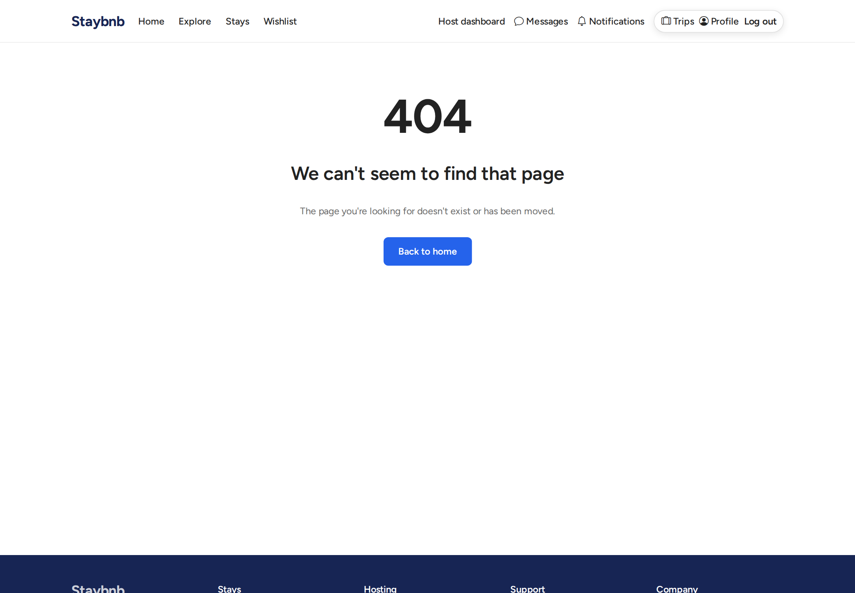
Host messages. Hosts can respond to guest enquiries from their inbox.

checkin step 1
Guest check-in step. Guests work through the guided check-in process step by step.

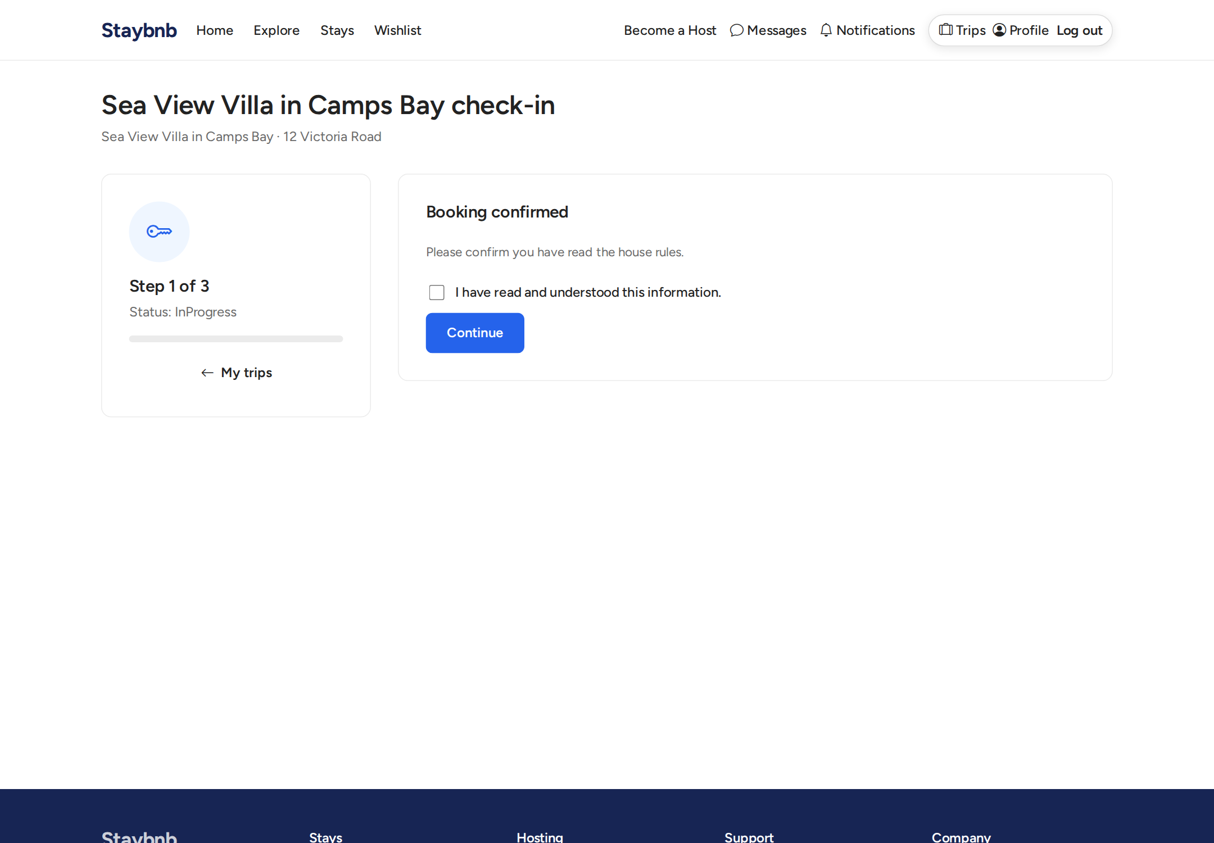
Guest check-in step. Guests work through the guided check-in process step by step.

checkin step 2
Guest check-in step with document upload. For document steps, guests upload their ID or passport for the host to verify.

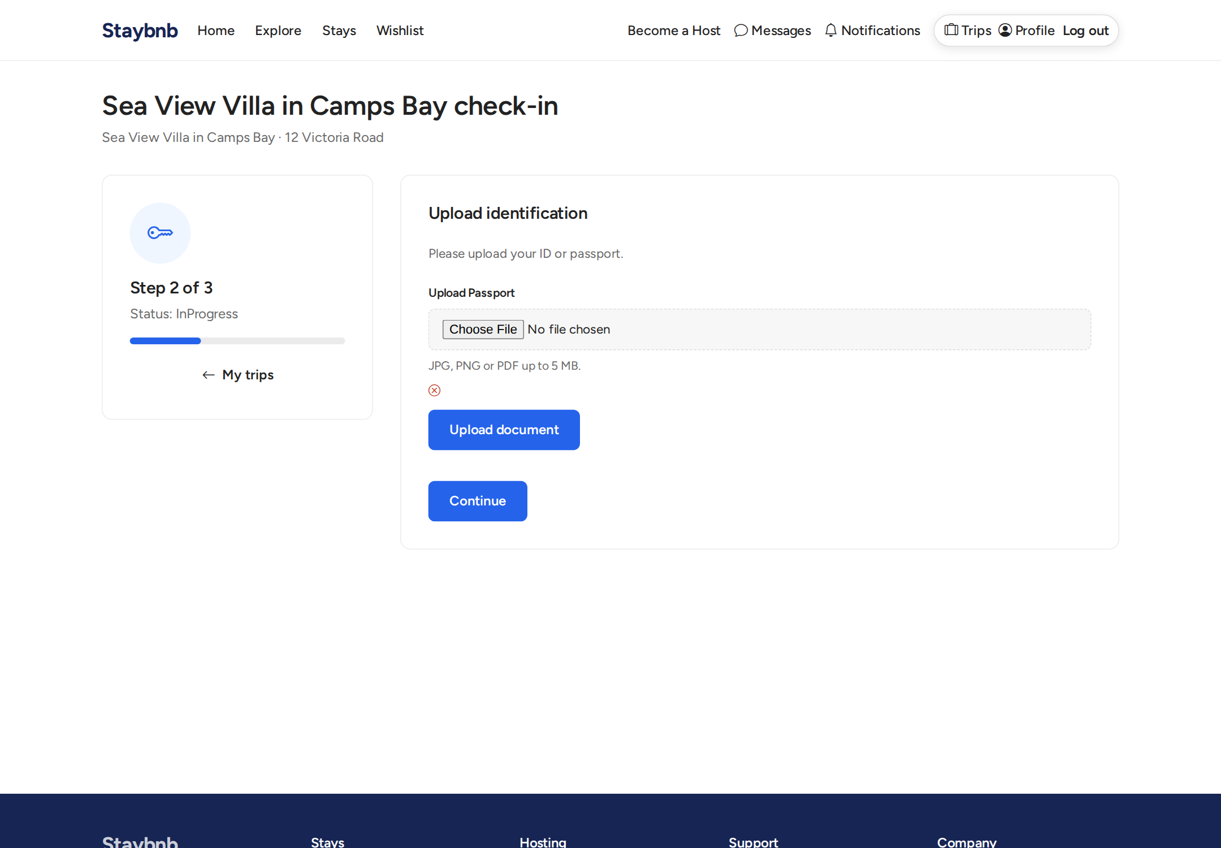
Guest check-in step with document upload. For document steps, guests upload their ID or passport for the host to verify.

admin dashboard
Admin dashboard. Shows platform totals like users, properties, bookings, applications, and recent activity.

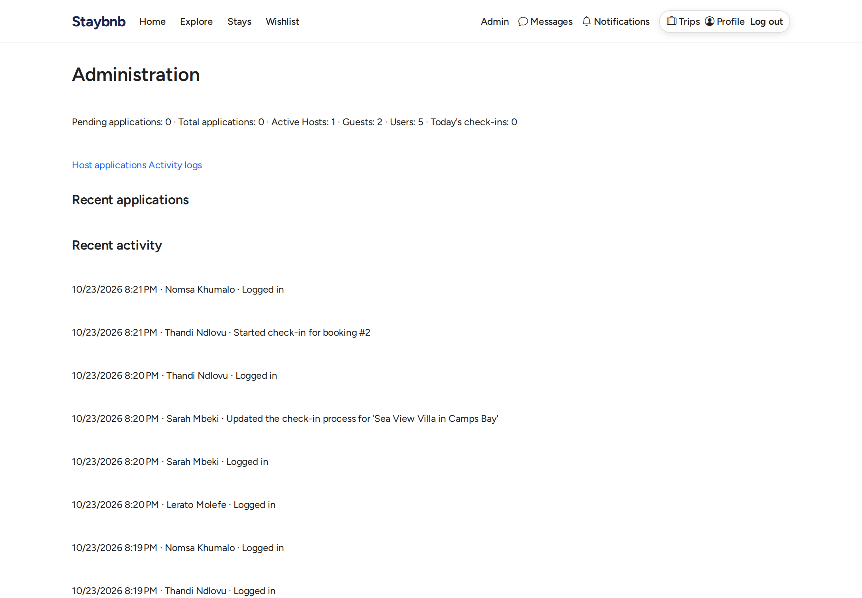
Admin dashboard. Shows platform totals like users, properties, bookings, applications, and recent activity.

admin applications
Admin applications list. Admins and SuperAdmins can review pending host applications.

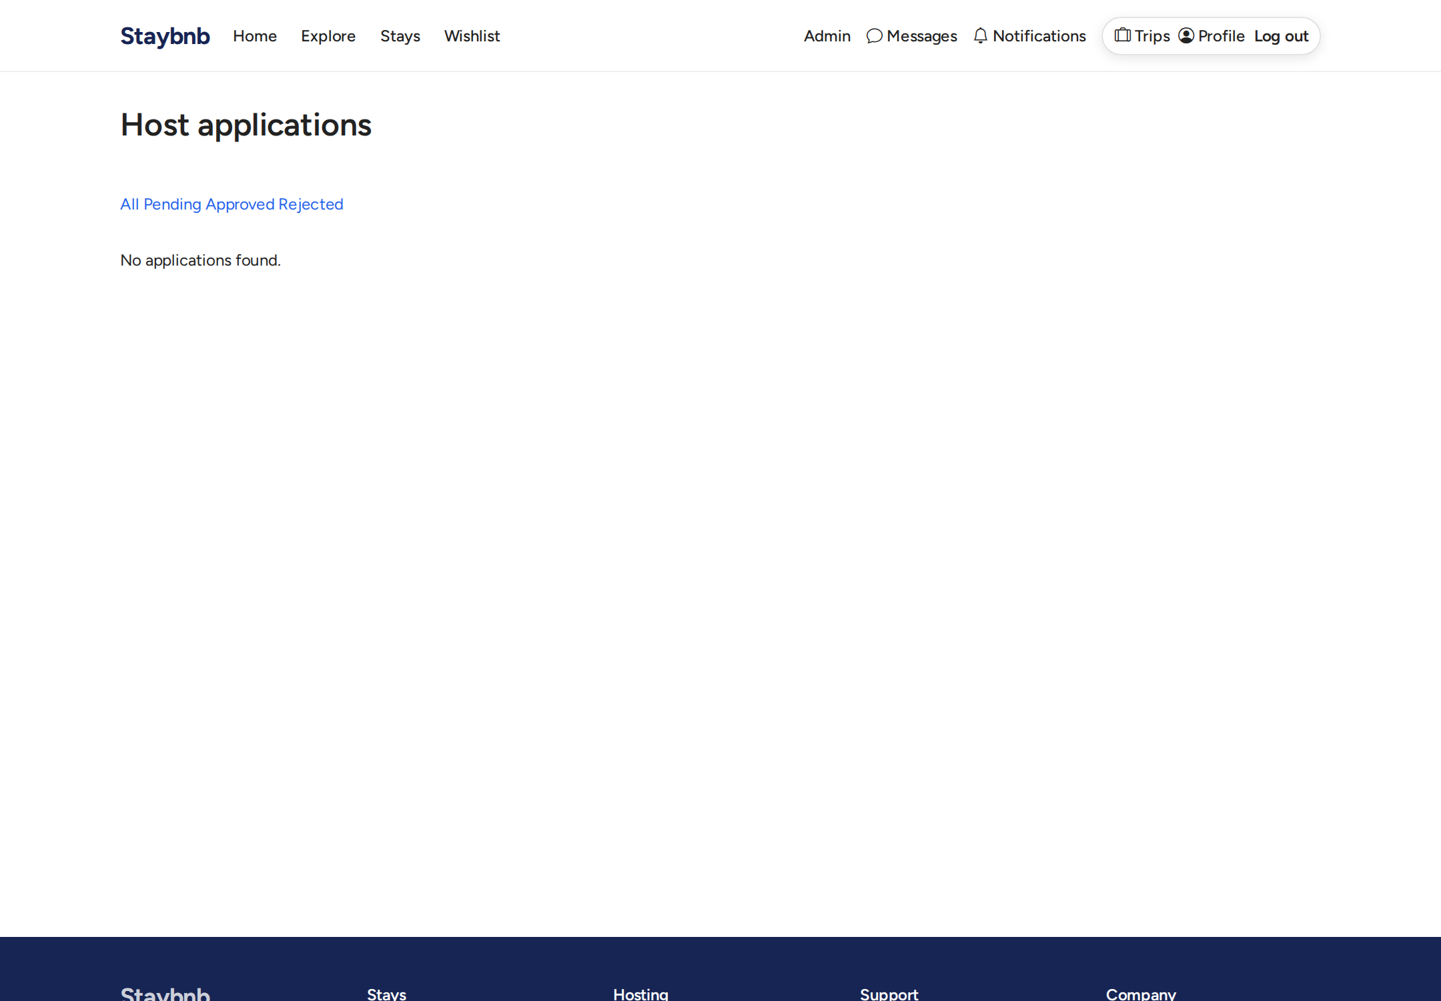
Admin applications list. Admins and SuperAdmins can review pending host applications.

admin activity log
Activity log. A filterable audit trail of important actions across the platform.

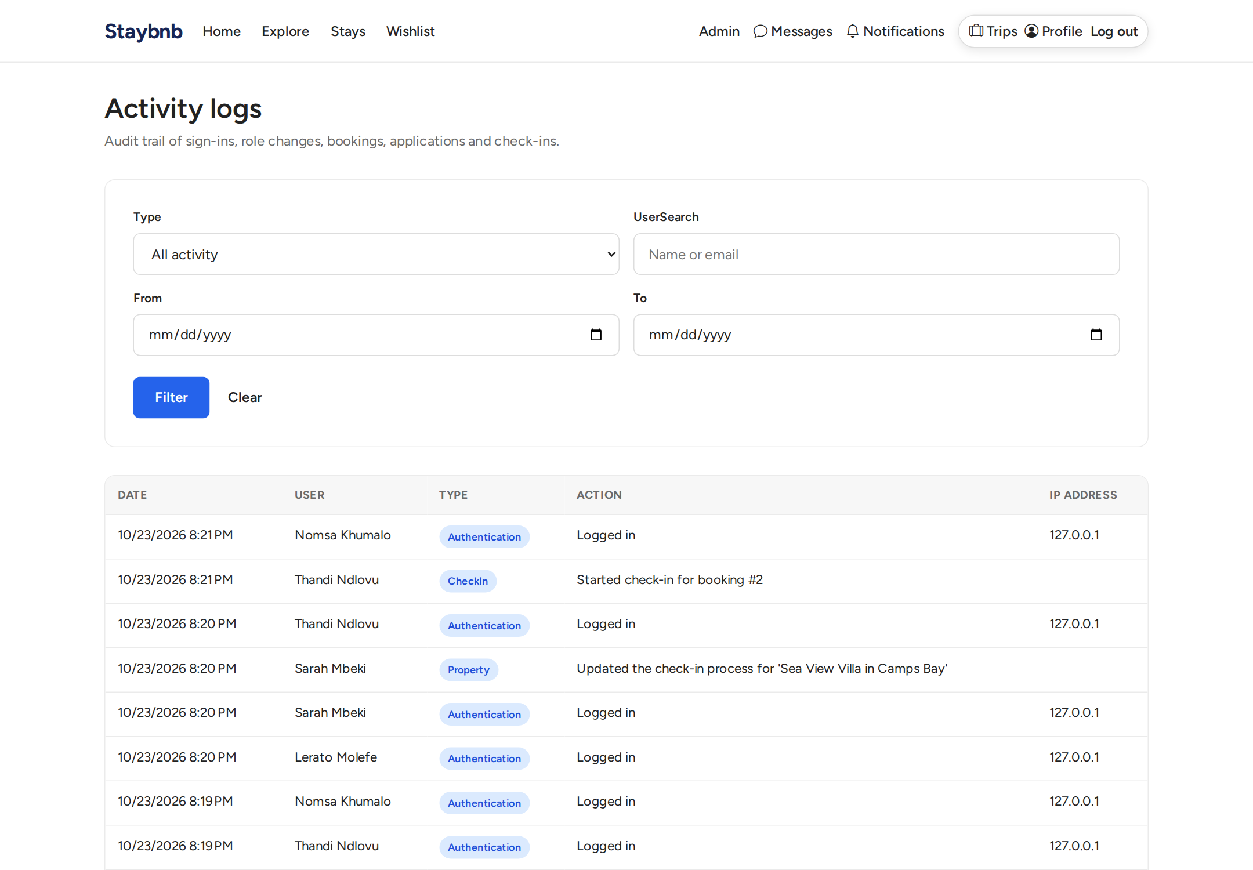
Activity log. A filterable audit trail of important actions across the platform.

admin user management
User management. Only the SuperAdmin can promote Guests to Admin.

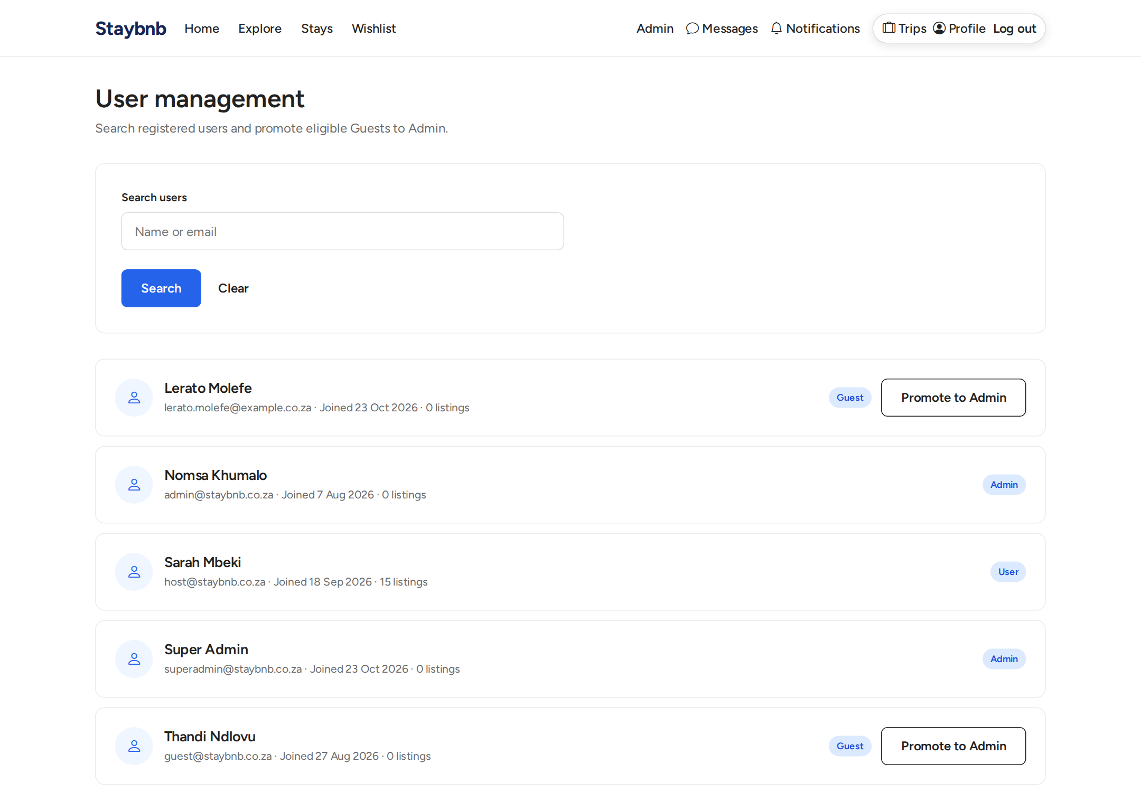
User management. Only the SuperAdmin can promote Guests to Admin.

admin application status
Admin view of pending applications. Admins can inspect application details and approve or reject them.

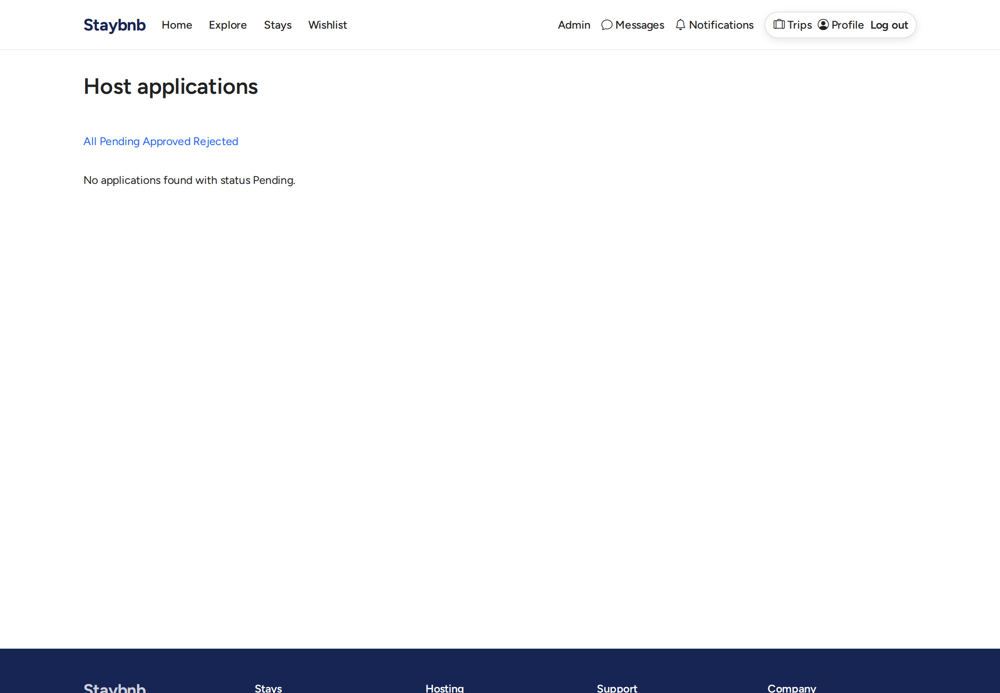
Admin view of pending applications. Admins can inspect application details and approve or reject them.

Conclusion

StayBnB brings together all the parts needed for a controlled accommodation marketplace. Guests can discover and book stays with confidence because prices are calculated on the server and bookings follow a clear approval flow. Hosts have tools to manage their properties, handle requests, and safely verify guests through a guided check-in process with document uploads. Administrators have visibility into applications and activity, and the SuperAdmin can manage admin access. The role-based permissions, ownership checks, and validation rules help ensure that only the right people can take the right actions at the right time.

The application is structured with clear separation between controllers, services, models, and views. Business logic such as pricing, booking state transitions, host application approval, and reviews is handled in dedicated services so the rules are consistent. The user interface covers all the main flows from browsing and booking to hosting and administration. With demo data included, the full system can be explored end to end. Overall, the application meets the requirements of a working marketplace with proper controls, clear workflows, and a complete set of pages for guests, hosts, and administrators.

