Affect of Angle of ramp on the acceleration of a Rolling Ball

Rationale:

Energy is the capacity to do work (Britannica, 2021). Types of energy present during the experiment included gravitational potential energy, kinetic energy, sound energy and heat energy. Gravitational potential energy is defined as mass multiplied by gravitational field multiplied by height. Increasing any of the values will increase the total gravitational potential energy. In the experiment the mass and gravitational field are constant with the height of the ramp increasing. During the experiment this potential energy is converted to kinetic energy heat and sound energy.

Kinetic energy is the push and pull force on object and is the force of motion. It is the most interacted with energy and is essential to everything we as humans can do. Kinetic energy can be transformed from other types of energy including heat, electricity and gravitational potential energy. It can also be transferred to and from objects when colliding. Kinetic energy also commonly has by-products such as heat, and sound caused by friction in either other surfaces or air. This means that kinetic energy is lost when objects move.

Original experiment:

A cart was rolled down a ramp and timed with varying amounts of blocks under one end of the ramp to create slopes of different steepness. The full original method can be found in appendix 1.

Research Question:

What is the affect of the angle of a ramp on the acceleration of a ball rolling down a ramp?

Modifications to Original Experiments:

* A ball was used instead of a cart to reduce friction, instability and the randomness associated with the use of a more complicated system.
* A camera was used to record the trials as using this to time how long the trials were as this is more accurate then using a stopwatch and removes human error.
* The ramp’s steepness was measured with the angle to the ground and not height in blocks. This added consistency as the position of the blocks along the ramp greatly affected the steepness.

The full modified method can be found in appendix 2.

Risk Assessment:

Raw Data:

**Table 1:** Time Taken for Ball to Reach End of Ramp

|  |  |  |  |  |  |  |  |
| --- | --- | --- | --- | --- | --- | --- | --- |
| Angle (Degrees) | Distance (m) | Mass (Kg) | Trial 1 | Trial 2 | Trial 3 | Trial 4 | Trial 5 |
| 2 | 2.50 | 0.05050 | 4.90 | 4.77 | 4.73 | 4.73 | 4.63 |
| 4 | 2.50 | 0.05050 | 3.30 | 3.43 | 3.43 | 3.40 | 3.40 |
| 6 | 2.50 | 0.05050 | 2.77 | 2.73 | 2.73 | 2.73 | 2.80 |
| 8 | 2.50 | 0.05050 | 2.37 | 2.37 | 2.37 | 2.37 | 2.43 |
| 10 | 2.50 | 0.05050 | 2.10 | 2.00 | 2.06 | 2.10 | 2.03 |

Processed Data:

**Figure 1:** Acceleration of Ball Rolling Down a Ramp

**Table 2:** Angle, Average Time, Average Speed, Final Speed, Average Acceleration and Coefficient of Variation of Trials

|  |  |  |  |  |  |  |
| --- | --- | --- | --- | --- | --- | --- |
| Angle (degrees) | Average Time(s) | Average Speed  (m/s) | Final Speed (m/s) | Average Acceleration (m/s/s) | Standard Deviation | Coefficient of Variation |
| 2 | 4.75 | 0.53 | 1.05 | 0.22 | 0.10 | 2.05 |
| 4 | 3.39 | 0.74 | 1.47 | 0.43 | 0.05 | 1.58 |
| 6 | 2.75 | 0.91 | 1.82 | 0.66 | 0.03 | 1.16 |
| 8 | 2.38 | 1.05 | 2.10 | 0.88 | 0.03 | 1.13 |
| 10 | 2.06 | 1.21 | 2.43 | 1.18 | 0.04 | 2.13 |

**Table 3:**  Sample Calculations of Angle Ramp of 2 Degrees

|  |  |
| --- | --- |
| **Formula used to process data** | **Sample calculation for ramp length of 1.20m** |
| $$Averagetime=\frac{trial1+trial2+trial3}{3}$$ | $$Averagetime=\frac{1.30s+1.32s+1.28s}{3}$$ $1.30s$ |
| $$Averagevelocity=\frac{Lengthoframp\left(m\right)}{time\left(s\right)}$$ | $$Averagevelocity=\frac{1.2m}{1.30s}$$ $0.92m/s$ |
| $$Finalvelocity=Averagevelocity×2$$ | $$Finalvelocity=0.92m/s×2=1.85m/s$$ |
| $$Acceleration=\frac{Finalvelocity}{time}$$ | $$Acceleration=\frac{1.85m/s}{1.30s}$$ |
| $$NetForce=mass×acceleration$$ | $$NetForce=0.01kg×1.42{m/s}/s$$ |
| $$Standarddeviationwascalculated∈$$ $$excelbyusingtheSTDEV.Sfunction$$ $$thetimerecordedforeachtrial$$ | $$Standarddeviationof1.30,1.32$$ |
| $$Coefficientofvariation=\frac{Standarddeviation}{mean}$$ | $$Coefficientofvariation=\frac{0.02}{1.30}$$ |

Trends patterns and relationships:

Figure 1 shows a clear linear increase of acceleration when increasing the angle of the ramp. When the ramp was set to two degrees the ball had an average acceleration of 0.22 m/s/s and at accelerated fastest at 10 degrees with an acceleration 1.18 m/s/s. The coefficient of variation between trials was highest at ten degrees with 2.13. The average increase of acceleration was 0.236. The standard deviation of the average increase of acceleration was 0.035. This shows very little deviation between the trend line and the results in figure 1. This was observed because as the steepness increases the height increases and as the height increases the gravitational potential energy. Because of this greater gravitational potential energy more kinetic energy is generated increasing the speed rolling down the ramp.

Evaluation of Methodology:

The Method used in the experiment was valid but has some minor uncontrolled variables. The method of the experiment measured only the time for the ball to reach the end of the ramp. If the final speed was not double the average speed this would skew the results. The acceleration was then calculated by assuming that the final speed was the double the average speed which may not be the case. Variation on how the person released the ball could have changed the initial velocity and spin of the ball. This would change the measured time which is used to calculate the acceleration.

Reference List:

Britannica, T. Editors of Encyclopaedia (2021). energy. Encyclopedia Britannica. Retrieved from https://www.britannica.com/science/energy

Appendix 1: Original Method

**Method**

1. Set up the ramp so that there is a gentle fall (approx. 2 blocks heigh). The ramp should be straight and not bent in the middle.
2. Place the cart so that the front of the cart is at the 2.5m mark.
3. Start the stopwatch as the car is released from the mark. Do not push the car.
4. Stop the stopwatch as it hits the end of the ramp.
5. Record the distance and time in the results table.
6. Repeat until 3 consistent measurements have been collected.
7. Repeat steps 3-7 for 3 and 4 blocks heigh.

Appendix 2: Modified Method

**Method**

1. Set up the ramp so that there is a gentle angle of 2 degrees. The ramp should be straight and not bent in the middle.

2. Place the ball so that the front of the ball is at the 2.5m mark.

3. Record the trials as the ball is released from the mark.

4. Repeat until 5 consistent measurements have been collected.

5. Repeat steps 1-4 for 4, 6, 7, 8 and 10 degrees.

6. Record the distance and time in the results table.

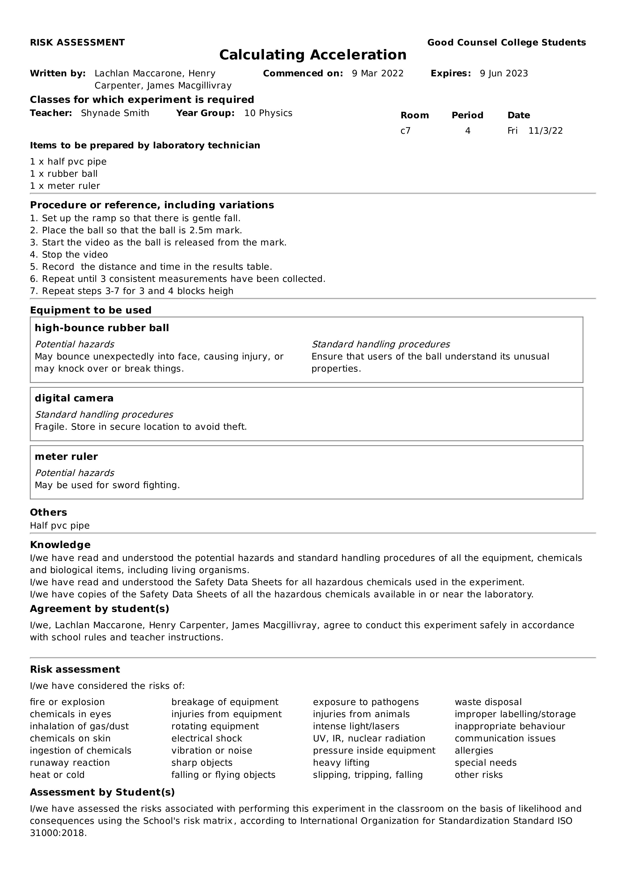Appendix 3: Risk Assesment