**An Interactive Gym Management System**

REVIEW REPORT

Submitted by

**Aman Anand (19BCE0521)**

**Lokesh Mishra (19BCE2672)**

**Ayush Khare (19BCE0498)**

**Rayirth Reddy Pakala (19BCE0529)**

Prepared For

**DATABASE SYSTEMS (CSE2004) – PROJECT COMPONENT**

Submitted To

**Dr. Anand Bihari**

**Assistant Professor (Sr)**

**School of Computer Science and Engineering**



## Declaration

We as a team, students of Vellore Institute of Technology, hereby declare that the project work entitled “An Interactive Smart Gym System” is a record of original work completed by us under the esteemed guidance of our professor, Dr. Anand Bihari, Associate Professor (Sr.), School of Information Technology and Engineering. Our project draws inspiration from various current smart systems being implemented and in no way is intended to be a duplication of others works. We further declare that this project will not intentionally be misused and replicated for any other ongoing courses that we have or may have in the near future.

(Student Signatures)

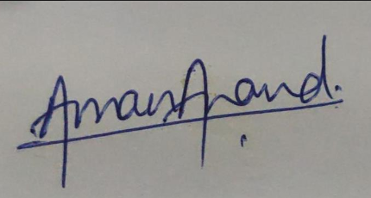 

Aman Anand (RN – 19BCE0521) Lokesh Mishra (RN – 19BCE2672)

 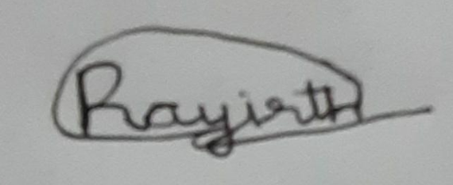

Ayush Khare (RN – 19BCE0498) Rayirth Reddy Pakala (RN – 19BCE0529)

## Acknowledgements

We as a team have taken many efforts in this project. However, this journey would not have been possible without the immense support and help of many individuals and organizations. We would like to extend our sincere thanks to all of them.

Primarily we would like to extend our thanks to God Almighty for providing us with everything that we required to complete this project.

We are highly indebted to our teacher in charge Dr. Anand Bihari for his guidance and constant supervision as well as for providing necessary information regarding the project and also for his support in completing this project

We would also like to express our gratitude towards our parents and fellow peers for their kind co-operation and encouragement while developing this project which helped us in the completion of this project.

We would also like to extend a special thanks to Mr. Murtaza and all industry people involved, whom we talked to while gathering the background information for this project.

All above mentioned people and organization played important roles that led to the successful development of our project and we as a team will be forever indebted to them. A final heartfelt thank you to all.

## Abstract

A customer greatly benefits form the information and facilities that are provided in the form of an easy to use and comprehensible websites. Any business that does not have its own website is lacking of one of the most powerful marketing skills that is available to them in today’s day and era. Usually, it is seen that the client makes use of software such as MS Excel or paper, to maintain their records, however it is not possible them to share the data from multiple system in multi user environment, there is lot of duplicate work, and chance of mistake. When the records are changed, they need to update each and every excel file. This dependency of the user on a virtual platform led us to our project idea. Through this project we plan to create an interactive smart interface based on a Gym Database that the user can exploit to gain information regarding the services provided by a certain gym. We as a team plan to integrate database creation software such as MySQL, Oracle SQL with frontend development languages such PHP, JavaScript, HTML, and CSS to produce a website environment based off of web-based servers. We will also incorporate into our project the concepts of entity relationships, multilevel indexing, n-tier architecture, relationship schemas etc. Our Gym Management System eliminates most of the limitations of the existing software along with increasing efficiency and effectiveness, automation, accuracy, user-friendly interface, information availability, communication capacity, maintenance, cost reduction makes our system smarter than most of the existing system. Our aim will also include the integration of some new, prominent and tech-savvy features that have been categorized as such in accordance to the norm in the modern technological universe into our software/web page program.

****Table of Contents****

Chapter i: Declaration i

[Chapter ii: Acknowledgement ii](#_Acknowledgements" \o "Go to Acknowledgement of Document)

Chapter iii: Abstract iii

[Chapter 1: Introduction 1](#_Toc21897138" \o "Skip to Introduction Section of Document )

[Chapter 2: Project Scope and System Study 2](#_Toc21897139" \o "Skip to Project Scope and System Study Section of Document )

[Chapter 3: Literature Review 4](#_Toc21897140" \o "Skip to Literature Review Section of Document )

[Chapter 4: Modules and Project Resources 7](#_Toc21897141" \o "Skip to Modules and Project Resources Section of Document )

[Chapter 5: System Implementation of the Project 4](#_System_Implementation_of" \o "Skip to System Implementation Section of Document )

[Chapter 6: ER Diagram and Relational Schema 8](#_ER_Diagram_and" \o "Skip to ERD and Relationship Schema Section of Document )

[Chapter 7: Tables and Constraints 10](#_Tables_and_Constraints" \o "Skip to Table and Constraints Section of Document )

[Chapter 8: Work Breakdown 12](#_Work_Break_Down" \o "Skip to Work Breakdown Section of Document )

[Chapter 9: Key Contacts and Stakeholders 13](#_Key_Contacts_and" \o "Skip to Key Contacts and Stakeholders Section of Document )

Chapter 10: Review Evaluation 14

# Introduction

We have all at some point in our lives used or heard the old adage that health is wealth. Especially as the generations progress in time, the need for eating healthy and keeping fit is increasing due to decrease in awareness of physical fitness. The need for making use of gymnasium facilities hence increases as environmental factors along with personal choice push people to spend less time exercising outside and more time in a controlled indoor environment. We have also seen that as time progresses the generation that succeeds its last generation gets more and more technology savvy. Businessmen and market capitalists have to work that much harder to get the current generation’s attention invested in their product. Relating the above two lines of thought, we aim to bridge the gap between technology and desire to exercise through our gym management system. Creating a seamless, user friendly and innovative platform that attracts a user base of all ages and backgrounds to participate and hence get motivated to work out and exercise, not only bridges the gap that was mentioned earlier but helps create substantial marketing byproducts for the companies and organizations that are invested in this market.

**Motivation and overview of the project:**

Our “Smart and Interactive Gym Management System” is aimed at the people who own and run a gymnasium business and plan to integrate a tech-savvy software into their systems. Our thorough research (conducted online via various surveys) highlights some major gaps in many gym systems that doesn’t allow them to churn out the number of members that they could originally be achieving had these drawbacks not existed. This industry needs a software that can maintain a high traffic of data and users as well as keep a track of each entity that is involved in the industry and a system that can integrate the software. The number of people registered, the payroll of the staff, the bills and their payment, etc. are just the tip of the metaphorical iceberg that this market needs to maintain a record of. We as a team have examined carefully how to make a fully functional and scalable registering system as well as tailor it to the need of each user according to their privilege.

# Project Scope and System Study

**The objectives of this study are summarized below:**

* The main objective of the project is to design and develop a user friendly efficient computerized Gym Management System
* An accurate system without any data redundancy.
* Secured data storage for Authority end.
* Secure the user ends data by providing each user’s own personal credentials.
* A flexible system which can maneuver the customer-staff relationship in an effective manner.
* To provide better graphical user interface.
* Computerization can be helpful as means of saving time & money.

**Theoretical Background:**

We have done a project on Gym Management and database management and transactions. This system is proposed to be an automate database management & transactions. This stores employee, member, receipts, salary, and products information. It also provides the facility of search & advanced search for searching the records efficiently & immediately. This system provides data storing & report generation with graphical user interface (GUI).

**System Study:**

It is always necessary to study and recognize the problems of existing system, which will help in finding out the requirements for the new system. System study helps in finding different alternatives for better solution.

**The project study basically deals with different operations:**

•Data Gathering

•Study of existing systems

•Analyzing problems

•Studying various documents

•Feasibility study for further improvements

**Following are the steps undertaken in our initial study:**

Initially, we collected all the information, which they wanted to store. Then we studied the working of the current system which is done manually. We noted the limitation of that system which motivated them to have new system. With the help of these documents we got the basic ideas about the system as well as input output of the developed system.

The most important thing is to study the system thoroughly. Here we are studying both the existing system and proposed system so that had advantages and disadvantages of both the systems can be understood. The first task as identifying how system can be computerized. Some analysis and projections were done regarding changes to be made to the existing system. The new developed system for Gym Management is simple and without complexities.

**Existing System:**

The online gym management system is user-friendly application. This automated system makes all functionality easier for both owners and customers. It is very simple in design and to implement. The system requirements are very low. System resources and the system will work in almost all configurations.

**It has the following objectives:**

**•Enhancement:**

The main objective of Smart Gym Management System is to enhance and upgrade the existing system by increasing its efficiency and effectiveness. The software improves the working methods by replacing the existing manual system with the computer- based system.

**•Automation:**

The Smart Gym Management System automates each and every activity of the manual system and increases its throughput. Thus, the response time of the system is very less and it works very fast.

**•Accuracy:**

The Smart Gym Management System provides the uses a quick response with very accurate information regarding the users etc. Any details or system in an accurate manner, as and when required.

**•User-friendly:**

The software Smart Gym Management System has a very user-friendly interface. Thus, the users will feel very easy to work on it. The software provides accuracy along with a pleasant interface. Make the present manual system more interactive, speedy and user friendly.

**•Availability:**

The transaction reports of the system can be retried as and when required. Thus, there is no delay in the availability of any information, whatever needed, can be captured very quickly and easily.

**•Maintenance cost:**

Reduce the cost of maintenance.

# Literature Review

|  |  |  |  |  |
| --- | --- | --- | --- | --- |
| **S.No** | **CONTRIBUTION** | **RESEARCH GAP** | **AUTHOR** | **REFERENCES** |
| 1. | This work presents a design for online database and transactions management. | The Smart Gym Management System automates each and every activity of the manual system and increases its throughput. Thus the response time of the system is very less and it works very fast. | Muhammad Abdul Shakoor  Muhammad Abbas  Muhammad Irfan Mehdi  Sajjad Hussain  Ashraf Ali | (i) Shakoor, M. A., Abbas, M., Mehdi, M. I., Hussain, S., & Ali, A. DATABASE AND TRANSACTIONS MANAGEMENT SYSTEM FOR A SMART GYM: LAYYAH FITNESS CENTER. |
| 2. | Developed a system “Virtual Gym Management” for a gymnasium in which customer can get all information about the access or enroll at the gym via online to access gymnasium and he can their workout. | Controlled flow structure which covers all parameters related to gymnasium like the functionalities of admin and the user. | Manjiri R. Girnale  Komal D. Untwal  Sonali S. Jathar  Prince Anand  Mansi Bhonsle | (i) Virtual Gym Management System International Journal of Engineering Technology Science and Research IJETSR ISSN 2394 – 3386 Volume 4, Issue 11 November 2017 |
| 3. | Increasing transparency  Online registration | Simple and efficient relational schema for clear understanding of relations. | Kasliwal Mahima  Raundal Pooja  Wagh Niyat  G.M. Lodha | (i) Survey Paper on Gym Management System Journal of Advancement in Software Engineering and Testing Volume 2 Issue 3 |
| 4. | The development of gym management system that hopefully could solve the problem of member registration by performing the procedure online which is more efficient and less expensive. | Keeping track of minor details like health status, timetable of the user. | Waigaemo Kendiga, J. | (i). Waigaemo Kendiga, J. (2017). *GYM Management System of Taurama Fitness Centre* (Doctoral dissertation, Universitas Komputer Indonesia). |

For our project we have referred four journals based on gym management systems. In all these papers the central idea is to develop a system for a gymnasium in which customer can get all information about the gymnasium and he can access or enroll at the gym via online to access their workout or trainer and diet or consultancy at the best time and place for their schedule. The base Journal paper which we found helpful was “Virtual gym management system” with this journal we got an idea about developing a system for a gymnasium in which customer can get all information about the gymnasium and he can access or enroll at the gym via online to access their workout or trainer and diet or consultancy at the best time and place for their schedule. This journal paper also gave an idea about how the system will be successfully designed and developed to fulfill the necessary requirements of user, such as recommending proper diet and exercise to user by well-known consultancy & trainer respectively, video or text chat, activity tracker, online payment and field level validation will perform efficiently .Even this system includes intelligence i.e. after certain data get store, system will recommend diet and exercise to user rather than any trainer and consultancy which will be benefited for admin as well as for user. Therefore, this project will be developed to meet the aspirations indicated in the modern age. Taking the above journal papers as references we have developed a project were we will be having a website for our gym management system where we have login portal for admin as well as the user (sometime in the near future) where admin will have control over many functionalities like subscription plan , timetable , health status etc. and user has privilege to login by entering his details as well as has control to edit their details. The aim of the project is to design and develop the automated system i.e. machine work. In this system presently records are kept in the gym by writing in a file on a paper or it will register. Every management task is done manually. Present system is unreliable for keeping accurate records.

# Modules and Project Resources

**Modules involved in the project:**

There are two basic modules in this system as describe briefly in below:

•**Administrative module:** This user is an admin type who has full rights on the system.

* **Administrative Module**

This module includes storing and retrieving the details of the data.

•Create, Update, Manage, Delete User

•Creating Offer Plan

•Manage Billing

•Mange User Enquiries

•Manage Owner Information

**System and software requirement of the project:**

* **UI Requirements**

•HTML will be used for the development of the user layout for the system

•PHP and JavaScript will be used for creating all the validations and client-side scripting functionality

•CSS has been used for the designing of the web page of the system.

* **Application Requirements**

•CoI (Client on Internet): Web Browser, OS (Windows 7 and Above)

•Web Server: Apache or XAMPPS

•Database: Oracle SQL 10g and MySQL

•Markup Language: HTML, CSS

•Scripting Language: PHP, JS

# System Implementation of the Project

**Implementation Methodology:**

We follow the MVC design pattern for developing our system. Model–view– controller (MVC) is a software design pattern for implementing user interfaces on computers. It divides a given software application into three interconnected parts, so as to separate internal representations of information from the ways that information is presented to or accepted from the user.

•**Model:** The model manages the behavior and data of the application domain, responds to requests for information about its state (usually from the view), and responds to instructions to change state (usually from the controller).

•**View:** The view manages the display of information.

•**Controller:** The controller interprets the mouse and keyboard inputs from the user, informing the model and/or the view to change as appropriate.

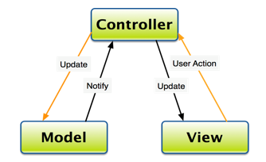

# ER Diagram and Relational Schema

**ERD:**

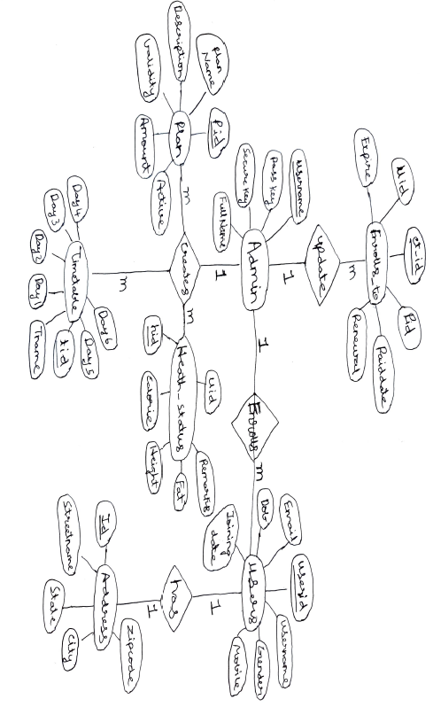

**RELATIONAL SCHEMA:**

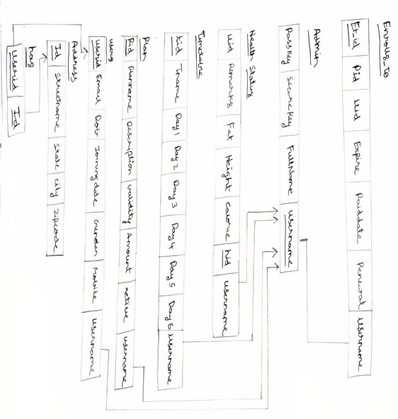

# Tables and Constraints

***Address***

|  |  |  |
| --- | --- | --- |
| **Attributes** | **Datatypes** | **Constraints** |
| Id | Varchar | Primary key |
| streetName | Varchar | Not Null |
| State | Varchar | Not null |
| City | Varchar | Not null |
| Zipcode | Varchar | - |

***Enrolls_to***

|  |  |  |
| --- | --- | --- |
| **Attributes** | **Datatypes** | **Constraints** |
| et_id | Integer | Primary key |
| Pid | Varchar | Not Null |
| Uid | Varchar | Not null |
| Paid_date | Varchar | - |
| Expire | Varchar | - |
| Renewal | Varchar | - |

***Admin***

|  |  |  |
| --- | --- | --- |
| **Attributes** | **Datatypes** | **Constraints** |
| Username | Varchar | Primary key |
| Pass_key | Varchar | Not Null |
| Securekey | Varchar | Not null |
| Full_name | Varchar | - |

***Health_status***

|  |  |  |
| --- | --- | --- |
| **Attributes** | **Datatypes** | **Constraints** |
| hid | Integer | Primary key |
| Calorie | Varchar | - |
| Height | Varchar | - |
| Fat | Varchar | - |
| Remarks | Varchar | - |
| Uid | Varchar | Not null |

***Plan***

|  |  |  |
| --- | --- | --- |
| **Attributes** | **Datatypes** | **Constraints** |
| Pid | Varchar | Primary key |
| planName | Varchar | Not null |
| Description | Varchar | Not null |
| Validity | Varchar | Not null |
| Amount | Integer | Not null |
| Active | Varchar | - |

***Timetable***

|  |  |  |
| --- | --- | --- |
| **Attributes** | **Datatypes** | **Constraints** |
| tid | Integer | Primary key |
| Tname | Varchar | - |
| Day1 | Varchar | - |
| Day2 | Varchar | - |
| Day3 | Varchar | - |
| Day4 | Varchar |  |
| Day5 | Varchar | - |
| Day6 | Varchar | - |

***Users***

|  |  |  |
| --- | --- | --- |
| **Attributes** | **Datatypes** | **Constraints** |
| Userid | Varchar | Primary Key |
| Username | Varchar | Not Null |
| Gender | Varchar | Not null |
| Mobile | Varchar | Not Null |
| Email | Varchar | Not null |
| Dob | Varchar | Not null |
| Joining_date | Varchar | Not null |

# Work Break Down

|  |  |  |
| --- | --- | --- |
| **NAME** | **Role** | **Responsibility** |
| Aman Anand | Team Lead | Project Layout/Design + Backend database construction using PhpMyAdmin (SQL Based) + Integration of SQL into frontend aspect of project |
| Lokesh Mishra | Team Member | Backend database construction using PhpMyAdmin (SQL Based) + Frontend designing + Project Design |
| Ayush Khare | Team Member | Backend database architecture layout + Schema Layout |
| Rayirth Reddy Pakala | Team Member | Backend database architecture design + Schema Layout + Literature Review |

# Key Contacts and Stakeholders

|  |  |  |  |
| --- | --- | --- | --- |
| **NAME** | **REG.NO.** | **SLOT** | **Phone No.** |
| Aman Anand | 19BCE0521 | D1 | 9765223734 |
| Lokesh Mishra | 19BCE2672 | D1 | 9125840067 |
| Ayush Khare | 19BCE0498 | D1 | 9952081510 |
| Rayirth Reddy Pakala | 19BCE0529 | D1 | 9110522204 |

# References

* “Database Systems Design, Implementation, & Management” by Carlos Colonel and Steven Morris
* “Database System Concepts” by Abraham Silberschatz, Henry F. Korth and S. Sudarshan
* “Fundamentals of Database Systems” by Elmasri and Navathe
* “Database Management Systems” by Raghu Ramakrishnan and Johannes Geherke
* [www.wikipedia.com](http://www.wikipedia.com/)
* [www.tutorialspoint.com](http://www.tutorialspoint.com)
* <http://www.slideshare.net/jagaarj/database-design-normalization>
* <http://ijetsr.com/images/short_pdf/1510987099_384-389-site139_ijetsr.pdf>
* <http://www.sci-int.com/pdf/636858255678952937.edited.pdf>
* <https://www.researchgate.net/publication/340491607_DATABASE_AND_TRANSACTIONS_MANAGEMENT_SYSTEM_FOR_A_SMART_GYM_LAYYAH_FITNESS_CENTER>
* <https://www.google.com/search?ei=LjaZX_f7Co2a4-EPus6HuAU&q=Survey+Paper+on+Gym+Management+System+Journal+of+Advancement+in+Software+Engineering+and+Testing+Volume+2+Issue+3&oq=Survey+Paper+on+Gym+Management+System+Journal+of+Advancement+in+Software+Engineering+and+Testing+Volume+2+Issue+3&gs_lcp=CgZwc3ktYWIQA1C0pgFYtKYBYMesAWgBcAB4AIABAIgBAJIBAJgBAKABAaABAqoBB2d3cy13aXqwAQDAAQE&sclient=psy-ab&ved=0ahUKEwj3yuiX-dbsAhUNzTgGHTrnAVcQ4dUDCA0&uact=5>

# Review Evaluation

|  |  |  |  |  |  |
| --- | --- | --- | --- | --- | --- |
| **COMPONENT** | **MARKS** | **MEMBER 1** | **MEMBER 2** | **MEMBER 3** | **MEMBER 4** |
| **Report** | 10 |  |  |  |  |
| **Project Implementation** | 25 |  |  |  |  |
| **Presentation** | 15 |  |  |  |  |
| **TOTAL** | 50 MARKS |  |  |  |  |