

***An Interactive Smart Gym Management System***

***A Project Component Report***

*for the course*

***Database Management Systems (CSE2004)***

**Submitted By:**

|  |  |  |
| --- | --- | --- |
| **NAME** | **REG. NO.** | **SLOT** |
| Aman Anand | 19BCE0521 | D1 |
| Lokesh Mishra | 19BCE2672 | D1 |
| Ayush Khare | 19BCE0498 | D1 |
| Rayirth Reddy Pakala | 19BCE0529 | D1 |

*In partial fulfillment of the award of the degree*

**Bachelor of Technology**

*in*

**Computer Science Engineering**

*Under the esteemed guidance of*

**Faculty:** Dr. Anand Bihari (Assistant Professor (Sr.))

**School of Computer Science and Engineering**

**Academic Year: 2020-2021(Fall Semester)**

**Declaration**

We as a team, students of Vellore Institute of Technology, hereby declare that the project work entitled “An Interactive Smart Gym System” is a record of original work completed by us under the esteemed guidance of our professor, Dr. Anand Bihari, Associate Professor (Sr.), School of Information Technology and Engineering. Our project draws inspiration from various current smart systems being implemented and in no way is intended to be a duplication of others works. We further declare that this project will not intentionally be misused and replicated for any other ongoing courses that we have or may have in the near future.

(Student Signatures)

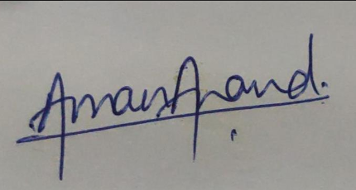 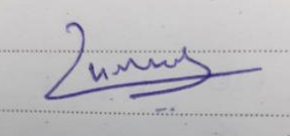

Aman Anand (RN – 19BCE0521) Lokesh Mishra (RN – 19BCE2672)

 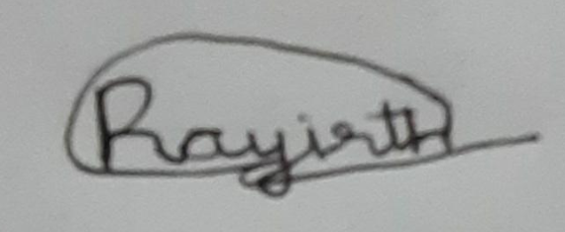

Ayush Khare (RN – 19BCE0498) Rayirth Reddy Pakala (RN – 19BCE0529)

**Acknowledgements**

We as a team have taken many efforts in this project. However, this journey would not have been possible without the king support and help of many individuals and organizations. We would like to extend our sincere thanks to all of them.

Primarily we would like to extend our thanks to God Almighty for providing us with everything that we required to complete this project.

We are highly indebted to our teacher in charge Dr. Anand Bihari for his guidance and constant supervision as well as for providing necessary information regarding the project and also for his support in completing this project

We would also like to express our gratitude towards our parents and fellow peers for their kind co-operation and encouragement while developing this project which helped us in the completion of this project.

We would also like to extend a special thanks to Mr. Murtaza and all industry people involved, whom we talked to while gathering the background information for this project.

All above mentioned people and organization played important roles that led to the successful development of our project and we as a team will be forever indebted to them. A final heartfelt thank you to all.

**Abstract**

A customer greatly benefits form the information and facilities that are provided in the form of an easy to use and comprehensible websites. Any business that does not have its own website is lacking of one of the most powerful marketing skills that is available to them in today’s day and era. Usually, it is seen that the client makes use of software such as MS Excel or paper, to maintain their records, however it is not possible them to share the data from multiple system in multi user environment, there is lot of duplicate work, and chance of mistake. When the records are changed they need to update each and every excel file. This dependency of the user on a virtual platform led us to our project idea. Through this project we plan to create an interactive smart interface based on a Gym Database that the user can exploit to gain information regarding the services provided by a certain gym. We as a team plan to integrate database creation software such as MySQL, Oracle SQL with frontend development languages such PHP, JavaScript, HTML, and CSS to produce a website environment based off of web-based servers. We will also incorporate into our project the concepts of web scrapping, entity relationships, multilevel indexing, n-tier architecture, relationship schemas etc. Our Gym Management System eliminates most of the limitations of the existing software along with increasing efficiency and effectiveness, automation, accuracy, user-friendly interface, information availability, communication capacity, maintenance, cost reduction makes our system smarter than most of the existing system. Our aim will also be to be integrating into our software some new, prominent and tech-savvy features that have been categorized as the norm in the current world such as webcam integration and login using face recognition.

**Table of Contents**

## Title Page …………………………………………………………...1

## Declaration …………………………………………………………2

## Acknowledgement ………………………………………………….3

## Abstract …………………………………………………………….4

## Chapter 1: Introduction

* 1. Overview of the project…………………………………………………6
  2. Aims and Objectives of the project………………………………..........7

## Chapter 2: Key Members and Project Workflow Breakup

2.1. Key Members and Stakeholders in the project………………………….7

2.2. Project Workflow Breakup……………………………………………...7

## Chapter 3: Theoretical Background and System Study

3.1. Theoretical Background………………………………………………...8

3.2. System Study……………………………………………………………8

3.3. Existing System…………………………………………………………9

3.4. Proposed Enhanced System…………………………………………...10

## Chapter 4: Modules and Features of the Project

4.1. Modules………………………………………………………………..11

4.2. Features………………………………………………………………..12

4.3. System and Software Requirements…………………………………...12

## Chapter 5: System Implementation and related schema

5.1. Implementation Methodology…………………………………………13

5.2. Tabular Schema………………………………………………………..14

5.3. ERD……………………………………………………………………16

5.4. Relational Schema of ERD……………………………………………17

## References and Bibliography……………………………………..18

## Appendix 1: SQL Code Snippets of Tables……………………...18

**Chapter 1: Introduction**

We have all at some point in our lives used or heard the old adage that health is wealth. Especially as the generations progress in time, the need for eating healthy and keeping fit is increasing due to decrease in awareness of physical fitness. The need for making use of gymnasium facilities hence increases as environmental factors along with personal choice push people to spend less time exercising outside and more time in a controlled indoor environment. We have also seen that as time progresses the generation that succeeds its last generation gets more and more technology savvy. Businessmen and market capitalists have to work that much harder to get the current generation’s attention invested in their product. Relating the above two lines of thought, we aim to bridge the gap between technology and desire to exercise through our gym management system. Creating a seamless, user friendly and innovative platform that attracts a user base of all ages and backgrounds to participate and hence get motivated to work out and exercise, not only bridges the gap that was mentioned earlier but helps create substantial marketing byproducts for the companies and organizations that are invested in this market.

1. **Overview of the Project**

Our “Smart and Interactive Gym Management System” is aimed at the people who own and run a gymnasium business and plan to integrate a tech-savvy software into their systems. Our thorough research (conducted online via various surveys) highlights some major gaps in many gym systems that doesn’t allow them to churn out the number of members that they could originally be achieving had these drawbacks not existed. This industry needs a software that can maintain a high traffic of data and users as well as keep a track of each entity that is involved in the industry and a system that can integrate the software. The number of people registered, the payroll of the staff, the bills and their payment, etc. are just the tip of the metaphorical iceberg that this market needs to maintain a record of. We as a team have examined carefully how to make a fully functional and scalable registering system as well as tailor it to the need of each user according to their privilege.

1. **Aim and Objectives**

The objectives of this study are summarized below:

* The main objective of the project is to design and develop a user friendly efficient computerized Gym Management System
* An accurate system without any data redundancy.
* Secured data storage for Authority end.
* Secure the user ends data by providing each user’s own personal credentials.
* A flexible system which can maneuver the customer-staff relationship in an effective manner.
* To provide better graphical user interface.
* Computerization can be helpful as means of saving time & money.

**Chapter 2: Key Member and Project Workflow Breakup**

1. **Key Members**

|  |  |  |  |
| --- | --- | --- | --- |
| **NAME** | **REG.NO.** | **SLOT** | **Phone No.** |
| Aman Anand | 19BCE0521 | D1 | 9765223734 |
| Lokesh Mishra | 19BCE2672 | D1 | 9125840067 |
| Ayush Khare | 19BCE0498 | D1 | 9952081510 |
| Rayirth Reddy Pakala | 19BCE0529 | D1 | 9110522204 |

1. **Project Workflow Breakup**

|  |  |  |
| --- | --- | --- |
| **NAME** | **Role** | **Responsibility** |
| Aman Anand | Team Lead | Project Layout/Design + Backend database construction using MySQL + Integration of SQL into frontend aspect of project |
| Lokesh Mishra | Team Member | Backend SQL database construction + Frontend designing |
| Ayush Khare | Team Member | Backend database architecture layout + Schema Layout |
| Rayirth Reddy Pakala | Team Member | Backend database architecture design + Schema Layout |

**Chapter 3: Theoretical Background and System Study**

1. **Theoretical Background**

We have done a project on Gym Management and database management and transactions. This system is proposed to be an automate database management & transactions. This stores employee, member, receipts, salary, and products information. It also provides the facility of search & advanced search for searching the records efficiently & immediately. This system provides data storing & report generation with graphical user interface (GUI).

1. **System Study**

It is always necessary to study and recognize the problems of existing system, which will help in finding out the requirements for the new system. System study helps in finding different alternatives for better solution.

**The project study basically deals with different operations:**

* Data Gathering
* Study of existing systems
* Analyzing problems
* Studying various documents
* Feasibility study for further improvements

**Following are the steps undertaken in our initial study:**

Initially, we collected all the information, which they wanted to store. Then we studied the working of the current system which is done manually. We noted the limitation of that system which motivated them to have new system. With the help of these documents we got the basic ideas about the system as well as input output of the developed system.

The most important thing is to study the system thoroughly. Here we are studying both the existing system and proposed system so that had advantages and disadvantages of both the systems can be understood. The first task as identifying how system can be computerized. Some analysis and projections were done regarding changes to be made to the existing system. The new developed system for Gym Management is simple and without complexities.

1. **Existing System**

An Existing system refers to the system that is being followed till now. The gym is working manually. The current system is time consuming and also it is very costly, because it involves a lot of paperwork. To manually handle the system was very difficult task. But now-a-days computerization made easy to work.

The following are the reasons why the current system should be computerized:

* To increase the efficiency with reduced cost
* To reduce the burden of physical paper work
* To save time and increase time management for recording details of each and every member and employee
* To generate required report efficiently and easily.

1. **Proposed Enhanced System**

The online gym management system is user-friendly application. This automated system makes all functionality easier for both owners and customers. It is very simple in design and to implement. The system requirements are very low. System resources and the system will work in almost all configurations.

**It has the following objectives:**

* **Enhancement:**

The main objective of Smart Gym Management System is to enhance and upgrade the existing system by increasing its efficiency and effectiveness. The software improves the working methods by replacing the existing manual system with the computer- based system.

* **Automation:**

The Smart Gym Management System automates each and every activity of the manual system and increases its throughput. Thus the response time of the system is very less and it works very fast.

* **Accuracy:**

The Smart Gym Management System provides the uses a quick response with very accurate information regarding the users etc. Any details or system in an accurate manner, as and when required.

* **User-friendly:**

The software Smart Gym Management System has a very user-friendly interface. Thus the users will feel very easy to work on it. The software provides accuracy along with a pleasant interface. Make the present manual system more interactive, speedy and user friendly.

* **Availability:**

The transaction reports of the system can be retried as and when required. Thus, there is no delay in the availability of any information, whatever needed, can be captured very quickly and easily.

* **Maintenance cost:**

Reduce the cost of maintenance.

**Chapter 4: Modules and Features of the project**

1. **Modules Involved**

There are two basic modules in this system as describe briefly in below:

* **Administrative module:** This user is an admin type who has full rights on the system.
* **User module:** This is a normal level of user who will be very few number of functionality of website.
* Administrative Module

This module includes storing and retrieving the details of the data.

* Create , Update, Manage, Delete User
* Creating Offer Plan
* Manage Billing
* Mange User Enquiries
* Manage Owner Information
* User Module

Depends on the privilege user’s access to features of the application is granted. Below are the some important functionality of user module.

* Applying for Packages and subscriptions
* Account Update
* Online Payment Facility
* Enquiry to Admin
* Login Features
* Verification/Authenticity

1. **Features of the Project**

There are many features that we plan to integrate into our system. Some salient features that will be highlighted further are:

* + - Phone number verification
    - Online Payment Gateway
    - Webcam Integration
    - Activity Log of User’s

1. **System and Software Requirements of the Application**

* UI Requirements
* HTML will be used for the development of the user layout for the system
* PHP and JavaScript will be used for creating all the validations and client side scripting functionality
* CSS has been used for the designing of the web page of the system.

* Application Requirements
* CoI (Client on Internet): Web Browser, OS (Windows 7 and Above)
* Web Server: Apache or XAMPPS
* Database: Oracle SQL 10g and MySQL
* Markup Language: HTML,CSS
* Scripting Language: PHP, JS, JQuery

**Chapter 5: System Implementation**

1. **Implementation Methodology**

We follow the MVC design pattern for developing our system. Model–view– controller (MVC) is a software design pattern for implementing user interfaces on computers. It divides a given software application into three interconnected parts, so as to separate internal representations of information from the ways that information is presented to or accepted from the user.

* + - **Model:** The model manages the behavior and data of the application domain, responds to requests for information about its state (usually from the view), and responds to instructions to change state (usually from the controller).
    - **View:** The view manages the display of information.
    - **Controller:** The controller interprets the mouse and keyboard inputs from the user, informing the model and/or the view to change as appropriate.

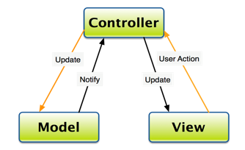

1. **Tabular Schema**

**USER**

|  |  |  |
| --- | --- | --- |
| **Attributes** | **Datatypes** | **Constraints** |
| User_id | Number | Primary key |
| User_name | Varchar | Not Null |
| User_email | Varchar | - |
| User_pass | Varchar | Not NULL |
| User_contact` | Number | Not Null |
| User_address | Varchar | - |
| User_age(derived attribute) | Number | Check (age>18) |
| Sub_id | Varchar | Foreign key |
| User_DOB | Date | NOT NULL |

**Trainer**

|  |  |  |
| --- | --- | --- |
| **Attributes** | **Datatypes** | **Constraints** |
| Tran_id | Number | Primary key |
| Tran_name | Varchar | Not NULL |
| Tarn_exp | Number | - |
| Trans_contact | Number |  |
| Batch_id | Number | Foreign key |

**Admin**

|  |  |  |
| --- | --- | --- |
| **Attributes** | **Datatypes** | **Constraints** |
| Admin_id | Number | Primary key |
| Admin_name | varchar |  |
| Admin_email | Varchar | Not Null |
| Admin_pass | Varchar | Not Null |
| Admin_contact | number | - |

**Subscription**

|  |  |  |
| --- | --- | --- |
| **Attributes** | **Datatypes** | **Constraints** |
| Sub_id | Number | Primary key |
| Sub_date | Date | Not null |
| Sub_amount | Number | - |
| User_id | Number | Foreign key |
| Sub_duration | Number | - |

**Batch**

|  |  |  |
| --- | --- | --- |
| **Attributes** | **Datatypes** | **Constraints** |
| Batch_id | Number | Primary key |
| Start_time | Timestamp | - |
| Finish_time | Timestamp | - |
| User_id | Number | Foreign key |
| Day_id | Number | Foreign key |

**Exercise**

|  |  |  |
| --- | --- | --- |
| **Attributes** | **Datatypes** | **Constraints** |
| Exer_id | Number | Primary key |
| Exer_name | Varchar | - |
| User_id | Number | Foreign key |
| Exer_equip(multivalued attribute) | Varchar | - |
| exer_sets | Number | - |

**Body Type**

|  |  |  |
| --- | --- | --- |
| **Attributes** | **Datatypes** | **Constraints** |
| Height | number | Not Null |
| Weight | Number | Not Null |
| User_id | Number | Foreign key, Primary key |
| Body_fat | Number | Not Null |

**Day**

|  |  |  |
| --- | --- | --- |
| **Attributes** | **Datatypes** | **Constraints** |
| Day_id | Number | Primary key |
| Day_name | Number | Not Null |

1. **Entity Relationship Diagram**

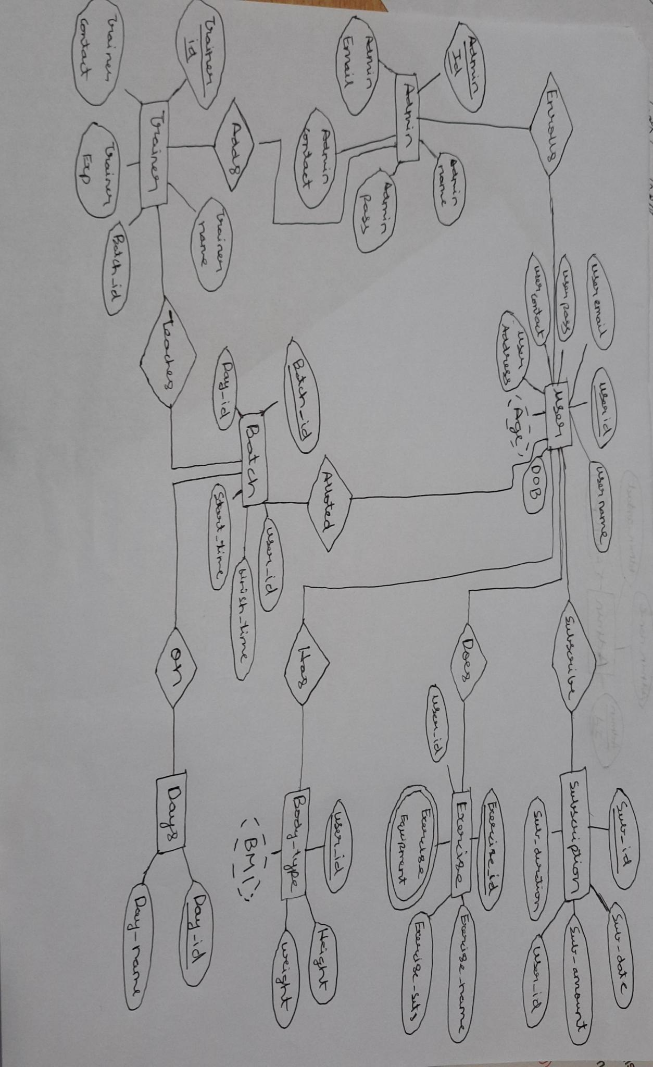

1. **Relationship Schema**

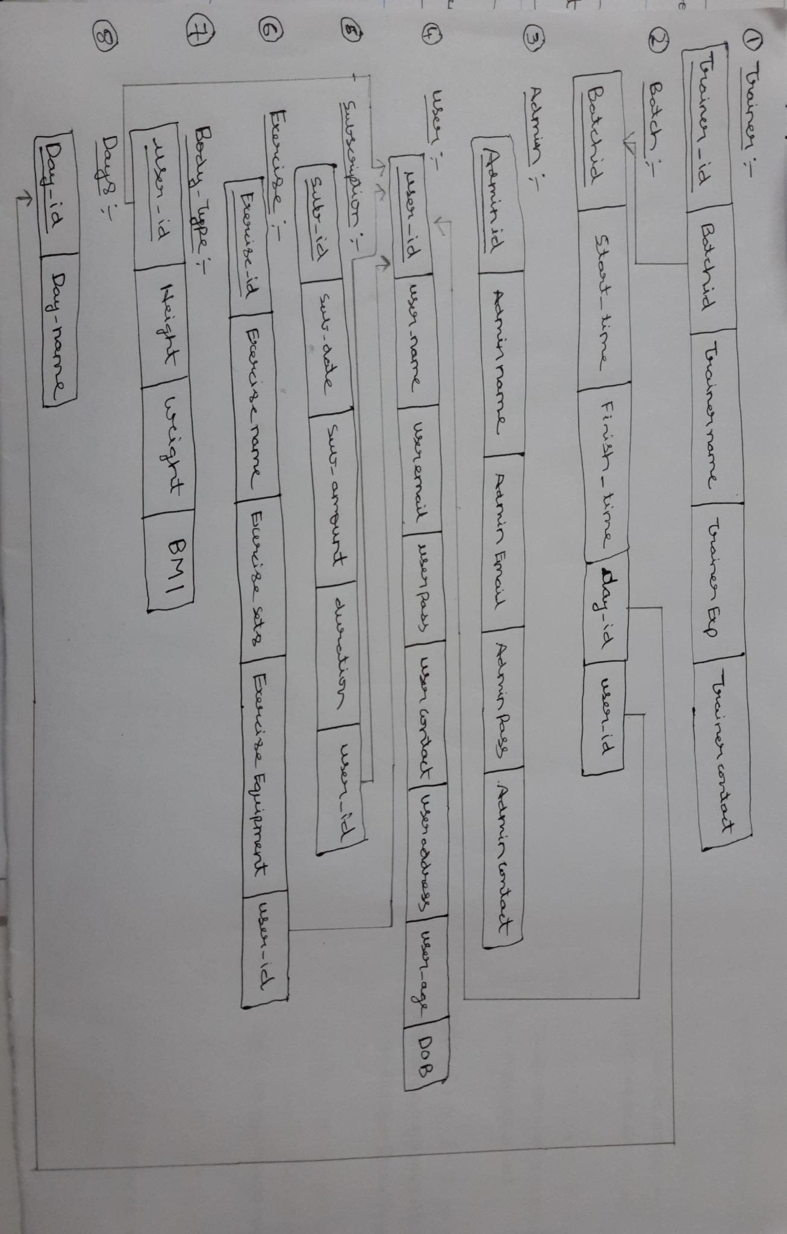

**References and Bibliography**

* “Database Systems Design, Implementation, & Management” by Carlos Colonel and Steven Morris
* “Database System Concepts” by Abraham Silberschatz, Henry F. Korth and S. Sudarshan
* “Fundamentals of Database Systems” by Elmasri and Navathe
* “Database Mangement Systems” by Raghu Ramakrishnan and Johannes Geherke
* [www.wikipedia.com](http://www.wikipedia.com/)
* [www.tutorialspoint.com](http://www.tutorialspoint.com)
* <http://www.slideshare.net/jagaarj/database-design-normalization>

**Appendix 1: SQL Code Snippets for Table Creation**

**Users**

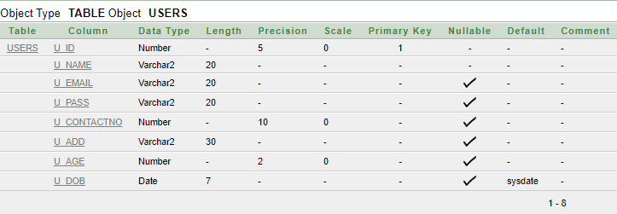

create table Users(

U_id number(5) not null,

U_name varchar2(20) not null,

U_email varchar2(20),

U_pass varchar2(20),

U_contactNo number(10),

U_add varchar2(30),

U_age number(2) check (U_age>=16),

U_DOB date default sysdate,

constraint Users_pk primary key(U_id));

**Trainer**

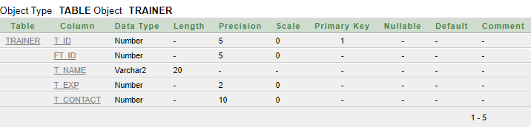

create table Trainer(

T_id number(5) not null,

FT_id number(5) not null,

T_name varchar2(20) not null,

T_exp number(2) not null,

T_contact number(10) not null,

foreign key (FT_id) references Batch(B_id),

constraint Trainer_pk primary key(T_id));

**Admin**

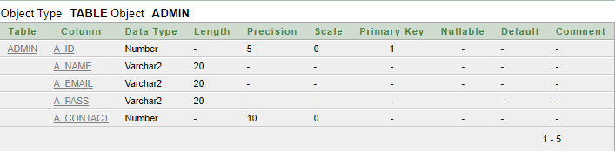

create table Admin(

A_id number(5) not null,

A_name varchar2(20) not null,

A_email varchar2(20) not null,

A_pass varchar2(20) not null,

A_contact number(10) not null,

constraint Admin_pk primary key(A_id));

**Subscription**

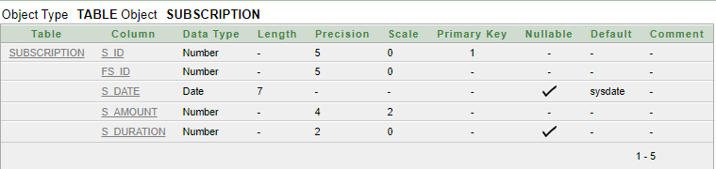

create table Subscription(

S_id number(5) not null,

FS_id number(5) not null,

S_date date default sysdate,

S_amount number(4,2) not null,

S_duration number(2) check (S_duration>=1),

foreign key (FS_id) references Users(U_id),

constraint Subscription_pk primary key(S_id));

**Batch**

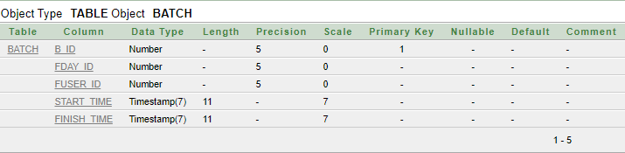

create table Batch(

B_id number(5) not null,

FDay_id number(5) not null,

FUser_id number(5) not null,

start_time timestamp(7) not null,

finish_time timestamp(7) not null,

foreign key (FUser_id) references Users(U_id),

foreign key (FDay_id) references Days(D_id),

constraint Batch_pk primary key(B_id));

**Exercise**

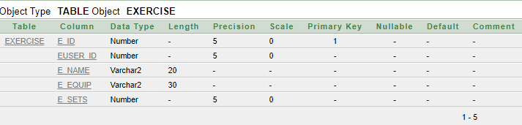

create table Exercise(

E_id number(5) not null,

EUser_id number(5) not null,

E_name varchar2(20) not null,

E_equip varchar2(30) not null,

E_sets number(5) not null,

foreign key (EUser_id) references Users(U_id),

constraint Exercise_pk primary key(E_id));

**BodyType**

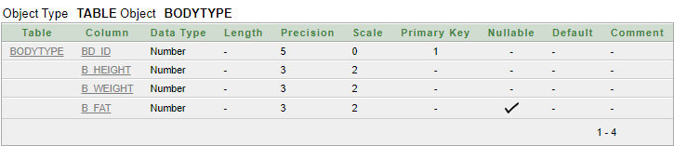

create table BodyType(

BD_id number(5) not null,

B_height number(3,2) not null,

B_weight number(3,2) not null,

B_fat number(3,2),

foreign key (BD_id) references Users(U_id),

constraint BodyType_pk primary key(BD_id));

**Days**

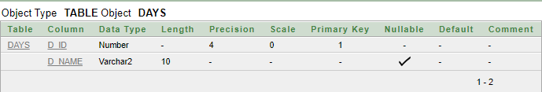

create table Days(

D_ID number(4) not null,

D_name varchar2(10),

constraint Day_pk primary key (D_ID));

**THANK YOU!!!**