

**TEXT AND WEB ANALYTICS**

**Lab Manual**

|  |  |
| --- | --- |
| Submitted By: | Rahul Dhawan |
| Class: | VIII-C |
| Roll Number: | 17CSU146 |
| Taught By: | Ms. Vaishali Kalra |
| Git-hub Link: | https://github.com/Crypto-Matrix/NLP-LAB |

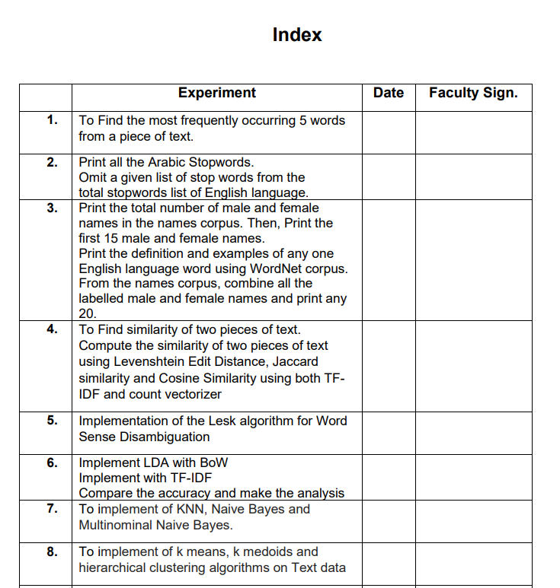

24-3

21-4

14-4

17-3

10-03

24-02

5-02

12-02



**TWIA Lab Manual (CSL 554)**

**2020-21**

**EXPERIMENT NO. 1**

|  |
| --- |
| **Student Name and Roll Number: RAHUL DHAWAN (17CSU146)** |
| **Semester /Section: 8-C** |
| **Date: 12 Feb 2021** |
| **Faculty Signature:** |
| **Grade:** |

|  |
| --- |
| **Objective:** To Find the most frequently occurring 5 words from a piece of text. |
| **Outcome:** Students will be able to demonstrate how to find stopwords from corpus. |
| **Problem Statement:** Select the documents and find most commonly occurring 5 words.  **Code**  import nltk  from nltk.corpus import stopwords  # print(stopwords.words('english'))  from nltk.tokenize import word_tokenize  txt="hello mr. smith, how are you doing today? the weather is great and pyhton is awesome. the sky is pinkish-blue, don't eat cardboard"  stop_words = set(stopwords.words('english'))  word_tokens = word_tokenize(txt)  result=[]  for w in word_tokens:  if w not in stop_words:  result.append(w)    # print(word_tokens)  # print('filtered sentence=', result)  fd = nltk.FreqDist(result)  print(fd.most_common(5))  Output: |
|  |



**TWIA Lab Manual (CSL 554)**

**2020-21**

**EXPERIMENT NO. 2**

|  |
| --- |
| **Student Name and Roll Number: RAHUL DHAWAN (17CSU146)** |
| **Semester /Section: 8-C** |
| **Date: 5 Feb 2021** |
| **Faculty Signature:** |
| **Grade:** |

|  |
| --- |
| **Objective:** To  a) Print all the Arabic Stopwords.  b) Omit a given list of stop words from the total stopwords list of English language. |
| **Outcome:** Students will be able to demonstrate how to print and omit stopwords. |
| **Problem Statement:** Select the documents and omit the given list of stopwords.  **Code (a)**  from nltk.corpus import stopwords  stopwords_list = stopwords.words('arabic')  print(stopwords_list)    **Output**    **Code (b)**  import nltk  nltk.download("stopwords")  from nltk.corpus import stopwords  english_stopwords = set(stopwords.words('english'))  stop_words = set(stopwords.words('english')) - set(['again', 'once', 'from'])  stop_words  **Output** |
|  |



**TWIA Lab Manual (CSL 554)**

**2020-21**

**EXPERIMENT NO. 3**

|  |
| --- |
| **Student Name and Roll Number: RAHUL DHAWAN (17CSU146)** |
| **Semester /Section: 8-C** |
| **Date: 5 Feb 2021** |
| **Faculty Signature:** |
| **Grade:** |

|  |
| --- |
| **Objective:** To  a) Print the total number of male and female names in the names corpus. Then, Print the first 15 male and female names.  b) Print the definition and examples of any one English language word using WordNet corpus. |
| **Outcome:** Students will be able to demonstrate how to use WordNet corpus. |
| **Problem Statement:** Select the documents and execute above statements.  **Code (a)**  from nltk.corpus import names  nltk.download('names')  print("\nNumber of male names:")  print (len(names.words('male.txt')))  print("\nNumber of female names:")  print (len(names.words('female.txt')))  male_names = names.words('male.txt')  female_names = names.words('female.txt')  print("\nFirst 10 male names:")  print (male_names[0:15])  print("\nFirst 10 female names:")  print (female_names[0:15])  **Output**    **Code (b)**  from nltk.corpus import wordnet  nltk.download('wordnet')  syns = wordnet.synsets("Education")  print("Defination of the said word:")  print(syns[0].definition())  print("\nExamples of the word in use::")  print(syns[0].examples())  **Output** |



**TWIA Lab Manual (CSL 554)**

**2020-21**

**EXPERIMENT NO. 4**

|  |
| --- |
| **Student Name and Roll Number: RAHUL DHAWAN (17CSU146)** |
| **Semester /Section: 8-C** |
| **Date: 12 Feb 2021** |
| **Faculty Signature:** |
| **Grade:** |

|  |
| --- |
| **Objective:** To implement Levenshtein Edit Distance , Jaccard similarity , Cosine Similarity using both TF-IDF and count vectorizer |
| **Outcome:** Students will be able to demonstrate Levenshtein Edit Distance , Jaccard similarity , Cosine Similarity using both TF-IDF and count vectorizer |
| **Problem Statement:** Select the documents and implement above similarities methods.  **Code (Jaccard Similarity)**  def jaccard_coef(x ,y ):    x = list(x.split())    y= list(y.split())    intersection = len(list(set(x).intersection(y)))    union = (len(x) + len(y)) - intersection    return float(intersection) / union  ref = 'meet me at the airport tomorrow'  test = 'meat me at the aeroport 2morrw'  print("Jaccard Coefficient =" , jaccard_coef(ref , test)) |



**TWIA Lab Manual (CSL 554)**

**2020-21**

**OUTPUT**

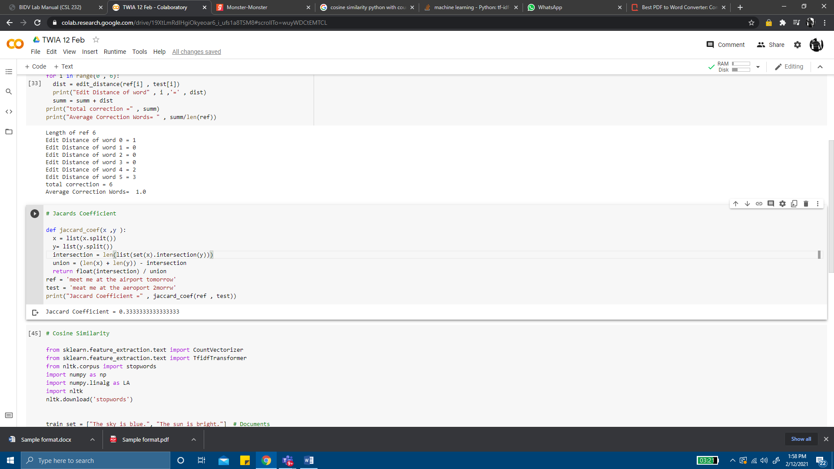

**CODE (Levenshtein Edit Distance)**

def edit_distance(s1, s2):

    m=len(s1)+1

    n=len(s2)+1

    tbl = {}

    for i in range(m): tbl[i,0]=i

    for j in range(n): tbl[0,j]=j

    for i in range(1, m):

        for j in range(1, n):

            cost = 0 if s1[i-1] == s2[j-1] else 1

            tbl[i,j] = min(tbl[i, j-1]+1, tbl[i-1, j]+1, tbl[i-1, j-1]+cost)

    return (tbl[i,j])

ref = 'meet me at the airport tomorrow'

test = 'meat me at the aeroport 2morrw'

ref = ref.split()

test = test.split()

print("Length of ref" , len(ref))

summ=0

for i in range(0 , 6):

  dist = edit_distance(ref[i] , test[i])

  print("Edit Distance of word" , i ,'=' , dist)

  summ = summ + dist

print("total correction =" , summ)

print("Average Correction Words= " , summ/len(ref))

**OUTPUT:**

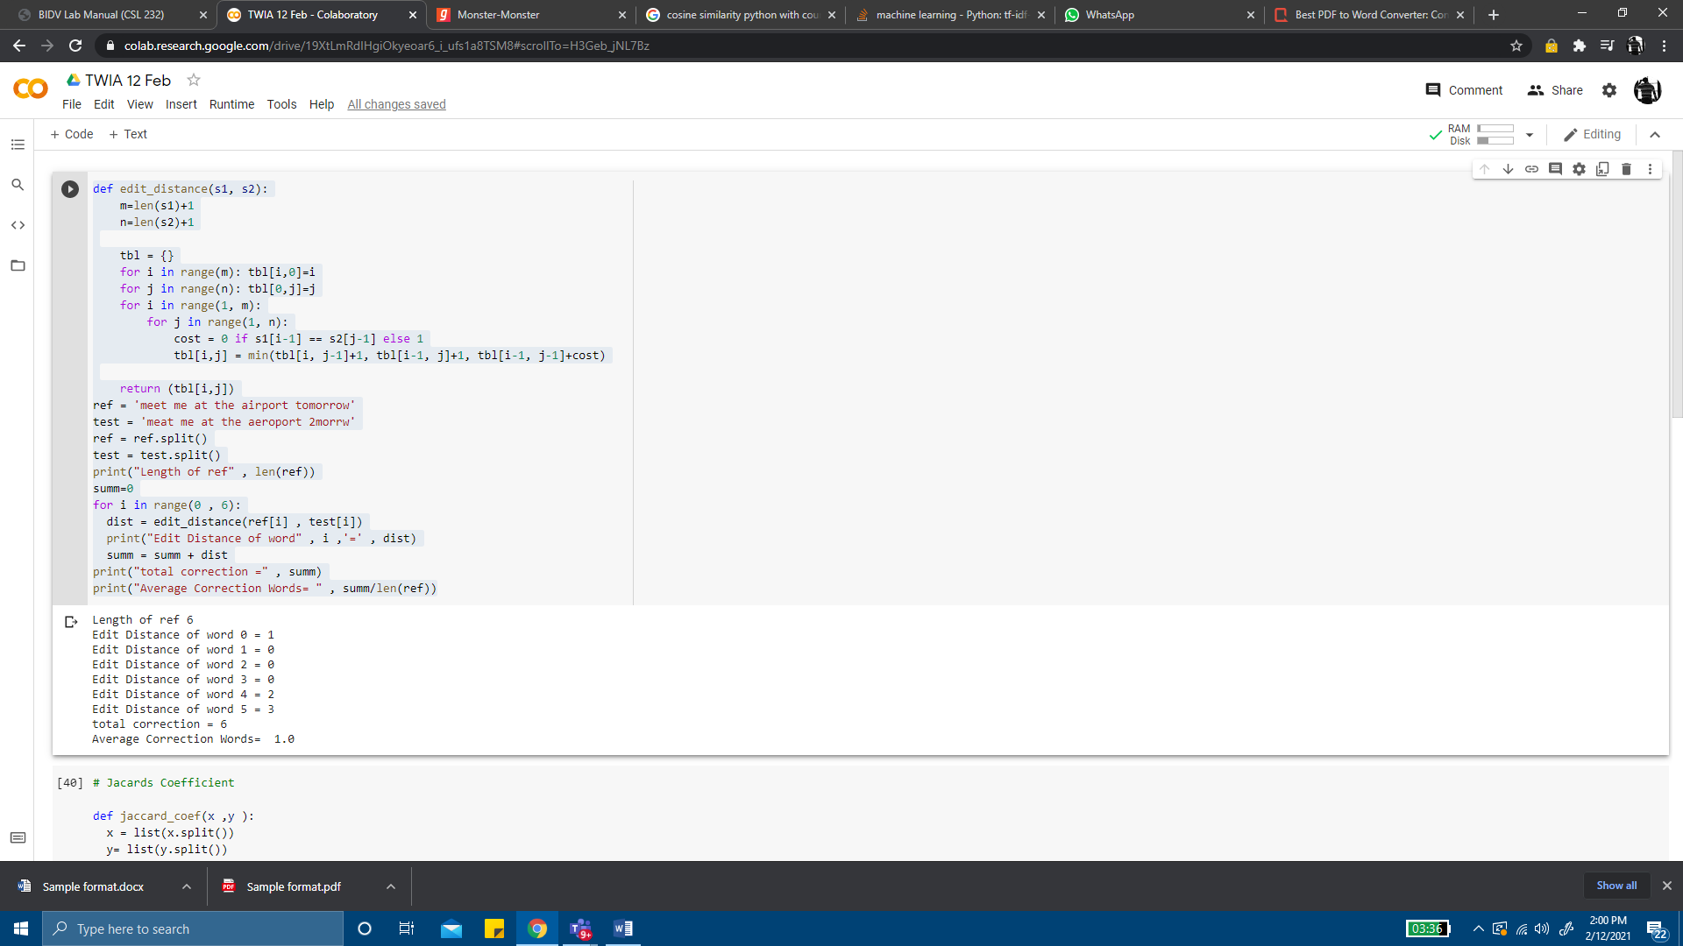

**CODE(Cosine Similarity using both TF-IDF and count vectorizer)**

# Cosine Similarity

from sklearn.feature_extraction.text import CountVectorizer

from sklearn.feature_extraction.text import TfidfTransformer

from nltk.corpus import stopwords

import numpy as np

import numpy.linalg as LA

import nltk

nltk.download('stopwords')

train_set = ["The sky is blue.", "The sun is bright."]  # Documents

test_set = ["The sun in the sky is bright."]  # Query

stopWords = stopwords.words('english')

vectorizer = CountVectorizer(stop_words = stopWords)

#print vectorizer

transformer = TfidfTransformer()

#print transformer

trainVectorizerArray = vectorizer.fit_transform(train_set).toarray()

testVectorizerArray = vectorizer.transform(test_set).toarray()

print ('Fit Vectorizer to train set', trainVectorizerArray)

print ('Transform Vectorizer to test set', testVectorizerArray)

transformer.fit(trainVectorizerArray)

print (transformer.transform(trainVectorizerArray).toarray())

transformer.fit(testVectorizerArray)

tfidf = transformer.transform(testVectorizerArray)

print(tfidf.todense())

**OUTPUT:**

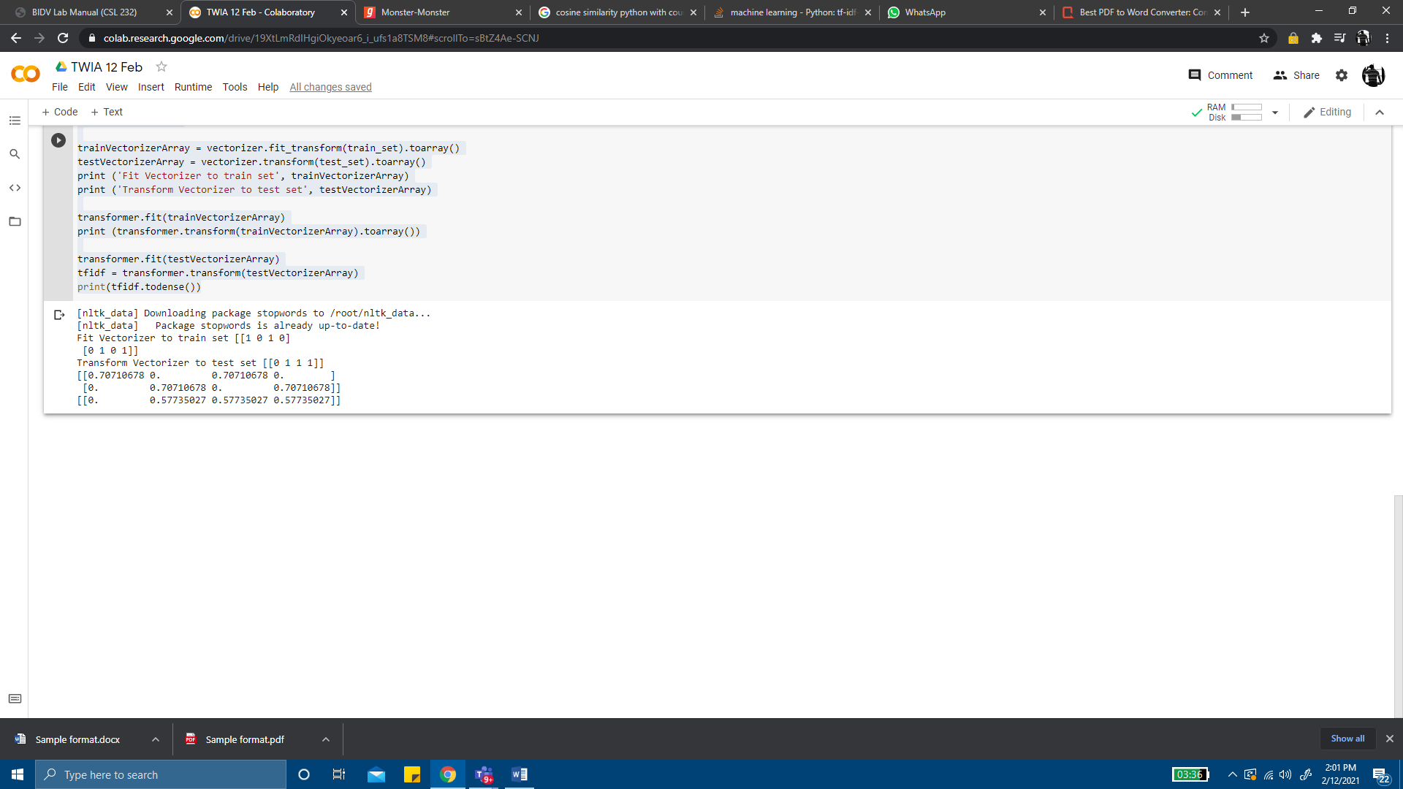



# EXPERIMENT NO. 5

**TWIA Lab Manual (CSL 554)**

**2020-21**

|  |
| --- |
| **Student Name and Roll Number: RAHUL DHAWAN (17CSU146)** |
| **Semester /Section: 8-C** |
| **Date: 6 March 2021** |
| **Faculty Signature:** |
| **Grade:** |

|  |
| --- |
| **Objective:** Implementation of the Lesk algorithm for Word Sense Disambiguation. |
| **Outcome:** Students will be able to demonstrate how to Lesk algorithm works.  **Problem Statement:** Implement Lesk algorithm for Word Sense Disambiguation.  **CODE AND OUTPUT:** |

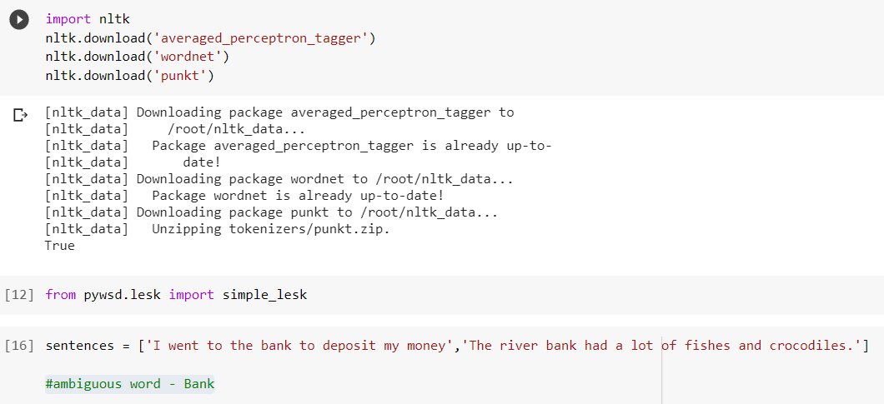

**LESK WORKS CORRECTLY**

}13] # Context 1 - Financial institution print (”Context-1: ”, sentences[0])

answer = simple lesk(sentences[0],'bank') print (”Sense:", answer)

print (”Definition ”, answer.definition())

# Correct Output - Financial Institution printed # No disambiguity

Context-1: I went to the bank to deposit my money Sense: Synset('depository_financial_institution.n.01')

Definition : a financial institution that accepts deposits and channels the money into lending activities

# Context 2 - River Bank

print (”Context-2: ", sentences[1]) answer = simple_lesk(sentences[1],'bank') print (”Sense:", answer)

print (”Definition ”, answer.definition())

# Correct Output - River Bank or sloping land printed # No disambiguity

Context-2: The river bank had a lot of fishes and crocodiles.

Sense: Syn set( ' bank. n. 01' )

Definition ’ sloping land (especially the slope beside a body of water)

**LESK WORKS INCORRECTLY**

new_sentences =[ ' the *workers* at the plant were overworked ' , ' The plant was no longer bearing flowers ' , ' the workers at the industrial plant were overworked ' ]

#ambiguous word °Plant

 *#* Context 1 - Industrial plant

print (“Context-1:“, new sentences[0]) answer = simple_lesk(new sentences[0]), print (“Sense:“, answer)

print(“Definition : “, answer definition())

# Incorrect output - Industria1 plant not printed # Disambiguity occurred

Context -1: The no Akers at the plant were ove ruorked Sense : Synset ( ' plant. v.06 ' )

Definat ion put firmly in the cdna

[19] 4 Context 2 — TnBe/SeBdf1ng/Sapf1ng

print ("Context-2:’, new sentences[1j) answer = simple_lesk(new sentences[1j,'plant’) print ("Sense:’, answer)

print ("Definition : ”, answer.definition())

# Correct output - Plant bearing flower sense printed

4 No disambiguity

Context-3: The plant was no longer bearing flowers Sense: Synset('plant.v.01’)

Definition : put or set (seeds, seedlings, or plants) into the ground

 # Context 3 - Industrial plant (Added the word industrial before plant in # Context 1)

print ("Context-3:’, new sentences[2j) answer = simple lesk(new sentences[2j,'plant’) print ("Sense:’, answer)

print ("Definition : ”, answer.definition())

# Correct output - Industrial plant printed

# (Disambiguity resolved by adding the word ’industrial’ in the sentence.)

 Context-3: The workers at the industrial plant were overworked Sense: Synset('plant.n.01’)

Definition : buildings for carrying on industrial labor



**TWIA Lab Manual (CSL 554)**

**2020-21**

**EXPERIMENT NO. 6**

|  |
| --- |
| **Student Name and Roll Number: RAHUL DHAWAN (17CSU146)** |
| **Semester /Section: 8-C** |
| **Date: 10 April 2021** |
| **Faculty Signature:** |
| **Grade:** |

|  |
| --- |
| **Objective: Implement LDA with BoW and TF-IDF features and compare the results** |
| **Outcome:** Students will be able to demonstrate LDA with BoW and TF-IDF features and compare the results |
| **Problem Statement:** Select the documents and implement above similarities methods.  **Code:**  **import** **pandas** **as** **pd**  data = pd.read_csv('abcnews-date-text.csv', error_bad_lines=**False**);  data_text = data[['headline_text']]  data_text['index'] = data_text.index  documents = data_text  **import** **gensim**  **from** **gensim.utils** **import** simple_preprocess  **from** **gensim.parsing.preprocessing** **import** STOPWORDS  **from** **nltk.stem** **import** WordNetLemmatizer  **from** **nltk.stem.porter** **import** *  **import** **numpy** **as** **np**  np.random.seed(2018)  **import** **nltk**  *# not stemming as it will not provide valid results*  *#lemmatizing*  *#removing stopwords and words with len<3*  **def** lemmatize_stemming(text):  **return** WordNetLemmatizer().lemmatize(text, pos='v')  **def** preprocess(text):  result = []  **for** token **in** gensim.utils.simple_preprocess(text):  **if** token **not** **in** gensim.parsing.preprocessing.STOPWORDS **and** len(token) > 3:  result.append(lemmatize_stemming(token))  **return** result  processed_docs = documents['headline_text'].map(preprocess)  processed_docs[:10]  dictionary = gensim.corpora.Dictionary(processed_docs)  dictionary.filter_extremes(no_below=15, no_above=0.5, keep_n=100000)  bow_corpus = [dictionary.doc2bow(doc) **for** doc **in** processed_docs]  **from** **gensim** **import** corpora, models  tfidf = models.TfidfModel(bow_corpus)  corpus_tfidf = tfidf[bow_corpus]  **from** **pprint** **import** pprint  **for** doc **in** corpus_tfidf:  pprint(doc)  **break**  lda_model = gensim.models.LdaMulticore(bow_corpus, num_topics=10, id2word=dictionary, passes=2, workers=2)  **for** idx, topic **in** lda_model.print_topics(-1):  print('Topic: **{}** **\n**Words: **{}**'.format(idx, topic))  lda_model_tfidf = gensim.models.LdaMulticore(corpus_tfidf, num_topics=10, id2word=dictionary, passes=2, workers=4)  **for** idx, topic **in** lda_model_tfidf.print_topics(-1):  print('Topic: **{}** Word: **{}**'.format(idx, topic))  **OUTPUT:**    **Testing both the models**  *# Bag Of Words*  *# Compute Perplexity*  **from** **gensim.models.coherencemodel** **import** CoherenceModel  print('**\n**Perplexity: ', lda_model.log_perplexity(bow_corpus)) *# a measure of how good the model is. lower the better.*  *# Compute Coherence Score*  coherence_model_lda = CoherenceModel(model=lda_model, texts=processed_docs, dictionary=dictionary, coherence='c_v')  coherence_lda = coherence_model_lda.get_coherence()  print('**\n**Coherence Score: ', coherence_lda)    *# TFIDF*  *# Compute Perplexity*  **from** **gensim.models.coherencemodel** **import** CoherenceModel  print('**\n**Perplexity: ', lda_model_tfidf.log_perplexity(bow_corpus)) *# a measure of how good the model is. lower the better.*  *# Compute Coherence Score*  coherence_model_lda = CoherenceModel(model=lda_model_tfidf, texts=processed_docs, dictionary=dictionary, coherence='c_v')  coherence_lda = coherence_model_lda.get_coherence()  print('**\n**Coherence Score: ', coherence_lda)  *#since tdidf has more coherence score therefore it is more effective than bow* |
|  |



**TWIA Lab Manual (CSL 554)**

**2020-21**

**EXPERIMENT NO. 7**

|  |
| --- |
| **Student Name and Roll Number: RAHUL DHAWAN (17CSU146)** |
| **Semester /Section: 8-C** |
| **Date: 20 April 2021** |
| **Faculty Signature:** |
| **Grade:** |

|  |
| --- |
| **Objective: Implementation of KNN, Naive Bayes and Multinominal Naive Bayes.** |
| **Outcome:** Students will be able to demonstrate KNN, Naive Bayes and Multinominal Naive Bayes. |
| **Problem Statement:** Select the documents and implement KNN, Naive Bayes and Multinominal Naive Bayes.  **Code:**  *# We defined the categories which we want to classify*  categories = ['rec.motorcycles', 'sci.electronics',  'comp.graphics', 'sci.med']  *# sklearn provides us with subset data for training and testing*  train_data = fetch_20newsgroups(subset='train',  categories=categories, shuffle=**True**, random_state=42)  print(train_data.target_names)  print("**\n**".join(train_data.data[0].split("**\n**")[:3]))  print(train_data.target_names[train_data.target[0]])  *# Let's look at categories of our first ten training data*  **for** t **in** train_data.target[:10]:  print(train_data.target_names[t])  knn = KNeighborsClassifier(n_neighbors=7)  *# training our classifier ; train_data.target will be having numbers assigned for each category in train data*  clf = knn.fit(X_train_tfidf, train_data.target)  *# Input Data to predict their classes of the given categories*  docs_new = ['I have a Harley Davidson and Yamaha.', 'I have a GTX 1050 GPU']  *# building up feature vector of our input*  X_new_counts = count_vect.transform(docs_new)  *# We call transform instead of fit_transform because it's already been fit*  X_new_tfidf = tfidf_transformer.transform(X_new_counts)  predicted = clf.predict(X_new_tfidf)  **for** doc, category **in** zip(docs_new, predicted):  print('**%r** => **%s**' % (doc, train_data.target_names[category]))  **from** **sklearn.model_selection** **import** train_test_split  X_train, X_test, y_train, y_test = train_test_split(X_train_tfidf, train_data.target, test_size=0.30, random_state=42)  print('Training Data Shape:', X_train.shape)  print('Testing Data Shape: ', X_test.shape)  Naive Bayes  **from** **sklearn.naive_bayes** **import** GaussianNB  lr_model = GaussianNB()  lr_model.fit(y1, y_train)  predictions = lr_model.predict(y2)  **from** **sklearn** **import** metrics  print(metrics.confusion_matrix(y_test,predictions))  print(metrics.classification_report(y_test,predictions))  print(metrics.accuracy_score(y_test,predictions))    Multinomial naive bayes |
|  |
|  |



**TWIA Lab Manual (CSL 554)**

**2020-21**

**EXPERIMENT NO. 8**

|  |
| --- |
| **Student Name and Roll Number: RAHUL DHAWAN (17CSU146)** |
| **Semester /Section: 8-C** |
| **Date: 20 April 2021** |
| **Faculty Signature:** |
| **Grade:** |

|  |
| --- |
| **Objective: Implementation of k means, k medoids and hierarchical clustering algorithms on Text data.** |

**Output:**

