ER OON Operating Model 2027: Executive Summary
Oct 8, 2026 · @Kamil Salameh

Summary
We will replace 12 facility teams with 10 full-cycle teams, one per manager, and add a 5-person US Gateway Desk that files disputes Lebanon prepares in our IDR Prep Studio (Model C, proposed). It goes live before the IDR Gateway becomes US-only on January 1, 2027. No one loses their job or pay because of the restructure; from December 2027 everyone is held to the same badge and performance standards.
Why now. Three pressures arrive together:
- The IDR Gateway goes US-only on January 1. Our negotiators spend 50–70% of their time in it today.
- Workload is uneven. It varies 5× between facility teams (138 to 704 open claims per person).
- We're growing. We go from 12 to 31 facilities in two years.
What changes:
- One owner per account. Each RCM Specialist owns an account from coding to final payment. This replaces the coder, biller and negotiator handoffs.
- Teams own payer portfolios, not facilities. Workload is balanced by effort, and new facilities join existing teams instead of creating new ones.
- A guided copy desk for the Gateway. Lebanon prepares every dispute in the IDR Prep Studio, which mirrors the Gateway page by page and checks every field. The US desk copies it into the Gateway in about 15 minutes and submits it. Pricing and strategy stay in Lebanon.
- Pay and promotion follow skill. Six levels (L0–L5) are earned through 15 skill badges in three families: C Core, B Specialist and A Advanced. L1 and L2 come automatically once the badges are held; L3, L4 and L5 need a leveling test, and L5 is the leadership level for team leads and managers. Every December the top 10% of each level earn their missing badges. Badges are earned in quarterly test windows and kept through a semiannual review.
- A fair transition. The top 10% of each role earn their role badges without tests. Everyone else has 3 months of tests, and the bottom 10% restart at L1 through the Academy. No one's pay goes down, and every move up comes with a raise.
Decisions requested:
- ☐ Approve Model C: a 5-person US Gateway Desk (1 lead, 4 associates) plus 2 staff on 3–6 month contracts until March 15, 2027, hired in-house from October.
- ☐ Approve moving to 10 full-cycle teams in January–February 2027.
- ☐ Approve the six levels (L0–L5), 15 badges, leveling tests and pay bands, the quarterly test windows and the semiannual review, including the badge-loss rules, subject to HR and legal review.
- ☐ Approve the January–March 2027 transition plan, with pay protection and guaranteed raises on upgrade.
- ☐ Approve the opt-in bridge night rota and its $30,000 quarterly bonus pool.
- ☐ Approve the Senior Manager role and the 11 manager portfolios.
- ☐ Approve closing NNSA claims older than 12 months, after a final high-dollar review.

Operating model
The 94 people in Lebanon are organized as 10 identical teams, with 2 floating team leads who cover absences and support the Academy. A 5-person US desk enters our prepared work into the Gateway. QA stays the separate department it is today.
Unit | People | Reports to | Owns
Full-cycle teams (10) | Each: 1 manager, 1 team lead, 7–8 RCM specialists; plus 2 floating team leads | Head of ER OON Revenue Cycle | A balanced book of payers, from coding to final payment
Bridge night rota | Opt-in L2–L4 members, 2 a night, 16:00–24:00 Beirut | Onshore–Offshore Liaison owner | Ticket checks, answers to the US desk within 15 minutes, same-day fixes
US Gateway Desk (Model C) | 1 lead, 4 associates; 2 more on contract until March 15, 2027 | Head of ER OON Revenue Cycle | Copying prepared disputes from the IDR Prep Studio into the Gateway; no pricing decisions
QA department (existing) | No change | No change | QA checklists, audit sample, seat on the Badge Panel
Manager portfolios. Each manager, and the new Senior Manager, owns one of 11 portfolios on top of their team, and reports on it monthly to the leadership board. Three examples:
- Training Academy: test windows, badge records, the semiannual review and the transition.
- Pricing guide: offer pricing and payer playbooks.
- Onshore–Offshore Liaison: the US desk, the bridge night rota and the accounting teams.
How work is assigned: by payer portfolio in three tiers, weighted by effort:
- Tier 1 goes to L3 and L4 Senior Specialists: highest-dollar claims and the hardest payers.
- Tier 2 is standard NSA work.
- Tier 3 is lower-dollar, high-volume claims.
Careers and pay (USD per month):
Level | Requirement | Band
L0 Junior RCM Specialist | New hire; no badges yet | 1,000–1,100
L1 RCM Specialist I | All 5 C badges; automatic | 1,000–1,300
L2 RCM Specialist II | 5 C + B1 or B2 + 2 of B3, B4, B5; automatic | 1,200–1,550
L3 Senior Specialist I | 5 C + 5 B + 1 of 5 A; L3 leveling test | 1,400–1,800
L4 Senior Specialist II | 5 C + 5 B + 3 of 5 A; L4 leveling test | 1,600–2,000
L5 Principal: Team Lead | 5 C + 5 B + 4 of 5 A; L5 leveling test with coaching assessment; team lead post | 1,400–2,000
L5 Principal: Manager | 5 C + 5 B + 4 of 5 A; L5 leveling test with leadership assessment; manager post | 2,000–3,000
Each A badge adds $50 a month, up to 2 badges ($100 a month). The quarterly bonus is 5–15% of base, paid on Net Recovery, quality and deadlines. Members who lose 25% of their badges at a semiannual review go on probation and coaching; losing 50% leads to termination, from December 2027. The full rules are in the Badges, Levels and Transition appendix and the badge competency matrix.

Implementation roadmap
The Gateway work is done and stable before team structure changes. The cutover is on December 19, which leaves two weeks of margin before the January 1 deadline.
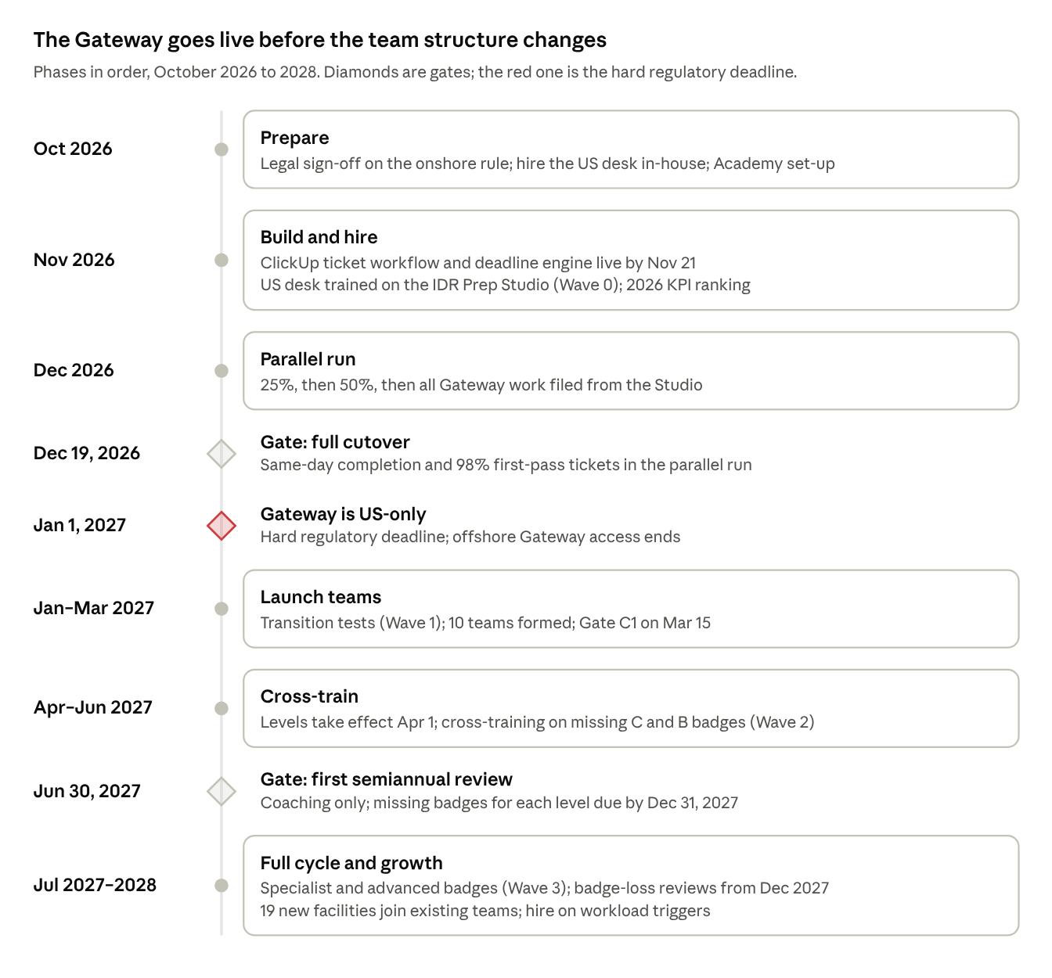
implementation roadmap · 6 phases, 3 gates
New facilities open straight into the 10 teams; a new team is added only when existing teams run above 110% of target workload for 4 weeks.

Training plan and strategy
Training is built around badges and done on live work, with a badge-holder checking. The Academy Committee runs it, L4 Senior Specialists II and team leads teach, and the QA department scores quality.
Wave | When | Who | What | Done when
0 · US desk | Nov–Dec 2026 | US desk (5, plus 2 on contract) | HIPAA, the IDR Prep Studio copy desk, each Gateway action, escalation path; then the December parallel run | 15 minutes or less per dispute and under 0.5% errors in the parallel run
0 · Studio and tickets | Nov 2026 | Negotiators and bridge night rota volunteers | Preparing disputes in the IDR Prep Studio; night rota duties | 98% first-pass accuracy in the parallel run
Ranking | Dec 2026 | Everyone | Ranking within each current role on 2026 KPIs; top and bottom 10% published | Lists checked and published
1 · Transition | Jan–Mar 2027 | Everyone | Top 10% receive their role badges (Negotiator: C2, C5, B2, B5, A2; Coder: C1, C5, B1, A3; Biller: C1–C4, B5, plus B3 for MVA or workers' comp); bottom 10% join the Academy at L1; everyone else takes the optional skill assessment and role badge tests in the February or March window | Levels take effect on April 1, 2027
2 · Missing badges | Apr–Dec 2027 | Anyone missing a badge for their level | Cross-training on the missing badges: negotiators learn C1, C3 and C4; coders learn C2, C3 and C4; billers learn C5; each paired with a badge-holder in their team | All badges for the confirmed level by December 31, 2027
3 · Specialist and advanced | Jul 2027 on | L1 and above | B badges (coding, IDR process, MVA and workers' comp, payer strategy, payer outreach) and A badges (reporting, IDR strategy, medical terminology, billing strategy, innovation) | At least 2 holders of every badge in every team
New hires | Monthly from 2027 | Groups of 4–6 at L0 | 2 weeks of Academy, then the C badges with supervised work in a team | L1 automatically at about 6 months
Guidelines:
- Protect the time. Everyone in Wave 2 gets 4 hours a week, about 7 FTE in total. Today's spare capacity covers it.
- Never assess your own team. Badge Panels (a QA reviewer plus 2 L4 Senior Specialists II or team leads from other teams) score every test window.
- Track it monthly. Measure badges earned against plan, QA scores by badge, and time to proficiency for new hires; review every member's badges each June and December.

Estimated cost: US Gateway Desk (Model C)
The proposed 5-person desk costs roughly $252,000–307,000 a year as direct hires, about $280,000 at the midpoint. These are approximate market figures for Texas data-entry roles, not offers; replace them with our own pay offers before approval. We recruit in-house and the desk uses systems and equipment we already have, so there are no recruiting fees or setup costs.
Line | Basis | Annual cost (USD)
4 Gateway associates | $18–22/hour × 2,080 hours, plus about 25% benefits and payroll taxes | 187,000–229,000
1 desk lead | $25–30/hour × 2,080 hours, plus about 25% benefits and payroll taxes | 65,000–78,000
Run rate |  | 252,000–307,000
Paid onboarding before go-live (one-time) | November–December salaries for the 5 permanent staff | 42,000–51,000
Cutover buffer (one-time) | 2 associates on contract, November to March 15, 2027 | 35,000–43,000
Against the alternatives: Model A (7 people typing from tickets) costs $346,000–421,000 a year. Model B (3 people with a form-filling Cockpit) costs $206,000–261,000, but needs written Gateway approval and new software. Model C saves $94,000–114,000 a year against Model A today. The full analysis is in the Model A vs B vs C comparison.
As volume grows, the desk scales on the backlog trigger, at about $47,000–57,000 per associate a year:
- About 8 people by the end of year 1: $393,000–478,000, against $580,000–707,000 under Model A.
- About 11 people by the end of year 2: $533,000–650,000, against $861,000–1,050,000 under Model A.
- If the Gateway allows bulk file upload, growth stays nearer the low end.
Hiring route: our in-house recruiting team hires 5 permanent staff and 2 on 3–6 month contracts from October, so everyone is in place for November onboarding. The contracts end at Gate C1 on March 15, 2027, once the desk holds 15 minutes per dispute, errors under 0.5% and no missed deadlines for 4 weeks.
New costs in Lebanon are small:
- Bridge night rota: a $30,000 quarterly bonus pool, up to $120,000 a year, shared at $300–3,000 per member a quarter.
- A-badge allowances: $50 per A badge a month, up to 2 per member.
- Guaranteed raises for anyone who moves up a level on April 1, 2027.
- The transition retention bonus for critical staff.
Team lead pay needs no raise, because the new band matches today's range.

Technical needs
Most of the build is in ClickUp, which we already use. The hard deadline is the ticket workflow, which must be live by the December parallel run.
Need | What it does | By
IDR Prep Studio (Model C copy desk) | Internal portal that mirrors the Gateway page by page, validates every field, keeps documents in Drive and gives the US desk one-click copy and a confirmation PDF; already built | Ready now; used in the December parallel run
ClickUp ticket workflow | One form per Gateway action that is not filed from the Studio; status flows back from the US desk | Nov 21, 2026
Deadline engine | Business-day timers for every NSA step; alerts the team lead, then the manager, 3 days before a deadline | Nov 21, 2026
US desk access | Individual Gateway credentials with MFA; access to the Studio copy desk only, no eCW | Dec 1, 2026
Bridge night rota channel | Rota roster, a live chat channel and the nightly handover log in ClickUp | Dec 1, 2026
HIPAA agreements | BAAs with ClickUp and our LLM provider | Before any PHI moves
Badge records and test windows | ClickUp fields for badges held, test enrolments and semiannual review results | Jan 2027
Work routing | Weighted work units, payer portfolio and badge fields, so ClickUp routes each task to a badge-holder and builds each person's Today list | Jan 2027
eCW | Role permissions and reports by team and payer portfolio instead of by facility | Jan 2027
Medical-necessity reports | Approved LLM tool under a BAA, with a versioned prompt library | Jan 2027
Dashboards | Net Recovery, deadlines, backlog and the team badge grid, from ClickUp and eCW exports | Feb 2027
Model web app | The Apps Script page that explains the model to staff | Ready now
Open question for the Gateway: does it accept bulk file upload for batched line items? The answer sets US desk size more than anything else.

Leadership approach
We lead this change by protecting people first, deciding close to the work, and changing one thing at a time.
Principles:
- Gateway first, structure second. The structure doesn't change until the Gateway cutover is stable, so any December problem has one cause.
- No job or pay loss from the restructure. Levels take effect on April 1, 2027, and badge-loss consequences start only with the December 2027 review.
- Decisions close to the work. Team leads approve settlements within set bands and rebalance their team; managers own results and people.
- Open criteria. Every badge, level, test and promotion rule is published before anyone is placed, and each person gets one appeal.
- Measure before judging. The June 2027 review is for coaching only. The only exception is missed deadlines, which get zero tolerance from day one.
Governance cadence:
Forum | When | Who | Decides
Team huddle | Daily, 10 minutes | Team lead and team | Deadlines due within 3 days, rebalancing
Managers' review | Weekly | 10 managers, Head | Workload, US desk backlog, escalations
Leadership review | Monthly | Head, managers, QA | Net Recovery, badges against plan, hiring triggers
Promotions panel | Quarterly | Academy owner + 2 managers from other teams | Level changes and promotions
Communication sequence:
- Leadership approval.
- Manager briefing.
- Team lead briefing, including choosing change champions.
- All-hands meeting, covering "what changes for you", the transition plan and our commitments.
- 1:1s within a week.
- A published FAQ.
We repeat the cycle at each phase gate.
Top risks:
Risk | Response
We misread the Gateway rule | Legal sign-off before the build; offshore access stays as a fallback until Dec 19
The 5-person US desk falls behind | 2 contract staff stay until Gate C1 on March 15; the backlog trigger adds staff within 2 weeks; the night rota reports it daily
Copy errors between the Studio and the Gateway | Field validation in the Studio, a per-field checklist and night rota review; errors under 0.5% at Gate C1
People see the new levels or tests as a threat | Top 10% earn badges without tests, protected pay, published criteria, one appeal, and consequences only from December 2027
We lose IDR experts | Retention bonus through January 2028; a Senior Specialist path that doesn't require managing

