Model B: Automation-First Operating Model
Oct 8, 2026 · @Kamil Salameh

Summary
Model B runs the US Gateway Desk with 3 people instead of 7. It does that by having Lebanon deliver every Gateway action as a ready-to-submit bundle, which a US operator checks and files in about 10 minutes instead of 47. It is riskier than Model A because it depends on new software, a much smaller US team, and a tighter daily cycle. In return it saves roughly $140,000–160,000 a year today and about $0.41–0.5 million a year by year two.
The five bold moves:
- A US Submission Cockpit replaces manual typing. A US operator opens a bundle on a US company device. A helper tool fills the Gateway forms from the bundle while the operator watches. The operator checks every field and clicks submit personally.
- Lebanon becomes a "dispute factory". AI drafts each packet, medical-necessity report and offer letter, and specialists review and approve the drafts. The target is 0.33 specialists per daily visit instead of 0.45.
- An Automation Cell of 2 Automation Analysts, both from current specialists, owns the bundle templates and the AI prompts. The bridge night rota runs the quality gate.
- Teams are paid on results. A team gainshare pool shares in recovery above baseline, and a bounty board pays for clearing aged claims.
- The US desk runs 12 hours a day. Three staggered US shifts cover 7:00–19:00 Central time, so work prepared in Lebanon is filed the same day.
The one idea we are not building is the mirror bot, which would replay Lebanese actions onto a US PC. It would let offshore staff operate the Gateway through a US machine. That defeats the onshore rule and puts our Gateway access at risk (see Compliance guardrails). The Cockpit reaches the same 3-person target with a US person genuinely doing the work.
Recommendation: Go live on January 1 with Model A's US desk, hired in-house on short contracts. Build the Cockpit in parallel and pilot it in February. Step down to 3 people only after the gates in Rollout are met. If they aren't, we stay on Model A at no extra cost.
Update: the proposal is now Model C, the guided copy desk. Lebanon prepares each dispute in the IDR Prep Studio, which mirrors the Gateway page by page and validates every field. A 5-person US desk copies each field into the Gateway with one-click copy buttons and submits personally; no tool touches the Gateway. It targets 15 minutes per dispute, is ready for January 1, and needs no Gateway approval beyond the onshore rule. It saves $94,000–114,000 a year today and $328,000–400,000 by year two against Model A, about 70–80% of Model B's saving. Model B remains the long-term option once the Gateway confirms in writing that assisted form filling is allowed.

Ideas we weighed
We tested ten unconventional ideas. Seven are in the model, one needs a check against the Gateway's terms first, and two are rejected.
Idea | Verdict | Why
Mirror bot: Lebanese actions replayed on a US PC | Rejected | Offshore staff would be operating the Gateway through a proxy, which is the access the rule removes
Fully automatic submission, with no person clicking submit | Only if the Gateway's terms allow it | Fastest option, but most portals ban unattended bots; it needs written confirmation first
Operator-run form filling (the Cockpit) | In | A US person runs every session and checks every field; the tool only removes typing
Gateway bulk upload for batched items | In, if available | Cuts the work on large batches the most
AI dispute factory in Lebanon | In | AI drafts packets, reports and offers; specialists approve
AI reading of determinations | In | Outcomes are logged automatically in ClickUp overnight
Three staggered US shifts | In | 12 hours of filing a day with 3 people
Team gainshare pool | In | Pays teams for recovery above baseline, with guardrails
Bounty board for aged claims | In | Clears the backlog without permanent hiring
US gig marketplace for data entry | Rejected | Health data (PHI), training and control risks are too high

How it works
Lebanon prepares everything, and a US operator files it. Only files cross between the two sides.
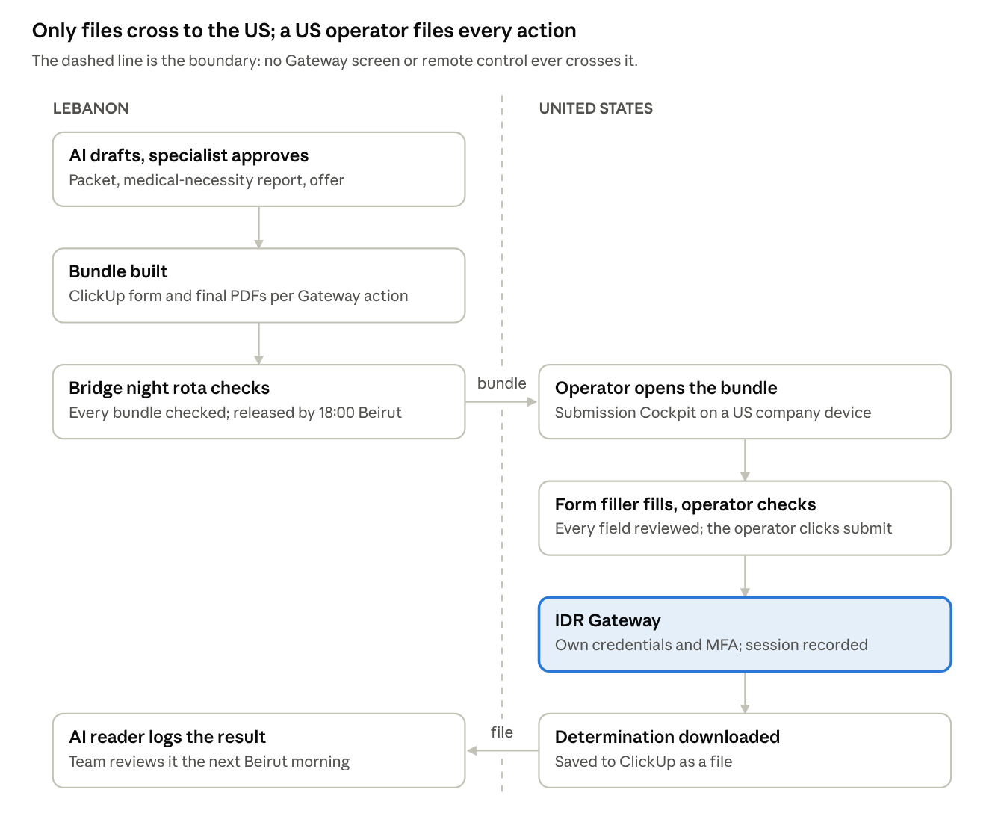
Model B flow · Lebanon prepares, the US files
The time saving comes from the bundle: the operator no longer types, looks things up or chooses anything. Their job is to check and submit, which brings filing time down from about 47 minutes per dispute to a target of 10.

Compliance guardrails
Only a US-based person, on a US company device, ever sees or acts in the Gateway. Lebanon prepares the work and never touches a Gateway session, directly or remotely.
Always | Never
A named US operator signs in with their own credentials and MFA | Shared logins, or credentials kept on a server
The operator reviews every field and clicks submit personally | Unattended submission, unless the Gateway's operator confirms in writing that it's allowed
Lebanon delivers bundles; the US sends results back as files | Screen sharing, remote control or mirroring of a Gateway session to Lebanon
Every session is logged and screen-recorded on the US device | Offshore staff seeing live Gateway screens
HIPAA BAAs with every vendor that holds PHI | PHI in any tool without a BAA
Before we build: we get written legal sign-off on the Cockpit design, and written confirmation that the Gateway's terms allow assisted form filling. If either answer is no, the Cockpit is limited to on-screen copy assistance and the desk stays at Model A's size.

Structure
The 10 managers and 10 teams stay as in Model A. Two changes: 2 current specialists form an Automation Cell, and the US desk shrinks to 3.
Unit | People | Reports to | Owns
Full-cycle teams (10) | 10 managers, 10 team leads, 70 RCM specialists | Head of ER OON Revenue Cycle | Accounts from coding to final payment; reviewing and approving the AI drafts
Automation Cell | 2 Automation Analysts (from current specialists) | Submission program manager (one of the 10 managers) | Bundle templates, AI prompts, ClickUp automations
Bridge night rota (Bundle QA) | 2 members a night from an opt-in rota of L2–L4 holding B2; at least one A2 holder each night | Onshore–Offshore Liaison portfolio owner | The final check before a bundle goes to the US; answering the US desk
US Submission Desk | 1 Submission Lead, 2 Submission Specialists | Head of ER OON Revenue Cycle | Filing every Gateway action from a bundle; sending results back
QA department (existing) | No change | No change | Audits, including a monthly review of Cockpit session recordings
Headcount: Lebanon headcount is the same as in Model A. The 2 Automation Analysts come from current specialists, and the bridge night rota is staffed by existing members who opt in. The US desk is 3 instead of Model A's 7.
Growth: with AI drafting, the target is 0.33 specialists per daily visit:
- About 102 specialists by year two instead of 125, roughly 23 fewer hires.
- The US desk grows to about 5 people in year one and 7 in year two, instead of 12 and 18.

Job descriptions
Four roles are new or changed; every other role is as in Model A.

US Submission Lead (1)
Purpose: Owns same-day filing and Gateway compliance in the US.
- Duties:
  - Files bundles about half the time.
  - Assigns the queue and plans coverage.
  - Manages credentials, MFA and quarterly access reviews.
  - Audits a daily sample of session recordings.
  - Escalates Gateway problems.
- Requirements: 3+ years in healthcare revenue cycle or payer portals; NSA/IDR experience preferred; HIPAA-trained; based in the US.
- KPIs:
  - 100% of bundles received by the cutoff filed the same day.
  - Zero filing errors reach the Gateway.
  - Backlog under 1 business day.
- Pay: $27–32 an hour (about $56,000–67,000), up to 10% quarterly bonus, full benefits.

US Submission Specialist (2)
Purpose: Files Gateway actions from bundles, accurately and on the same day.
- Duties:
  - Works the Cockpit queue during the shift.
  - Checks every filled field against the bundle checklist, then submits.
  - Records fees.
  - Downloads determinations and correspondence.
  - Returns any mismatch to Bundle QA within 15 minutes.
- Requirements: 1–2 years of healthcare or insurance data entry; pass a 99% accuracy test; HIPAA-trained; based in the US.
- KPIs:
  - About 40 disputes' worth of actions per shift.
  - Error rate under 0.5%.
  - Same-day completion.
- Pay: $21–25 an hour (about $44,000–52,000), up to 10% quarterly bonus, full benefits.

Automation Analyst, Lebanon (2)
Purpose: Keeps bundles and AI drafts accurate and fast.
- Duties:
  - Maintains a bundle template for each Gateway action.
  - Keeps the AI prompt library versioned.
  - Builds ClickUp automations.
  - Tracks how often AI drafts are rejected.
  - Updates Cockpit field mappings when the Gateway changes.
- Requirements: L3 Senior Specialist I, or a strong L2 holding B2; A5 Innovation preferred; confident with ClickUp automations and spreadsheets; basic scripting is a plus.
- KPIs:
  - Bundle defect rate under 2%.
  - At least 80% of AI drafts accepted without major edits.
  - Mapping fixes within 1 business day.
- Pay: L3 Senior Specialist I band ($1,400–1,800) plus a $100 monthly automation allowance.

Bridge night rota (Bundle QA)
Purpose: Nothing reaches the US desk unless it is ready to file. There are no bridge shift leads; the bridge night rota does Bundle QA.
- Who: any L2, L3 or L4 holding B2 can opt in. Each night has at least one A2 holder as night lead. The rota reports to the Onshore–Offshore Liaison portfolio owner, who sets it each quarter from the opt-ins.
- Hours: 16:00–24:00 Beirut, Monday to Friday (08:00–16:00 Central), 2 members a night.
- Duties:
  - Checks every bundle against the checklist before release.
  - Answers the US desk within 15 minutes.
  - Fixes rejected bundles the same US day.
  - Posts the nightly handover log.
- KPIs:
  - 98% of bundles right the first time.
  - US desk questions answered within 15 minutes.
  - No deadline missed because of a bundle.
- Pay: a $30,000 quarterly pool shared equally by the rota ($300–3,000 each, about $230 per night worked). Full share when the rota meets its targets and the member works all assigned nights; transport home after the shift.

Schedules
Work moves in one 24-hour loop. Lebanon releases bundles throughout the afternoon, the US files them from 7:00 to 19:00 Central, and results are waiting in ClickUp when Beirut starts the next morning.
Beirut | Central (US) | Lebanon | US desk
08:00 | 00:00 | Teams start (08:00–16:30); review overnight determinations already logged by AI | —
12:00 | 04:00 | Approved bundles released continuously | —
15:00 | 07:00 | — | Specialist A starts (07:00–15:30)
16:00 | 08:00 | Teams finish at 16:30; the bridge night rota starts (16:00–24:00) and checks every bundle before release | Lead starts (08:00–16:30)
18:00 | 10:00 | Last release for same-day filing | Specialist B starts at 10:30 (10:30–19:00)
24:00 | 16:00 | Bridge night rota posts the handover log and ends | Rejected bundles after this point are fixed the next Beirut morning
03:00 | 19:00 | — | Queue cleared; determinations downloaded; AI logs them overnight
Coverage rules:
- At least 2 of the 3 US staff work every weekday.
- Leave is approved only while the backlog is under half a day.
- 2 pre-trained on-call staff, recruited in-house, cover sickness.
The offset is 8 hours for most of the year. Shift times move for the few weeks each spring and autumn when the two countries change their clocks on different dates.

Pay and benefits
Model B pays more for results and less for headcount. Base pay bands are unchanged from Model A; the extras below are new.
Element | Who | How it works | Guardrail
US package | US desk | Direct hire with health benefits, 15 days' paid leave, remote work on an existing company device | US-only devices and network; session recording on
US quarterly bonus | US desk | Up to 10% of base: same-day completion, error rate, backlog | Nothing paid in a quarter with a filing error that cost a deadline
Team gainshare pool | Each Lebanon team | 3% of the team's Net Recovery above its baseline quarter, split by work units × quality score | Capped at 15% of the team's quarterly base pay; each missed deadline cuts the pool by 25%; coding is never paid on dollars
Bounty board | L2 and above | Claims over 90 days old posted with work-unit bounties; $3 per unit closed outside regular work | Up to $150 a month; quality score of 95% or higher required
Automation allowance | Automation Analysts | $100 a month | Paid while bundle defect rate is under 2%
Bridge night rota bonus | Bridge night rota (L2–L4 holding B2) | $30,000 a quarter shared equally by the rota ($300–3,000 each, about $230 per night worked); transport home after the shift | Full share only when rota targets are met and all assigned nights are worked; missed nights reduce the share pro rata
Learning stipend | Everyone | $200 a year toward external courses (coding, AI tools) | Requires passing the course
The gainshare is the riskiest pay element. It rewards the work that drives recovery, but it could push people toward aggressive settlements. That's why it is capped, why it's tied to quality, and why settlement decision rights don't change.

Tools and technology
The Submission Cockpit is the one new build, and we build it in-house on our existing Google Workspace, starting from the IDR Prep Studio. Everything else is configuration of tools and devices we already have. Model A's ClickUp ticket workflow and deadline engine stay underneath as the fallback.
Tool | What it does | Build or buy | Estimated cost (USD) | Ready by
Submission Cockpit | US-hosted web app with sign-on and MFA: bundle queue, a checklist for each Gateway action, a full audit log | Build in-house | Staff time; runs on existing systems | Feb 2027 pilot
Form filler | Browser extension on the US desk's company devices; the operator starts it and it fills the page from the bundle; never submits by itself | Built with the Cockpit | Included | Feb 2027, only if the Gateway's terms allow it
Bundle builder | ClickUp form for each action, plus automatic PDF assembly | Configure | Staff time | Jan 2027
AI drafting | Drafts packets, medical-necessity reports and offer letters for specialist approval | Buy (AI service covered by a BAA) | 12,000–30,000 a year | Jan 2027
AI determination reader | Turns determination PDFs into ClickUp fields overnight | Build on the same AI service | Included | Mar 2027
US device security | Device management, screen recording and US-only network rules on existing company devices | Buy | Staff time | Dec 2026
Dashboards | Net Recovery, gainshare, bounty board, US queue | Configure (Looker Studio) | Low | Feb 2027

Cost: Model B against Model A
Model B has almost no up-front cost: the Cockpit is built in-house on existing systems, so its only one-time item beyond Model A's is the legal review. It saves $140,000–160,000 a year at today's volume once the desk steps down to 3 people, and the savings grow with volume. US figures are approximate Texas market rates (direct hire, plus 25% for benefits and payroll taxes), not quotes. Recruiting is in-house, and neither model carries infrastructure costs.
Annual cost (USD) | Model A | Model B | Model B saves | Model C (proposed)
US desk today | 7 people, direct hire: 346,000–421,000 | 3 people, direct hire, with bonus: 194,000–231,000 |  | 5 people, direct hire: 252,000–307,000
New technology, running costs | — | AI drafting service: 12,000–30,000 |  | — (IDR Prep Studio runs on existing Google Workspace)
Today, total | 346,000–421,000 | 206,000–261,000 | 140,000–160,000 | 252,000–307,000 (saves 94,000–114,000)
Year 1 (about 4,400 disputes a month) | 12 people: 580,000–707,000 | 5 people + AI drafting: 331,000–408,000 | 249,000–299,000 | 8 people: 393,000–478,000 (saves 187,000–229,000)
Year 2 (about 6,500 disputes a month) | 18 people: 861,000–1,050,000 | 7 people + AI drafting: 452,000–551,000 | 409,000–499,000 | 11 people: 533,000–650,000 (saves 328,000–400,000)
One-time | Paid onboarding, November–December: 58,000–70,000 | The same onboarding, plus legal review of the Cockpit (quote needed) | — | The same onboarding only
Lebanon: AI drafting targets about 23 fewer hires by year two, worth roughly $380,000 a year at the L2 midpoint. The gainshare pays 3% of recovery above baseline, so it funds itself, and it's capped at 15% of base pay.
Cost of the safety net: Model A's contract US desk runs January to March while the Cockpit is piloted. Under Model B that is about $87,000–105,000, which we spend anyway under Model A.

Rollout, gates and kill switches
Model B is earned in stages. Each gate must pass before the next step, and the January 1 deadline never depends on new software.
- October–December 2026: Model A, with an exit option.
  - Hire the 7-person US desk in-house on 3–6 month contracts.
  - Get legal sign-off on the Cockpit and the Gateway terms check.
  - Start the Cockpit build and pick the Automation Cell.
  - Gate 0, November 30: legal and the Gateway terms both say yes. If not, Model B stops here and Model A continues.
- January 1, 2027: the Gateway goes US-only, on Model A's desk.
- February–mid-March 2027: Cockpit pilot.
  - Two contractors file 20%, then 50%, of volume through the Cockpit, timed side by side with manual entry.
  - Gate 1, March 15: 12 minutes or less per dispute, error rate under 0.5%, 98% of bundles right the first time, and no missed deadlines.
- March–April 2027: step down.
  - Hire the 3 permanent US staff.
  - Let contracts end one at a time as the Cockpit's share reaches 100%.
  - Gate 2, April 30: 4 weeks on 3 people with the backlog under 1 business day.
- May 2027 onward: scale the bold parts.
  - Switch on the AI determination reader.
  - Set gainshare baselines from February to April data, then start gainshare and the bounty board in the third quarter.
Kill switches. We go back to Model A staffing if any of these happens:
- The backlog stays above 1 business day for 5 days in a row.
- The desk or a bundle causes a missed IDR deadline.
- The error rate stays above 1% for 2 weeks.
- The Gateway changes its terms or blocks the form filler.
The way back is ready at all times. In-house recruiting keeps a bench of pre-screened candidates so 4 trained people can start within 2 weeks, and Model A's manual ticket flow stays live so manual entry is always possible.

Risks
Model B swaps headcount risk for technology and concentration risk. The biggest single risk is that one absence leaves the desk a third short.
Risk | Likelihood | Impact | Response
Gateway terms forbid the form filler | Medium | High | Gate 0 checks first; fall back to copy assistance on screen and Model A staffing
One US absence cuts capacity by a third | High | High | 2 trained on-call staff; leave rules; kill switch on backlog
A Gateway screen change breaks the Cockpit's field mapping | Medium | Medium | Analysts fix mappings within 1 day; manual entry always available
AI drafts contain errors | Medium | High | Every draft approved by a specialist; QA samples AI output weekly
Gainshare pushes aggressive settlements | Low | Medium | Cap, quality multiplier, unchanged decision rights
A bundle defect spreads to many disputes | Low | High | The bridge night rota checks 100% of bundles; analysts fix the template, not just the case
The US team burns out at 40 disputes a shift | Medium | Medium | Quarterly bonus, remote work, review of the pace at Gate 2

