**Program Structures & Algorithms**

**Spring 2021**

**Covid-19 Simulation**

Members

* Kan Zhang 001529338
* Yumeng Zhang 001543248
* Xinyi Wu 001529267

**Introduction**

This project aims to simulate the spread of a virus such as Covid-19 or SARS. The simulation takes into account of basic reproduction number, mask usage, vaccine availability, barrier actions, prevalence of testing and contact tracing, population and recovery.

**Guidance**

We designed a user interface to allow soft coding from users and execute the program. The main entrance shows as below:

<img>

User can execute the program by clicking “Run”, set the default value by clicking “Default” or clean all the inputs by clicking “Clear”.

Then it will pop up a page with figures of simulation result.

**Algorithms & Assumptions**

The basic idea is to modify R0 corresponding to the external and internal variants. Core formula is:

$$new case=current case*R$$

where R is the combination of R0 and all variants.

We count new case at the end of every day and renew the input variants for next status.

Variants

1. Mask

We have two soft coded variants as “Up Limit” and “Effectiveness”. Both values are between 0 and 1. The formula is:

$$R=R_{init}*(1-usage*Effectivness)$$

where usage is determined by:

*e = $({\frac{day}{100})}^{0.1}$ if day < 100 else 1*

$$usage=Up Limit *e *{(\frac{current case}{TOTAL PPL})}^{0.1}$$

“day” is the spanning day from simulation begins. “TOTAL PPL” is total population as an invariant in this simulation.

This is to consider people raise the attentiveness when day goes by and case number goes up.

2. Vaccine

Four soft coded variants: “Up Limit”, “Efficacy”, “Created Day”, and “All Injected Day”

Before “Created Day”, there are no people injected of vaccine. After “All Injected Day”, “Up Limit” of people get injected considering some would not like to take the vaccine. The popularizing progress is linear. It goes like this:

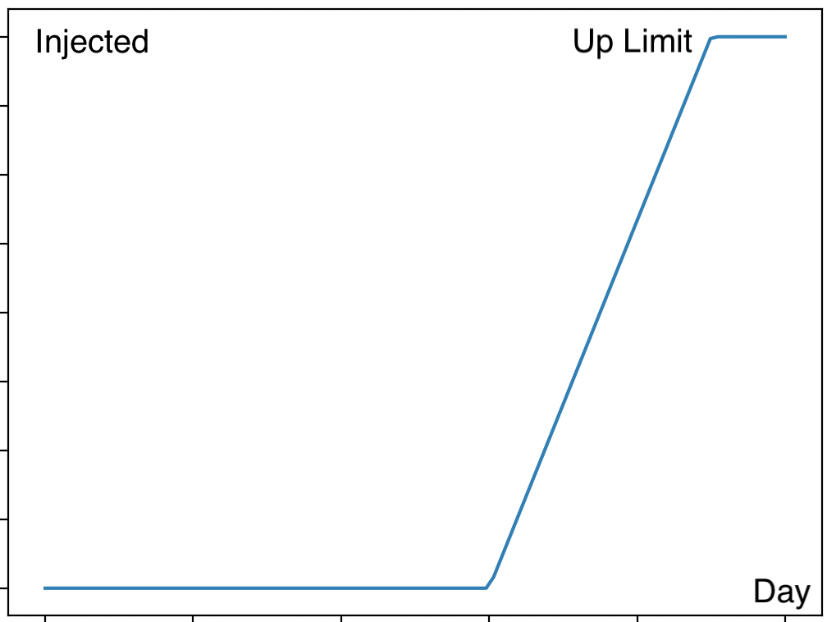

And the effect to R is like:

3. Barrier

In this case, we consider two measures – “Quarantine” and “Ventilation”. “Quarantine” is parted into “Susceptible” and “Patient” due to different medications to the crowd. We will count “Patient” in Recovery later. The basic formula is:

4. Test & Trace

We have four variants, “Test Efficiency”, “Test Percentage”, “Trace Efficiency”, and “Trace Percentage”. Like Barrier, it goes like:

5. Population

When infected case goes up, the spread of virus would get faster due to the large patient crowd. However, when it comes to certain level, people raise the attentiveness and be more conscious of protection. Thus, the proportion would be smaller. $$R=R_{init}*\left(1-{\frac{current case}{TOTAL PPL}}^{0.015}\right)$$

Y = 1 – X^0.015 goes like this:

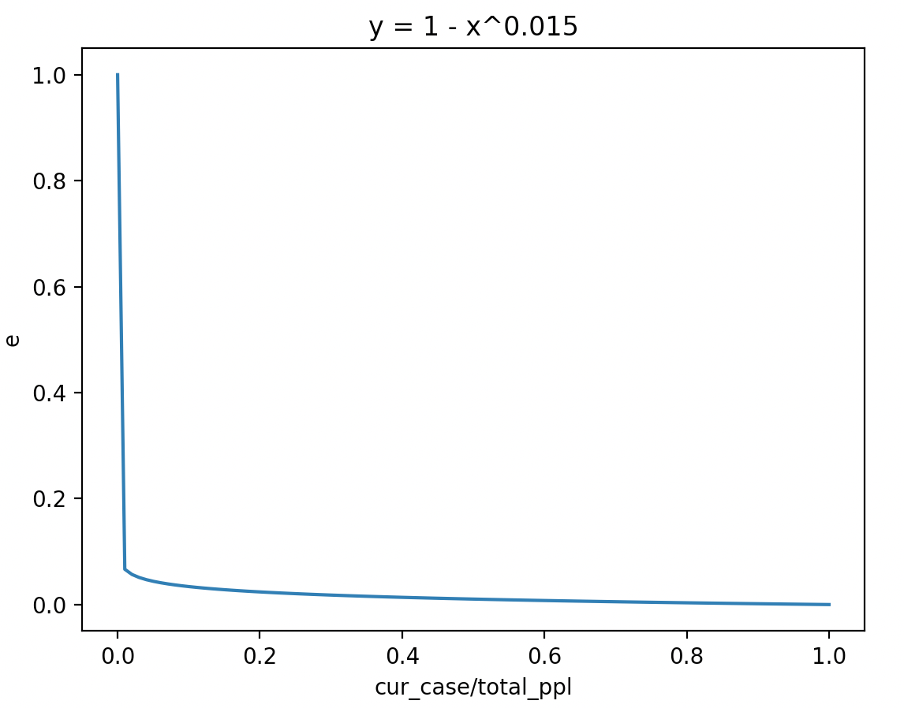

When virus just exploded which means current case is small, we assume most of people would be careful about that so the reproduction number drops significantly. However, there are still remaining part that go to party regardless of the pandemic. The case number does little to their lifestyle. So population limitation drops slowly afterwards.

6. Recovery

Patients would recover from Covid-19 due to the quarantine or other medications. We suppose an average recovery day in this case as “Cure Need Days”. Other variants go like “Cure Percentage” and “Quarantine Effectiveness of Patient”. When we do good medications and quarantine, the “Cure Percentage” raise up.

$$Cure Cases=Case\left(Cure Need Days ago\right)*Cure Percentage$$

And we add arbitrary factor to cover those unexpected situations:

$$Random Cure Cases=Case*Random Cure Percentage$$

The Random Percentage is set up to 0.05.

**Output**

Here we provide with an example of an anonymous viruswhich R0 is set up to 15. It shows an obvious change: <https://youtu.be/Wj48V1YD-8c>

Here are animated pie charts of Covid-19 and SARS

[<animated pie chart of Covid-19 R0 = 2>](https://youtu.be/rMSMOSxsACw)

[<animated pie chart of Sars R0 = 3>](https://youtu.be/0NyIeBcWkn8)

<example line graphs of anonymous virus R0=15>

<line graphs of Covid-19 R0=2>

<line graphs of SARS R0=3>

**Mathematical Analysis**

Compare two virus,

**Conclusion**

**Unit tests result**

