Kan Zhang (NUID 001529338)

**Program Structures & Algorithms**

**Spring 2021**

**Assignment No. 3**

* **Task**
* Step 1:  
  (a) Implement height-weighted Quick Union with Path Compression. For this, you will flesh out the class UF_HWQUPC. All you have to do is to fill in the sections marked with // TO BE IMPLEMENTED ... // ...END IMPLEMENTATION.
* (b) Check that the unit tests for this class all work. You must show "green" test results in your submission (screenshot is OK).
* Step 2:  
  Using your implementation of UF_HWQUPC, develop a UF ("union-find") client that takes an integer value n from the command line to determine the number of "sites." Then generates random pairs of integers between 0 and n-1, calling connected() to determine if they are connected and union() if not. Loop until all sites are connected then print the number of connections generated. Package your program as a static method count() that takes n as the argument and returns the number of connections; and a main() that takes n from the command line, calls count() and prints the returned value. If you prefer, you can create a main program that doesn't require any input and runs the experiment for a fixed set of n values. Show evidence of your run(s).
* Step 3:  
  Determine the relationship between the number of objects (n) and the number of pairs (m) generated to accomplish this (i.e. to reduce the number of components from n to 1). Justify your conclusion.
* **Output**

N = number of sites. M = number of pairs generated. Each N runs 100 experiments. The average result is in the table below.

|  |  |  |  |  |  |  |  |  |  |
| --- | --- | --- | --- | --- | --- | --- | --- | --- | --- |
| N | 50 | 100 | 150 | 200 | 250 | 300 | 350 | 400 | 450 |
| m | 117.75 | 259.59 | 413.1 | 614.97 | 750.39 | 975.97 | 1167.81 | 1282.58 | 1497.33 |

**The whole result of runs is too long. I snip part as below.**

The number of sites is: 450

The number of connections is: 1758

The number of sites is: 450

The number of connections is: 1354

The number of sites is: 450

The number of connections is: 1377

The number of sites is: 450

The number of connections is: 1598

The number of sites is: 450

The number of connections is: 1232

* **Relationship Conclusion:**

**m = 3.5364*N – 94.05**

* **Evidence to support the conclusion:**

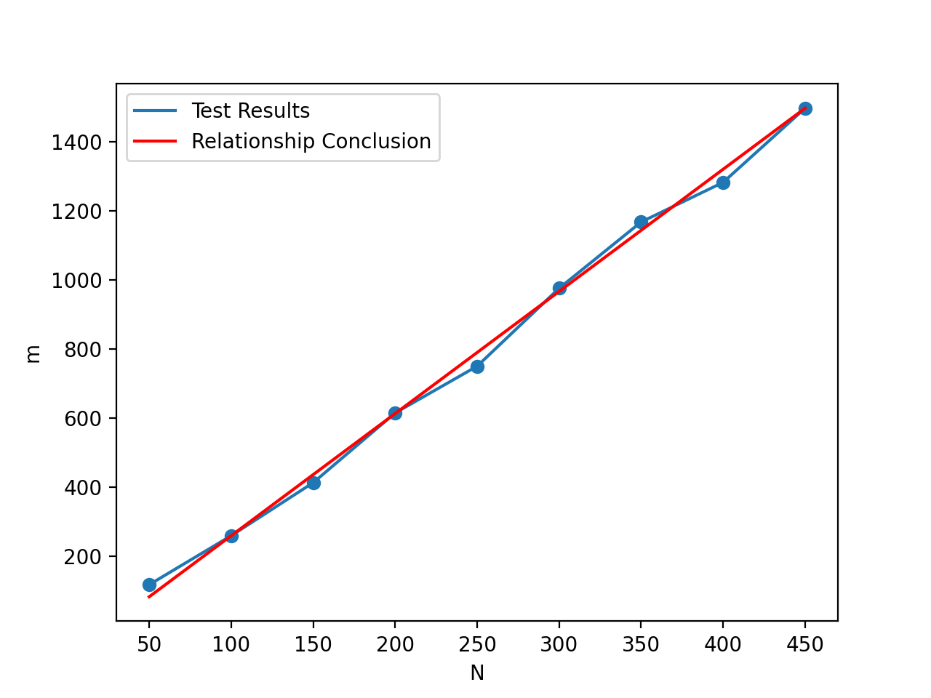

* **Unit tests result:**

Step1: 