1. Creating and Renaming Files/Directories

Create a directory named test_dir using mkdir.

Inside test_dir, create an empty file called example.txt.

Rename example.txt to renamed_example.txt using mv

**Solution**

**Commands in brief:**

1. ls without creating directive
2. created directory
3. ls with new directory
4. created file inside directory using touch
5. went into directory
6. ls
7. renamed using mv
8. ls

**Screenshot**

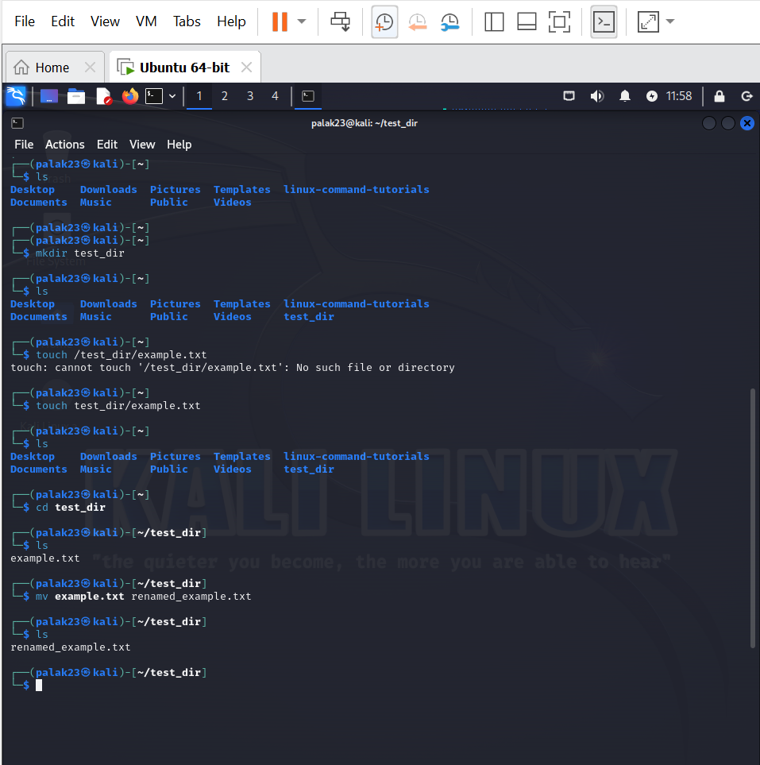

2. Viewing File Contents

Use cat to display the contents of /etc/passwd.

Display only the first 5 lines of /etc/passwd using head.

Display only the last 5 lines of /etc/passwd using tail.

**Solution**

**Commands:**

1. cat /etc/passwd
2. head -n 5 /etc/passwd
3. tail -n 5 /etc/passwd

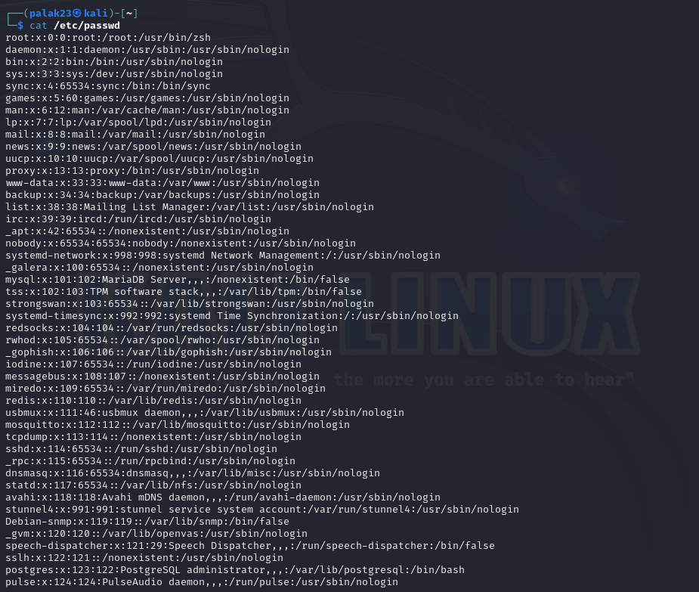**Screenshot:**

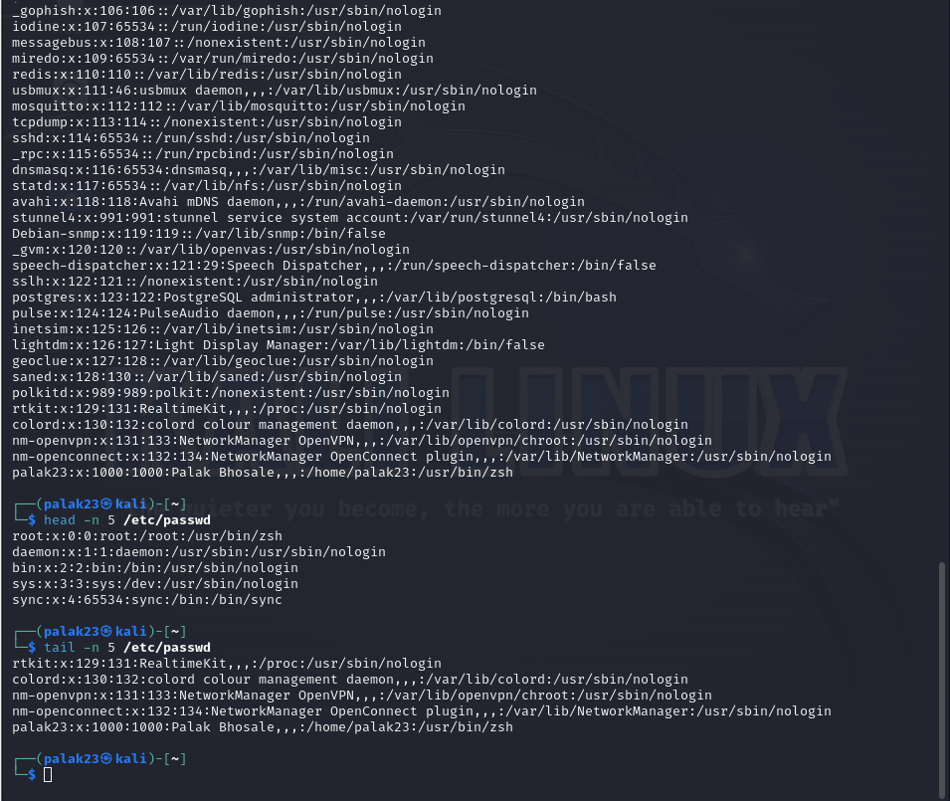

3.Searching for Patterns

Use grep to find all lines containing the word "root" in /etc/passwd.

**Solution:**

**Commands:**

1. cat /etc/passwd | grep -n root /etc/passwd

**Screenshot:**

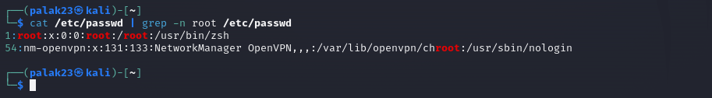

4. Zipping and Unzipping

Compress the test_dir directory into a file named test_dir.zip using zip.

Unzip test_dir.zip into a new directory named unzipped_dir.

**Solution:**

**Commands:**

1. ls
2. zip -r test_dir.zip test_dir
3. ls
4. unzip test_dir.zip -d unzipped_dir
5. ls

**Screenshot:**

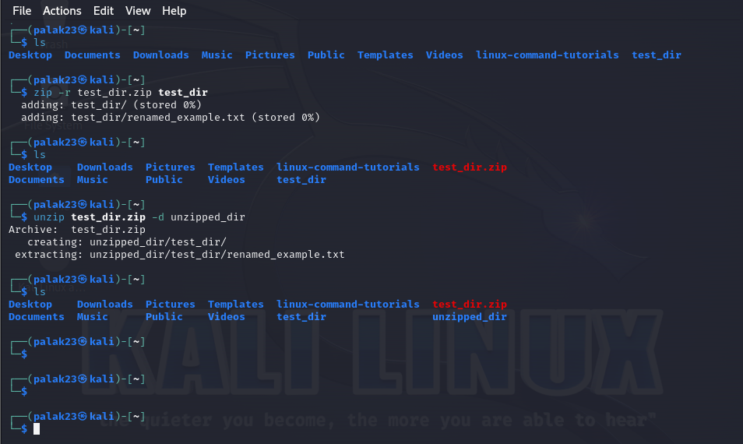

5. Downloading Files

Use wget to download a file from a URL (e.g., <https://example.com/sample.txt>).

**Solution:**

**Commands:**

1. wget <https://example.com/sample.txt>

**Screenshot:**

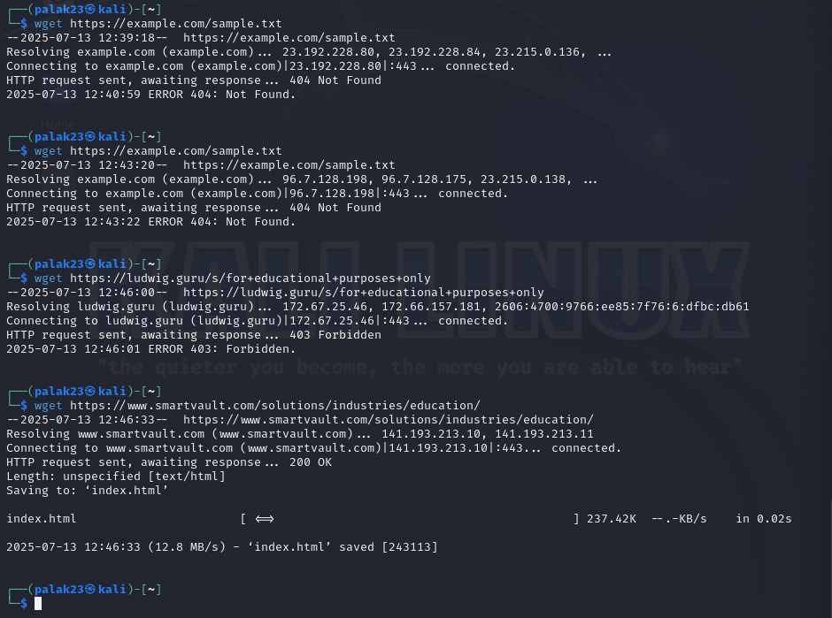

6. Changing Permissions

Create a file named secure.txt and change its permissions to read-only for everyone using chmod.

**Solution:**

**Command:**

1. ls -l
2. touch secure.txt
3. ls -l
4. chmod 444 secure.txt
5. ls -l

**Screenshot:**

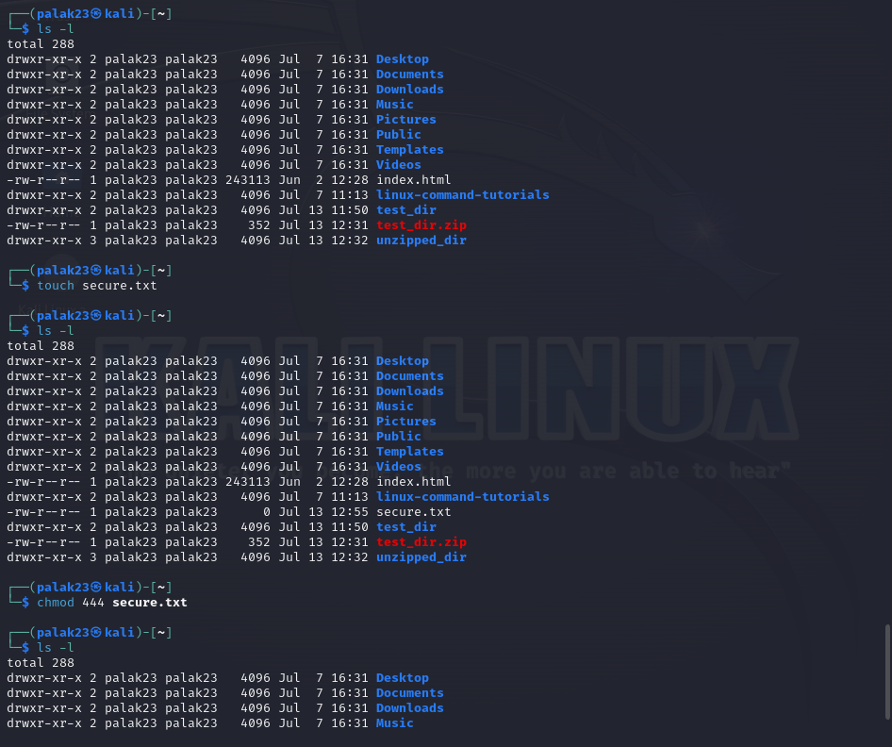

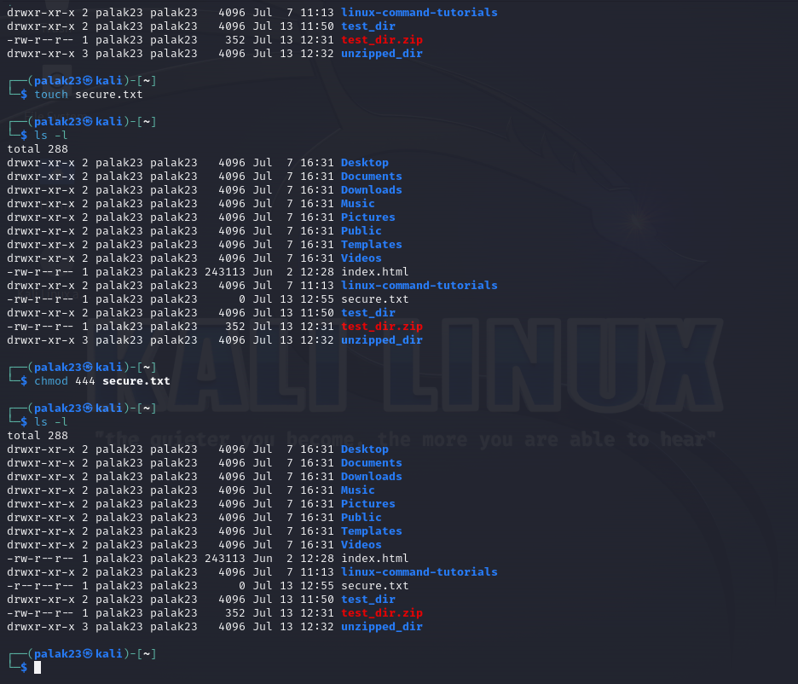

7. Working with Environment Variables

Use export to set a new environment variable called MY_VAR with the value "Hello, Linux!".

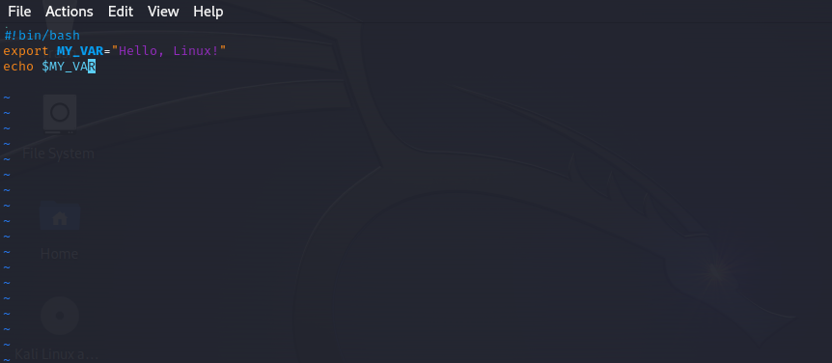**Screenshot:**

