Cloud Storage Forensic Examination
Dropbox, Google Drive, and OneDrive — reconstructing account activity from local sync artifacts

Objective
Examine the local artifacts three major cloud storage clients leave behind on a Windows system, in order to establish account ownership, reconstruct synchronization history, and evaluate how each vendor's proprietary storage format affects what a standard forensic tool can and can't read natively.

Tools
Autopsy for ingest, keyword search, and file triage; DB Browser for SQLite to directly query a client's local database; EpochConverter to translate UNIX timestamps recovered from logs and databases into human-readable dates.

Process
- Ingested logical file sets containing each client's AppData and Prefetch artifacts in Autopsy, then used a keyword search for “users” against prefetch files and account metadata to establish ownership for each account.
- Dropbox: the initial ingest didn't parse the expected folder structure. Rather than stop there, I ran the Dropbox executable locally first to generate its standard folder layout, then re-ingested — which resolved the issue and exposed the AppData subfolders needed for the rest of the analysis.
- Google Drive: used DB Browser for SQLite to open snapshot.db directly and inspect the cloud_entry table, distinguishing its role (a current-state record of what's deleted) from sync_log.log's RawEvents (a chronological record of the delete action itself, useful even after the entry is gone from the database).
- OneDrive: parsed the plaintext SyncDiagnostics.log to recover the account's Client ID (CID) and cloud folder hierarchy, then reconciled a contradiction between the log's reported file count and what Autopsy's tree pane showed was actually present on disk.
- Compared the three vendors' underlying storage logic directly: Dropbox encodes its local database in Base-64, Google Drive uses queryable SQLite databases, and OneDrive relies on plaintext diagnostic logs and binary .odl files — three different architectures requiring three different investigative approaches.

Dropbox — Encoded Local Databases
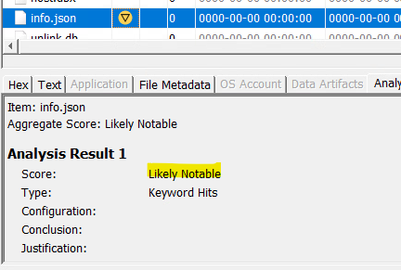
Figure 1 — filecache.dbx and info.json flagged as “Likely Notable” by Autopsy's automated triage.

Prefetch artifacts (DROPBOX.EXE and DROPBOXINSTALLER.EXE) confirmed the application had been installed and run, and a keyword search tied account activity to a specific Windows user profile. Autopsy could detect filecache.dbx and flag it as high-value, but could not natively decode its contents — Dropbox has stored this file in Base-64 since 2012, so the viewer just displayed encoded, unreadable text. The tool proves the file's existence and relevance; interpreting it requires recognizing the encoding first.

Google Drive — Querying a Client's Own Database
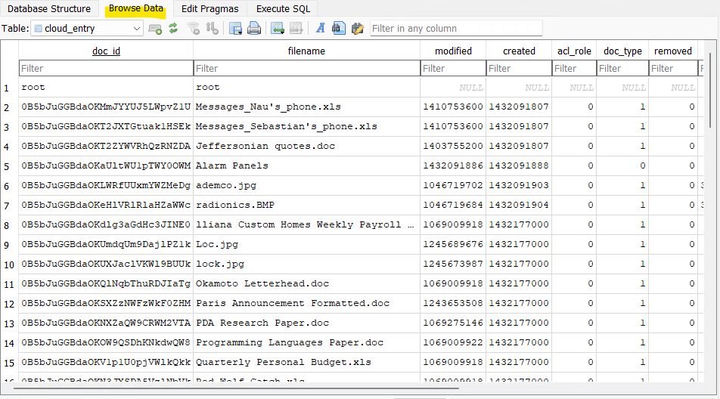
Figure 2 — snapshot.db opened directly in DB Browser for SQLite, showing the cloud_entry table's tracked file records.

Rather than relying only on what Autopsy could surface automatically, I opened Google Drive's snapshot.db directly in DB Browser for SQLite. That let me inspect the cloud_entry table's deletion-tracking column as the authoritative current-state record, and separately confirm that sync_log.log's RawEvents (CREATE/MODIFY/DELETE entries, each carrying a UNIX timestamp and inode number) preserve a permanent record of file activity even after an entry is gone from the live database. That distinction — a state database versus an event log — recurs across cloud forensics and shaped how I read the other two clients.

OneDrive — Reconciling the Log Against the Disk
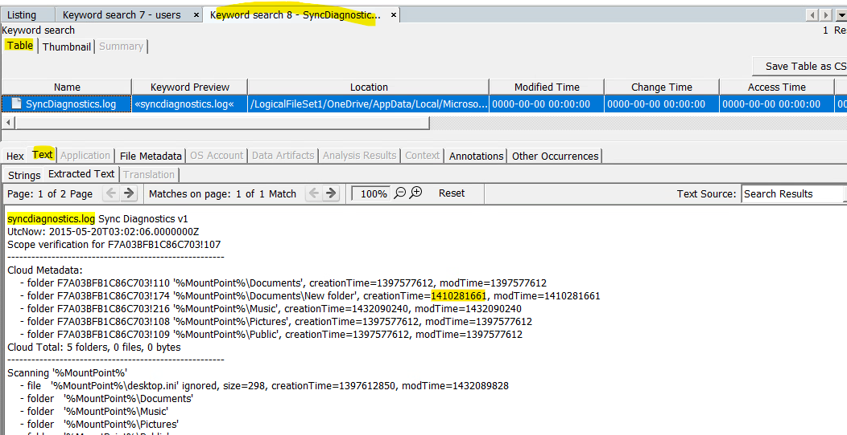
Figure 3 — SyncDiagnostics.log exposing the account's Client ID (CID) and cloud folder hierarchy.

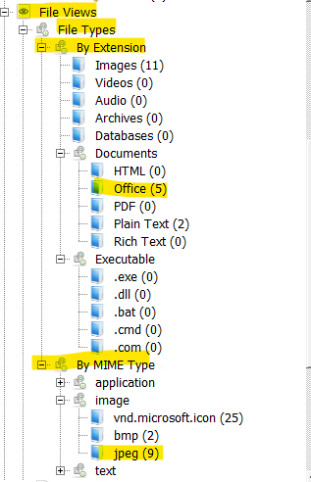
Figure 4 — Autopsy's tree pane showing Office and image files physically present on disk.

SyncDiagnostics.log surfaced the account's CID — a persistent, hardware-independent identifier that survives a username or email change and is what would actually be provided to Microsoft in a subpoena for account attribution. The log also reported the sync engine was tracking zero full or stub files, which on its face reads as an empty account. Autopsy's tree pane told a different story: real Office documents and images physically present on the disk. Reconciling those two views showed that a signed-out or unlinked account can still leave orphaned, forensically recoverable data behind — the sync log reflects what's actively being tracked, not what's actually sitting on the drive.

Key Findings
- Each vendor stores local sync metadata in a fundamentally different format — encoded (Dropbox), relational (Google Drive), and plaintext diagnostic (OneDrive) — and a standard tool's ability to read that format natively can't be assumed; it has to be verified per vendor.
- A state database (like snapshot.db) and an event log (like RawEvents) answer different questions — “what's true right now” versus “what happened and when” — and a thorough examination needs both.
- A persistent identifier like OneDrive's CID is more forensically durable than a username, since it survives account renaming in a way a display name doesn't.
- A sync log reporting zero tracked files doesn't mean zero recoverable evidence — orphaned local copies can outlive the sync relationship itself.

Conclusion
Across all three clients, the consistent lesson was that a cloud account's “private” activity is rarely fully remote — local sync artifacts reconstruct a surprising amount of account and timeline evidence on their own. But the reverse is just as true: each vendor's storage choices actively shape what an investigator can pull out with default tooling versus what requires stepping outside it, whether that's decoding, direct database queries, or reconciling a log against the disk it claims to describe.

