Cross-File-System Forensic Examination
FAT32, NTFS, and HFS+ — comparative disk image analysis using FTK Imager

Objective
Examine three disk images formatted with different file systems — FAT32, NTFS, and HFS+ — to compare how each stores, structures, and marks deleted data, and to establish a working baseline for cross-platform disk forensics.

Tools
AccessData FTK Imager, used to mount each image, inspect drive geometry, and read file-system metadata directly from the Properties pane.

Process
- Mounted all three disk images (.001) in FTK Imager and confirmed each file system from the Properties pane before analysis.
- Recorded drive geometry (sector size, sector count, cluster count) for the FAT32 image to establish the physical-to-logical mapping of the disk.
- Located each file system's identifying hex signature at its known offset — NTFS at offset 0, HFS+ at offset 1024 — to confirm file-system type independent of OS labeling.
- Compared how each system marks and stores deleted files: FAT32/NTFS flag deleted entries with a leading hex byte (visually shown as a red X in FTK Imager), while HFS+ instead relocates deleted items into a hidden .Trashes/501 folder.

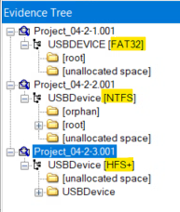
Figure 1 — Evidence tree confirming FAT32, NTFS, and HFS+ across the three mounted images.

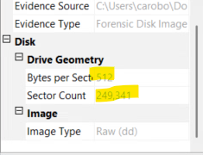
Figure 2 — Drive geometry for the FAT32 image: 249,341 sectors (512 bytes each), 120,574 clusters.

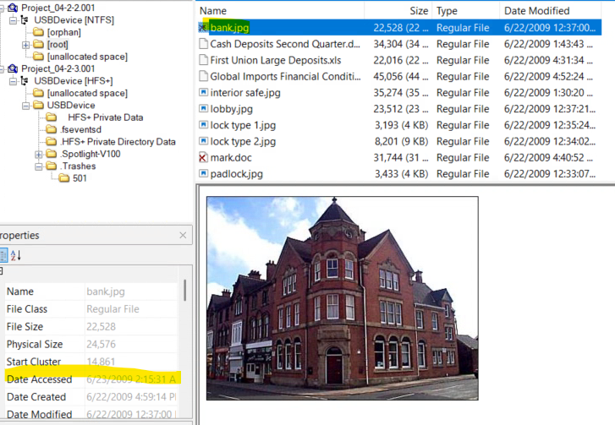
Figure 3 — NTFS file-system signature (4E 54 46 53 / “NTFS”) confirmed at offset 0 in the hex view.

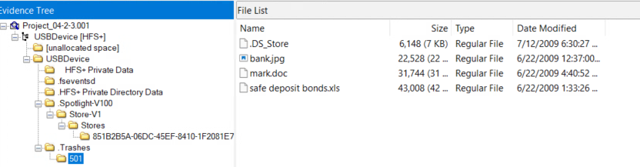
Figure 4 — HFS+ .Trashes/501 folder holding deleted items, in place of a FAT/NTFS-style red-X marker.

Key Findings
- FAT32 image: 249,341 total sectors and 120,574 clusters; 16 total files identified, 13 existing and 3 deleted.
- File-system fingerprinting by hex signature is possible independent of file extension or OS reporting — verified for both NTFS and HFS+.
- File signature verification (e.g., confirming a renamed file as a JPEG via its JFIF header) demonstrated that a file's extension cannot be trusted as evidence of its true type.
- HFS+ does not expose a Volume Serial Number in the same way Windows file systems do, and start-sector information is comparatively harder to locate — a practical limitation to account for when planning a macOS-based examination.

Conclusion
This comparison reinforced that a file's extension and an OS's own file-type reporting are conveniences, not evidence — the hexadecimal header and the file system's own structures are what an investigator can actually rely on. It also highlighted that recovery approaches have to be file-system-aware: the same conceptual goal (finding a deleted file) requires a different technique depending on whether the evidence is FAT32, NTFS, or HFS+.

