Mobile Device Forensic Examination
Recovering and verifying evidence from a mobile handset's storage using Autopsy and FTK Imager

Objective
Ingest and analyze a forensic image of a mobile device's removable storage (Motorola.E01) to identify the file system in use, recover deleted multimedia content, and confirm the device's make, model, and technical specifications from embedded metadata.

Tools
Autopsy, used for ingest, automated file carving, and EXIF metadata extraction; FTK Imager Lite, used to inspect a second handset image directly for text messages, phone numbers, and photos.

Process
- Ingested the Motorola.E01 image in Autopsy and identified the MicroSD card as a SanDisk “SANVOL” volume formatted with FAT16, a legacy file system common on older removable mobile storage.
- Used Autopsy's automated ingest modules to run file carving ($CarvedFiles) against unallocated space, recovering image fragments that no longer had an active directory entry.
- Cross-referenced EXIF metadata against the Master Boot Record to independently confirm the originating hardware, without relying on file names or directory structure alone.
- Repeated a parallel examination on a second device image (LG VX6000) directly in FTK Imager Lite to extract text messages, phone numbers, and photos without a full case ingest.

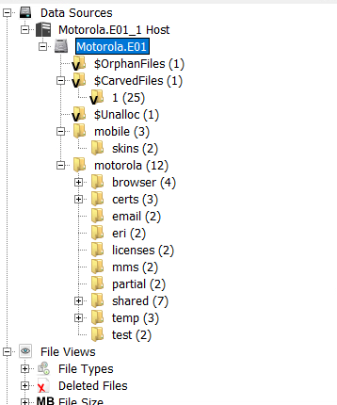
Figure 1 — EXIF metadata confirming the originating device: Motorola hardware, 1.3 Megapixel camera.

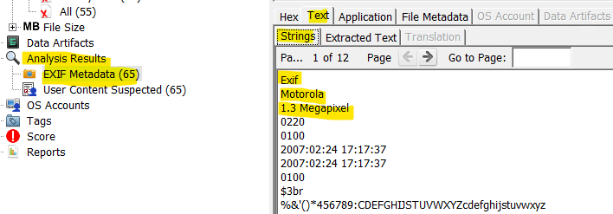
Figure 2 — Carved files recovered from unallocated space; several thumbnails render blank where the file body was overwritten.

Key Findings
- Volume and file system: SanDisk SANVOL, FAT16 — directory last modified 2006-03-09 06:38:20 EST.
- Hardware confirmation: EXIF metadata definitively linked recovered photos to Motorola hardware with a 1.3 Megapixel sensor, independent of any file or folder naming.
- Recovery scope: 65 images carried valid EXIF metadata; 25 additional files were recovered purely through carving, with no surviving directory entry.
- Tool limitation observed: several carved thumbnails rendered blank (black) — Autopsy could locate a file's header signature but could not reconstruct the image where the underlying data had already been overwritten. This is a real ceiling on carving-based recovery, not a configuration issue.
- Deleting a file does not remove its corroborating metadata: even where content was destroyed, the MBR and EXIF metadata remained intact, meaning device attribution can often still be proven.

Conclusion
This examination showed the practical gap between recovering a file's existence and recovering its usable content: carving can prove that something was there and, through surviving metadata, often what device produced it, even when the actual image data is unrecoverable. For an investigator, that distinction changes what can and can't be claimed from a piece of recovered evidence — a limitation worth stating plainly rather than glossing over in a report.

