##### DATA FLOW DIAGRAMS

##### DATA FLOW DIAGRAMS:

A graphical tool used to describe and analyze the moment of data through a system manual or automated including the process, stores of data, and delays in the system. Data Flow Diagrams are the central tool and the basis from which other components are developed. The transformation of data from input to output, through processes, may be described logically and independently of the physical components associated with the system. The DFD is also know as a data flow graph or a bubble chart.

DFDs are the model of the proposed system. They clearly should show the requirements on which the new system should be built. Later during design activity this is taken as the basis for drawing the system’s structure charts. The Basic Notation used to create a DFD’s are as follows:

**Dataflow:** Data move in a specific direction from an origin to a destination.

**Process:** People, procedures, or devices that use or produce (Transform) Data. The physical component is not identified.

**3. Source:** External sources or destination of data, which may be People, programs, organizations or other entities.

**Data Store:** Here data are stored or referenced by a process in the System.

**Context Level DATA FLOW DIAGRAM:**



**AUTHENTICATION DFD:**



Level 2 Data Flow Diagram for Users Authentication

**ADMIN:**



Level1 Data Flow Diagram for Admin:



**LEVEL-2:**

**Administrator:**













**LEVEL-3:**

**ADMINISTRATOR:**













**LEVEL-4:**

**Administrator:**



Level 4 Data Flow Diagram for Add Employee Details

 Level 4 Data Flow Diagram for Add Acc Types Details

**Employee:**



**Level1 Data Flow Diagram for Employee:**



**LEVEL-2:**

**EMPLOYEE:**













**LEVEL-3:**

**Employee:**



















**LEVEL-4:**

**Employee:**



Level 4 Data Flow Diagram for Stop Payment Master Details

**LEVEL-0:**

**Customer:** 

**Level1Data Flow Diagram For Customer:**



**LEVEL-2:**

**Customer:**













**LEVEL-3:**

**Customer:**

















**LEVEL-4:**

**Customer:**



Level 4 Data Flow Diagram for Add Cheque Book Request Details

**E-R Diagram**

In this the structural and behavioral aspects of the environment in which the system is to be implemented are represented.

**UML is specifically constructed through two different domains they are:**

* 1. UML Analysis modeling, this focuses on the user model and structural model views of the system.
  2. UML design modeling, which focuses on the behavioral modeling, implementation modeling and environmental model views.

**Use case Diagrams** represent the functionality of the system from a user’s point of view. Use cases are used during requirements elicitation and analysis to represent the functionality of the system. Use cases focus on the behavior of the system from external point of view.

**Actors** are external entities that interact with the system. Examples of actors include users like administrator, bank customer …etc., or another system like central database.

**Class Collaboration Diagram**

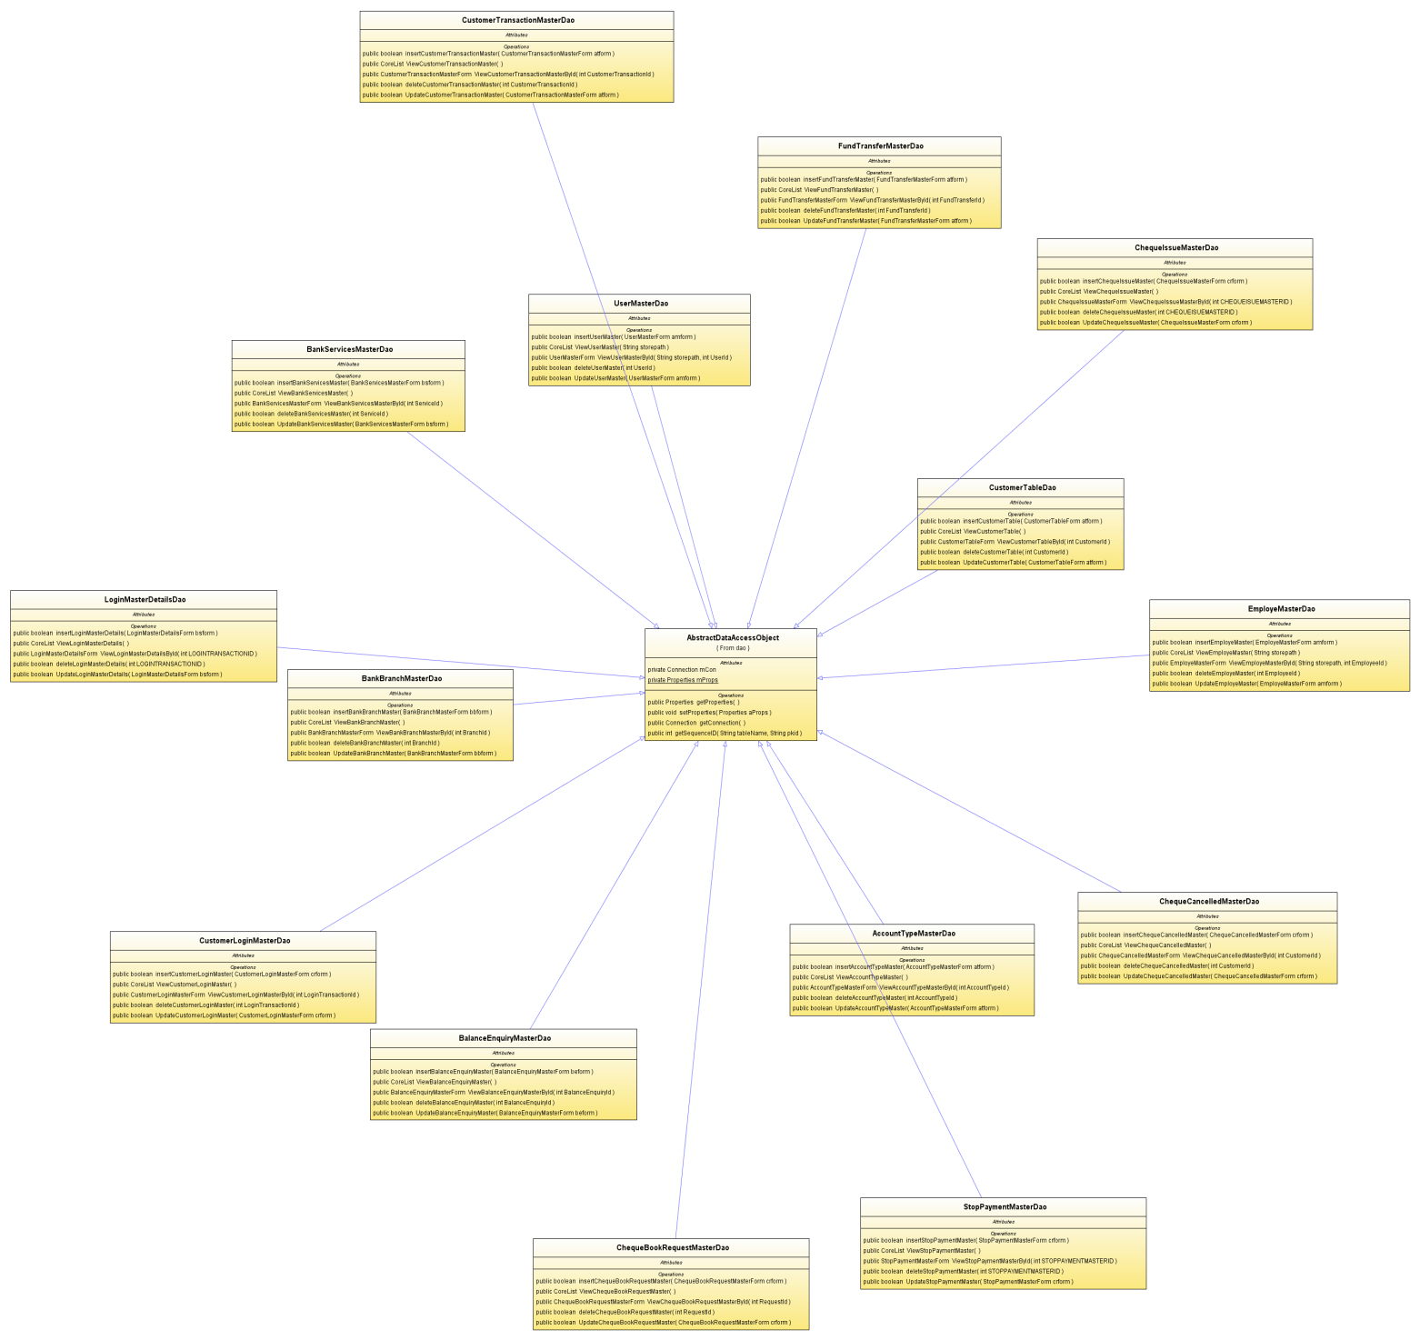

**Use Case Diagrams**

**System use case Diagram:**



**Administrator Use case Diagram:**



**Employee Use case Diagram:**



**Customer Use Case Diagram:**

