**CRYPTOPAL CLIENTS INTRO**

1. **CryptoPal home screen**

**Payment:**

| On the initial payment screen, information about the purchase is displayed and one of the offered payment methods is selected. |
| --- |

1. **They are shown in the upper part of the screen:**

-web address of the WebShop

- cards, individually, for each of the products/services that are purchased, which contain: product/service name, quantity and price per unit.

- the total amount to be paid

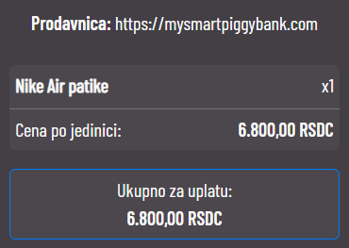

1. **In the lower part of the screen there are available payment methods.**

There are three payment methods available:

**a. CryptoCode (no commission)**

**b. Stock market (without commission)**

**c. Blockchain (chain commission)**

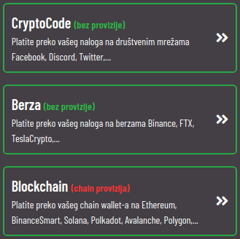

1. **Payment by option - CryptoCode (no commission)**

A payment method that enables payment via social networks Facebook, Discord, Twitter,...

SOON

1. **Payment by option - Stock Exchange (no commission)**

A payment method that enables payment through a personal account on exchanges: TeslaCrypto, Binance, FTX,...

b.1 TeslaCrypto payment

In order to be able to make a payment through the TeslaCrypto exchange, you need to have an open account on the TeslaCrypto platform (with 2FA enabled - two-step authentication factor).

You must also have the required amount on your account for the payment you have chosen, in one of the offered cryptocurrencies.

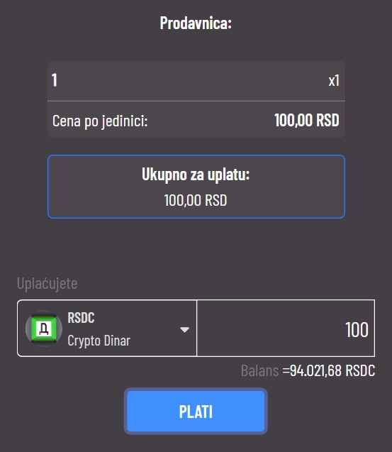

By pressing the menu, the available cryptocurrencies will appear

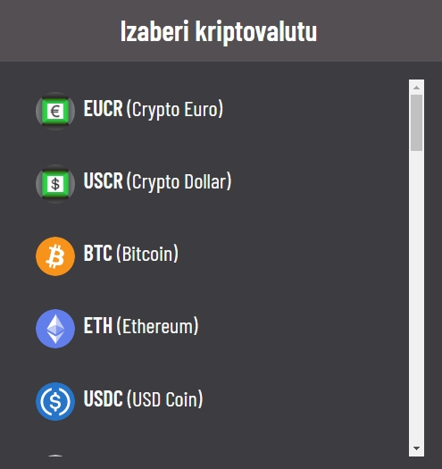

When you select the cryptocurrency you want to make the payment with, you will automatically be shown the calculation of the required amount in that cryptocurrency.

At the very bottom you will see your current balance in the chosen cryptocurrency.

After choosing a cryptocurrency and if you have enough funds in that cryptocurrency, press the "PAY" button and a transaction confirmation modal will open.

When you confirm the transaction, the payment will be made.

1. **Payment by option - Blockchain (chain commission)**

A payment method that enables payment through your blockchain wallet on Ethereum, BinanceSmart, Solana, Polkadot, Avalanche, Polygon,...

This payment method is the only one with a commission that depends on the blockchain itself.

You only need to choose the cryptocurrency in which you will make the payment (and the price will be automatically calculated) and enter the address of your wallet in which you have selected means of payment and from which you will make the transaction.

By pressing the CONFIRM button, you will be shown the total payment amount in the cryptocurrency you have chosen.

Below that, you will be shown the remaining time for the payment (the deadline is 5 minutes) and the address of the wallet to which you need to send the payment.

The sending address can be displayed in two ways:

SCAN - scan the QR code with your phone

COPY - manual copying of the address

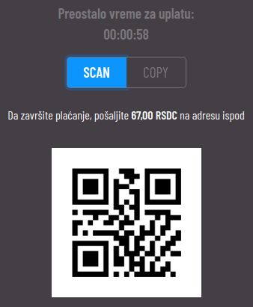

1. **Marketplace**
2. **CryptoCode**
3. **TeslaCrypto**