**CRYPTOPAL PLUGIN SPECIFICATION**

1. **INTRO**

CryptoPal is a crypto currency payment processor.

CryptoPal Shop DEMO: <https://mysmartpiggybank.com/shop/>

Our WooCommerce test shop: <https://smartshopping.network/shop/>

1. **CRYPTOPAL API**

**API URL:** [https://app.teslacrypto.](https://app.teslacryptocap.com)me

**HTTP Request**: POST /cryptopalPayments

**Request Headers:**

| **Header** | **Value** |
| --- | --- |
| “Accept” | “application/json” |
| “Content-Type” | “application/json” |

**Request Parameters**:

| **Parameter** | **Required** | **Type** | **Comment** |
| --- | --- | --- | --- |
| item | yes | array | array of item* objects |
| webshopID | yes | string | ID of your webshop provided on TeslaCrypto app |
| currency | yes | string | webshop currency specified in woocommerce |

**item object** - is an object that has 3 fields:

1. name ( required: yes, type: string )

2. amount ( required: yes, type: number )

3. price ( required: yes, type: number )

**Response Parameters:**

| **Parameter** | **Type** | **Comment** |
| --- | --- | --- |
| url | string | Redirection URL which opens CryptoPal in a new browser window |
| paymentID | string | ID of the payment |

1. **WOOCOMMERCE PLUGIN**

We need a plugin that connects WooCommerce with CryptoPal. More specifically a plugin that adds <Pay With CryptoPal> option to the WooCommerce Admin Dashboard so that Web Shops that work with us can add CryptoPal as a payment option to their shops (just like PayPal).

Plugin needs to connect to our CryptoPal API (section 2) and redirect the user to our app upon payment. **API calls have to be made server side and not be exposed to the client**.

The required fields for the plugin setup page on woo commerce admin dashboard should be: 1. Enable CryptoPal (checkbox) 2. Description (textarea) 3. MerchantID (text input) 4. Webhook (url input). All 4 fields are required. MerchantID and Webhook will be provided to the merchant through a setup process on our app.

This is our demo shop example <https://mysmartpiggybank.com/shop/>. To test it and see how it should look like, go to our demo shop, choose any product and click on the button “Kupi”, after that a modal will pop up, select the amount in the “Količina” field, select “Kripto plaćanje” as payment option and finally click on the “Nastavi Kupovinu” button.

When Merchants create their WebShops entries on our app, they have to enter a route that will serve as a webhook. This webhook needs to be configured to listen to incoming HTTP POST requests through our plugin. Since some payments can take up to 10 minutes to process, we will provide the status of the payment through the webhook. Until the payment is processed, the payment status should be “pending”. After the payment is done either successful/failed, the status of the payment should be updated on the woocommerce admin dashboard too.

1. **COMPETITION PLUGINS /similar to us/**

<https://docs.8pay.network/plugins/woocommerce>

<https://wordpress.org/plugins/coinpayments-payment-gateway-for-woocommerce/#description>

<https://bitpay.com/integrations/woocommerce>

<https://wordpress.org/plugins/bitpay-checkout-for-woocommerce/>

<https://wordpress.org/plugins/coingate-for-woocommerce/>

**DOCUMENTATION**

**# README v1.0**

**2022.07.11.**

**# Project name**

Cyptopal Gateway

**# Introduction**

Cryptopal Gateway allows to add to the wordpress shop an additional payment gateway wich allows to pay the shopping with cripto currency.

**##Table of Contents (TOC)**

at the beginning of the documentation makes sense, especially when your README file is more than a few paragraphs. If you think that the README file has grown too large, put some of the more detailed parts, such as installation or configuration sections, into their own files.

**# Usage (getting started)**

Provide a short code snippet (if applicable), or short usage instructions.

These instructions will get you a copy of the project up and running on your local machine for development and testing purposes.

**# Requirements (prerequest)**

In order to use cryptopal gateway plugin, you must have a wordpress installation running on your system and a woocommerce shop as well.

**# Installation**

Search and install the Cryptopal Gateway plugin in your wordpress.

**# Configuration**

You must configure the plugin in order to function correctly.Go to Woocommerce -> settings -> payments menu

1- Click on Cryptopal gateway "Manage" button.

2-Fill the required data...

-Enable/Disable -> Enables or disabled the plugin.

-Description -> A short descripion for the plugin.

-Whebshop ID -> An ID that you must have from us in order to use the plugin.

-Webhook -> Give a unique name to where the plugin will be receiving information from our app.

3-Click Save Changes and you are ready to go.

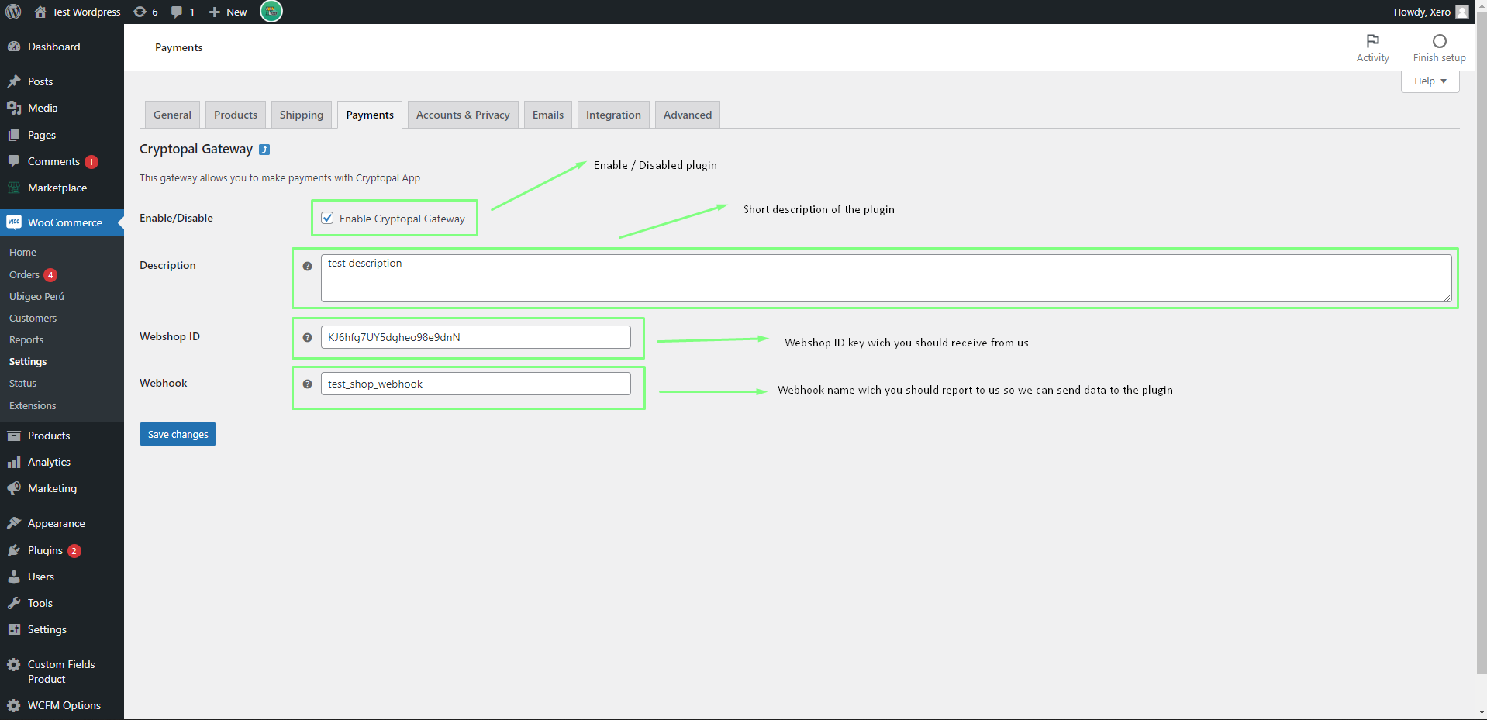

**# Deployment**

Download our plugin from wordpress.org, install it on your wordpress installation, configure it, and start shopping with crypto currency.

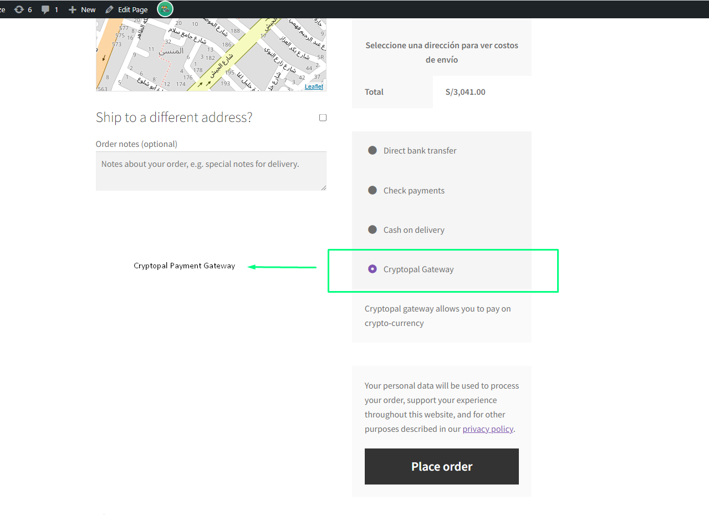

**### Running the tests**

Explain how to run the automated tests for this system

Break down into end to end tests. Explain what these tests test and why

Give an example and coding style tests. Explain what these tests test and why

Give an example.

**### Help**

Explain which communication channels are available to request help. Communication

channels with a proven track record are mailing lists, IRC channels, and forums. Also be sure to tell your more experienced users how and where to submit bugs or feature requests, possibly turning them into project participants.

**### Credits (authors)**

Jorge Blanco Suarez

Web: https://jorgewebcuba.000webhostapp.com/curriculum-vitae

**### Contributing**

Give instructions on how to participate in your project patches.

Please read CONTRIBUTING.md for details on our code of conduct, and the process for submitting pull requests to us.+

**### Contact**

People may want to reach out to you for various reasons, ranging from DCMA take down notices to questions about how to donate to your project. Provide contact information, such as an email address, and keep in mind that some countries may require certain information by law, such as a full postal address, website URL, and company name.

**# License**

This project is licensed under [insert license]. The license should be in a separate file called LICENSE, so don't explain it in detail within your documentation. Also, don't forget to specify licenses of third-party libraries and programs you use.

**#Versioning**

We use SemVer for versioning. For the versions available, see the tags on this repository.

**# Acknowledgments**

Hat tip to anyone who's code was used

Inspiration, etc..