**CRYPTOPAL MERCHANTS INTRODUCTION**

1. **Merchant registration**

In order to use the TeslaCrypto application as a merchant, you must first register as a user, and as a legal entity.

Before registering, you MUST read the "Terms of Use".

It is necessary to register the user in the following way - it is mandatory to:

1. - upload your profile picture (maximum image size: 5MB, supported image formats: JPG, JPEG, PNG, WEBP)
2. - enter the abbreviated name of your company, which will also be your username in the application (minimum 4, maximum 20 characters)
3. - enter the full name of your company (minimum 4, maximum 170 characters)
4. - enter your email address (maximum 70 characters)
5. - enter the PIB number of your company (9 digits)
6. - enter the MB of your company (minimum 7, maximum 8 digits)
7. - select from the list the country in which your company is located
8. - enter the city where your company is located (minimum 2, maximum 70 characters)
9. - enter the street where your company is located (minimum 4, maximum 70 characters)
10. - enter the address number of your company (minimum 1, maximum 20 characters)
11. - set your password, which you will keep privately in a safe place (minimum 6, maximum 50 characters)

If you agree with the stated conditions, check "Yes, I accept the Terms of Use." and press the REGISTER button to complete the registration.

To confirm the registration, you need to visit the confirmation link that will be sent to the email address you used during registration.

Also, it is mandatory to go through the complete verification process as well as perform two-factor authentication (2FA).

1. **Activating crypto payment processing**

Activating the store is done in the WebShop section by creating the WebShop itself. This enables the creation of POS products/services and the creation of payment instructions.

1. **WEB Shop payment processing settings**

On the CryptoPal > Processing screen in the WebShop section you have the option of creating your WebShops. On this screen, you can also see your WebShops created so far, as well as the history (overview) of all successfully sold products and services from your WebShops.

1. Creating a WebShop

By pressing the "CREATE WebShop" button, the creation screen opens.

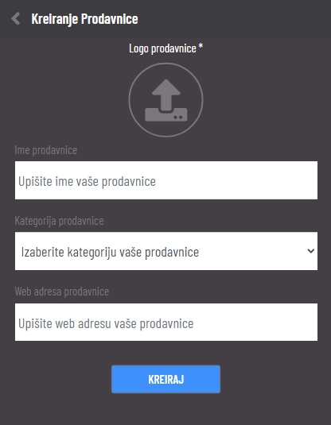

The following fields must be filled in:

* Logo* - upload your shop logo image (maximum image size: 5MB, supported image formats: JPG, JPEG, PNG, WEBP)
* Category of your WebShop (choose from the list)
* WebShop Name*
* Web address of your WebShop*
  1. **Connecting the cart to the CryptoPal API**

In order to connect Cryptopal with your website, you need to make an API call to our endpoint and after receiving the Redirect URL, do a client side redirect to that URL.

**More information in a separate document**

* 1. **Linking the cart to the CryptoPal widget**

Coming soon

1. **Setting up PoS payment processing**

On the CryptoPal > Processing screen in the POS section you have the option of creating POS products/services. On this screen you can also see the history (overview) of all your created POS products/services.

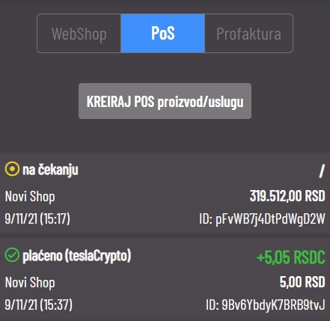

1. Creating a POS product/service

Pritiskom na dugme “KREIRAJ POS proizvod/uslugu” otvara nam se ekran za kreiranje.

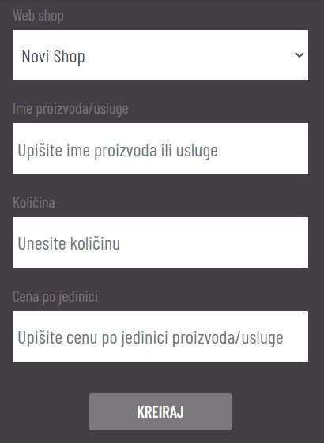

The following fields must be filled in:

* Web shop* - you choose one of your previously created shops
* Product/Service Name*
* Amount*
* Price per product/service unit*

By pressing the "CREATE" button, the POS product/service is created and you will be redirected to a new screen.

POS product/service - screen

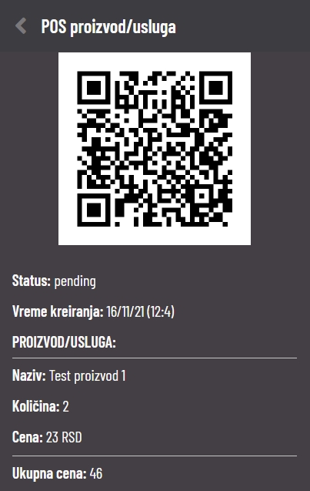

This screen displays a QR code that takes the user who purchases (the created POS product/service) to the payment page.

It is necessary for the user who wants to make a purchase to scan the displayed QR code with the camera of his phone. After that, the payment page will be opened for him.

1. **Setting up payment processing Pro-invoice**

On the CryptoPal > Processing screen in the Invoice section, you have the option of creating payment instructions. On this screen you can also see the history (view) of all your created payment instructions.

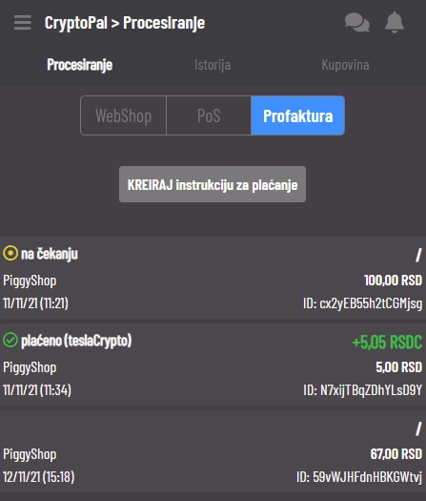

1. Creating a payment instruction

Pritiskom na dugme “KREIRAJ instrukciju za plaćanje” otvara nam se ekran za kreiranje.

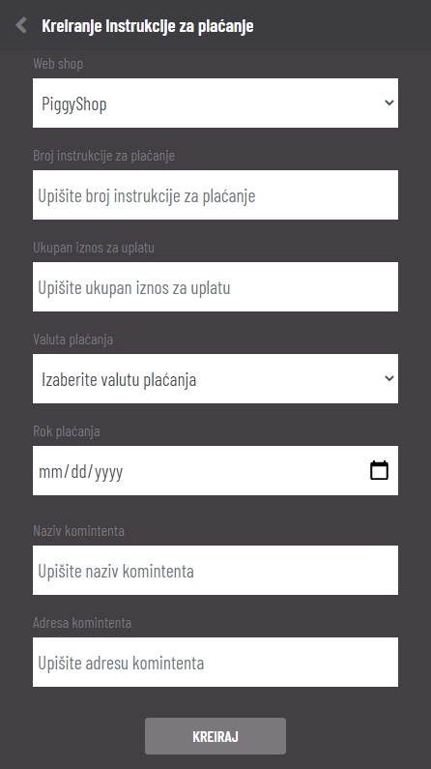

The following fields must be filled in:

* Web shop* - you choose one of your previously created shops
* Payment instruction number*
* Total amount to pay*
* Currency payments*
* Date of Payment*
* Client Name*
* Customer's address*

By pressing the "CREATE" button, a payment instruction is created and you will be redirected to a new screen.

Payment instruction - screen

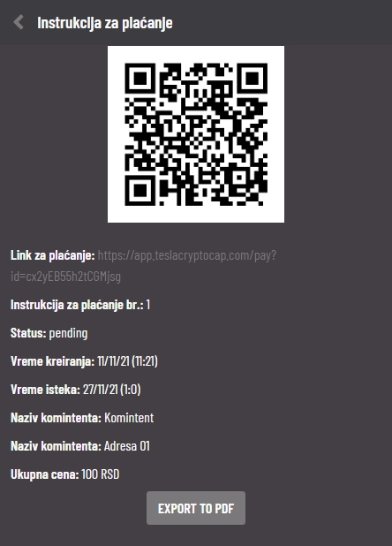

This screen displays a QR code that takes the user paying the created payment instruction to the payment page. Also, the user can access the mentioned payment page via the generated payment link.

By pressing the "EXPORT TO PDF" button, you get a created PDF document with all the information on this screen, which you can forward to the customer.

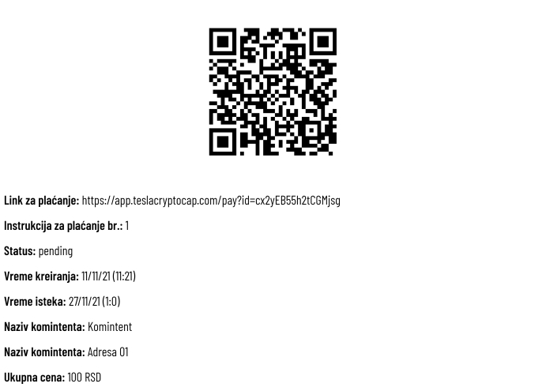

It is necessary for the user who wants to make a purchase to scan the displayed QR code or visit the payment link with the camera of his phone. After that, the payment page will be opened for him.

1. **Setting up payment processing for Funds**

Coming soon

**Example of WEB shop operation**

1. **PiggyShop activation**

Filling in all required fields.

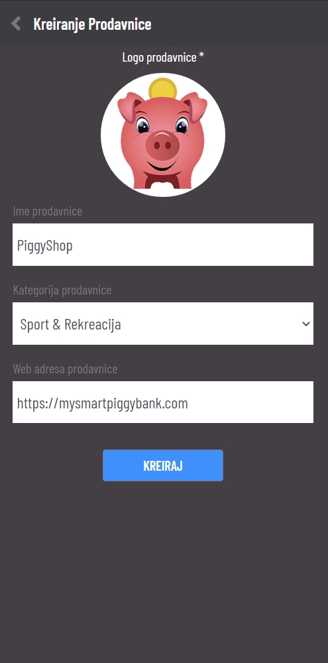

1. **PiggyShop settings**

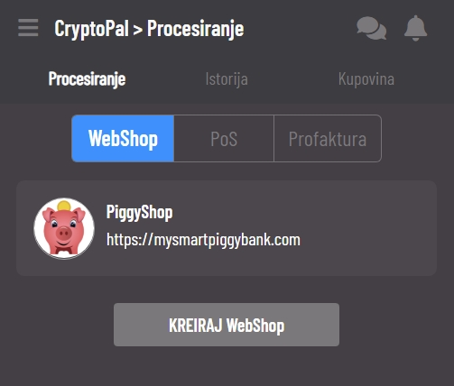

1. **PiggyShop integration**

In order to connect Cryptopal with your website, you need to make an API call to our endpoint and after receiving the Redirect URL, do a client side redirect to that URL.

**More information in a separate document**

1. **Shopping on PiggyShop**

[**https://mysmartpiggybank.com/shop/**](https://mysmartpiggybank.com/shop/)

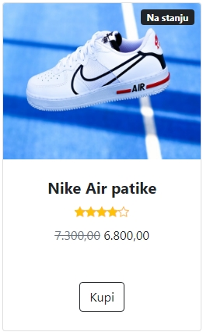

1. **PiggyShop payment processing**

