OBJECTIVE: Create a Word Template based on file WORD_Resume1.pdf.
- Determine the Font Types present in the document or use similar ones.
Note. Try using this Font Type Finder for the determine the main title font.

- Create the text styles for:
- Main Title, Heading1, Heading2, Heading3 and Heading4.
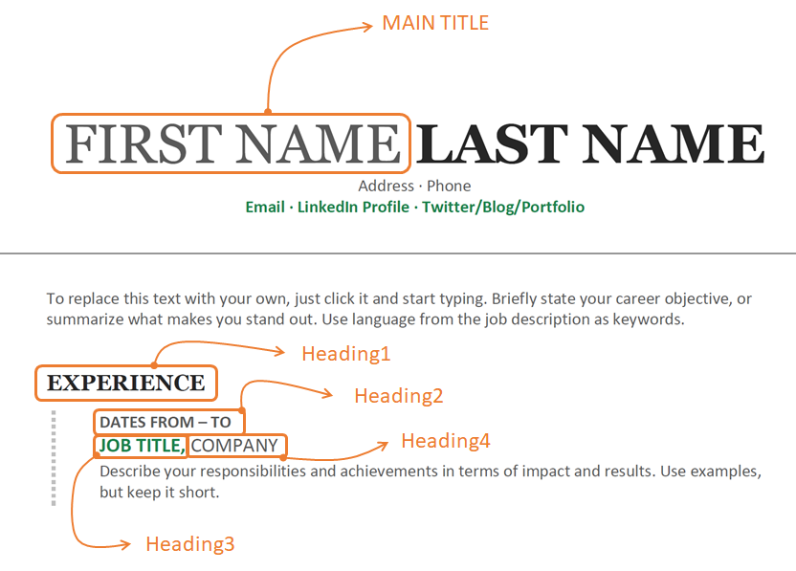
Note. Use the following color codes for green and grey:
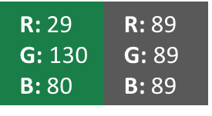

- Use tables to frame each Resume entry in ‘Experience’ and ‘Education’.
- Use a custom List in ‘Skills’ (green Bullet).
- Save the file as a ‘Word Template’.

First Name Last Name
Address · Phone
Email · LinkedIn Profile · Twitter/Blog/Portfolio

To replace this text with your own, just click it and start typing. Briefly state your career objective or summarize what makes you stand out. Use language from the job description as keywords.
Experience
Dates From – To
Job Title, Company
Describe your responsibilities and achievements in terms of impact and results. Use examples but keep it short.

Education
Month Year
Degree Title, School
It’s okay to brag about your GPA, awards, and honors. Feel free to summarize your coursework too.

Skills
List your strengths relevant for the role you’re applying for
List one of your strengths

Activities
Use this section to highlight your relevant passions, activities, and how you like to give back. It’s good to include Leadership and volunteer experiences here. Or show off important extras like publications, certifications, languages and more.

Use the text content included in the next page.

