OBJECTIVE: Create a Word Template based on file WORD_Resume2.pdf.
- Create a grid to place all document elements.
- Create the text styles for:
- Main Title, Heading1, Heading2, Heading3, Introduction and Contact.
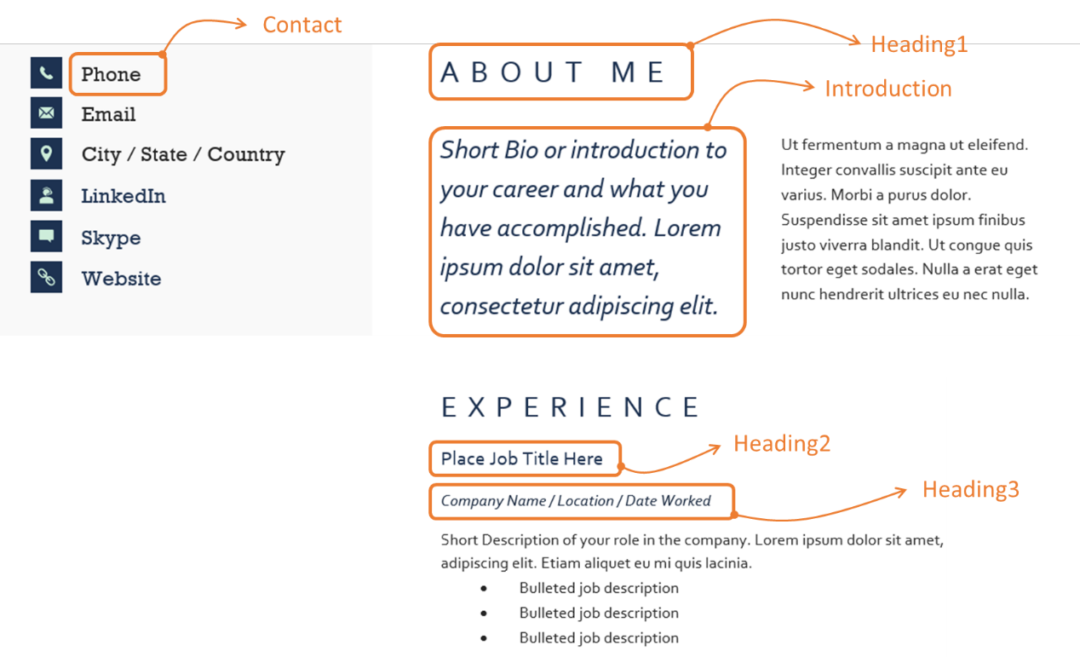
Note1. Use the following style format description:
HEADING1
Heading2
Heading3
Introduction
Contact
Normal

Note2. Use the following color codes for blue and soft green:
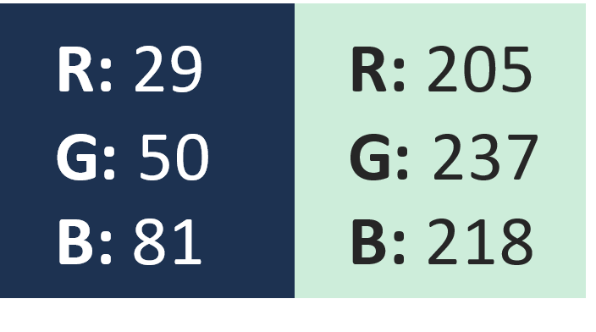
- Place the icons in the ‘Contact’ section (images provided).
- Create and place shapes and text the ‘Skills’ section.

Phone
Email
City / State / Country
LinkedIn
Skype
Website

About Me
Short Bio or introduction to your career and what you have accomplished. Lorem ipsum dolor sit amet, consectetur adipiscing elit.
Ut fermentum a magna ut eleifend. Integer convallis suscipit ante eu varius. Morbi a purus dolor. Suspendisse sit amet ipsum finibus justo viverra blandit. Ut congue quis tortor eget sodales. Nulla a erat eget nunc hendrerit ultrices eu nec nulla.

Experience
Place Job Title Here
Company Name / Location / Date Worked
Short Description of your role in the company. Lorem ipsum dolor sit amet, consectetur adipiscing elit. Etiam aliquet eu mi quis lacinia.
• Bulleted job description
• Bulleted job description
• Bulleted job description

Education
Degree / Diploma Name
University or College Name
20YY – 20YY

Use the text content included in the next page.

