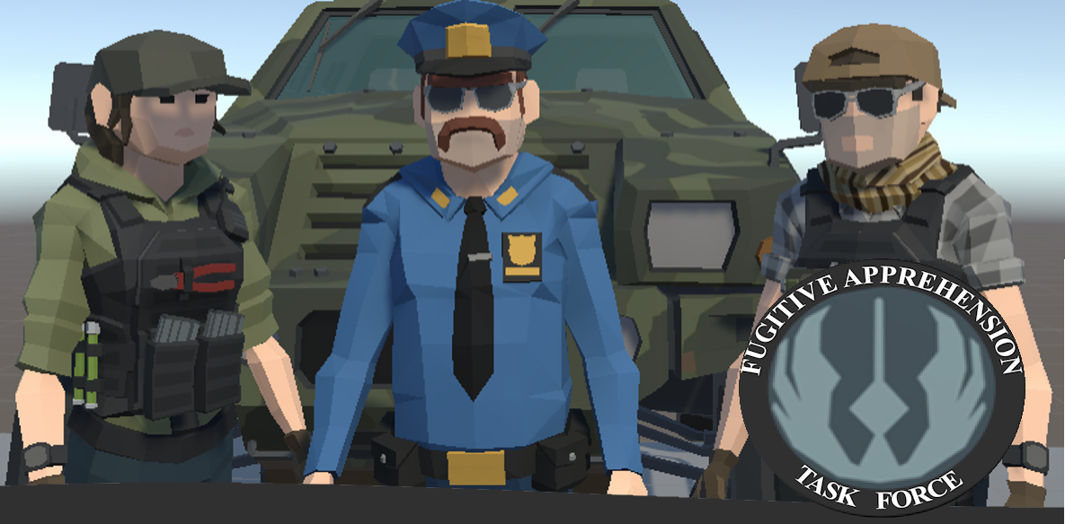
Game DESIGN document
Fugitive Apprehension Task Force

4 July 2025
Echelon interactive studio
[Company address]
Contents
Scope 3
Overview 3
Game Objectives 3
Core Experience 4
Theme 4
Art Direction 7
Design Pillars 8
Game Flow 8
Setup 0
Rules 0
Core Mechanics 2
Player Health 2
Resistance System 2
Bounty Contracts / Job System 2
Lawful Order/ Conversation System 2
Combat 2
Melee Combat System 3
Firearm Combat System 3
Destruction System 4
Searching System 4
Ragdoll Physics 4
Reputation System 4
Equipment Management system 4
Emergency System 4
Controls 5
Camera Controls 5
Movement System (RTS Style) 5
Interactions: 5
Combat Controls 5
Ranged Combat 6
Melee Combat 6
Mission / Level Design 6
Audio 6
User Feedback 6
Non diegetic SFX 6
Diegetic SFX 6
Particle FX 7
User Interface 7
Game Assets 7
Animations 7
Player characters/ Classes 8
Game Objects 9
Keywords: 10

Scope

Overview
The scope for this project is to plan, develop, test and launch the pc game Fugitive Apprehension Task Force (FATF) for Echelon Interactive Studio. This game design document is designed to assist in the design and development. FATF is a single player casual, action, strategy game where players take on the role of bounty hunters tasked with accepting bounties, searching for and apprehending, or eliminating targets in tactical 3D isometric game levels.
The gameplay will focus on top-down, tactical search and apprehension of wanted fugitives, without relying on unrestricted violence and lethal shoot-outs. Elements within the game world will be destructible with the right tools, and each fugitive character will have a fun, and quirky 3D model. The game will generate urgency by implementing an emergency system where the player could be called to an emergency at any time during gameplay like in the real world where any given situation would be given a priority level. Typically, these bounty hunter agents are not looking for hardened criminals, but rather petty criminals on bail or wanted for minor crimes.
The game will feature:
- tactical searching of homes and property,
- interesting npc’s and interactions,
- a fugitive resistance system,
- multiple combat scenarios for players to navigate,
- an unlockable dog companion who can assist you,
- ragdoll physics that should provide lots of entertainment for the player,
- environmental destruction for when fugitives have locked themselves in a room, cupboard, structure, or vehicle.
The player should feel a moral conflict between storming into a fugitive’s home, armed with their lethal 9mm Pistol, and shooting to kill and feeling out the scenario, determining the npc’s level of resistance and gradually escalating as the situation unfolds.

Game Objectives
Develop and release a unique bounty hunter law enforcement game that focuses on less lethal combat and tactics and specialised law enforcement roles like K9 dog handling.
Single-player game where players apprehend fugitives using a mix of strategy, investigation, and combat.
Engaging gameplay mechanics, including search systems, NPC interactions, and destructible elements. See below for a comprehensive breakdown of core mechanics.
Implement a progression system where players earn money and reputation, unlocking better gear, agents, vehicles and a dog.
A balance between realism and fun, incorporating ragdoll physics, resistance levels, and NPC behaviours.
A quality and stable gaming experience for users.
Successfully launch Fugitive Apprehension Task Force into early access by NOVEMBER 03, 2025.

Core Experience
The core experience for FATF is the tension and strategy involved in locating and apprehending your fugitive utilising all your tools at your disposal. Controlling the professional bounty hunter(s), equipped with Handcuffs, Hammers, and Axes and a mixture of lethal and less-lethal weapons like tasers, shotguns and 9mm pistols, players must use their skills and situational awareness to successfully capture their target.
Upon arrival to the scene players should search and explore the exterior of the house, to secure the perimeter. Within the property boundary there may be secondary structures, vehicles and various points of interest and spaces a fugitive might potentially be hiding. There may also be booby traps situated anywhere so the player must show caution. Obtain entry into the house by talking to occupant(s), interrogate npc’s, by stealth, or by use of force. Windows and doors might be unlocked which will provide easy access, but if they’re not, the player will have to consider an alternative method of entry. Carefully enter and search avoiding any traps, aggressive occupants, or unexpected surprises. Inside a building will be very typical with bed, kitchen, and dining rooms each of which will have spots a fugitive might be hiding in, around or under.
All scenarios and interactions should feel dynamic. Civilian and fugitive NPC’s may resist, comply, or attempt to flee.
Alongside conducting the bounty hunters, the players agents are also local sheriffs, and will be called to high priority callouts, so players will be compelled to work with urgency to capture your fugitive. Urgency is Paramount!
How the player conducts their duties will impact their reputation. Once your target is found, the player must decide to:
- use stealth,
- persuasion, or
- force to capture the fugitives.
All actions have consequences. Players earn or lose money based on the outcome of the mission. They can also lose or gain reputation based on their performance. If an agent flashbangs or gases a complying civilian, that is likely to be reported back to your boss.
The game will not tell the player what to do, rather motivate them to play how they want.

Theme
The game is inspired by popular tv series like Dog The Bounty Hunter, and Youtube Bounty Hunter Patty Mayo. Patty Mayo’s Youtube is incredibly popular, and many people who watch do not realise their scenarios are staged for entertainment purposes. The scenarios are likely based on real world events but with an added level of fun and wackiness.
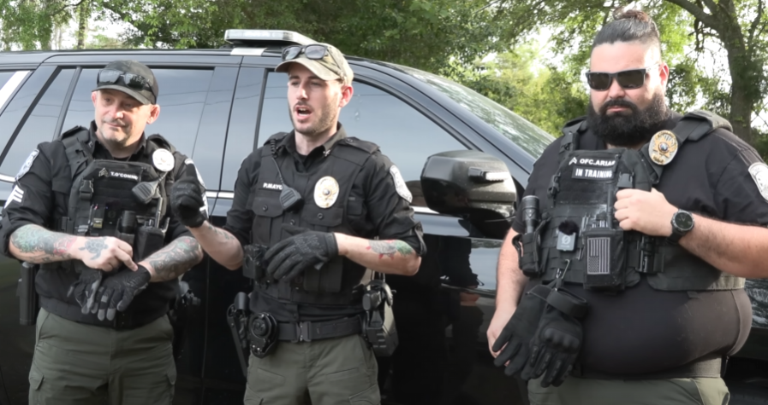
Figure 1: Patty Mayo - Mission Briefing
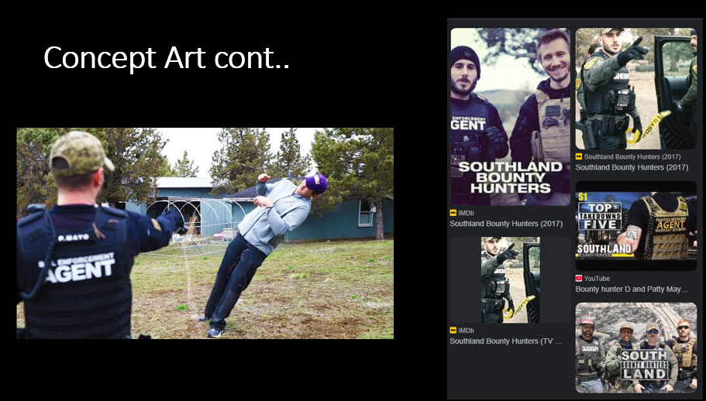
Figure 2: Concept Art from pitch presentation
Adding to the theme of fun and wacky, the lineup of fugitives will be just that. The player can expect to be looking for Walter from Breaking Bad, Santa, a hombre wearing a sombrero, and man in a hotdog suit and many more.
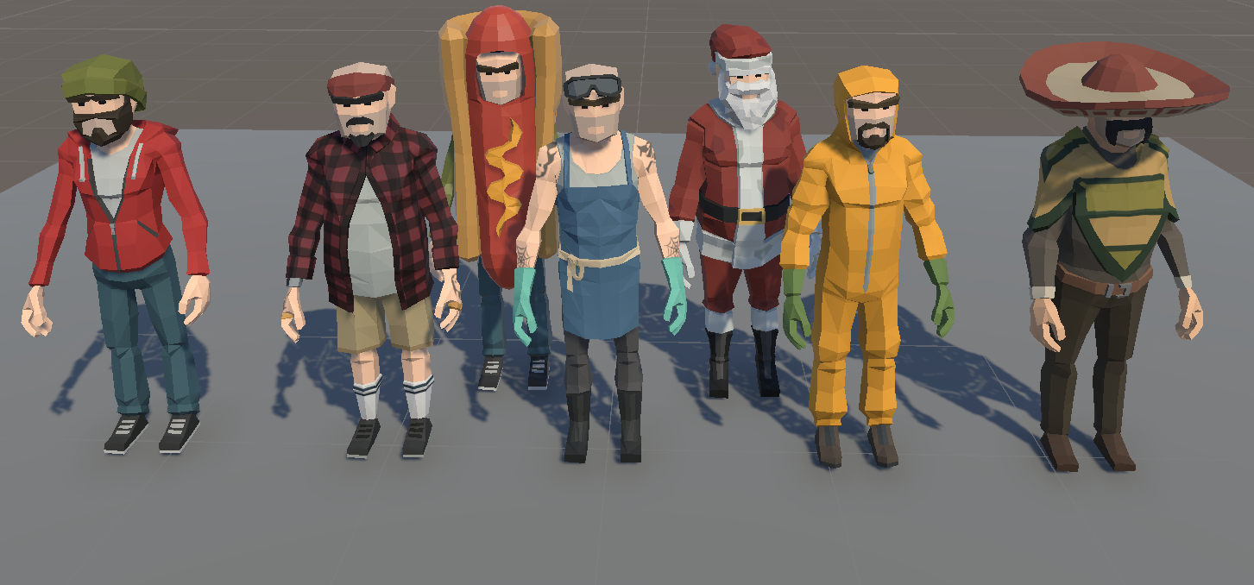
Figure 3: Probable fugitive characters
Players will select from 2 male and 1 female Bounty Hunters, each with their own stats.
- Overweight, failed police academy recruit
- Wannabe Military, Airsoft enthusiast
- Female ex-military
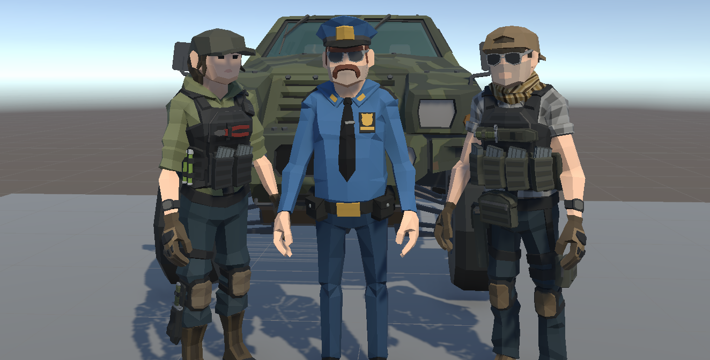
Figure 4: Probable agent characters

Art Direction
The art direction aligns with the casual, goofy and fun core experience with low poly Synty Studio assets. They’re cartoonish but provide sufficient detail and there is a vast number of models that we have licensed to use.
Visual style: low poly, flat, pastel-like colour palette.
Character Design: Since all characters are from Synty asset packs the style of all the characters will be consistent. There may be opportunities to customise character assets if the need arises, but there will be opportunities for players to customise their characters accessories.
Environmental Design: Synty asset packs always ship with demo scenes which both showcase all the assets and provide a starting point and inspiration for our own game levels.
UI/ UX Design: The look and feel of this game should feel very familiar as there is no intention of doing anything drastic or different similar games. A HUD when an agent is selected will provide the player with controls to interact with the game world.
Game logo: An art asset found within a Synty asset packs was chosen as the basis for the game logo. Further iterations and design will finalise a game logo that symbolises law enforcement
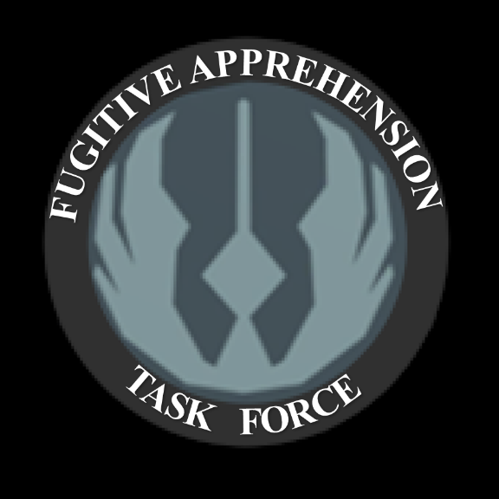
Figure 5: Game Logo Concept

Design Pillars
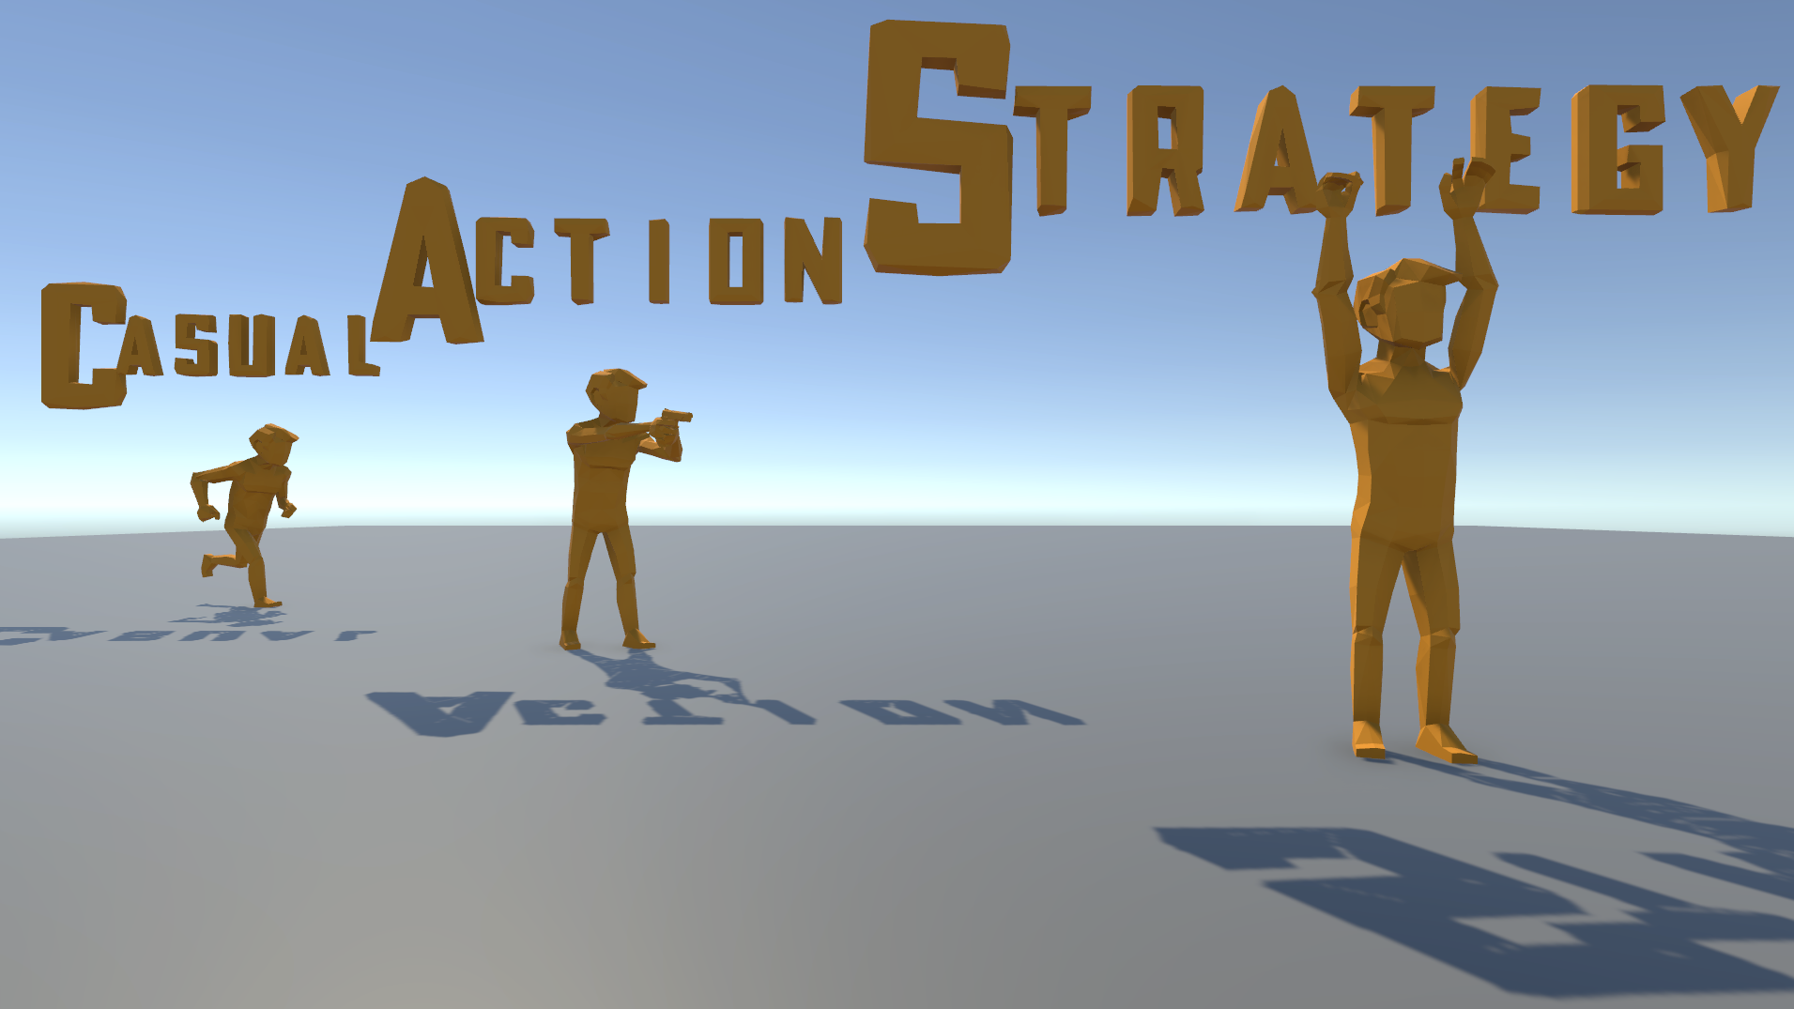
Figure 6: Game Design Pillars

Game Flow
The Main Menu will consist of your typical options including START, LOAD, SETTINGS, CREDITS, and EXIT.
On START GAME, the OPERATIONS ROOM loads with the agent relaxing inside.
There will be X options inside the OPERATIONS ROOM
- Upgrade vehicle,
- Purchase/ Upgrade weapons,
- Fugitive / Job Selection,
There is a possibility to add nice to have options including
- Entering the Firing Range to practice shooting, and
- Interacting with your pet dog.
Atomic Element: Sequence: the order of play Atomic Element: Game State: resources, owned, unowned, player stats- health armor,
Once a fugitive is selected the GAME SCENE will load, and the agent will spawn at the address of the fugitive and can begin to conduct the searching phase. Players can choose whether to search outside or commence the attempt to enter the main building. Once entry is obtained the scene will change to the building interior. TBD.
Once the hiding spot is discovered, the fugitive will spawn/ enable and become visible to the player where they must then gauge their resistance level. Once resistance level is low enough, a fugitive will give up, and can be apprehended, finishing the level.
An agent will be awarded reputation points, and the cash bounty for the fugitive and return to the OPERATIONS ROOM with a fresh set of fugitives/ jobs and more money to spend and increased reputation.
Player progression and upgrade

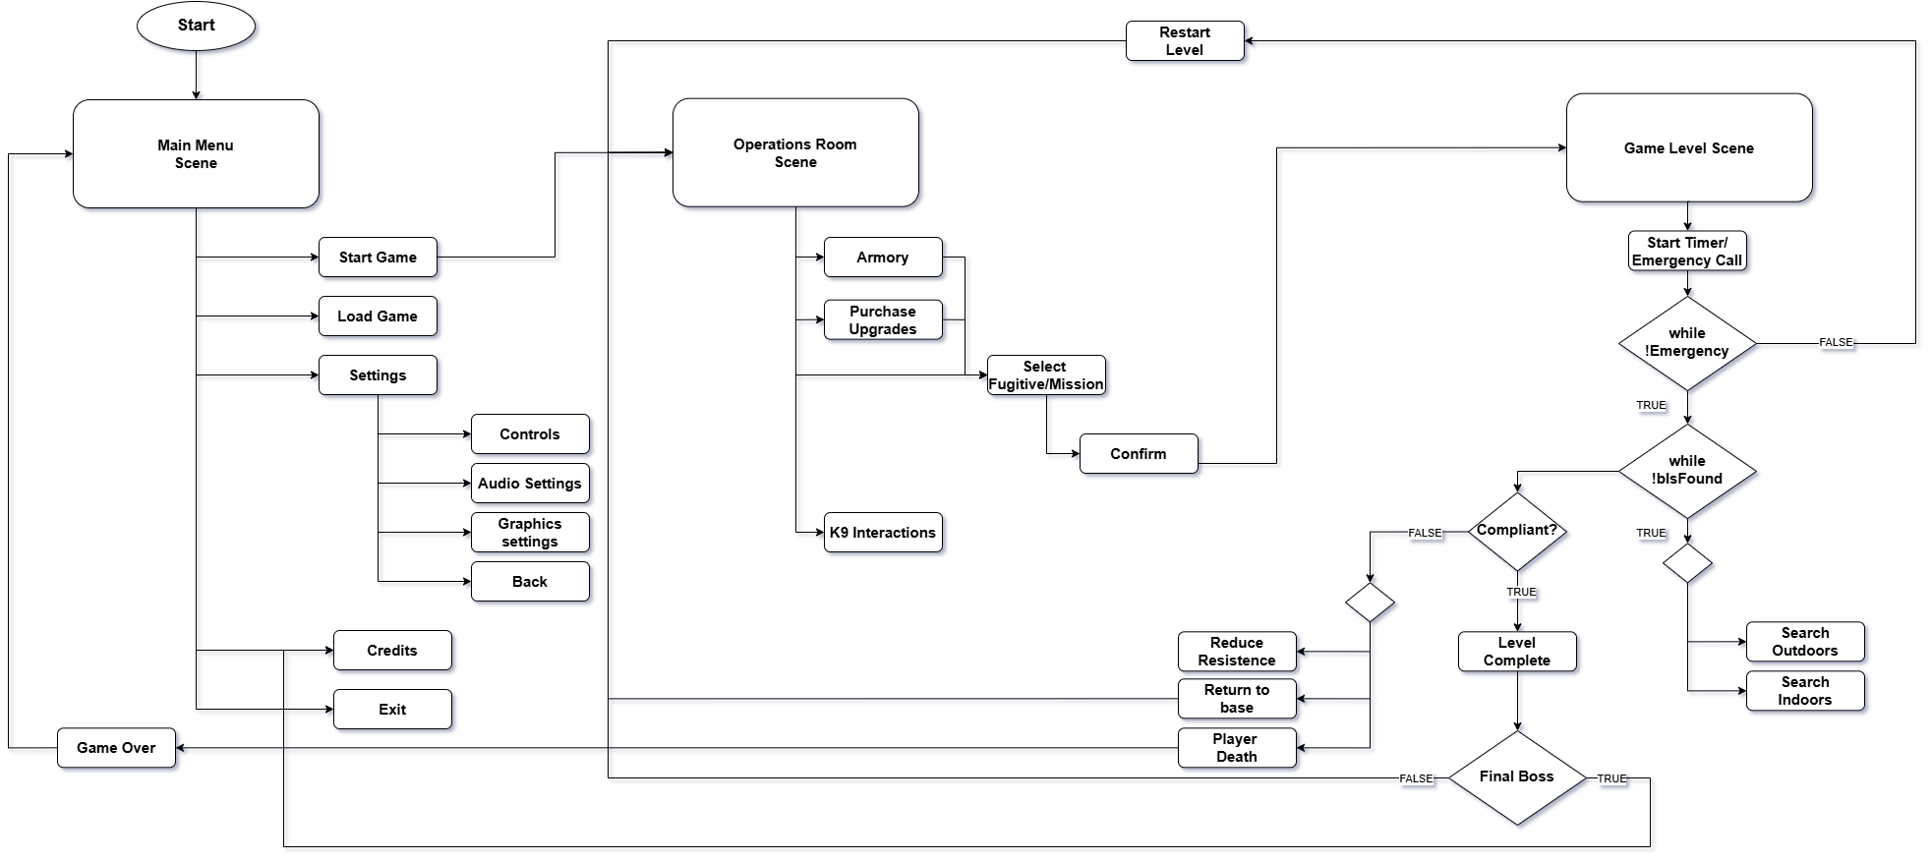

Setup
Players will choose their primary law enforcement officer before being sent to the OPERATIONS ROOM where they must choose which fugitive to target.

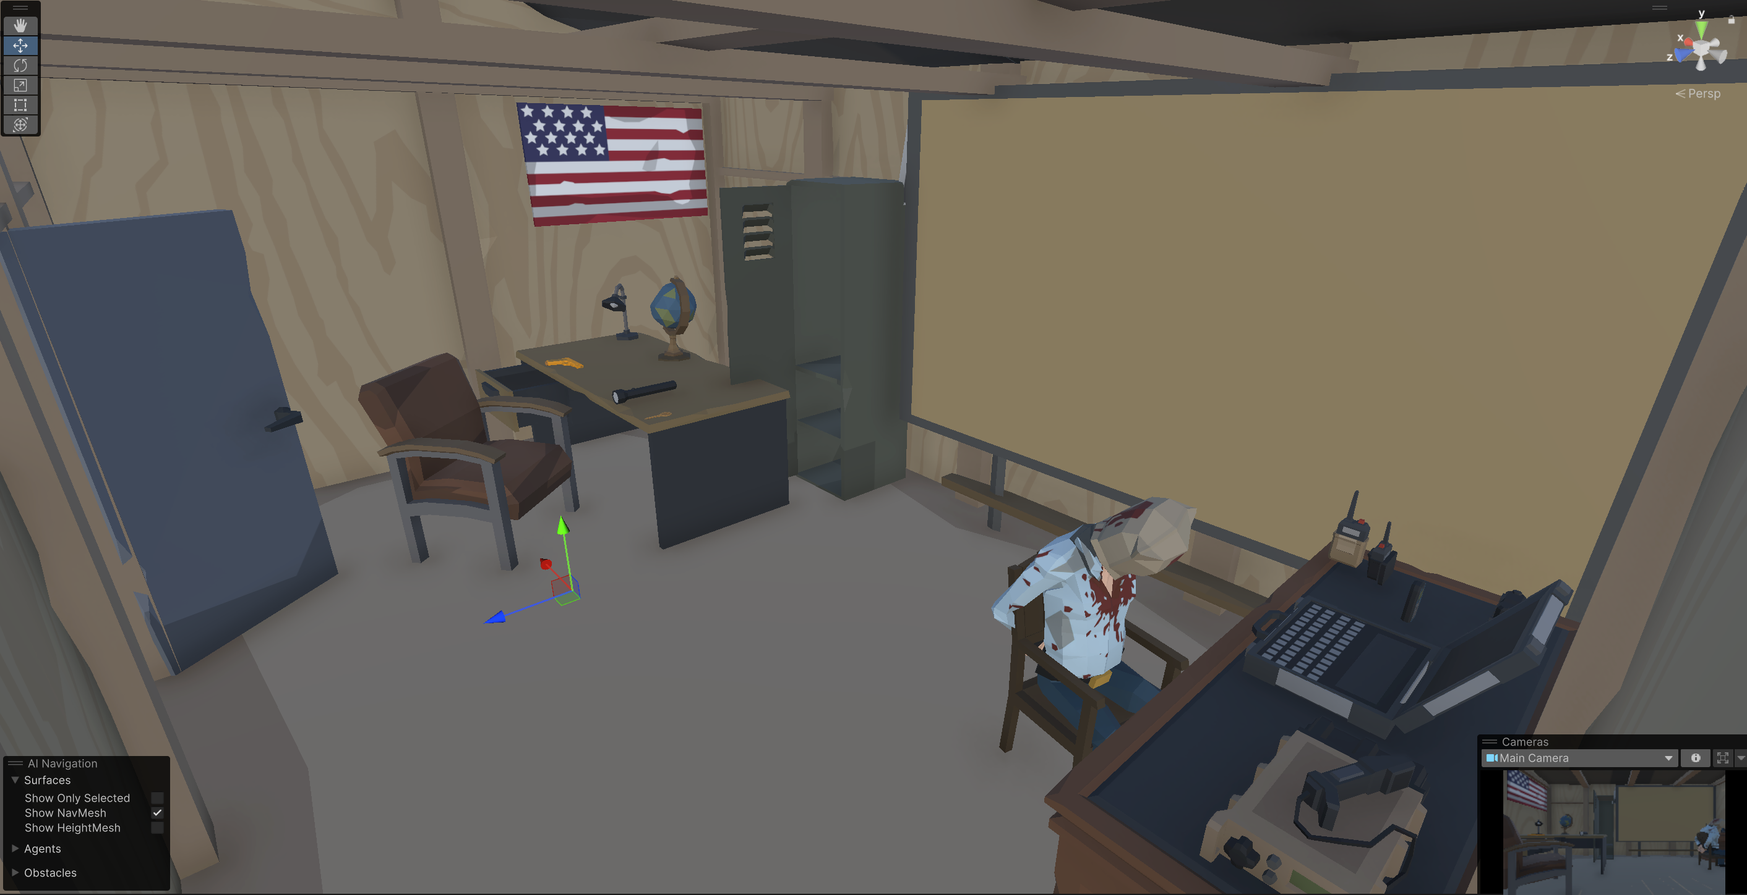
Insert caption here:
The OPERATIONS ROOM also serves as a base of operations and the player will be able to purchase ammo, upgrade their weapons, armour, vehicles and even train as a dog handler.
Once a fugitive is chosen to target you will travel to their location and begin the level.
A typical scenario is the bounty hunter receives a file from the bond office with the information of the fugitive. The bounty hunter travels to the current residence of the fugitive and attempts to gain access to the address. Depending on the warrant conditions, the bounty hunter may/ may not have authorisation to enter the home. Sometimes other residences in the home will attempt to stall your investigations, (Harbouring, Aiding and abedding), a US federal crime, to circumnavigate justice. It is up to you how to handle the situation. Put enough pressure on them and they may fold, or simply put them in cuffs and turn them in as well.
Houses have many places to hide, cupboards, false walls, attics, or in locked rooms.
Hardened criminals might also be armed with weapons so ensure your safety at all times and utilise all tools currently at your disposal.
Information stored in the game:
All fugitive characters, and their stats
Players current cash, reputation, current health, current loadout, ammunition,

Rules
Rules for setup:
All agents will be armed with a lethal 9mm Pistol and can use it at any time. Doing so will likely result in the death of the fugitive so therefore should only be used in self-defence.
All buildings, vehicles, and containers may or may not be locked requiring a key or forced entry depending on the agents approach.
If a fugitive makes it to the boundary when attempting to flee, they would have escaped.
If the player is attacked and sustains enough damage they will automatically retreat and return to base.
An agent cannot leave the property boundary of the current fugitive they’re searching for unless they return to base.
The scenes boundaries will be the property boundary.
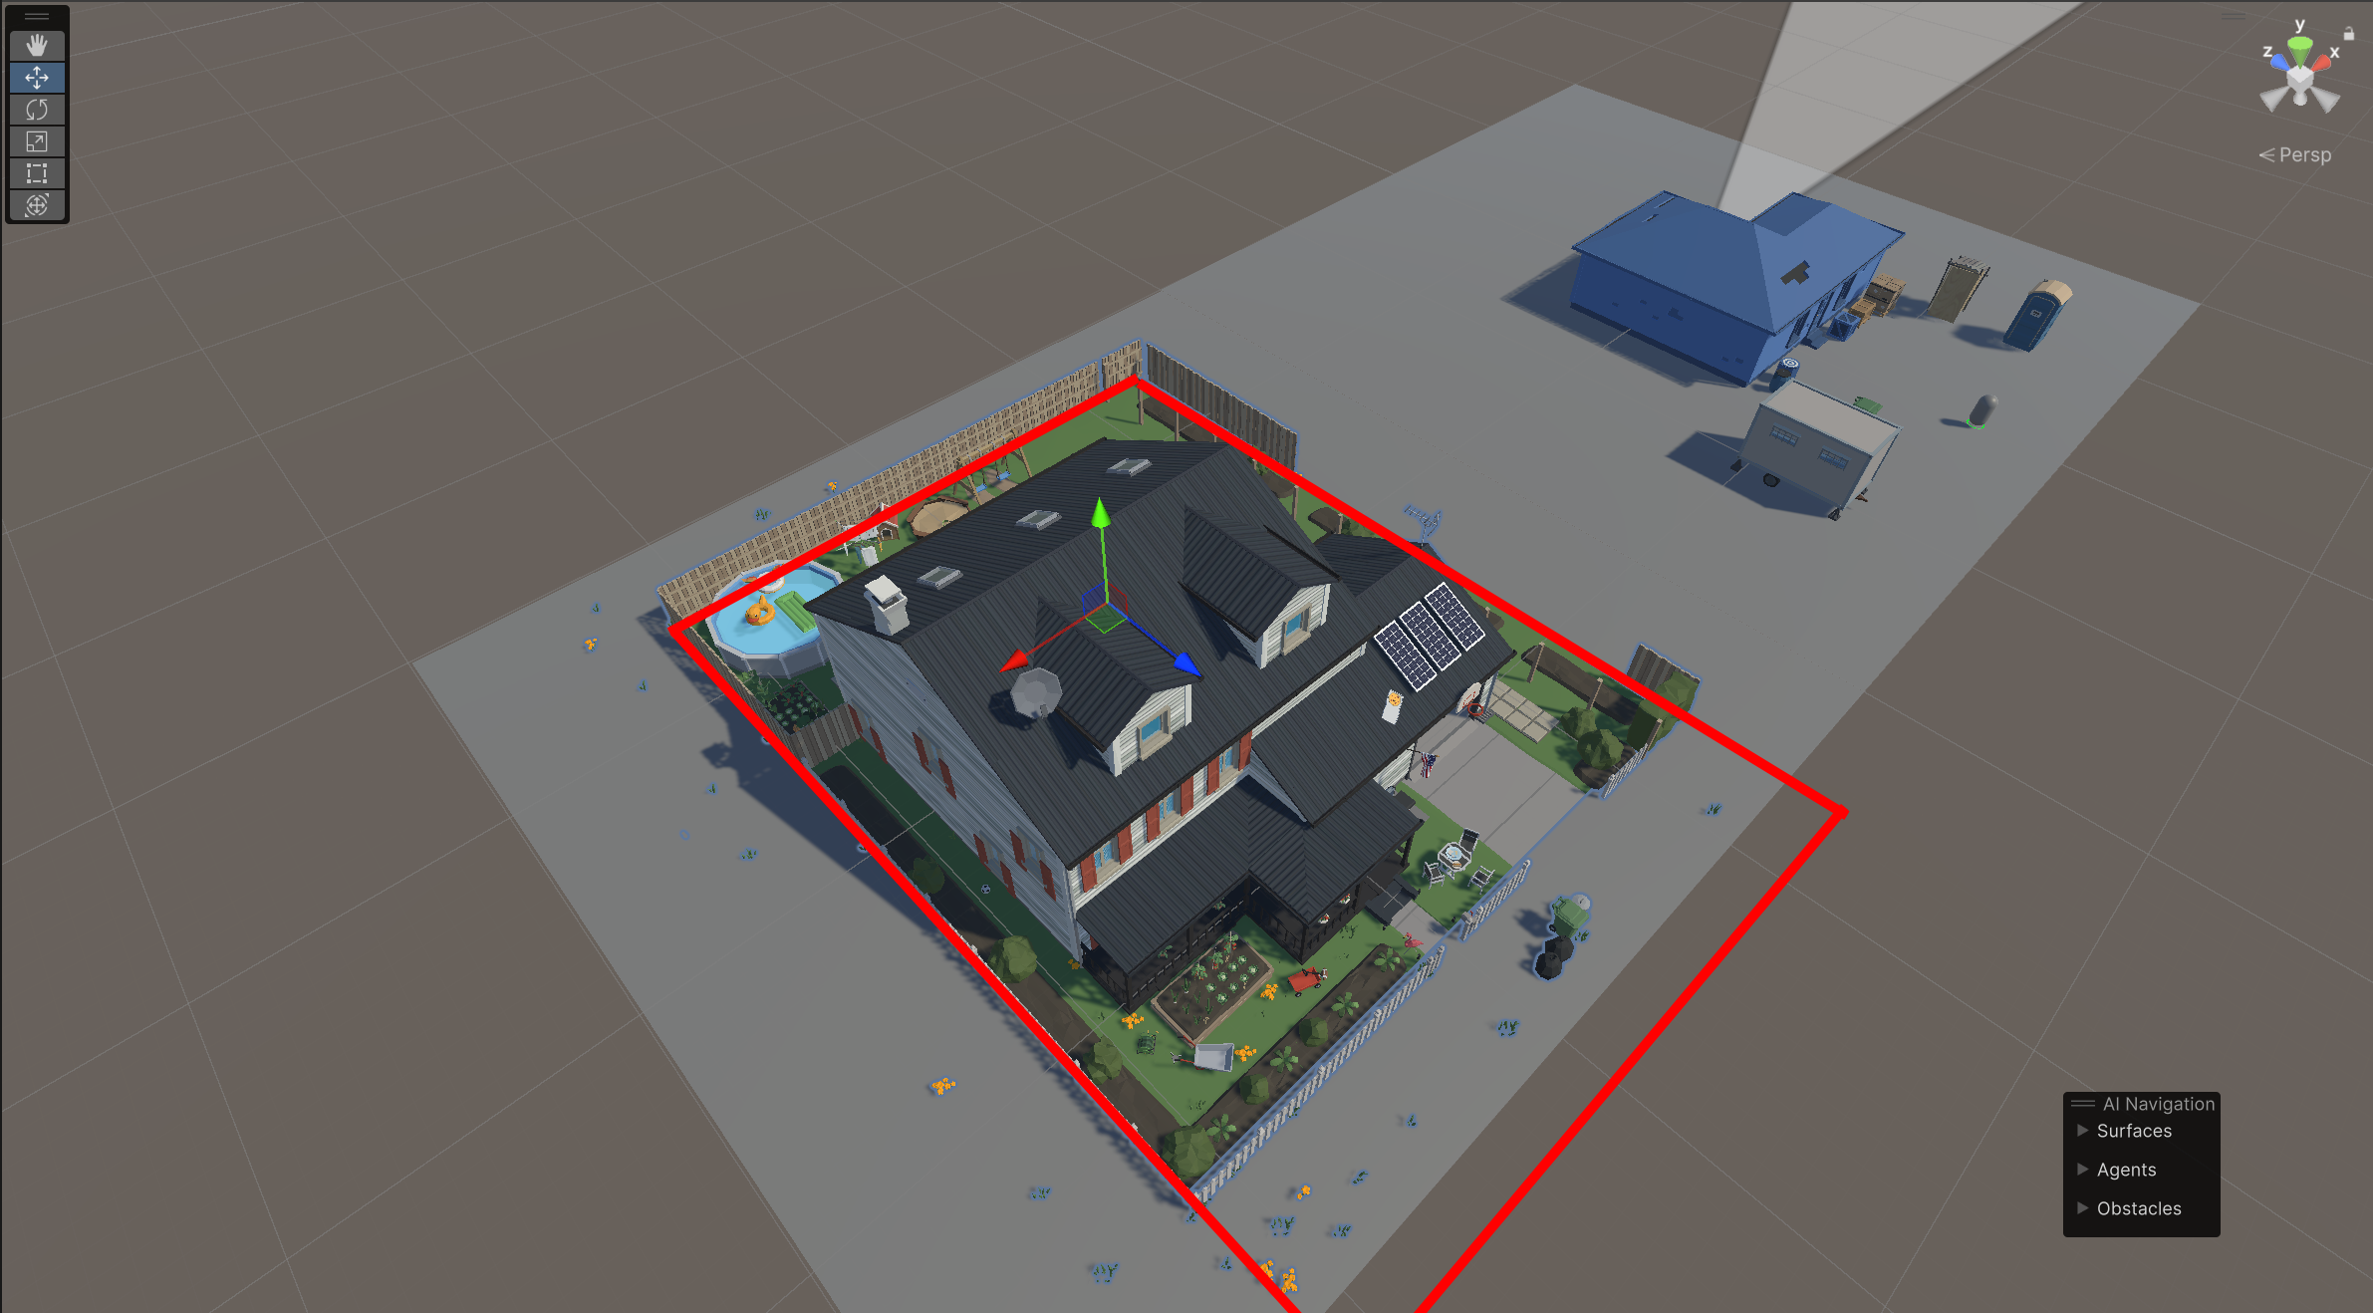
Figure 7: Level and boundary indicator
Rules for progression:
Once the game begins, what can the players do, and what happens when they do things?
While in the OPERATIONS ROOM, players can purchase upgrades, equipment that they can afford, and that has been unlocked by their reputation points.
A successful apprehension will result in a monetary reward whereas an unsuccessful mission will result in a loss of reputation.

Rules for winning and losing:
A player will lose if their Health is decreased to 0, resulting in game over.
The player will win the game when they capture all the fugitives in the city.

Core Mechanics
Checklist
Player Health
Resistance
KILL VS CAPTURE
Lawful Order/Conversation
Melee
Ranged
Destruction
Searching
Ragdoll
Bounty Contracts / Job System
Reputation System
Equipment Management System

Player Health
Simple HP health and Health bar system.

Resistance System
This is essentially a health bar with a fancy name. Resistance can be increased and decreased by players actions.

Bounty Contracts / Job System
Used to determine and track current game state.

Lawful Order/ Conversation System
Mechanic to interact with npc’s.
Enemy Behaviours might include
- Comply with orders,
- Aid/Abed in hiding fugitive,
- Run/ flee the scene, therefore escaping,
- Hide,
- Melee Attack,
- Ranged Attack, and
- Barricade within building or room.

Combat
Combat plays a key part in the game. It effects the players current health but for fugitives it effects their resistance level. The one exception will be where a player is forced to use lethal munitions and if shot the fugitive will die.
If a players current health reaches zero they will die, but can choose to RTB where the level will reset and any progress will be lost.
Players, fugitives and npc’s can all be equipped with melee and ranged weapons. AI will manage if, or when an enemy is armed with an enemy, and the decision will be tied to the fugitives level of resistance. The higher the resistance, the more likely the are to be armed.
For PVE Once an object reaches zero, it will be destructed, with effects and physics.

Melee Combat System
Fugitive melee attacks will affect the players current health while a players melee attack will affect the fugitive’s resistance.
Some examples where you might see melee combat include:
- The player needs to gain access to the fugitive’s residence through a locked door or window, a fireman’s axe is the perfect solution.
- Attacking other destructible objects.
- The player equips their baton if the situation escalates to counterattack an attacking fugitive.
- Fugitives might arm themselves with a plunger, broom, baseball bat, or anything they can find to intimidate you, and it is up to you to react accordingly.
Melee weapons in the game include
- Sword
- Baseball bat
- Police baton
- Broom
- Plunger
- Hammer
- Fireman’s axe

Firearm Combat System
Ranged attacks on the player will affect current health substantially compared to a melee attack. A player can choose either lethal or less lethal ranged weapons to lower resistance of a fugitive. Less lethal attacks lower the fugitives resistance more than melee attacks, whereas a lethal ranged attack will kill the fugitive.
Ranged weapons can be used to destroy destructible objects however this is not advised.
Your Bounty hunter will have access to less lethal weapons including
- A Taser,
- Shotgun with 12 gauge less lethal rounds
- Semi-automatic rifle with rubber bullets, hard balls, inert rounds, gas rounds,
- 9mm Pistol with live rounds for worst case scenarios.
- flash bangs

Destruction System
If you can see it, it can break, and if you break it, you probably have to pay for it. If the door isn’t opened after a lawful order is … , you are cleared to smash it down, or pull it off its hinges.

Searching System
Players can move agents in vicinity of an interactable object, and if it is unlocked they will commence a SEARCH. If the object is locked, they player must decide how to handle the situation by either finding a key, or using an equippable tool to smash your way in. Any property of value will likely result in a financial deduction.
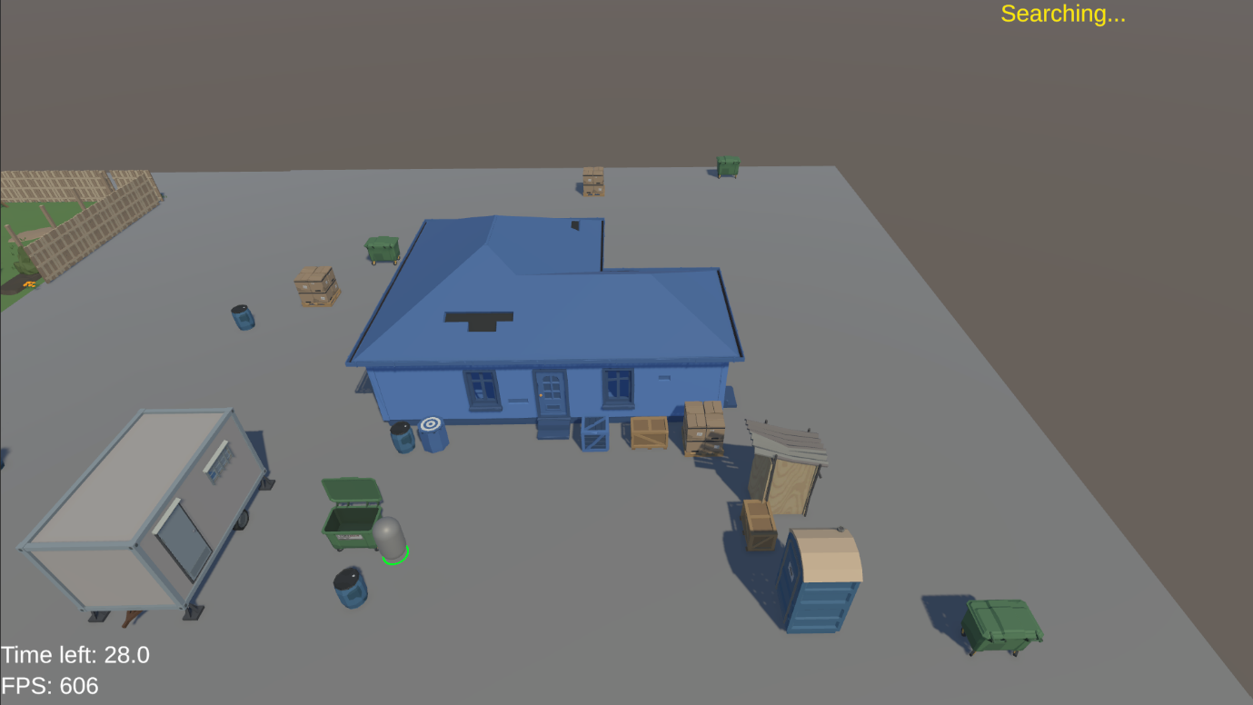
Figure 8: Search System prototyping

Ragdoll Physics
Characters will have ragdoll physics which will active if injured, shot with a taser, tackled which will make for some incredibly funny situations.

Reputation System
TODO::

Equipment Management system
Always ensure your weapons and ammo are stocked up. Nothing worse than turning up to a job and you have no rounds to load.

Emergency System
This system is designed to create URGENCY for the player. Law enforcement officers work on a priority system where the situation with the highest priority is where they’re required. It will essentially be an timer counting down in the background, and once it reaches 0, the agent will be forced to RETURN TO BASE simulating being called to an emergency situation.
As such, the bounty hunters might be called to an emergency at any time. When they are, effective the level is reset, without reputation loss but you will lose any resources you utilised i.e flashbangs, rubber bullets, etc. The sooner their target is apprehended the better.

Controls

Camera Controls
- Mouse Pan: Move the mouse cursor to the edges of the screen to pan the camera.
- Zoom in and out: Zooming functionality via scroll wheel.

Movement System (RTS Style)
- Selection:
  - Single Left Click: Select individual agents.
  - Click-and-Drag Box: Select multiple agents.
- Movement:
  - Right Click on Terrain: Move selected agent(s) to the clicked location.
  - Pathfinding Feedback: Show destination markers and real-time path predictions.
  - Double Right Click: Agents sprint to the destination (faster movement speed).
  - UI
- Movement Variants:
  - Walking Speed: Default pace for precise movement and positioning.
  - Sprinting Speed: Faster movement, used for urgency or longer distances.
- Environmental Interaction:
  - Players may need to jump onto or climb objects to inspect or reach obscured areas (may require dedicated jump or contextual interaction key).
- Contextual Cues: UI indicators for when agents are selected, sprinting, or ready to attack.

Interactions:
- Contextual Cues: UI indicators for when agents can interact with interactable.

Combat Controls
- Weapon Handling:
  - Equip / Unequip: Toggle weapons via a hotkey or radial menu.
  - Active Weapon Slot: Displayed in HUD; switchable with number keys or quick-access buttons.
  - Accessories: Toggle or use attachments (e.g., scopes, silencers) via a designated key.
- Reloading:
  - At Vehicle Only: Weapons can only be reloaded at the player's designated vehicle or resupply station.
- Combat Feedback: Include hit markers, recoil animations, and impact effects.

Ranged Combat
- Fire Mode: Left-click to fire; right-click to aim down sights (ADS).
- Weapon Types: Rifles, pistols, etc., each with unique recoil, fire rates, and effective ranges.
- Ammo Management: Display remaining ammo; highlight when a reload is needed.

Melee Combat
- Primary Attack: Click or key-press for a standard melee swing.
- Charged Attack: Hold attack button to perform a heavier strike with increased damage.
- Blocking/Parrying: Optional defensive mechanics to add depth to melee encounters.

Mission / Level Design

Tutorial Mission required? Prototype?
There will be 10 levels the player must work through. Each level will have a specific fugitive the player must apprehend. Should the search come up empty handed, return to base and consider alternative methods, or other tools which could be utilised to capture the fugitive.
Procedural level design to add unpredictability and strategy.??

Audio
TODO::
Action Cinematic Beat #10 : Percussion style (Start Menu or Operations Room)
Action Cinematic Loop #12 “
Modern Heavier Theme #2
Short Hard Rock Loops Loop #1
Short Hard Rock Loops Loop #4 ( End Level )

User Feedback

Non diegetic SFX
- background music/ soundtracks

Diegetic SFX
Validation SFX
- Out of ammo/reloaded
- Weapon firing
- Vehicle idling
- Cursing bleep?
- Object breaking
- Person shot
- Person hit with object
- Person dying

Particle FX
- Tazer FX
- Bullet Trail FX
- Items destroying FX
- Player increasing speed
- Dog Scenting?

User Interface
TODO::
- Atomic Element: Visible information in the game.
- The visible information in a game is dependent on players, resources, rules and boundaries of the game.
- Complete/incomplete information
- perfect/imperfect information
Main Menu Scene
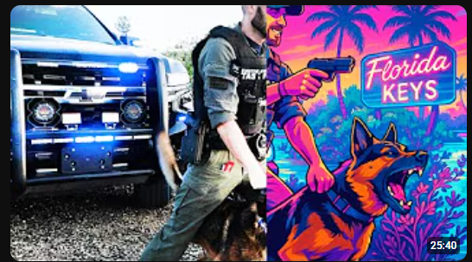
Growling dog between handlers legs. ( facing towards camera, close up )?

Game Assets

Animations
Animations Checklist
Human
Walk ☐
Run ☐
Rifle_ready ☐
Rifle_aim ☐
Dog
Walk ☐
Run ☐
Dog_Attack ☐

Player characters/ Classes
- 5 - 15: Enemies
- 16 - 26 NPC's
Player Agents:

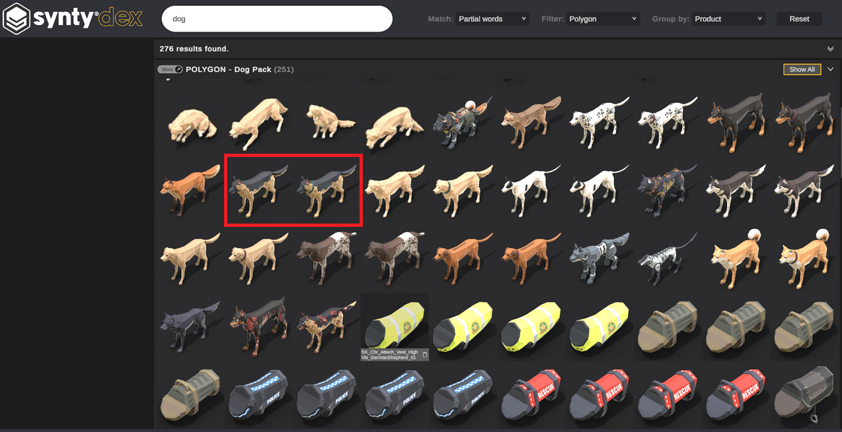

Enemies:

Developer Information only
Static Mesh Name | Asset Pack
Character_Male_Hoodie | City
SM_Chr_Cook_Male_01_FixedScale | Gang Warfare
SM_Chr_GangMember_Male_01_FixedScale | Gang Warfare
SM_Chr_Hazmat_Suit_Male_01_FixedScale | Gang Warfare
Character_Mexican_Male_01 | Western Frontier
Character_Hotdog_01 | Character_City_Characters
Character_Santa

Game Objects
Buildings
- Houses
- Outhouses
- Removeable buildings
- Shipping containers
- Garages
- Barns
- Portaloo
Vehicles
- 1 Agent 1 Overweight, failed police academy recruit
- 2 Agent 2 Wannabe Military, Airsoft enthusiast
- 3 Agent 3 Female ex-military
- 4 Civ 1
- 5 Civ 2
- 6 Civ 3
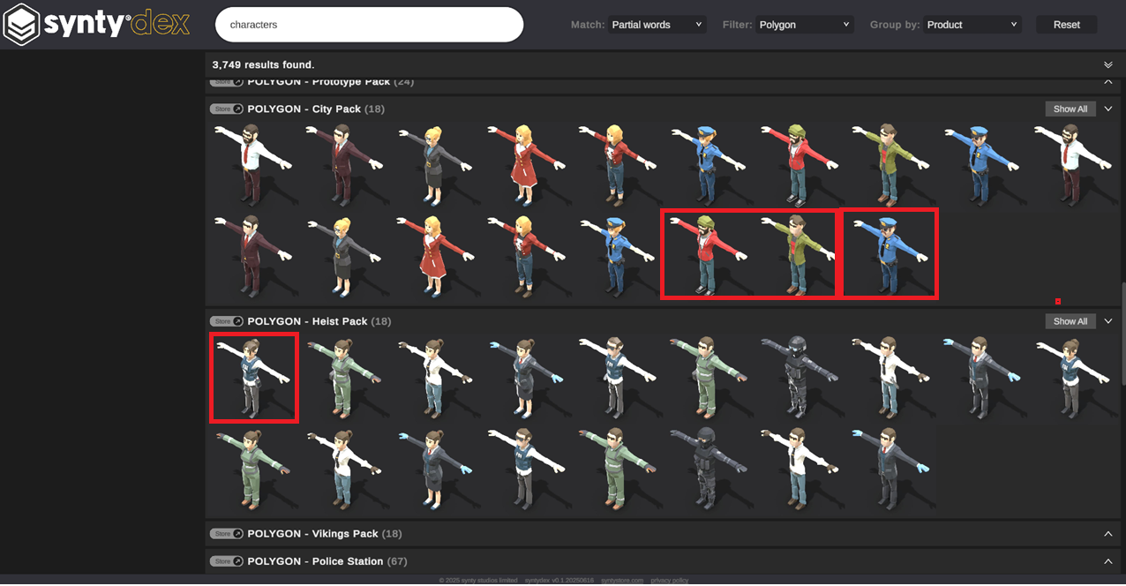
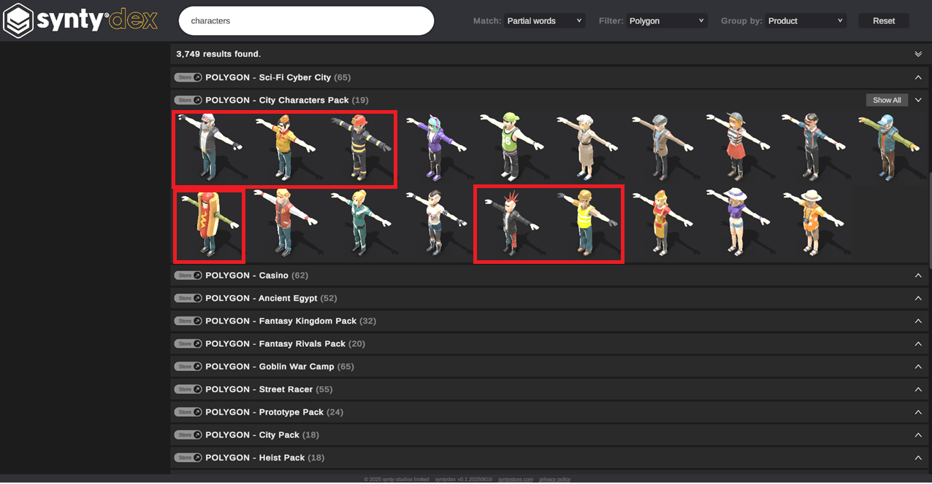
Vehicles
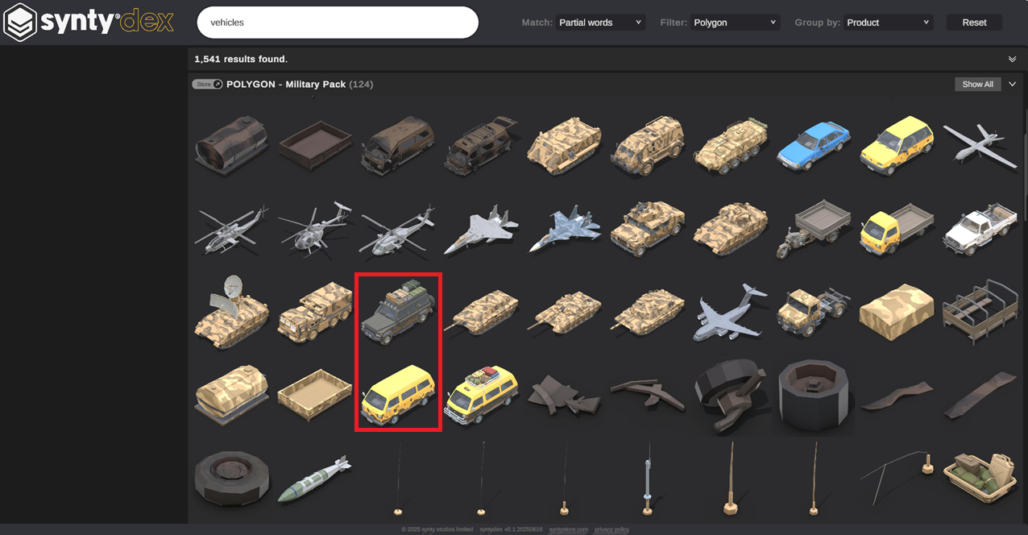
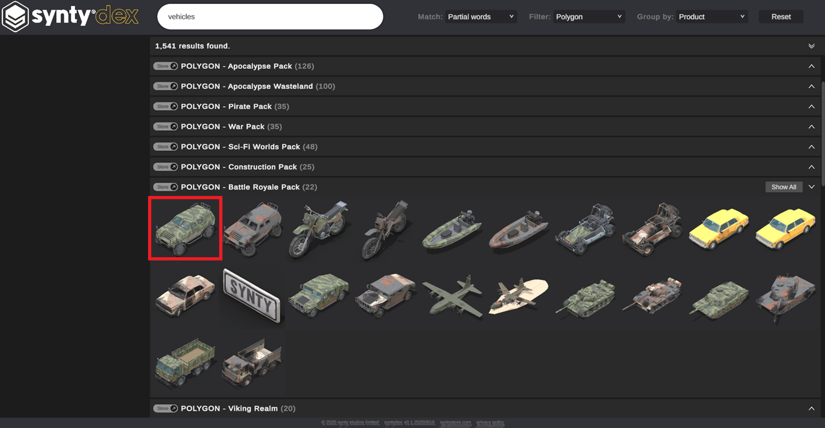
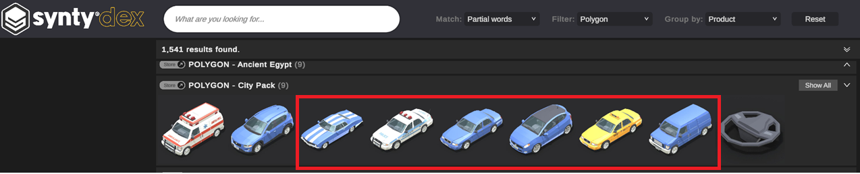
Weapons
- Pistol (lethal)
- Shotgun (less)
- Rifle (less)
- Tazer (less)
- Flashbangs
- Gas
- Baseball bat
- Golf club
- Police Baton
- Sword
- Broom
- Plunger
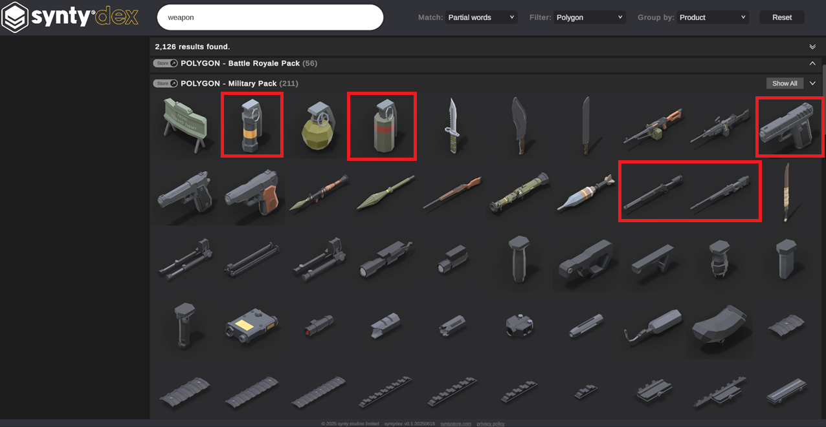
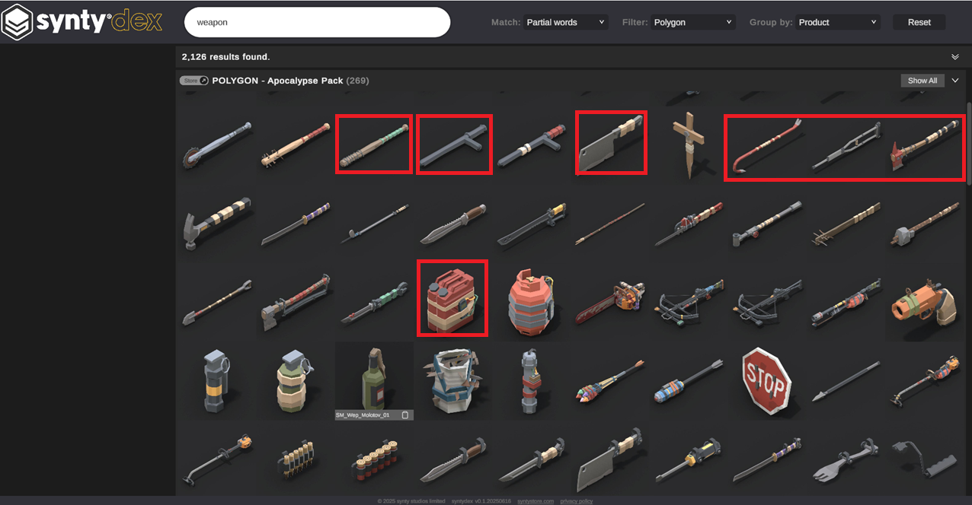
Tools
- Handcuffs
- Hammers
- Axes
- Riot Shield
- UHF Radio
- Spotlight/ torch
- Bulletproof vest/ Stab proof vest
- Helmet

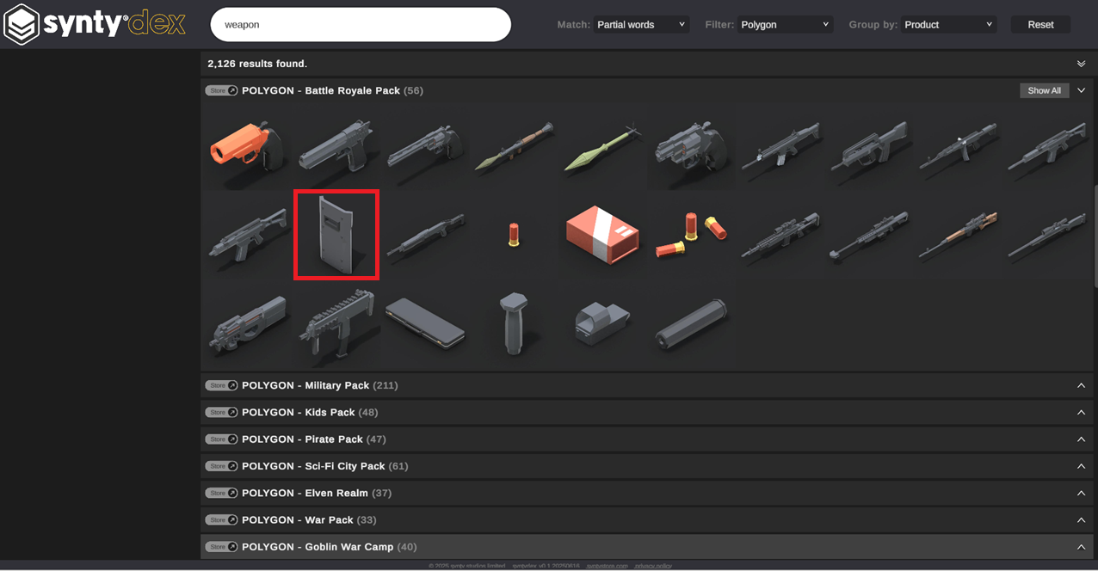
Contraband
- 1 Alcohol
- 2 Ammunition
- 3 Drugs
- 4
- 5

Boobytraps
- 1
- 2
- 3
- 4
- 5
Ammo
- 1 Tazer ammunition
- 2 Rubber bullets
- 3 9mm bullets
- 4 rubber bullets, hard balls, inert rounds, gas rounds,

Interactable
- Barrels
- Crates
- Boxes
- Skip bins
- Cupboards
- Beds
- Furniture
- Doors
- Windows

Destructible
If it is interactable, it will probably be destructible.
- Windows
- Doors
- crates
- 4 boxes
- Barrels

Ideas: POV “Tracking Mode”;
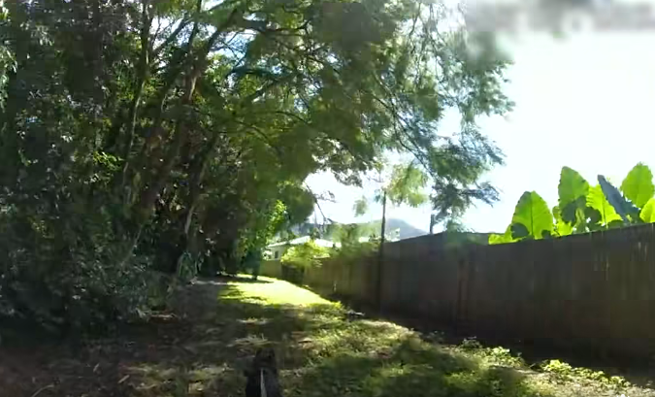

Keywords:
Bail Enforcement
Arrest Warrant
Fugitive Apprehension Task Force
Land rover, Humvee, APC, Ambulance
Ride the lightening Bitch! Tazer reference.
Development: Plan?
Pseduo code
Coding Standards
Atomic elements of Game:
Game state: the state of the game at any point in time
• Information: the visible information in the game
• Sequence: the order of play

Verbs: Actions of Gameplay elements
May belong to any element: can apply to level, enemy,
Player blocks | Player Selected , Shield Equipped | Right Mouse Held
Player aims | Weapon Equipped |
Player shoots | Player Selected , Weapon Equipped | Left Mouse Clicked
Player hits | Player Selected , Melee Equipped | Left Mouse Clicked
Player moves | Player Selected | Left Mouse Clicked
Player retreats | | UI RTB Button Clicked
Player destroys | Player Selected, Melee Equipped | Left Mouse Clicked
Player interacts | Player Selected , Nothing Equipped | Left Mouse Clicked
Players searches| Player Selected , Nothing Equipped | Left Mouse Clicked
Player commands

Enemy hides
Enemy runs
Enemy resists
Enemy complies
Enemy shoots
Enemy hits

Dynamics
• Various dynamics may emerge from the existing rules and mechanics in a game.
• Bluffing
• Not explicitly in rules, but facilitated by rules
• Emerges as a way to take advantage of betting rules
• Patterns of play in Chess
• Not the rules themselves
• New patterns are still being discovered (Scotch open, Queen's gambit)

Quotes
You are under arrest! Failure to comply could result in serious bodily Injury!
You could be subjected to tazers, teargas, a dog, rubber bullets, flash bangs, smoke grenades, and other things that may hurt you!
Do you understand? You could get hurt?

