Technical Design Document
for
Echelon Interactive Studio
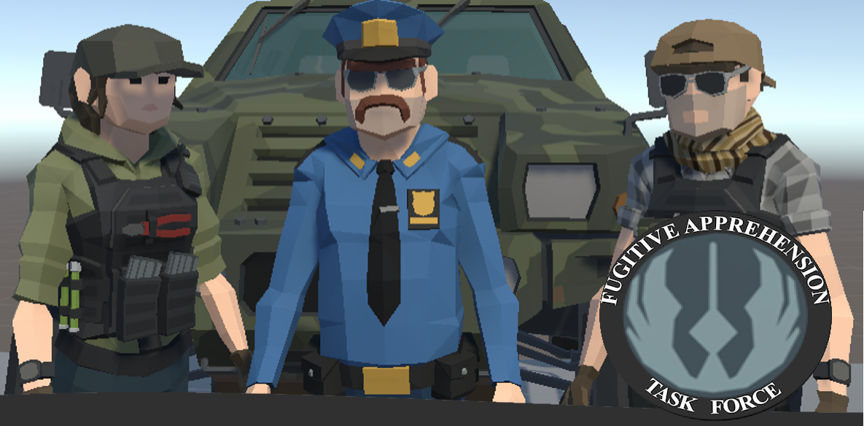
Version <1.0>

Prepared by Will Fowlds
APRIL 07 2025

Table of Contents
1.0 Introduction 4
1.1 Assumptions, dependencies and constraints 4
Technical Assumptions 4
Technical dependencies 4
Technical constraints 4
1.2 Definitions and Acronyms 4
2.0 System Features and Requirements 4
2.1 Functional Requirements 4
2.2 Non-functional Requirements 4
2.3 External Interface Requirements 4
3.0 Development Requirements 4
3.1 Technology Diagram 4
4.1 Scene Layout Diagrams 4
4.1.1 Wireframes and UI Mock-ups 4
4.3 Design Diagram 4
4.0 Implementation Diagram 4
4.1 Gameplay Diagram 4
5.0 System Level Design 4
5.1 Core Class Structures 4
5.1 Structural Design 4
6.0 Game Development Tools 4
6.1 Unity Software Development Kit (SDK) 4
6.2 Unity Hub 4
6.3 Visual Studio Code (VS Code) 4
6.4 Blender 4
6.5 Git and GitHub 4
6.6 Audacity 4
6.7 Draw.io 4
Tools TBD: 4
7.0 3D Objects, Terrian and Scene Management 4
7.1 3D Objects 4
7.2 Scene Management 4
8.0 Collision Detection, Physics and interaction 4
8.1 Collision Detection 4
8.2 Physics 4
8.3 Interaction 4
9.0 Game Logic and Artificial Intelligence 4
10.0 Audio and Visual Effects 4
10.1 Sound 4
10.2 Visual 4
11.0 Platform, Hardware & Software Requirements 4
11.1 Hardware Requirements 4
11.2 Software Requirements 4
12.0 Risk, Dependencies and Change Prediction 4
13.0 Prioritisation 4
Conclusion 4

Figure 1: Document Relationships 3
Figure 2: Feature Tree Diagram 3
Figure 3: Scene Layout Diagram 4
Figure 4: Teck Stack Diagram 5
Figure 5: Component Diagram of Game Subsystems 6
Figure 6: Project Milestones Timeline 6
Figure 7: High Level Game Flow 6
Figure 8: Sequence Diagram 7
Figure 9: Class Diagram of Core Components 8
Figure 10: Data Flow Diagram (DFD) 9
Figure 11: AI Behaviour Flow Chart 10
Figure 12: Toolchain Diagram 10
Figure 13: Player Movement use case model 15

1.0 Introduction
This Technical Design Document (TDD) should be used in conjunction with the user requirements document and Game Design Document (GDD) which captures the important design aspects of Fugitive Apprehension Task Force (FATF).
The purpose of this TDD is to breakdown user requirements of FATF, analyse them and break them out into their systems and subsystems to be designed. This document should provide sufficient detail to enable any developer to seamlessly develop FATF according to the user requirements and the GDD.
A comprehensive Schedule can be found in the Project Management Plan (PMP) under the Schedule Section.
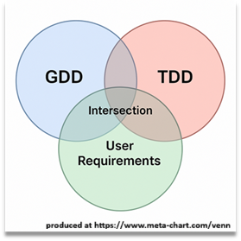
Figure 1: Document Relationships

Assumptions, dependencies and constraints
For a full list of assumptions, dependencies and constraints can be found in the Pitch Proposal Document and Project Management Plan.

1.1.1 Technical Assumptions
- Customisation will be limited due to the utilisation of third-party assets, and
  - lack of experience and knowledge in 3D art. Any customisations will require time to learn and develop the skill.
- The 3D game models polygon count are as low as possible.
- The game model textures are optimised for performance.
- Steep learning curve with Steam’s marketing algorithm, and best practices.
  - It is expected I will seek guidance from forums, vlogs and other indie game developers.

1.1.2 Technical dependencies
- Learn and implement Level of Detail (LOD) techniques, or occlusion culling especially where player transitions from inside to outside.
- Determining between baked and dynamic lighting for different lighting requirements.
- Identifying scene objects that will be static or dynamic to improve performance.
- Utilise multithreading where possible to achieve smoother gameplay and performance.
- Development relies on the availability of Unity. Should Unity Engine cease to exist, I would have to draw on previous experience in Unreal Engine 4/5 development which will really slow down progress as I relearn this engine and associated systems and processes.
- Unity Engine 2023.2.1f1 with the possibility of porting to the latest stable version of Unity 6.
- Visual Studio Code is the favoured IDE for development with an excellent range of extensions and a great look and feel.
- Github utilisation for version controlling is pivotal to avoid and potential loss of files and data and it saves lots of time and storage not having to manually save game files over and over.
- Draw.io is a great visualisation tool to create flow charts, class diagrams, prototypes and anything visual. Visualisations are often as good if not better than lengthy descriptions and will always complement any description or paragraph.
- Gantt software allows us to visualise the expected timeline for the project. Particularly important for stakeholders and those who are not intimately familiar with the plan, or who just need a little bit of information.
- A Steamworks account and SDK to launch the game on the platform. Without this account developers and publishers cannot launch their products onto Steam.

1.1.3 Technical constraints
- Unity engine limitations: Ai behaviour, destructible environments may be challenging to implement efficiently. I have also never attempted to develop a system where a player communicates with another entity, so I foresee challenges there.
- Inability to download and install third party software on SIT issue devices necessary to complete tasks.
- The final product must meet Steam’s publishing requirements, including their content policies and technical standards.
- Performance limitations: This game must be able to run on a range of pc hardware, therefore will require optimisation for lower-end systems.

1.2 Definitions and Acronyms
GDD – Game Design Document - A document outlining gameplay mechanics, art direction, story, UI, and design aspects of the game.
PMP - Project Management Plan – A document which encapsulates subsidiary plans the outline the project, describing how the project will be executed, monitored, and closed.
FATF – Fugitive Apprehension Task Force is the title of the PC game being developed.
IDE – Integrated Development Environment – Software used by developers to code, debug, and managing their code base.
FPS – frames per second describes how many frames the computer system can render per second and reflects the performance of the game.
GPU – Graphics processing unit is the hardware that is dedicated to rendering graphics within a computer system.
RTS – Real-Time Strategy is a genre of game where the players must make decisions and action in real-time and respond to their current environment and surroundings. It is a sub-genre of strategy, and as the name suggests are games that challenge the player to strategise, and figure out ways to beat the current level, or mission.

2.0 System Features and Requirements
The feature tree below breaks down this project into logical features that will be developed.
Fugitive Apprehension Task Force
- Gameplay
  - Character Selection
  - Level Progression
  - Tactical Command
    - Search
    - Apprehend
    - Defend
    - Attack
  - Resistance System
  - Player health
  - Conversation System
  - Load / Save System
    - Data persistence
- AI
  - Fugitive AI Behaviours
  - Civilian AI Behaviours
- UI / UX
  - Fugitive / Mission Selection
  - Agent HUD
  - Menus
  - Weapon Selection
- Controls
  - Camera Control
  - Real-time Strategy (RTS) Input
    - Mouse Commands
- Audio
  - Sound Fx
  - Voice overs
  - Music

2.1 Functional Requirements
- Single player
- 3D Isometric point of view
- Game Levels in a game world consisting of
  - Interactable 3D Objects. [TODO::]See Section 7 for a full breakdown of Interactable objects.
  - Destructible 3D Objects,
  - Non-player characters, player characters,
  - 3D buildings, rooms, walls, doors, windows, stairs,
  - A level boundary,
  - other dwellings (sheds, barns, offices, garages, outhouses, warehouses),
  - boobytraps,

- Game Levels with:
  - Increasingly higher difficulty level as game progresses,
    - Promote urgency with a limited amount of time to apprehend the fugitive.
  - Different challenges including boobytraps, obstacles, unhelpful civilian AI,
  - Game progression,
  - Randomly selected hiding positions,
Game Controls
- Camera movement with A,S,W,D and mouse position/ screen-edge panning.
- RTS player selection and movement
  - Select/ deselect their player character(s)
  - Issue walk or sprint move orders.
  - Issue action orders to non-player characters such as Search, Apprehend, Melee attack, Shoot.
  - Change equipped primary and secondary weapons and their Rules of Engagement i.e Weapons free, Hold Fire, Defensive stance
Effects
- Audio and sound FX
- Lighting effects
  - Day/ Night settings
Characters
- Variety of Fugitive and civilian characters
- Realistic non-player character with basic AI including
  - Idle
  - Run
  - Hide
  - Attack
  - Give up
- A Resistance System whereby the higher the resistance the less likely a fugitive is to give up.
- Resistance is lowered utilising different tactical methods, and weapons.
User Interface
- Responsive, intuitive user interface
- Heads up display
  - In Game Menu
    - User feedback
    - User action prompts: Opening door button, Attacking damageable items button etc
  - Agent HUD Menu
  - Weapon Selection Menu
  - Vehicle HUD Menu
- Menus
  - Main Menu
    - Start button
    - Load button
    - Settings button
    - Credits button
    - Exit button
  - Pause Menu
    - Settings
  - Credits Menu

- Operations Room Scene UI shows Money, Reputation,
User Experience
- Player can track the resources via UI.
  - currently equipped weapon,
  - weapons on person,
  - ammunition left
- Progression System with money and reputation

2.2 Non-functional Requirements

Performance:
- Given the is a 3D top-down game, 60 frames per second (fps) should be achievable on devices with the GTX 1080 graphics processing unit (GPU) or equivalent.
Stability:
- No crashing issues in-game or between scenes.
Compatibility:
- Developed for Windows OS,
- Launched via Steam platform.
Usability:
- Controls should be intuitive and familiar to gamers, and
- well documented.
Intellectual Property:
- Game content, code, and audio assets must not infringe on third-party IP
- All source code must be original or properly licensed (e.g., Synty assets)

2.3 External Interface Requirements
Steamworks Integration:
- The game will be deployed via Steam, using the Steamworks SDK for integration. This includes:
- Steamworks SDK Integration
- Integration of Steamworks SDK version X.X (specify version used)
- Steam App ID setup and configuration
- Implementation of steam_appid.txt during testing to enable developer preview
Publishing Requirements:
- content and quality guidelines,
- All content must conform to Steam's age rating and violence depiction standards.
Marketing and Deployment:
- Game must include Steam-specific assets:
  - Capsule images,
  - Library hero/banner,
  - Game logo and icons,
- Steam Store Metadata including game description, tags, trailer, and screenshots,
- Early Access label to ensure users have clear expectations of the game.

3.0 Development Requirements

3.1 Technology Diagram
Maya, Steam SDK, Photoshop
Game Engine | 
3D Modelling | 
Texture and Animation
Development | 
Version Control | 
Project Management | 

Figure 2: Teck Stack Diagram

3.2 Scene Layout Diagrams

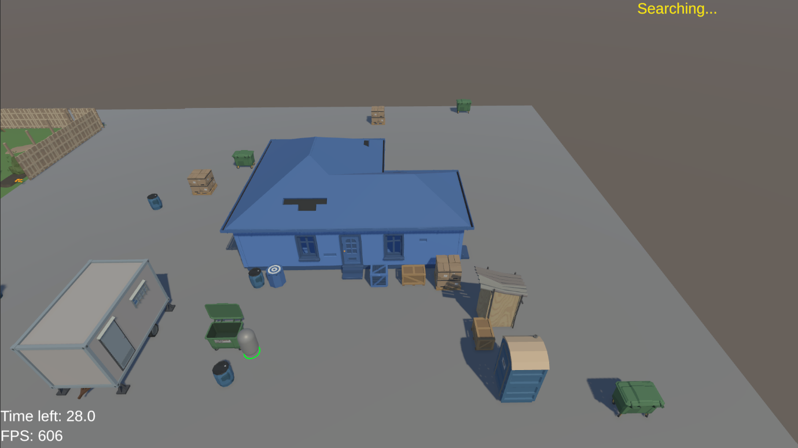
Figure 3: Scene Layout Diagram

3.3 Wireframes and UI Mock-ups
Helps visualize HUD elements, main menus, in-game prompts — critical for UI/UX design review.

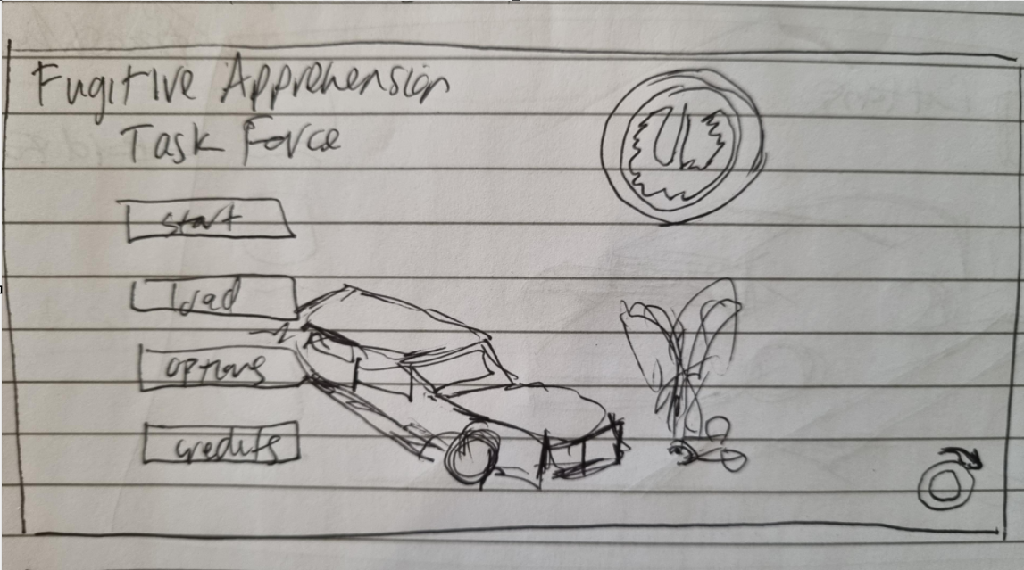
Main Menu sketch
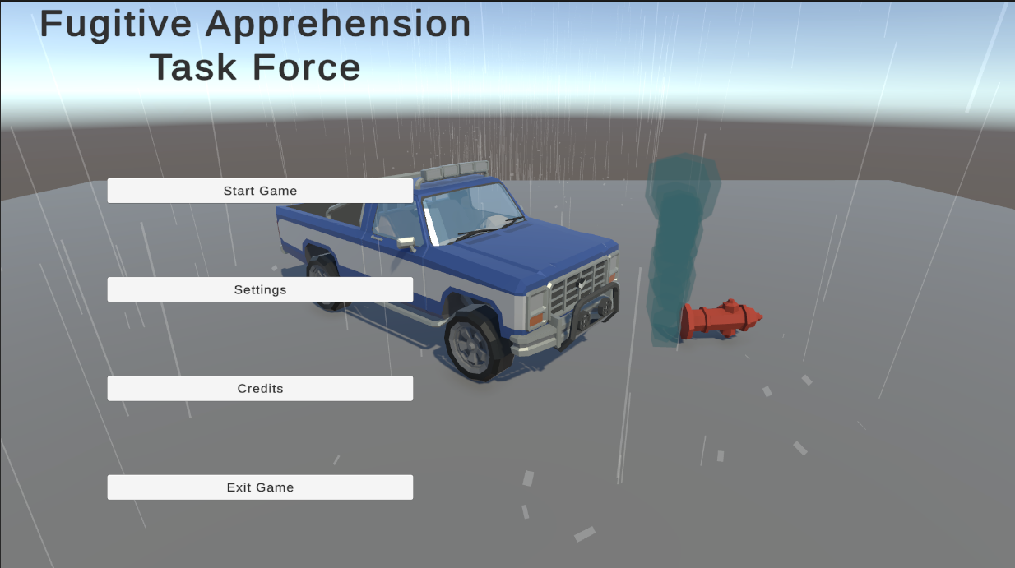
Main Menu - First in game iteration
Main menu will feature your usual buttons aligned to the left with a simple background scene which will include an agent, and a dog in action. This scene will also have a game logo and the title clearly displayed.

HUD sketch

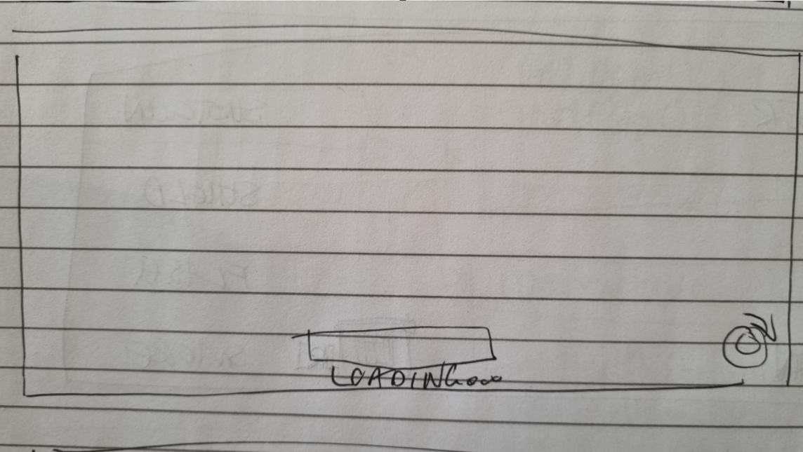
Loading progress bar sketch
Loading screens will feature a progress bar to show the user expected time remaining until loading is complete, and the game logo or a military challenge coin spinning/ rotating in the bottom right corner.

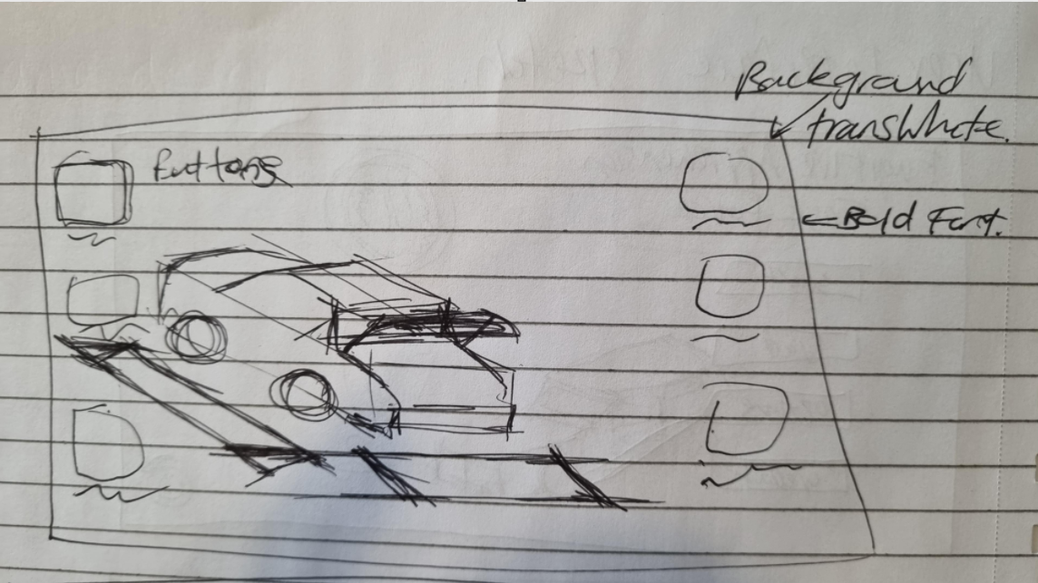
Vehicle Trunk UI
Vehicle trunk UI will display all equipment available to the agent to equip, and the presence of a dog if available. Different slots will either be selectable or greyed out depending on availability.

3.4 Design Diagram
In lieu of an organisation chart, this section will highlight how the game systems interact with one another.
AI, UI, Input, Physics, Audio
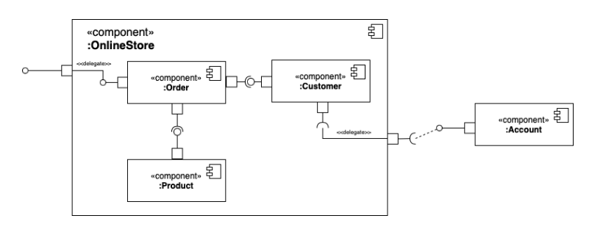
Figure 4: Component Diagram of Game Subsystems

4.0 Implementation Diagram

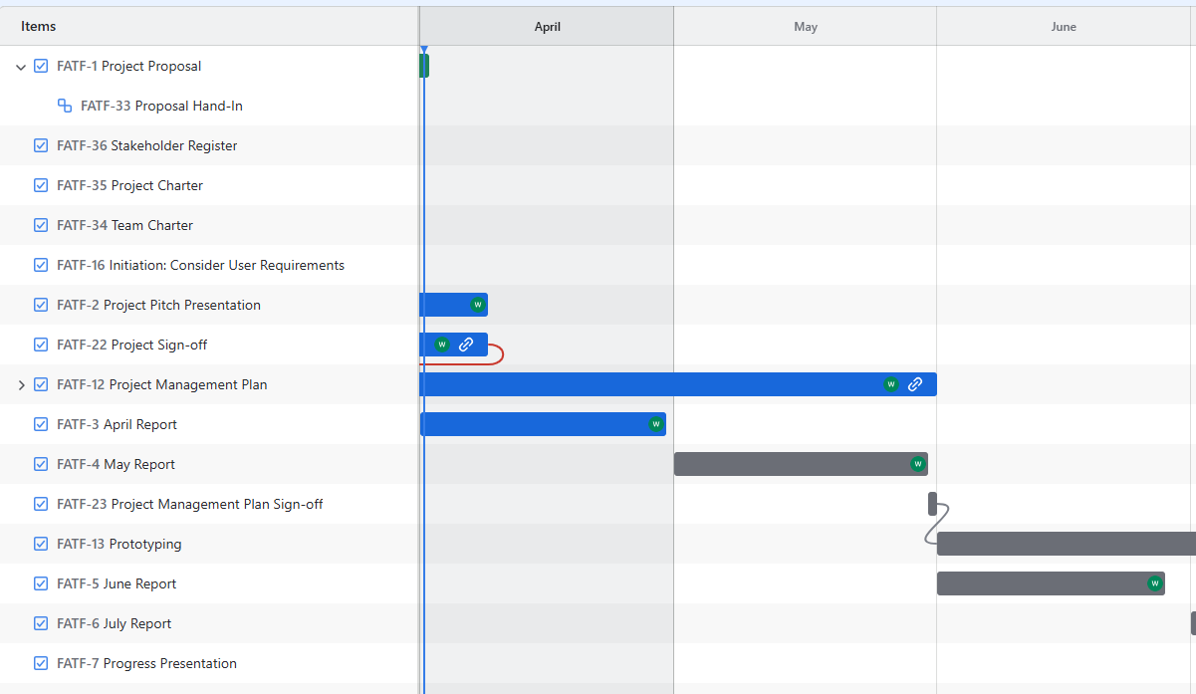
Figure 5: Project Milestones Timeline

4.1 Gameplay Diagram

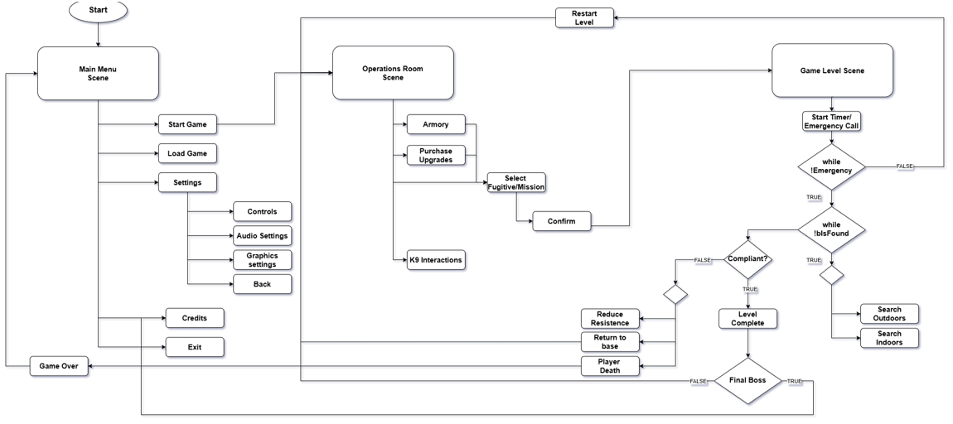

Figure 6: High Level Game Flow

5.0 System Level Design
In-depth technical breakdown of the game’s subsystems and how they interact. For example, detailing how the physics engine, AI systems, and input systems will work together.

Classes
UIManager (Singleton)
Enum UIState
- MainMenu
- InGame
- Pause
- GameOver
- Options

InputHandler
PlayerInventoryManager
PlayerManager
PlayerLocomotionManager (movement)
PlayerAnimationManager
PlayerStatsManager
- Const MAX_HEALTH
- currentHealth
- const MAX_STAMINA
- currentStamina
PlayerReputation
WeaponSlotManager
PlayerEquipmentManager
BaseCharacter
- Agent
  - Dog
- Fugitive
- Civilian
Interactable
- 1
- 2
- 3
- 4
- 5
IDestructible
- 1
- 2
- 3
- 4
BaseEquipment
- Melee
- Ranged
  - Throwable
  - Launched
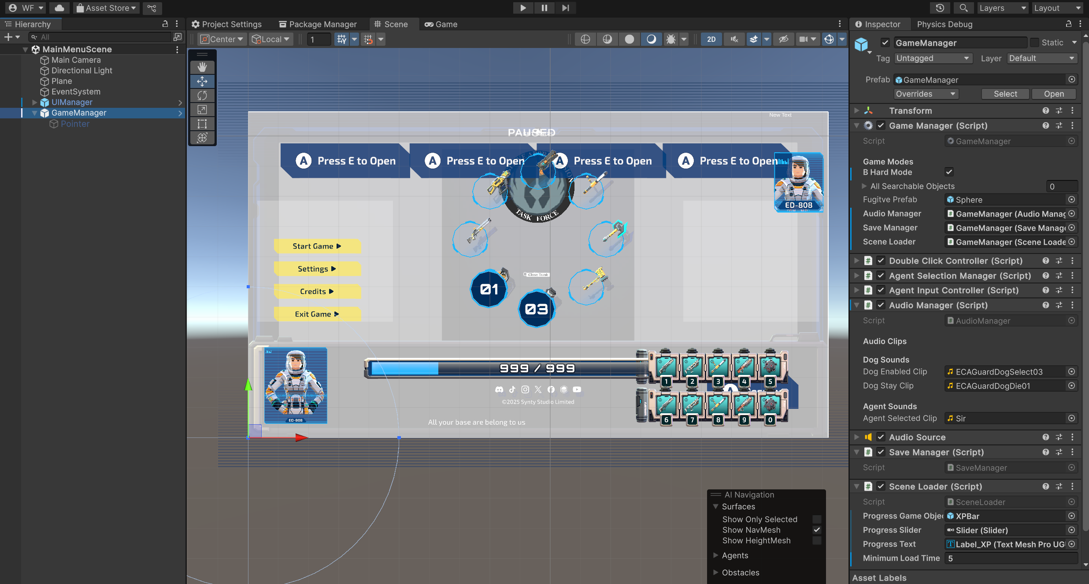

5.1 Core Class Structures
All code attempts to adhere to Object Orientated Programming principles as learned through my development journey. Concepts including
- Inheritance
- Encapsulation
- Abstraction
Other design concepts that are utilised include
- Association
- Aggregation
- Composition
The core class structure is planned to utilise different design patterns including but not limited to
- Singleton
- Facade
- Finite state machines
- Interfaces
- Observer (Unity event system)
Potential design patterns include:
- Object Pooling to optimise for improved performance. It reuses game objects to reduce garbage collection.

Singleton:
The singleton design pattern makes sure there is only one instance of the class and enables global access to it.
It is incorporated with a GameManager, UIManager, AudioManager classes to name a few.
Façade:
A façade design pattern provides a simplified interface to multiple subsystems.
A façade is implemented with a controller class that is designed to control subsystems like the AudioManager, SaveManager, and SceneLoader.
Finite State Machine (FSM):
The FSM design pattern allows decouples of behaviours into independent, manageable states. Benefits include
- Separation of concern: Each behaviour is self-contained.
- Easier debugging: Easier to pinpoint an issue with the agent.
- Scalable: Adding states or behaviours is simple.
Each Agent, Fugitive, and Civilian will have their own StateMachine component that manages its current state (Idle, Moving, Attacking, etc.). Each state inherits from a base state class and implements EnterState, ExitState, and update methods.

Interface:
An interface defines a contract that a class agrees to implement, specifying methods and properties without enforcing how they are implemented (Microsoft, n.d.).

Observer:
What:

How:

Examples of implementation can be found below.

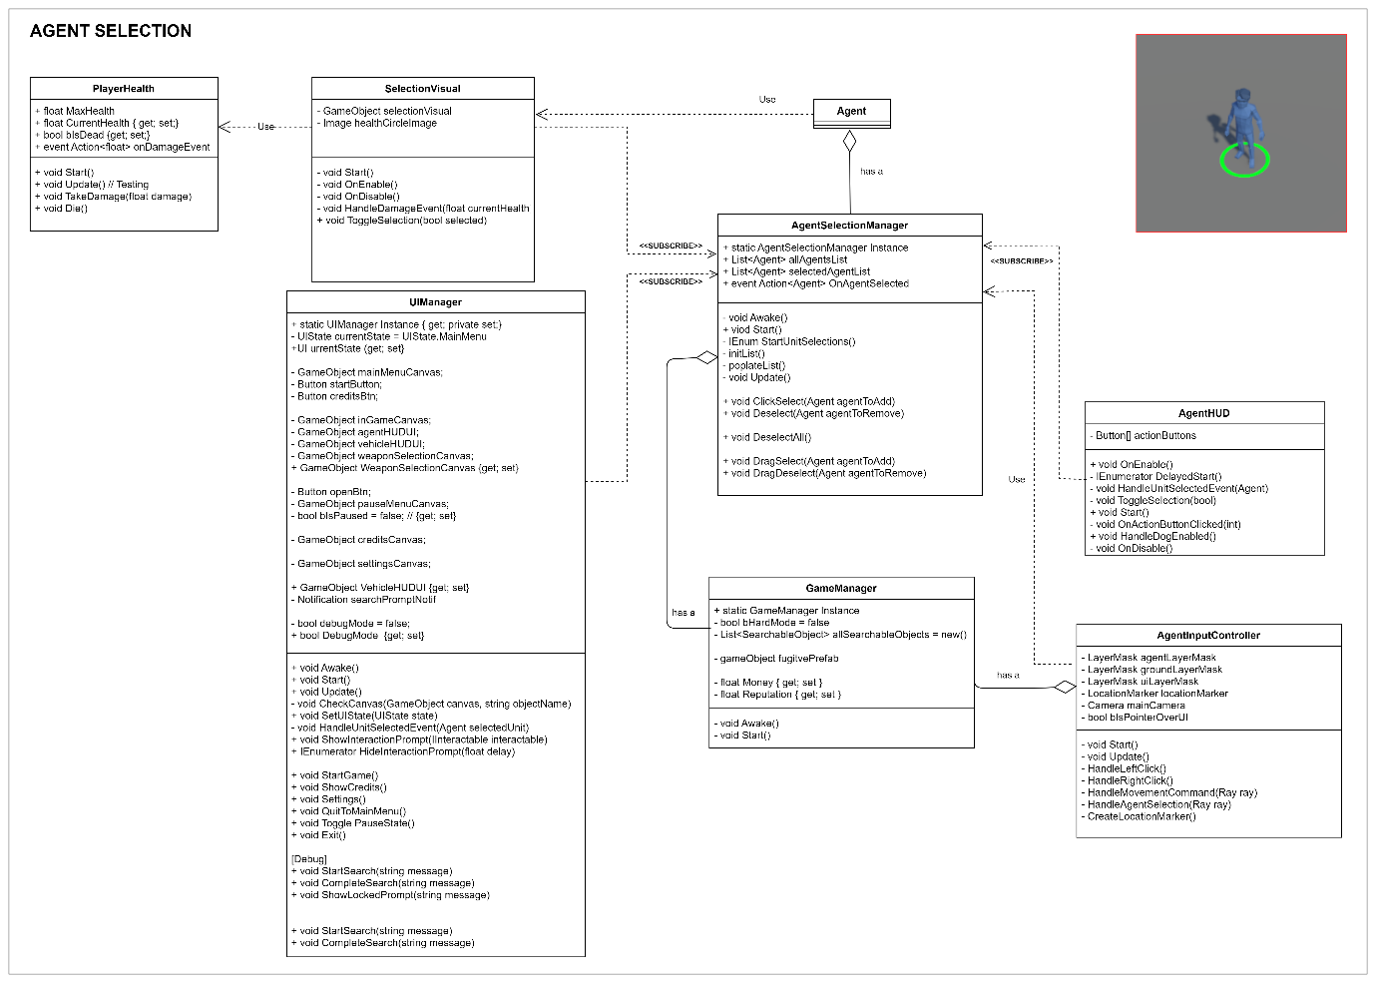
Figure 7: Agent selection and player feedback
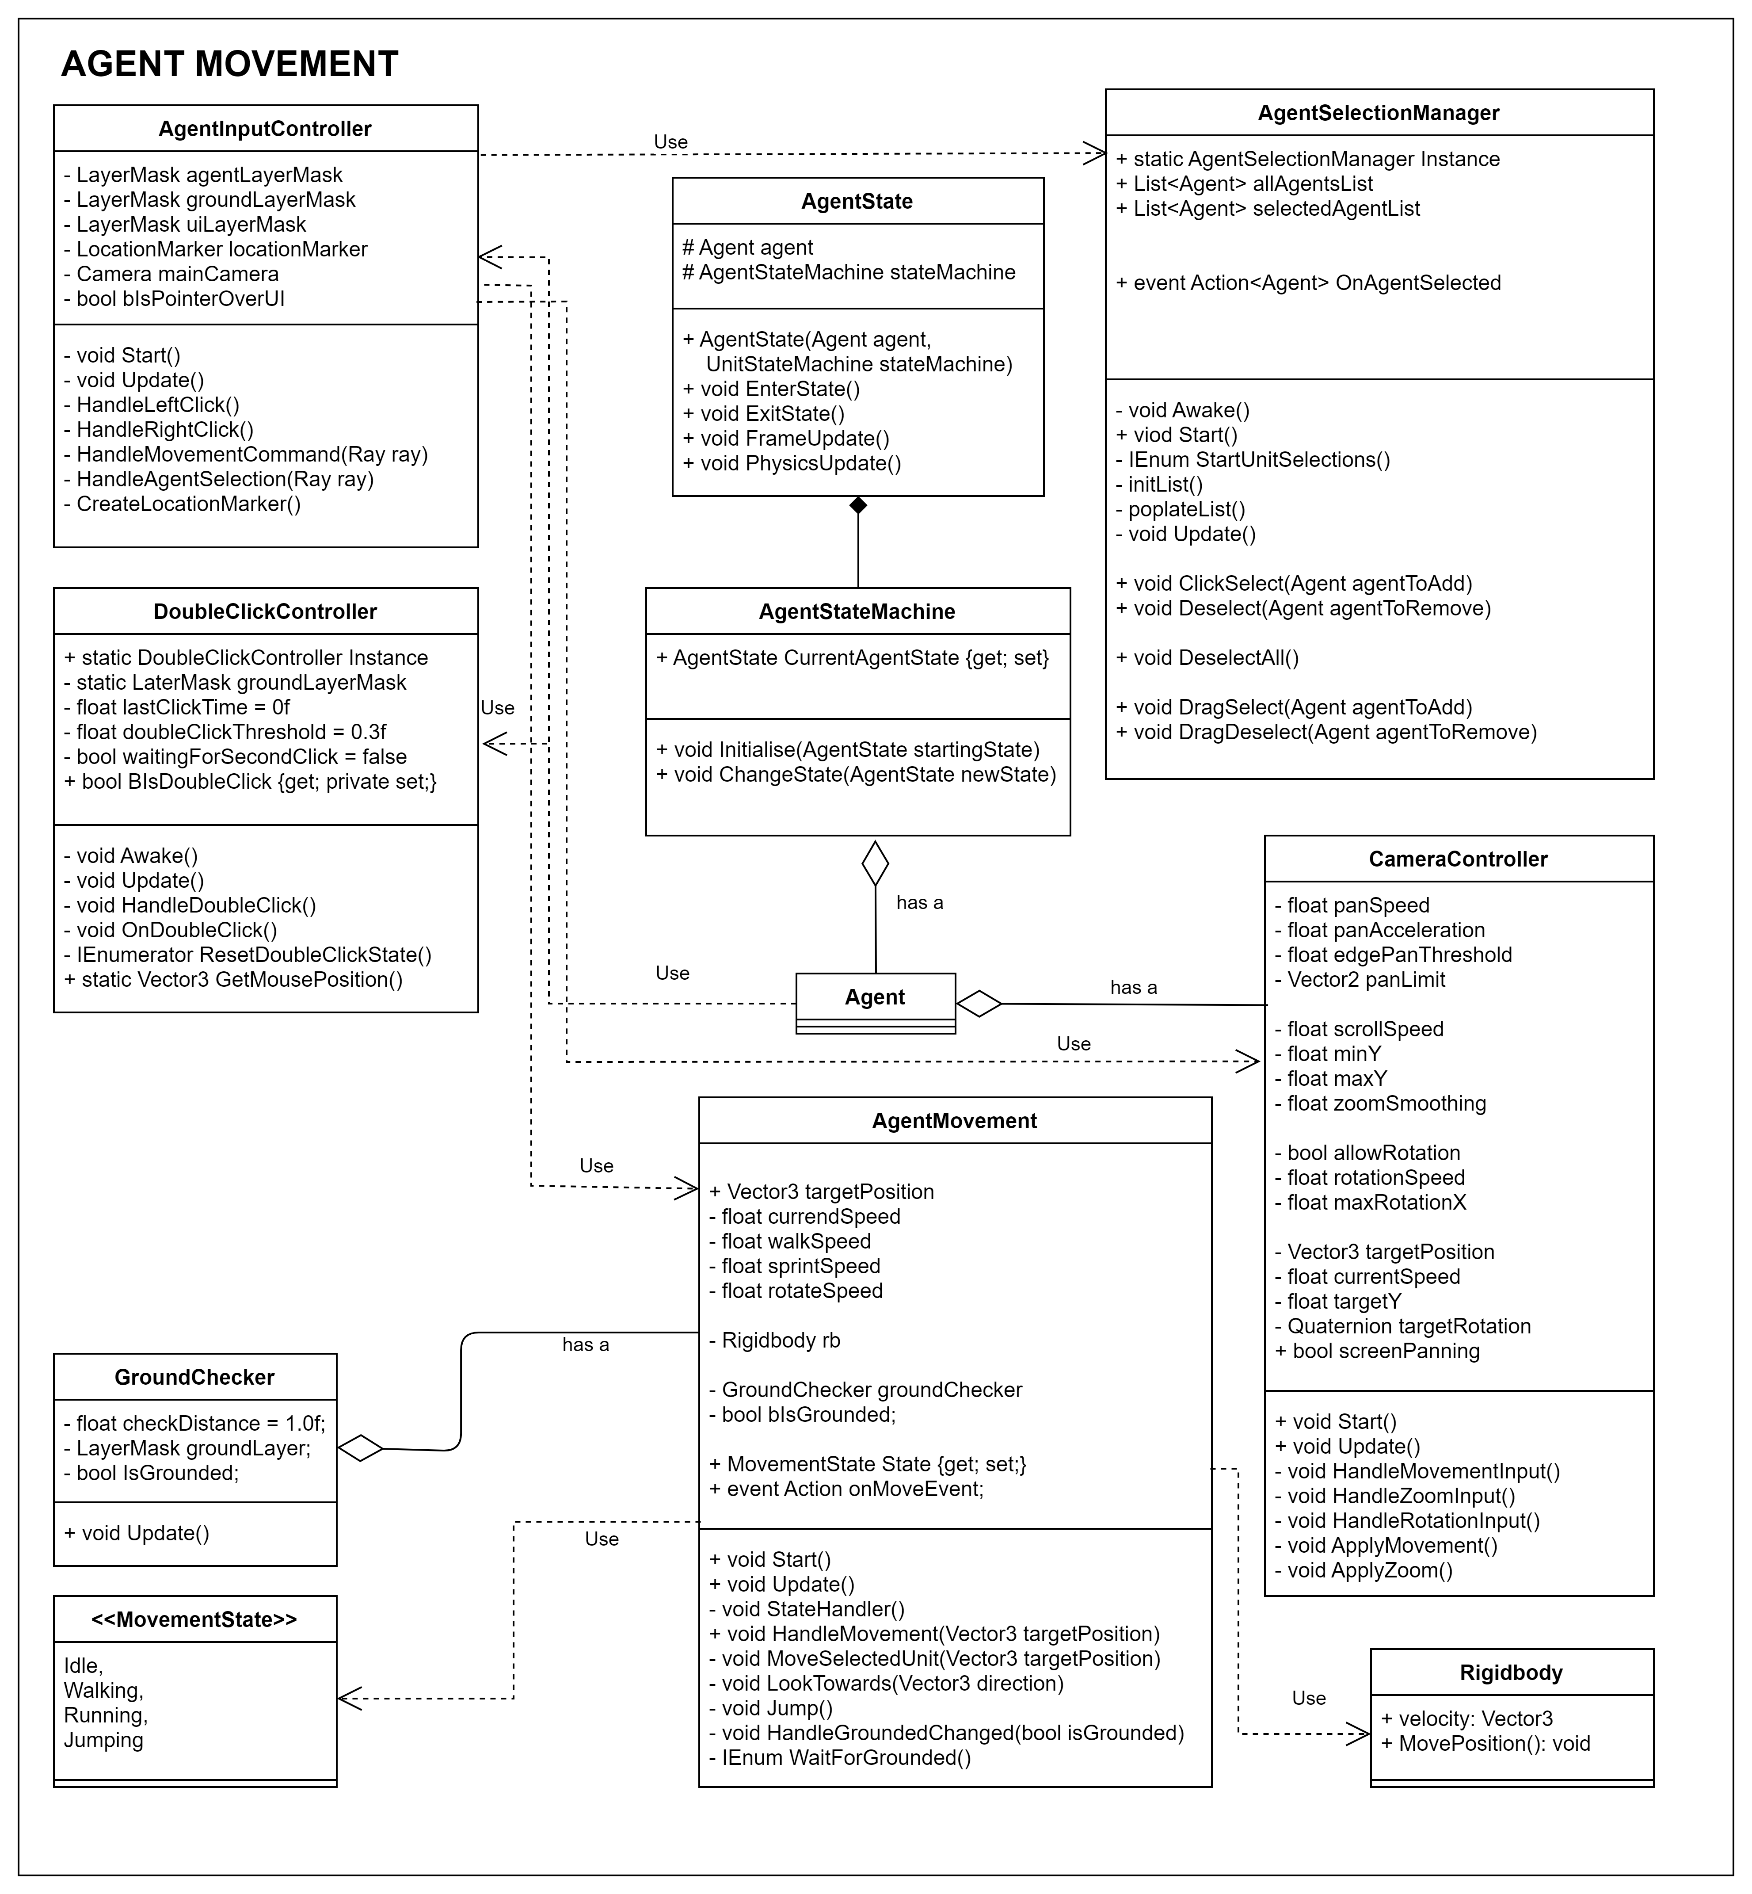

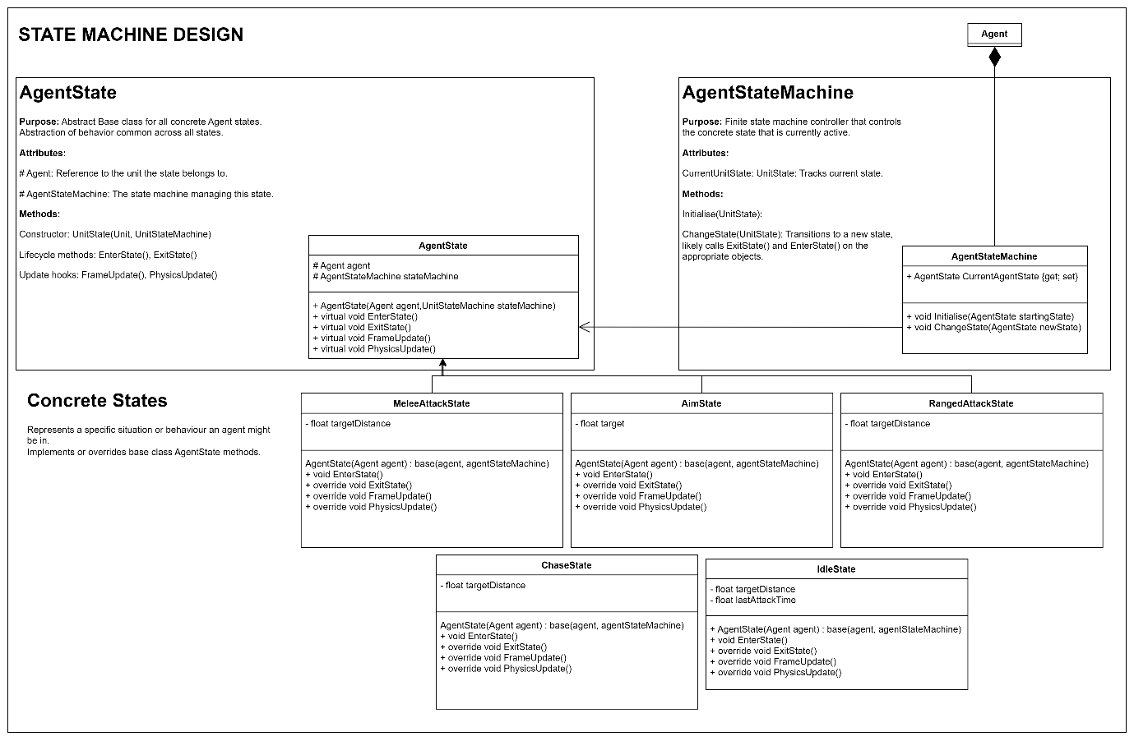

Figure 8: Sequence Diagram

Figure 9: Class Diagram of Core Components

5.2 Structural Design
The overall architecture of the game, such as how the code is organised, the use of design patterns, and the flow of data between systems.
Data Flow Diagram (DFD) - Shows how data flows between systems like Player Input → Command Processor → AI → Animation

Figure 10: Data Flow Diagram (DFD)

Algorithms and Logic: Descriptions of any algorithms used in the game, like pathfinding for AI or procedural content generation for levels.

Figure 11: AI Behaviour Flow Chart

AI will be equipped with an inbuilt nav mesh agent to handle pathfinding and random roaming.
A NavMeshAgent (agent) is an inbuilt component in unity that….
A NavMeshSurface (surface) has parameters the user must set. From those parameters the surface is baked into the scene automatically creates obstructions or no-go zones for an agent but more importantly lays out all reachable positions an agent can reach in the scene.

6.0 Game Development Tools
Tools that make the development of this game possible include:
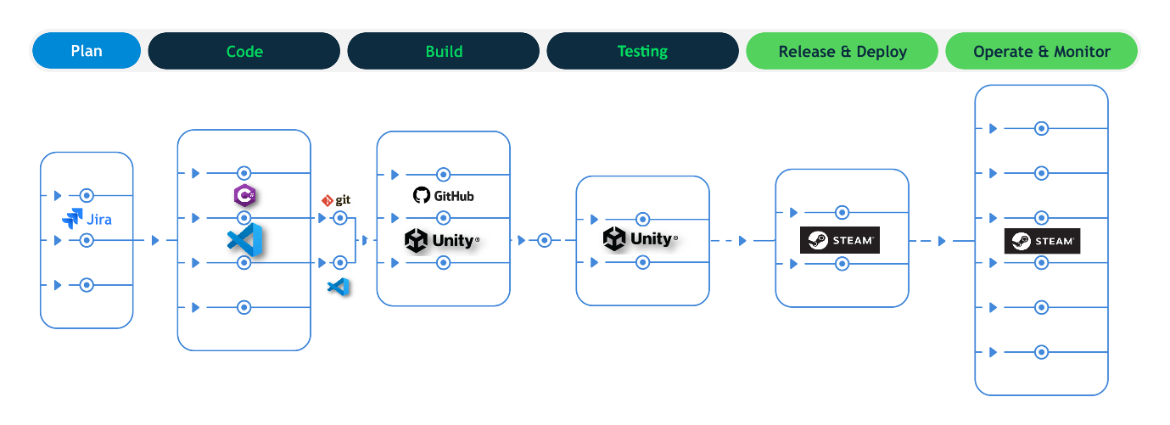
Figure 12: Toolchain Diagram

6.1 Unity Software Development Kit (SDK)
6.1.1 Version 2023.2.1f1
6.1.2 About Unity:
- The most popular game engine in the world according according to a 2025 “Game Market Overview” report by Devtodev (authored by D. Byshonkov).
- Used in the film industry.
- Free for students, and anyone earning less than $USD 100,000 per year.
6.1.3 Used for:
- Debugging,
- Prototyping,
- Game Development,
- Scene creation and layout,
- User interface creation and layout,
- Game Asset Management, and
- Development testing and game builds.

6.2 Unity Hub
6.2.1 Version 3.12.1
6.2.2 About Unity Hub:
- Proprietary software by Unity.
6.2.3 Used for:
- Storing unity project information,
- Installing different Unity game engine versions,
- Provides education resources for users,
- Links to the Unity Asset Store,
- Stores information for its community of users like blogs, and discussions.

6.3 Visual Studio Code (VS Code)
6.3.1 Version: Visual Studio Code 1.85
6.3.2 About Visual Studio Code:
- Source code editor developed by Microsoft.
- Supports lots of programming languages, including C#.
- Works seamlessly with Unity and Git.
- Helps uses with IntelliSense, debugging, and code formatting.
6.3.3 Used for:
- Writing and editing Unity C# scripts,
- Highlighting syntax issues,
- Uses IntelliSense for coding hints,
- Debugging and viewing console logs,
- Integrating with Git for version control,
- Unity support via extensions.

6.4 Blender
6.4.1 Version: Blender 3.6 LTS
6.4.2 About Blender:
- A free and open-source 3D creation suite.
- Used for modelling, rigging, animation, simulation, rendering, and compositing.
- Highly compatible with Unity for asset export.
6.4.3 Used for:
- Creating 3D models and animations
- Designing environments and characters
- Exporting FBX/OBJ assets for use in Unity

6.5 Git and GitHub
6.5.1 Version: Git 2.43 and GitHub web-based platform
6.5.2 About Git and GitHub:
- Version control system.
- Hosting and managing Git repositories.
- Assists in collaboration and project management.
6.5.3 Used for:
- Managing projects and tracking changes,
- Hosting and backing up the game project online, and
- Branching projects, reviewing and merging code bases.

6.6 Audacity
6.6.1 Version: Audacity 3.4.2
6.6.2 About Audacity:
- A free, open-source digital audio editor and recording software.
- Compatible with multiple formats including WAV, MP3, and OGG.
- Widely used in game development for sound design and audio editing.
6.6.3 Used for:
- Editing and enhancing sound effects and voiceovers
- Recording and trimming background music or ambient audio
- Normalizing, compressing, and cleaning up audio clips for game use
- Exporting optimized audio assets for use in Unity

6.7 Draw.io
6.7.1 Version: Web-based
6.7.2 About Draw.io:
- A free web-based diagramming tool.
- Users can create flowcharts, UML diagrams, wireframes, entity-relationship models etc.
- no account is required.
6.7.3 Used for:
- Designing flowcharts and logic diagrams for game mechanics,
- Planning out class structure, system interactions, and UI flow, and
- Assisting in technical and game design documentation.

Tools TBD:
X.x Adobe Photoshop
X.X.X Version:
Adobe Photoshop 2024
X.X.X About Photoshop:
- Industry-standard software for digital image creation and editing.
- Widely used in game development for texture creation and UI design.
X.X.X Used for:
- Creating and editing 2D textures and sprites
- Designing menus and UI elements
- Enhancing visual assets with effects and filters

7.0 3D Objects, Terrian and Scene Management

7.1 3D Objects
Object 1
Object 2

7.2 Scene Management
The responsibility of the Scene Management System is the efficient rendering and loading of complex scenes.
Components include:
Culling and occlusion
Level of Detail (LOD)
Clipping

8.0 Collision Detection, Physics and interaction

8.1 Collision Detection
Collision Detection will be required to restrict movement of the player and the ability to move through objects, to determine when the play colliders with an object, allow players to jump over and onto accessible areas, or to make players move around solid objects.
DC will also be needed for melee attacks on non-player character’s, players and destructible objects.
ranged attacks on players?
Collision detection will be enforced using bounding boxes and UDK.

8.2 Physics
Help to add realism into the game. For example items should fall over realistically, have force applied to smash, be affected by gravity.
Required for objects falling, object destruction, player and non-player character ragdoll simulations during tazer events, ono-player character and player deaths.

8.3 Interaction
This is how the player interacts with the game world.
Interactions with game interactable game objects/ items:
Opening and closing doors and windows.
Securing contraband, evidence.
Searching in , around, under objects.
Interactions with destructible objects

Smashing open locked doors and windows
Smashing open crates, boxes, and anything destructible.
Interacting with civilian/ fugitives
Defending against melee attacks
Melee attacking

9.0 Game Logic and Artificial Intelligence

Section 9 Networking

10.0 Audio and Visual Effects

10.1 Sound
Free sounds from the internet
Licensed music and sounds from Unity Asset Store

10.2 Visual
Licensed VFX from Synty Studio.
Free VFX from the internet.

11.0 Platform, Hardware & Software Requirements
PC Windows
Steam

11.1 Hardware Requirements

11.2 Software Requirements
Windows 10 or above
Direct X Version 9, 10, or 11

12.0 Risk, Dependencies and Change Prediction

4. Risk Analysis and Mitigation
- Risk Identification: Potential risks to the project’s success (e.g., technical challenges, resource shortages, scope creep).
- Mitigation Strategies: How risks will be minimized or addressed, such as fallback solutions, alternative approaches, or adjusting timelines.
5. Testing and Quality Assurance (QA)
- Test Plans: Describes how various aspects of the game will be tested, including unit tests, integration tests, and performance testing.
- Bug Tracking: Information on how bugs will be tracked, reported, and fixed.
6. Performance and Optimization
- Target Performance Metrics: Benchmarks for how the game should perform, such as frame rate (FPS), memory usage, and load times.
- Optimization Plan: A plan for how to ensure the game runs efficiently, including code optimization, asset compression, and other performance-enhancing techniques.

13.0 Prioritisation

1.1.22. The first priority is to implement the controls and player movement so we can test the game feel and get a prototype together.
1.1.23. Other priorities include implementing the AI so the mechanics can be tested. The game’s core is mechanics, outside of some placeholders, the art and sound can be handled later.
1.1.24. Performance will need to be tested and adjusted early due to the hardware limitations of the mobile platform.
1.1.25. Ensuring that the game adheres to the rules and regulations of the mobile application stores throughout development.

Conclusion

• Code Structure: An outline of how the code will be organized and the naming conventions that will be followed.
• Asset Pipeline: Details on how game assets (models, textures, sound, etc.) will be imported, processed, and utilized.

// Features from SRS
user-focused, descriptive.
Often uses "The Player must..." / "The Player should..."
Function Requirements?
The Player’s money must be displayed in Operations Room Scene.
The Player’s reputation points must be displayed in Operations Room Scene.
The Player’s equipment must be available in the Operations Room Scene (armory).
The Player should be able to select their next fugitive from Operations Room Scene to start new level.
The Player must be able to spend their money on upgrades and purchases in the Operations Room Scene.

Player should be able to automatically jump atop accessible areas.
Player should be able to climb up and down ladders they have access to.
Control system should all players to select/ deselect their agent and issue walk or sprint move orders.
The control system should allow players to issue action orders to non-player characters such as Search, Apprehend, Melee attack, Shoot.
The control system should allow players to change their equipped primary and secondary weapons and their Rules of Engagement i.e Weapons free, Hold Fire, Defensive stance

Figure 13: Player Movement use case model

Game level/ Design
Game consists of different levels the player can play. Each level has a fugitive they must capture to progress.
Interactable objects:
Destructible objects: Objects the player can choose to destroy if they have the appropriate tool equipped. Destroyed objects will make visible to contents of the object, or provide access to what is behind it, for example a locked door or window.
Boobytraps: Items that look like normal object may be hiding a deadly secret. Traps can be set which will harm the player if they’re set off.
Characters: Any non-player character could be armed with a melee or ranged weapon and should be dealt with accordingly.
Civilian: A non-player character who the player might encounter on the operations. They may/ may not assist you in your investigations and could potentially end up hindering them forcing the player to act. Detain, arrest, or interrogate them.
Fugitive: The non-player character you have chosen to pursue. They May/ may not be home when you arrive, however that is up to the player to work out. You might waste time searching only to determine that they were not home in the first place. Successfully have them give up and put in handcuffs to return to base and move to the next level.

Progression: Players should earn money and reputation points upon successful apprehension of fugitives and lose reputation if the RTB empty handed. Money is used to improve weapons, armor, add members to your team, upgrade vehicles etc.
Unlocking other agents and a Dog will significantly increase chances of finding and apprehending fugitives.

Reference
Unknown (n.d.) 2025 Unity Gaming Report. Retrieved 18 April, 2025 from https://unity.com/resources/gaming-report

Atlassian. (n.d.). Jira logo [Online image]. Atlassian. Retrieved from https://www.atlassian.com/legal/trademark#customers-and-general-public

Atlassian. (n.d.). Jira – Project management and issue tracking software. Retrieved from https://www.atlassian.com/software/jira

Blender Foundation. (n.d.). Blender logo [Online image]. Blender. Retrieved from https://www.blender.org/about/logo/
Byshonkov, D. (2025, February). Game market overview: The most important reports published in February 2025. Devtodev. Retrieved from https://www.devtodev.com/resources/articles/game-market-overview-the-most-important-reports-published-in-february-2025
diagrams.net. (n.d.). draw.io logo [Online image]. diagrams.net. Retrieved from https://github.com/jgraph/drawio-desktop/blob/dev/build/icon.svg

diagrams.net. (n.d.). diagrams.net – Online diagramming tool. Retrieved from https://www.diagrams.net/

GitHub, Inc. (n.d.). GitHub logo [Online image]. GitHub. Retrieved from https://github.com/logos

Google. (n.d.). Firebase logo [Online image]. Firebase. Retrieved from https://firebase.google.com/brand-guidelines
Microsoft. (n.d.). Interfaces (C# Programming Guide). Microsoft Learn. https://learn.microsoft.com/en-us/dotnet/csharp/programming-guide/interfaces/
Microsoft. (n.d.). C# logo [Online image]. Microsoft. Retrieved from https://commons.wikimedia.org/wiki/File:Csharp_Logo.png

Microsoft. (n.d.). Visual Studio logo [Online image]. Microsoft. Retrieved from https://code.visualstudio.com/brand

https://steamcdn-a.akamaihd.net/steamcommunity/public/images/steamworks_docs/english/steam_brandGuidelines.pdf

https://devops.kocsistem.com.tr/toolchain/detail
Unity Technologies. (n.d.). Unity logo [Online image]. Unity. Retrieved from https://unity.com/legal/branding-trademarks

