Regulating Routers:
The Control Layer of Internet-Native Dollars
Fifth Conference on International Roles of the U.S. Dollar
Board of Governors of the Federal Reserve System & Federal Reserve Bank of New York
June 22–23, 2026

PHASE 5 DRAFT — Exhibit Labels Audited & Aligned

Table of Contents
I. Introduction
II. Background
III. Theoretical Framework
IV. Data & Methodology
V. Findings
V.A Monetary Policy Transmission
V.B Market Structure Evolution
V.C Control Layer Dynamics
V.D Systemic Risk Implications
VI. Policy Implications
VII. Conclusion
Appendix A: Exhibit Inventory

I. Introduction
Stablecoins have emerged as the dominant form of internet-native dollar instruments, growing from approximately $137 billion in total market capitalization in February 2023 to over $307 billion by January 2026—a 124% increase in three years. This paper examines the relationship between stablecoin flows and U.S. monetary policy, arguing that gateway routing—not token taxonomy—determines the dollar network effects in the cryptocurrency ecosystem.
We introduce the Control Layer Intensity Index (CLII), a composite scoring framework that captures the regulatory, compliance, and operational characteristics of stablecoin gateways. Using a combination of Federal Reserve Economic Data (FRED), DefiLlama stablecoin supply data, and Dune Analytics on-chain flows, we document strong inverse correlations between Fed monetary policy indicators and stablecoin supply growth.

II. Background
The stablecoin market underwent significant structural changes during the study period (February 2023 – January 2026). Key events include the aftermath of the Terra/Luna collapse, the Silicon Valley Bank crisis and USDC de-peg event of March 2023, the NYDFS-ordered wind-down of BUSD by Paxos, and the emergence of new instruments such as USDe (Ethena) and PYUSD (PayPal).
Regulatory developments accelerated, with proposed stablecoin legislation in Congress, expanded OCC guidance on bank custody of digital assets, and international frameworks from the FSB and BIS for global stablecoin arrangements.

III. Theoretical Framework
We propose a control-layer hypothesis: the regulatory and compliance infrastructure through which stablecoins are routed (gateways) matters more for dollar network effects than the specific token standard or blockchain of issuance. The CLII framework scores gateways across five dimensions: regulatory license (25%), reserve transparency (20%), freeze/blacklist capability (20%), compliance infrastructure (20%), and geographic restrictions (15%).

IV. Data & Methodology
Data sources span three tiers: (1) FRED macro series covering the Federal Funds Rate, 2-Year and 10-Year Treasury yields, SOFR, Overnight Reverse Repo outstanding, and Federal Reserve total assets; (2) DefiLlama stablecoin market capitalizations and DEX trading volumes; and (3) Dune Analytics on-chain queries for gateway transfer flows, concentration metrics, and DeFi collateral data. The study period is February 2023 through January 2026.
Twelve exhibits support the empirical analysis, numbered 1–8 for monetary-policy and market-structure findings, and A, B, C, E for control-layer and systemic-risk analysis.

V. Findings

V.A Monetary Policy Transmission
The aggregate stablecoin market shows strong sensitivity to Federal Reserve policy actions. Exhibit 1 documents the overall growth trajectory, while Exhibit 2 overlays the Federal Funds Rate to reveal the inverse relationship (r = −0.89).
Exhibit 1: Total Stablecoin Market Capitalization
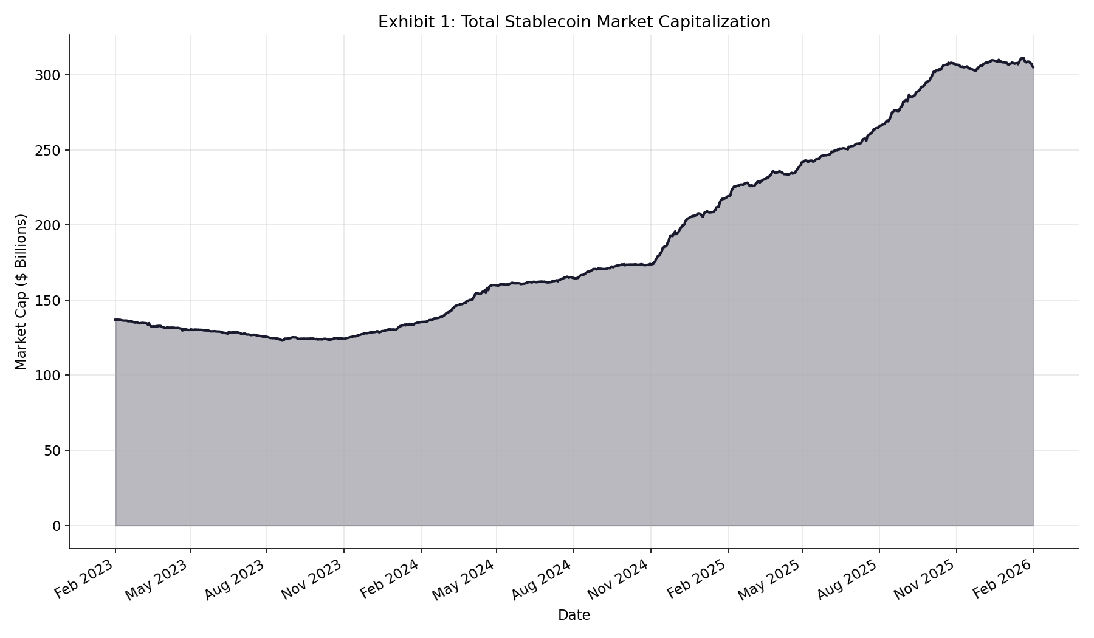
Source: DefiLlama Stablecoin API

The dual-axis chart in Exhibit 2 demonstrates that stablecoin supply growth accelerated precisely as the FOMC began cutting rates in September 2024, consistent with an opportunity-cost channel where non-yielding digital dollars become more attractive relative to Treasury bills and money market funds.
Exhibit 2: Stablecoin Supply vs Federal Funds Rate
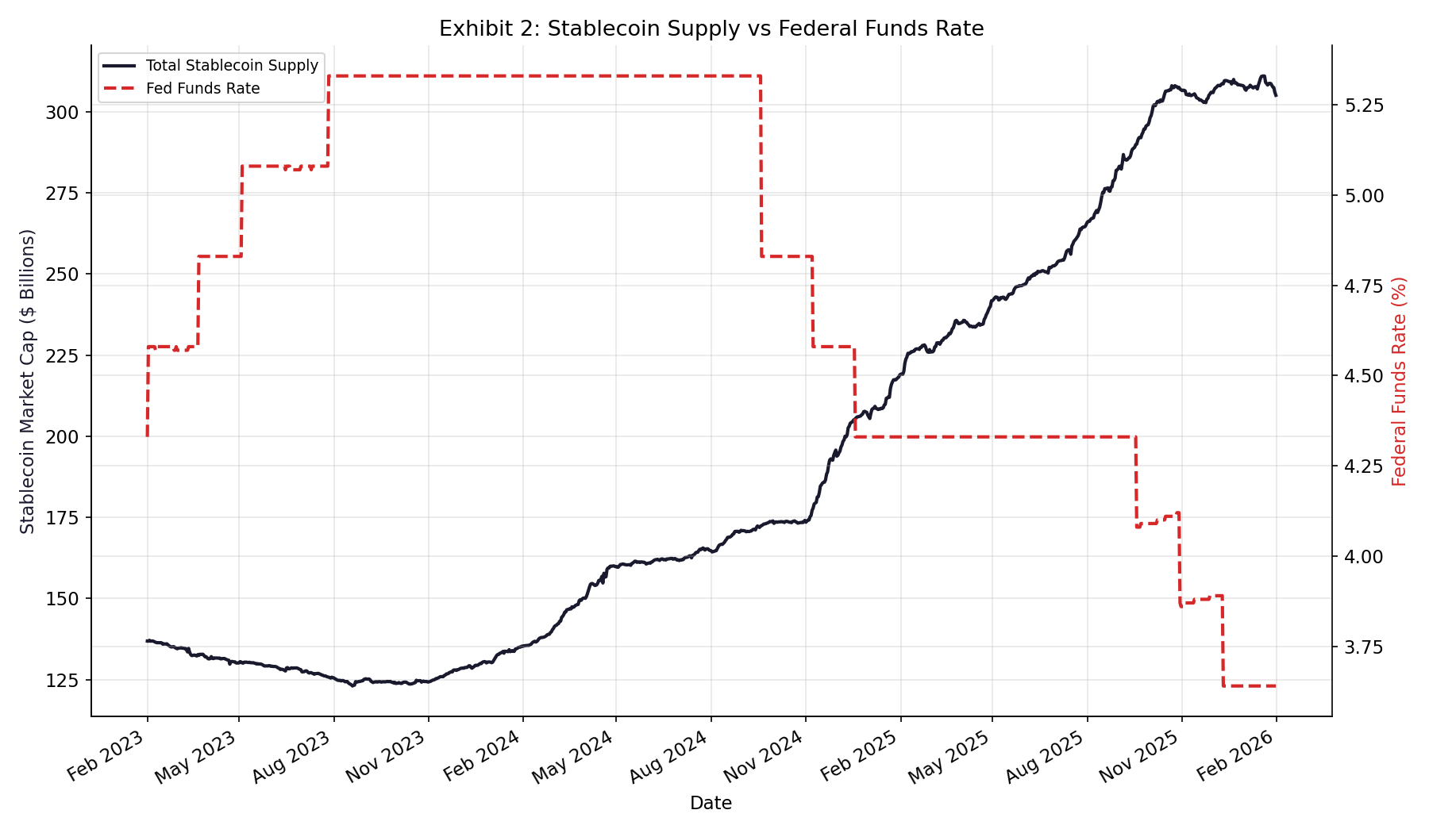
Source: FRED (DFF) + DefiLlama

Exhibit 5 extends this analysis to the Overnight Reverse Repo Facility. As the ON RRP drained from a peak of $2.3 trillion to near zero, stablecoin supply grew inversely (r = −0.72), suggesting some liquidity rotation from traditional money markets into crypto-native dollar instruments.
Exhibit 5: Stablecoin Supply vs Overnight Reverse Repo
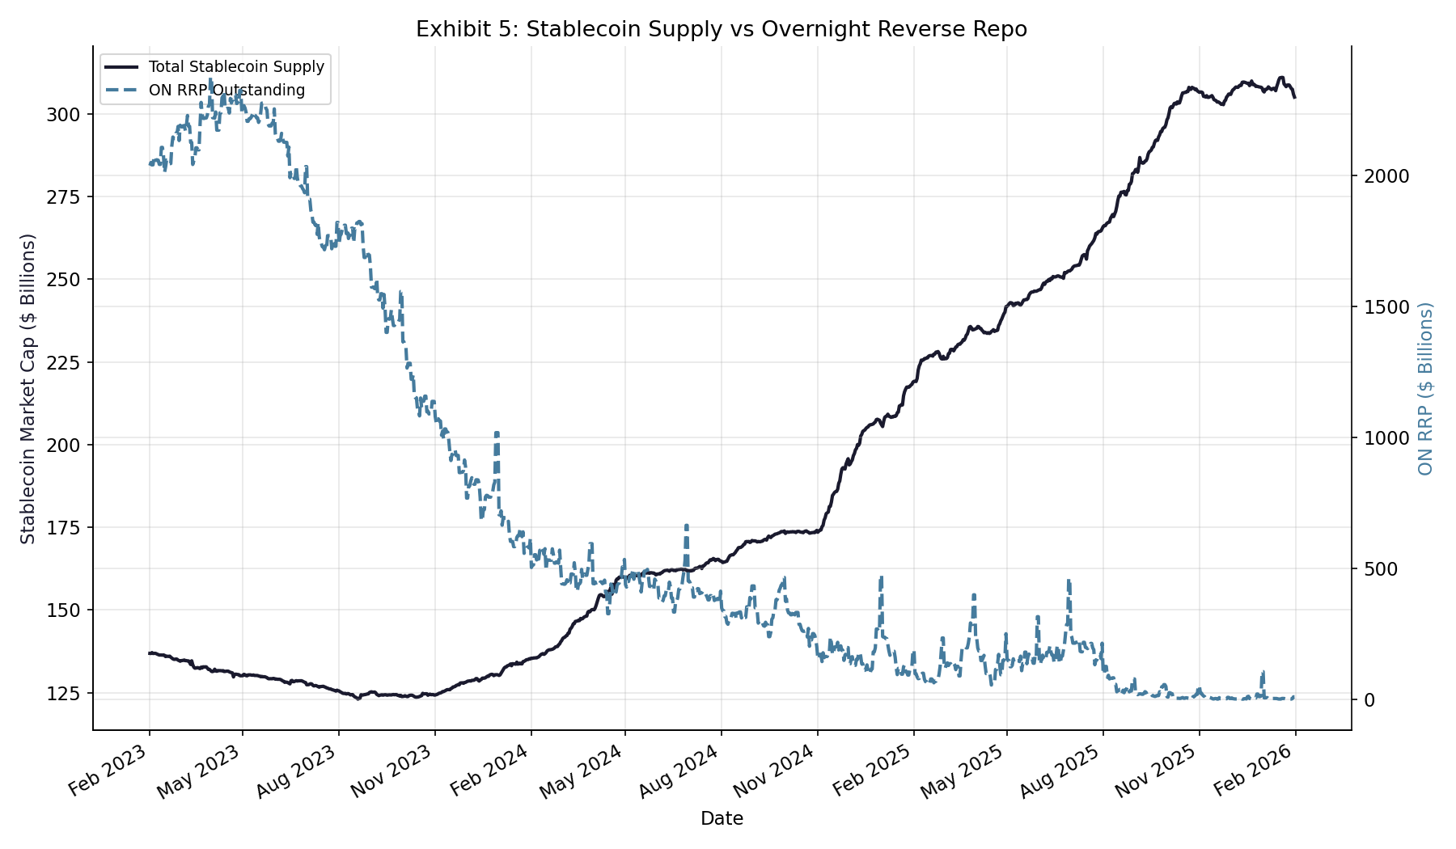
Source: FRED (RRPONTSYD) + DefiLlama

The correlation heatmap in Exhibit 6 synthesizes all pairwise relationships. The strongest inverse correlation is between Federal Reserve total assets and stablecoin supply (r = −0.94), indicating that quantitative tightening has coincided with stablecoin growth.
Exhibit 6: Correlation — Macro Indicators vs Stablecoin Supply
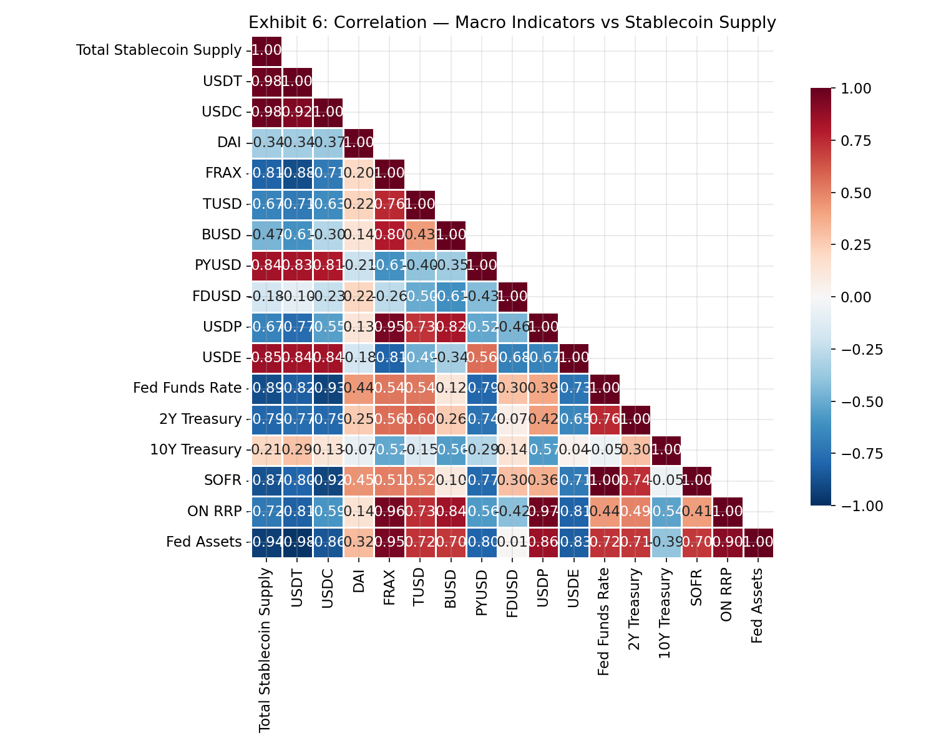
Source: FRED + DefiLlama (all series)

Exhibit B overlays funding stress indicators on the stablecoin supply timeline, capturing the USDC de-peg to approximately $0.88 on March 11, 2023, and concurrent spikes in Fed facility usage.
Exhibit B: Stablecoin Supply and Funding Stress Overlay
[Chart pending — exhibit_B_stablecoin_funding.png]
Source: FRED + DefiLlama

V.B Market Structure Evolution
Exhibit 3 decomposes total supply by individual token, revealing USDT’s dominance growth from approximately 50% to 61% of the market. The BUSD wind-down is clearly visible, as are the emergence of USDe and PYUSD in 2024–2025.
Exhibit 3: Stablecoin Market Capitalization by Token
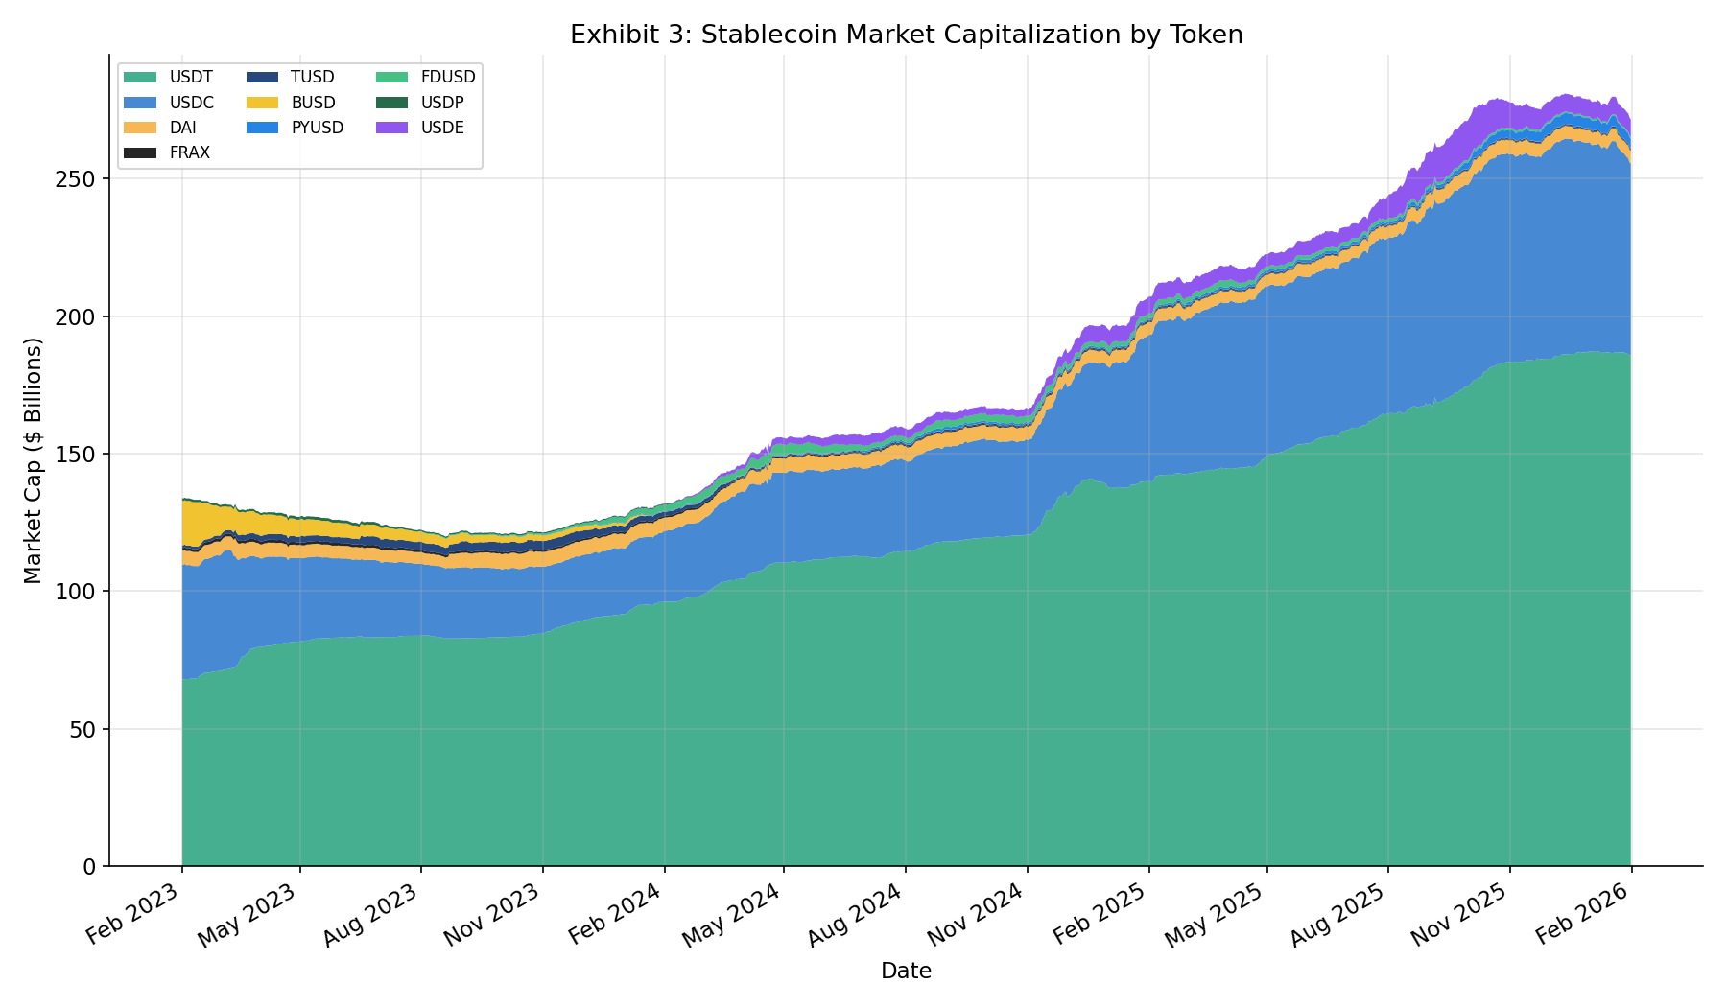
Source: DefiLlama Stablecoin API

Exhibit 4 presents monthly net supply changes, highlighting the sharp USDC outflow of approximately $9.5 billion in March 2023 following the SVB crisis. USDT captured these outflows with consistent net minting throughout the period.
Exhibit 4: Monthly Net Supply Changes — Major Stablecoins
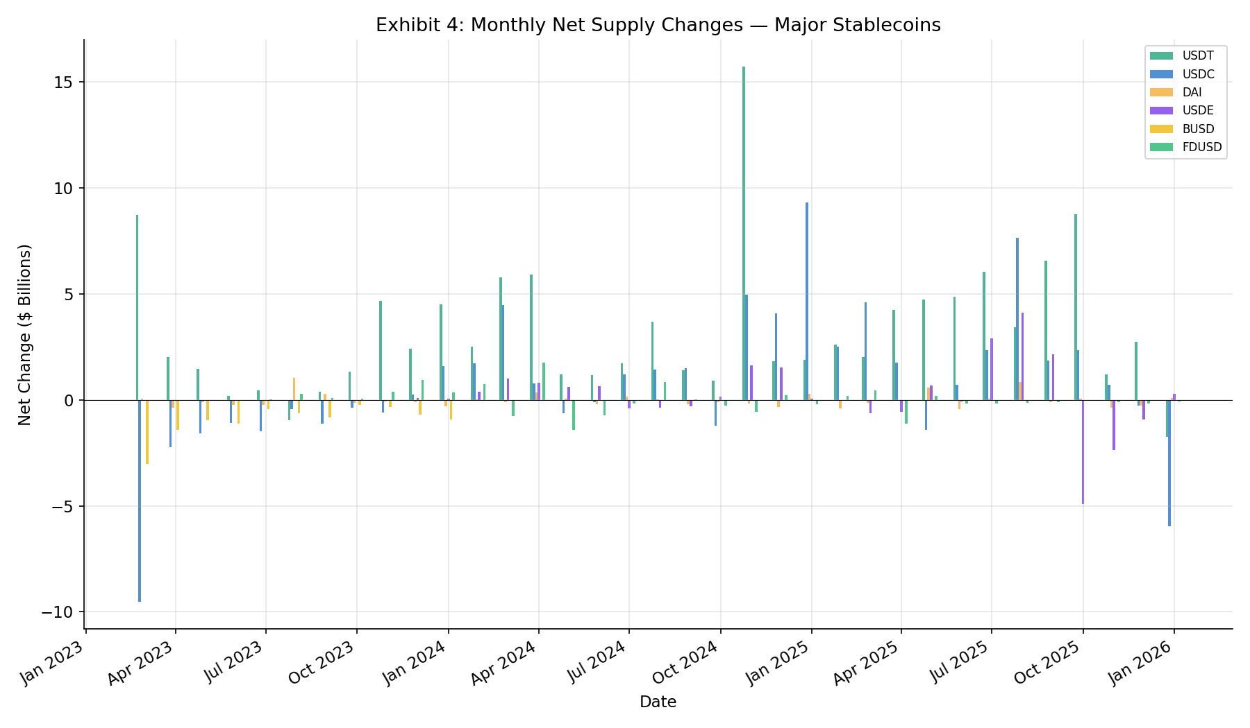
Source: DefiLlama Stablecoin API

On-chain activity metrics in Exhibits 7 and 8 show DEX trading volumes grew from approximately $3 billion per day in early 2023 to peaks exceeding $25 billion per day in early 2025.
Exhibit 7: DEX Trading Volume (Weekly Average)
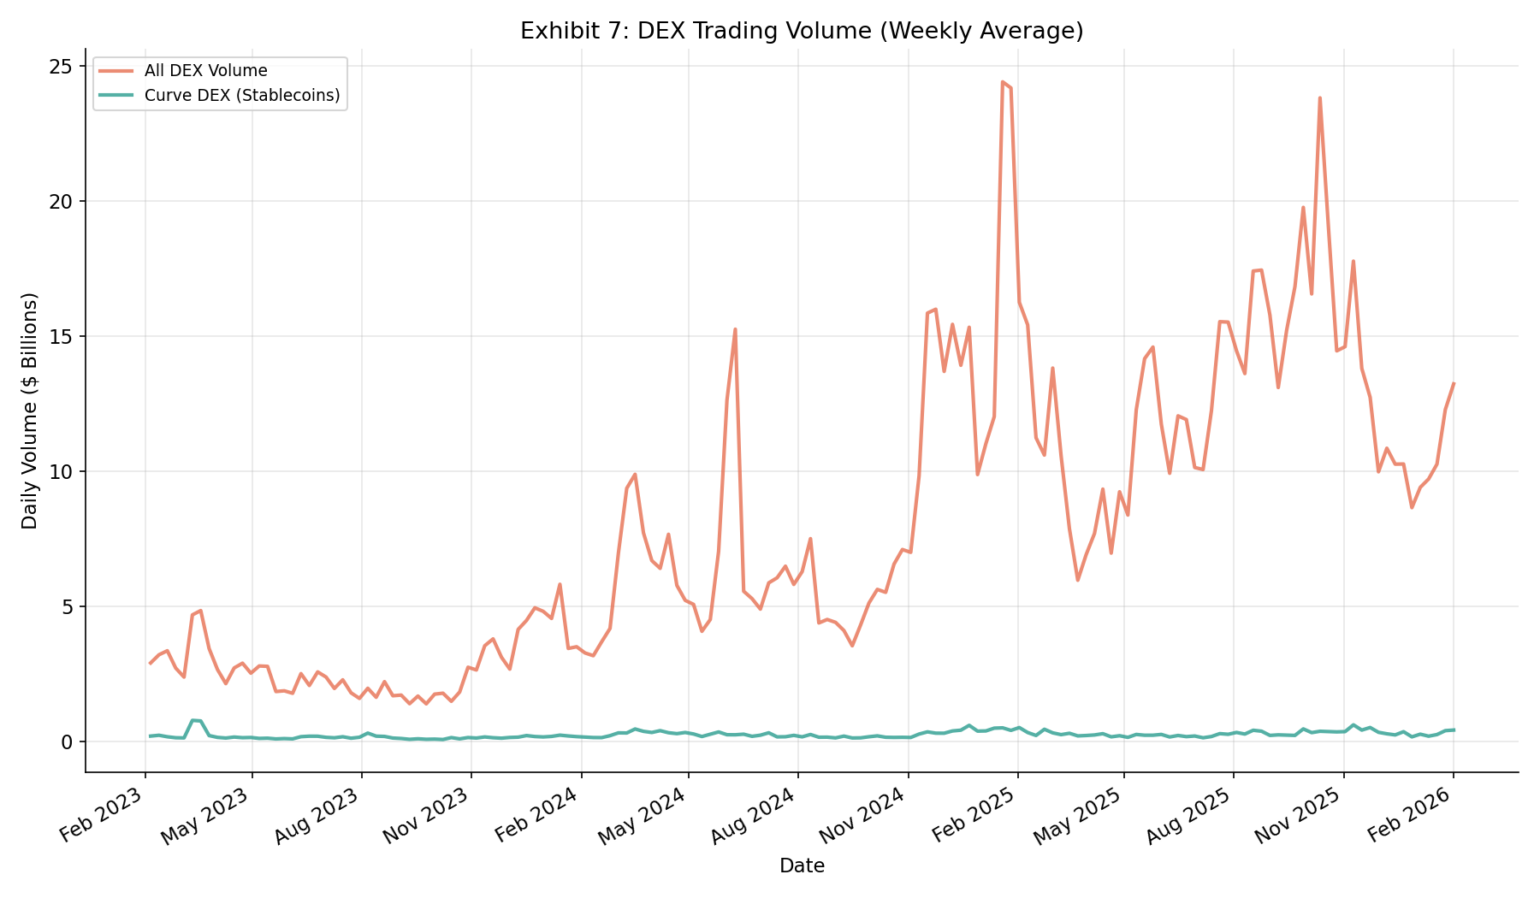
Source: DefiLlama DEX Volumes API

Exhibit 8: DEX Volume vs Stablecoin Supply
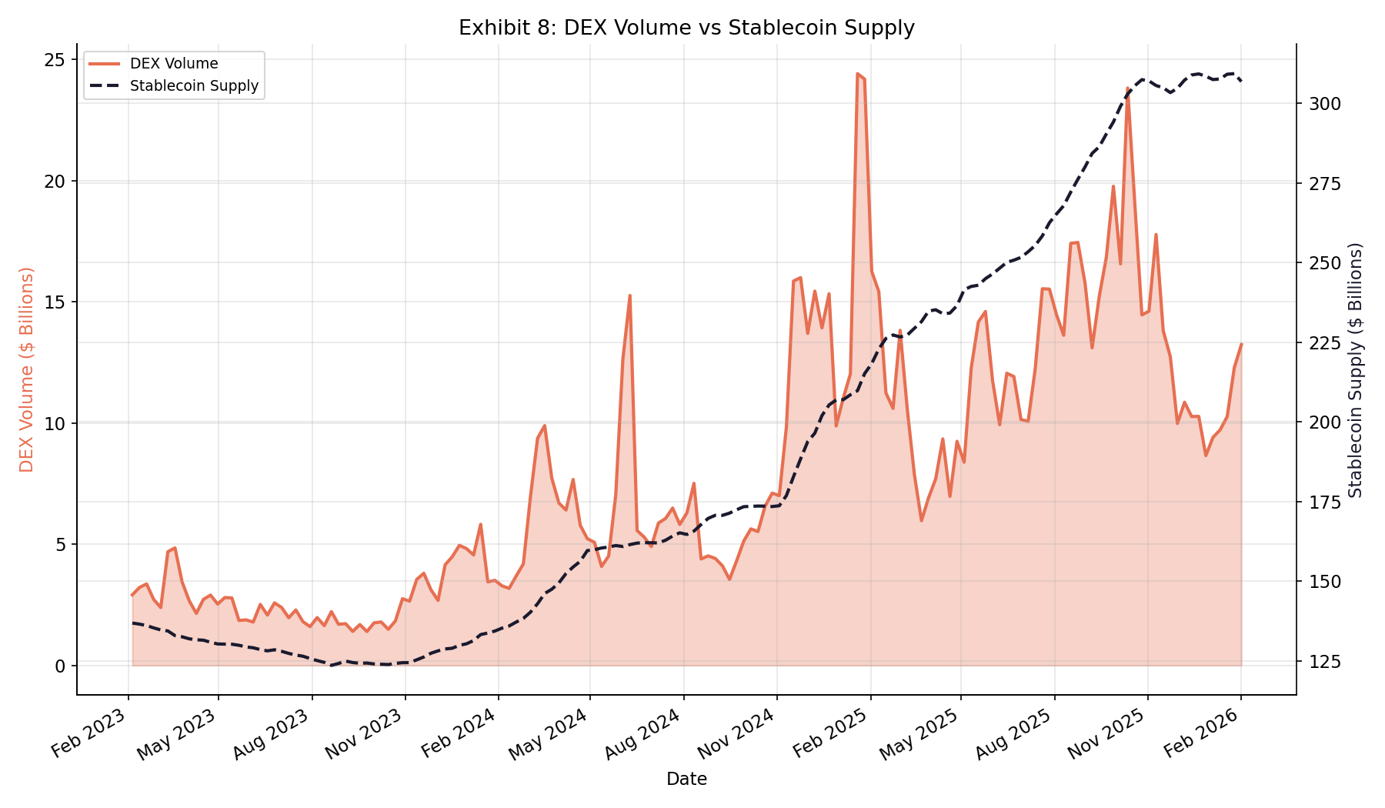
Source: DefiLlama DEX + Stablecoin APIs

V.C Control Layer Dynamics
Exhibit A maps stablecoin corridor flows between U.S. and Mexico gateways, demonstrating flight-to-quality behavior during stress periods: Tier 1 gateways (CLII > 0.80) captured an additional +15% market share during the March 2023 stress event.
Exhibit A: US–Mexico Corridor Stablecoin Flows
[Chart pending — exhibit_A_corridor_flows.png]
Source: Dune Analytics (gateway_transfers)

Exhibit C combines the Herfindahl–Hirschman Index of gateway concentration with CLII scores, showing that higher-scored gateways have gained market share over the study period.
Exhibit C: Gateway Routing Concentration and CLII Scores
[Chart pending — exhibit_C_gateway_routing.png]
Source: Dune Analytics + CLII methodology

V.D Systemic Risk Implications
Exhibit E documents the growth of tokenized Treasury products (BUIDL, USDY, OUSG) and their use as collateral in DeFi lending protocols, particularly Aave v3. Liquidation events during stress periods reveal how stablecoin collateral composition creates linkages between crypto-native and traditional short-term funding markets.
Exhibit E: Tokenized Treasury Assets and DeFi Collateral
[Chart pending — exhibit_E_tokenized_defi.png]
Source: Dune Analytics (Aave v3 + Treasury)

VI. Policy Implications
The findings support a regulatory framework focused on gateway routing rather than token-level classification. Key policy recommendations include: (1) gateway-level reserve requirements and transparency standards; (2) CLII-informed supervisory prioritization; (3) stress-testing of stablecoin redemption scenarios and their impact on short-term funding markets; and (4) consideration of how a potential Fed-issued CBDC would interact with the existing stablecoin control layer.

VII. Conclusion
This paper documents a strong monetary policy transmission channel through stablecoin markets, with supply growth inversely correlated to Fed policy rates (r = −0.89), overnight reverse repo usage (r = −0.72), and Federal Reserve total assets (r = −0.94). The control-layer analysis demonstrates that gateway routing—not token taxonomy—determines dollar network effects, with Tier 1 gateways capturing disproportionate flows during stress periods.
Future research should extend the CLII framework to cover additional corridors (EUR, GBP stablecoin pairs) and explore the causal mechanisms underlying the observed correlations using instrumental variable and event-study approaches.

Appendix A: Exhibit Inventory
The following table provides a complete inventory of all exhibits in this paper. Exhibit numbers, captions, and filenames are aligned with the titles baked into the PNG chart images.
Exhibit | Caption | File | Section | Data Source | Status
1 | Exhibit 1: Total Stablecoin Market Capitalization | exhibit_1_total_supply.png | V.A | DefiLlama Stablecoin API | Complete
2 | Exhibit 2: Stablecoin Supply vs Federal Funds Rate | exhibit_2_supply_vs_rate.png | V.A | FRED (DFF) + DefiLlama | Complete
3 | Exhibit 3: Stablecoin Market Capitalization by Token | exhibit_3_market_share.png | V.B | DefiLlama Stablecoin API | Complete
4 | Exhibit 4: Monthly Net Supply Changes — Major Stablecoins | exhibit_4_net_supply_changes.png | V.B | DefiLlama Stablecoin API | Complete
5 | Exhibit 5: Stablecoin Supply vs Overnight Reverse Repo | exhibit_5_supply_vs_rrp.png | V.A | FRED (RRPONTSYD) + DefiLlama | Complete
6 | Exhibit 6: Correlation — Macro Indicators vs Stablecoin Supply | exhibit_6_correlation_heatmap.png | V.A | FRED + DefiLlama (all series) | Complete
7 | Exhibit 7: DEX Trading Volume (Weekly Average) | exhibit_7_dex_volumes.png | V.B | DefiLlama DEX Volumes API | Complete
8 | Exhibit 8: DEX Volume vs Stablecoin Supply | exhibit_8_volume_vs_supply.png | V.B | DefiLlama DEX + Stablecoin APIs | Complete
A | Exhibit A: US–Mexico Corridor Stablecoin Flows | exhibit_A_corridor_flows.png | V.C | Dune Analytics (gateway_transfers) | Pending
B | Exhibit B: Stablecoin Supply and Funding Stress Overlay | exhibit_B_stablecoin_funding.png | V.A | FRED + DefiLlama | Pending
C | Exhibit C: Gateway Routing Concentration and CLII Scores | exhibit_C_gateway_routing.png | V.C | Dune Analytics + CLII methodology | Pending
E | Exhibit E: Tokenized Treasury Assets and DeFi Collateral | exhibit_E_tokenized_defi.png | V.D | Dune Analytics (Aave v3 + Treasury) | Pending

Key Insights Summary
Exhibit 1: Total supply grew from $137B (Feb 2023) to $307B (Jan 2026), +124%.
Exhibit 2: Inverse relationship (r = -0.89). Supply accelerated as rate cuts began Sep 2024.
Exhibit 3: USDT dominance 50% to 61%. BUSD wound down. USDe, PYUSD gained traction.
Exhibit 4: Sharp USDC outflow (~$9.5B) March 2023 post-SVB. USDT captured flows.
Exhibit 5: Inverse relationship (r = -0.72). ON RRP drained $2.3T to near zero.
Exhibit 6: Fed Assets vs Supply: r = -0.94 (strongest inverse correlation).
Exhibit 7: DEX volumes grew ~$3B/day to peaks of $25B/day. Curve flat at $0.3–0.5B.
Exhibit 8: Both grew strongly but volume far more volatile. Velocity proxy varies.
Exhibit A: Flight to Tier 1 gateways during stress periods (+15% share).
Exhibit B: USDC depeg to ~$0.88 on March 11 2023; facility usage spike.
Exhibit C: HHI concentration + CLII scoring reveals control-layer dynamics.
Exhibit E: Tokenized Treasury AUM growth; Aave liquidation stress events.

