System Design and Delta-Based Heterogeneous Teleoperation of a Mecanum-Wheeled Quadrupedal Mobile Manipulator
line 1: 1st Given Name Surname  line 2: dept. name of organization (of Affiliation)  line 3: name of organization (of Affiliation)  line 4: City, Country  line 5: email address or ORCID | line 1: 2nd Given Name Surname  line 2: dept. name of organization (of Affiliation)  line 3: name of organization (of Affiliation)  line 4: City, Country  line 5: email address or ORCID | line 1: 3rd Given Name Surname  line 2: dept. name of organization (of Affiliation)  line 3: name of organization (of Affiliation)  line 4: City, Country  line 5: email address or ORCID

Abstract—Quadrupedal manipulators combine terrain adaptability and environmental interaction for disaster response, hazardous operations, and campus inspection. This paper presents a Mecanum-wheeled quadrupedal mobile manipulator and heterogeneous teleoperation system. Each leg has two pitch joints and one wheel-drive degree of freedom; The four Mecanum wheels enable omnidirectional planar motion. Hierarchical torque feedforward combines single-leg virtual-work mapping and whole-body single-rigid-body modeling, with attitude feedback adjusting leg length. The six-axis arm uses analytical inverse kinematics through position–orientation decomposition. A Delta parallel mechanism provides master position input, and a three-axis handle with three encoders provides orientation input. Frame calibration and pose mapping convert these inputs into arm joint commands. The framework connects mechanism design, kinematic modeling, model-based feedforward, and joint control to support system design and implementation. Physical demonstrations illustrate system operation.
Keywords—wheeled-legged robot, Mecanum wheel, mobile manipulation, torque feedforward, heterogeneous teleoperation

Introduction
As robotics expands into emergency response, hazardous-area inspection, and remote maintenance, mobile robots must navigate complex terrain, sense their surroundings, and grasp, transport, and operate equipment. These tasks require terrain adaptability, flexible end-effector manipulation, and effective human–robot interaction.
Prior work includes wheel–leg coordination using rolling constraints and whole-body control [1], [2], and Mecanum quadrupeds for planar motion [3]. Mobile-manipulation studies address arm-constrained learning, cross-configuration control, and whole-body optimization [4]–[6]. Teleoperation has used mixed reality [7] and Delta-based six-degree-of-freedom masters [8]. Task-specific chassis–arm coordination and heterogeneous pose mapping remain important integration challenges.
This paper presents an integrated Mecanum-wheeled quadrupedal mobile manipulator and heterogeneous teleoperation architecture. Its control system coordinates chassis locomotion, arm manipulation, and Delta-master input. Grasping and step-climbing demonstrations evaluate the integrated system.

Proposed Method
Figure 1 shows the chassis, arm, Delta master, and principal coordinate frames. The robot has a 12-degree-of-freedom chassis, a six-revolute-joint arm, and a one-degree-of-freedom gripper (19 active degrees of freedom total); the master provides three translational and three orientation-input degrees of freedom.
System Architecture and Notation
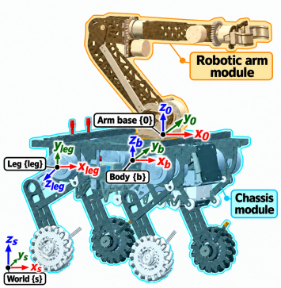 | 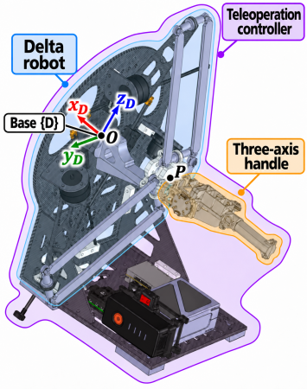
(a) Robot | (b) Teleoperation controller
Fig. 1. System modules and coordinate frames. (a) Robot: orange/cyan mark the arm/chassis; {s}, {b}, {leg}, and {0} denote the inertial frame, base center, illustrated hip, and arm base. Forward is rightward. (b) Teleoperation master: purple marks the controller; light blue/orange mark the Delta mechanism/three-axis handle. {D} is centered at O on the fixed platform; P marks the moving-platform center. All frames are right-handed.

Fig. 2 summarizes the control workflow. Chassis inputs are desired translational velocity and acceleration, baseline height, and roll and pitch. Control has joint, Mecanum wheel, and model-based feedforward branches. Cascaded attitude-angle and angular-rate proportional (P) loops use inertial measurement unit (IMU) feedback to generate equivalent leg-length increments. Accumulation, leg-height allocation, and leg inverse kinematics yield joint targets; cascaded joint position and velocity proportional–integral–derivative (PID) control generates control torques. Wheel kinematics gives wheel-motor speed targets for speed-loop PID control. Single-rigid-body dynamics allocates desired contact forces; wheel dynamics and leg-linkage force mapping convert them into motor feedforward torques. Each joint and wheel motor sums its control and corresponding feedforward torques.
The arm maps the master pose through position scaling and orientation transformation to a slave target homogeneous transformation. Analytical inverse kinematics generates six joint targets. Cascaded joint position and velocity control uses encoder feedback and adds arm gravity feedforward. The master expresses Cartesian intent; the arm executes joint-space commands. The chassis uses its own commands and IMU and encoder feedback for locomotion and support adjustment.
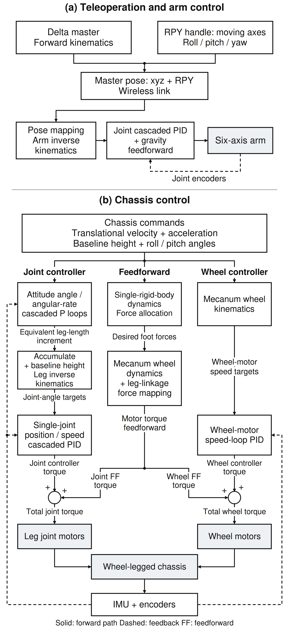
Fig. 2. System control workflow. (a) Master-to-arm pose mapping and arm control. (b) Chassis joint, Mecanum wheel, and feedforward branches. Contact-force allocation and force mapping generate feedforward torques, added to control torques. Solid/dashed lines denote forward/feedback paths; FF denotes feedforward.

Scalars are italic, vectors bold italic, and matrices bold upright; descriptive subscripts, units, and function names are upright. Superscripts $T$ and $†$ denote transpose and the Moore–Penrose pseudoinverse; $[x]_{×}y=x×y$. The $n$-dimensional identity is $I_{n}$; inertia tensors are $I_{c}$ or $I_{b}$. Symbols $d$, $ff$, and $fb$ denote desired, feedforward, and feedback quantities. Length, time, and angle use SI units. An overdot denotes a time derivative, with a desired marker indicating its reference value. Vectors $e_{x}、e_{y}、e_{z}$ are the corresponding frame’s three axis unit vectors.
The inertial frame $\{s\}$ has an upward vertical axis. Body frame $\{b\}$ is fixed to the chassis base center, with $x$, $y$, and $z$ pointing forward, left, and upward. Leg frame $\{{leg}_{i}\}$ is at hip $i$, with leg motion in its $xy$ plane. Matrix $R_{sb}$ transforms body-frame components into inertial frame {s}.
Slave arm base frame {A} is fixed to the arm base, corresponding to {0} in Fig. 1. Master base frame {D} is fixed to the Delta fixed-platform center, with axes defined in Section II-D. Frame transformation precedes slave inverse kinematics.

Chassis Module

Overview: The chassis has a base and four legs, each with a hip pitch joint, parallel-axis knee joint, and Mecanum wheel: 12 active degrees of freedom. Front and rear legs share geometry; left and right legs are mirrored. Hip and knee motors are coaxial at the hip. The hip motor directly drives the thigh; a parallelogram linkage transmits knee-motor motion and torque to the shank. Eliminating a motor at the moving knee reduces shank inertia and permits equivalent two-revolute-joint modeling of wheel-center positioning.
Control proceeds from single-leg modeling to whole-body resultant-force allocation and joint execution. Leg joints adjust support height and fore–aft wheel-center positions; wheels provide planar motion.

Single-Leg Kinematics: Let the equivalent joint angles be $q_{leg}=[q_{leg,1},q_{leg,2}]^{T}$, thigh and shank lengths $L_{1},L_{2}$, and wheel-axis center position $p_{a}^{leg}=[x_{a},y_{a},0]^{T}$. At zero configuration, both links extend along negative $y$ in {leg}; see Fig. 3(a).
- Single-Leg Geometric and Transmission Parameters
Symbol | Value or unit | Definition
$$L_{1}$$ | $$0.170 m$$ | Thigh joint-center distance
$$L_{2}$$ | $$0.220 m$$ | Shank joint-center distance
$$q_{leg,1},q_{leg,2}$$ | $$rad$$ | Equivalent serial joint angles
$$η_{leg}$$ | $$rad$$ | Hip-mounted drive output angles
$$m_{w}$$ | $$0.547 kg$$ | Single-wheel model mass
$$r_{w}$$ | 0.07 $m$ | Effective wheel rolling radius

The forward kinematics is
$\begin{aligned}x_{a}=L_{1}sinq_{leg,1}+L_{2}sin(q_{leg,1}+q_{leg,2}), \\ y_{a}=-L_{1}cosq_{leg,1}-L_{2}cos(q_{leg,1}+q_{leg,2}).\end{aligned}$ (1)
For the below-hip wheel-center branch, define
$\begin{aligned}ρ_{leg}=\sqrt{x_{a}^{2}+y_{a}^{2}}, \\ α_{leg}=arccos\frac{L_{1}^{2}-L_{2}^{2}+ρ_{leg}^{2}}{2L_{1}ρ_{leg}}, \\ β_{leg}=atan2(-y_{a},x_{a}).\end{aligned}$ (2)
Set $γ_{leg}=α_{leg}+β_{leg}$, and the inverse angles are
$\begin{aligned}q_{leg,1}=\frac{π}{2}-γ_{leg}, \\ q_{leg,2}=atan2\left(y_{a}+L_{1}sinγ_{leg}, x_{a}-L_{1}cosγ_{leg}\right) \\ +γ_{leg}.\end{aligned}$ (3)
The solution requires $|L_{1}-L_{2}|≤ρ_{leg}≤L_{1}+L_{2}$ and $ρ_{leg}>0$.

Mecanum Wheel Kinematics: A Mecanum wheel has a driven hub and passive peripheral rollers. Roller handedness sets the signs relating lateral velocity to hub speed; Fig. 3(b) and (c) show both types. Unlike conventional wheels, passive rollers permit contact-point motion in a specified direction. A suitable four-wheel arrangement enables forward, lateral, and yaw motion.
Velocity $v_{i}$ of wheel center i is relative to the inertial frame, with body-frame components. In top view, number wheels counterclockwise from front-left: $i=1,2,3,4$ denote front-left, rear-left, rear-right, and front-right. In the body frame, $p_{i}$ is wheel-center position, $v_{b}$ base-origin velocity, and $ω_{b}=ω_{b,z}e_{z}$ body angular velocity. For a level base with legs stationary relative to it,
$v_{i}=v_{b}+ω_{b}×p_{i}.$ (4)
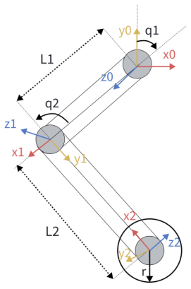  (a) Leg structure | 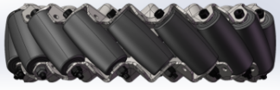  (b) Type A  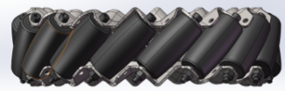  (c) Type B
Fig. 3. Leg and Mecanum wheel structures. (a) Leg frames; angles show geometry, with zero configuration defined in the text. (b), (c) Type-A and Type-B wheels.

Let $ω_{i}$ be hub angular speed, $a_{i}$ the axle unit vector, and $d_{i}=e_{z}×a_{i}$ the rolling unit vector. Positive wheel speed gives contact hub velocity $-r_{w}ω_{i}d_{i}$. The roller’s free-rolling and axial directions are
$\begin{aligned}t_{i}=sinϑ_{i}d_{i}+cosϑ_{i}a_{i}, \\ n_{i}=cosϑ_{i}d_{i}-sinϑ_{i}a_{i},\end{aligned}$ (5)
Here $ϑ_{i}=±π/4$ is the directed angle from the wheel axle to the roller’s free-rolling direction. Ideal contact prevents relative slip along the roller axis:
$n_{i}^{T}\left(v_{i}-r_{w}ω_{i}d_{i}\right)=0.$ (6)
Eliminating passive-roller velocity yields
$ω_{i}=\frac{v_{i}⋅d_{i}-(v_{i}⋅a_{i})tanϑ_{i}}{r_{w}}.$ (7)
Equation (7) maps body velocity to wheel-motor angular speeds, forming the chassis inverse-kinematic model.

Wheel Dynamics and Contact-Force Mapping: Full multibody dynamics increases parameter-identification and real-time computation costs. The hierarchical model therefore retains wheel mass and maps contact forces to leg motors by virtual work. Fig. 4 shows the wheel free-body diagram.
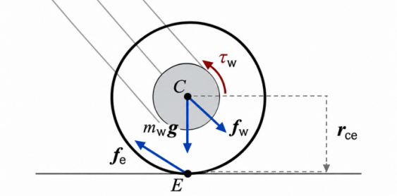
Fig. 4. Wheel free-body diagram: contact/axle forces, gravity, drive torque, and wheel-center-to-contact moment arm.

Let $f_{e}$ be ground force on the wheel, $f_{w}$ shank force on the wheel, $a_{c}$ wheel center-of-mass acceleration, and $g$ gravitational acceleration. In a common frame, Newton’s equation gives
$f_{w}=m_{w}a_{c}-f_{e}-m_{w}g.$ (8)
Let $r_{ce}$ be the wheel-center-of-mass-to-contact moment arm and $e_{ax}$ the positive axle unit vector. Axial wheel-motor drive torque is
$\begin{aligned}τ_{w}=e_{ax}^{T}(I_{c}{\dot{ω}}_{w}+ω_{w}×(I_{c}ω_{w}) \\ -r_{ce}×f_{e}).\end{aligned}$ (9)
Here $I_{c}$ is the wheel center-of-mass inertia tensor, $ω_{w}$ wheel angular velocity relative to the inertial frame, and ${\dot{ω}}_{w}$ angular acceleration, all expressed in the same frame.
Assume equivalent leg joint angles and drive output angles satisfy
$q_{leg}=A_{tr}η_{leg}, A_{tr}=\left[\begin{matrix}1 & 0 \\ -1 & 1\end{matrix}\right].$ (10)
For virtual joint displacement $δq_{leg}$, generalized torque $τ_{q}$ is power-conjugate to $q_{leg}$, and drive torque $τ_{η}$ to $η_{leg}$. The wheel applies force $-f_{w}$ and reaction axle torque $-τ_{w}$ to the shank. Taking the axial scalar positive consistently with $q_{leg,1}+q_{leg,2}$, virtual work relates these generalized forces.
Neglecting leg-link gravity and inertia, the resulting torque mapping is
$\begin{aligned}τ_{q}=J_{leg}^{T}f_{w}+[1,1]^{T}τ_{w}, \\ τ_{η}=A_{tr}^{T}τ_{q}.\end{aligned}$ (11)
The second relation follows from $τ_{η}^{T}δη_{leg}=τ_{q}^{T}δq_{leg}$, using the transpose transmission matrix. Here $τ_{η}$ is leg-motor output torque.
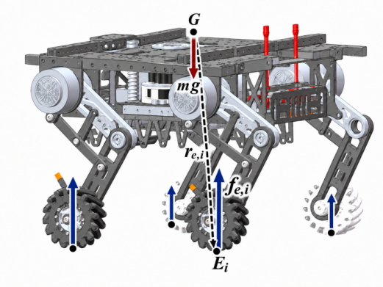
Fig. 5. Whole-body center of mass and four wheel-contact forces; arrows show application points and the force/moment arm at contact i.

Whole-Body Single-Rigid-Body Dynamics: Fig. 5 shows the whole-body center of mass and contact forces on the three-dimensional chassis configuration. During rapid chassis motion, the arm is usually stationary relative to the chassis. Both can then be approximated as one rigid body with equivalent mass and inertia. Let $m$ be total mass, $a_{G}$ center-of-mass acceleration, and $r_{e,i}$ the vector from the center of mass to contact $i$.
In the inertial-frame dynamics, let $ω$ be body angular velocity, $\dot{ω}$ angular acceleration, and $I_{b}$ whole-body center-of-mass inertia expressed in the body frame. Its inertial-frame form is $I_{s}=R_{sb}I_{b}R_{sb}^{T}$. Define
$H=\left[\begin{matrix}I_{3} & I_{3} & I_{3} & I_{3} \\ [r_{e,1}]_{×} & [r_{e,2}]_{×} & [r_{e,3}]_{×} & [r_{e,4}]_{×}\end{matrix}\right],$ (12)
$\begin{aligned}b_{dyn}=\left[\begin{matrix}m(a_{G}-g) \\ I_{s}\dot{ω}+ω×(I_{s}ω)\end{matrix}\right], \\ f_{e}=[f_{e,1}^{T},…,f_{e,4}^{T}]^{T}.\end{aligned}$ (13)
Here $H$ maps contact forces to whole-body resultant force and moment, $f_{e}$ stacks the four contact forces, and $b_{dyn}$ contains the required resultant contact force and moment. Newton–Euler dynamics gives
$Hf_{e}=b_{dyn}.$ (14)
Here $H∈R^{6×12}$. At low speeds, $ω×(I_{s}ω)$ may be neglected, providing sufficiently accurate modeling and computation for small attitude variations with the arm nearly stationary relative to the chassis. Minimum-norm contact-force allocation gives
$f_{e}^{⋆}=H^{†}b_{dyn}=H^{T}(HH^{T})^{-1}b_{dyn},$ (15)
The right-hand inverse requires $H$ to have full row rank. In the nominal four-wheel stance, the contact points are not all collinear, so the matrix has full row rank (6). The solution minimizes the contact-force vector’s Euclidean norm.

Attitude Controller: Fixed leg angles cannot readily accommodate ground-height changes. IMU roll $ϕ$, pitch $θ$, and angular-rate feedback therefore drive incremental leg-length adjustment. Cascaded angle and angular-rate P loops generate leg-height correction increments (Fig. 6). For either attitude axis $χ∈\{ϕ,θ\}$,
$\begin{aligned}e_{χ}[k]=χ_{d}[k]-χ[k], \\ {\dot{χ}}_{d}[k]=k_{p,χ}e_{χ}[k], \\ Δu_{χ}[k]=k_{h,χ}\left({\dot{χ}}_{d}[k]-\dot{χ}[k]\right), \\ u_{χ}[k]=u_{χ}[k-1]+Δu_{χ}[k].\end{aligned}$ (16)
Here $k$ is the sample index; $χ[k]$ and $χ_{d}[k]$ are current and desired attitude angles, and $e_{χ}[k]$ their error, all in radians. The IMU measures current angular rate $\dot{χ}[k]$; $\dot{χ_{d}}[k]$ is the angle-loop desired rate, both in radians per second.
Angle-loop gain $k_{p,χ}$ converts attitude error into desired angular rate; angular-rate-loop gain $k_{h,χ}$ converts rate error into leg-height correction increment $Δu_{χ}[k]$. Accumulated correction $u_{χ}[k]$ has previous value $u_{χ}[k-1]$. Both correction and increment are in meters.
Height corrections follow body-frame wheel positions. The forward and left components of wheel-center position $p_{i}$ are $p_{i,x}$ and $p_{i,y}$; $a_{b}$ and $b_{b}$ are positive front–rear and left–right wheel-center half-spacings. All lengths are in meters. For approximately symmetric legs, small attitude angles, and temporarily fixed contact heights,
$h_{i}^{d}[k]=h_{0}+\frac{p_{i,y}}{b_{b}}u_{ϕ}[k]-\frac{p_{i,x}}{a_{b}}u_{θ}[k].$ (17)
Here $h_{0}$ is baseline leg height, and ${h_{i}}^{d}$ the desired height of leg $i$, both positive downward in meters. Roll and pitch height corrections are $u_{ϕ}$ and $u_{θ}$. Target coordinates $x_{i}$ and $y_{i}$ of wheel center $i$ in its leg frame correspond to $x_{a}$ and $y_{a}$ in single-leg inverse kinematics. Attitude adjustment retains baseline $x_{i}$ and sets $y_{i}$ = −${h_{i}}^{d}$; inverse kinematics gives joint targets.
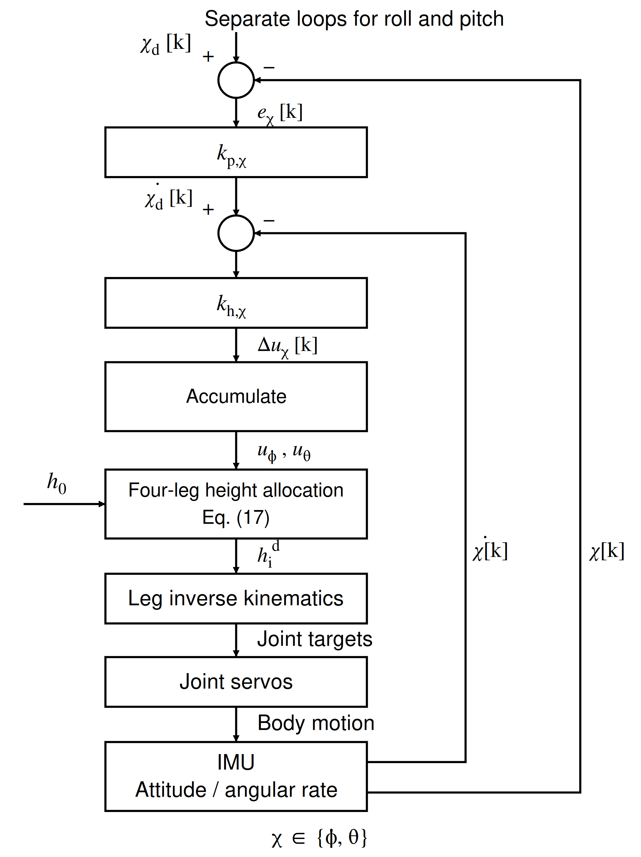
Fig. 6. Closed-loop chassis attitude control. Cascaded roll/pitch P loops and height-increment accumulation follow (16); (17) allocates both corrections to four legs. Joint-servo inner loops are combined.

Arm Inverse Kinematics
Following Pieper’s analytical solution for a six-axis arm with a spherical wrist [9], the inverse kinematics separates wrist-center positioning from wrist orientation. Given the end-effector target p₀₆ and orientation R₀₆ in frame {0}, the wrist center is pW = p₀₆ − d₆R₀₆eᵧ, where eᵧ is the tool-frame +y unit vector and d₆ is the tool offset. Let ρW = √(xW² + yW²), ρA = √((ρW − a₁)² + (zW − d₁)²), γA = atan2(zW − d₁, ρW − a₁), ℓ₂ = a₂, and ℓ₃ = d₄. Here a₁, d₁, a₂, and d₄ are DH geometric parameters; d₄ locates the wrist center along z₃. The selected arm branch is:
$$\begin{aligned}q_{a,1}=atan2(y_{W},x_{W}), \\ q_{a,2}=γ_{A}+arccos\frac{ℓ_{2}^{2}+ρ_{A}^{2}−ℓ_{3}^{2}}{2ℓ_{2}ρ_{A}}, \\ q_{a,3}=−π+arccos\frac{ℓ_{2}^{2}+ℓ_{3}^{2}−ρ_{A}^{2}}{2ℓ_{2}ℓ_{3}}.\end{aligned}$$
Using the first three joint angles to form R₀₃ from the DH model, define R₃₆ = R₀₃ᵀR₀₆ = [n o a], whose columns are n, o, and a. For sin θ₅ ≠ 0, the wrist branches are:
$$\begin{aligned}θ_{5}^{(±)}=±arccos(−o_{z}), \\ θ_{4}^{(±)}=atan2(o_{y}sinθ_{5}^{(±)},o_{x}sinθ_{5}^{(±)}), \\ θ_{6}^{(±)}=atan2(a_{z}sinθ_{5}^{(±)},n_{z}sinθ_{5}^{(±)}).\end{aligned}$$
The actual wrist joints are qₐ,j = θⱼ − θ₀,j (j = 4, 5, 6), where θ₀,j are the DH zero offsets. Forward-kinematics substitution verifies each candidate; the nearest feasible branch to the previous joint state is selected.

Delta Teleoperation Controller

Structure: The master uses a three-limb Delta parallel mechanism for translation and a three-axis handle with three encoder-equipped revolute joints on the moving platform for orientation input (Fig. 7). Parallelogram passive arms keep both platforms parallel, separating position and orientation. Fig. 7 identifies the Delta mechanism, handle, and rotation axes. After encoder zero and direction calibration, joints j1–j3 provide moving-axis roll, pitch, and yaw (RPY), respectively.
A side-mounted reference-reset button permits segmented repositioning: resetting the master–slave position reference while maintaining slave target-pose continuity allows further commands.

Forward Kinematics: Table II lists Delta geometry. Three limb constraints are formulated in platform base frame {D}, defined above.
Origin O of $\{D\}$ is at the fixed-platform center. Positive $x_{D}$ is normal to that platform, directed from moving to fixed platform. In the fixed-platform plane, positive $z_{D}$ points from O to first-limb attachment $A_{1}$; $y_{D}$ completes the right-handed frame. The working side is $x_{D}<0$. Attachment-circle radii of fixed and moving platforms are $R_{D},r_{D}$; active- and passive-arm lengths are $L_{D},L_{P}$. Limb azimuths follow the right-hand rule about positive $x_{D}$, measured from positive $z_{D}$: $ψ_{i}=2π(i-1)/3$, with radial unit vectors $e_{i}=[0,-sinψ_{i},cosψ_{i}]^{T}$. Active-arm angle $θ_{D,i}$ is measured from the radially outward direction in the fixed-platform plane, positive toward the negative $x_{D}$ working side. Fig. 8 shows the geometry. Its symmetric single-limb view defines angles and lengths; the dashed segment represents the equivalent length constraint in (19).
- Delta Master Geometric Parameters
Symbol | Value | Definition
$$R_{D}$$ | $$0.095 m$$ | Fixed-platform attachment radius
$$r_{D}$$ | $$0.066 m$$ | Moving-platform attachment radius
$$L_{D}$$ | $$0.150 m$$ | Active-arm center distance
$$L_{P}$$ | $$0.200 m$$ | Passive-arm center distance

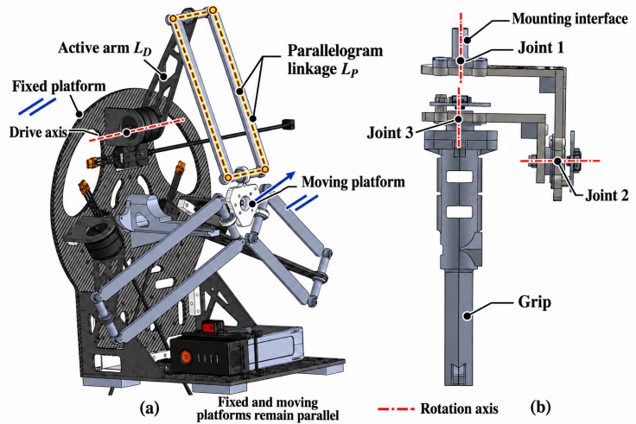
Fig. 7. Teleoperation master and rotation axes. (a) Delta mechanism; highlighted parallelogram links keep the platforms parallel. (b) Three-axis handle, with joints and rotation axes shown from mount to grip.

For moving-platform center $p_{D}=[x_{D},y_{D},z_{D}]^{T}$, incorporating the moving-platform radius into each limb gives equivalent sphere center
$c_{i}=(R_{D}-r_{D}+L_{D}cosθ_{D,i})e_{i}-L_{D}sinθ_{D,i}e_{x}.$ (18)
Equal passive-arm lengths impose the three-sphere intersection constraints
$∥p_{D}-c_{i}∥_{2}^{2}=L_{P}^{2}, i=1,2,3.$ (19)
Subtracting the first equation from the second and third eliminates quadratic terms:
$2(c_{i}-c_{1})^{T}p_{D}=∥c_{i}∥_{2}^{2}-∥c_{1}∥_{2}^{2}, i=2,3.$ (20)
Writing $c_{i}=[c_{ix},c_{iy},c_{iz}]^{T}$, define
$\begin{aligned}B_{D}=2\left[\begin{matrix}c_{2y}-c_{1y} & c_{2z}-c_{1z} \\ c_{3y}-c_{1y} & c_{3z}-c_{1z}\end{matrix}\right], \\ d_{D}=\left[\begin{matrix}∥c_{2}∥^{2}-∥c_{1}∥^{2} \\ ∥c_{3}∥^{2}-∥c_{1}∥^{2}\end{matrix}\right], \\ e_{D}=2[c_{2x}-c_{1x},c_{3x}-c_{1x}]^{T}.\end{aligned}$ (21)
If $B_{D}$ is invertible, let $u=B_{D}^{-1}d_{D}$ and $v=-B_{D}^{-1}e_{D}$. Then$[y_{D},z_{D}]^{T}=u+vx_{D}.$.
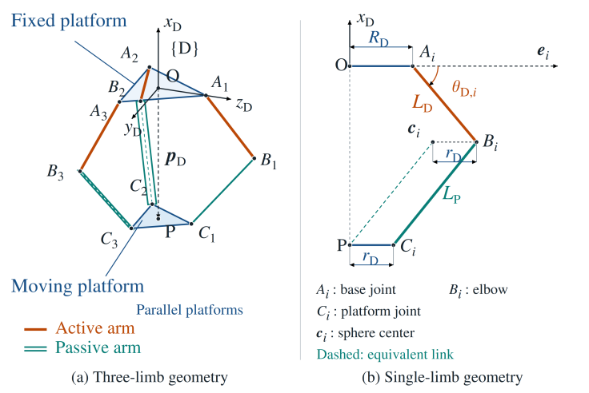
Fig. 8. Delta geometry. (a) Three limbs and right-handed frame {D}: O is the fixed-platform center, the +x axis is normal to the platform and points from the moving platform toward the fixed platform, +z toward A1, and P marks the moving-platform center. Parallelogram links keep platforms parallel. (b) Symmetric limb section with radii, lengths, active-arm angle, and equivalent sphere center.

Let $c_{1,yz}={[c_{1y},c_{1z}]}^{T}$. Substitution into the first sphere equation gives $A_{D}x_{D}^{2}+B_{D}x_{D}+C_{D}=0$, where
$\begin{aligned}A_{D}=1+v^{T}v, \\ B_{D}=2\left[v^{T}(u-c_{1,yz})-c_{1x}\right], \\ C_{D}=∥u-c_{1,yz}∥^{2}+c_{1x}^{2}-L_{P}^{2}.\end{aligned}$ (22)
Select the candidate root satisfying the working-side and continuity conditions.

Pose Mapping and Joint Commands: The Delta moving-platform center $p_{D}={\left[x_{D},y_{D},z_{D}\right]}^{T}$ provides master position. After encoder zero and direction calibration, joints j1–j3 specify moving-axis roll, pitch, and yaw, respectively; the corresponding angles are $\left(ϕ_{h},θ_{h},ψ_{h}\right)$ (in radians). The handle rotation and homogeneous pose matrices are
$\begin{aligned}R_{h}=R_{h,0}R_{x}\left(ϕ_{h}\right)R_{y}\left(θ_{h}\right)R_{z}\left(ψ_{h}\right), \\ T_{Dh}=\left[\begin{matrix}R_{h} & p_{D} \\ 0^{T} & 1\end{matrix}\right].\end{aligned}$ (23)
Here $R_{h,0}$ is the fixed mounting rotation relative to {D}; $R_{h,0}$ equals $I_{3}$ when the zero axes align. Matrix $R_{h}$ maps handle-frame components into {D}.
Use slave arm base frame {A} from Section II-A. Initialization records master position zero $p_{D,0}$ and slave reference position $p_{A,0}$. Master matrix position and orientation blocks give slave targets:
$\begin{aligned}p_{A,d}=p_{A,0}+K_{map}R_{AD}\left(p_{D}-p_{D,0}\right), \\ R_{A,d}=R_{AD}R_{h}R_{tool}.\end{aligned}$ (24)
Here $R_{AD}$ rotates components from {D} to {A}; dimensionless matrix $K_{map}=diag\left(k_{x},k_{y},k_{z}\right)$ scales position along slave base axes; $R_{tool}$ is the fixed calibration rotation of the slave tool relative to the handle. The master calibrates orientation before transmitting RPY; the receiver reconstructs $R_{A,d}$ with the same moving-axis X–Y–Z convention.
Combining the position and orientation targets in (24) gives the slave end-effector target homogeneous transformation relative to its arm base:
$T_{A,d}=\left[\begin{matrix}R_{A,d} & p_{A,d} \\ 0^{T} & 1\end{matrix}\right].$ (25)
Analytical inverse kinematics (IK) [9] gives six-axis arm joint commands; the gripper performs grasping. For six joint targets $q_{a,d}$,
$q_{a,d}=IK\left(T_{A,d}\right).$ (26)

Experiments and Results
Physical motion and control demonstrations illustrate the complete system’s terrain traversal and teleoperation capabilities.

Delta Master Operation
The operator inputs position through the Delta moving platform and orientation through the three-axis handle (Fig. 9). Forward and rightward grasping approach and grasp a cup from different directions; upward and downward commands produce corresponding tilted end-effector poses. Each view includes master and robot, showing operator-input/slave-motion correspondence and practical pose adjustment and grasping through pose mapping and joint control.
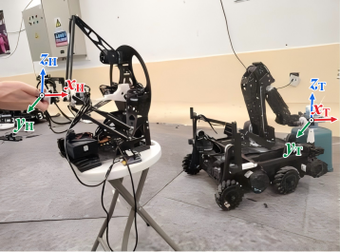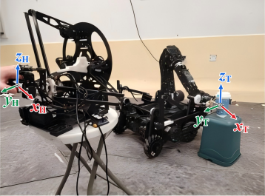
(a) Forward grasp (b) Rightward grasp
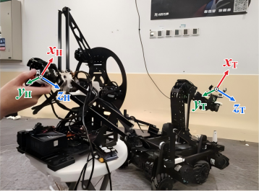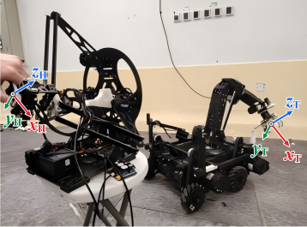
(c) Upward tilt (d) Downward tilt
Fig. 9. Delta-master teleoperation. (a) Forward grasp. (b) Rightward grasp. (c) Upward tilt. (d) Downward tilt. Each panel shows the operator/master and robot/arm; and denote the handle and gripper-tool frames.$\{H\}$$\{T\}$

Consecutive Step Climbing
Fig. 10 shows consecutive two-step climbing in time order. From the lower floor, coordinated leg reconfiguration and wheel motion successively transfer front and rear wheels onto the first tread. Support readjustment and forward motion carry the robot over the second step until all wheels reach the upper platform. Arm posture is adjusted during climbing to help regulate whole-body mass distribution. The demonstration illustrates terrain traversal through combined wheel motion and leg support adjustment.
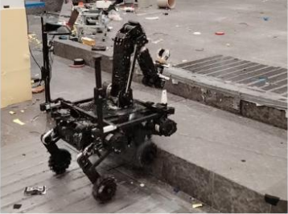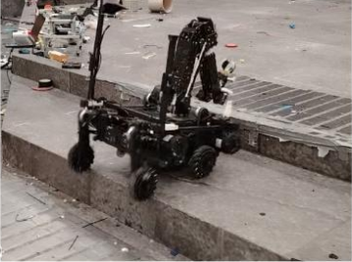
(a) 1.8 s (b) 2.6 s
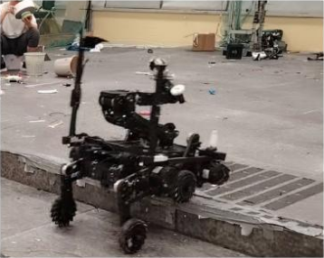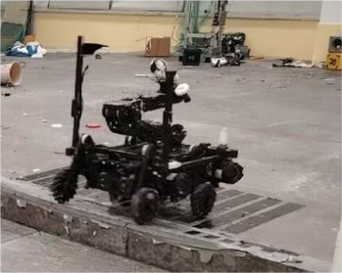
(c) 5.1 s (d) 5.8 s
Fig. 10. Two-step climbing sequence (left-to-right by row; times relative to video): (a), (b) first step; (c), (d) second step.

Conclusion
This paper presents structural design, kinematic mapping, and chassis model-based feedforward for a Mecanum-wheeled quadrupedal chassis, six-axis arm, and Delta heterogeneous teleoperation controller. Two-joint wheeled legs and Mecanum wheels provide support adjustment and planar mobility through single-leg virtual-work mapping and whole-body single-rigid-body force allocation. Analytical arm inverse kinematics converts end-effector targets into joint commands. Delta translation, three-axis, three-encoder orientation input, and frame calibration and position scaling connect operator and robot.
The workflow integrates chassis locomotion and attitude control, arm inverse kinematics, and master–slave pose mapping. Physical demonstrations verify terrain traversal and complete teleoperation execution.

References
- M. Bjelonic et al., “Keep rollin’—Whole-body motion control and planning for wheeled quadrupedal robots,” IEEE Robot. Autom. Lett., vol. 4, no. 2, pp. 2116–2123, 2019, doi: 10.1109/LRA.2019.2899750.
- M. Bjelonic, R. Grandia, O. Harley, C. Galliard, S. Zimmermann, and M. Hutter, “Whole-body MPC and online gait sequence generation for wheeled-legged robots,” in Proc. IEEE/RSJ Int. Conf. Intell. Robots Syst. (IROS), 2021, pp. 8388–8395, doi: 10.1109/IROS51168.2021.9636371.
- F. Iotti, A. Ranjan, F. Angelini, and M. Garabini, “OmniQuad: A wheeled-legged hybrid robot with omnidirectional wheels,” Mech. Mach. Theory, vol. 214, Art. no. 106125, 2025, doi: 10.1016/j.mechmachtheory.2025.106125.
- Z. Wang et al., “Arm-constrained curriculum learning for loco-manipulation of a wheel-legged robot,” in Proc. IEEE/RSJ Int. Conf. Intell. Robots Syst. (IROS), 2024, pp. 10770–10776, doi: 10.1109/IROS58592.2024.10802062.
- R. Zhang, H. Du, P. Qiu, Y. Yang, and W. Song, “Motion control of a hybrid self-reconfigurable wheel-legged dual-arm robot,” in Proc. IEEE/RSJ Int. Conf. Intell. Robots Syst. (IROS), 2025, pp. 16483–16488, doi: 10.1109/IROS60139.2025.11246212.
- Z. Chen, S. Li, B. Liu, M. Li, Z. Yin, and Y. Li, “Whole-body motion control of an omnidirectional wheel-legged mobile manipulator via contact-aware dynamic optimization,” 2025, arXiv:2509.14010. [Online]. Available: https://arxiv.org/abs/2509.14010
- C. Cruz Ulloa, D. Domínguez, A. Barrientos, and J. del Cerro, “Design and mixed-reality teleoperation of a quadruped-manipulator robot for SAR tasks,” in Robotics in Natural Settings, ser. Lecture Notes in Networks and Systems, vol. 530. Cham, Switzerland: Springer, 2023, pp. 181–194, doi: 10.1007/978-3-031-15226-9_19.
- M. Uchiyama, Y. Tsumaki, and W.-K. Yoon, “Design of a compact 6-DOF haptic device to use parallel mechanisms,” in Robotics Research, ser. Springer Tracts in Advanced Robotics, vol. 28. Berlin, Germany: Springer, 2007, pp. 145–162, doi: 10.1007/978-3-540-48113-3_14.
- D. L. Pieper, “The kinematics of manipulators under computer control,” Ph.D. dissertation, Stanford Univ., Stanford, CA, USA, 1968.

