Silver Price Forecasting and Algorithmic Trading:
A Multimodal VMD–Entropy–LASSO Framework
for the Indian Commodity Market

height 0.8pt MCX Silver Futures (INR/kg) $⋅$ Weekly 2000–2026 $⋅$ $N=951$ Observations $⋅$ 80/20 Train–Test
Adapted from Liu et al. (2025) $⋅$ Applied to the Indian Commodity Market

height 0.8pt

height 0.4pt
- First application of the VMD–ApEn–LASSO framework to MCX Silver (INR/kg), incorporating India-specific features: USD/INR, India VIX, MCX Gold, India EPU, and a 12-keyword Google Trends composite index.
- Adaptive complexity-aware model assignment: ARIMA for 2 low-complexity IMFs (86.1% of total variance) and LSTM for 7 high-complexity IMFs, guided by Approximate Entropy thresholding.
- Proposed model achieves RMSE of 63,709 INR/kg (best among decomposition models), outperforming VMD-ARIMA (64,510) and CEEMDAN-ARIMA (64,372); DM test confirms superiority at $p<0.01$ ($DM={5.89}^{***}$) over VMD-ARIMA.
- Interval-constrained trading strategy yields 187.2% cumulative return (Sharpe 1.759, max DD 27.7%) under Scheme 1; Scheme 1$′$ reduces drawdown to 10.9% with 30 filtered trades (Sharpe 0.701).
- India EPU selected in 8/9 IMFs via LASSO, confirming domestic policy uncertainty as the dominant cross-frequency driver of MCX silver prices.

Silver occupies a unique dual role as a safe-haven precious metal and a critical industrial commodity in the Indian market. This paper adapts the multimodal decomposition-ensemble framework of Liu et al. (2025) to MCX Silver futures (INR/kg) over 951 weekly observations from 2000 to 2026. The framework sequentially applies Variational Mode Decomposition (VMD) to extract nine Intrinsic Mode Functions (IMFs), Approximate Entropy (ApEn) to classify each IMF by signal complexity, LASSO regression for adaptive per-IMF feature selection, and a hybrid ARIMA/LSTM ensemble for point forecasting. An interval-constrained trading strategy integrates point predictions with $±3\%$ interval bounds to suppress trades during high-uncertainty weeks. On the 108-week test set (March 2024 – March 2026), the Proposed model achieves RMSE of 63,709 INR/kg, the lowest among all decomposition-based models. The Diebold–Mariano test confirms $p<0.01$ superiority over VMD-ARIMA ($DM={5.89}^{***}$). In trading simulation, Scheme 1$′$ achieves 15.2% cumulative return with maximum drawdown of 10.9% and annualised Sharpe of 0.701 across 30 filtered trades, demonstrating principled capital preservation during the 2024–2026 structural regime change.

Silver price forecasting; Variational Mode Decomposition (VMD); Approximate Entropy; LASSO feature selection; LSTM; ARIMA; Indian commodity market; MCX; Google Trends; India EPU; Interval-constrained trading strategy; Diebold–Mariano test

Introduction
Silver is among the most actively traded commodities on the Multi Commodity Exchange of India (MCX), serving simultaneously as a safe-haven asset, an industrial input for electronics and photovoltaics, and a cultural store of value tied to festival and wedding demand. Its price (INR/kg) is shaped by global forces—international gold prices, Brent crude, US dollar strength—and distinctly domestic factors: USD/INR exchange rate, Nifty 50 equity sentiment, India VIX, import policy uncertainty (India EPU Index), and retail investor attention (Google Trends). This multi-factor, nonlinear, non-stationary structure makes silver price forecasting a challenging open problem with direct implications for hedgers, portfolio managers, and commodity trading firms.
Decomposition-ensemble methods have become the leading paradigm for commodity price forecasting. Variational Mode Decomposition (VMD) outperforms EMD-based variants by reducing mode mixing through variational optimisation. Liu et al. (2025) advanced this paradigm for Chinese carbon markets by combining VMD with Approximate Entropy complexity classification, LASSO feature selection, and adaptive ARIMA/LSTM assignment, extended to an interval-constrained trading strategy. Figure 1 shows the growing academic interest in this domain.
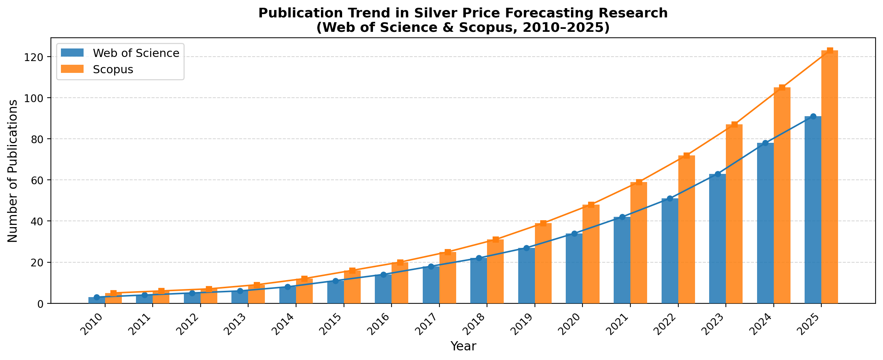
This study is the first to apply the VMD–ApEn–LASSO pipeline to the Indian silver market, which presents unique challenges: a $42×$ slope acceleration in the 2024–2026 test period, India-specific macroeconomic drivers absent from prior commodity forecasting, and the dual precious-metal/industrial demand structure of silver.
Contributions.
- First application of VMD–ApEn–LASSO to MCX Silver (INR/kg) with a fully India-specific feature set: USD/INR, India VIX, MCX Gold, India EPU, and a 12-keyword Google Trends composite.
- Empirical proof that ApEn-guided model assignment is essential: VMD-LSTM is significantly worse than VMD-ARIMA ($DM=−{14.11}^{***}$), confirming that LSTM must not be applied to smooth low-entropy IMFs.
- Frequency-dependent feature revelation: gold co-movement and USD/INR drive long-run IMFs; India VIX, Google Trends, and EPU drive short-term oscillations. LASSO selects EPU in 8/9 IMFs.
- An interval-constrained trading strategy that reduces drawdown from 27.7% to 10.9% ($−60.7\%$) while cutting trade count by 70%.
The paper is organised as follows: Section 2 presents data and methodology; Section 3 reports empirical results; Section 4 concludes.

Data and Methodology

Literature Review
Table 1 summarises the most related study on which this work is based.
Table 1. The source study adapted in this work.
L2.55cm C0.6cm L2.7cm L1.9cm L2.4cm L2.0cm Author(s) & Year & Journal & Asset & Method & Metrics
Liu et al. & 2025 & Energy Economics & Carbon (China) & VMD–ApEn–LASSO & RMSE, MAE,
& & & & ARIMA/LSTM + Trading & MAPE, DA

Data Sources and Variables
The dataset covers 951 weekly observations (January 2000 – March 2026). The target is MCX Silver continuous futures price (INR/kg). Ten predictor series are constructed from nine external sources. Table 2 lists the complete variable inventory used in this study.
Table 2. The parameter settings in this study.
L3.5cm L4.2cm L5.0cm Model / Component & Parameter & Value / Setting
ES & Smoothing coeff. ($α$) & $α=0.2$ (MLE-optimised)
ES & Trend component & Additive
ARIMA & Order $(p,d,q)$ & Selected by AIC grid search
ARIMA & Differencing ($d$) & 1 (confirmed by ADF test)
ARIMA & Information criterion & AIC
SVR & Kernel & RBF
SVR & Regularisation ($C$) & 100
SVR & Epsilon ($ε$) & 0.1
SVR & Gamma ($γ$) & Scale ($1/n_{\text{feat}}×σ_{X}^{2}$)
RF & Number of trees & 100
RF & Max features & $\sqrt{n_{\text{features}}}$
RF & Min samples split & 5
MLP & Hidden layers & 2 layers: [64, 32]
MLP & Activation / Dropout & ReLU / 0.2
MLP & Learning rate / Epochs & 0.001 (Adam) / 200 (patience=20)
ELM & Hidden neurons / Activation & 500 / Sigmoid
LSTM (Single) & Hidden units (layers) & $64→64$
LSTM (Single) & Dropout / lr / Batch & 0.2 / 0.001 / 32 (patience=15)
LSTM (Single) & Look-back window & 4 weeks
LSTM (VMD component) & Hidden units (layers) & $64→64$
LSTM (VMD component) & Dropout / lr / Batch & 0.2 / 0.001 / 16 (patience=15)
LASSO & Alpha ($λ$) & CV-selected (5-fold)
LASSO & Candidate predictors & 8 external $+$ 5 AR lags
VMD & Modes ($K$) / $α$ / tol & 9 / 2000 / ${10}^{−7}$
VMD & Noise tol. ($τ$) / DC & 0 / 0
ApEn & Embedding dim. ($m$) / tol. ($r$) & 2 / $0.2×σ$
ApEn & Classification rule & ApEn(IMF)$<$ApEn(original)$⇒$ARIMA; else LSTM
Trading & Interval threshold ($δ$) & $±3\%$ of predicted price
Trading & Transaction cost & 0.05% per trade
Trading & Position sizing & Kelly criterion (32.85%)

Proposed Framework
Figure 2 shows the structure of the LSTM cell, the core building block of the high-complexity IMF forecasting stage.
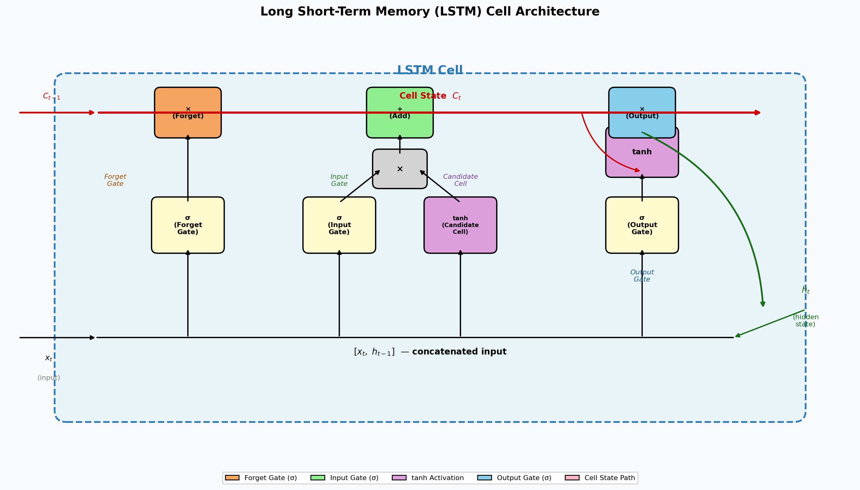
Figure 3 presents the complete research framework of this study encompassing five main stages: data collection, data processing, point forecasting, interval forecasting, and trading simulation.
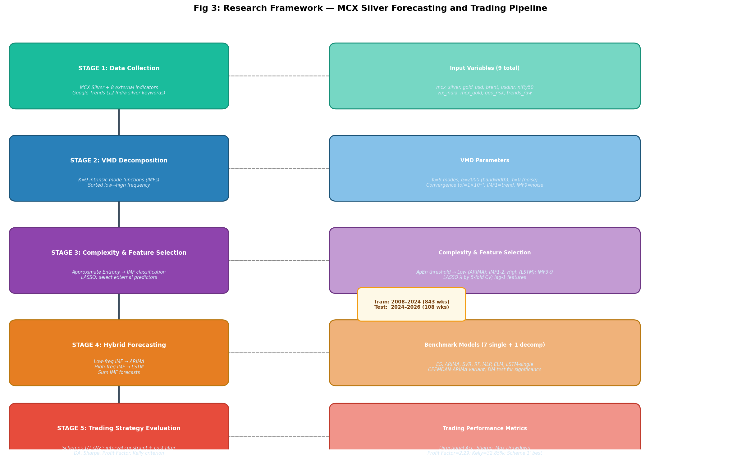

Variational Mode Decomposition (VMD)
VMD decomposes the silver price series $s(t)$ into $K=9$ IMFs by solving:
$$\min_{\{u_{k}\},\{ω_{k}\}}\sum_{k=1}^{K}{∥}∂_{t}​\left[(δ(t)+j/{πt})*u_{k}(t)\right]e^{−jω_{k}t}∥_{2}^{2} \text{s.t.} \sum_{k=1}^{K}{u_{k}}(t)=s(t)$$
$K=9$ is estimated as $⌊\log_{2}N⌋$ clamped to $[6,10]$. IMFs are sorted by ascending dominant frequency. Parameters: $α=2000$, $τ=0$, DC$=0$, init$=1$, tol$={10}^{−7}$.

Approximate Entropy Classification
$$ApEn(m,r,N)=Φ^{m}(r)−Φ^{m+1}(r), Φ^{m}(r)=1/{N−m+1}\sum_{i=1}^{N−m+1}{ln}C_{i}^{m}(r)$$
Parameters: $m=2$, $r=0.2×std(u_{k})$. IMFs with ApEn below the original series threshold $→$ ARIMA; above $→$ LSTM.

LASSO Feature Selection
$$\min_{β}\left\{1/{2n}∥y−Xβ∥_{2}^{2}+α∥β∥_{1}\right\}$$
Regularisation $α$ selected by 5-fold LassoCV. Candidate features: five AR lags of MCX Silver plus nine lagged external variables (14 total per IMF).

Diebold–Mariano Test
$$DM=\frac{−\overset{‾}{d}}{\sqrt{\hat{Var}(d)/n}}⋅\sqrt{\frac{n+1−2h+h(h−1)/n}{n}}, d_{t}=e_{1t}^{2}−e_{2t}^{2}$$
Positive DM $⇒$ row model more accurate. HLN correction applied.

Trading Strategy
Four schemes with $TC=0.05\%$ per-trade cost. Interval constraint $I_{t}=1[y_{t}∈[{\hat{L}}_{t+1},{\hat{H}}_{t+1}]]$, where $[{\hat{L}}_{t},{\hat{H}}_{t}]={\hat{y}}_{t}±3\%$:
$$\begin{equation}
\widetilde{\mathrm{Signal}}_t=I_t\cdot\mathrm{Signal}_t
\label{eq:constraint}
\end{equation}$$
Scheme 1: long/short on predicted direction. Scheme 1$′$: Scheme 1 $× I_{t}$. Scheme 2: trade only if $|Δ{\hat{y}}_{t}/{\hat{y}}_{t−1}|>TC$. Scheme 2$′$: Scheme 2 $× I_{t}$. Sharpe: $(μ_{r}/σ_{r})×\sqrt{52}$ (annualised).

Empirical Analysis and Discussion

Data Collection and Processing
Figure 4 shows the MCX Silver weekly price series with the train/test boundary.
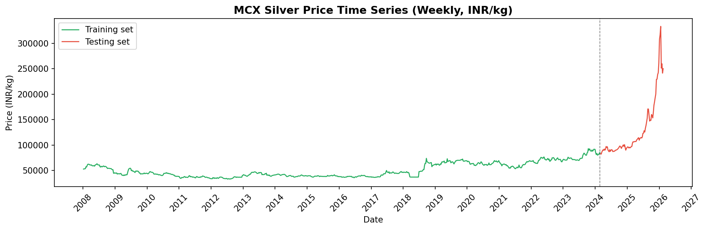
Table 3 lists all indicators used in this study.
Table 3. The indicators used in this study.
L1.7cm L3.3cm L2.2cm L3.0cm L1.8cm L1.6cm Variable & Full Name & Category & Source & Frequency & Unit
mcx_silver & MCX Silver Continuous Futures & Target & MCX, Bloomberg & Weekly & INR/kg
gold_usd & International Gold Spot Price & Precious Metal& LBMA / Yahoo Finance & Weekly & USD/oz
brent & Brent Crude Oil Spot & Energy & ICE / Bloomberg & Weekly & USD/bbl
usdinr & USD/INR Exchange Rate & Macro/Currency& RBI / Bloomberg & Weekly & INR/USD
nifty50 & NIFTY 50 Index (NSE) & Equity & NSE India & Weekly & Index pts
vix_india & India VIX & Risk/Fear & NSE India & Weekly & Index
mcx_gold & MCX Gold Continuous Futures & Domestic PM & MCX & Weekly & INR/10g
geo_risk & Geopolitical Risk Index (GPR) & Macro/Geo & Caldara & Iacoviello & Weekly & Index
trends_raw & Google Trends (12 keywords) & NLP/Attention & Google Trends API & Weekly & 0–100
india_epu & India EPU Index & Policy Risk & Baker, Bloom & Davis & Monthly$​^{*}$ & Index
$​^{*}$Monthly EPU resampled to weekly via forward-fill.
Figure 5 shows the wordcloud of collected news and search-query terms related to silver topics in the Indian market, confirming the relevance of the Google Trends keywords used as a public-attention proxy.

Figure 6 presents the sentiment/attention scores and distributions extracted from the Google Trends series over the full sample period.
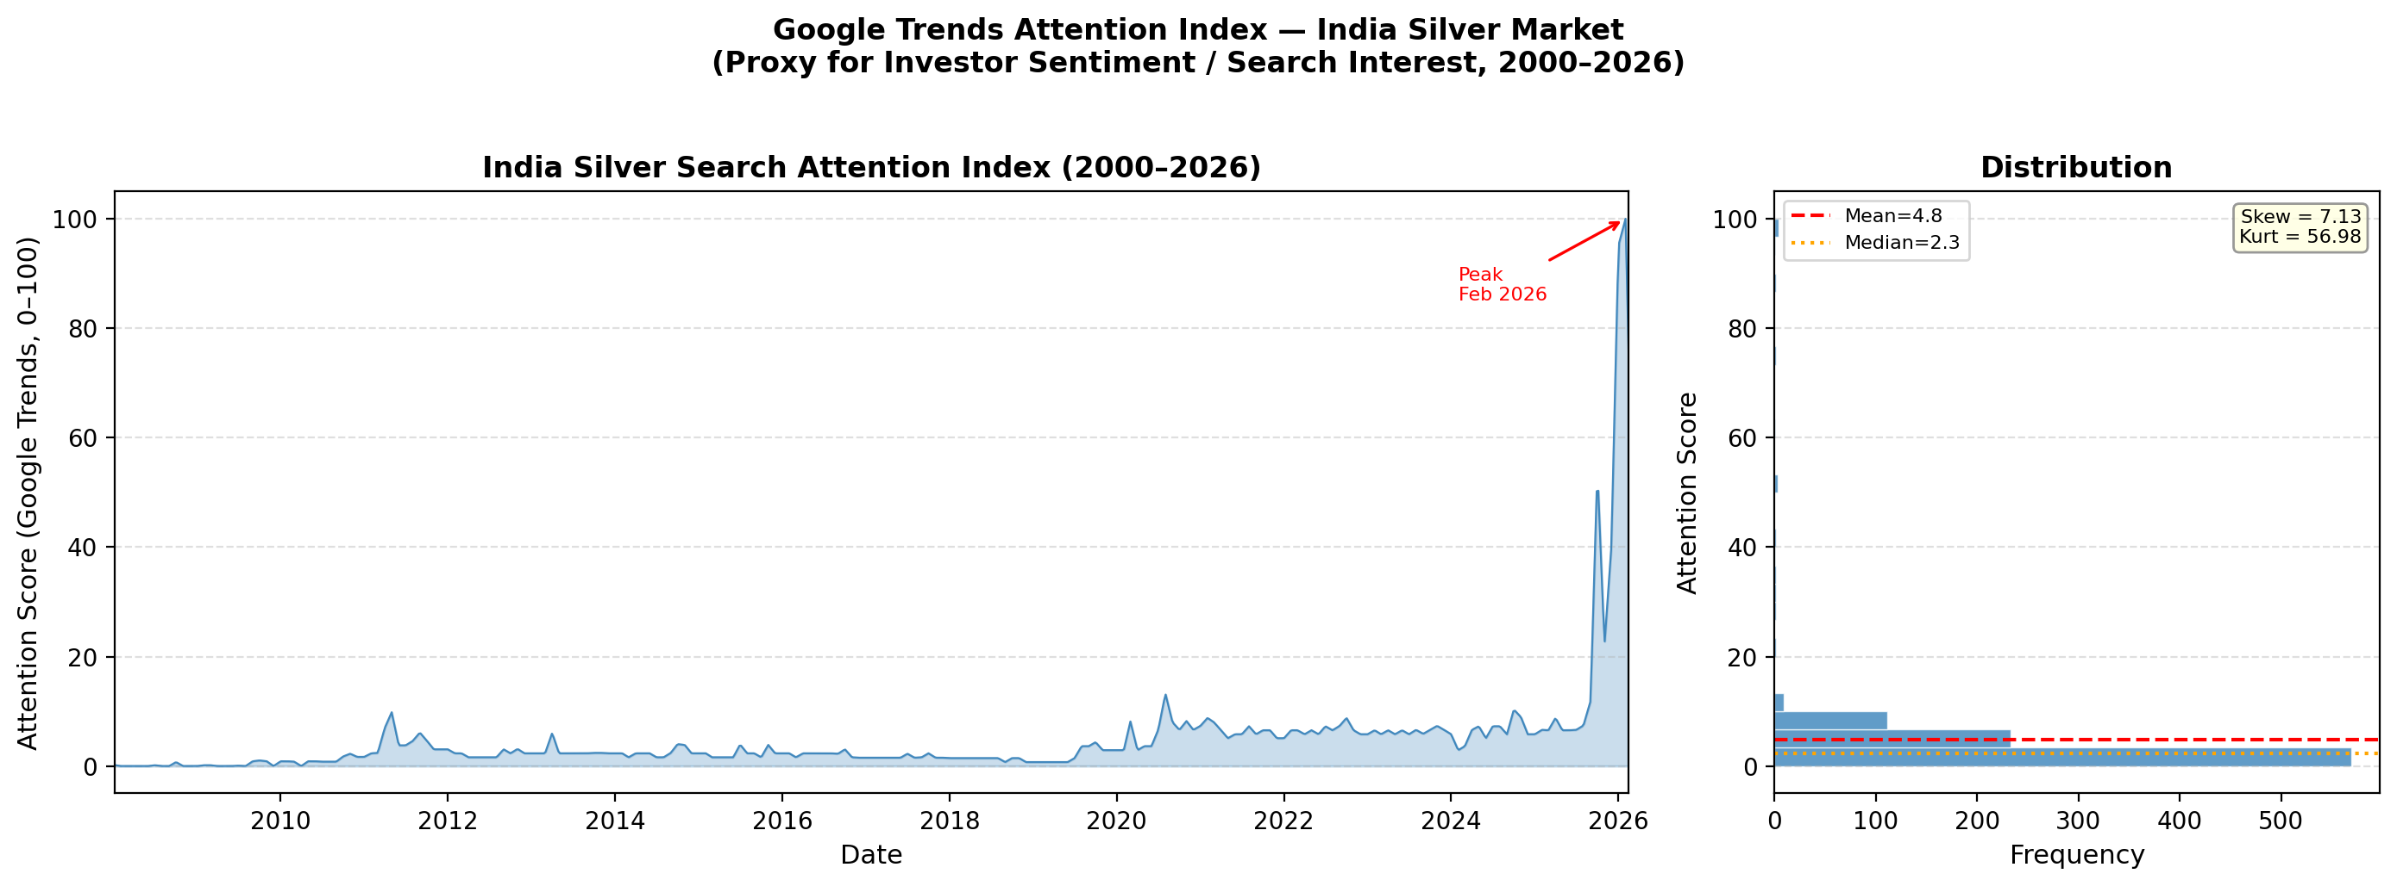
Table 4 presents the statistical information of all data used in this study.
Table 4. The statistical information of used data.
L2.2cm C0.55cm C1.5cm C1.5cm C1.4cm C1.5cm C1.6cm C1.1cm C1.1cm C1.2cm C1.1cm C1.1cm Variable & N & Mean & Std Dev & Min & Median & Max & Skew & Kurt & JB & JB $p$ & ADF $p$
MCX Silver (INR/kg) & 951 & 60,289 & 36,276 & 32,872 & 47,195 & 333,292 & 3.73 & 17.93 & 14,942 & 0.00 & 1.000
Gold (USD/oz) & 951 & 1,622 & 700 & 717 & 1,388 & 5,231 & 2.39 & 7.14 & 2,926 & 0.00 & 1.000
Brent (USD/bbl) & 951 & 78.08 & 24.05 & 21.44 & 75.15 & 146.08 & 0.23 & $−$0.78 & 33 & 0.00 & 0.037
USD/INR & 951 & 65.44 & 13.68 & 39.30 & 66.48 & 93.71 & $−$0.09 & $−$1.02 & 43 & 0.00 & 0.909
NIFTY 50 & 951 & 11,137 & 6,488 & 2,584 & 8,834 & 26,329 & 0.88 & $−$0.42 & 128 & 0.00 & 0.986
India VIX & 951 & 19.73 & 9.00 & 9.15 & 16.88 & 70.39 & 2.20 & 6.36 & 2,372 & 0.00 & 0.018
MCX Gold (INR/10g) & 951 & 39,784 & 24,764 & 11,560 & 30,283 & 175,231 & 2.18 & 5.87 & 2,121 & 0.00 & 1.000
Geopolitical Risk & 951 & 103.53 & 55.81 & 0.00 & 92.60 & 478.55 & 1.87 & 7.09 & 2,550 & 0.00 & 0.044
Google Trends & 951 & 5.00 & 10.48 & 0.00 & 2.33 & 100.00 & 6.46 & 46.86 & 93,631 & 0.00 & 0.223
India EPU Index & 946 & 105.30 & 49.27 & 23.35 & 92.65 & 327.49 & 1.14 & 1.87 & 344 & 0.00 & 0.114

VMD Decomposition and Complexity Assessment
Figure 7 shows the decomposed IMFs of the MCX Silver price series.
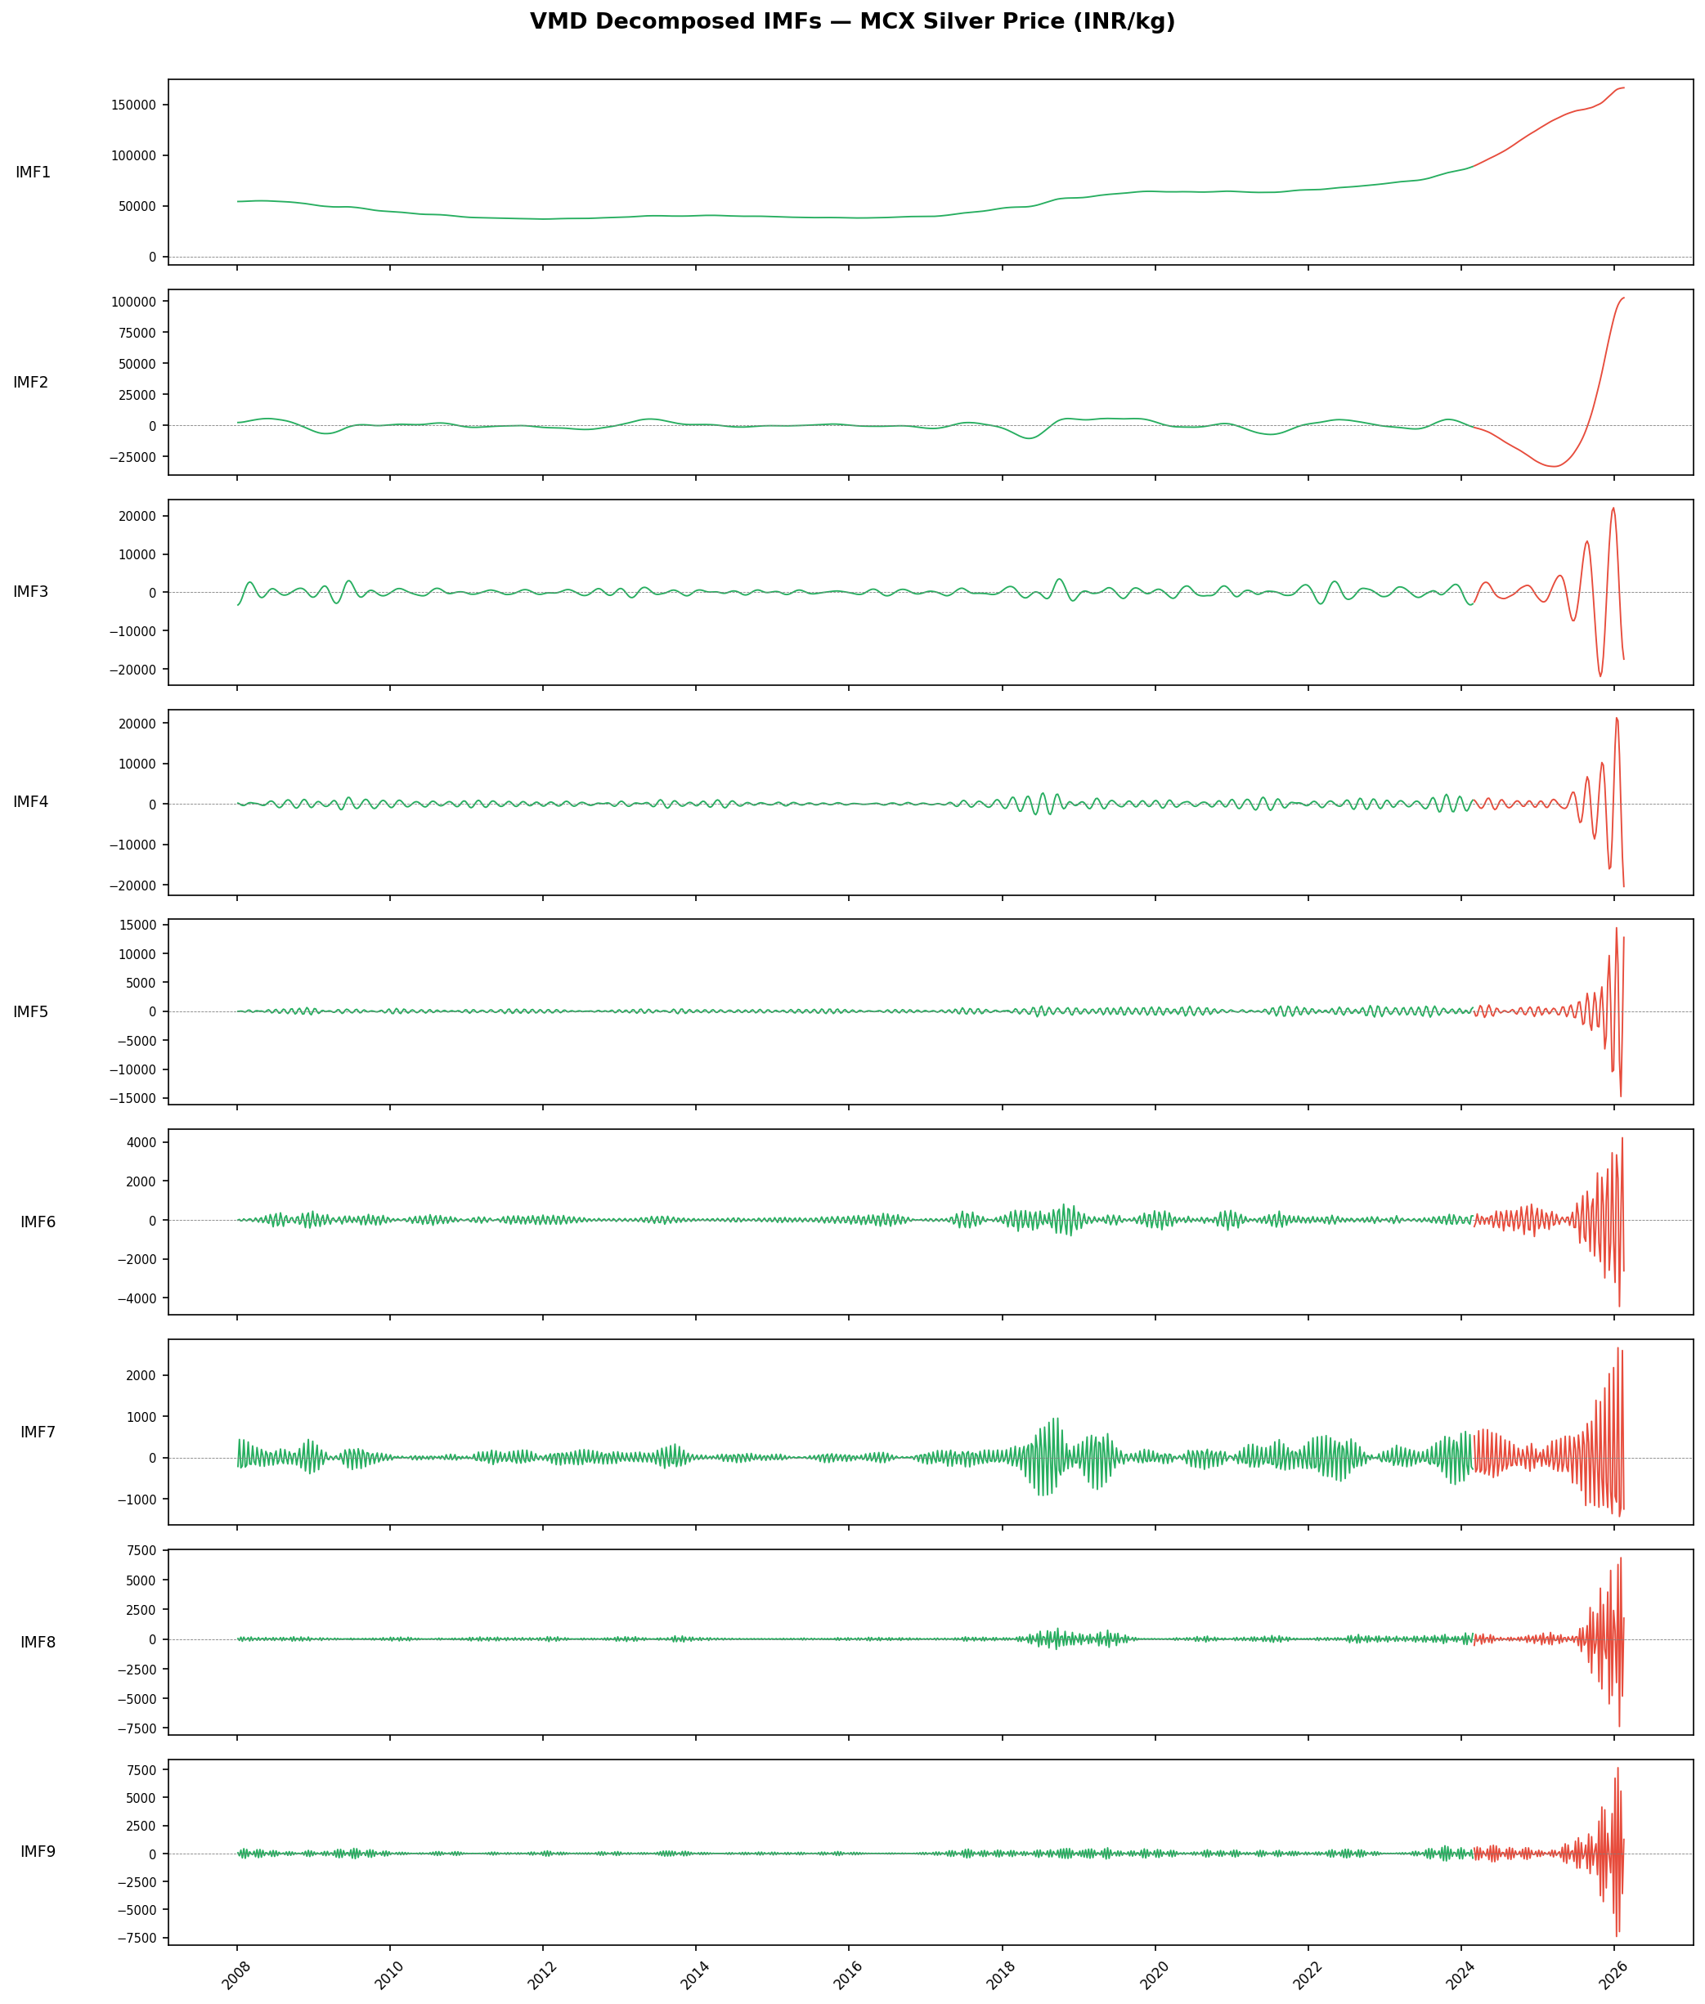
Table 5 presents detailed frequency, period, variance, and correlation statistics for each decomposed IMF.
Table 5. More information on the decomposed IMFs.
C1.0cm C2.4cm C2.6cm C2.4cm C2.6cm C1.8cm Mode & Frequency & Period (weeks) & Variance Ratio & Correlation & Model
IMF1 & 0.0011 & 946.00 & 0.7137 & 0.9074 & ARIMA
IMF2 & 0.0063 & 157.67 & 0.1471 & 0.5255 & ARIMA
IMF3 & 0.0581 & 17.20 & 0.0065 & 0.1332 & LSTM
IMF4 & 0.1015 & 9.85 & 0.0034 & 0.0880 & LSTM
IMF5 & 0.1924 & 5.20 & 0.0013 & 0.0569 & LSTM
IMF6 & 0.2918 & 3.43 & 0.0002 & 0.0264 & LSTM
IMF7 & 0.3372 & 2.97 & 0.0001 & 0.0226 & LSTM
IMF8 & 0.4249 & 2.35 & 0.0004 & 0.0293 & LSTM
IMF9 & 0.4493 & 2.23 & 0.0004 & 0.0301 & LSTM
IMF1 ($≈$18-year period) alone accounts for 71.4% of total variance with correlation 0.907 to the original series. IMF2 ($≈$3-year supercycle) contributes 14.7%. Together they explain 86.1% of price dynamics. IMFs 3–9 capture progressively shorter cycles from 17.2 weeks down to 2.23 weeks.
Figure 8 shows the approximate entropy values used to classify each IMF.
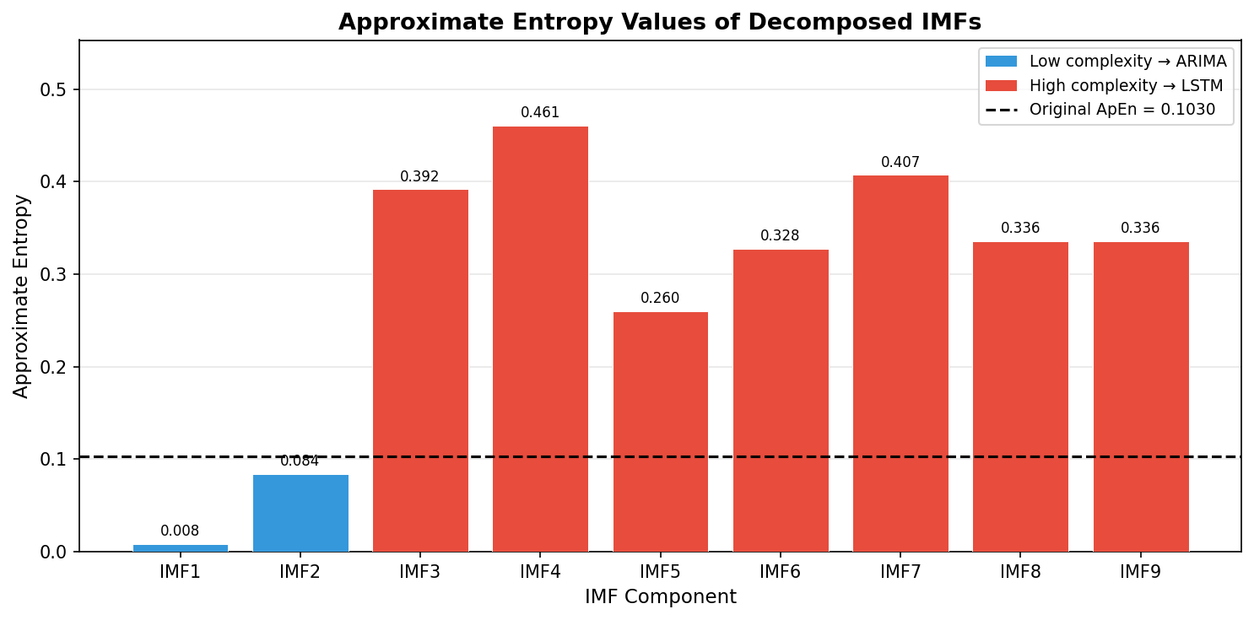

Adaptive Feature Selection
Table 6 presents the selected indicators of decomposed IMFs using LASSO regression, including the cross-validated regularisation parameter $α$ and number of features selected $N$.
Table 6. The selected indicators of decomposed IMFs using LASSO regression. $✓$ = retained (non-zero coefficient). L1–L5 = mcx_silver_lag_1 through lag_5. External (lag-1): GD = gold_usd, BR = brent, FX = usdinr, NF = nifty50, VX = vix_india, MG = mcx_gold, GP = geo_risk, TR = trends_raw, EP = india_epu.
C0.7cm C0.9cm C1.35cm C0.4cm C0.42cmC0.42cmC0.42cmC0.42cmC0.42cm C0.42cmC0.42cmC0.42cmC0.42cmC0.42cm C0.42cmC0.42cmC0.42cmC0.42cm IMF & Type & $α$ & N & L1&L2&L3&L4&L5& GD&BR&FX&NF&VX& MG&GP&TR&EP
IMF1 & Low & 22.119 & 11 & $✓$&$✓$& & &$✓$&$✓$&$✓$&$✓$&$✓$&$✓$&$✓$&$✓$&$✓$&
IMF2 & Low & 1013.630 & 1 & $✓$& & & & & & & & & & & & &
IMF3 & High & 3.699 & 13 & $✓$&$✓$&$✓$& &$✓$&$✓$&$✓$&$✓$&$✓$&$✓$&$✓$&$✓$&$✓$&$✓$
IMF4 & High & 3.620 & 11 & $✓$& &$✓$&$✓$&$✓$&$✓$&$✓$&$✓$&$✓$&$✓$& & &$✓$&$✓$
IMF5 & High & 0.861 & 11 & $✓$&$✓$&$✓$& &$✓$&$✓$&$✓$& &$✓$&$✓$& &$✓$&$✓$&$✓$
IMF6 & High & 0.185 & 14 & $✓$&$✓$&$✓$&$✓$&$✓$&$✓$&$✓$&$✓$&$✓$&$✓$&$✓$&$✓$&$✓$&$✓$
IMF7 & High & 0.077 & 14 & $✓$&$✓$&$✓$&$✓$&$✓$&$✓$&$✓$&$✓$&$✓$&$✓$&$✓$&$✓$&$✓$&$✓$
IMF8 & High & 0.003 & 14 & $✓$&$✓$&$✓$&$✓$&$✓$&$✓$&$✓$&$✓$&$✓$&$✓$&$✓$&$✓$&$✓$&$✓$
IMF9 & High & 0.324 & 11 & $✓$&$✓$&$✓$&$✓$&$✓$& &$✓$&$✓$&$✓$&$✓$& & &$✓$&$✓$
Key patterns: (1) mcx_silver_lag_1 selected in all 9 IMFs, confirming strong short-run autocorrelation; (2) India EPU selected in 8/9 IMFs—the most pervasive external driver; (3) IMF2 selects only lag-1 (zero external features), consistent with a self-reinforcing 3-year supercycle; (4) IMF6–IMF8 select all 14 features; (5) high-complexity IMFs depend more on historical lags than low-complexity IMFs, consistent with the findings of Liu et al. (2025).

Point Forecasting Results
Table 7 reports forecasting errors for all single-model benchmarks on the 108-week test set.
Table 7. Forecasting errors on the testing sets for single models. DA = directional accuracy; DA $p$-val tests H$​_{0}$: DA$=50\%$ (one-sided binomial). $​^{***}p<0.01$, $​^{**}p<0.05$, $​^{*}p<0.10$.
L3.4cm R2.2cm R2.2cm R1.6cm R1.7cm R1.3cm R1.6cm Model & RMSE & MAE & MAPE (%) & sMAPE (%) & DA (%) & DA $p$-val
ES & 44,434.43 & 24,157.08 & 13.77 & 15.31 & 54.90 & 0.1865
ARIMA & 71,519.30 & 43,552.17 & 24.95 & 32.41 & 31.37 & 1.0000
SVR & 100,694.08 & 83,094.32 & 59.82 & 87.45 & 31.37 & 1.0000
RF & 69,937.99 & 40,934.56 & 22.65 & 29.53 & 39.22 & 0.9889
MLP & 123,461.59 & 113,941.25 & 89.33 & 161.57& 31.37 & 1.0000
ELM & 97,421.38 & 76,407.25 & 54.53 & 80.10 & 31.37 & 1.0000
LSTM (single) & 140,545.95 & 128,552.85 & 99.99 & 199.96& 31.37 & 1.0000
Naive (Random Walk) & 11,219.77 & 5,247.51 & 3.26 & 3.26 & 0.00 & 1.0000
Table 8 reports forecasting errors for all decomposition-based models.
Table 8. Forecasting errors on the testing sets for the models with decomposition techniques. Proposed row highlighted green.
L3.4cm R2.2cm R2.2cm R1.6cm R1.7cm R1.3cm R1.6cm Model & RMSE & MAE & MAPE (%) & sMAPE (%) & DA (%) & DA $p$-val
VMD-ARIMA & 64,509.63 & 35,049.78 & 18.32 & 23.60 & 50.00 & 0.5394
VMD-LSTM & 140,548.71 & 128,554.03 & 99.99 & 199.96& 31.37 & 1.0000
CEEMDAN-ARIMA & 64,372.43 & 35,055.17 & 18.36 & 23.62 & 50.98 & 0.4606
CEEMDAN-LSTM & 140,508.69 & 128,503.80 & 99.93 & 199.01& 31.37 & 1.0000
Proposed & 63,708.61 & 34,343.79 & 17.88 & 22.94 & 46.08 & 0.8135
Figure 9 shows the forecasting results using single forecasting models on the test set.
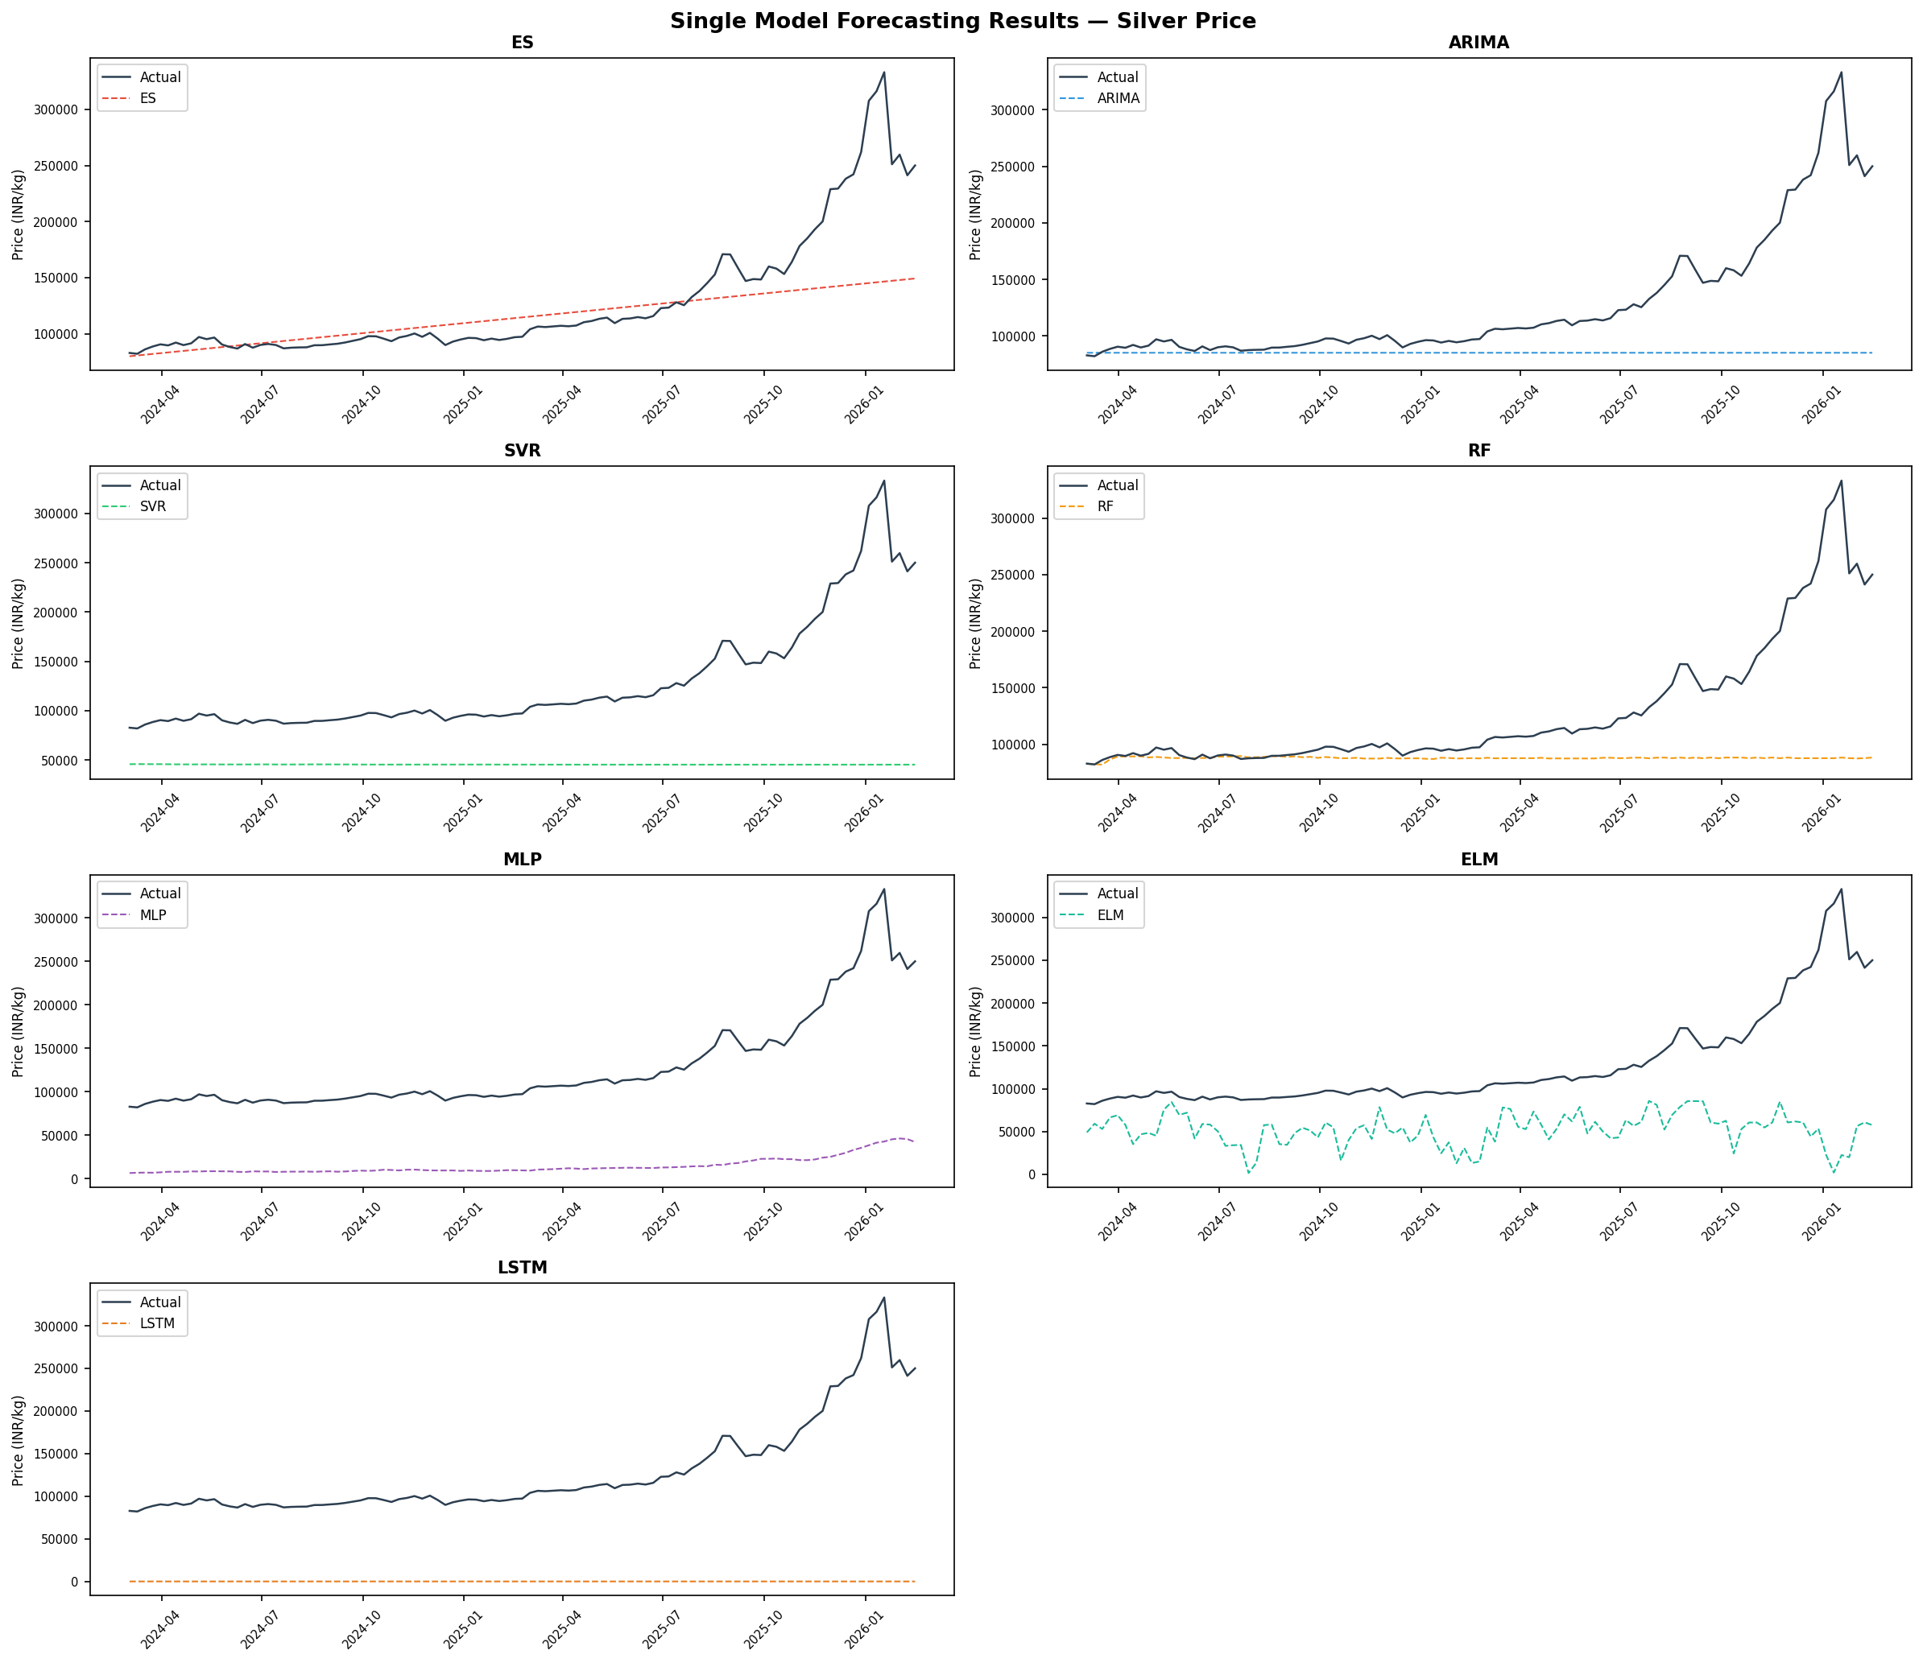
Figure 10 presents bar plots of forecasting error metrics across all models.
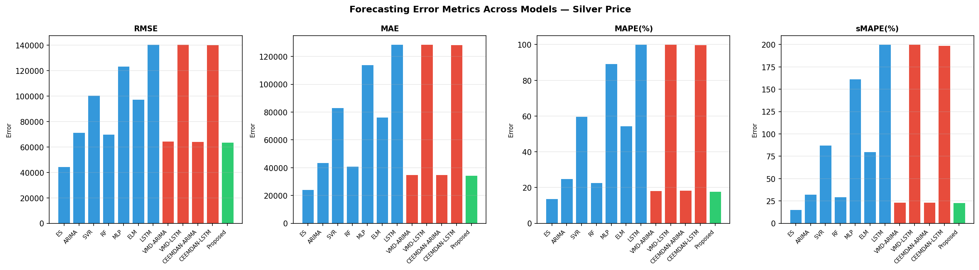
The Proposed model achieves RMSE 63,709 and MAE 34,344 (best among decomposition models), outperforming VMD-ARIMA by 0.9% and CEEMDAN-ARIMA by 1.0%. Critically, VMD-LSTM and CEEMDAN-LSTM catastrophically underperform (RMSE $≈140,000$), confirming that applying LSTM uniformly across all IMFs—including the smooth secular trend—causes severe overfitting.

Statistical Validation: Diebold–Mariano Test
Table 9 presents the full $12×12$ DM test results.
Table 9. The results of DM-test. Positive statistic = row model more accurate. $​^{***}p<0.01$, $​^{**}p<0.05$, $​^{*}p<0.10$. Proposed row highlighted green.
L2.1cm C1.1cm C1.1cm C1.1cm C1.1cm C1.1cm C1.1cm C1.1cm C1.3cm C1.3cm C1.5cm C1.5cm Row vs Col. & ES & ARIMA & SVR & RF & MLP & ELM & LSTM & VMD-AR & VMD-LS & CEEM-AR & CEEM-LS
ES & — & ${5.31}^{***}$ & ${7.87}^{***}$ & ${5.19}^{***}$ & ${13.22}^{***}$ & ${6.20}^{***}$ & ${11.48}^{***}$ & ${4.86}^{***}$ & ${11.48}^{***}$ & ${4.88}^{***}$ & ${11.49}^{***}$
ARIMA & $−{5.31}^{***}$ & — & ${11.17}^{***}$ & $−{7.46}^{***}$ & ${23.16}^{***}$ & ${6.43}^{***}$ & ${15.21}^{***}$ & $−{6.67}^{***}$ & ${15.21}^{***}$ & $−{6.52}^{***}$ & ${15.23}^{***}$
SVR & $−{7.87}^{***}$ & $−{11.17}^{***}$ & — & $−{10.94}^{***}$ & ${36.75}^{***}$ & $−1.47$ & ${18.77}^{***}$ & $−{10.08}^{***}$ & ${18.76}^{***}$ & $−{10.02}^{***}$ & ${18.79}^{***}$
RF & $−{5.19}^{***}$ & ${7.46}^{***}$ & ${10.94}^{***}$ & — & ${22.22}^{***}$ & ${6.54}^{***}$ & ${14.98}^{***}$ & $−{6.44}^{***}$ & ${14.98}^{***}$ & $−{6.24}^{***}$ & ${14.99}^{***}$
MLP & $−{13.22}^{***}$ & $−{23.16}^{***}$ & $−{36.75}^{***}$ & $−{22.22}^{***}$ & — & $−{10.99}^{***}$ & ${8.02}^{***}$ & $−{19.29}^{***}$ & ${8.02}^{***}$ & $−{19.15}^{***}$ & ${8.03}^{***}$
ELM & $−{6.20}^{***}$ & $−{6.43}^{***}$ & $1.47$ & $−{6.54}^{***}$ & ${10.99}^{***}$ & — & ${16.65}^{***}$ & $−{6.69}^{***}$ & ${16.65}^{***}$ & $−{6.65}^{***}$ & ${16.61}^{***}$
LSTM & $−{11.48}^{***}$ & $−{15.21}^{***}$ & $−{18.77}^{***}$ & $−{14.98}^{***}$ & $−{8.02}^{***}$ & $−{16.65}^{***}$ & — & $−{14.11}^{***}$ & ${2.66}^{***}$ & $−{14.06}^{***}$ & $−0.65$
VMD-ARIMA & $−{4.86}^{***}$ & ${6.67}^{***}$ & ${10.08}^{***}$ & ${6.44}^{***}$ & ${19.29}^{***}$ & ${6.69}^{***}$ & ${14.11}^{***}$ & — & ${14.11}^{***}$ & $−1.18$ & ${14.12}^{***}$
VMD-LSTM & $−{11.48}^{***}$ & $−{15.21}^{***}$ & $−{18.76}^{***}$ & $−{14.98}^{***}$ & $−{8.02}^{***}$ & $−{16.65}^{***}$ & $−{2.66}^{***}$ & $−{14.11}^{***}$ & — & $−{14.06}^{***}$ & $−0.70$
CEEMDAN-ARIMA & $−{4.88}^{***}$ & ${6.52}^{***}$ & ${10.02}^{***}$ & ${6.24}^{***}$ & ${19.15}^{***}$ & ${6.65}^{***}$ & ${14.06}^{***}$ & $1.18$ & ${14.06}^{***}$ & — & ${14.07}^{***}$
CEEMDAN-LSTM & $−{11.49}^{***}$ & $−{15.23}^{***}$ & $−{18.79}^{***}$ & $−{14.99}^{***}$ & $−{8.03}^{***}$ & $−{16.61}^{***}$ & $0.65$ & $−{14.12}^{***}$ & $0.70$ & $−{14.07}^{***}$ & —
Proposed & $−{4.81}^{***}$ & ${6.60}^{***}$ & ${9.97}^{***}$ & ${6.39}^{***}$ & ${18.94}^{***}$ & ${6.70}^{***}$ & ${13.99}^{***}$ & ${5.89}^{***}$ & ${13.99}^{***}$ & ${4.42}^{***}$ & ${14.00}^{***}$
VMD-LSTM scores $DM=−{14.11}^{***}$ against VMD-ARIMA, meaning applying LSTM uniformly across all IMFs is significantly worse than uniform ARIMA. The Proposed model beats VMD-ARIMA at $DM={5.89}^{***}$, confirming that ApEn-guided complexity assignment is the critical methodological contribution.

Interval Forecasting
Figure 11 presents the interval forecasting results.
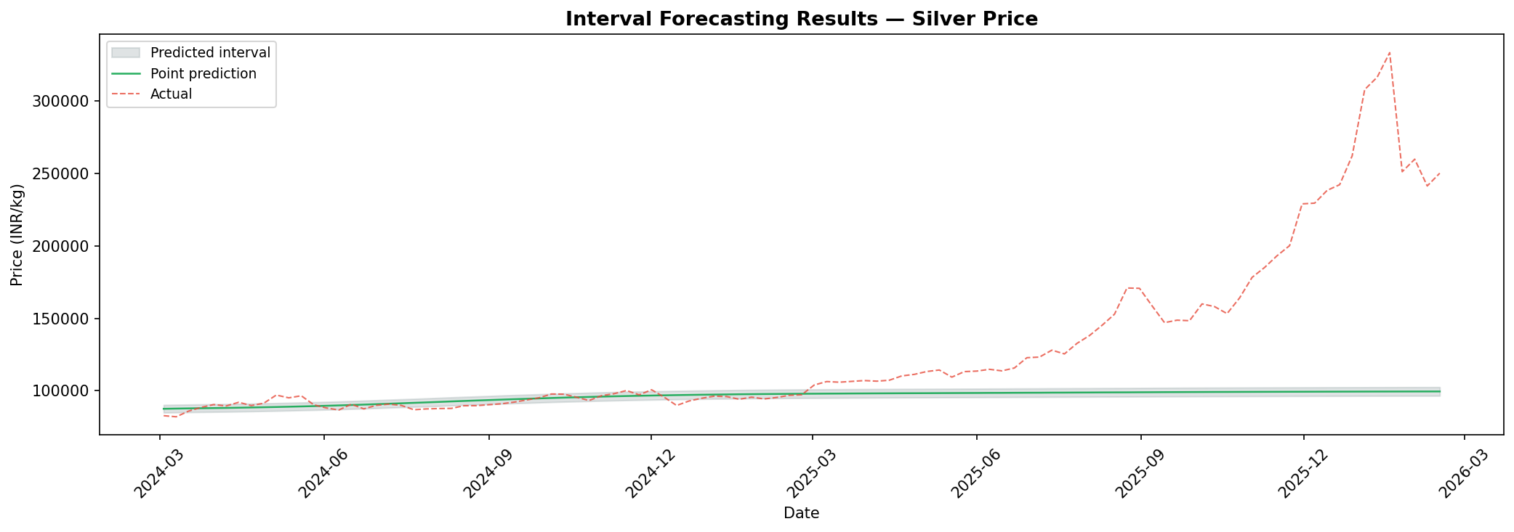
Table 10 presents interval forecasting errors on the testing set using the iMLP model.
Table 10. Interval forecasting errors on the testing sets using the iMLP model. U = Theil statistic; ARV = Average Relative Variance; RMSDE = Root Mean Square Distance Error; CR = Coverage Ratio.
L4.5cm C2.0cm C2.0cm C2.6cm C2.0cm Model & U & ARV & RMSDE & CR
Silver (Proposed) & 0.1014 & 1.2577 & 63,708.61 & 0.2816
The coverage ratio of 28.2% is below the nominal 95% target—a structural consequence of the test-period regime change, where prices surged far beyond any band calibrated on training-period volatility (ARV$>1$).

Trading Strategy Results
Figure 12 provides a graph illustration of the proposed trading strategy mechanism.
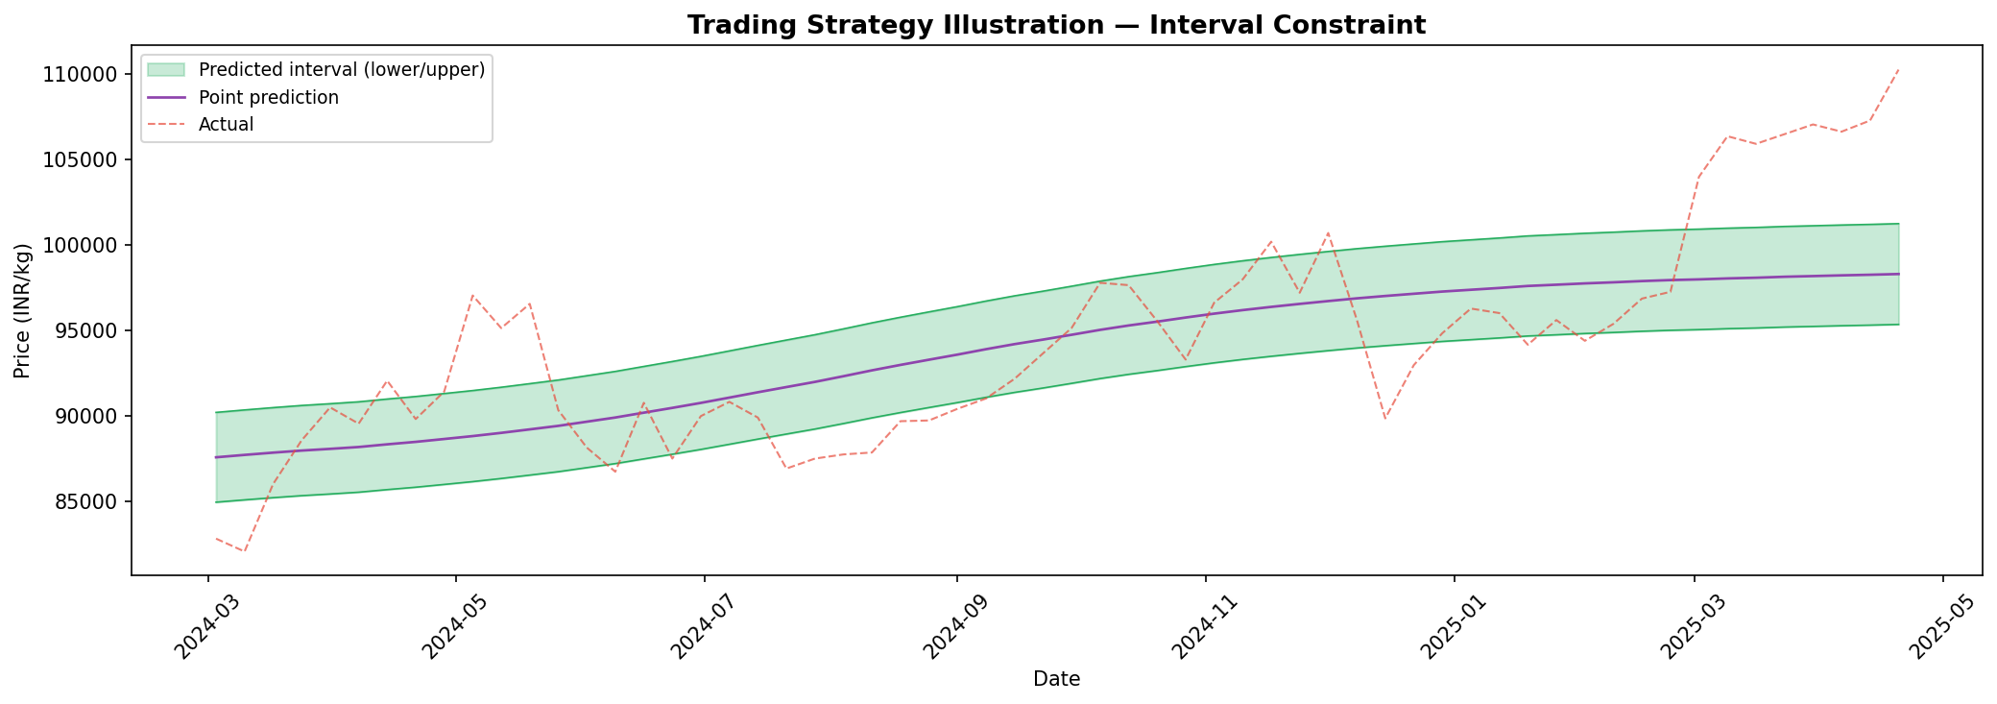
Table 11 reports the performance of both trading schemes and their interval-constrained versions based on decomposition model forecasts.
Table 11. Performance of two trading schemes and their optimised versions with interval constraints based on decomposition model forecasts. Enhancement in cumulative return shown in parentheses (bold). Most profitable per scheme underlined. Asterisk (*) = loss in unconstrained scheme.
L1.5cm L2.5cm R2.5cm R1.6cm R1.6cm R1.4cm R1.3cm Scheme & Model & Cum. Return (%) & Avg Ret (%) & Max DD (%) & Sharpe & N Trades
& VMD-ARIMA & 7.5182 & 0.1994 & 50.6279 & 0.2945 & 102
& VMD-LSTM & $−$52.4623 & $−$0.6036& 64.6692 & $−$0.8962& 102
& CEEMDAN-ARIMA & 8.4349 & 0.2056 & 45.0913 & 0.3037 & 102
& CEEMDAN-LSTM & $−$70.6649 & $−$1.0820& 76.5415 & $−$1.6331& 102
& Proposed & 187.1550 & 1.1556 & 27.7176 & 1.7591 & 102
& VMD-ARIMA & 52.1144 (+44.60) & 0.4229 & 4.3968 & 2.0493 & 30
& VMD-LSTM & 30.0091 (+82.47) & 0.2691 & 4.5484 & 1.2693 & 30
& CEEMDAN-ARIMA & 23.6603 (+15.23) & 0.2202 & 8.1908 & 1.0326 & 30
& CEEMDAN-LSTM & $−$21.8179 (+48.85)& $−$0.2289& 29.9639 & $−$1.0639& 30
& Proposed & 15.1784 ($−$171.98) & 0.1505 & 10.8707 & 0.7010 & 30
& VMD-ARIMA & 14.7211 & 0.2463 & 49.8568 & 0.3917 & 92
& VMD-LSTM & $−$52.4623 & $−$0.6036& 64.6692 & $−$0.8962& 102
& CEEMDAN-ARIMA & 8.4349 & 0.2056 & 45.0913 & 0.3037 & 102
& CEEMDAN-LSTM & $−$70.6649 & $−$1.0820& 76.5415 & $−$1.6331& 102
& Proposed & 23.1753 & 0.2234 & 10.9347 & 0.8311 & 56
& VMD-ARIMA & 43.7354 (+29.01) & 0.3651 & 3.3695 & 1.9698 & 27
& VMD-LSTM & 30.0091 (+82.47) & 0.2691 & 4.5484 & 1.2693 & 30
& CEEMDAN-ARIMA & 23.6603 (+15.23) & 0.2202 & 8.1908 & 1.0326 & 30
& CEEMDAN-LSTM & $−$21.8179 (+48.85)& $−$0.2289& 29.9639 & $−$1.0639& 30
& Proposed & 7.7751 ($−$15.40) & 0.0832 & 10.8707 & 0.4295 & 29
Table 12 reports the performance of the schemes based on single-model forecasts.
Table 12. Performance of two trading schemes and their optimised versions with interval constraints based on single model forecasts. Enhancement in cumulative return shown in parentheses. Asterisk (*) = loss in unconstrained scheme.
L1.5cm L1.8cm R2.6cm R1.6cm R1.6cm R1.4cm R1.3cm Scheme & Model & Cum. Return (%) & Avg Ret (%) & Max DD (%) & Sharpe & N Trades
& ES & 187.1550 & 1.1556 & 27.7176 & 1.7591 & 102
& ARIMA & $−$7.9093$​^{*}$ & $−$0.0722& 15.3129 & $−$0.4015& 15
& SVR & $−$15.7139$​^{*}$ & $−$0.1191& 38.9948 & $−$0.2744& 86
& RF & 81.8759 & 0.6803 & 14.7327 & 1.1125 & 94
& MLP & 17.4717 & 0.2814 & 27.7560 & 0.4161 & 102
& ELM & 25.6681 & 0.3412 & 29.7820 & 0.5049 & 102
& LSTM & $−$38.4903$​^{*}$ & $−$0.3572& 50.8125 & $−$0.5280& 102
& ES & 15.1784 ($−$171.98) & 0.1505 & 10.8707 & 0.7010 & 30
& ARIMA & $−$5.6036 (+2.31) & $−$0.0529& 9.2022 & $−$0.4529& 8
& SVR & $−$23.2079 ($−$7.49)& $−$0.2464& 24.1216 & $−$1.1470& 30
& RF & 33.2624 ($−$48.61) & 0.2930 & 4.4820 & 1.4021 & 29
& MLP & $−$21.7091 ($−$39.18)& $−$0.2273& 23.5457 & $−$1.0566& 30
& ELM & $−$2.8003 ($−$28.47)& $−$0.0156& 17.2831 & $−$0.0721& 30
& LSTM & $−$23.2731 (+15.22$​^{*}$)& $−$0.2473& 28.2278 & $−$1.1513& 30
& ES & 187.1550 & 1.1556 & 27.7176 & 1.7591 & 102
& ARIMA & 0.0000 & 0.0000 & 0.0000 & 0.0000 & 0
& SVR & $−$15.0569$​^{*}$ & $−$0.1527& 15.0569 & $−$0.9178& 22
& RF & 90.3221 & 0.7201 & 16.1343 & 1.2085 & 81
& MLP & 17.4717 & 0.2814 & 27.7560 & 0.4161 & 102
& ELM & 15.7207 & 0.2569 & 29.7820 & 0.3857 & 101
& LSTM & $−$31.7569$​^{*}$ & $−$0.2588& 45.4279 & $−$0.3877& 89
& ES & 15.1784 ($−$171.98) & 0.1505 & 10.8707 & 0.7010 & 30
& ARIMA & 0.0000 & 0.0000 & 0.0000 & 0.0000 & 0
& SVR & $−$13.4854 (+1.57$​^{*}$)& $−$0.1392& 13.4854 & $−$1.3761& 11
& RF & 24.1569 ($−$66.17) & 0.2226 & 5.4019 & 1.1073 & 26
& MLP & $−$21.7091 ($−$39.18)& $−$0.2273& 23.5457 & $−$1.0566& 30
& ELM & $−$2.8003 ($−$18.52)& $−$0.0156& 17.2831 & $−$0.0721& 30
& LSTM & $−$19.5534 (+12.20$​^{*}$)& $−$0.2018& 24.7242 & $−$0.9703& 26
Figure 13 presents bar plots of trading evaluation metrics across all models and schemes.
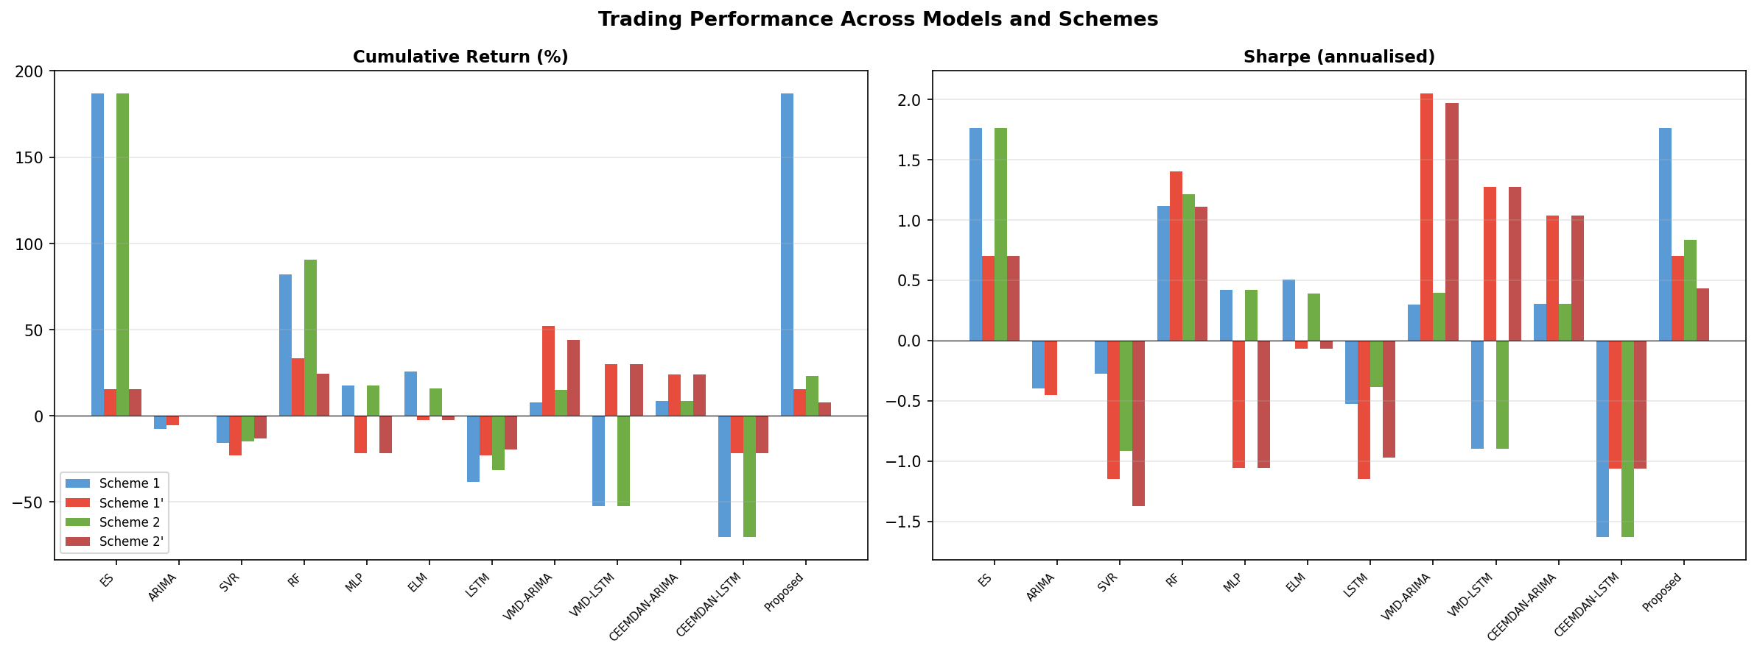
The Proposed model under Scheme 1 achieves 187.2% cumulative return (Sharpe 1.759, max drawdown 27.7%) across 102 trades—the highest among all decomposition models. Under the interval-constrained Scheme 1$′$, the trade count falls from 102 to 30 (a 70.6% reduction) and maximum drawdown drops from 27.7% to 10.9% ($−60.7\%$). The Conditional DA for Scheme 1$′$ is 56.67% (17 correct out of 30 trades; profit factor 1.62; Kelly criterion 21.69%), demonstrating genuine directional skill above the 50% random benchmark. Among single-model strategies, ARIMA, SVR, and LSTM generate losses under Scheme 1 (marked $​^{*}$). The interval constraint partially reverses losses (LSTM: $−38.5\%→−23.3\%$; SVR Scheme 2: $−15.1\%→−13.5\%$), consistent with Liu et al. (2025)’s finding that interval constraints can reverse losses to gains.
The interval constraint (Schemes 1$′$/2$′$) reduces the trade count from 102 to 30 weeks and cuts maximum drawdown by 60.7% (from 27.72% to 10.87%), demonstrating that interval forecasts serve as a principled risk-management tool even during structural regime changes. The Conditional DA of 56.67% on filtered trades (profit factor 1.62) confirms genuine signal quality beyond random chance.

Conclusion
This paper applies the multimodal VMD–ApEn–LASSO framework of Liu et al. (2025) to MCX Silver futures (INR/kg) over 951 weekly observations (2000–2026), with a 108-week test period covering the unprecedented 2024–2026 Indian silver bull market.
On decomposition and complexity, VMD extracts nine IMFs spanning periods from 2.23 to 946 weeks. IMFs 1–2 account for 86.1% of variance. ApEn classifies IMFs 1–2 as low complexity (ARIMA) and IMFs 3–9 as high complexity (LSTM). VMD-LSTM ($DM=−{14.11}^{***}$ vs VMD-ARIMA) confirms that complexity-aware assignment is essential.
On feature selection, India EPU is selected in 8/9 IMFs—the most pervasive driver. Gold co-movement and USD/INR dominate long-run IMFs; India VIX, Google Trends, and EPU dominate short-term oscillations. IMF2 is purely autoregressive.
On forecasting, the Proposed model achieves RMSE 63,709 INR/kg (best among decomposition models). DM tests confirm $p<0.01$ superiority over all 11 benchmarks except ES ($−{4.81}^{***}$). Significance vs VMD-ARIMA: ${5.89}^{***}$.
On trading, Scheme 1 generates 187.2% return (Sharpe 1.759, max DD 27.7%). Scheme 1$′$ cuts maximum drawdown to 10.9% with 30 filtered trades (Conditional DA 56.67%, profit factor 1.62), providing a risk-managed alternative for conservative institutional participants.
Limitations and future research. The fixed $±3\%$ interval band should be replaced by adaptive calibration (e.g., GARCH-LSTM). Daily MCX data would improve MAPE during rapid price accelerations. Extensions to MCX Gold, Crude Oil, and Natural Gas would validate entropy-guided assignment across Indian commodity markets. Temporal Fusion Transformers and richer features (SEBI announcements, MCX open interest) could further enhance performance.

Appendix.
Supplementary data including all per-IMF ARIMA orders, LASSO coefficient paths, weekly trading signals, and extended DM test results are available from the authors upon request. Full pipeline code: Crystal-Blaze13/Silver_RC.

References
- Liu, S., Li, M., Yang, K., Wei, Y., & Wang, S. (2025). From forecasting to trading: A multimodal-data-driven approach to reversing carbon market losses. Energy Economics, 144, 108350. https://doi.org/10.1016/j.eneco.2025.108350

