Lab 1

SQL Injection

SQL injection works by using special characters to escape and run code inside a web form. Assuming you know that the administrator’s **firstName** in the SQL table is **Admin**,and that the password is being hashed with SHA-1, try and use SQL injection to login as the administrator.



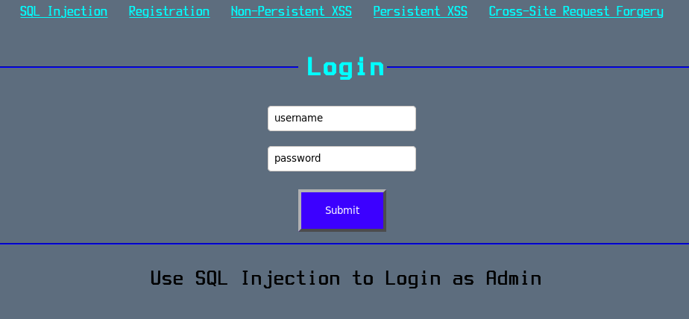

Questions

1. What was entered for the username?

2. What was entered for the password?

3. Please include a screenshot of the login greeting page.