Lab 2

Cross Site Scripting (XSS)

An XSS attack may modify the appearance or behavior of a web page. There are two primary forms that this attack may take. A Non-Persistent XSS attack may be crafted using another web page or a script from an email message. This will then redirect the victim to the newly modified web page. This form of XSS is not permanently stored anywhere and is lost when the page is revisited. The other common type of XSS is known a Persistent XSS. This type will store code in the server’s database and will be re-executed every time the page is revisited. Persistent XSS will likely prevent a web page from functioning properly altogether.

Part 1. (Non-Persistent XSS)

Questions

1. Using HTML tags find at least 3 different ways you can modify or add components to the web page. (Include screenshots)

2. Using the <script> tag create an alert box that says “XSS!” (Include a screenshot)

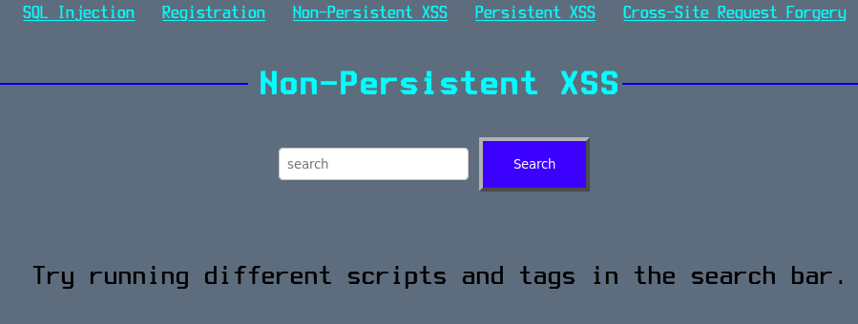

Part 2. (Persistent XSS)

Questions

1. Using an <a> tag create a link to **https://www.uncp.edu/** (Include a screenshot of inserted tag)

2. Using an <script> tag create a page redirect to **https://www.uncp.edu/** (Include a screenshot of inserted tag)

