Lab 1

What is an interrupt? Why the PC register and PSW register must be saved before anything else when processing an interrupt? What saving these two registers must be done by the hardware rather than software?
An interrupt in computer systems (including C programming on bare metal or OS-level contexts) is an asynchronous event that disrupts the usual flow of execution and passes control to an Interrupt Service Routine (ISR).
Why should the PC and PSW be saved first?
- Program counter (PC)
  - The PC carries the address of the next instruction to be executed.
  - If it is not saved before proceeding to the ISR, the CPU will not know where to continue execution once the interrupt has completed.

- Program Status Word (PSW) (also known as processor flags or status register).
  - The PSW stores essential state such as condition codes (zero, carry, and overflow), interrupt enabling bits, CPU mode (user/supervisor), and so on.
  - This must be retained so that the halted program can resume with the same execution context and privilege status.
Why must saving be done by hardware rather than software?

When the interrupt is triggered, the CPU prepares to jump to the ISR. If the ISR program was responsible for saving PC and PSW, they would have already been overwritten or lost (since execution had been diverted).
Hardware must therefore:
Automatically push PC and PSW (typically to the stack or specific registers).
Then get to the ISR.
This ensures that before any software is executed, the CPU's fundamental state is retained.

C Programming Exercise 2
#include <stdio.h> // for printf and fgets
#include <stdlib.h> // for exit
#define BUFSIZE 128
int main(void)
{
char name[BUFSIZE];
printf("Type your full name: ");
fgets(name, BUFSIZE, stdin);
printf("Your name is %s\n", name);
exit(0);
}
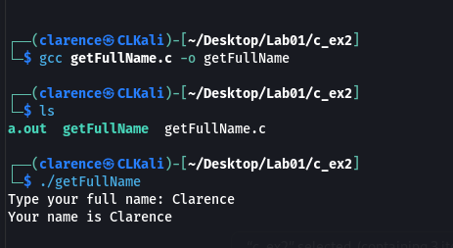

C Programming Exercise 3
#include <stdio.h>
#include <string.h>

#define MAXLINE 1000 // maximum input line size

int main(void) {
char line[MAXLINE];
int n, i;

// Read a line from standard input
printf("Enter a word or sentence: ");
if (fgets(line, sizeof(line), stdin) == NULL) {
return 1; // no input
}

// Remove the newline if present
n = strlen(line);
if (n > 0 && line[n - 1] == '\n') {
line[n - 1] = '\0';
n--; // adjust length
}

// Print the reversed line
for (i = n - 1; i >= 0; --i) {
putchar(line[i]);
}
putchar('\n');

return 0;
}
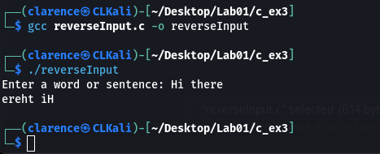

C Programming Exercise 5
#include <stdio.h>
#include <string.h>
#include <stdlib.h>

#define MAXLINE 1000 // maximum input line size

int main(void) {
char line[MAXLINE];
int n, i;
char *fname = "foo2";
FILE *fstr;

// Open file for writing (creates foo2 if it doesn’t exist, overwrites if it does)
printf("Enter a word or sentence: ");
fstr = fopen(fname, "w+");
if (fstr == NULL) {
fprintf(stderr, "Cannot open file %s, terminate program\n", fname);
exit(1);
}

// Read a line from standard input
if (fgets(line, sizeof(line), stdin) == NULL) {
fclose(fstr);
return 1; // no input
}

// Remove the newline if present
n = strlen(line);
if (n > 0 && line[n - 1] == '\n') {
line[n - 1] = '\0';
n--; // adjust length
}

// Write the reversed line to foo2
for (i = n - 1; i >= 0; --i) {
fputc(line[i], fstr); // write one char at a time
}
fputc('\n', fstr); // add a newline

// Close the file
fclose(fstr);

return 0;
}
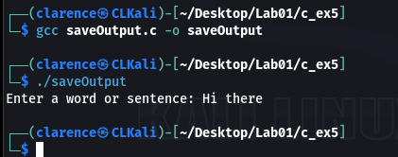
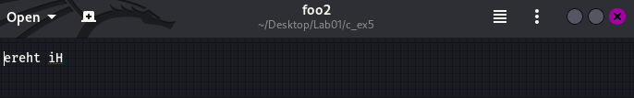

Lab 2
What is the virtual address and what is the relationship between a virtual address and its physical address?
When a process accesses memory, it believes it is using a virtual address.
Independent of other processes, each process has its own virtual address space, which typically begins at address 0.
For instance, since there are virtual addresses in different spaces, it is acceptable for process B to hold a variable at its own 0x1000 address if process A maintains one at address 0x1000.

The MMU converts virtual addresses to physical addresses at runtime using page tables controlled by the operating system.
For example:
Process Virtual Address: 0x00001000
↓ (via MMU + page table).
Physical Address in RAM: 0xA3F21000.
The Relationship
This mapping allows:
- Isolation: Each process can only view its own address space.

- Protection: A process cannot access another process's memory.
- Convenience: Programs can be written starting at address 0x0, eliminating the requirement for collisions.
- Flexibility: The operating system allows for page swapping between RAM and HDD (virtual memory).

C Program Exercise 2.
#include <stdio.h>

#define BUF_SIZE 10 // enough to hold 3-letter month + '\0'

int main(void) {
int date, year;
char month[BUF_SIZE];

printf("Please enter the date in the form of date-short_month-year,\n");
printf("such as 8-Aug-2006, where the month is written in exactly three letters:\n");

if (scanf("%d-%3s-%d", &date, month, &year) != 3) {
printf("Invalid input format!\n");
return 1;
}

printf("Day: %d\n", date);
printf("Month: %s\n", month);
printf("Year: %d\n", year);

return 0;
}
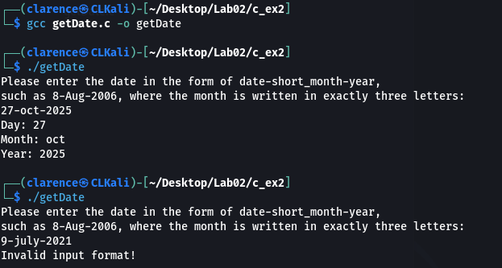

C Program Exercise 4.
#include <stdio.h>

#define BUF_SIZE 10 // enough for 3-char month + null terminator

int main(void) {
const char *date_str1 = "8-Aug-2006";
const char *date_str2 = "25-Dec-1999";
const char *date_str3 = "1-Jan-2024";

int date, year;
char month[BUF_SIZE];

// Test 1
if (sscanf(date_str1, "%d-%3s-%d", &date, month, &year) == 3) {
printf("Date string: %s\n", date_str1);
printf("Parsed: %s %d, %d\n\n", month, date, year);
}

// Test 2
if (sscanf(date_str2, "%d-%3s-%d", &date, month, &year) == 3) {
printf("Date string: %s\n", date_str2);
printf("Parsed: %s %d, %d\n\n", month, date, year);
}

// Test 3
if (sscanf(date_str3, "%d-%3s-%d", &date, month, &year) == 3) {
printf("Date string: %s\n", date_str3);
printf("Parsed: %s %d, %d\n\n", month, date, year);
}

return 0;
}
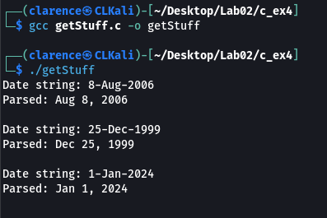

C Program Exercise 5.
#include <stdio.h>
#include <stdlib.h>
#include <string.h>

int main(int argc, char *argv[]) {
int i;

if (argc == 1) {
printf("Usage: %s [options] [files...]\n", argv[0]);
exit(0);
}

printf("There are %d command line arguments (including program name).\n", argc);

for (i = 1; i < argc; ++i) {
if (argv[i][0] == '-') {
// It's an option (starts with '-')
printf("Option: %s\n", argv[i]);
}
else {
// It's not an option → treat as filename or operand
printf("File/Argument: %s\n", argv[i]);
}
}

return 0;
}
