Lab3
What would happen in a process switch? What is the role of CPU hardware and the operating system kernel respectively in a process switch?
A process switch (also known as a context switch) occurs when the CPU stops executing one process and begins performing another.
At a high level:
- The current process's state (context) must be saved.
- The next process's state needs to be restored.
- The CPU continues to execute as if the new process had always been operating.
Context usually includes:
- CPU registers include general-purpose registers, the program counter (PC), the stack pointer (SP), and so on.
- Program Status Word (PSW) / Flags Register.
- Sometimes floating-point registers, SIMD registers, and so forth.
- Memory management information (such as the page table base register).
- Kernel bookkeeping (process control block, scheduling details).
Hardware is responsible for:

- Creating an interrupt or trap (such as a timer interrupt or a system call) that triggers the switch opportunity.
- Automatically saving minimal context, typically PC + PSW, to the kernel stack (allowing the CPU to securely transfer control to the OS).
- Supporting privileged instructions used by the kernel during the switch (for example, changing the base page table and disabling interrupts).

- Memory protection: ensuring that the new process cannot access another process's memory after the switch.

The kernel performs the heavy lifting:
- Handles interrupts/traps and determines if a context transition is required (e.g., when the current process reaches its time limit).
- Saves the whole context of the previous process to its Process Control Block (PCB).
- Determines the next process to perform (scheduler).
- Restores the saved context of the selected process (loading registers, SP, PC, etc. from its PCB).
- Resumes execution of the new process from where it left off.
C Program Exercise 1.
#include <stdio.h>

int main(void) {
int ai[10];
int *pi;
int i, n;

// Initialise array elements
for (i = 0; i < 10; ++i) {
ai[i] = i + 100;
}

// Make pi point to start of ai
pi = ai; // same as pi = &ai[0];

printf("Access array elements using six different notations:\n\n");

// 1) n = ai[i];
printf("1) Using ai[i]\n");
for (i = 0; i < 10; ++i) {
n = ai[i];
printf("ai[%d] = %d\n", i, n);
}
printf("\n");

// 2) n = pi[i];
printf("2) Using pi[i]\n");
for (i = 0; i < 10; ++i) {
n = pi[i];
printf("pi[%d] = %d\n", i, n);
}
printf("\n");

// 3) n = *(ai + i);
printf("3) Using *(ai + i)\n");
for (i = 0; i < 10; ++i) {
n = *(ai + i);
printf("*(ai + %d) = %d\n", i, n);
}
printf("\n");

// 4) n = *(pi + i);
printf("4) Using *(pi + i)\n");
for (i = 0; i < 10; ++i) {
n = *(pi + i);
printf("*(pi + %d) = %d\n", i, n);
}
printf("\n");

// 5) pi = pi + i; n = *pi;
printf("5) Using pi = pi + i; n = *pi;\n");
pi = ai; // reset pointer to start of array
for (i = 0; i < 10; ++i) {
int *tmp = pi + i; // avoid moving pi itself permanently
n = *tmp;
printf("*(pi + %d) = %d\n", i, n);
}
printf("\n");

// 6) pi = ai + i; n = *pi;
printf("6) Using pi = ai + i; n = *pi;\n");
for (i = 0; i < 10; ++i) {
pi = ai + i;
n = *pi;
printf("*(ai + %d) = %d\n", i, n);
}
printf("\n");

return 0;
}

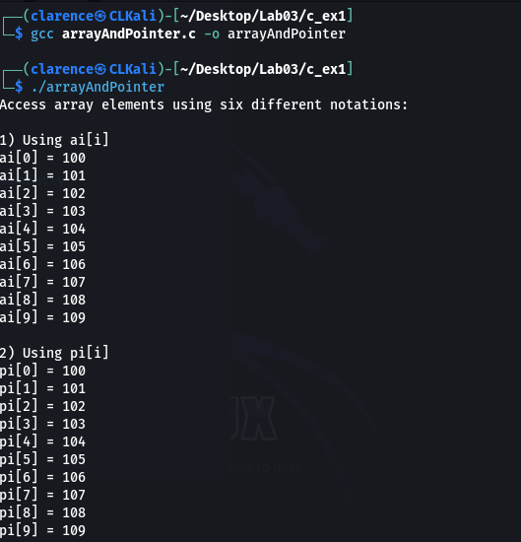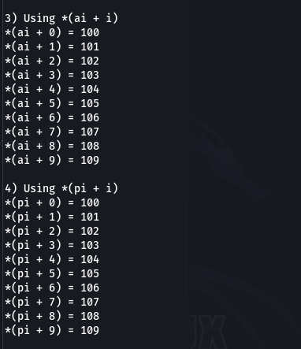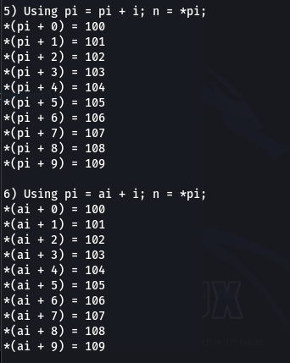

C Program Exercise 2.
#include <stdio.h>

// Function prototype
void fillArray(int array[], int arraySize);
void printArray(int array[], int arraySize);

int main(void) {
int arr1[5];
int arr2[3];

printf("Fill arr1 (size 5):\n");
fillArray(arr1, 5);
printf("You entered arr1: ");
printArray(arr1, 5);

printf("\nFill arr2 (size 3):\n");
fillArray(arr2, 3);
printf("You entered arr2: ");
printArray(arr2, 3);

return 0;
}

// Fill array with user input
void fillArray(int array[], int arraySize) {
for (int i = 0; i < arraySize; i++) {
printf("Enter element %d: ", i);
scanf("%d", &array[i]);
}
}

// Print array contents
void printArray(int array[], int arraySize) {
for (int i = 0; i < arraySize; i++) {
printf("%d ", array[i]);
}
printf("\n");
}

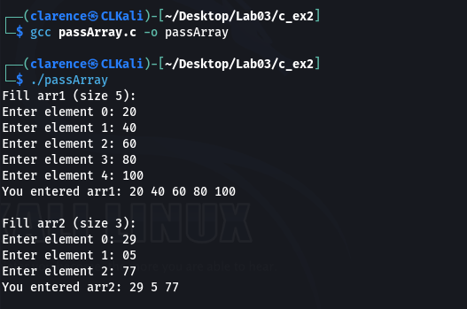

C Program Exercise 4.
#include <stdio.h>
#include <stdlib.h>

// Function that creates, fills, and returns a dynamic array
int *getArray(int arraySize) {
int *array;

// Allocate memory for arraySize integers
array = (int *)malloc(arraySize * sizeof(int));
if (array == NULL) {
printf("Memory allocation failed!\n");
exit(1);
}

// Fill the array with values (user input here)
for (int i = 0; i < arraySize; i++) {
printf("Enter element %d: ", i);
scanf("%d", &array[i]);
}

return array; // return pointer to caller
}

// Helper function to print an array
void printArray(int *array, int arraySize) {
for (int i = 0; i < arraySize; i++) {
printf("%d ", array[i]);
}
printf("\n");
}

int main(void) {
int *pi;
int n;

printf("Enter array size: ");
scanf("%d", &n);

// Create and fill dynamic array
pi = getArray(n);

// Print the array
printf("You entered: ");
printArray(pi, n);

// Free the memory when done
free(pi);

return 0;
}
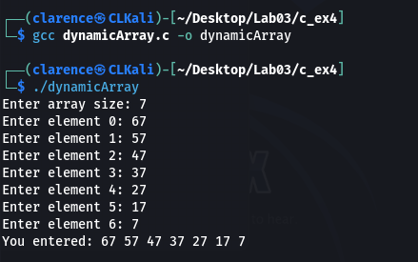

Lab4
C Programming Exercise 4.
#include <stdio.h>

// A function that squares its argument
int square(int n) {
return n * n;
}

int main(void) {
int (*fp)(int); // declare a function pointer
int n;

// Print the address of the function
printf("Address of function square: %p\n", (void *)square);

// Assign function address to function pointer
fp = square;

// Call function directly
n = square(10);
printf("square(10) = %d (direct call)\n", n);

// Call function via pointer
n = fp(10);
printf("fp(10) = %d (via function pointer)\n", n);

return 0;
}
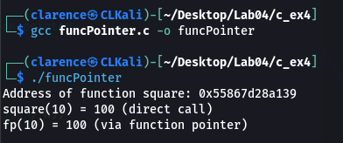

Unix Programming Exercise 7.
#!/usr/bin/env bash
set -o errexit
set -o nounset
set -o pipefail

N="$1"

validate_input() {
if [[ ! "$N" =~ ^[0-9]+$ ]] || [[ "$N" -le 0 ]]; then
printf "Usage: %s <positive_integer>\n" "$0" >&2
return 1
fi
}

create_child() {
local i pid ppid minutes
i="$1"
pid=$$
ppid=$(ps -o ppid= -p "$pid" | tr -d ' ')
if [[ -z "$ppid" ]]; then
printf "Error: Could not retrieve PPID for PID %d\n" "$pid" >&2
return 1
fi
printf "Child %d: PID=%d, PPID=%d\n" "$i" "$pid" "$ppid"
minutes=$((i * 60))
sleep "$minutes"
exit 0
}

main() {
if ! validate_input; then
return 1
fi

local i child_pid
for ((i=1; i<=N; i++)); do
if (create_child "$i") & then
child_pid=$!
if [[ -z "$child_pid" ]]; then
printf "Error: Failed to retrieve PID of child %d\n" "$i" >&2
continue
fi
else
printf "Error: Failed to fork child %d\n" "$i" >&2
fi
done

wait
}

main "$@"
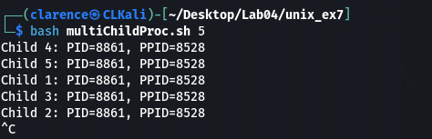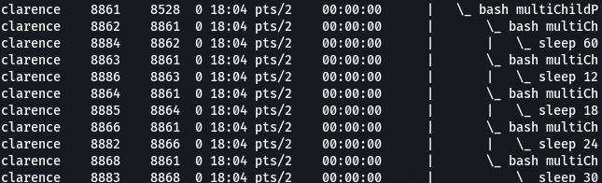

Unix Programming Exercise 11.
#!/usr/bin/env bash
set -o errexit
set -o nounset
set -o pipefail

read_command() {
local cmd
printf "%% " >&2 # print prompt to stderr so it doesn’t pollute the command
if ! IFS= read -r cmd; then
printf "Error: Failed to read command\n" >&2
return 1
fi
printf "%s" "$cmd"
}

execute_command() {
local cmd=$1
if [[ -z "$cmd" ]]; then
return 0
fi
if [[ "$cmd" == "bye" ]]; then
return 2
fi

if command -v "$cmd" >/dev/null 2>&1; then
"$cmd"
else
# try to handle arguments (e.g., "ls -l")
eval "$cmd" || {
printf "Error: Failed to execute command '%s'\n" "$cmd" >&2
exit 127
}
fi
}

main() {
local cmd child_pid status
while true; do
cmd=$(read_command) || continue
if [[ "$cmd" == "bye" ]]; then
break
fi

( execute_command "$cmd" ) &
child_pid=$!
if ! wait "$child_pid"; then
status=$?
printf "Child terminated with status %d\n" "$status" >&2
fi
done
}

main
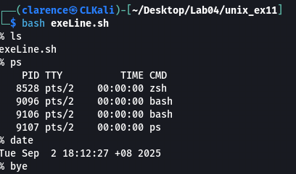

Unix Programming Exercise 12.
#!/usr/bin/env bash
set -o errexit
set -o nounset
set -o pipefail

LOGFILE="/tmp/daemon.log"
PIDFILE="/tmp/daemon.pid"

start_daemon() {
(
# Start new session, detach from terminal
setsid bash -c '
umask 0
cd /
exec >/dev/null 2>&1
while true; do
printf "I have nothing to do\n" >> "'"$LOGFILE"'"
sleep 10
done
' &
echo $! > "$PIDFILE"
)

sleep 0.2
if [[ -s "$PIDFILE" ]]; then
local daemon_pid
daemon_pid=$(cat "$PIDFILE")
printf "Daemon started with PID %d\n" "$daemon_pid"
else
printf "Error: Failed to start daemon\n" >&2
return 1
fi
}

stop_daemon() {
if [[ -s "$PIDFILE" ]]; then
local daemon_pid
daemon_pid=$(cat "$PIDFILE")
if kill "$daemon_pid" 2>/dev/null; then
printf "Daemon with PID %d stopped\n" "$daemon_pid"
rm -f "$PIDFILE"
else
printf "Error: Could not kill daemon with PID %d\n" "$daemon_pid" >&2
fi
else
printf "No running daemon found\n" >&2
fi
}

main() {
case "${1:-}" in
start) start_daemon ;;
stop) stop_daemon ;;
*) printf "Usage: %s {start|stop}\n" "$0" >&2; return 1 ;;
esac
}

main "$@"
