Lab5
C Programming Exercise 4.
/*
* file: stack.h
*/
typedef struct node {
char *str;
struct node *next;
} Node;

typedef struct {
Node *top;
int number;
} Stack;

// create and return an empty stack
//
Stack *create_stack();

// push the string "str" into the stack "stack"
//
void push_stack(Stack *stack, char *str);

// pop off the string at the top of the stack "stack"
// and return the string
//
char *pop_stack(Stack *stack);

// return the number of strings in the stack
//
int size_of_stack(Stack *stack);

// chech whether the stack is empty
// return 1 if empty and 0 if not
//
int empty_stack(Stack *stack);

/*
* file: stack.c
*/
#include <stdlib.h>
#include <stdio.h>
#include "stack.h"

Stack *create_stack()
{
Stack *s;

s = malloc(sizeof(Stack));

if (s==NULL) {
fprintf(stderr, "No more memory - quit\n");
exit(1);
}

s->top = NULL;
s->number = 0;
return s;
}

void push_stack(Stack *stack, char *str)
{
Node *newNode;

newNode = malloc(sizeof(Node));
if (newNode == NULL) {
fprintf(stderr, "No more memory - quit!\n");
exit(1);
}

newNode -> str = str;
newNode->next = stack->top;
stack->top = newNode;
stack -> number += 1;
}

char *pop_stack(Stack *stack)
{
Node *np;
char *str;

if (empty_stack(stack))
return NULL;

np = stack->top;
stack->top = np->next;
stack->number -= 1;

str = np->str;
free(np);
return str;
}

int size_of_stack(Stack *stack)
{
return stack->number;
}

int empty_stack(Stack *stack)
{
return stack->number == 0;
}

/*
* file: testStack.c
*/
#include <stdlib.h>
#include <stdio.h>
#include "stack.h"

int main(int argc, char *argv[])
{
Stack *s;
int i;

// create an empty stack
s = create_stack();

// push all command line arguments into the stack
for (i=0; i<argc; ++i)
push_stack(s, argv[i]);

printf("there are %d strings in the stack\n", size_of_stack(s));

// pop out the strings in the stack and print them out
while ( !empty_stack(s) )
printf("Stack item: %s\n", pop_stack(s));

printf("now there are %d strings in the stack\n", size_of_stack(s));

exit(0);
}

# makefile for teststack
# filename: Makefile

testStack: testStack.o stack.o
gcc testStack.o stack.o -o testStack

testStack.o: testStack.c stack.h
gcc -c testStack.c

stack.o: stack.c stack.h
gcc -c stack.c

clean:
rm *.o

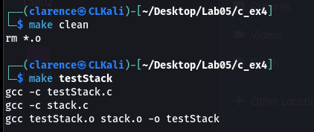

Unix Programming Exercise 5.
#!/usr/bin/env bash
set -o errexit
set -o nounset
set -o pipefail

FILE="$1"

validate_input() {
if [[ -z "$FILE" ]]; then
printf "Usage: %s <filename>\n" "$0" >&2
return 1
fi
if [[ ! -e "$FILE" ]]; then
printf "Error: File '%s' does not exist\n" "$FILE" >&2
return 1
fi
}

report_file_info() {
local ftype perms inode size
if ! ftype=$(stat -c %F -- "$FILE" 2>/dev/null); then
printf "Error: Failed to determine file type\n" >&2
return 1
fi
if ! perms=$(stat -c %A -- "$FILE" 2>/dev/null); then
printf "Error: Failed to get permissions\n" >&2
return 1
fi
if ! inode=$(stat -c %i -- "$FILE" 2>/dev/null); then
printf "Error: Failed to get inode number\n" >&2
return 1
fi
if ! size=$(stat -c %s -- "$FILE" 2>/dev/null); then
printf "Error: Failed to get file size\n" >&2
return 1
fi

printf "File: %s\n" "$FILE"
printf "Type: %s\n" "$ftype"
printf "Permissions: %s\n" "$perms"
printf "I-node: %s\n" "$inode"
printf "Size: %s bytes\n" "$size"
}

main() {
if ! validate_input; then
return 1
fi
report_file_info
}

main "$@"
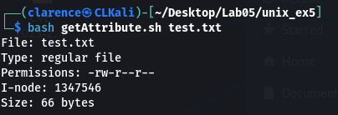

Unix Programming Exercise 7.
#!/usr/bin/env bash
set -o errexit
set -o nounset
set -o pipefail

DIR="$1"

validate_input() {
if [[ -z "$DIR" ]]; then
printf "Usage: %s <directory>\n" "$0" >&2
return 1
fi
if [[ ! -d "$DIR" ]]; then
printf "Error: '%s' is not a directory\n" "$DIR" >&2
return 1
fi
}

list_inodes() {
local entry inode
if ! cd -- "$DIR"; then
printf "Error: Could not enter directory '%s'\n" "$DIR" >&2
return 1
fi

for entry in . .. *; do
if [[ ! -e "$entry" ]]; then
continue
fi
if ! inode=$(ls -id -- "$entry" 2>/dev/null | awk '{print $1}'); then
printf "Error: Failed to get inode for %s\n" "$entry" >&2
continue
fi
printf "Name: %-30s Inode: %s\n" "$entry" "$inode"
done
}

main() {
if ! validate_input; then
return 1
fi
list_inodes
}

main "$@"
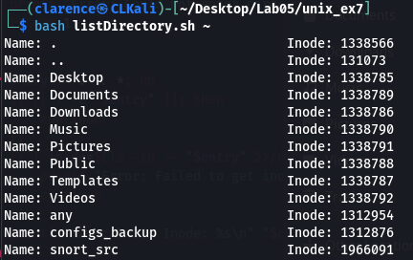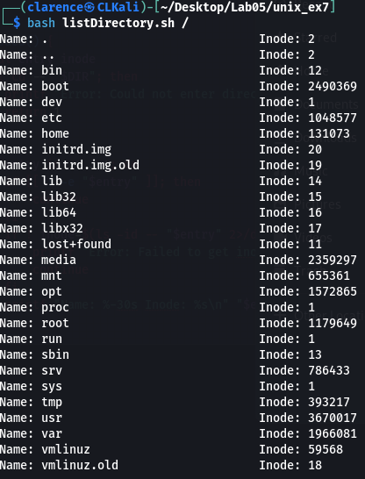

Unix Programming Exercise 11.
#!/usr/bin/env bash
set -o errexit
set -o nounset
set -o pipefail

OUTPUT="foo"

run_ls() {
if ! ls -lt >"$OUTPUT" 2>/dev/null; then
printf "Error: Failed to execute ls -lt\n" >&2
return 1
fi
printf "Output written to %s\n" "$OUTPUT"
}

main() {
run_ls
}

main "$@"
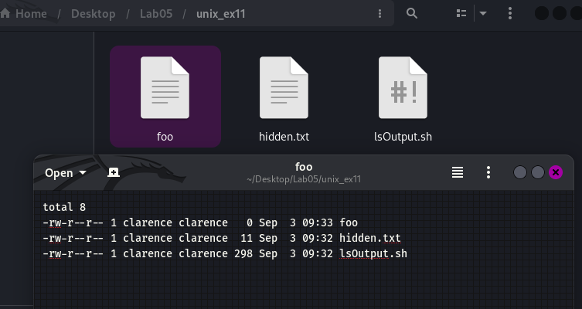

Lab6
C Programming Exercise 3.
/*
* file: main.c
*/
#include <stdio.h>
#include <string.h>
#include "token.h"

#define MAXLINE 1000

int main(void) {
char line[MAXLINE];
char *tokens[MAX_NUM_TOKENS];
int ntok, i;

while (1) {
// Display a prompt
printf("%% ");
fflush(stdout);

// Read a line
if (fgets(line, sizeof(line), stdin) == NULL) {
break; // EOF
}

// Remove trailing newline
size_t len = strlen(line);
if (len > 0 && line[len - 1] == '\n') {
line[len - 1] = '\0';
}

// Exit command
if (strcmp(line, "exit") == 0) {
break;
}

// Tokenise
ntok = tokenise(line, tokens);
if (ntok == -1) {
printf("Error: too many tokens!\n");
continue;
}

// Print tokens
printf("Found %d tokens:\n", ntok);
for (i = 0; i < ntok; i++) {
printf("Token[%d] = \"%s\"\n", i, tokens[i]);
}
}

printf("Goodbye!\n");
return 0;
}

/*
* file: token.h
*/
#ifndef TOKEN_H
#define TOKEN_H

#define MAX_NUM_TOKENS 100

// Breaks inputLine into tokens separated by whitespace.
// Stores pointers to tokens in token[].
// Returns number of tokens found, or -1 if too many tokens.
int tokenise(char *inputLine, char *token[]);

#endif

/*
* file: token.c
*/
#include <stdio.h>
#include <string.h>
#include <ctype.h>
#include "token.h"

int tokenise(char *inputLine, char *token[]) {
int count = 0;
char *p = inputLine;

while (*p != '\0') {
// Skip leading whitespace
while (*p == ' ' || *p == '\t' || *p == '\n') {
p++;
}

if (*p == '\0') {
break; // end of string
}

// Found start of a token
if (count >= MAX_NUM_TOKENS) {
return -1; // too many tokens
}
token[count++] = p;

// Move until end of token
while (*p != '\0' && *p != ' ' && *p != '\t' && *p != '\n') {
p++;
}

// Null-terminate token
if (*p != '\0') {
*p = '\0';
p++;
}
}

return count;
}

# Makefile for tokeniser program

CC = gcc
CFLAGS = -Wall -g

all: tokenizer

tokenizer: main.o token.o
$(CC) $(CFLAGS) main.o token.o -o tokenizer

main.o: main.c token.h
$(CC) $(CFLAGS) -c main.c

token.o: token.c token.h
$(CC) $(CFLAGS) -c token.c

clean:
rm -f *.o tokenizer
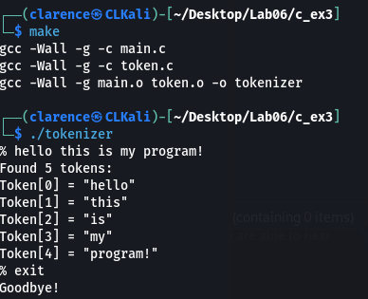

Unix Programming Exercise 5.
#!/usr/bin/env bash
set -o errexit
set -o nounset
set -o pipefail

sigint_count=0
sigquit_count=0

handle_sigint() {
sigint_count=$((sigint_count + 1))
if [[ $sigint_count -eq 1 ]]; then
printf "Caught SIGINT (Ctrl+C) once. PID=%d\n" "$$"
else
printf "Caught SIGINT again, exiting. PID=%d\n" "$$"
exit 0
fi
}

handle_sigquit() {
sigquit_count=$((sigquit_count + 1))
if [[ $sigquit_count -eq 1 ]]; then
printf "Caught SIGQUIT (Ctrl+\\) once. PID=%d\n" "$$"
else
printf "Caught SIGQUIT again, exiting. PID=%d\n" "$$"
exit 0
fi
}

catch_signals() {
trap handle_sigint INT
trap handle_sigquit QUIT
printf "Catching SIGINT and SIGQUIT. PID=%d\n" "$$"
}

infinite_loop() {
while true; do
sleep 1
done
}

main() {
catch_signals
infinite_loop
}

main "$@"
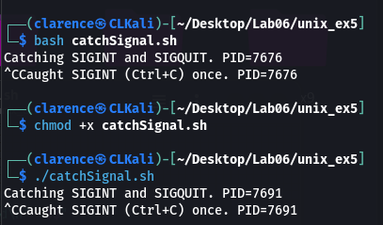
The program did not work as intended where it should only exit when CTRL + \ was detected even when I tried to execute the file directly by granting it executable function.

Unix Programming Exercise 8.
#!/usr/bin/env bash
set -o errexit
set -o nounset
set -o pipefail

child_pid=0

handle_sigchld() {
local cpid
if ! cpid=$(ps -o pid= --ppid "$$" 2>/dev/null | tr -d ' '); then
printf "SIGCHLD received, but failed to determine child PID\n" >&2
return
fi
printf "SIGCHLD received: child with PID %s has terminated\n" "$cpid"
}

handle_sigalrm() {
printf "SIGALRM received: alarm clock expired\n"
}

handle_sigint() {
printf "SIGINT received: numeric value is %d\n" "$((INT))"
}

setup_traps() {
# Use trap with specific handlers
trap handle_sigchld CHLD
trap handle_sigalrm ALRM
trap handle_sigint INT
}

create_child() {
(
sleep 10
) &
child_pid=$!
printf "Child created with PID %d\n" "$child_pid"
}

set_alarm() {
# In Bash, no direct alarm(), emulate with a background sleep+kill
(
sleep 20
kill -ALRM "$$"
) &
}

main_loop() {
local i=0
while true; do
i=$((i + 1))
printf "Parent loop iteration %d (PID=%d)\n" "$i" "$$"
sleep 1
done
}

main() {
setup_traps
create_child
set_alarm
main_loop
}

main "$@"
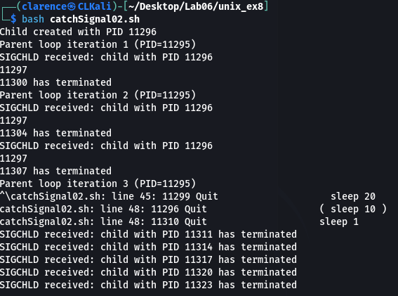

Unix Programming Exercise 9.
#!/usr/bin/env bash
set -o errexit
set -o nounset
set -o pipefail

START_TIME=$(date +%s)
CAN_EXIT_AFTER=$((START_TIME + 30))
EXIT_REQUESTED=0

handle_sigint() {
local now remaining
now=$(date +%s)
if [[ $now -ge $CAN_EXIT_AFTER ]]; then
printf "\nSIGINT received. Exiting now (uptime >= 30s)\n"
exit 0
else
remaining=$((CAN_EXIT_AFTER - now))
printf "\nSIGINT received but uptime < 30s. Will exit automatically after %d more seconds.\n" "$remaining"
EXIT_REQUESTED=1
fi
}

handle_sigquit() {
local now remaining
now=$(date +%s)
if [[ $now -ge $CAN_EXIT_AFTER ]]; then
printf "\nSIGQUIT received. Exiting now (uptime >= 30s)\n"
exit 0
else
remaining=$((CAN_EXIT_AFTER - now))
printf "\nSIGQUIT received but uptime < 30s. Will exit automatically after %d more seconds.\n" "$remaining"
EXIT_REQUESTED=1
fi
}

setup_traps() {
trap handle_sigint INT
trap handle_sigquit QUIT
}

interactive_loop() {
local input now uptime remaining
while true; do
uptime=$(( $(date +%s) - START_TIME ))

if [[ $EXIT_REQUESTED -eq 1 ]]; then
now=$(date +%s)
if [[ $now -ge $CAN_EXIT_AFTER ]]; then
uptime=$((now - START_TIME))
printf "30s runtime reached (uptime %ds). Exiting.\n" "$uptime"
exit 0
fi
remaining=$((CAN_EXIT_AFTER - now))
printf "[Uptime: %ds] Countdown to exit: %ds\n" "$uptime" "$remaining"
sleep 1
continue
fi

printf "[Uptime: %ds] Type something: " "$uptime"
if ! IFS= read -r input; then
continue
fi
printf "You typed: %s\n" "$input"
done
}

main() {
setup_traps
interactive_loop
}

main "$@"
