Lab7
C Programming Exercise 2.
/*
* file: command.h
*/
#include "token.h"

#define MAX_NUM_COMMANDS 100

struct CommandStructure {
int first; // index of the first token of the command
int last; // index of the last token of the command
char *separator; // "|" or "&" or ";" if one follows, else NULL
};

typedef struct CommandStructure Command;

// Break a list of tokens into commands
// Returns number of commands found
int separateCommands(char *tokens[], int ntok, Command command[]);

#endif

/*
* file: command.c
*/
#include <string.h>
#include "command.h"

static int is_sep(const char *t) {
return (strcmp(t, "|") == 0) || (strcmp(t, "&") == 0) || (strcmp(t, ";") == 0);
}

int separateCommands(char *tokens[], int ntok, Command command[]) {
int ncmd = 0;
int start = 0;

for (int i = 0; i < ntok; i++) {
if (is_sep(tokens[i])) {
// Command is from [start .. i-1]
if (i > start) {
command[ncmd].first = start;
command[ncmd].last = i - 1;
command[ncmd].separator = tokens[i];
ncmd++;
} else {
// Two separators in a row; ignore empty command
}
start = i + 1;
}
}

// Trailing command (no separator after it)
if (start < ntok) {
command[ncmd].first = start;
command[ncmd].last = ntok - 1;
command[ncmd].separator = NULL;
ncmd++;
}

return ncmd;
}

/*
* file: token.h
*/
#ifndef TOKEN_H
#define TOKEN_H

#define MAX_NUM_TOKENS 100

// Breaks inputLine into tokens separated by whitespace.
// Stores pointers to tokens in token[].
// Returns number of tokens found, or -1 if too many tokens.
int tokenise(char *inputLine, char *token[]);

#endif

/*
* file: token.c
*/
#include <stdio.h>
#include <string.h>
#include <ctype.h>
#include "token.h"

int tokenise(char *inputLine, char *token[]) {
int count = 0;
char *p = inputLine;

while (*p != '\0') {
// Skip leading whitespace
while (*p == ' ' || *p == '\t' || *p == '\n') {
p++;
}

if (*p == '\0') {
break; // end of string
}

// Found start of a token
if (count >= MAX_NUM_TOKENS) {
return -1; // too many tokens
}
token[count++] = p;

// Move until end of token
while (*p != '\0' && *p != ' ' && *p != '\t' && *p != '\n') {
p++;
}

// Null-terminate token
if (*p != '\0') {
*p = '\0';
p++;
}
}

return count;
}

/*
* file: main.c
*/
#include <stdio.h>
#include <string.h>
#include <stdlib.h>
#include <unistd.h>
#include <sys/types.h>
#include <sys/wait.h>
#include <errno.h>

#include "token.h"
#include "command.h"

#define MAXLINE 1000

static int is_pipe_sep(const char *s) { return s && strcmp(s, "|") == 0; }
static int is_bg_sep(const char *s) { return s && strcmp(s, "&") == 0; }
// ';' or NULL -> wait

// Execute a pipeline group: commands[i..j] (inclusive).
// If bg==1, do not wait; otherwise wait for all children.
static void run_pipeline(char *tokens[], Command *commands, int i, int j, int bg) {
int n = j - i + 1;
if (n <= 0) return;

int pipes_needed = (n > 1) ? (n - 1) : 0;
int pipes[64][2]; // enough for simple cases; feel free to make dynamic
if (pipes_needed > 64) {
fprintf(stderr, "Too many pipeline segments\n");
return;
}

for (int k = 0; k < pipes_needed; k++) {
if (pipe(pipes[k]) < 0) {
perror("pipe");
return;
}
}

pid_t pids[128];
if (n > (int)(sizeof pids / sizeof pids[0])) {
fprintf(stderr, "Too many commands in pipeline\n");
// Close any opened pipes
for (int k = 0; k < pipes_needed; k++) { close(pipes[k][0]); close(pipes[k][1]); }
return;
}

for (int idx = 0; idx < n; idx++) {
int ci = i + idx;

// Build argv for this command from tokens[first..last]
int argc = commands[ci].last - commands[ci].first + 1;
if (argc <= 0) continue;

char **argv = calloc((size_t)argc + 1, sizeof(char*));
if (!argv) {
perror("calloc");
// Close pipes before returning
for (int k = 0; k < pipes_needed; k++) { close(pipes[k][0]); close(pipes[k][1]); }
return;
}
for (int t = 0; t < argc; t++) {
argv[t] = tokens[commands[ci].first + t];
}
argv[argc] = NULL;

pid_t pid = fork();
if (pid < 0) {
perror("fork");
free(argv);
// Parent: close pipes and bail
for (int k = 0; k < pipes_needed; k++) { close(pipes[k][0]); close(pipes[k][1]); }
return;
}

if (pid == 0) {
// Child
// If not first, hook stdin to previous pipe's read end
if (idx > 0) {
if (dup2(pipes[idx - 1][0], STDIN_FILENO) < 0) {
perror("dup2 stdin");
_exit(127);
}
}
// If not last, hook stdout to this pipe's write end
if (idx < n - 1) {
if (dup2(pipes[idx][1], STDOUT_FILENO) < 0) {
perror("dup2 stdout");
_exit(127);
}
}

// Close all pipe fds in child
for (int k = 0; k < pipes_needed; k++) {
close(pipes[k][0]);
close(pipes[k][1]);
}

execvp(argv[0], argv);
perror("execvp");
_exit(127);
}

// Parent
pids[idx] = pid;
free(argv);
}

// Parent closes all pipe ends
for (int k = 0; k < pipes_needed; k++) {
close(pipes[k][0]);
close(pipes[k][1]);
}

if (bg) {
// Background: don't wait; print the first PID (like a job id hint)
printf("[background] started pipeline (pids:");
for (int idx = 0; idx < n; idx++) printf(" %d", (int)pids[idx]);
printf(" )\n");
fflush(stdout);
} else {
// Foreground: wait for all
int status;
for (int idx = 0; idx < n; idx++) {
while (waitpid(pids[idx], &status, 0) < 0 && errno == EINTR) { /* retry */ }
}
}
}

int main(void) {
char line[MAXLINE];
char *tokens[MAX_NUM_TOKENS];
Command commands[MAX_NUM_COMMANDS];

while (1) {
printf("%% ");
fflush(stdout);

if (!fgets(line, sizeof(line), stdin)) break;

// Strip trailing newline
size_t len = strlen(line);
if (len > 0 && line[len - 1] == '\n') line[len - 1] = '\0';

if (strcmp(line, "exit") == 0) break;

int ntok = tokenise(line, tokens);
if (ntok == -1) {
printf("Error: too many tokens!\n");
continue;
}
if (ntok == 0) continue;

int ncmd = separateCommands(tokens, ntok, commands);
if (ncmd <= 0) continue;

// Group commands by pipelines; decide wait/background by last separator in group
for (int i = 0; i < ncmd; ) {
int j = i;
// Extend through pipes
while (j < ncmd - 1 && is_pipe_sep(commands[j].separator)) j++;

// Decide background/foreground by separator after the last command in the group
int bg = 0;
if (is_bg_sep(commands[j].separator)) bg = 1;
// ';' or NULL -> wait (bg=0)

run_pipeline(tokens, commands, i, j, bg);
i = j + 1;
}
}

return 0;
}

/*
* file: Makefile
*/
# Makefile for mini shell with tokenizer and command splitter

CC = gcc
CFLAGS = -Wall -g

# default target
all: minishell

# link objects into final program
minishell: main.o token.o command.o
$(CC) $(CFLAGS) main.o token.o command.o -o minishell

# compile object files
main.o: main.c token.h command.h
$(CC) $(CFLAGS) -c main.c

token.o: token.c token.h
$(CC) $(CFLAGS) -c token.c

command.o: command.c command.h token.h
$(CC) $(CFLAGS) -c command.c

# clean up build artifacts
clean:
rm -f *.o minishell
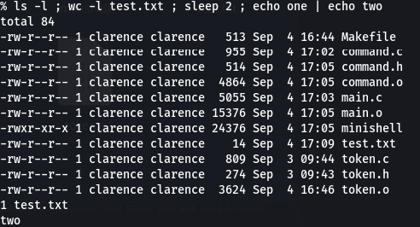

Unix Programming Exercise 2.
#!/usr/bin/env bash
set -o errexit
set -o nounset
set -o pipefail

# Globals (allowed by style rules)
CHILD_PID=""
COPROC_RFD=""

start_child_coproc() {
# Start a coprocess (child). Child writes one message to stdout (the pipe),
# sleeps 10s, closes its stdout (the write end of the pipe), reports to stderr,
# sleeps another 10s, then exits.
if ! coproc {
printf "Hello from child!\n"
sleep 10

# close child's stdout (write end of pipe)
exec 1>&-
printf "Child: closed write end of pipe.\n" >&2

sleep 10
printf "Child: terminating now.\n" >&2
}; then
printf "Error: failed to start coprocess\n" >&2
return 1
fi

local pid; pid=$COPROC_PID
CHILD_PID=$pid
COPROC_RFD="${COPROC[0]}"
printf "Child started with PID %s\n" "$CHILD_PID"
return 0
}

parent_wait_for_pipe_close() {
local rfd line
rfd=$COPROC_RFD

# Duplicate the coprocess read fd to fd 3 for stable reading
if ! exec 3<&"$rfd"; then
printf "Error: failed to dup coproc read fd %s\n" "$rfd" >&2
return 1
fi

# Read lines until EOF (child closes write end)
while IFS= read -r line <&3; do
printf "Parent: received message: %s\n" "$line"
done

# EOF reached -> child has closed its write end
printf "Parent: detected that child closed the pipe. Exiting now.\n"

# Close fd 3 cleanly
exec 3<&-
return 0
}

main() {
if ! start_child_coproc; then
return 1
fi

if ! parent_wait_for_pipe_close; then
return 1
fi

return 0
}

main "$@"
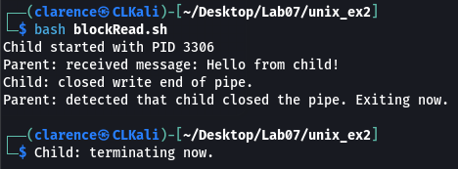

Unix Programming Exercise 5.
#!/usr/bin/env bash
set -o errexit
set -o nounset
set -o pipefail

FIFO_PATH="/tmp/myfifo_$$"

cleanup() {
rm -f "$FIFO_PATH"
}
trap cleanup EXIT INT QUIT TERM

start_child_fifo() {
{
# Child writes message into FIFO
printf "Hello from child!\n"
sleep 10

# Close write end explicitly
exec 1>&-
printf "Child: closed write end of FIFO.\n" >&2

sleep 10
printf "Child: terminating now.\n" >&2
} >"$FIFO_PATH" &
CHILD_PID=$!
printf "Child started with PID %s\n" "$CHILD_PID"
}

parent_read_fifo() {
local line
# Parent reads from FIFO until EOF
while IFS= read -r line <"$FIFO_PATH"; do
printf "Parent: received message: %s\n" "$line"
done
printf "Parent: detected that child closed the FIFO. Exiting now.\n"
}

main() {
mkfifo "$FIFO_PATH"
start_child_fifo
parent_read_fifo
}

main "$@"
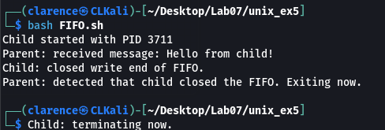

Unix Programming Exercise 9.
# ===== getMark.sh =====
#!/usr/bin/env bash
set -o errexit
set -o nounset
set -o pipefail

SHM_FILE="/tmp/student_marks.shm"

# Ensure shared file exists and is empty
: > "$SHM_FILE"

main() {
local mark
while true; do
printf "Enter student mark (or 'end' to finish): "
if ! IFS= read -r mark; then
continue
fi

if [[ $mark = "end" ]]; then
printf "Producer: input finished. Signaling average mark calculator.\n"
printf "END\n" >> "$SHM_FILE"
break
fi

# Validate numeric mark
if ! printf "%s" "$mark" | grep -Eq '^[0-9]+$'; then
printf "Invalid mark. Please enter a number or 'end'.\n" >&2
continue
fi

printf "%s\n" "$mark" >> "$SHM_FILE"
printf "Producer: stored mark %s\n" "$mark"
done
}

main "$@"

# ===== averageMark.sh =====
#!/usr/bin/env bash
set -o errexit
set -o nounset
set -o pipefail

SHM_FILE="/tmp/student_marks.shm"

main() {
local sum=0 count=0 mark

printf "Consumer: waiting for marks...\n"

# Read file continuously until END marker appears
while true; do
if ! IFS= read -r mark; then
sleep 1
continue
fi

if [[ $mark = "END" ]]; then
break
fi

if [[ -n $mark ]]; then
sum=$((sum + mark))
count=$((count + 1))
printf "Consumer: received mark %s\n" "$mark"
fi
done < <(tail -n 0 -f "$SHM_FILE")

if [[ $count -gt 0 ]]; then
avg=$((sum / count))
printf "Consumer: average mark = %d (from %d students)\n" "$avg" "$count"
else
printf "Consumer: no marks received.\n"
fi
}

main "$@"
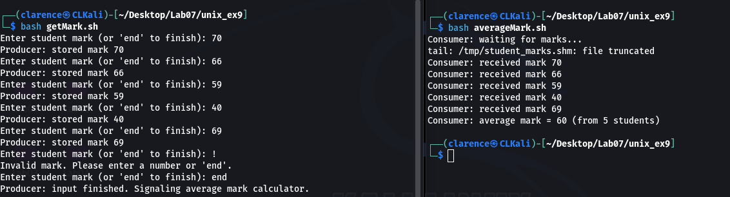

Lab8
C Programming Exercise 2.
/*
* file: command.h
*/
#ifndef COMMAND_H
#define COMMAND_H

#include "token.h"

struct CommandStructure {
int first; // index of first token
int last; // index of last token
char *separator; // "|" or "&" or ";" or NULL

// new fields
char **argv; // NULL-terminated array of arguments
char *stdin_file; // input redirection file
char *stdout_file; // output redirection file
};

typedef struct CommandStructure Command;

// split tokens into commands
int separateCommands(char *tokens[], int ntok, Command command[]);

// redirection scanner
void searchRedirection(char *tokens[], Command *cp);

// build argv[] array for execvp
void buildCommandArgumentArray(char *tokens[], Command *cp);

#endif

/*
* file: command.c
*/
#include <stdio.h>
#include <stdlib.h>
#include <string.h>
#include "command.h"

void searchRedirection(char *tokens[], Command *cp) {
cp->stdin_file = NULL;
cp->stdout_file = NULL;

for (int i = cp->first; i <= cp->last; i++) {
if (strcmp(tokens[i], "<") == 0 && i + 1 <= cp->last) {
cp->stdin_file = tokens[i + 1];
i++;
} else if (strcmp(tokens[i], ">") == 0 && i + 1 <= cp->last) {
cp->stdout_file = tokens[i + 1];
i++;
}
}
}

void buildCommandArgumentArray(char *tokens[], Command *cp) {
int n = (cp->last - cp->first + 1);

if (cp->stdin_file) n -= 2;
if (cp->stdout_file) n -= 2;

n += 1; // for NULL terminator

cp->argv = realloc(cp->argv, sizeof(char *) * n);
if (cp->argv == NULL) {
perror("realloc");
exit(1);
}

int k = 0;
for (int i = cp->first; i <= cp->last; i++) {
if (strcmp(tokens[i], "<") == 0 || strcmp(tokens[i], ">") == 0) {
i++; // skip redirection symbol + filename
} else {
cp->argv[k++] = tokens[i];
}
}
cp->argv[k] = NULL;
}

int separateCommands(char *tokens[], int ntok, Command command[]) {
int ncmd = 0;
int start = 0;

for (int i = 0; i < ntok; i++) {
if (strcmp(tokens[i], "|") == 0 ||
strcmp(tokens[i], "&") == 0 ||
strcmp(tokens[i], ";") == 0) {

command[ncmd].first = start;
command[ncmd].last = i - 1;
command[ncmd].separator = tokens[i];
command[ncmd].argv = NULL;
command[ncmd].stdin_file = NULL;
command[ncmd].stdout_file = NULL;
ncmd++;
start = i + 1;
}
}

if (start < ntok) {
command[ncmd].first = start;
command[ncmd].last = ntok - 1;
command[ncmd].separator = NULL;
command[ncmd].argv = NULL;
command[ncmd].stdin_file = NULL;
command[ncmd].stdout_file = NULL;
ncmd++;
}

/*
* file: token.h
*/
#ifndef TOKEN_H
#define TOKEN_H

#define MAX_NUM_TOKENS 100

// Breaks inputLine into tokens separated by whitespace.
// Stores pointers to tokens in token[].
// Returns number of tokens found, or -1 if too many tokens.
int tokenise(char *inputLine, char *token[]);

#endif

/*
* file: token.c
*/
#include <stdio.h>
#include <string.h>
#include <ctype.h>
#include "token.h"

int tokenise(char *inputLine, char *token[]) {
int count = 0;
char *p = inputLine;

while (*p != '\0') {
// Skip leading whitespace
while (*p == ' ' || *p == '\t' || *p == '\n') {
p++;
}

if (*p == '\0') {
break; // end of string
}

// Found start of a token
if (count >= MAX_NUM_TOKENS) {
return -1; // too many tokens
}
token[count++] = p;

// Move until end of token
while (*p != '\0' && *p != ' ' && *p != '\t' && *p != '\n') {
p++;
}

// Null-terminate token
if (*p != '\0') {
*p = '\0';
p++;
}
}

return count;
}

/*
* file: main.c
*/
#include <stdio.h>
#include <string.h>
#include "token.h"
#include "command.h"

#define MAXLINE 1000
#define MAX_NUM_COMMANDS 100

int main(void) {
char line[MAXLINE];
char *tokens[MAX_NUM_TOKENS];
Command commands[MAX_NUM_COMMANDS];

while (1) {
printf("%% ");
fflush(stdout);

if (!fgets(line, sizeof(line), stdin)) break;

size_t len = strlen(line);
if (len > 0 && line[len - 1] == '\n') line[len - 1] = '\0';

if (strcmp(line, "exit") == 0) break;

int ntok = tokenise(line, tokens);
if (ntok <= 0) continue;

int ncmd = separateCommands(tokens, ntok, commands);

for (int i = 0; i < ncmd; i++) {
printf("Command %d:\n", i);
for (int j = 0; commands[i].argv[j] != NULL; j++) {
printf(" argv[%d] = %s\n", j, commands[i].argv[j]);
}
if (commands[i].stdin_file)
printf(" stdin redirect: %s\n", commands[i].stdin_file);
if (commands[i].stdout_file)
printf(" stdout redirect: %s\n", commands[i].stdout_file);
printf(" separator: %s\n",
commands[i].separator ? commands[i].separator : "(none)");
}
}

return 0;
}

/*
* file: Makefile
*/
# Makefile for mini shell with tokenizer and command splitter

CC = gcc
CFLAGS = -Wall -g

# default target
all: minishell

# link objects into final program
minishell: main.o token.o command.o
$(CC) $(CFLAGS) main.o token.o command.o -o minishell

# compile object files
main.o: main.c token.h command.h
$(CC) $(CFLAGS) -c main.c

token.o: token.c token.h
$(CC) $(CFLAGS) -c token.c

command.o: command.c command.h token.h
$(CC) $(CFLAGS) -c command.c

# clean up build artifacts
clean:
rm -f *.o minishell
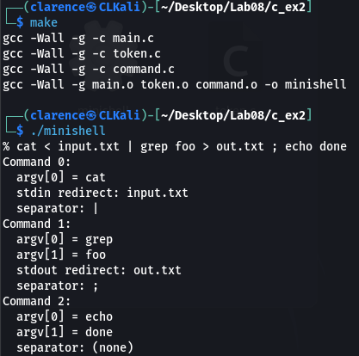

Unix Programming Exercise 4.
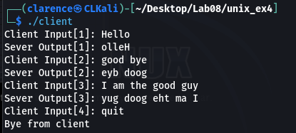

Unix Programming Exercise 6
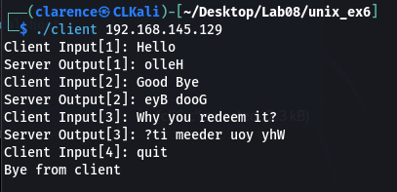

Unix Programming Exercise 7
