LABORATORY EXERCISE 3

ROUTING AND MVC STRUCTURE

Learning Objectives
By the end of this laboratory exercise, students should be able to:
- Understand CodeIgniter's MVC (Model-View-Controller) architecture and routing system.
- Configure custom routes in `app/Config/Routes.php`.
- Create a controller with multiple methods and their corresponding views.
- Implement navigation between pages in a CodeIgniter application.
- Utilize GitHub to track and manage project versions.

Prerequisite student experiences and knowledge
Before starting this exercise, students should have:
- Basic knowledge of HTML, CSS, and PHP.
- Familiarity with CodeIgniter's file structure.
- Experience using a local web server (XAMPP/WAMP/LAMP).
- Understanding of basic Git commands and GitHub usage.
- Ability to use a text editor/IDE such as Visual Studio Code.

Background
CodeIgniter follows the MVC architecture, separating application logic into Models, Views, and Controllers. Routing in CodeIgniter determines which controller and method are executed based on the URL. Understanding how to set up routes and navigate between pages is essential for building dynamic and maintainable applications. GitHub will be used for version control and documenting each stage of development.

Materials/Resources
- Personal Computer with Internet Access
- XAMPP/WAMP/LAMP server installed
- CodeIgniter Framework (latest version)
- Visual Studio Code or any code editor
- Git and GitHub Account
- Web Browser (Chrome, Firefox, etc.)
Laboratory Activity
Step 1: Project Setup
- Open your previously created CodeIgniter project ITE311-LASTNAME.
- Run the local server and confirm the project is working: http://localhost/ITE311-LASTNAME

Step 2: Create a Home Controller
- Navigate to app/Controllers/ and create a file named Home.php.
- Add the following methods:
  - index() → Loads a homepage.
  - about() → Loads an about page.
  - contact() → Loads a contact page.

Step 3: Configure Routes
- Open `app/Config/Routes.php`.
- Add custom routes for:
  - `/` → `Home::index`
  - `/about` → `Home::about`
  - `/contact` → `Home::contact`

Step 4: Create Views
- Inside `app/Views/`, create:
  - `index.php` (Homepage)
  - `about.php` (About Page)
  - `contact.php` (Contact Page)
- Add navigation links between the pages in each view using HTML anchor tags.

Step 5: Test Navigation
- Run the application and test:
  - Homepage → About → Contact
- Ensure that the navigation works correctly and each page displays its content.

Step 6: Push to GitHub
- Stage and commit your migration and seeder files:
git add .
git commit -m "Added Home controller, routes, and views for basic navigation"

Output / Results
- Screenshot of the homepage, about page, and contact page.
- Screenshot of `Routes.php` configuration.
- A screenshot of the GitHub repository with the latest commit is attached.

QUESTIONS:
- Explain the role of the controller in CodeIgniter's MVC structure.
The role of the controller in CodeIgniter MVC is the one that control the systems flow. When user click the link or in the navigation the code igniter will go to the controller that manages what the user click.
- Why is routing important in a web application?
The routing is important because it handles the system response to the users interaction, in codeigniter the route connects the url to the controller that manage it so route and controller is are working together for the smooth user interaction
- How does GitHub help in tracking changes in your CodeIgniter project?
Github helps on tracking the changes in the workspace when commmited, also gives an history on what was changed, update delete, etc. Help put your work in secured and organized. Also know can go back to to files before it was changed.

Output / Results
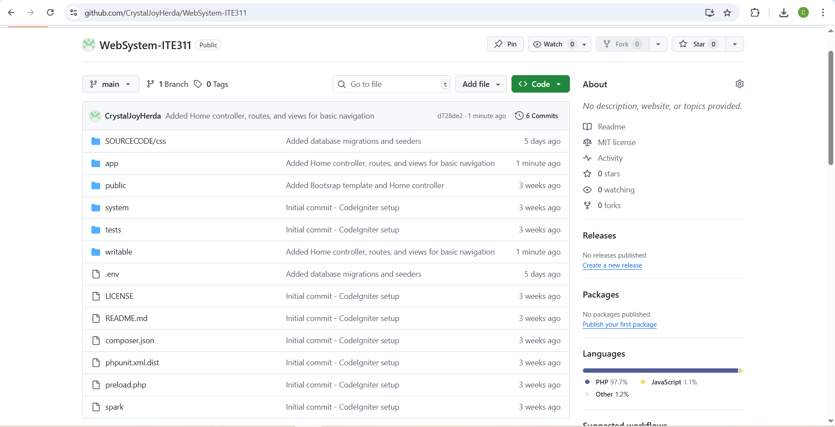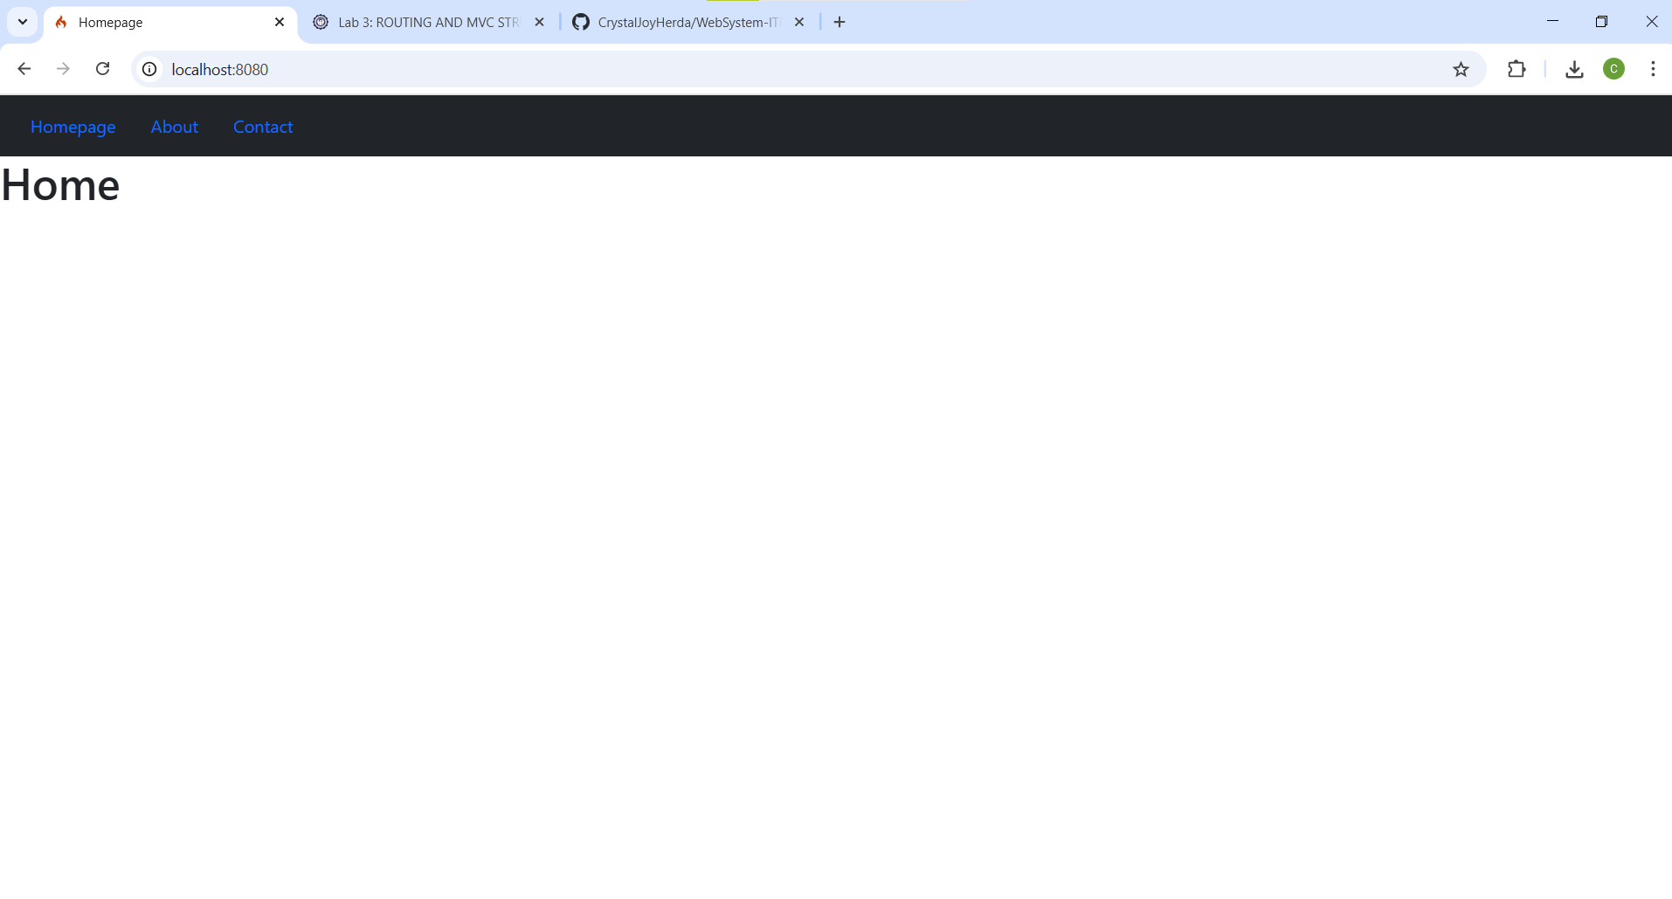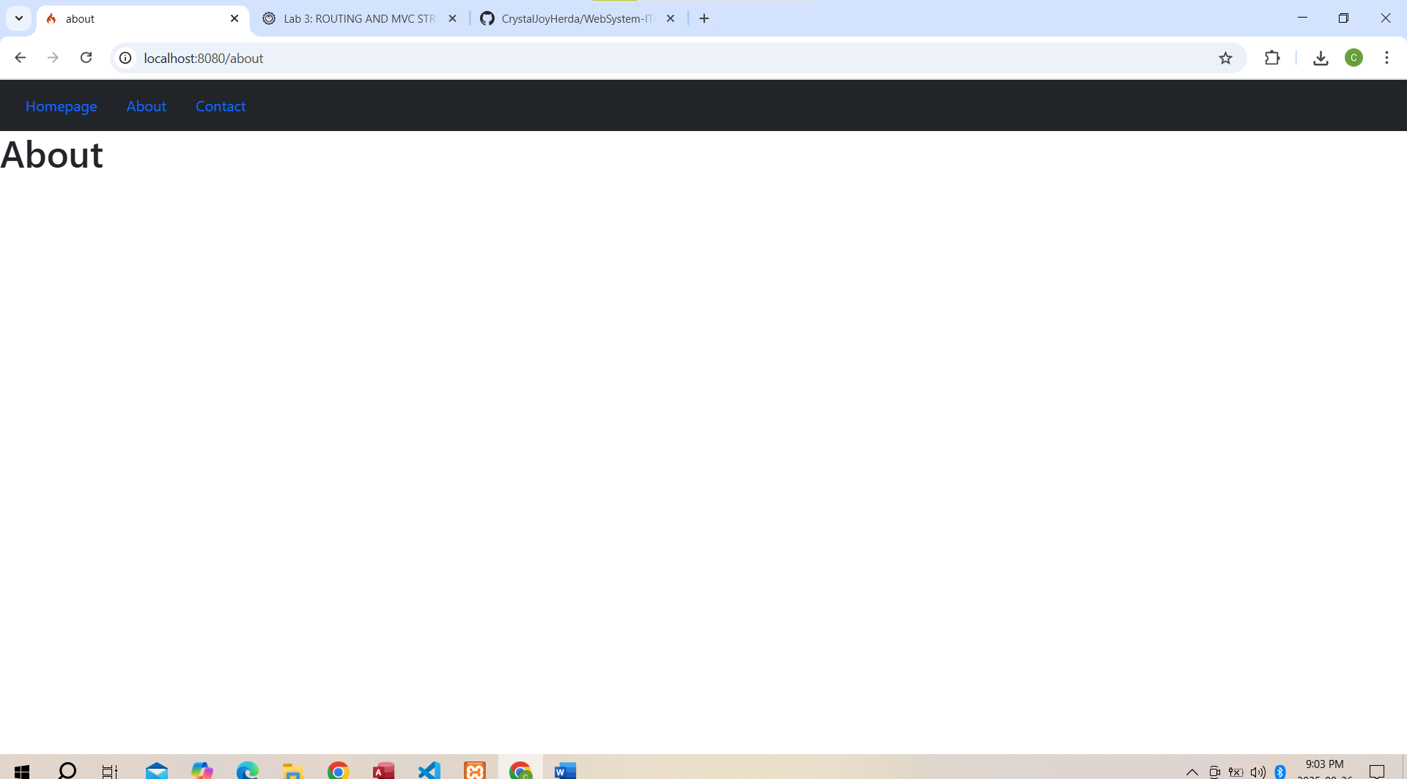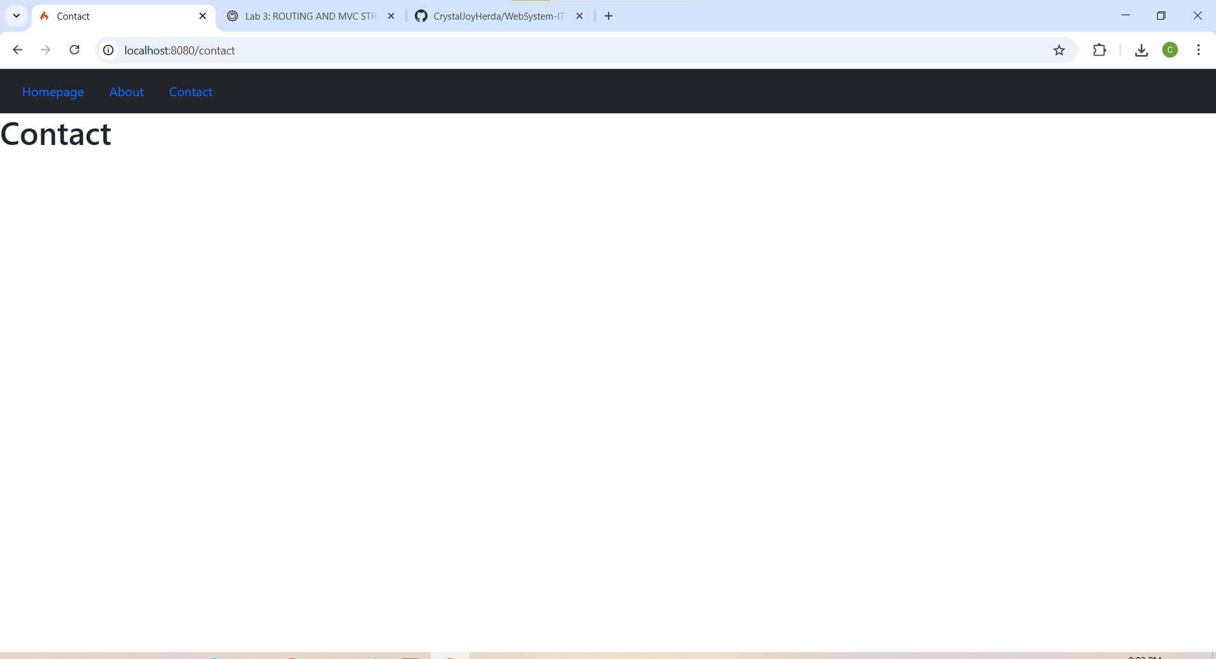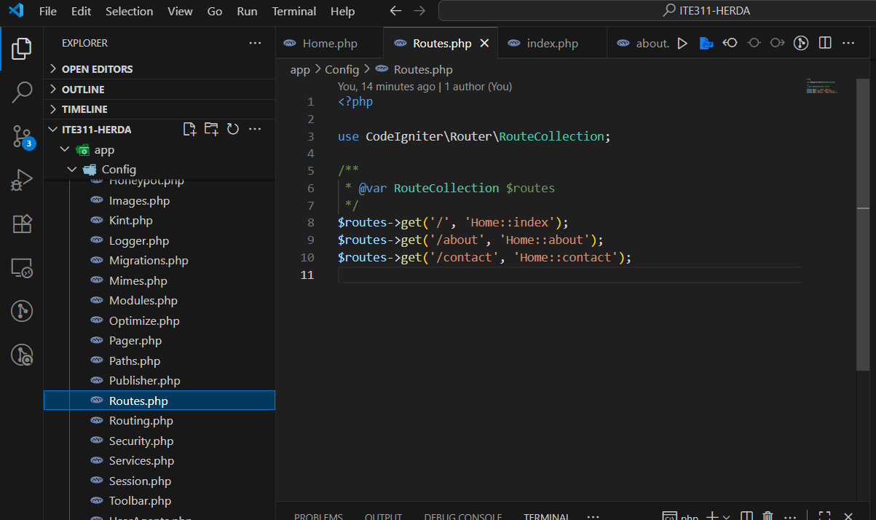

Conclusion
In this activity when using a framework, must have a knowledge when it comes to the routing and controller for be able to have a responsive interface that can interact to the users want.In this activity also help us the importance of learning the MVC structure.

