LABORATORY EXERCISE 4

USER AUTHENTICATION (LOGIN/REGISTRATION)

Learning Objectives
By the end of this laboratory exercise, students should be able to:
- Create and run database migrations in CodeIgniter 4 to manage schema changes.
- Build secure user registration and login functionalities.
- Implement form validation using CodeIgniter's built-in Validation library.
- Manage user sessions to control access to protected pages.
- Structure views using Bootstrap for a responsive and styled interface.
- Utilize GitHub to track and manage project versions.

Prerequisite student experiences and knowledge
Before starting this exercise, students should have:
- Completed Laboratory Exercise 3 (Routing and MVC Structure).
- Understanding of PHP, HTML forms, and basic SQL.
- Familiarity with CodeIgniter's MVC architecture and routing.
- Experience using a local web server (XAMPP/WAMP/LAMP).
- Understanding of basic Git commands and GitHub usage.
- Ability to use a text editor/IDE such as Visual Studio Code.

Background
User authentication is a fundamental part of most web applications. It involves verifying a user's identity, typically through a login process, and then maintaining that user's state (session) across multiple pages. CodeIgniter provides powerful libraries for Validation, Sessions, and Database interaction, making it efficient to build secure authentication systems. Migrations allow for version control of your database schema, ensuring consistency across different development environments. This exercise will combine these components to create a complete login and registration system.

Materials/Resources
- Personal Computer with Internet Access
- XAMPP/WAMP/LAMP server installed
- CodeIgniter Framework (latest version)
- Visual Studio Code or any code editor
- Git and GitHub Account
- Web Browser (Chrome, Firefox, etc.)
Laboratory Activity
Step 1: Project Setup
- Open your previously created CodeIgniter project ITE311-LASTNAME.
- Ensure your local server and database are running.
- Open a terminal/command prompt in your project root.

Step 2: Create a Database Migration for Users Table
- Create a new migration file to define the users table schema.
Run: php spark make:migration CreateUsersTable
- Open the newly created file in app/Database/Migrations/.
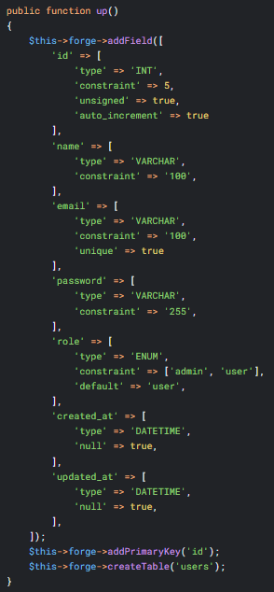
- In the up() method, define the table with fields: id, name, email, password, role, created_at, updated_at.

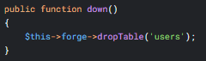
- In the down() method, define how to drop the table.
- Run the migration to create the table in your database: php spark migrate

Step 3: Create an Auth Controller
- Navigate to app/Controllers/ and create a file named Auth.php.
- Add the following methods:
- register() Displays the registration form and processes form submission.
- login() Displays the login form and processes form submission.
- logout() Destroys the user's session and redirects them.
- dashboard() A protected page that only logged-in users can see.

Step 4: Implement Registration Functionality
- In the register() method, check if the form was submitted (POST request).
- Set validation rules for the name, email, password, and password_confirm fields.
- If validation passes, hash the password using the password_hash() function.
- Save the user data (name, email, hashed_password, role) to the users table.
- On success, set a flash message and redirect to the login page.
- Load a view (app/Views/auth/register.php) that contains a Bootstrap-styled registration form.

Step 5: Implement Login Functionality
- In the login() method, check for a POST request.
- Set validation rules for email and password.
- If validation passes, check the database for a user using the provided email.
- Verify the submitted password against the stored hash using password_verify().
- If credentials are correct, create a user session (store: userID, name, email, role).
- Set a welcome flash message and redirect to the dashboard.
- Load a view (app/Views/auth/login.php) that contains a Bootstrap-styled login form.

Step 6: Implement Session Management and Logout
- In the logout() method, destroy the current session using session()->destroy().
- Redirect the user to the homepage or login page.
- In the dashboard() method, check if a user is logged in at the start of the method. If not, redirect them to the login page.

Step 7: Create Views and Configure Routes
- Create a directory auth inside app/Views/.
- Create the views register.php and login.php inside this directory. Use Bootstrap classes for styling.
- Update app/Config/Routes.php to include routes for your new authentication pages:
$routes->get('/register', 'Auth::register');
$routes->post('/register', 'Auth::register');
$routes->get('/login', 'Auth::login');
$routes->post('/login', 'Auth::login');
$routes->get('/logout', 'Auth::logout');
$routes->get('/dashboard', 'Auth::dashboard');

Step 8: Test the Application
- Run the application and test the complete flow:
  - Register a new user account.
  - Log in with the new credentials.
  - Access the protected dashboard.
  - Log out and try to reaccess the dashboard.

Step 9: Push to GitHub
- Push your changes to your GitHub repository every time you have changes in your syntax.

Output / Results
- Screenshot of the successful migration run in the terminal.
- Screenshots of the registration form, login form, and user dashboard.
- Screenshot of the users table in your database (phpMyAdmin or equivalent) showing the hashed password.
- A screenshot of the GitHub repository with the latest commit.

QUESTIONS:
- Why is it critical to hash passwords before storing them in a database? Which PHP function did you use for this?
Answer :
It is critical because storing plain text-password puts the data in a serious risk if ever the database will be compromise, so hashing password ensures the irreversible and cannot easily convert it back to normal text so its much harder for the attackers misuse the stolen credentials. In PHP the recommended way to do is to use the password_hash() function in which it automatically applies a secure algorithm with a unique salt to each password in this it stores the data hore significally because it hashes the password and more secure,
- Explain the purpose of the Session library in CodeIgniter in the context of user authentication.
Answer:
Because it allows to maintain the user’s login state across different pages. When the user successfully login its information it happen to store in the session rather than to re-enter it in every page, this makes to identify user during multiple request and in control access to restricted areas of the system. The session data is securely stored on the server which helps to protect the data and the sensitive credentials. in short the session library ensures the user once they login their information or it is authenticated, their identity and their permission will be used and remembered throughout the interaction of the user with the application until they logout or the session expires.
- What is the advantage of migrations (as in Step 2) over manually creating the database table
Answer:
Migration makes a structured , version-controlled way of managing the database changes, the migration allows you to define the tables in code and it makes easy to track and roll back and share when its necessary and it makes it easier to maintain the history database changes and ensures the updates can be repeated reliably and reducing risk of the errors that often come with manual database editing.

Output / Results
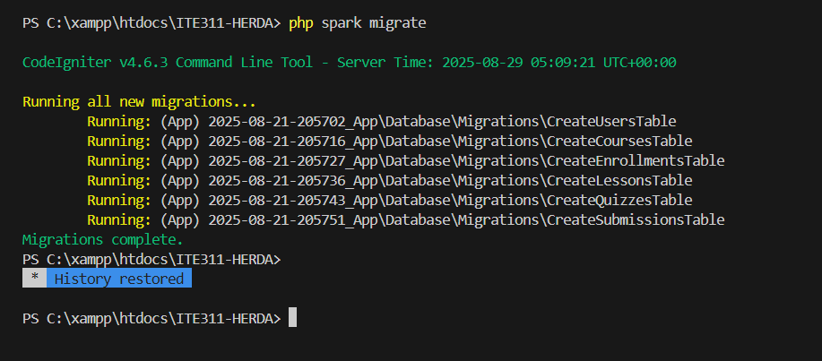
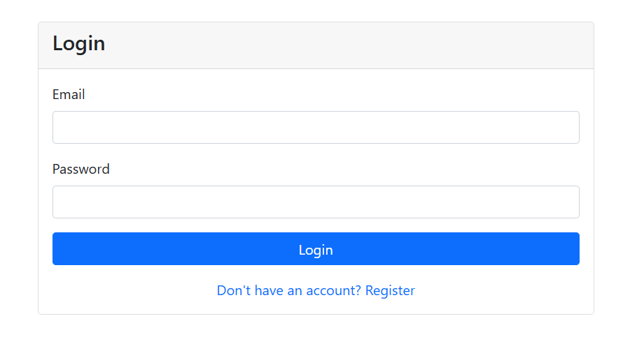

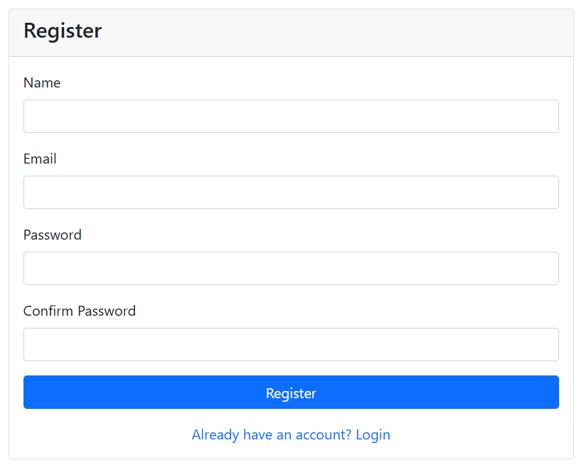
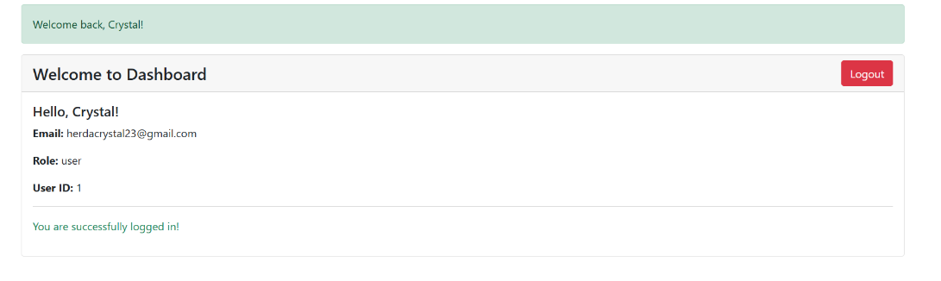

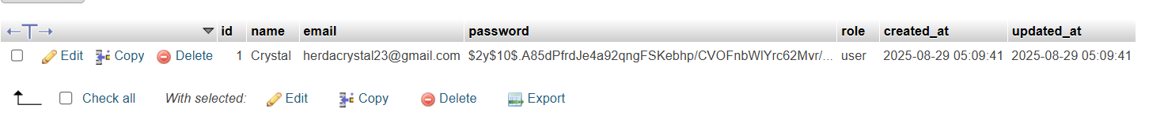

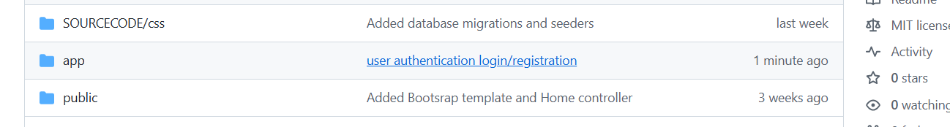

Conclusion
By implementing registration and login functionalities with proper form validation and password hashing, it emphasized the importance of security in handling user data to avoid the attackers to use the credentials of the user been authentoicated. The use of sessions allowed for effective access control that no need for the user to re-enter its credential into other pages because the session remembered the user throughout their interaction to the application until they log out or the session expires.

