

Intelligent Systems with Applications 24 (2024) 200439
Contents lists available at ScienceDirect

Intelligent Systems with Applications

journal homepage: www.journals.elsevier.com/intelligent-systems-with-applications

DeepInvesting: Stock market predictions with a sequence-oriented BiLSTM  stacked model – A dataset case study of AMZN
Ashkan Safari , Mohammad Ali Badamchizadeh *
Faculty of Electrical, and Computer Engineering, University of Tabriz, Tabriz

A R T I C L E I N F O

Keywords:
Deep learning
Stock price prediction Multimodal modeling Bidirectional LSTMS Financial forecasting Algorithmic trading
A B S T R A C T

Intelligent forecasters are now being considered in the stock market, providing essential insights and strategic guidance to investors and traders by presenting analytical tools and predictive models, thus enabling informed decision-making and mitigating financial risks in this dynamic market. The importance of intelligent analyzers in stock trading routines is considered in this work, where DeepInvesting, a multimodal deep learning model tailored for stock price prediction, is introduced. Employing a Sequence-Oriented, Long-Term Dependent (SoLTD) architecture featuring Bidirectional Long Short-Term Memory (BiLSTM) networks, DeepInvesting is applied to essential features of the Amazon Corp. (AMZN) market dataset, gathered from Yahoo Finance, including Closing, Opening, High, Low, Volume, and Adj Close prices. Exceptional performance in forecasting Closing, Opening, High, Low, and Adj Close prices is demonstrated, with minimal Mean Absolute Percentage Error (MAPE) and Root Mean Squared Percentage Error (RMSPE) scores, coupled with high R-squared (R²) values, manifesting a robust fit to the data, as well as computational complexity, and Rates Per Second (RPS) metrics in comparison to other models of KNN, LSTM, RNN, CNN, and ANN. Finally, challenges in the accurate prediction of trading volumes are identified, highlighting an area for future enhancement.

Introduction

Driven by the imperative need for heightened accuracy in stock market predictions, this research is motivated by recent advances in the field of financial forecasting. By the side of literature review, Utilizing Artificial Intelligence (AI) for accurate stock price prediction was driven by dissatisfaction as a catalyst, with promise shown by methods such as Artificial Neural Networks (ANN) despite limitations (Sheth & Shah, 2023; Luo et al., 2022) presents an AI-based stock market profit fore-casting model utilizing LSTM and an evolved Shuffled Frog Leaping Algorithm (SFLA) for enhanced accuracy. Amidst global economic growth, accurate stock volatility prediction is facilitated by machine learning, achieving up to 52 % accuracy in Asian markets (Lee et al., 2022; Song et al., 2023) combines deep learning and GARCH-MIDAS to forecast stock market volatility using low-frequency macroeconomic variables, demonstrating improved accuracy.
Amid AI advancements, the use of Long/Short Term Memory (LSTM) for predicting the next-day closing price of the S&P 500 is demonstrated, highlighting the superior accuracy of the single-layer model compared to multilayer models (Bhandari et al., 2022; Fathali et al., 2022) predicts
NIFTY 50 stock prices and demonstrates that LSTM yields lower pre-diction errors than Recurrent Neural Networks (RNN) and Convolu-tional Neural Network (CNN) models. The utilization of LSTM, PCA, stock indices, and futures for forecasting financial market volatility is accompanied by better performance in predicting stock index futures’ volatilities compared to other models (Chen & Hu, 2022; Chhajer et al., 2022) surveys the use of AI and Machine Learning (ML) for stock market prediction, highlighting their strengths, weaknesses, and applications. In the complex field of stock market forecasting, effective solutions are presented by AI and ML algorithms, such as Support Vector Machine (SVM) Regressions, Autoregressive Integrated Moving Average (ARIMA), and LSTM, to predict stock prices influenced by various fac-tors (Kumar & Anitha, 2022; Yu et al., 2023) demonstrates that an in-tegrated GVMD-Q-DBN-LSTM-GRU model accurately predicts stock index realized volatility.
Enhanced short-term trading returns are aimed to be achieved
through the utilization of AI and ML strategies such as ARIMA, LSTM, and various hybrid models for accurate stock price forecasting, with considerations for factors, such as RMSE, MAPE, and MAE measures in recent studies (Shah et al., 2022).
(AlSallami et al., 2023) provides to this effort by exploring,

* Correspondig author.
E-mail address: mbadamchi@tabrizu.ac.ir (M.A. Badamchizadeh).

https://doi.org/10.1016/j.iswa.2024.200439
Received 17 May 2024; Received in revised form 20 August 2024; Accepted 14 September 2024
Available online 19 September 2024
2667-3053/© 2024 The Author(s). Published by Elsevier Ltd. This is an open access article under the CC BY-NC license (http://creativecommons.org/licenses/by-
nc/4.0/).

Nomenclature

Abbreviations
AI DL NN PV ANN KNN CNN RNN
LSTM MAPE RMSPE BiLSTM
Artificial Intelligence Deep Learning Neural Network Photovoltaic
Artificial Neural Network K-Nearest Neighborhood
Convolutional Neural Networks Recurrent Neural Networks Long/Short Term Memory
Mean Absolute Percentage Error Root Mean Square Percentage Error Bidirectional LSTM
P_{c} A_{c} σ_{c} C
i_{t} f_{t} O_{t}
C_{t}
C
̃
t
Parameters
$;Open
High
$;Low
$;AdjClose
$;Close
$;
Input Open Price Values Input High Price Values Input Low Price Values Input Adj Close Price Values
Input Close Price Values
$;TradedVolume Input TradedVolumes Values
W_{c} b_{c}
Convolution Weight Matrices Convolution Bias
W_{t} b_{t} U_{t} h_{t} H_{f} C_{f} ZCon Z_{d} σ_{d}
Y
Z_{f} W_{d} b_{d} Wout bout
Max Pooling Operation Max Pooling Factor
Convolution Activation Function Convolution Operation
Input Gate Forget Gate Output Gate
Memory Cell Candidate Memory Cell
LSTM Weights LSTM Bias
LSTM Control Signal Hidden Gate
LSTM Forward Hidden State LSTM Forward Cell State Concatenated State
Dense Layer Representation
Dense Activation Function Final Output
Layer Tensor Input Dense Wight Matrices Dense Bias Vector Output Weight Matrices Output Bias Vector

comparing, and analyzing various AI techniques used for stock price prediction, with a focus on detecting unfair trading and explaining the role of reinforcement deep learning in risk analysis and avoidance within the stock market. Due to dynamic behavior, predicting stock market prices is challenging; machine learning methods like SVM and ANN are commonly employed for future price forecasting, as demon-strated on the Mexican stock market (Rafiuddin et al., 2023). (Per-ez-Hernandez, Arevalo-de-Pablos et al.) proposes a hybrid model combining ANN and traditional metrics for accurate market risk factor volatility prediction, with SVM and LSTM models showing superior re-sults in stability periods. Amidst the economic impact of the COVID-19 pandemic and turbulence in the energy market, the effectiveness of stability and recovery strategies is demonstrated by employing ML models such as NARX NN for forecasting energy equity prices (Alshater et al., 2022; Pokhrel et al., 2022) demonstrates that among deep learning models, LSTM outperforms by accurately forecasting the next day’s closing price of the Nepal Stock Exchange index. In order to address challenges related to stock value prediction caused by volatility, the LT-SMF hybrid approach is proposed, which involves combining IBO and BPO for refining data and selecting features. By utilizing FEL-DNN, the model we have developed surpasses the accuracy of existing methods, thereby improving stock price forecasting with social media data (Venkateswararao & Reddy, 2023; Abd Elminaam et al., 2022) utilizes programmable methods like K-nearest Neighbor (KNN), Random Forest (RF), and Gradient Boosting (GB) to attain precise forecasting, substantiated by the validation of this research through metrics including R², RMSE, and MAE. A robust deep learning framework combining LSTM and CNN-LSTM is introduced to predict Tesla and Apple closing prices, demonstrating better performance than existing
systems (Tesla: R²= 98.37 %; Apple: R²= 99.48 %) (Aldhyani &
Alzahrani, 2022).
(Cheng et al., 2022) combines various methods to forecast stock prices, utilizing LSTM and Gradient Recurrent Unit (GRU) models with selected key indicators, outperforming existing approaches in both fluctuating and stable environments. The effectiveness of AI in utilizing advanced Deep Learning (DL) and ML techniques for successful trading in complex financial markets is demonstrated by recent papers, using
advantages of rapid data analysis and HFT (Cohen, 2022; Singh et al., 2022) aims to improve predictions for government oil corporations using a hybrid Machine Learning and Data Science model, achieving approximately 99 percent accuracy. Proposing a novel method that combines Elman neural networks and quantum mechanics to enhance stock market predictions, the approach is validated through the fore-casting of closing prices for six markets (Liu & Ma, 2022; Ma & Yan, 2022) predicts stock price changes in the Chinese market with an average 70 % accuracy, while also demonstrating the augmentation of forecasting performance through social media sentiment for both in-dexes and individual stocks. Amid stock market volatility, the pursuit of accurate predictions using various methods, from traditional analysis to modern machine learning and deep learning techniques (Sharma & Bhalla, 2022; Li et al., 2023) predicts energy sector stock volatility using SPCA-LSTM models, demonstrating superior forecasting performance and robust results. By utilizing deep learning models like Bi-LSTM, the achievement of more accurate long horizon time series forecasting is realized, surpassing the performance of other deep neural networks (Bhambu, 2023).
(Arif et al., 2023) forecasts stock returns in the volatile Oil and Gas sector, indicating superior performance for the OGDC stock and poten-tial benefits for investors and researchers. Introduced through a DCGAN, stock price prediction is enhanced, compared to traditional methods, showcasing the potential of DL in financial forecasting (Staffini, 2022; Li et al., 2022) employs PCC and BLS to select input features for stock price prediction, demonstrating superior performance compared to other methods. Also, (Leng et al., 2022), and (Shah et al., 2022) presented gated orthogonal recurrent units, and reviewed AI models in stock market prediction. The study conducted by Sun et al. (2023) investigates the problem of composite adaptive fuzzy finite-time prescribed perfor-mance control in switched nonlinear systems that are affected by un-known external disturbances and performance criteria. The initial approach involves utilizing the piecewise switched composite parameter update rule to improve the accuracy of approximating unknown non-linearities. This is achieved by making use of compensation and pre-diction errors. Subsequently, a refined fractional-order filter and error compensation signal are presented to mitigate the effects of rapid

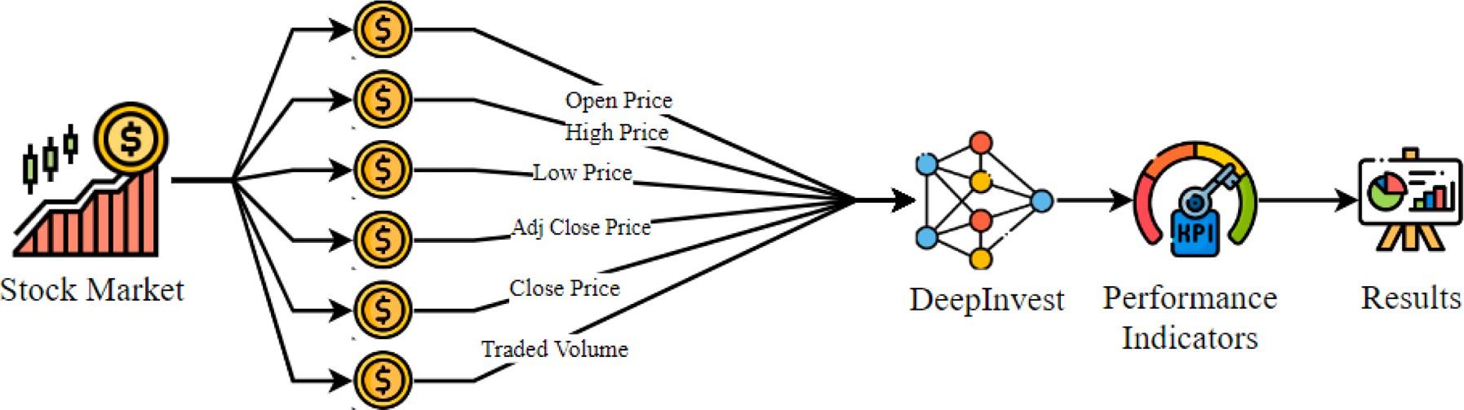

Fig. 1. The overall process of DeepInvesting.
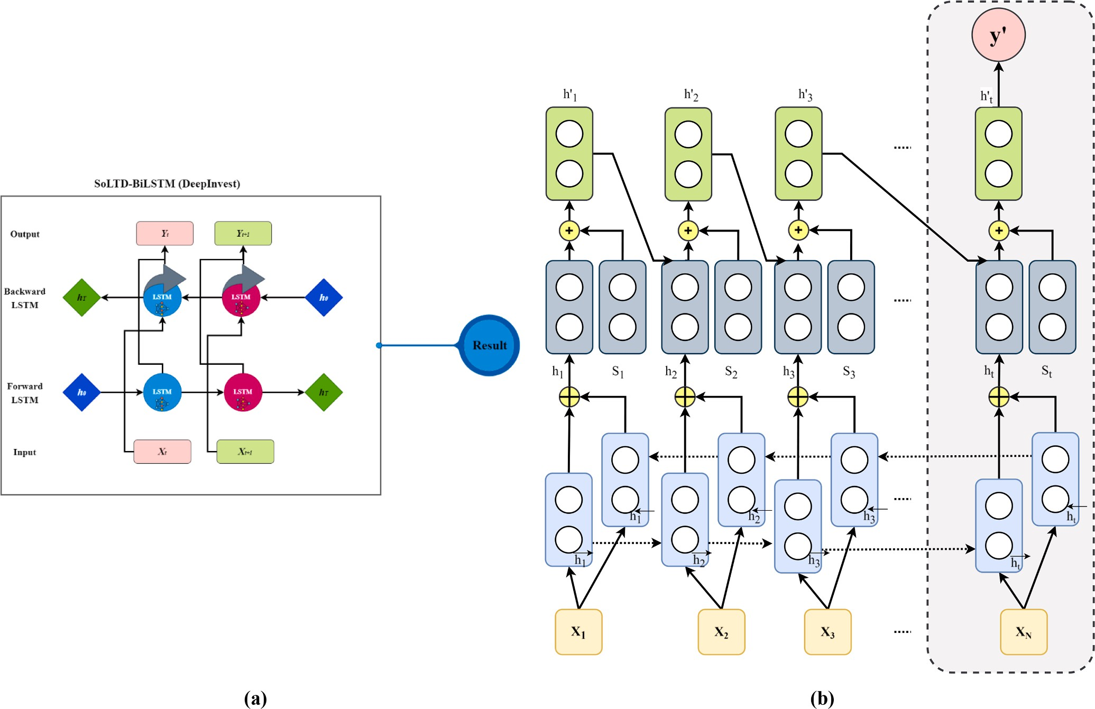

Fig. 2. The structural details of DeepInvest in (a) Overall, and (b) Detailed format.

calculation and filter inaccuracies, respectively. A piecewise switched nonlinear disturbance observer is meant to simultaneously alleviate the impacts of compound disturbances, such as unknown disturbances and approximation mistakes. Moreover, stability analysis verifies that the suggested performance control scheme guarantees that all states of the closed-loop system are constrained within a finite period and that the tracking error converges to a predetermined region within a finite time. The work by You et al. (2024) presents a method for model predictive control (MPC) of Takagi-Sugeno (T-S) fuzzy systems. The methodology combines the homogeneous polynomial technique with a switching mechanism. The objective of this switching Model Predictive Control (SMPC) method is to improve the overall performance of the system by dynamically transitioning between different controllers in response to variations in system dynamics. The SMPC approach employs a sequence of optimization problems to ascertain the most favorable switching strategy and the accompanying control actions. At each instance, an
optimization problem is addressed to provide a control sequence that optimizes the gain matrices, hence minimizing the performance index. The SMPC method, which is based on the standard MPC structure, in-corporates the use of the homogeneous polynomial method to minimize conservatism in controller design while solving linear matrix inequality (LMI) requirements.
In this regard, the gap that persists lies in the accuracy of predictive models, necessitating the development of innovative approaches. Addressing this challenge, DeepInvesting is developed, a multimodal deep learning model tailored to enhance the precision of stock price predictions. In this paper, the development, application, and evaluation of DeepInvesting across various key features of the AMZN dataset are explored, illuminating its remarkable performance metrics. These re-sults underscore its potential to bridge the existing accuracy gap in stock market forecasting. As well, the contributions of the paper are summa-rized as:

Algorithm 1
Pseudocode of DeepInvesting.
- Load the dataset
Input: Stock data with columns (Open, High, Low, Close, Adj Close, Volume)
- Preprocess the data
  - Normalize the features using MinMaxScaler
- Features: X ←{Open, High, Low, Close, Adj Close, Volume}

- Normalize: X

scaled
← X - Xmin Xmax - Xmin

- Prepare data for the BiLSTM model
  - Define sequence length, seq_length
  - Create sequences of features and corresponding target values For i in range(len(X_scaled) - seq_length):
Yseq, i ← [Xscaled, i to Xscaled, i+seq length ]
Yseq, i ← Closei+seq length
- Split the data into training and testing sets
  - Define split ratio, split_ratio
  - Split the sequences into training and testing sets
- XTrain , XTest ← Xseq, i - - Xseq, split ratio
- YTrain , Ytest ← Yseq, i - - Yseq, split ratio
- Build the BiLSTM Stacked Model
  - Initialize Sequential model
  - Add layers
: Add BiLSTM layer with units and input_shape h_{1t} ←O_{t} ⊙ tanh(C_{1t} ) Y←Ψ_{d}⋅W_{out} + b_{out}
- Compile the model
  - Define loss function, as MSE
  - Define optimizer, Adam
  - Compile the model with loss function and optimizer
- Train the model
  - Fit the model with XTrain , YTrain
  - Define number of epochs and batch size
- Evaluate the model
  - Predict using XTrain
  - Calculate KPIs

MAPE(%)←1 ∑n
⃒⃒⃒κi,actual - κi,predicted ⃒⃒⃒

n i=1 ⃒ κi,actual ⃒
√∑̅̅̅̅̅_{n}̅̅̅̅̅(̅̅̅κ̅̅i̅a̅̅c̅̅t̅u̅a̅̅l̅̅̅-̅̅̅̅κ̅̅̅i̅p̅̅r̅e̅̅d̅̅ic̅̅t̅e̅d̅̅)̅̅̅₂̅̅
RMSPE(%)←
i=1
,
,
n × κi,actual
∑n (κi predicted - κi actual )2
n i=1
,
∑
R2 ←1 - i=1 , ,
(κi actual - κi )2
- Output of the systems

- Efficient model (SoLTD-BiLSTM) applied to AMZN dataset for various metrics
- Demonstrates considerable performance in price forecasting
- Achieves minimal MAPE and RMSPE, as well as R² scores robust fit to the data
- Multimodal approach captures intricate financial patterns
- Benchmarked against other models: KNN, LSTM, RNN, CNN, and ANN

Consequently, the paper is constructed as following:
Sections 2, and 3 present the model structure, and its results, respectively. As well, the comparison of DeepInvesting, with other models, and future works are provided by Sections 4, and 5. Lastly, Section. 6 draws the conclusion of the work.

Performing structure

In this work, DeepInvesting is employed to analyze five aspects of the AMZN dataset: Open, Close, High, Low, and Volume. Applying its SoL-TDBiLSTM architecture, DeepInvesting captured intricate patterns
model processes data bidirectionally, capturing both past and future context for each time step, enhancing its ability to discern complex temporal patterns. What sets SoLTDBiLSTM apart is its focus on a sequence-oriented, long-term dependent learning approach, enabling the model to grasp intricate sequential patterns and extended de-pendencies over time. This unique combination empowers SoL-TDBiLSTM to excel in tasks demanding a profound understanding of historical trends and nuanced long-term relationships within sequential data, making it invaluable for accurate and nuanced predictions in real-world applications, as its structure depicted in Fig. 2.
The BiLSTM network’s specific flow chart for predicting the type of the entity is depicted in the dotted grey box in Fig. 2. Four components are present in the system (See Fig. 2). First one is the input layer. The objective is to prevent the LSTM network from ignoring the information of the key entities. Secondly, BiLSTM layer with two hidden states at the time phase, which can be interpreted as a combination of past and future information. As the third one, attention mechanism is the information filtered with the weight vector. Finally, the output layer is the final prediction resulted by the system. As the next step, LSTM models should be formulated to set up DeepInvesting. LSTM model is calculated as:

within each modality. Rigorous evaluations led to the derivation of KPIs,
i1t = σ(W1ih1t 1 + U1i [$;
$; $; $;
$; $; ] + b_{1i})

including MAPE, RMSPE and R² values, serving as metrics to assess the models’ accuracy, as depicted in Fig. 1.
Sequence-Oriented, Long-Term Dependent Bidirectional Long Short-Term Memory (SoLTDBiLSTM), named DeepInvesting, represents an advanced neural network architecture tailored for sequential data analysis, particularly applicable to time series forecasting in fields of finance and natural language processing. By integrating BiLSTM, the
- Open High Low AdjClose Close TradedVolume In1t
(1)
f1t = σ((W1f h1t-1 + U1f [$;Open $;High $;Low $;AdjClose $;Close $;TradedVolume ]In1t + b1f )

(2)

Table 1
The details of the utilized dataset.

Price Interval | Mean | Variance | Total Data
Open | 32.67057 | 2377.662 | 19,791
High | 33.06519 | 2434.057 | 19,791
Low | 32.2411 | 2316.163 | 19,791
Close | 32.65989 | 2374.508 | 19,791
Adj Close | 32.65989 | 2374.508 | 19,791
Volume 1.42E+08 1.95E+16 19,791
metric of evaluation. Unlike its counterpart, RMSPE is quantified as a percentage relative to the actual values. This vital index unveils the average percentage deviation between projected and actual values, concurrently integrating the influence of squared deviations. In essence, RMSPE amalgamates precision with the incorporation of squared dif-ferences, offering a holistic perspective on predictive accuracy expressed in percentage terms.
√∑̅̅̅̅̅_{n}̅̅̅̅(̅̅̅κ̅̅̅̅̅̅̅̅̅̅̅̅̅-̅̅̅̅̅κ̅̅̅̅̅̅̅̅̅̅̅̅̅̅̅̅)̅̅2̅̅
RMSPE(%) =
i=1 i,actual i,predicted
n × κi,actual
(13)

O1t = σ((W1oh1t-1 +U1o [$;Open $;High $;Low $;AdjClose $;Close $;TradedVolume ]In1t

+b_{1o}
)
(3)

R-squared (R²) is a statistical measure that quantifies the fraction of variability within the dependent variable that can be elucidated by the
independent variables encompassed within a regression model. Mani-

C̃ σ(W h U [
] b )
festing within a range from 0 to 1, R² attains greater magnitudes as the

1t =
1 1t-1 +
1 $;Open $;High $;Low $;AdjClose $;Close $;TradedVolume In1t +
1
(4)
∑
n i=1
(κ
- κ )2
model’s alignment with the data augments. This index serves to gauge the appropriateness of the model’s fit to the data, rendering it a fundamental measure of goodness of fit.

C_{1t} = (f_{1t} ⊙ C_{1t-1}) + (i_{1t} ⊙ C̃1t ) (5)

Where, i_{1t}, and f_{1t} compensating the input gate, and the forget gate,

∑_{n} (κ κ )₂
i,actual
i

respectively. O_{1t}, and C_{1t} are utilized as the output gate, and memory cell candidate of the LSTM network. As the output vector of the LSTM, h_{1t} is defined of the output of the network as:
̃
R2 = 1 - i=1 i,predicted - i,actual
(14)
h_{1t} = O_{t} ⊙ tanh(C_{1t}) (6)
For the Bidirectional operation, the forward, backward, and concatenated LSTMs are constructed as:
Hʹ, Cʹ = LSTM(X_{b}) (7)
H_{b}, C_{b} = LSTM(X^{rev}) (8)
b
Ψ_{Con} = Concatenate H_{f} , H_{b} (9)
( )
Where, Hʹ, Cʹ, and H , C are the hidden, and cell states of forward, and
Also, in order to assess the hardware properties of the developed model, the factors of Rates Per Second (RPS), and computational complexity can be defined. RPS: A metric used to assess the efficacy of forecasting AI models is RPS, which quantifies the number of predictions that a model can produce per second. This rate is influenced by the computational complexity of the model, which determines the resources required for processing. Forecasting models, particularly those that utilize advanced methods such as deep learning, can demonstrate vari-ability in their complexity, which is frequently expressed in terms of time complexity (e.g., O(n²) or O(n log n). The RPS of high-complexity models, such as large neural networks, is typically lower as a result of the intensive computations that involve numerous parameters and layers. In contrast, models that are simpler and have lower computa-

b b tional requirements can attain a higher RPS.

backward LSTMs, respectively. As well, Ψ_{Con} is the concatenated version
of states. To have the fully connected layers, output is determined as following:
Ψ_{d} = σ_{d}(Ψ_{f} ⋅W_{d} + b_{d}) (10)
Y = Ψ_{d}⋅W_{out} + b_{out} (11)
Which, Ψ_{d}, σ_{d}, and Ψ_{f} are the dense layer representation, activation function, and previous layer tensor input, respectively. As well, dense weight matrices, and bias vectors are defined by W_{d}, and b_{d}. Y, W_{out}, and
b_{out} are the final output of the system, output layer weight matrices, and bias vectors. The overall process of the systems is algorithmized in Al-gorithm 1.
Also, in order to perform the evaluation on the model, the following KPIs determined (Safari and Ghavifekr, 2021; Safari, 2022; Safari and Badamchizadeh, 2023):
MAPE (Mean Absolute Percentage Error) serves as a tool to gauge the average percentage discrepancy between predicted and actual values. This pivotal metric bestows a window into the scale of errors, expressed as a proportion of the actual values themselves. Such a rep-resentation facilitates the comprehension of errors and permits seamless comparisons across diverse datasets, ultimately fostering a clear and intuitive assessment of predictive performance.
1 ∑ ⃒⃒κi,actual - κi,predicted ⃒⃒⃒
n
⃒
MAPE(%) = n
⃒⃒
κ
(12)
i=1
i,actual

The computational complexity of AI models, particularly for large-scale forecasting tasks, is influenced by the size of the system RAM [GB] and the disk [GB]. RAM is essential for the storage of active data, computations, and model parameters during training and inference. High-complexity models require an important quantity of memory to prevent delays caused by frequent memory switching. On the other hand, disk space is necessary for the storage of datasets, model check-points, and records. The loading and saving times can be impacted by the rapid consumption of storage by large datasets and complex models.

Simulations and derived results

In the simulation, the DeepInvesting model was employed to analyze the provided dataset, encompassing critical financial metrics, including Open, High, Low, Close, Adj Close prices, and Volume for AMZN stock. The dataset was examined, with mean values of 32.67 for Open, 33.07 for High, 32.24 for Low, 32.66 for Close, 32.66 for Adj Close, and an average Volume of approximately 141.54 million. Notably, the dataset showcased substantial variability, indicated by respective variances of 2377.66, 2434.06, 2316.16, 2374.51, 2374.51, and a variance of
1.95E+16 for Volume, underscoring the diverse market conditions
encapsulated within the data. The details of the utilized dataset, and the results derived by DeepInvesting are available in Table 1, and Fig. 4, respectively.
According to Fig. 3, the initial parts show the times Amazon went
public on May 15, 1997. During the late 1990s, the stock price soared along with the rest of the technology sector, reaching an all-time high of

Where n is the number of data, and κ_{i,Observed}, with κ_{i,Predicted} are the observed, and predicted values of grid community, respectively.
RMSPE (Root Mean Square Percentage Error) is analogous to the traditional RMSE with a distinctive variation, the RMSPE stands as a
around $113 per share in December 1999. However, like many other internet-based companies, Amazon’s stock was not immune to the bursting of the dot-com bubble in 2000. By the end of 2001, the stock

Open Price Forecasting

High Price Forecasting

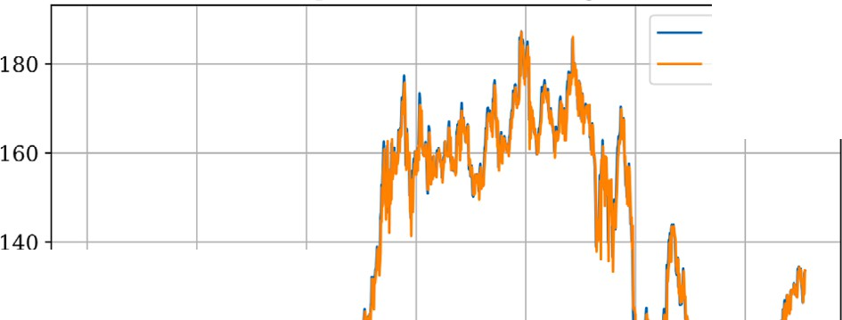
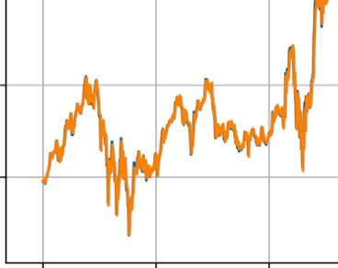
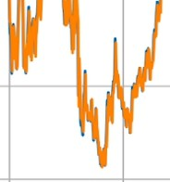
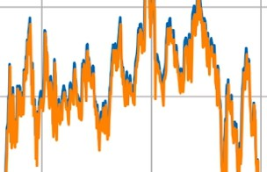
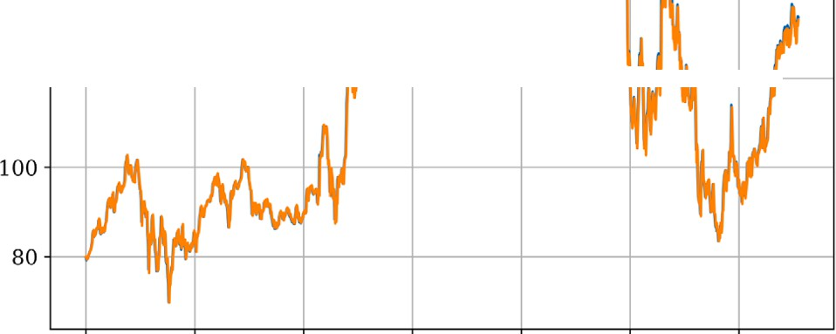

;"e<..'> 120 >--+----+------+---+-------< Hl-a--ffr--1--f--l
Actual Predicted -
180
Actual Predicted
160
- 140 -l-+----+----+---l--+----+------l-'l-+-11--+ I
�
·.::
"- 120 -1-+----t------+----+----t +ft-1"-Wr--+--I
"<..'>

100

80

0 200 400 600 800 1000 1200
Index Number

(a)
Low Price Forecasting
0 200 400 600 800 1000 1200
Index Number

(b)
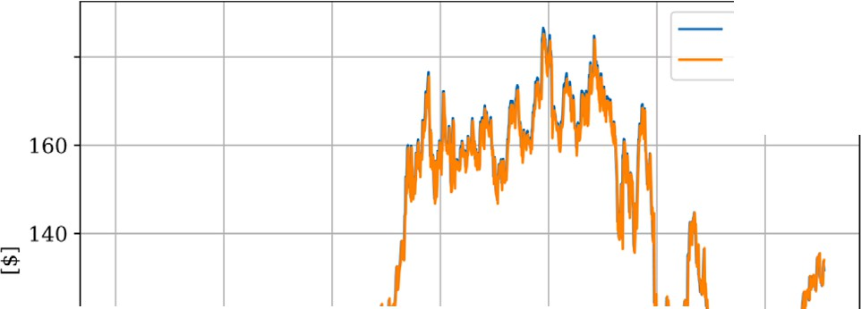
Adj Close Price Forecasting
180
Actual Predicted
J"<..:'> 120 1-+---f---+---ill--t----+---tt-Hlf--t-Jr--l

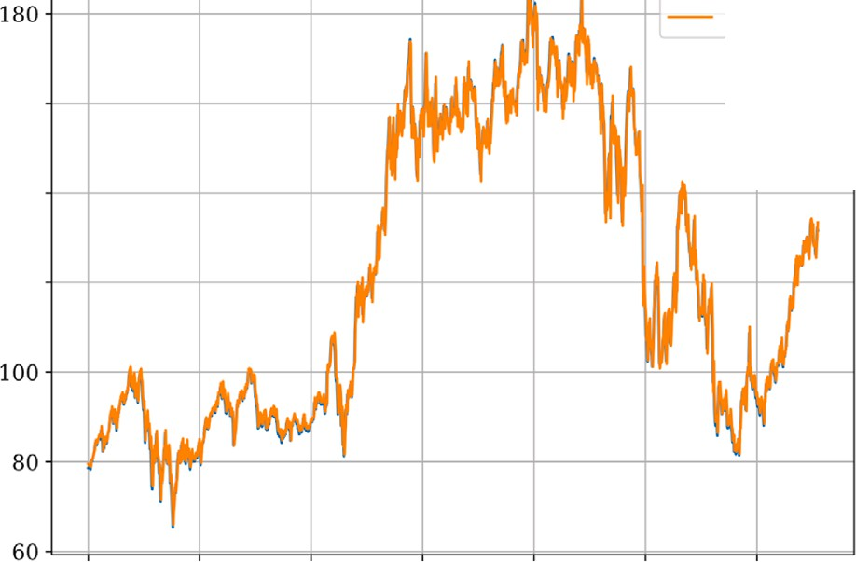
�
Actual
Predicted ...
160
140

J"<..:>' 120

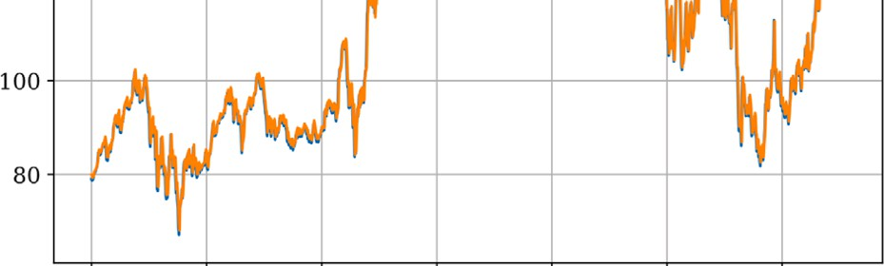
0 200 400 600 800 1000 1200 0 200 400 600 800 1000 1200

Index Number

(c)
Close Price Forecasting
Index Number

(d
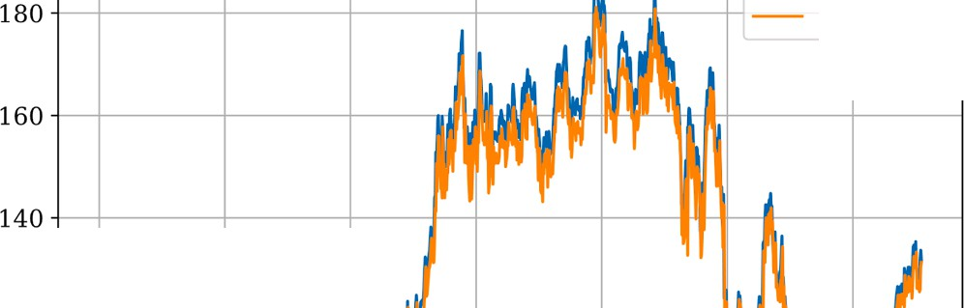
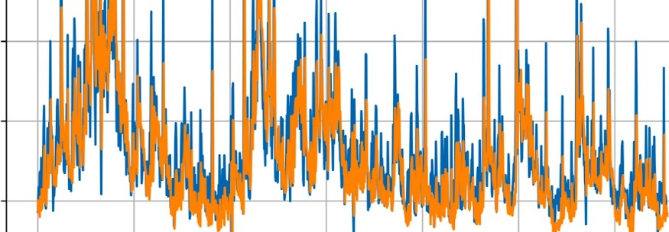
le8 Traded Volume Forecasting
Actual Predicted"
3.0 i--+--�--t----i-t-----+----+ +-
Actual Predicted
2.i5--+---11--1-t-----t-t----+-----j j
2.01-+-.---llHf-l+----t-H+--+-----lr--+-+--+-t l
1.5
1.0
0.5

�
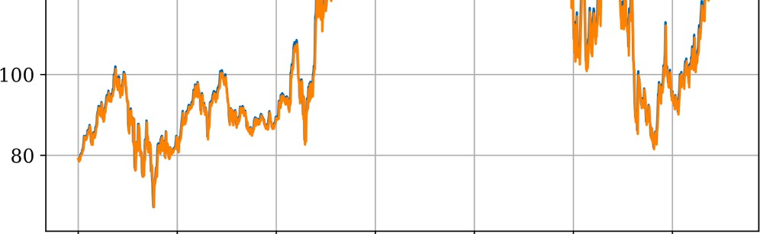
;"e<..'> 120

-1----+----+----+--4,,. -, ---+ H>-+--tll--+--•--t

""O'
.E
-a
�

0 200 400 600 800
Index Number

(e)

1000 1200
0 200 400 600 800
Index Number
(f)
1000 1200

Fig. 3. The prediction price profiles of (a) Open, (b) High, (c) Low, (d) Adj Close, (e) Close, and (f) Traded Volume.

0.00025

0.00020

0.00015

0.00010
Open Price Model Loss

0.00025

0.00020

0.00015

0.00010,
High Price Model Loss

0.00005

0.00000

0 20 40 60 80 100
,_ | �  I--

Epoch

(a)
Low Price Model Loss
0.00005 .

0.00000
-t  _  J-  Lt: | -+----  -11-----  .  :=:::: | f------  -� +  =±=== | +----+  --  ==k= | ---+- | ---+- | 1
 |  |  |  | =d== | =d=== | LI

0 20 40 60 80 100
Epoch

(b)
Adj Close Price Model Loss
1- |  |  |  |  | ·--
 | -A.

0.0006

0.0005

0.0004

0.0003

0.0002

0.0001

0.00020

0.00015

0.00010

0.00005

0.0000

0.0004

0.0003

0.0002

0.0001

0.0000

0 20 40 60 80 100
Epoch

(c)
Close Price Model Loss
,_
�
0 20 40 60 80 100
Epoch

(e)
0.00000

0.0034

0.0032

0.0030

0.0028

0.0026

0.0024

0.0022

0 20 40 60 80 100
Epoch

(d)
Traded Volume Model Loss
-
 | \_
 | ·v | �-- �"- .. | � | C'\,,. .A
 |  |  |  | ''\ ,.,\ | �
0 20 40 60 80 100
Epoch

(f)

Fig. 4. The prediction price profiles of (a) Open, (b) High, (c) Low, (d) Adj Close, (e) Close, and (f) Traded Volume.

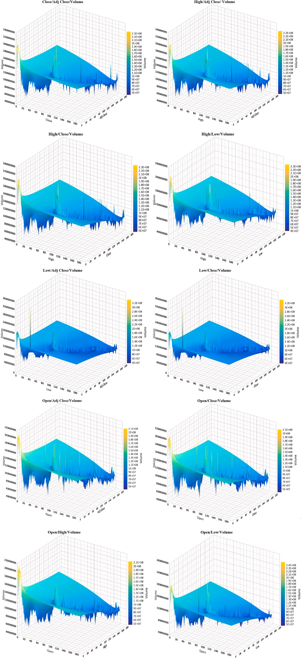

Fig. 5. The correlation profile of the modals.

Table 2
The KPI results of DeepInvesting.

MAPE |  | RMSPE R²
Closing | 0.0176 | 0.0238 | 0.9923
Opening | 0.0184 | 0.0263 | 0.9906
High | 0.0142 | 0.0207 | 0.9941
Low | 0.0188 | 0.027 | 0.9901
Volume | 0.277 | 0.3437 | 0.4466
Adj Close | 0.0189 | 0.027 | 0.99

Table 3
The computational complexity results of the systems.

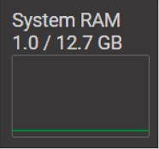
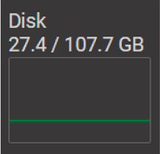
System Type/Factors RAM [GB] Disk [GB] GPU RAM [GB]
became a significant revenue generator. By 2013, the stock price sur-passed $300 per share, reflecting investors’ confidence in Amazon’s diversification and innovation strategies. Amazon Prime continued to attract millions of subscribers worldwide, and the company expanded its presence in various markets. Strategic acquisitions, such as the purchase of Whole Foods Market in 2017, further bolstered its position. The stock price surged, reaching $1000 per share in 2017 and then doubling to over $2000 per share in 2018. By 2019, Amazon’s stock price hit a new milestone, reaching over $2000 per share. The COVID-19 pandemic in 2020 led to a surge in online shopping, benefiting Amazon immensely. As lockdowns and social distancing measures forced people to rely more on e-commerce, the company experienced unprecedented demand for its services. Amazon’s stock price reached new all-time highs, surpassing
$3000 per share in July 2020 and continuing its upward trajectory. As

Central Processing Unit (CPU)
–
well, model losses are illustrated by Fig. 4.
As depicted in Fig. 4, the model loss rapidly diminished across all six modalities - Open, Close, High, Low, and Volume - approaching zero by the third iteration. This trend signifies the exceptional learning capa-bilities of our models, as the prediction errors substantially decreased, indicating their adeptness at capturing the intricate patterns within the historical AMZN data. The rapid convergence of the prediction errors in the early iterations underscores the models’ efficiency and adaptability, essential traits in financial forecasting. As well, the relations under-pinned by the modalities are drawn to analysis to extract their different correlations, as anticipated in Fig. 5.

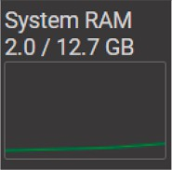
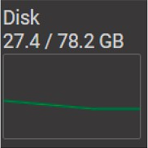
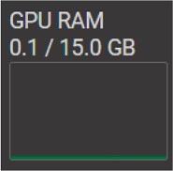
had plummeted to around $6 per share. In the early 2000s, Amazon focused on expanding its product offerings and improving customer experience. The stock price gradually recovered, reaching the $100 mark again in 2009. During this period, Amazon introduced its popular Amazon Prime subscription service, Kindle e-readers, and later, the Kindle Fire tablet, which contributed to its growth.
Graphical Processing Unit (GPU)
Amazon’s stock price continued its upward trajectory, driven by the success of the Kindle devices and the introduction of Amazon Web Services (AWS) in 2006. AWS, the company’s cloud computing platform,
Following the application of the prediction models to the AMZN dataset in a variety of modalities, Fig. 5 clarifies a number of interesting relationships between the financial measures. Notably, there is a sig-nificant positive correlation between the Open and Close prices. This relationship highlights how important opening prices are to closing prices. This is a typical phenomenon in the stock market that is linked to intraday trading patterns, where the opening price often determines how much trading activity occurs during the day. High and Low prices, on the other hand, also show a positive link. According to this,

Table 4
The comparison KPI results.
Model | Metric | Close | Open | High | Low | Adj Close | Volume
KNN | MAPE | 0.0067 | 0.0067 | 0.0067 | 0.0067 | 0.0067 | 0.0032
(Siddartha Reddy et al., 2024) | RMSPE | 0.951 | 0.9502 | 0.9518 | 0.9498 | 0.951 | 0.4624
R2 |  | -2.04 | -2.03 | -2.03 | -2.03 | -2.04 | 0.15
 | RPS | 128,449.07 | 159,844.12 | 113,845.16 | 166,283.51 | 123,204.69 | 27,964.26
LSTM | MAPE | 0.0003 | 0.0002 | 0.0003 | 0.0002 | 0.0002 | 0.0038
(Botunac et al., 2024) | RMSPE | 0.0501 | 0.0326 | 0.0502 | 0.0405 | 0.0437 | 0.4283
R2 |  | 0.99 | 1 | 0.99 | 0.99 | 0.99 | 0.27
 | RPS | 1574.47 | 1582.94 | 1279.01 | 1573.08 | 1837.09 | 1571.45
RNN | MAPE | 0.0006 | 0.0004 | 0.0002 | 0.0002 | 0.0003 | 0.0068
(Billah et al., 2024) | RMSPE | 0.0937 | 0.0682 | 0.0429 | 0.0453 | 0.0637 | 0.5998
R2 |  | 0.97 | 0.98 | 0.99 | 0.99 | 0.99 | -0.42
 | RPS | 4353.58 | 3002.11 | 2066.55 | 3652.20 | 4239.12 | 4587.55
CNN | MAPE | 0.0017 | 0.0005 | 0.0001 | 0.0007 | 0.0009 | 0.0025
(Jiang et al., 2024) | RMSPE | 0.2418 | 0.0796 | 0.0234 | 0.0974 | 0.1242 | 0.3917
R2 |  | 0.8 | 0.98 | 1 | 0.97 | 0.95 | 0.39
 | RPS | 8998.85 | 6220.74 | 8645.07 | 8539.95 | 8779.20 | 9621.78
ANN | MAPE | 0.0008 | 0.0016 | 0.0002 | 0.0004 | 0.001 | 0.0049
(Oyewole et al., 2024) | RMSPE | 0.123 | 0.2271 | 0.0275 | 0.0547 | 0.1538 | 0.5192
R2 |  | 0.95 | 0.83 | 1 | 0.99 | 0.92 | -0.07
 | RPS | 8858.61 | 4954.08 | 9129.20 | 9314.20 | 9289.40 | 10,721.17
DeepInvesting | MAPE | 0.0176 | 0.0184 | 0.0142 | 0.0188 | 0.277 | 0.0189
 | RMSPE | 0.0238 | 0.0263 | 0.0207 | 0.027 | 0.3437 | 0.027
R² 0.9923 0.9906 0.9941 0.9901 0.4466 0.99
RPS 1901.68 2174.40 1038.41 2148.66 2536.98 1571.18
Table 5
The comparison KPI results.
Model | KNN | LSTM | RNN | CNN | ANN | DeepInvesting
RPS | 119,931.80 | 1569.67 | 3650.19 | 8467.60 | 8711.11 | 1895.22

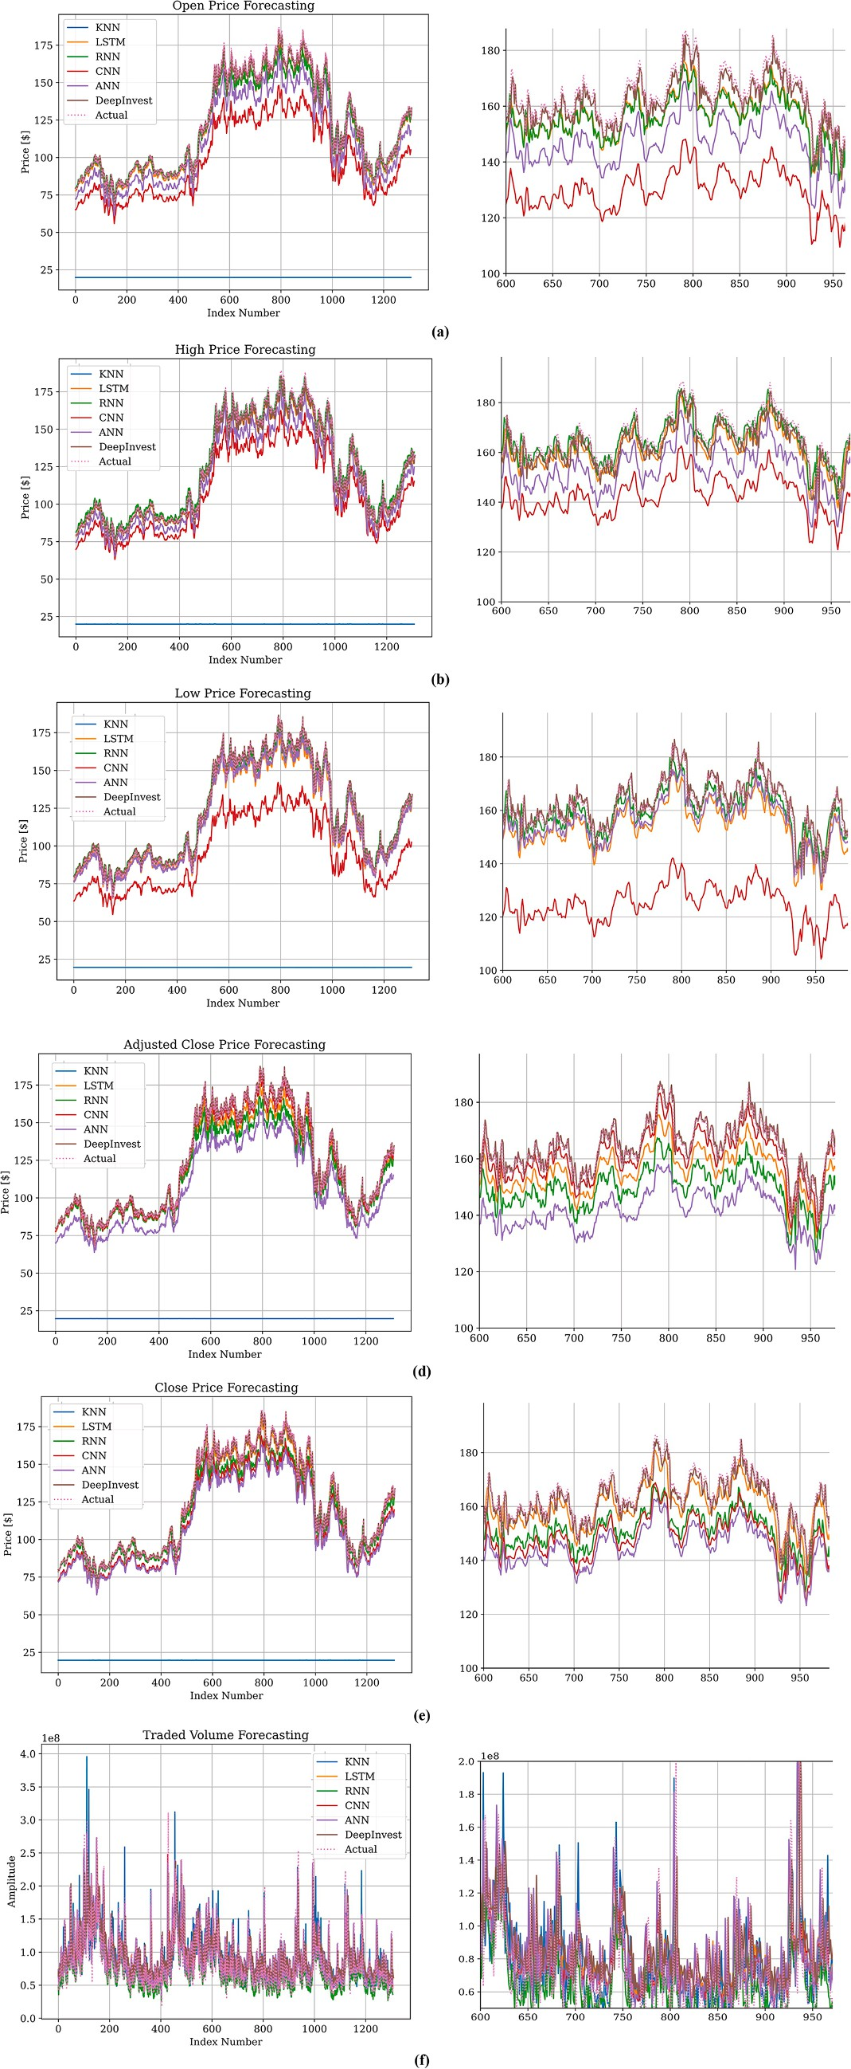

Fig. 6. The prediction price profiles of (a) Open, (b) High, (c) Low, (d) Adj Close, (e) Close, and (f) Traded Volume in different models of KNN, LSTM, RNN, CNN, ANN, and DeepInvesting.

significant price swings within a day are usually reflected in both the high and low ends of the price range. This suggests that the daily highest and lowest prices tend to move in tandem, reflecting the overall market volatility. Furthermore, there is a correlation between the Volume measure and both the High and Low prices. Given that larger amounts frequently result in greater price variability due to more active market involvement, this shows that increased trading activity generally cor-responds with fluctuations in prices. Additionally, there is a correlation between Adj Close prices and Open and Close prices, showing the close relationship between adjusted closing values and the daily opening and closing prices. This relationship shows that after taking company events such stock splits and dividends into account, adjusted closing prices reflect the day’s total trading performance.
System performance evaluation, using KPIs, such as MAPE, RMSPE,
R² (as shown in Table 2), further enhances insights into the dataset’s predictive accuracy.
The KPI results for the AMZN stock prediction models performed, as resulted in Table 2. A MAPE of 0.0176, an RMSPE of 0.0238, and a R² of 0.9923 were attained by DeepInvesting for closing prices, demonstrating a high level of accuracy. The MAPE of the opening prices was 0.0184, as well as the RMSPE of 0.0263, and the R² was 0.9906. The highest ac-curacy among the pricing metrics was demonstrated by the High prices, which had a MAPE of 0.0142, an RMSPE of 0.0207, and a R² of 0.9941. The MAPE, RMSPE, and R² turned out 0.0188, 0.027, and 0.9901, respectively. Volume predictions exhibited substantially higher errors, with a MAPE of 0.277, an RMSPE of 0.3437, and a lower R² of 0.4466, implying a lower level of accuracy in volume predictions. Lastly, the Adjusted Close prices exhibited a MAPE of 0.0189, an RMSPE of 0.027, and a R² of 0.99, indicative of performance that was consistent with the other price metrics.
Regarding the computational complexity of the system, the results are manifested in Table 3.
Based on Table 3, DeepInvesting used lower resources while run by CPU, regarding GPU. Although DeepInvesting performed well in KPIs. Its performance should be compared with other related models to manifest the better performance regarding the price forecasting. Consequently, a detailed comparative analysis of machine learning models, including ANN, LSTM, CNN, RNN, and KNN is performed uti-lizing performance metrics such as MAPE, RMSPE, and R² score, besides RPS, as the results are presented in Tables 4, and 5, as well as Fig. 6.
Regarding Table 3, and Fig. 6, in the KNN model, the MAPE is consistently 0.0067 for all price metrics and 0.0032 for Volume, with RMSPE values of approximately 0.951 for prices and 0.4624 for Volume. Nevertheless, the R² values for pricing metrics (-2.04 to -2.03) and Volume (0.15) are negative, implying that the performance is poor. The
LSTM model exhibits performance, with MAPE values ranging from 0.0002 to 0.0003 for prices and 0.0038 for Volume, RMSPE values ranging from 0.0326 to 0.0502 for prices and 0.4283 for Volume, and high R² values (0.99 to 1 for prices and 0.27 for Volume). The RNN model shows marginally higher MAPE values (0.0002 to 0.0006 for prices and 0.0068 for Volume), 0.0429 to 0.0937 for RMSPE values and 0.5998 for Volume, and R² values ranging from 0.97 to 0.99 for prices
and -0.42 for Volume. The CNN model indicates moderate perfor-
mance, with MAPE values ranging from 0.0001 to 0.0017 for prices and 0.0025 for Volume, RMSPE values ranging from 0.0234 to 0.2418 for prices and 0.3917 for Volume, and R² values between 0.8 and 1 for prices and 0.39 for Volume. Regarding ANN, MAPE values of 0.0002 to 0.0016 for prices and 0.0049 for Volume, RMSPE values of 0.0275 to
0.2271 for prices and 0.5192 for Volume, and R² values of 0.83 to 1 for prices and -0.07 for Volume are presented. Lastly, the DeepInvesting model exhibits better performance in price metrics (MAPE: 0.0142 to
0.0189, RMSPE: 0.0207 to 0.027, R²: 0.9901 to 0.9941).

Future works

In stock market prediction, future research could focus on refining
the predictive capabilities of models such as DeepInvesting, especially concerning challenging aspects like accurately forecasting trading vol-umes. Addressing the complexities associated with volume prediction presents an opportunity for improvement. By developing specialized strategies or incorporating additional data sources tailored to volume forecasting, researchers can enhance the accuracy and reliability of models, such as DeepInvesting, ensuring their effectiveness across a broader spectrum of financial data. By the other side, robustness of the model regarding the sudden news or changes in the market that can go differently than the prediction is among the other challenges. Finally, the computational complexity and smooth performance of the model in different environments are among the other future lines can be expanded.

Conclusion

This work has presented DeepInvesting, a multimodal deep learning model designed to enhance the accuracy of stock price predictions. By implementing a sequence-oriented, long-term dependent architecture with BiLSTM networks, DeepInvesting demonstrated predictive capa-bilities across essential features of the AMZN dataset. The results ob-tained provide the role of intelligent forecasters in the stock market, emphasizing the importance of advanced predictive models in enabling investors and traders. Regarding the performance, the proposed model compared with others of KNN, LSTM, CNN, ANN, and RNN in KPIs of MAPE, RMSPE, R² and RPS in different market labels. Consequently, the model achieved MAPE of values ranging from 0.0142 for High to 0.277 for Adj Close, indicating the average magnitude of errors as percentages in predicting these metrics. RMSPE values range from 0.0207 for High to 0.3437 for Adj Close, providing another measure of predictive accuracy. R² values are ranging from 0.9901 for Low to 0.9941 for High. Finally, RPS values vary widely across the metrics, reflecting the model’s ability to predict the ranking or order of observations relative to actual values. As the financial markets continues to evolve, the further innovations in predictive modeling can be considered, enabling more informed and strategic decision-making in dynamic financial markets and the related investment techniques.

Compliance with ethical standards

Ethical approval

This article does not contain any studies with human participants or animals performed by any of the authors.

Data availability

The datasets generated during the current study are available from the authors on reasonable request email.

Funding

None.

Permission to reproduce materials from other sources

None.

CRediT authorship contribution statement

Ashkan Safari: Conceptualization, Methodology, Software, Formal analysis, Investigation, Writing – original draft, Visualization. Mohammad Ali Badamchizadeh: Formal analysis, Writing – review & editing, Supervision.

Declaration of competing interest

None.

Data availability

The data that has been used is confidential.

References

Abd Elminaam, D. S., El Tanany, A., Salam, M. A., & Abd El Fattah, M. (2022). CPSMP_ ML: closing price prediction of stock market using machine learning models. In 2022 2nd International Mobile, Intelligent, and Ubiquitous Computing Conference (MIUCC). IEEE.. https://doi.org/10.1109/MIUCC55081.2022.9781756
Aldhyani, T. H., & Alzahrani, A. (2022). Framework for predicting and modeling stock market prices based on deep learning algorithms. Electronics, 11(19), 3149. https:// doi.org/10.3390/electronics11193149
AlSallami, N., Salah, R. M., Hossain, M., Altaf, S., Salahuddin, E., & Kaur, J. (2023). In Comparative Analysis: Accurate Prediction to the Future Stock Prices. International Conference on Interactive Collaborative Robotics. Springer.. https://doi.org/10.1007/ 978-3-031-35308-6_13
Alshater, M. M., Kampouris, I., Marashdeh, H., Atayah, O. F., & Banna, H. (2022). Early warning system to predict energy prices: The role of artificial intelligence and machine learning. Annals of Operations Research, 1–37. https://doi.org/10.1007/ s10479-022-04908-9
Arif, U., Khan, N., & Burki, J. R. (2023). forecasting stock returns: Application of machine learning algorithm to psx. International Journal of Business and Management Sciences, 4(3), 45–57. https://ijbms.org/index.php/ijbms/article/view/446.
Bhambu, A. (2023). Stock market prediction using deep learning techniques for short and long horizon. In Soft Computing for Problem Solving: Proceedings of the SocProS 2022 (pp. 121–135). Springer. https://doi.org/10.1007/978-981-19-6525-8_11.
Bhandari, H. N., Rimal, B., Pokhrel, N. R., Rimal, R., Dahal, K. R., & Khatri, R. K. (2022).
Predicting stock market index using LSTM. Machine Learning with Applications, 9, Article 100320. https://doi.org/10.1016/j.mlwa.2022.100320
Billah, M. M., Sultana, A., Bhuiyan, F., & Kaosar, M. G. (2024). Stock price prediction: Comparison of different moving average techniques using deep learning model.
Neural Computing and Applications, 36(11), 5861–5871. https://doi.org/10.1007/ s00521-023-09369-0
Botunac, I., Bosna, J., & Mateti´c, M. (2024). Optimization of Traditional Stock Market
Strategies Using the LSTM Hybrid Approach. Information, 15(3), 136. https://doi. org/10.3390/info15030136
Chen, X., & Hu, Y. (2022). Volatility forecasts of stock index futures in China and the US–A hybrid LSTM approach. PloS one, 17(7), Article E0271595. https://doi.org/ 10.1371/journal.pone.0271595
Cheng, C.-H., Tsai, M.-C., & Chang, C. (2022). A time series model based on deep learning and integrated indicator selection method for forecasting stock prices and evaluating trading profits. Systems, 10(6), 243. https://doi.org/10.3390/ systems10060243
Chhajer, P., Shah, M., & Kshirsagar, A. (2022). The applications of artificial neural networks, support vector machines, and long–short term memory for stock market prediction. Decision Analytics Journal, 2, Article 100015. https://doi.org/10.1016/j. dajour.2021.100015
Cohen, G. (2022). Algorithmic trading and financial forecasting using advanced artificial intelligence methodologies. Mathematics, 10(18), 3302. https://doi.org/10.3390/ math10183302
Fathali, Z., Kodia, Z., & Ben Said, L. (2022). Stock market prediction of Nifty 50 index applying machine learning techniques. Applied Artificial Intelligence, 36(1), Article 2111134. https://doi.org/10.1080/08839514.2022.2111134
Jiang, M., Chen, W., Xu, H., & Liu, Y. (2024). A novel interval dual convolutional neural network method for interval-valued stock price prediction. Pattern Recognition, 145, Article 109920. https://doi.org/10.1016/j.patcog.2023.109920
Kumar, K. V., & Anitha, R. (2022). A detailed survey to forecast the stock prices by applying machine learning predictive models and artificial intelligence techniques. In 2022 International Conference on Computing, Communication, Security and Intelligent Systems (IC3SIS). IEEE. https://doi.org/10.1109/IC3SIS54991.2022.9885309.
Lee, P., Huang, Z., & Tang, Y. (2022). Trend Prediction model of Asian stock market volatility dynamic relationship based on machine learning. Security and Communication Networks. https://doi.org/10.1155/2022/5972698
Leng, J., Liu, W., & Guo, Q. (2022). Stock movement prediction model based on gated orthogonal recurrent units. Intelligent Systems with Applications, 16, Article 200156. https://doi.org/10.1016/j.iswa.2022.200156
Li, G., Zhang, A., Zhang, Q., Wu, D., & Zhan, C. (2022). Pearson correlation coefficient-based performance enhancement of broad learning system for stock price prediction. IEEE Transactions on Circuits and Systems II: Express Briefs, 69(5), 2413–2417. https:// doi.org/10.1109/TCSII.2022.3160266
Li, H., Zhou, D., Hu, J., Li, J., Su, M., & Guo, L. (2023). Forecasting the realized volatility of Energy Stock Market: A multimodel comparison. The North American Journal of Economics and Finance, 66, Article 101895. https://doi.org/10.1016/j. najef.2023.101895
Liu, G., & Ma, W. (2022). A quantum artificial neural network for stock closing price prediction. Information Sciences, 598, 75–85. https://doi.org/10.1016/j. ins.2022.03.064
Luo, J., Zhu, G., & Xiang, H. (2022). Artificial intelligent based day-ahead stock market profit forecasting. Computers and Electrical Engineering, 99, Article 107837. https:// doi.org/10.1016/j.compeleceng.2022.107837
Ma, C., & Yan, S. (2022). Deep learning in the Chinese stock market: The role of technical indicators. Finance Research Letters, 49, Article 103025. https://doi.org/10.1016/j. frl.2022.103025
Oyewole, A. T., Adeoye, O. B., Addy, W. A., Okoye, C. C., Ofodile, O. C., & Ugochukwu, C. E. (2024). Predicting stock market movements using neural networks: A review and application study. Computer Science & IT Research Journal, 5 (3), 651–670. https://doi.org/10.51594/csitrj.v5i3.912
Pokhrel, N. R., Dahal, K. R., Rimal, R., Bhandari, H. N., Khatri, R. K., Rimal, B., et al. (2022). Predicting nepse index price using deep learning models. Machine Learning with Applications, 9, Article 100385. https://doi.org/10.1016/j.mlwa.2022.100385
Rafiuddin, A., Gaytan, J. C. T., Ahmed, G., & Alshurideh, M. (2023). Machine learning techniques for stock market predictions: a case of mexican stocks. the effect of information technology on business and marketing intelligence systems (pp. 1833–1843). Springer. https://doi.org/10.1007/978-3-031-12382-5_100
Safari, A. (2022). Data driven artificial neural network LSTM hybrid predictive model applied for international stock index prediction. In In2022 8th International Conference on Web Research (ICWR) (pp. 115–120). IEEE. https://doi.org/10.1109/ ICWR54782.2022.9786223.
Safari, A., & Badamchizadeh, M. A. (2023). Stock index forecasting using DACLAMNN: A new intelligent highly accurate hybrid ACLSTM/Markov neural network predictor. Cognitive Computation and Systems, 5(3), 181–194. https://doi.org/10.1049/ ccs2.12086
Safari, A., & Ghavifekr, A. A. (2021). International stock index prediction using artificial neural network (ANN) and Python programming. In In2021 7th International Conference on Control, Instrumentation and Automation (ICCIA) (pp. 1–7). IEEE. https://doi.org/10.1109/ICCIA52082.2021.9403580.
Shah, J., Vaidya, D., & Shah, M. (2022). A comprehensive review on multiple hybrid deep learning approaches for stock prediction. Intelligent Systems with Applications, Article 200111. https://doi.org/10.1016/j.iswa.2022.200111
Sharma, K., & Bhalla, R. (2022). Stock market prediction techniques: A review paper. In Second International Conference on Sustainable Technologies for Computational Intelligence: Proceedings of ICTSCI 2021. Springer. https://doi.org/10.1007/978-981-16-4641-6_15.
Sheth, D., & Shah, M. (2023). Predicting stock market using machine learning: Best and accurate way to know future stock prices. International Journal of System Assurance Engineering and Management, 14(1), 1–18. https://doi.org/10.1007/s13198-022-
01811-1
Siddartha Reddy, A., M. Praneeth, K.Praneeth Reddy, and Amedapu Srinivas Reddy. “Stock Market Trend Prediction Using K-Nearest Neighbor (KNN) Algorithm.” (2024). https://ssrn.com/abstract=4817841.
Singh, A. K., Patra, J., Chakraborty, M., & Gupta, S. (2022). Prediction of Indian
government stakeholder oil stock prices using hyper parameterized LSTM models. In 2022 International Conference on Intelligent Controller and Computing for Smart Power (ICICCSP). IEEE. https://doi.org/10.1109/ICICCSP53532.2022.9862425.
Song, Y., Tang, X., Wang, H., & Ma, Z. (2023). Volatility forecasting for stock market incorporating macroeconomic variables based on GARCH-MIDAS and deep learning models. Journal of Forecasting, 42(1), 51–59. https://doi.org/10.1002/for.2899
Staffini, A. (2022). Stock price forecasting by a deep convolutional generative adversarial network. Frontiers in Artificial Intelligence, 5, Article 837596. https://doi.org/ 10.3389/frai.2022.837596
Sun, P., Song, X., Song, S., & Stojanovic, V. (2023). Composite adaptive finite-time fuzzy control for switched nonlinear systems with preassigned performance. International Journal of Adaptive Control and Signal Processing, 37(3), 771–789. https://doi.org/ 10.1002/acs.3546
Venkateswararao, K., & Reddy, B. V. R. (2023). LT-SMF: Long term stock market price trend prediction using optimal hybrid machine learning technique. Artificial Intelligence Review, 56(6), 5365–5402. https://doi.org/10.1007/s10462-022-10291-
5
You, W., Xie, X., Wang, H., Xia, J., & Stojanovic, V. (2024). Relaxed Model Predictive Control of TS Fuzzy Systems Via a New Switching-Type Homogeneous Polynomial Technique. IEEE Transactions on Fuzzy Systems. https://doi.org/10.1109/ TFUZZ.2024.3405078
Yu, Y., Lin, Y., Hou, X., & Zhang, X. (2023). Novel optimization approach for realized volatility forecast of stock price index based on deep reinforcement learning model. Expert Systems with Applications. , Article 120880. https://doi.org/10.1016/j. eswa.2023.120880



Ashkan Safari (Member, IEEE) is a distinguished%1 technology-oriented student researcher specializing in Engi-neering and Intelligent Finance. With a proven track record of delivering high-quality research and management, he has presented his technical findings at numerous international journals and conferences. His research interests span a variety of topics, including Electrical Engineering, Optimization and Control Intelligent Methodologies, Smart Sustainable Cities, Smart Grids, Finance, Management, and Investment in Engi-neering Science & Technology. He is a prolific author, having contributed to papers and peer reviews. He is a respected
professional member of >50 committees and is also an
esteemed international professional member of the Institute of Electrical and Electronics Engineers (IEEE), a professional organization dedicated to the advancement of technology. His technical skills are demonstrated by his successful completion of >250 certifications from prestigious institutions such as top universities, scientific institutes, and giant tech corporations.

Mohammad Ali Badamchizadeh was born in Tabriz, Iran, in 1975. He received the B.S. degree in electrical engineering and the M.S. and Ph.D. degrees in control engineering from the University of Tabriz, Tabriz, Iran, in 1998, 2001, and 2007, respectively. He is currently a Professor with the Faculty of Electrical and Computer Engineering, University of Tabriz. His current research interests include adaptive control, fractional systems, stability of systems, and system identification.

