# Scenario simulation of employment and unemployment during and after the end of the UK government Coronavirus Job Retention Scheme

## Introduction

This model has been developed in order to simulate the effect of the furlough scheme from the present (22nd June) to the end of the scheme (currently 1st November) and beyond.

**This is a work in progress and needs further work to accommodate important states such as employment, self-employment and different industries. It also needs review and evaluation. However, it is useful as the kernel for development and is being shared early in its development for transparency and to allow greater collaboration.**

## Input data

Starting employment, unemployment, and furlough values for 22nd June were estimated using HMRC, ONS and NOMIS data:

Total economically active, NOMIS (Feb 2020-Apr 2020) = 34,326,606

Furloughed, HMRC (14th June, supported by ONS_BICS survey) = 9,100,000

Unemployed, NOMIS (Feb 2020-Apr 2020) = 1,335,531

Employed = Total – Furloughed – Unemployed

## Methodology

The model is a simple compartment model, built in R. It has three compartments: Employed (Em), Furloughed (Fu) and Unemployed (Un).

The simulation is split into two phases: PeriFurlough and PostFurlough. Each phase as separate partial equations for the transfer between compartments.

In the PeriFurlough phase individuals can move between employed and unemployed in either direction, and also employed and furloughed in either direction. They cannot move from unemployed to furloughed as this is not a feasible transition. They also cannot move from furloughed to unemployed because the ONS impact on work survey (11th-14th of June) suggests the rate of redundancy is very low (<1%) so far.

In the PostFurlough phase individuals can no longer enter the Furloughed compartment, but can leave it to enter employment or unemployment.

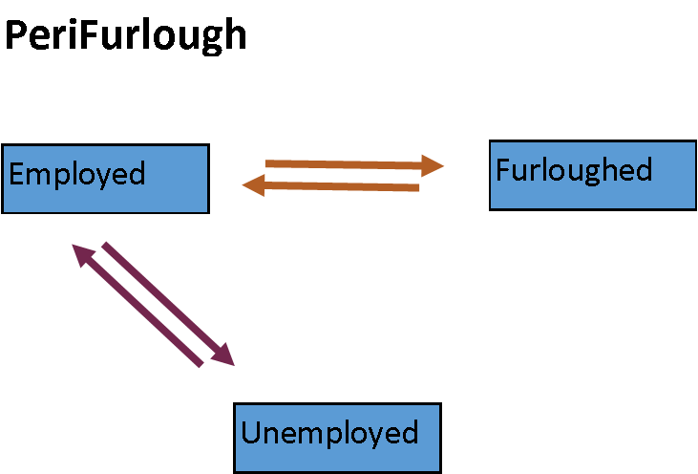 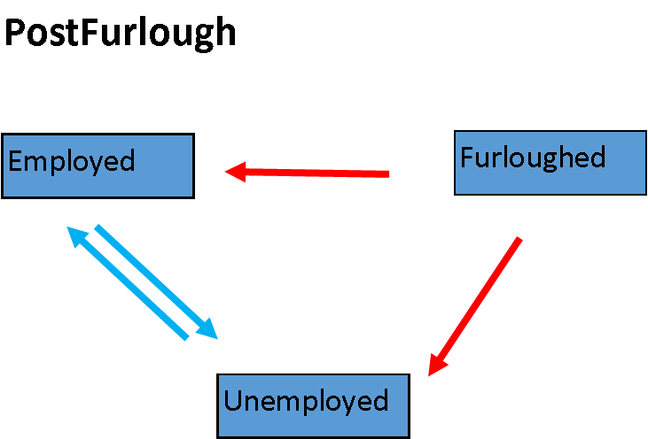

For each phase four parameters were chosen to represent these transitions. These parameters were organized in pairs, corresponding to the coloured pairs shown above. Each pair included a ratio parameter, which can be used to vary the steady-state relative sizes of the compartments without altering the rate at which that steady-state is approached, and also a dampening parameter, which can be used to vary the rate at which that steady-state is reached without affecting the relative sizes of the compartments at steady-state.

These parameters are described in more detail in the Appendix.

Parameter values were selected for the PeriFurlough phase by removing all other transitions and then optimizing the ratio parameter such that the steady state closely matched the currently estimated compartment sizes given in the input data. For example, a model including just transitions between employed and unemployed was used to find a ratio value for Employed<>Unemployed such that the unemployed fraction at steady state was approximately the current estimated value of 3.9%. Then a model including all three compartments and using that estimated ratio value was used to find a ratio value for Employed<>Furlough such that the Furloughed fraction at steady state was approximate the current estimated value of 9.1M. Currently available data does not clearly suggest an increasing or decreasing trend for any of these compartments, hence the choice of parameters to maintain them at steady state. These can be altered if and when new data is available.

For the PostFurlough phase there is no data on which to base parameter values. Therefore values were selected to give a scenario that was considered plausible and illustrative, such that altering these values could be used to explore the possible effects of alternative scenarios.

## Results

For the scenario simulations below, each scenario is compared to a default scenario. For all scenarios the PeriFurlough parameters are kept constant, and only the PostFurlough parameter values are altered.

### Baseline scenario

PeriFurlough parameter values:

peri_EmFu_FuEm_ratio <-0.39

peri_EmFu_FuEm_damp <-100

peri_EmUn_UnEm_ratio <-0.041

peri_EmUn_UnEm_damp <- 100

PostFurlough parameter values:

post_FuEm_FuUn_ratio <- 0.5

post_FuEm_FuUn_damp <- 10

post_EmUn_UnEm_ratio <- 0.041

post_EmUn_UnEm_damp <- 100

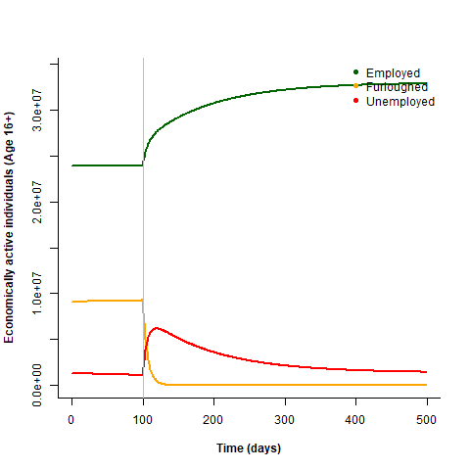

This scenario results in a pulse of unemployment immediately post-furlough that gradually returns to the baseline unemployment.

### Severe social lockdown

To simulate a severe lockdown policy post-furlough that prevents people from returning to work immediately we decrease the FuEm:FuUn ratio from 0.5 to 0.1:

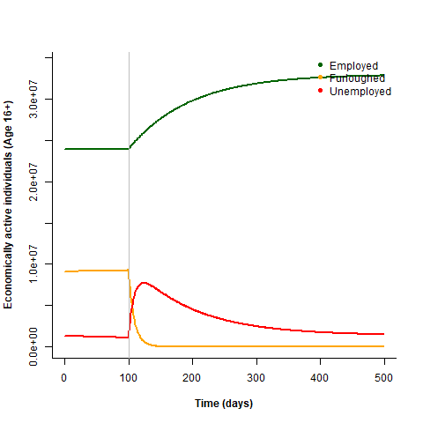

This results in a higher peak of unemployment post-furlough.

### Relaxed social lockdown

To simulate a relaxed lockdown policy that allows businesses to reopen and furloughed workers to return to work immediately we increase the FuEm:FuUn ratio from 0.5 to 2:

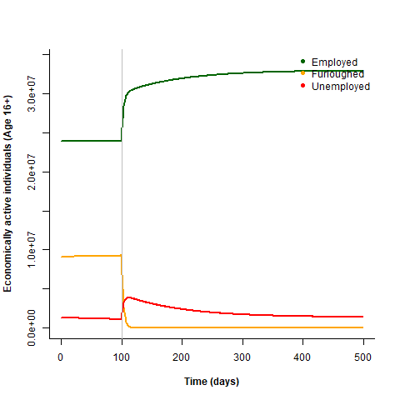

This results in a much smaller peak of unemployment immediately post-furlough, and a steeper increase in employment.

### Economic recession

To simulate an economic recession post-furlough that reduces job opportunities in the long term we increase the EmUn:UnEm ratio from 0.041 to 0.15:

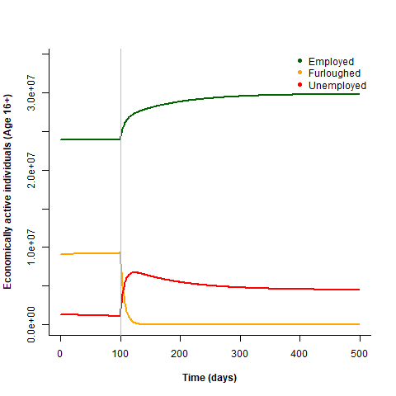

This results in a much weaker recovery after the initial peak of unemployment.

### Phased end of furlough

To simulate a phased ending to the furlough scheme we increase the FuEm_FuUn dampening from 10 to 100, so that employees are rehired or made redundant more gradually.

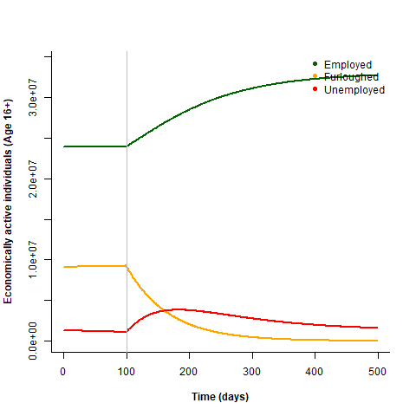

This results in a flattened peak of unemployment and a more gradual rehiring of furloughed workers.

### Faster economic recovery

To simulate a faster economic recovery back to pre-covid levels after the end of the furlough scheme we decrease the EmUn_UnEm dampening from 100 to 10.

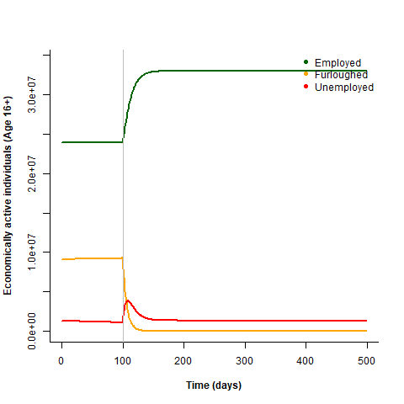

This results in a smaller peak of unemployment and faster return to pre-covid unemployment levels.

## Conclusions

Despite the lack of relevant data, this simple compartment model includes 4 parameters to explore scenarios for the effect on unemployment after the end of the UK government Coronavirus Job Retention Scheme.

However, the model does not explicitly include consideration of the role of social lockdown rules, or the performance of the UK economy, both of which are likely to affect the values of the parameters used here and how they could change over time.

Also not considered are the differences between industries, or differences between employed and self-employed workers.

## Appendix

### Table of parameters

