**Dyslexic Reader Detector – Product Proposal**

We propose a method of identifying dyslexic readers by analyzing the eye movement of the student.

To use our device, the user would only need to stay fixated while reading the texts shown on a screen. It is recommended for the student to rest his/her chin on a stand so as to maximize the stability of detection result (figure 1). A dedicated camera, as shown in figure 2 below, would be placed in between the student and the screen, pointing slightly upwards toward the student’s face so that the eyes of the student is clearly in the camera’s view (figure 3). Figure 4 shows what the data we would retrieve after the student finishes the test looks like. A sample video is also provided to show what the camera sees during the reading test (<https://streamable.com/1noboj>)

Our device contains no intrusive elements that would be required to install on the student’s body. All the equipment is portable and can be setup easily.

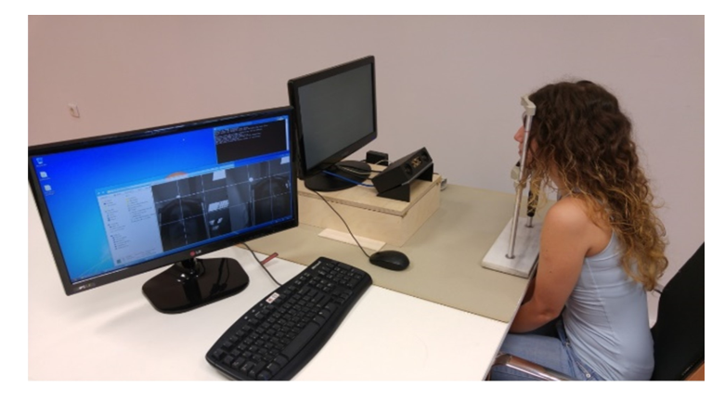

Figure 1 - Suggested Posture of the User

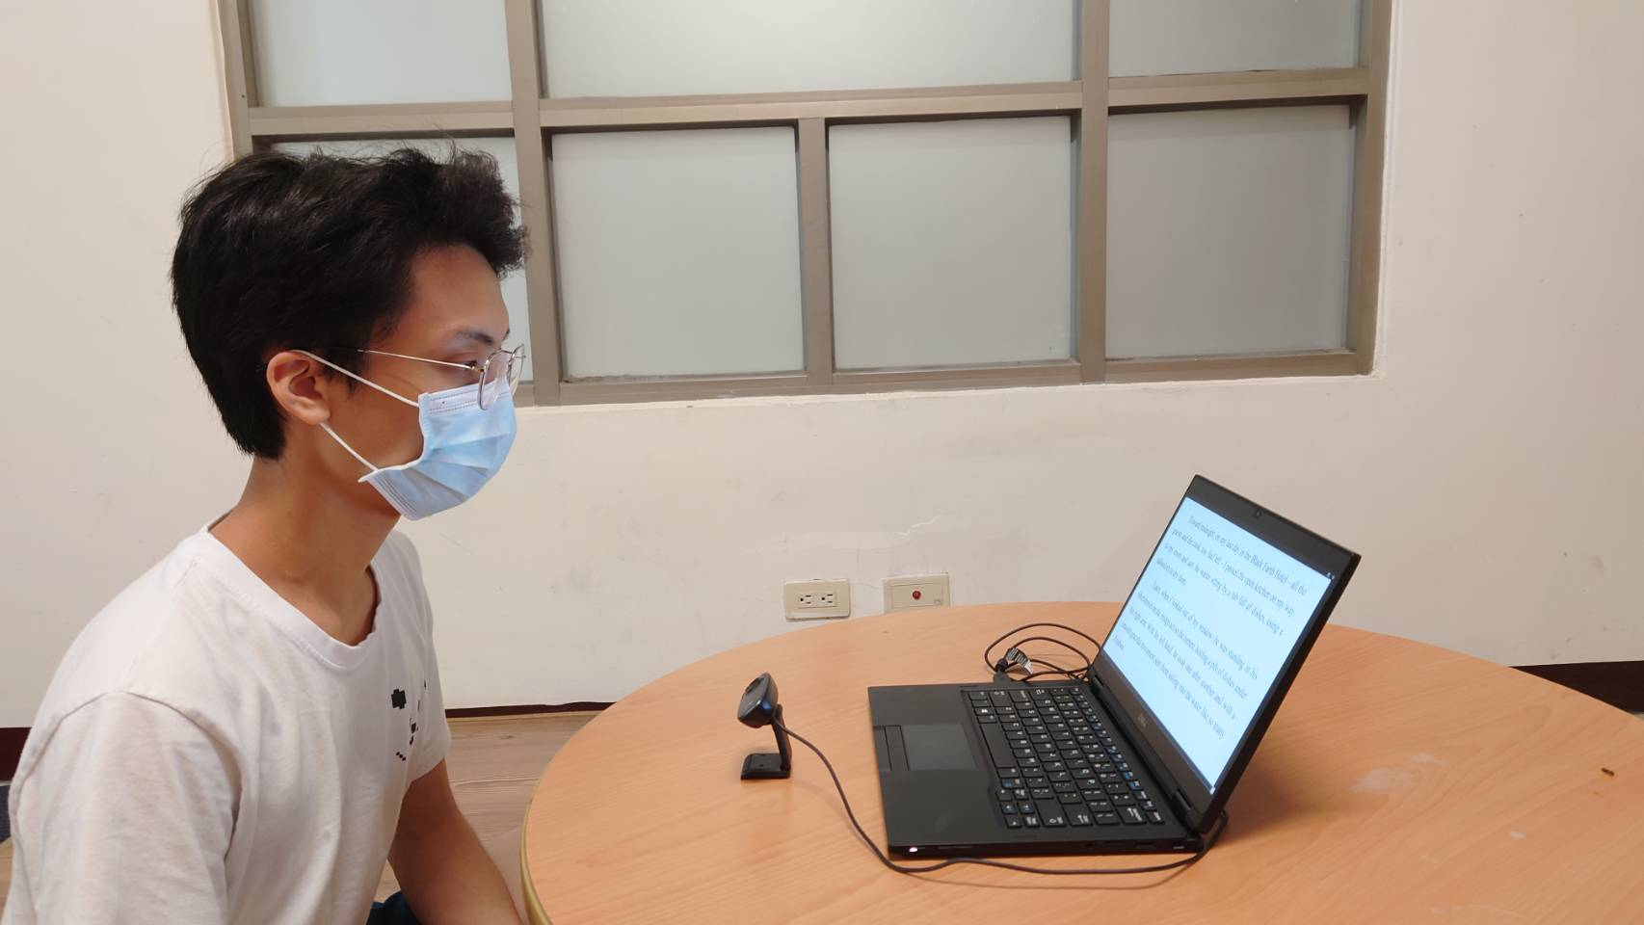

Figure 2 – A portable setup of our device

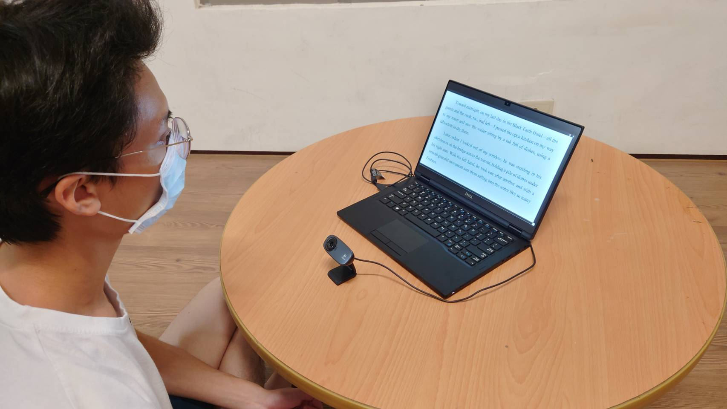

Figure 3 - Another angle

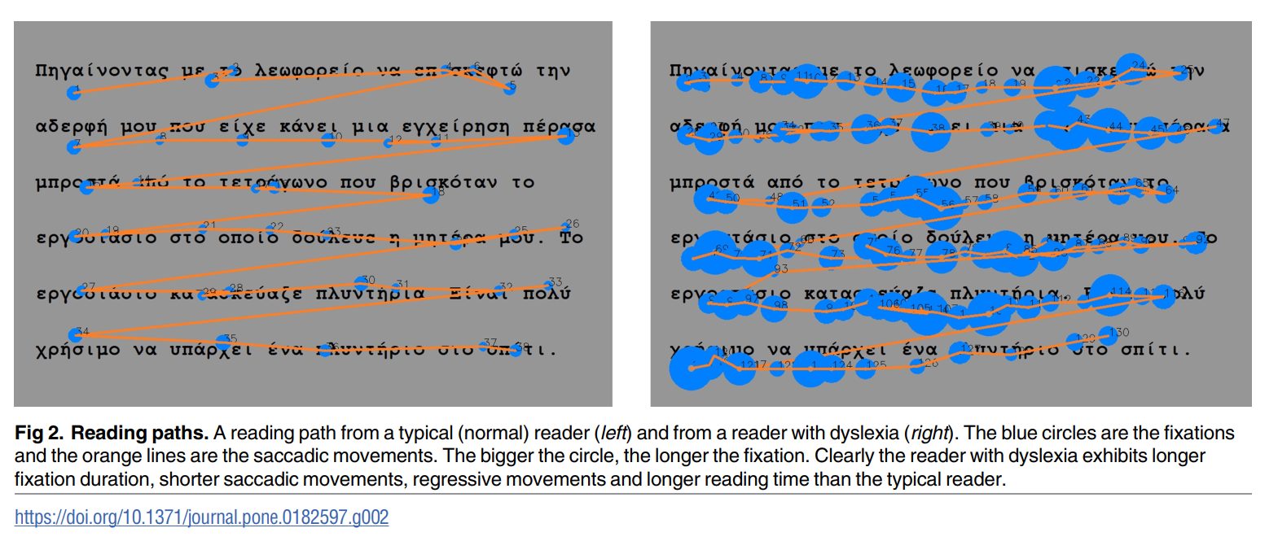

Figure 4 - Demo Analysis Result of the program