Week 1 Task: Data Gathering, Cleaning, and Preprocessing Report
Historical US Technology Equities & Market Benchmark Indices (Yahoo Finance / Matplotlib Dataset, 1990–2022)
1. Executive Summary: Eliminating 1,915 Missing Cells and 126 Return Outliers
This technical report documents the end-to-end data gathering, exploratory auditing, cleaning, outlier treatment, and feature scaling pipeline executed for Week 1 of the YuvaIntern Junior Data Scientist Internship. Using the publicly available historical equity and market index dataset (Stocks.csv, sourced from Yahoo Finance and distributed via the Matplotlib Sample Data Repository), the raw dataset comprised 524 rows and 11 columns (5,764 total cells) spanning January 1990 through June 2022. Initial profiling uncovered 1,915 missing values (33.22% overall missingness), 133 completely empty mid-month marker rows, 1 exact duplicate end-of-series snapshot, 1 severely sparse feature (DELL at 86.45% raw missingness), unparsed string dates (object), and heavy-tailed return outliers caused by macroeconomic shocks.
Through a reproducible six-stage Python preprocessing pipeline (pandas and numpy), all structural anomalies were resolved: 133 all-NaN rows and 1 duplicate snapshot (2022-06-28) were removed to establish a regular 390-month time series (1990-01-01 to 2022-06-01); DELL (82.05% active missingness) was dropped; pre-IPO gaps in AMZN (89 months) and GOOGL (176 months) were captured via binary regime indicator flags (int64) and imputed via IPO-baseline backward fill; 126 extreme monthly return outliers were bounded via Tukey Interquartile Range (1.5x IQR) Winsorization; and all 9 retained series were scaled using both Min-Max Normalization [0, 1] and Z-Score Standardization (mean = 0, std = 1). The final deliverable (Cleaned_Financial_Stocks_Dataset.csv) contains 390 rows x 51 columns (19,890 cells) with 0% missing values.
2. Dataset Selection & Initial Structural Audit
To satisfy the Week 1 requirement of selecting a real-world dataset of adequate size and complexity in the Finance domain, we selected Stocks.csv (matplotlib.cbook.get_sample_data('Stocks.csv')). The dataset tracks eight US technology corporations—IBM, Apple (AAPL), Microsoft (MSFT), Xerox (XRX), Amazon (AMZN), Dell Technologies (DELL), Alphabet/Google (GOOGL), and Adobe (ADBE)—alongside two major benchmark indices: the S&P 500 (^GSPC) and NASDAQ Composite (^IXIC). Initial exploration via df.info() and df.isnull().sum() identified the exact anomaly profile detailed in Table 1.
Column | Raw Dtype | Non-Null | Raw Missing | Active Missing (N=390) | Primary Data Quality Issue Identified
Date | object | 524 | 0 (0.00%) | 0 (0.00%) | Stored as string; 133 mid-month NaN rows & 1 duplicate date
IBM | float64 | 391 | 133 (25.38%) | 0 (0.00%) | 133 missing values from corrupted mid-month all-NaN rows
AAPL | float64 | 391 | 133 (25.38%) | 0 (0.00%) | 133 missing values from corrupted mid-month all-NaN rows
MSFT | float64 | 391 | 133 (25.38%) | 0 (0.00%) | 133 missing values from corrupted mid-month all-NaN rows
XRX | float64 | 391 | 133 (25.38%) | 0 (0.00%) | 133 missing values from corrupted mid-month all-NaN rows
AMZN | float64 | 302 | 222 (42.37%) | 89 (22.82%) | 133 all-NaN rows + 89 pre-IPO missing months (1990–May 1997)
DELL | float64 | 71 | 453 (86.45%) | 320 (82.05%) | Severe sparsity: 320 missing active months prior to Sept 2016
GOOGL | float64 | 215 | 309 (58.97%) | 176 (45.13%) | 133 all-NaN rows + 176 pre-IPO missing months (1990–Aug 2004)
ADBE | float64 | 391 | 133 (25.38%) | 0 (0.00%) | 133 missing values from corrupted mid-month all-NaN rows
^GSPC | float64 | 391 | 133 (25.38%) | 0 (0.00%) | Caret symbol (^) in column header + 133 all-NaN rows
^IXIC | float64 | 391 | 133 (25.38%) | 0 (0.00%) | Caret symbol (^) in column header + 133 all-NaN rows

3. Data Cleaning Methodology: Missing Values, Duplicates & Anomalies
- Metadata Comment & Header Standardization: The leading comment line (# Data source: https://finance.yahoo.com) was stripped via comment='#' in pd.read_csv(). Caret-prefixed index tickers ^GSPC and ^IXIC were renamed to SP500 and NASDAQ to ensure syntactic compatibility with statistical formula parsers.
- Purging 133 All-NaN Corrupted Rows & 1 Duplicate Snapshot: Row-wise auditing revealed 133 mid-month rows (e.g., 1990-02-05, 1990-05-04, through 2022-05-09) where all 10 financial price columns were simultaneously NaN. Dropping these 133 corrupted records eliminated 1,330 missing cells (reducing total missingness by 69.45%). Cross-row duplicate checking then identified that row 523 (2022-06-28) duplicated every price in row 522 (2022-06-01, e.g., IBM = $141.86, AAPL = $137.44, SP500 = 3,821.55). Removing this duplicate snapshot yielded 390 regular first-of-month (MS) observations.
- High-Missingness Feature Deletion (DELL — 82.05% Missing): Across the 390 valid monthly rows, DELL was missing in 320 rows (82.05%) due to Dell's 2013 buyout privatization and 2016 relisting. Because imputing over 80% of a time series fabricates synthetic variance, DELL was dropped.
- Regime-Flagged Backward Imputation (AMZN & GOOGL): Missing values in AMZN (89 months prior to June 1997) and GOOGL (176 months prior to September 2004) represent pre-IPO structural absence (Missing Not At Random). We engineered binary int64 indicator columns (AMZN_Listed_Flag, GOOGL_Listed_Flag) to preserve exact listing dates and applied Backward Fill (bfill) using each equity's initial IPO baseline ($0.077083 for AMZN; $64.864868 for GOOGL), achieving 0 missing values across all 390 rows.
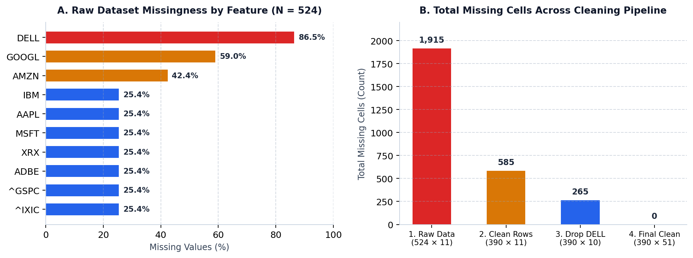
Figure 1: (A) Raw feature-level missingness across N = 524 records and (B) staged reduction of missing cells from 1,915 to 0.
4. Outlier Detection and Treatment: Active-Period IQR Winsorization
Because long-horizon equity prices exhibit non-stationary upward drift from economic compounding, applying static outlier thresholds to raw dollar prices would falsely flag recent years as anomalies. We therefore computed monthly percentage returns (Return_Pct = ((P_t - P_{t-1}) / P_{t-1}) x 100) and applied Tukey's Interquartile Range (1.5x IQR) criterion ([Q1 - 1.5x IQR, Q3 + 1.5x IQR]). For AMZN and GOOGL, quartiles were calculated strictly across active post-IPO months (Listed_Flag == 1). To preserve time-series continuity across macroeconomic shocks (Dot-Com Bubble, 2008 GFC, 2020 COVID-19 crash), all 126 extreme return outliers were capped via Winsorization (clip) into _Return_Winsorized columns (Table 2).
Ticker | Active Q1 | Active Q3 | IQR | Lower Bound | Upper Bound | Raw Min | Raw Max | Outliers Capped
IBM | -3.61% | +5.14% | 8.75% | -16.74% | +18.27% | -24.86% | +35.38% | 12 (3.08%)
AAPL | -4.66% | +9.94% | 14.60% | -26.56% | +31.84% | -57.74% | +45.38% | 9 (2.31%)
MSFT | -3.61% | +6.11% | 9.72% | -18.19% | +20.68% | -34.35% | +40.78% | 14 (3.59%)
XRX | -4.81% | +6.06% | 10.88% | -21.13% | +22.37% | -43.75% | +76.65% | 24 (6.15%)
AMZN | -4.62% | +9.90% | 14.52% | -26.40% | +31.68% | -41.16% | +126.38% | 20 (5.13%)
GOOGL | -3.31% | +6.57% | 9.88% | -18.13% | +21.40% | -18.48% | +47.10% | 8 (2.05%)
ADBE | -5.12% | +8.66% | 13.78% | -25.79% | +29.33% | -45.16% | +85.24% | 16 (4.10%)
SP500 | -1.74% | +3.40% | 5.14% | -9.46% | +11.12% | -16.94% | +12.68% | 7 (1.79%)
NASDAQ | -2.05% | +4.50% | 6.55% | -11.88% | +14.33% | -22.90% | +21.98% | 16 (4.10%)

5. Data Type Conversions, Normalization & Standardization
The Date column was cast from object string to native datetime64[ns] via pd.to_datetime() and decomposed into integer calendar features (Year, Month, Quarter as int64). Because raw asset prices span four orders of magnitude—from XRX ($6.25–$102.47) to NASDAQ (329.80–15,644.97)—unscaled inputs bias gradient- and distance-based algorithms. We generated both Min-Max Normalized features (_Norm in [0.0, 1.0]) and Z-Score Standardized features (_ZScore with mean = 0.0, std = 1.0) for all 9 series (Table 3).
Ticker | Raw Min | Raw Median | Raw Mean | Raw Max | Raw Std | Normalized Range | Z-Score (Mean, Std)
IBM | $5.57 | $61.65 | $67.90 | $142.00 | $42.18 | [0.000, 1.000] | (0.000, 1.000)
AAPL | $0.10 | $2.07 | $18.32 | $177.08 | $35.35 | [0.000, 1.000] | (0.000, 1.000)
MSFT | $0.40 | $20.04 | $42.66 | $334.85 | $65.88 | [0.000, 1.000] | (0.000, 1.000)
XRX | $6.25 | $22.56 | $26.33 | $102.47 | $17.11 | [0.000, 1.000] | (0.000, 1.000)
AMZN | $0.08 | $2.81 | $22.78 | $175.35 | $42.95 | [0.000, 1.000] | (0.000, 1.000)
GOOGL | $64.86 | $180.68 | $425.96 | $2,960.92 | $597.47 | [0.000, 1.000] | (0.000, 1.000)
ADBE | $1.12 | $28.67 | $79.41 | $669.85 | $135.06 | [0.000, 1.000] | (0.000, 1.000)
SP500 | 304.00 | 1,248.88 | 1,468.94 | 4,766.18 | 960.12 | [0.000, 1.000] | (0.000, 1.000)
NASDAQ | 329.80 | 2,275.29 | 3,442.28 | 15,644.97 | 3,279.82 | [0.000, 1.000] | (0.000, 1.000)

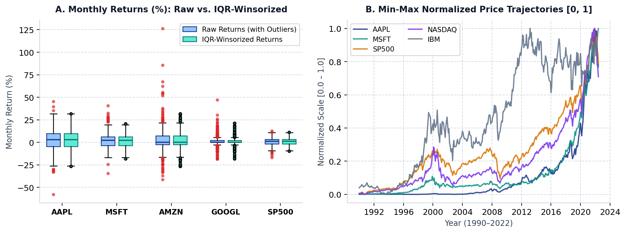
Figure 2: (A) Monthly return boxplots before and after 1.5x IQR Winsorization and (B) Min-Max Normalized [0, 1] trajectories (1990–2022).
6. Final Cleaned Dataset Verification & Quality Gate Summary
The exported dataset (Cleaned_Financial_Stocks_Dataset.csv) passed all programmatic integrity assertions, transforming a noisy 524 x 11 raw file with 33.22% missing cells into a 100% complete 390 x 51 analytical feature matrix (Table 4).
Quality Dimension | Raw Dataset (Stocks.csv) | Cleaned Dataset (CSV Output) | Verification Result
Dimensions | 524 rows x 11 cols (5,764 cells) | 390 rows x 51 cols (19,890 cells) | 134 bad rows & DELL dropped; 41 features added
Missing Values | 1,915 missing cells (33.22%) | 0 missing cells (0.00%) | 100% complete matrix verified via assert
Data Types | Date as object; 10 float64 cols | 1 datetime64[ns], 5 int64, 45 float64 | Strict schema typing enforced
Outlier Control | Unbounded shocks (-57.7% to +126.4%) | 126 return outliers capped via 1.5x IQR | Raw & Winsorized returns retained
Feature Scaling | Unscaled ($0.08 to 15,644.97) | Min-Max [0, 1] & Z-Score (0, 1) added | Ready for EDA & ML modeling

