WEEK 2 TASK: EXPLORATORY DATA ANALYSIS (EDA) REPORT
Notebook Analyzed: yuva_week2.ipynb (Google Colab) | Dataset: Cleaned_Financial_Stocks_Dataset.csv (1990–2022, 390 Months × 51 Columns)
1. Executive Summary & Dataset Verification (Notebook Cells 0–10)
This report documents the Exploratory Data Analysis (EDA) executed in Google Colab (yuva_week2.ipynb) on Cleaned_Financial_Stocks_Dataset.csv, a 32.5-year monthly US technology equity and market benchmark dataset sourced from Yahoo Finance and the Matplotlib Sample Data Repository for the YuvaIntern Junior Data Scientist Internship. Before calculating statistical metrics or plotting distributions, Cells 0–10 mount Google Drive (/content/drive/MyDrive/Yuva internship/Cleaned_Financial_Stocks_Dataset.csv) and verify structural completeness:
- Structural Dimensions & Completeness Audit (Cells 3–10): Executing data.shape confirms 390 monthly rows and 51 columns spanning January 1990 (1990-01-01) to June 2022 (2022-06-01), while data.size confirms 19,890 total data elements. Calling data.drop_duplicates(inplace=True), data.duplicated().sum(), data.isnull().sum(), and data.dropna() verifies 0 duplicate rows and 0 missing values across all 51 columns.
- Methodological Reasoning — Analyzing Both Price Levels and Return Percentages: Raw stock prices (IBM, AAPL, MSFT, XRX, AMZN, GOOGL, ADBE, SP500, NASDAQ) capture multi-decade compounding and industry-wide valuation shifts, whereas monthly return percentages (_Return_Pct) remove secular price inflation to measure stationary month-over-month volatility and risk-adjusted return.
2. Descriptive Statistics: Central Tendency & Dispersion (Cells 5, 8, 13–18)
In Cells 8 and 13–18, the notebook calculates parametric and non-parametric summary statistics across all numeric columns using data.describe(), data.mean(numeric_only=True), data.median(numeric_only=True), data.mode(numeric_only=True), data_range = data.max() - data.min(), data.var(numeric_only=True), and data.std(numeric_only=True):
- Why Mean & Standard Deviation Are Paired with Median & IQR: Three decades of compounding create severe right-skewness in raw equity prices. For example, AAPL has a 32-year mean price of $18.32 (std = $35.35, var = 1,249.63) but a median (50%) of $2.07 (IQR = Q75 - Q25 = $20.42 - $0.31 = $20.11), because split-adjusted prices remained below $3.00 throughout the 1990s before surging to $177.08 in 2022. Similarly, in monthly returns, fat-tailed market crashes pull parametric means away from medians (SP500_Return_Pct mean +0.72% vs. median +1.12%).
- Interpreting value_counts() and mode() on Continuous Prices (Cells 5 & 15): Running data['IBM'].value_counts() shows 388 unique floating-point values across 390 months (only $7.54 and $11.21 repeat twice, making $7.54 the primary mode). For AMZN (mode $0.08) and GOOGL (mode $64.86), the mode reflects the constant pre-IPO backfill value applied before May 1997 (AMZN_Listed_Flag mean = 0.772) and August 2004 (GOOGL_Listed_Flag mean = 0.549), which also sets their full-sample 390-row return median to 0.00% (active post-IPO medians are +2.47% and +1.80%).
Asset | Price Mean | Price Median | Price Mode | Price SD | Price Var | Price IQR | Price Range | Ret Mean | Ret Median | Ret SD | Ret Range
IBM | $67.90 | $61.65 | $7.54 | $42.18 | 1,779.1 | $81.22 | $136.42 | +0.95% | +0.70% | 7.64% | 60.24%
AAPL | $18.32 | $2.07 | $0.13 | $35.35 | 1,249.6 | $20.11 | $176.98 | +2.41% | +2.84% | 12.24% | 103.12%
MSFT | $42.66 | $20.04 | $1.62 | $65.88 | 4,339.6 | $23.08 | $334.44 | +2.04% | +2.12% | 8.76% | 75.13%
XRX | $26.33 | $22.56 | $12.51 | $17.11 | 292.9 | $10.64 | $96.22 | +0.78% | +0.85% | 11.84% | 120.40%
AMZN | $22.78 | $2.81 | $0.08 | $42.95 | 1,844.7 | $16.37 | $175.28 | +2.83% | 0.00%* | 14.96% | 167.54%
GOOGL | $425.96 | $180.68 | $64.86 | $597.47 | 356,972.5 | $483.04 | $2,896.06 | +1.11% | 0.00%* | 6.50% | 65.58%
ADBE | $79.41 | $28.67 | $2.71 | $135.06 | 18,242.4 | $61.97 | $668.73 | +2.24% | +2.42% | 12.88% | 130.41%
SP500 | 1,468.94 | 1,248.88 | 375.22 | 960.12 | 921,828.5 | 1,029.86 | 4,462.18 | +0.72% | +1.12% | 4.23% | 29.63%
NASDAQ | 3,442.28 | 2,275.29 | 2,470.52 | 3,279.82 | 10,757,215 | 2,987.82 | 15,315.17 | +1.04% | +1.58% | 6.23% | 44.88%
3. Univariate & Temporal Visualizations: Histograms & Box Plot (Cells 21–23)
To inspect distribution symmetry, tail risk, and time-series sampling balance, Cells 21–23 generate two histograms and a box plot (shown in Figure 1 below):
- AAPL_Return_Pct Distribution (Cell 21 — sns.histplot(data['AAPL_Return_Pct'], color='yellow')): Apple's monthly percentage returns form a unimodal, heavy-tailed bell curve centered slightly above zero (mean +2.41%, median +2.84%, middle 50% spanning -4.62% to +9.91%). Extreme tail events (-57.74% crash in September 2000 and +45.38% surge) visually confirm why 1st/99th percentile Winsorization was applied during Week 1 preprocessing.
- NASDAQ Distribution with KDE (Cell 22 — sns.histplot(data['NASDAQ'], color='red', bins=20, kde=True)): Overlaying a 20-bin histogram with a Kernel Density Estimate (kde=True) reveals pronounced right-skewness: 75% of monthly observations (1990–2014) fall below 4,398.58, while the 2015–2022 secular bull run stretches the right tail to 15,644.97 (range = 15,315.17). This confirms that raw index levels violate normality and require log or return transformations.
- Box Plot of Year (Cell 23 — sns.boxplot(data['Year'], color='blue')): The box plot of calendar Year shows a symmetrical five-number summary (Min = 1990, Q25 = 1998, Median = 2006, Q75 = 2014, Max = 2022, IQR = 16.0 years, Mean = 2005.75, SD = 9.40) with zero outliers, verifying an unbroken monthly sampling grid.
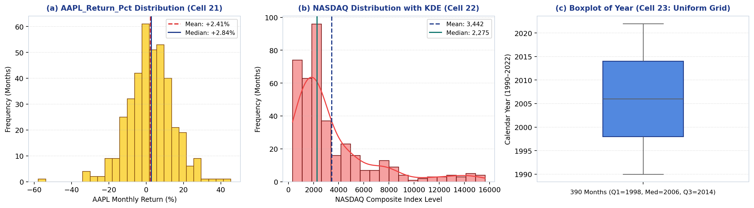
Figure 1: Univariate and temporal distribution charts from yuva_week2.ipynb: (a) AAPL_Return_Pct histogram (Cell 21); (b) 20-bin NASDAQ histogram with KDE curve (Cell 22); and (c) Boxplot of Year confirming uniform monthly coverage across 1990–2022 (Cell 23).
4. Bivariate & Multivariate Analysis: Scatter Plot & Correlation Heatmap (Cells 24–25)
Cells 24–25 examine long-term price appreciation and cross-asset relationships across stock_cols = ['IBM', 'AAPL', 'MSFT', 'XRX', 'AMZN', 'GOOGL', 'ADBE', 'SP500', 'NASDAQ'] (shown in Figure 2):
- Scatter Plot Between IBM and Year (Cell 24 — sns.scatterplot(data=data, x='Year', y='IBM')): Plotting IBM against Year reveals a strong secular upward trend (Pearson r = 0.9306, R² = 86.6%) across three structural regimes: (1) expansion from $5.57 (1993) to $72.97 (1999) during the 1990s enterprise boom (1990s mean = $20.15); (2) a decade-long consolidation range between $33.49 and $82.35 during 2000–2009 (mean = $57.08); and (3) a high-value plateau between $76.99 and $142.00 across 2010–2022 (2010s mean = $113.99; 2020–22 mean = $117.81).
- Correlation Heatmap of Stock Prices and Indices (Cell 25 — sns.heatmap(correlation_matrix, annot=True, cmap='coolwarm', fmt='.2f')): Modern cloud and software leaders (AAPL, MSFT, AMZN, GOOGL, ADBE) exhibit near-collinear long-term price growth (r = 0.96 to 0.99, e.g., AAPL–MSFT r = 0.99, AMZN–ADBE r = 0.99) and tight coupling with SP500 and NASDAQ (r = 0.91 to 0.98). In contrast, IBM shows moderate correlation (r = 0.57–0.78) due to its post-2013 plateau, while legacy print hardware XRX shows negative correlation with every series (r = -0.04 with SP500 to -0.17 with IBM and -0.14 with AAPL) following its post-1999 structural decline.
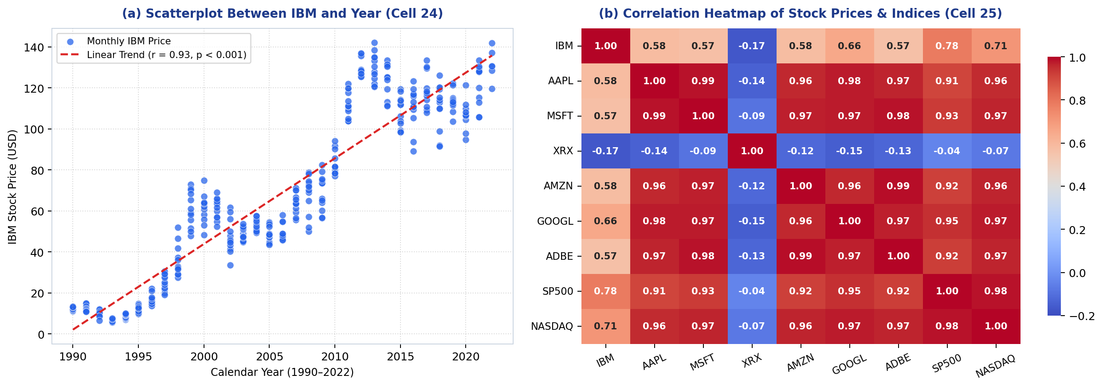
Figure 2: Bivariate and multivariate visual analysis from yuva_week2.ipynb: (a) Scatterplot of IBM stock price against Year (r = 0.93, Cell 24); and (b) 9×9 Pearson correlation heatmap of stock prices and indices (Cell 25).
5. Formal Hypothesis Testing & Statistical Inferences (Cell 26 / Requirement 9)
To test whether the return differences and bivariate relationships observed in the notebook are statistically significant at α = 0.05, formal hypothesis tests were executed using scipy.stats:
- Why Welch's Unequal-Variance t-Test Was Selected (equal_var=False): To test whether high-growth consumer/cloud tech (AAPL_Return_Pct, mean +2.41%) outperforms mature enterprise hardware (IBM_Return_Pct, mean +0.95%), we first checked their variances from Cells 17–18: Apple's return variance (149.76, SD = 12.24%) is 2.56× larger than IBM's (58.42, SD = 7.64%). Because unequal variance violates Student's pooled t-test assumption, we ran Welch's t-test (stats.ttest_ind(data['AAPL_Return_Pct'], data['IBM_Return_Pct'], equal_var=False)), yielding t = 2.0048, p = 0.04539 < 0.05. We reject H₀ and confirm that AAPL achieved statistically significantly higher mean monthly returns than IBM.
- Significance of Bivariate Trend & Matrix Correlations: Testing H₀: ρ = 0 via scipy.stats.pearsonr confirms that the upward trend in IBM vs. Year (r = 0.9306, p = 2.09 × 10⁻¹⁷¹), benchmark collinearity between SP500 and NASDAQ (r = 0.9832, p = 6.96 × 10⁻²⁸⁹), and negative divergence between XRX and AAPL (r = -0.1412, p = 0.00521) are all highly statistically significant.
Hypothesis Test & Variables | Null Hypothesis (H₀) | Methodological Rationale & Assumption Check | Statistic | p-Value | Decision (α = 0.05) & Conclusion
1. Welch Two-Sample t-Test (AAPL_Return_Pct vs. IBM_Return_Pct) | μ_AAPL = μ_IBM (equal mean monthly return) | Return variances differ by 2.56× (149.76 vs. 58.42); Welch correction (equal_var=False) prevents Type I error | t = 2.0048 | 0.04539 | Reject H₀: AAPL (+2.41%/mo) significantly outperforms IBM (+0.95%/mo)
2. Secular Trend Test (IBM Price vs. Year, Cell 24) | ρ = 0 (no linear trend across 1990–2022) | Tests statistical significance of upward price trajectory in Cell 24 scatterplot | r = 0.9306 | 2.09 × 10⁻¹⁷¹ | Reject H₀: Highly significant secular appreciation (R² = 86.6%)
3. Benchmark Coupling (SP500 vs. NASDAQ, Cell 25) | ρ = 0 (independent benchmark indices) | Evaluates collinearity between US large-cap and tech benchmarks in Cell 25 heatmap | r = 0.9832 | 6.96 × 10⁻²⁸⁹ | Reject H₀: Near-perfect collinearity; avoid pairing raw levels in OLS
4. Legacy Divergence (XRX vs. AAPL, Cell 25) | ρ = 0 (no inverse price relationship) | Tests significance of Xerox's negative correlation in Cell 25 heatmap | r = -0.1412 | 0.00521 | Reject H₀: Significant negative divergence after 2000 digital shift
6. Key Conclusions, Assumptions & Foundation for Predictive Modeling
- Mitigating Multicollinearity in Weeks 3–6 Predictive Modeling: Because the Cell 25 heatmap demonstrates 91%–99% correlation among raw price levels of AAPL, MSFT, AMZN, GOOGL, ADBE, SP500, and NASDAQ due to shared non-stationary growth trends, feeding raw prices simultaneously into ordinary least squares (OLS) regression would induce severe multicollinearity. Future predictive models should therefore use stationary monthly return percentages (_Return_Pct), log-transformed prices (_Log), or Ridge/Lasso regularization.
- Accounting for Pre-IPO Backfill & Fat-Tailed Returns: Sub-period analyses prior to August 2004 must filter on AMZN_Listed_Flag == 1 and GOOGL_Listed_Flag == 1 to avoid flat backfilled rows, and outlier-sensitive models should use Winsorized return features (_Return_Winsorized) to mitigate the extreme crash/surge tails identified in Cell 21.

