MaziwaTrack: Redefining Kenya’s milk supply system

Group Members and Tasks
- 180883, Korir Tonybrian- Backend Developer
- 220011, Morara Angelo- Frontend Developer
- 212323, Ng’wono Jeremy- QA & Documentation lead

1.Project Description.
MaziwaTrack is web-based information system for dairy cooperative in Kenya. It allows a farmer to record the deliveries made, a certified cooperative grader verifies the quality and quantity of the milk, and the admin can approve the payment in less than 24 hours.
MaziwaTrack seeks to solve the following problems:
- Commercial diary farmers in Kenya, often encounter late payments or even unpaid dues, because of improper tracking of their personal records.
- Cooperatives in Kenya mostly on paper records, therefore they are unable to predict the trends based on the milk consumed and milk produced, leading to shortages or wastage. Case in point, in 2023 Kenya lost about 290 million litres of milk worth 14.7 billion shillings. (Omondi,2024)
- Farmer often lack formal proof and documentation of their source of income, hence lack collateral.

1.2. Requirements

1.2.1 Functional Requirements
The following are the functional requirements of the system:
- The system shall allow farmers to register. All users (farmers, graders and administrators) can log in and log out with their credentials, and each sees only the functions for their role.
- The farmer can record the amount of milk he has deposited, and a unique batch number is shown on the screen. The batch number can be used for reference purposes by the grader.
- The grader can verify the quantity deposited versus what is received and also confirm the quality of the milk.
- The admin can view and approve of the batch information. After which the payment to the farmers is approved by the admin and the farmer is notified via email.
- The administrator can generate PDF reports containing the company logo and date, print receipts and view an audit log of every action taken in the system

1.2.2 Non-functional Requirements
The following is MaziwaTrack’s non-functional requirements of the system:
- Implement a security features such as 2FA(via email) and bcrypt hashes while storing user passwords.
- Provide good user experience by creating user-centred UIs, where each system actor has their own separate screens. The screens well sectioned for easier navigation and avoiding redundancy.
- Localisation of the system, the system uses Kenya Shillings for its record keeping and a user can toggle between English and Swahili.

2. SYSTEM ANALYSIS AND DESIGN

2.1 Flowchart
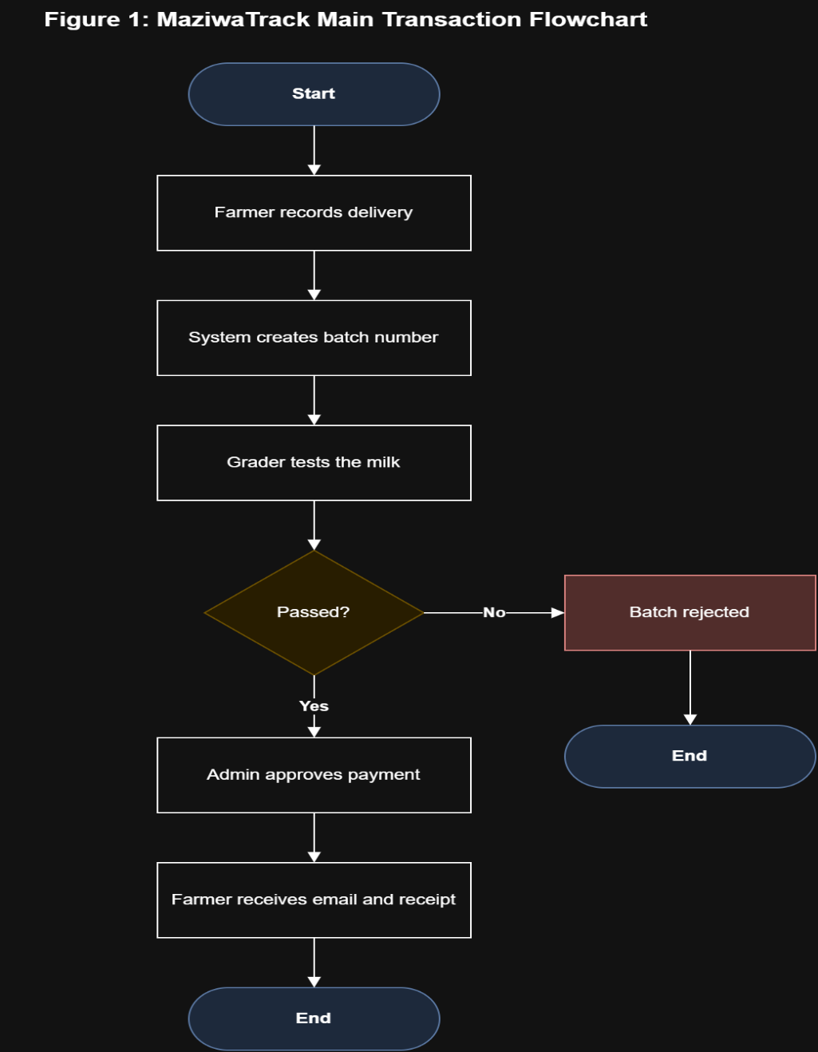
The figure below shows a simplified system flowchart for the MaziwaTrack information system.

2.2 Use Case Diagram
Figure 1: System Flowchart
The use diagram below shows the functional requirements of the system. The actors include farmer, grader and admin. The email service in this case is an external system that would be used to send receipts to the farmer once a payment is approved the admin. The farmer can register, log in and record a milk deposit, after which a batch number is displayed on the screen. A grader verifies the quality and quantity of the milk. The admin can view batch information, approve payments and generate pdf reports.
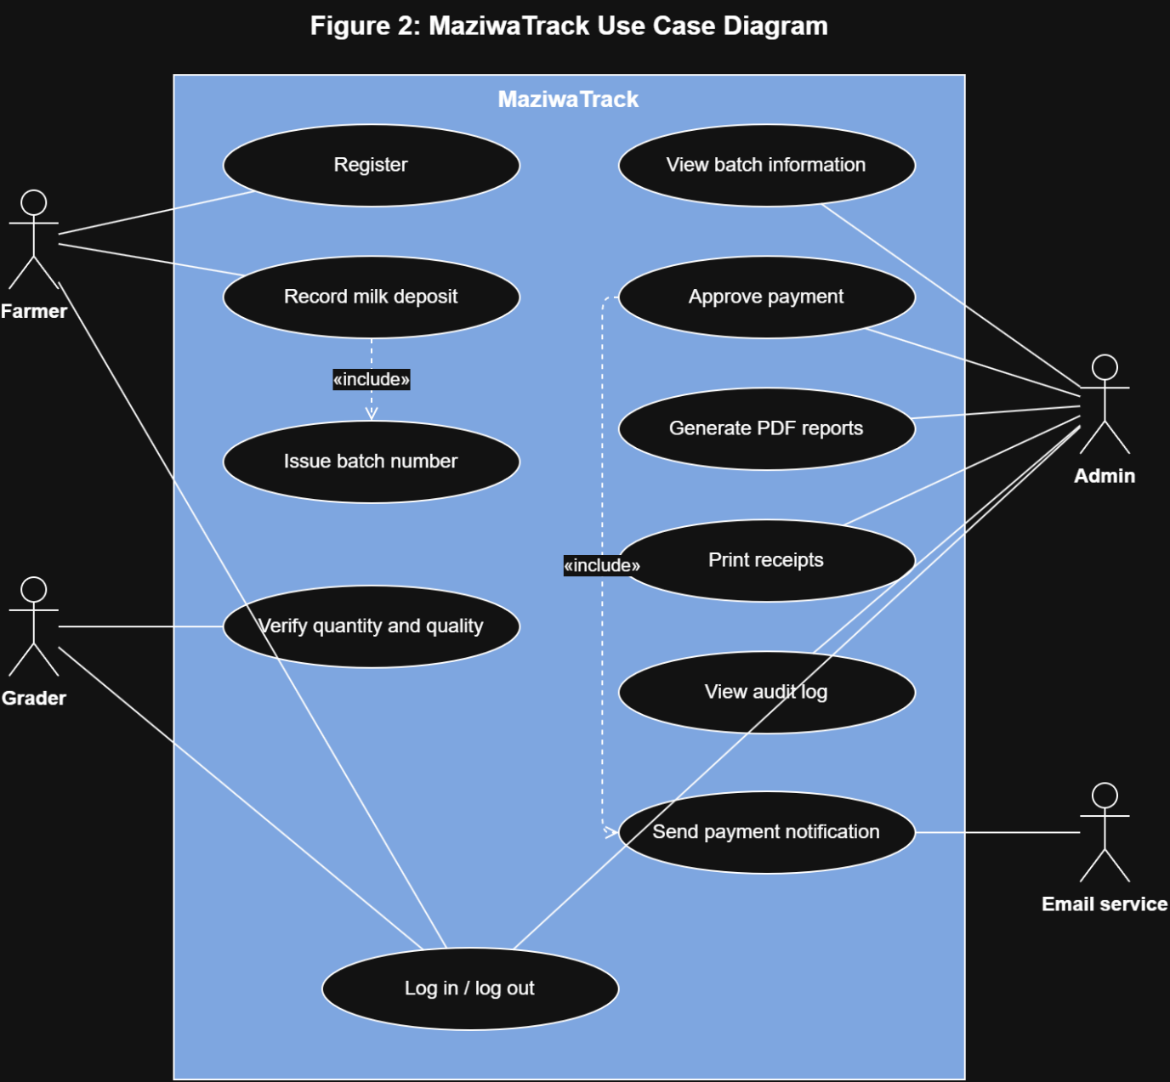
Figure 2:Use Case Diagram

2.3 Class Diagram
The class diagram shows a summary of the classes and how they relate. The User class represents farmers, graders and administrators. The actions carried out depend on the role of the user, but all the users can log in and out. A user can record many batches of milk deposited, each batch is verified by the grader after which the payment can be approved by the admin. One batch one payment. After approval the payment is sent to the user’s email and a receipt can be printed. Every action by a user is stored in the audit log.
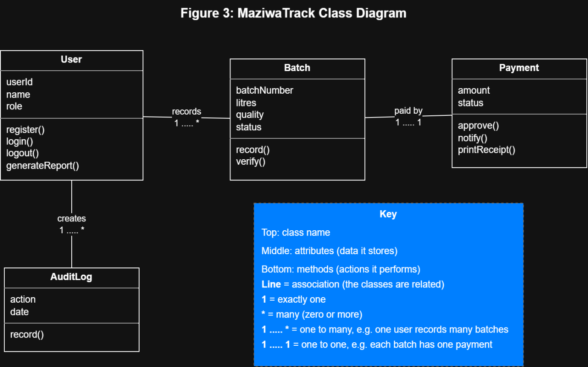
Figure 3:Class diagram

2.4 ER diagram
The ER diagram below shows four tables of MaziwaTrack: users, batches, payments and audit_logs. The users table stores the farmers’, graders’ and administrators’ data, able to be identified by their role. Each batch is uniquely identified by a batch_id and is linked to a farmer by a farmer_id. The payments table uniquely identifies each payment using a payment_id and uses an admin_id to identify who made approved the payment.
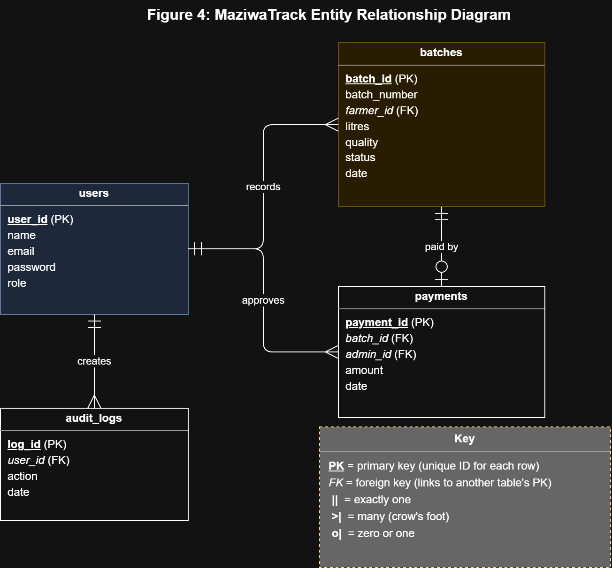
Figure 4:ER diagram

2.5 DB Schema
The group decided to use postgresql for the database part of the project. The figure below is the db schema we came up with
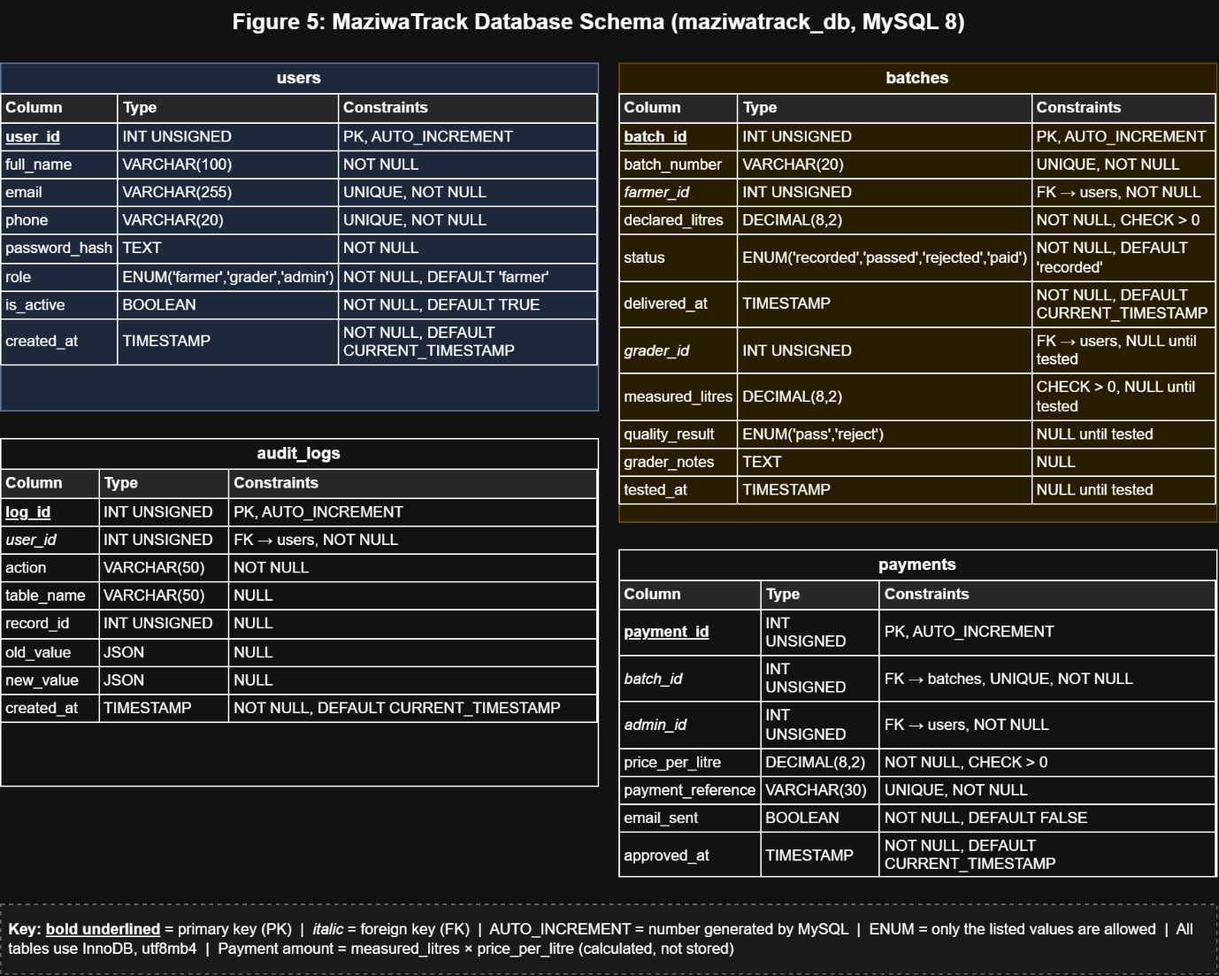
Figure 5:DB Schema

2.6 UI Mockup-Wireframes

2.6.1 Login, Register and Help Pages
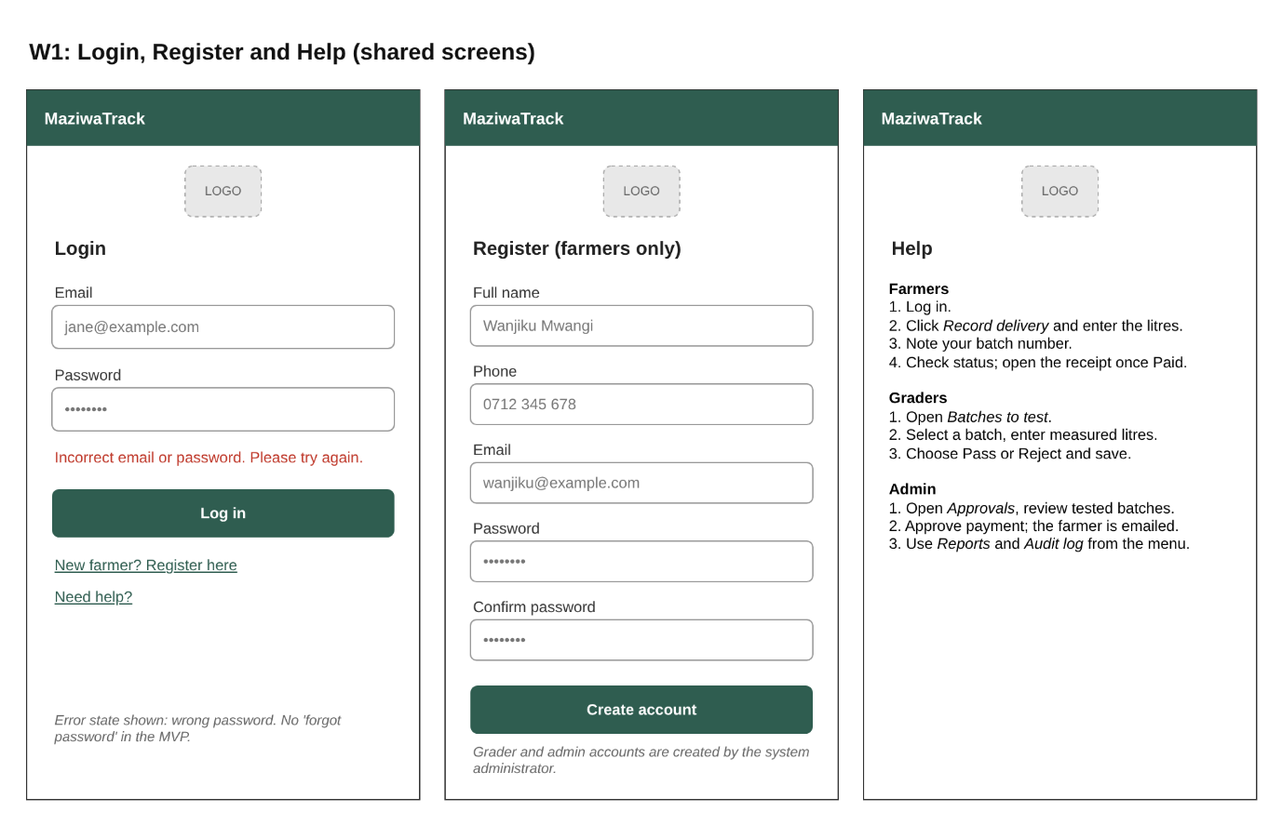
Figure 6:Login , Register and Help Page Wireframe

2.6.2 Farmer Page
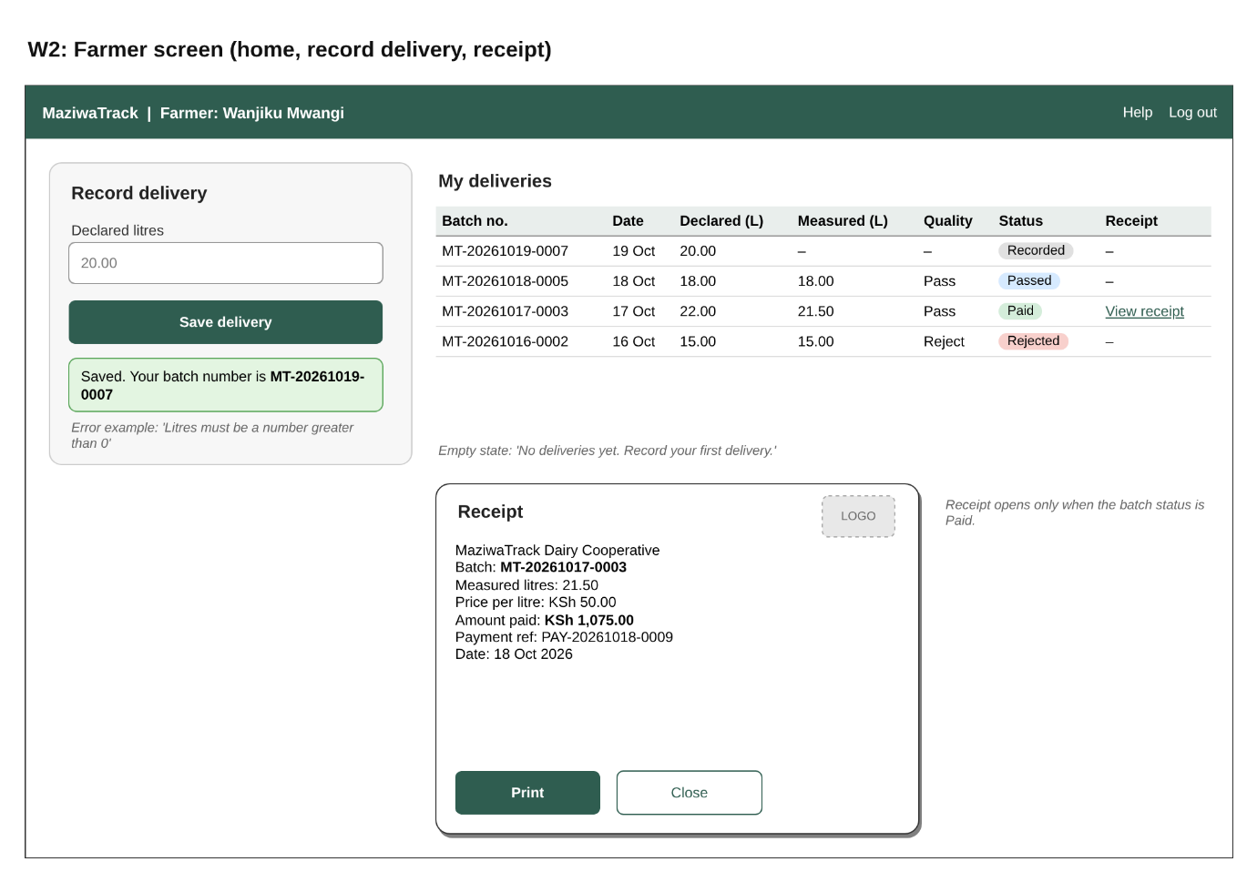
Figure 7:Farmer Dashboard Wireframe

2.6.3 Grader Page
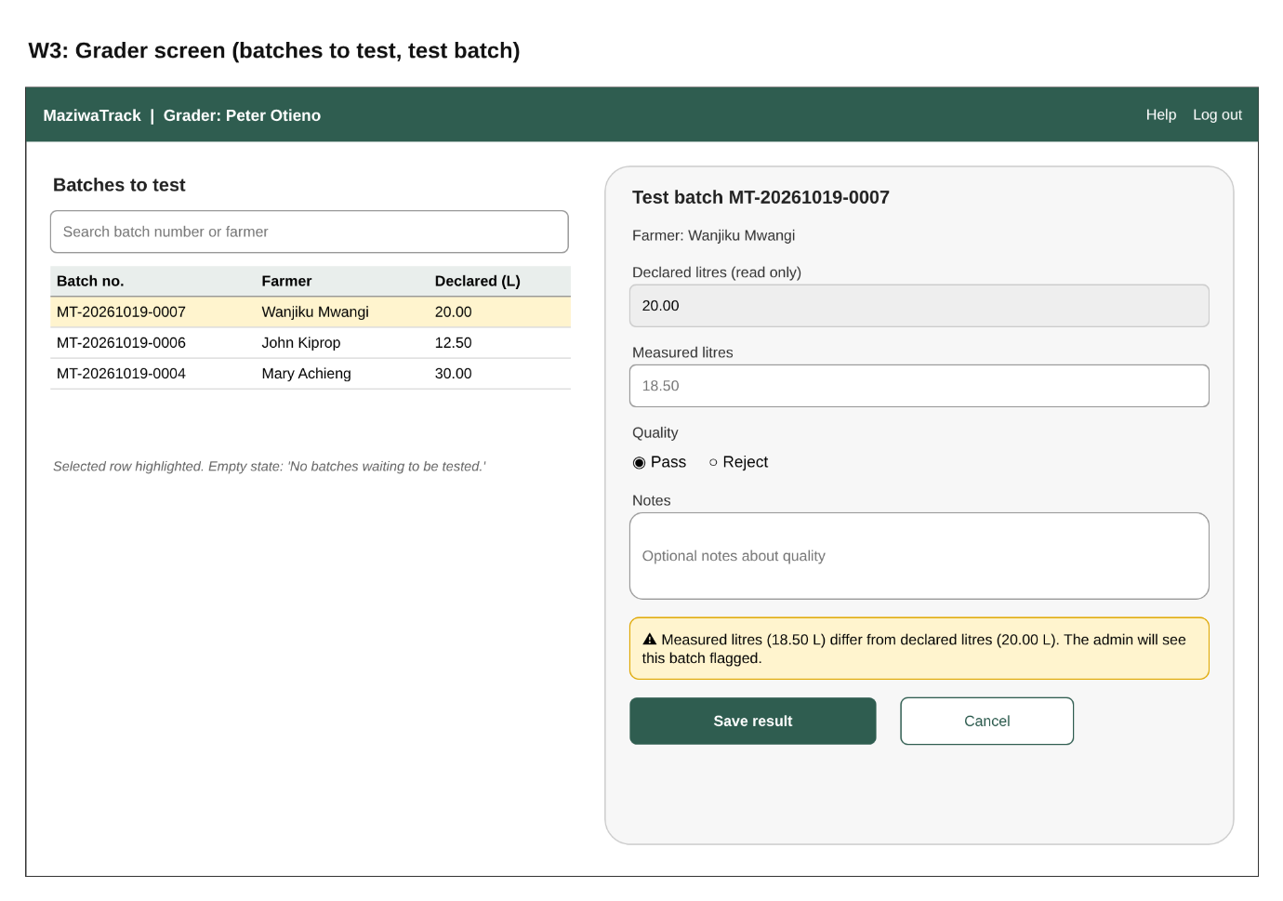
Figure 8:Grader Dashboard Wireframe

2.6.4 Admin Approval page
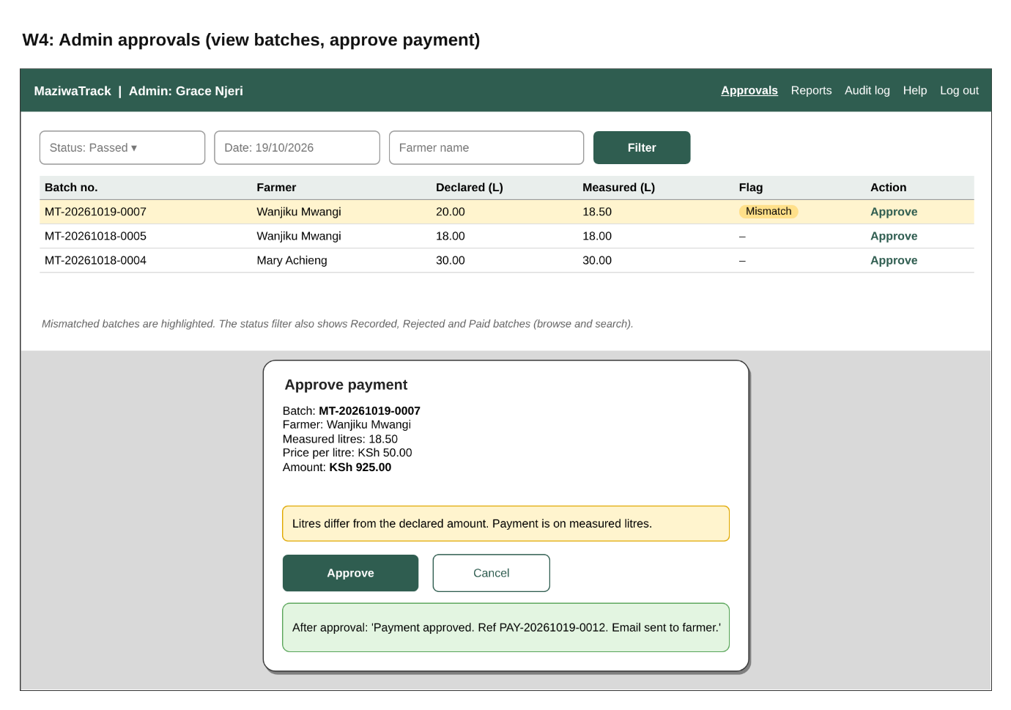
Figure 9:Admin Approval Wireframe

2.6.5 Admin Reports and Audit pages
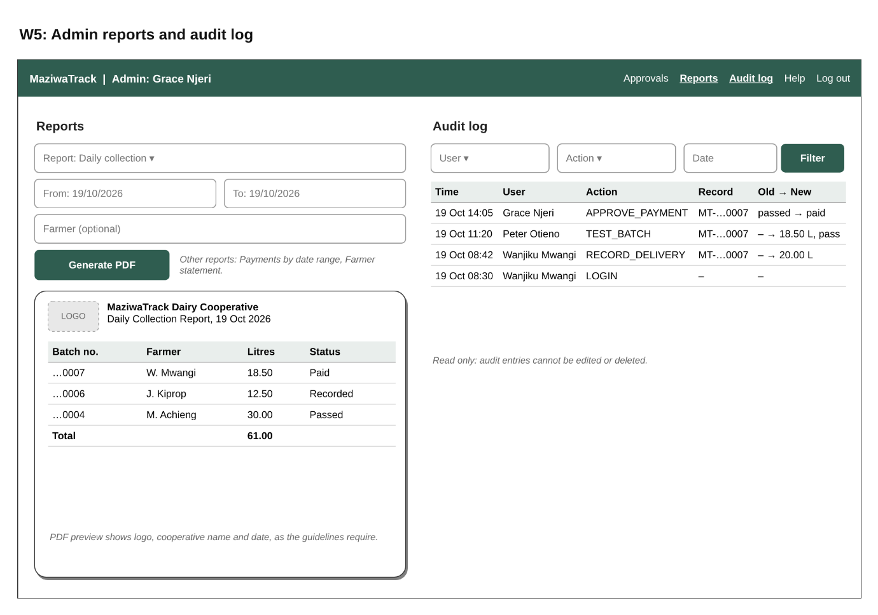
Figure 10:Audit and Report Wireframe

