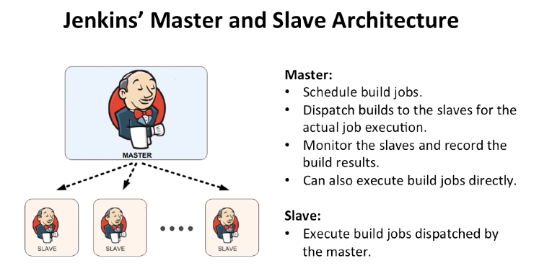

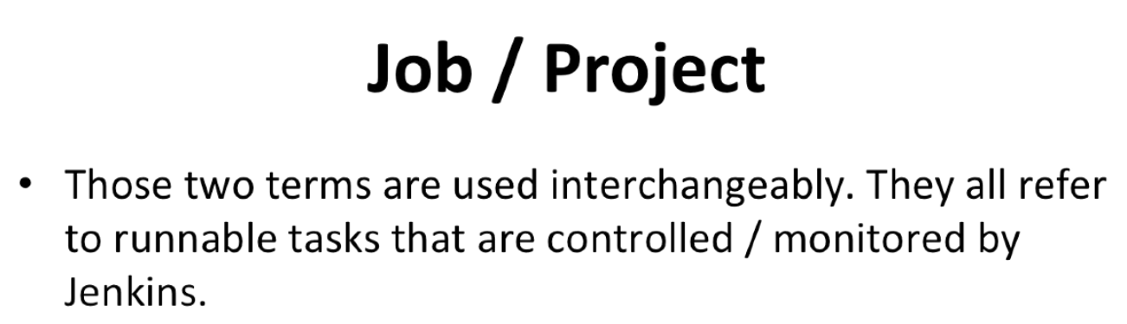

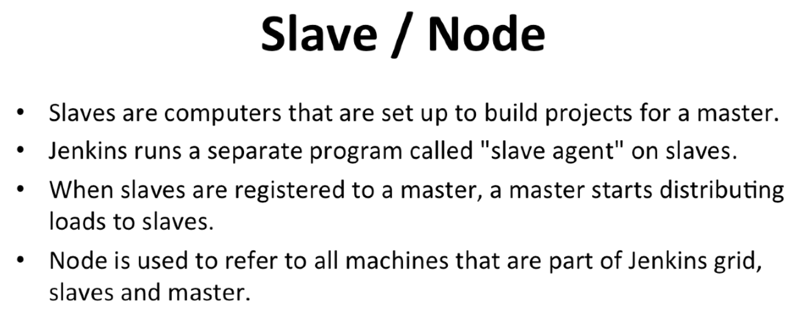

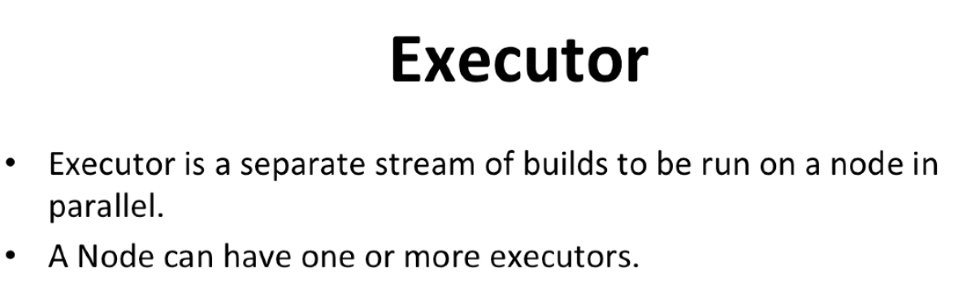



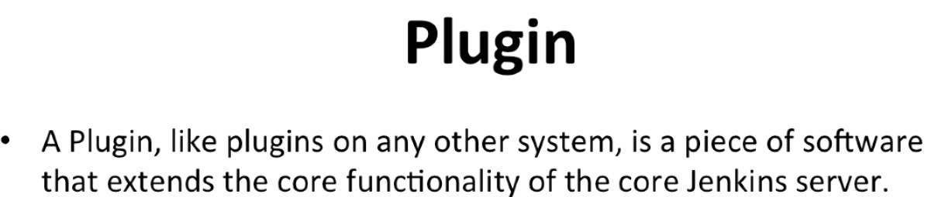

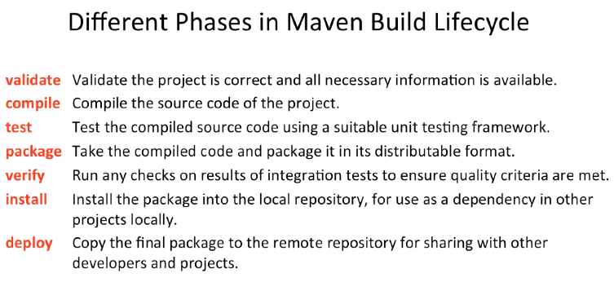

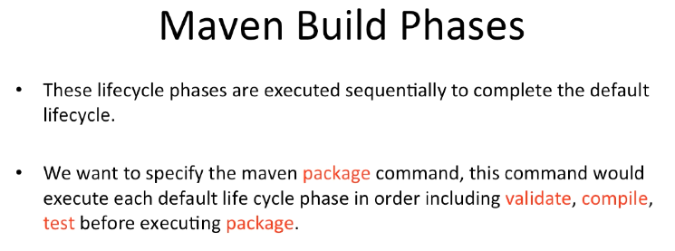

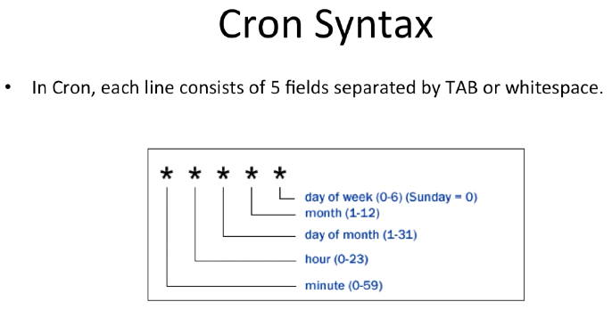

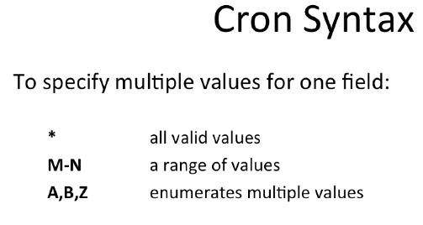

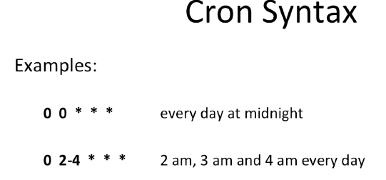

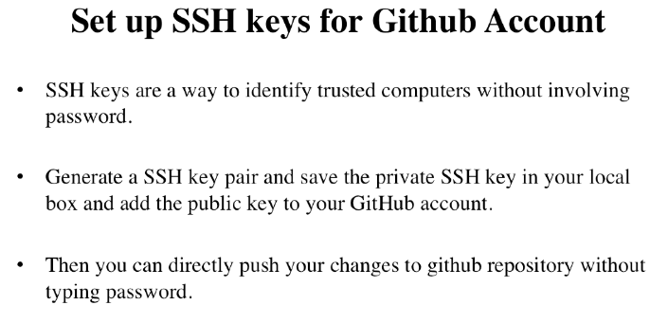

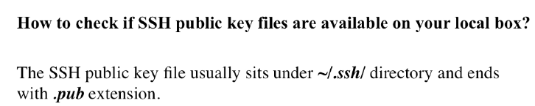

[**https://help.github.com/articles/generating-a-new-ssh-key-and-adding-it-to-the-ssh-agent/**](https://help.github.com/articles/generating-a-new-ssh-key-and-adding-it-to-the-ssh-agent/)

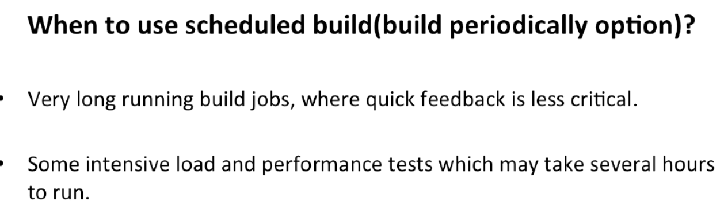

* **To GitHub hook trigger for GITScm polling**

**Go to github plugin page**

[**https://wiki.jenkins.io/display/JENKINS/GitHub+Plugin**](https://wiki.jenkins.io/display/JENKINS/GitHub+Plugin)

* **Java Static analysis tools**

**. we used checkstyle plugin**

**In maven we did**

**clean package checkstyle:checkstyle**

**most famous is**

