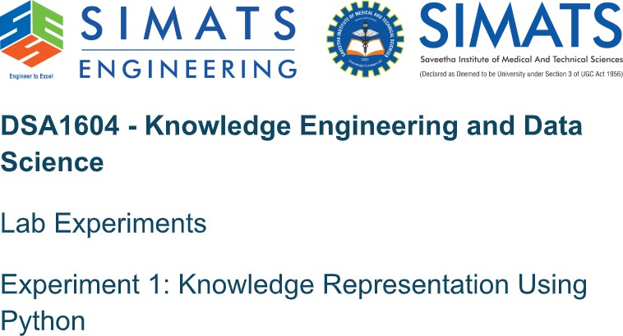

Aim:
To represent facts about a student using a Python dictionary and display the stored knowledge.

Algorithm:
- Start the program.
- Create a dictionary containing student details.
- Store name, department, course, and year as key-value pairs.
- Display the knowledge representation heading.
- Traverse the dictionary using the items() method.
- Print each attribute and its corresponding value.
- Stop the program.

Pseudocode:
BEGIN
CREATE student dictionary DISPLAY heading
FOR each key and value in student PRINT key and value
END FOR END

Program:
student = { "name": "Arun",
"department": "CSE",
"course": "Python Programming", "year": 2
}
print("Student Knowledge Representation") for key, value in student.items():
print(key, ":", value)

Input:
Predefined facts: name=Arun, department=CSE, course=Python Programming, year=2

Output:
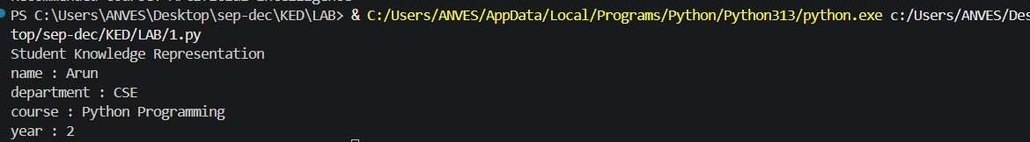

Result:
Thus, student knowledge was represented using a Python dictionary and displayed successfully.

Aim:
To acquire knowledge from a user and store it as structured facts.

Algorithm:
- Start the program.
- Read the expert's name from the user.
- Read the area of expertise.
- Read the years of experience as an integer.
- Store the collected information in a dictionary.
- Display the acquired knowledge with the expert's details.
- Stop the program.

Pseudocode:
BEGIN
INPUT expert name INPUT area of expertise INPUT years of experience
STORE details in knowledge dictionary DISPLAY expert name
DISPLAY area of expertise DISPLAY years of experience
END

Program:
name=input("enter expert name: ") domain=input("enter area of expertise: ") experience=int(input("enter years of experience: ")) knowledge={
"expert":name, "domain":domain,

"experience":experience
}
print("\nAcquired Knowledge") print("Expert:", knowledge["expert"]) print("domain:", knowledge["domain"])
print("Expertience:", knowledge["experience"], "years")

Input:
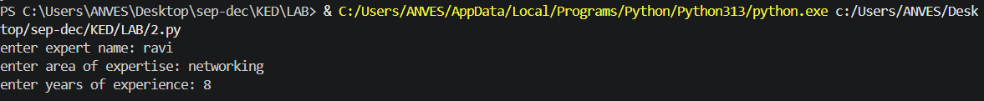

Output:
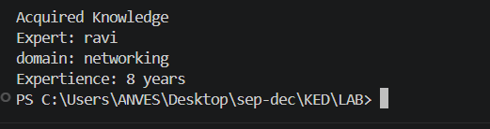

Result:
Thus, knowledge was acquired from the user and stored and displayed successfully in a structured form.

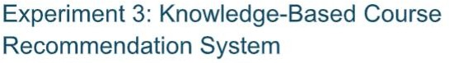

Aim:
To recommend a course using a small knowledge base and decision rules.

Algorithm:
- Start the program.
- Read the student's area of interest.
- Remove extra spaces and convert the input to lowercase.
- Check whether the interest is ai.
- If the interest is ai, recommend Artificial Intelligence.
- Otherwise, check for data or web and recommend the corresponding course; if no match is found, display a message.
- Display the recommended course and stop the program.

Pseudocode:
BEGIN
INPUT interest
CONVERT interest to lowercase IF interest = "ai"
course = "Artificial Intelligence" ELSE IF interest = "data"
course = "Data Science" ELSE IF interest = "web"
course = "Web Development" ELSE
course = "No matching course found" END IF

DISPLAY recommended course END

Program:
interest = input("Enter your interest (AI, Data, Web): ").strip().lower() if interest == "ai":
course = "Artificial Intelligence" elif interest == "data":
course = "Data Science" elif interest == "web":
course = "Web Development" else:
course = "No matching course found" print("Recommended Course:", course) Input:

Output:

Result:
Thus, a knowledge-based course recommendation system was implemented successfully using Python decision rules.

Aim
To develop a Python program that uses a rule-based system to identify common network problems and suggest suitable solutions based on user input.
Algorithm
1. Start the program.
2. Ask the user whether the internet is working, Wi-Fi is connected, and the router is powered on.
3. Collect the user's responses.
4. Apply IF–THEN production rules to identify the possible network problem.
5. Display the identified problem and its suggested solution.
6. Stop the program.
Program
print("NETWORK TROUBLESHOOTING SYSTEM")
router = input("Is the router powered on? (yes/no): ").lower()
wifi = input("Is Wi-Fi connected? (yes/no): ").lower()
internet = input("Is the internet working? (yes/no): ").lower()
if router == "no":
print("Problem: Router is powered off")
print("Solution: Turn on the router and check the power cable")
elif wifi == "no":
print("Problem: Wi-Fi is disconnected")
print("Solution: Connect your device to the correct Wi-Fi network")
elif internet == "no":
print("Problem: Internet connection failure")
print("Solution: Restart the router and contact your ISP if needed")
else:
print("Problem: No network issue detected")
print("Solution: Your network is working properly")

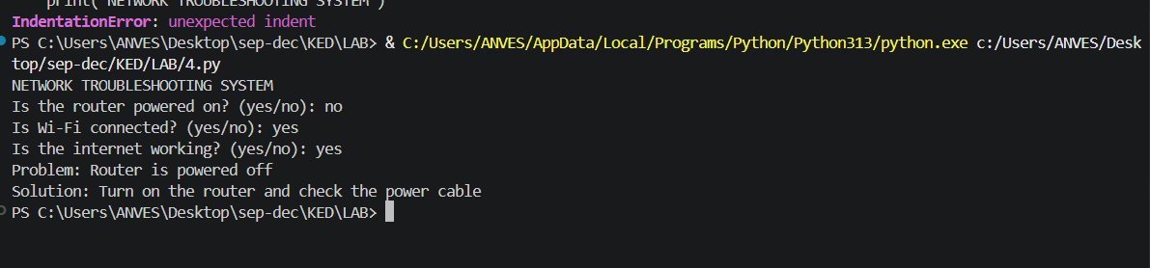

RESULT:
The rule-based network troubleshooting system was implemented successfully using Python.

Aim:
To represent knowledge using nodes and relationships in a semantic network.
Algorithm:
1. Start the program.
2. Define concepts and their relationships.
3. Display the semantic network.
4. Stop the program.
Program:
semantic_network = [
("Student", "enrolls in", "Course"),
("Teacher", "teaches", "Course"),
("Student", "belongs to", "Department")
]
print("Semantic Network:")
for subject, relation, obj in semantic_network:
print(subject, "-->", relation, "-->", obj)
INPUT: Predefined concepts and relationships.
Output:
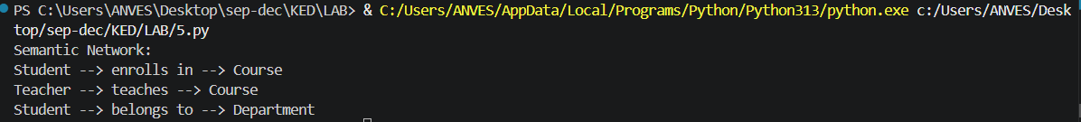
RESULT:
The semantic network was successfully represented using Python

Aim
To implement production rules using forward chaining in Python to derive new facts from known facts.
Algorithm
1. Start the program.
2. Define initial facts and IF–THEN rules.
3. Check rule conditions against known facts.
4. Add new conclusions when conditions match.
5. Display the final facts and stop.
Program:
facts = {"fever", "cough"}
rules = [
({"fever"}, "possible_illness"), ({"fever", "cough"}, "possible_infection")
]
changed = True while changed:
changed = False for conditions, conclusion in rules:
if conditions.issubset(facts) and conclusion not in facts:
facts.add(conclusion) changed = True print("Final Facts:")
for fact in sorted(facts):
print(fact)
INPUT:
fever cough
OutPut:
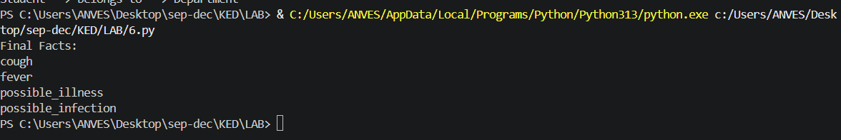
RESULT:
Production rules and forward chaining were implemented successfully using Python.

Aim
To implement a frame-based knowledge representation system using Python to store and display information about an object.
Algorithm
1. Start the program.
2. Create a frame named Student.
3. Define slots such as name, age, course, and department.
4. Store values in the frame.
5. Display the frame details.
6. Stop the program.
Pseudo code:
START CREATE
a frame named Student
STORE name, age, course, department
DISPLAY all frame details
STOP
Sample Input
Name: Divya Age: 21 Course: B.Tech Department: CSE
Output:
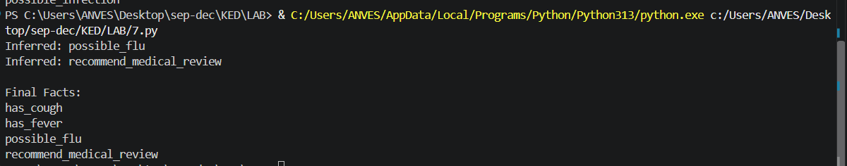
Result
Thus, the frame-based knowledge representation system was successfully implemented in Python to store and display student information using slots and values.

Aim:
To create a simple university ontology with classes, properties, and individuals.
Software Required: Protégé Desktop and a compatible OWL reasoner such as HermiT
Procedure / Algorithm
Create a new ontology named UniversityOntology.
Create classes Person, Student, Faculty, and Course.
Make Student and Faculty subclasses of Person.
Create the object property enrolledIn with domain Student and range Course.
Create individuals Arun (Student) and PythonProgramming (Course).
Assert that Arun enrolledIn PythonProgramming.
Run the reasoner and inspect inferred class membership.
Output:
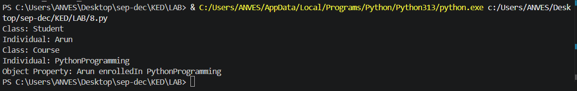
Result:
Created a university ontology and used subclass reasoning to infer that Arun is a Person.

