**Software Requirements Document**

**for**

**Disp**

**Version 1.0**

**October 2016**

***Prepared by:***

**Dramane Diakite**

**Ihar Pikaliuk**

**Ian M Fraser**

**Steven Polanco**

|  |  |
| --- | --- |
| Disp | Version <1.0> |
| Software Requirements Specification | 10/09/2016 |
| <document identification> |  |

**Revision History**

|  |  |  |  |
| --- | --- | --- | --- |
| Date | Version | Description | Authors |
| 10/14 | 1.0 |  | Dramane Diakite  Ihar Pikaliuk  Ian M Fraser  Steven Polanco |
|  |  |  |  |

**Table of Content**

**1. Introduction:**

1.1 Purpose

1.2 Scope

1.3 Definitions, Acronyms, and Abbreviations

1.4 References

1.5 Overview

**2. Overall Description:**

2.1 Use-Case Model Survey

2.2 Assumptions and Dependencies

**3. Specific Requirements:**

3.1 Use-Case Reports

3.2 Supplementary Requirements

**4. Supporting Information:**

**1. Introduction:**

This section gives a scope description and overview of everything included in this Software Requirements Specification document. Also, the purpose for this document is described and a list of abbreviations and definitions is provided.

1.1 **Purpose:**

The purpose of this document is to describe the requirements for the software system being created (Disp). It describes the functionalities, features, and use cases in great detail. This document is the blueprint of Disp.

1.2 **Scope :**

Disp is an online application for users who would like to:

* Sell their products to other users of this system
* Buy products from other users of this system
* Provide services to other users of this system
* Request services from other users of Disp
* Deposit funds into his account
* Withdraw funds from his account

Disp provides a users with a profile page where the user will be directed to upon signing in.

Disp will be available for visitors to browse listings and apply for an account.

An administrator (Super-user) can accept or reject a visitor application to become a user.

Disp will use a database to store the inventories.

1.3 **Definitions, Acronyms, and Abbreviations:**

|  |  |
| --- | --- |
| **Term** | **Definition** |
| Visitors(V) | People who use the system, but did not register for an account |
| Users(U) | People who register for the system |
| Super-Users(S) | The Administrator of the system |
| Javascript | An object-oriented computer programming language commonly used to create interactive effects within web browsers |
| Database | A collection of information that is organized so that it can easily be accessed, managed, and updated |
|  |  |

1.4 **References**

*IEEE. IEEE Std 830-1998 IEEE Recommended Practice for Software Requirements Specifications. IEEE Computer Society, 1998. Wikipedia.org*

1.5 **Overview**

The next chapter, the Overall Description section, of this document gives an overview of the functionality of the product. It describes the informal requirements and is used to establish a context for the technical requirements specification in the next chapter. The third chapter, Requirements Specification section, of this document is written primarily for the developers and describes in technical terms the details of the functionality of the product. Both sections of the document describe the same software product in its entirety, but are intended for different audiences and thus use different language.

2.0 **Overall Description**

2.1 Use-Case Model Survey

In this section we will introduce the use-case model used to describe the relationship between our users (actors) and our software’s features (cases). In Section 3.1, we will describe these relationships in more detail.

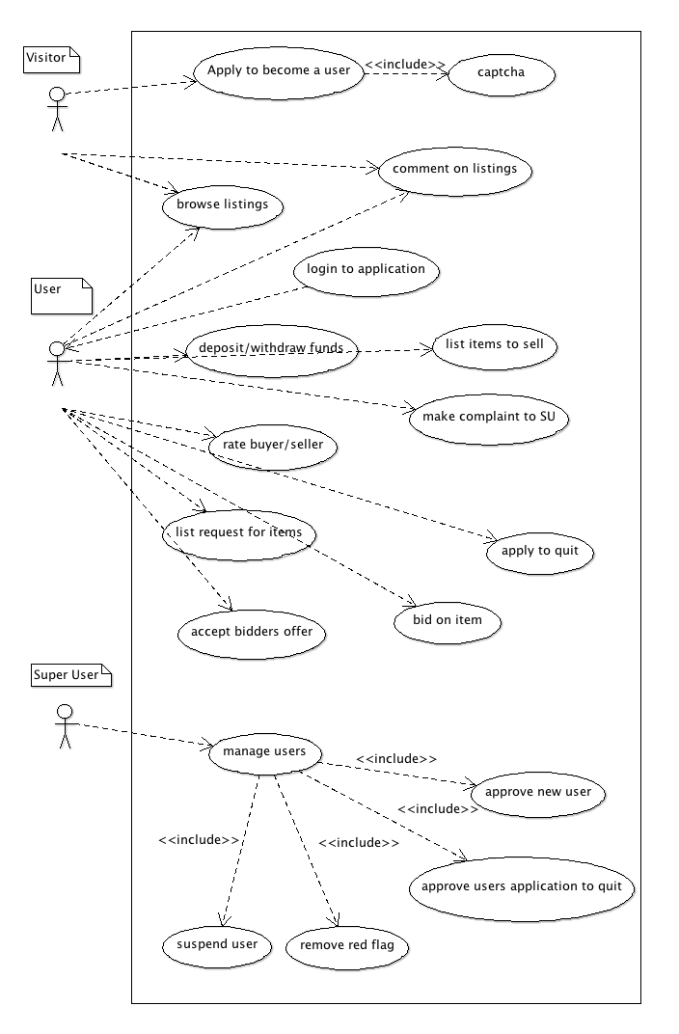

Figure 1. The Use-Case Diagram

We have three different actors in our system: the visitor (V), the user (U) and the super-user (SU).

The visitor is anyone who visits the application but does not have a membership. The visitor can view all posts made by registered users, can comment on them, but cannot place a bid or make a listing. To do so, they must register to the super-user for membership.

The user also has full access to viewing posts and commenting, but can also create new listings, manage their financial accounts, and rate their transactions.

The super-user is a user who fills the role of the administrator. They can approve new users, suspend users, decide who can give up memberships, as well as remove any red flags that users have gained from poor ratings.

2.2 Assumptions and Dependencies

It is assumed that this system will handle a large volume of users over a long period of time. This would require efficient algorithm design and a sturdy web server to ensure that things stay operational even during times of heavy traffic.

3.0 **Specific Requirements**

3.1 Use-Case Reports

Use case: Apply to become a user.

Detailed Description:

In order to interact with the features offered through our site, a visitor must apply to become a user. Before the application is sent to the super-user (SU) for approval, the visitor must answer several questions or a CAPTCHA to prove that he/she is a human, and not a machine. Once completed, the visitor must wait for SU approval before logging in to the site as a user.

Use case: Apply to quit.

Detailed Description:

If a user has decided that they no longer would like to use the services provided by the site, they can apply to quit, which must be approved by the super user.

Use case: Login to application.

Description:

In order for a user to interact with the features offered, he/she must login to the application first. Users, and super-users must complete this step before using certain features. Visitors must apply to become a user before login.

Use case: Browse listings

Description:

Browsing the listings provided by the user is open to anyone. This includes visitors, users, and super users. The listings are items or needs being offered for sale on the site.

Use case: Comment on listings

Description:

Visitors, users, and super users can comment on the items or needs being listed on the site by other users.

Use case: Deposit / withdraw funds.

Description:

Users must have an active balance in their account to purchase the items that they have asked/bid for. They can add and remove money as much as they would like, so long as they do not exceed less than $0.

Use case: List items to sell.

Description:

Users can list items to sell, or request items they may need. When creating the listing, the user will provide an image of the item being sold, an asking price or starting bid, and a description of the item being sold.

Use case: Bid on items.

Description:

Users can bid on items that have been listed by other users. In order to bid, the user must have an adequate amount of money in their balance to qualify. The user selling the item can decide whether or not he/she would like to sell to the bidder.

Use case: Rate transaction.

Description:

Users can rate the transaction after it complete. The rating is from 1 to 5 stars. Both the buyer and seller can rate each other anonymously.

Use case: File complaint to super user.

Description:

Users can file a complaint about other users to the super user. The super-user can decided to suspend a users account based on the severity of the complaint.

Use case: Manage users.

Description:

The super user must manage the users of the site. They must approve applications, suspend users with low ratings, and approve users who are leaving the site.